Session 2025-2026

Vision: To help businesses uncover crucial  insights | Mission: To be a good data scientist

Program Educational Objectives of the program (PEO): (broad statements that describe the professional and career accomplishments)
PEO1 | Preparation | P: Preparation | Pep-CL abbreviation  pronounce as Pep-si-lL easy to recall
PEO2 | Core Competence | E: Environment (Learning Environment)
PEO3 | Breadth | P: Professionalism
PEO4 | Professionalism | C: Core Competence
PEO5 | Learning Environment | L: Breadth (Learning in diverse areas)

Program Outcomes (PO): 1. Understand and Apply Parallel Programming Concepts
2. Analyse and Improve Program Performance.
3. Demonstrate Practical Skills in HPC Tools and Environments.
Keywords of POs:
Engineering knowledge, Problem analysis, Design/development of solutions, Conduct Investigations of Complex Problems, Engineering Tool Usage, The Engineer and The World, Ethics, Individual and Collaborative Team work, Communication, Project Management and Finance, Life-Long Learning

PSO Keywords: Cutting edge technologies, Research

“I am an engineer, and I know how to apply engineering knowledge to investigate, analyse and design solutions to complex problems using tools for entire world following all ethics in a collaborative way with proper management skills throughout my life.” to contribute to the development of cutting-edge technologies and Research.

Integrity: I will adhere to the Laboratory Code of Conduct and ethics in its entirety.

Name and Signature of Student and Date
Aryan Sukhdewe
01/09/2025

Session | 2025-26 (ODD) |  | Course Name | HPC Lab
Semester | 7 |  | Course Code | 22ADS706
Roll No | 40 |  | Name of Student | Aryan Sukhdewe
Practical Number |  | 3
Course Outcome |  | - Understand and Apply Parallel Programming Concepts  - Analyse and Improve Program Performance
Aim |  | Introduction to OpenMP
Problem Definition |  | Introduction to OpenMP
Theory  (100 words) |  | OpenMP stands for Open Multi-Processing. It is an API (Application Programming Interface) that supports multi-platform shared-memory multiprocessing programming in C, C++, and  Fortran.  It allows developers to write parallel code easily using compiler directives, library routines, and environment variables.  Key Features:  - Supports shared memory multiprocessing  - Uses fork-join model: master thread forks a specified number of slave threads  - Simple and readable syntax using pragma directives  - Controlled by environment variables (e.g., OMP_NUM_THREADS)  - Scales well for multi-core CPUs  Execution Steps on CentOS/Linux  Step 1: Install GCC with OpenMP support  Most CentOS systems have GCC preinstalled. If not:  sudo yum install gcc  To verify OpenMP support:  gcc -fopenmp --version  Step 2: Write the OpenMP Program  Create a file named openmp_example.c.  nano openmp_example.c  Paste your OpenMP C code (example below).  Step 3: Compile the Program  Use -fopenmp flag to enable OpenMP:  gcc -fopenmp -o openmp_example openmp_example.c  Step 4: Set Number of Threads (Optional)  You can set how many threads OpenMP should use:  export OMP_NUM_THREADS=4  Step 5: Run the Program  ./openmp_example
Code: |  | #include <stdio.h>  #include <omp.h>  int main() {  int i;  int n = 12;  #pragma omp parallel for schedule(static, 3)  for (i = 0; i < n; i++) {  printf("Thread %d processing iteration %d\n", omp_get_thread_num(), i);  }  return 0;  }
Output |  | 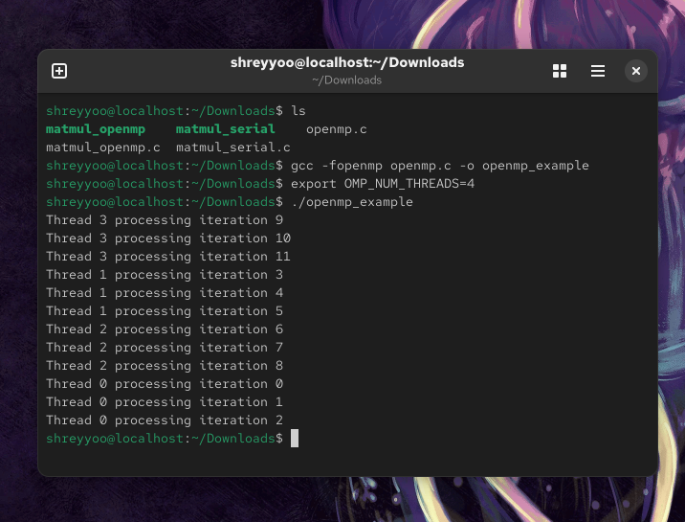
Output Analysis |  | Our program successfully executes using OpenMP and four threads.
Link of student Github profile where lab assignment has been uploaded |  | https://github.com/aryanycce/HPC-Practicals
Conclusion |  | OpenMP supports shared memory multiprocessing, has simple and readable syntax and scales well for multi-core CPUs.
Plag Report (Similarity index < 12%) |  | 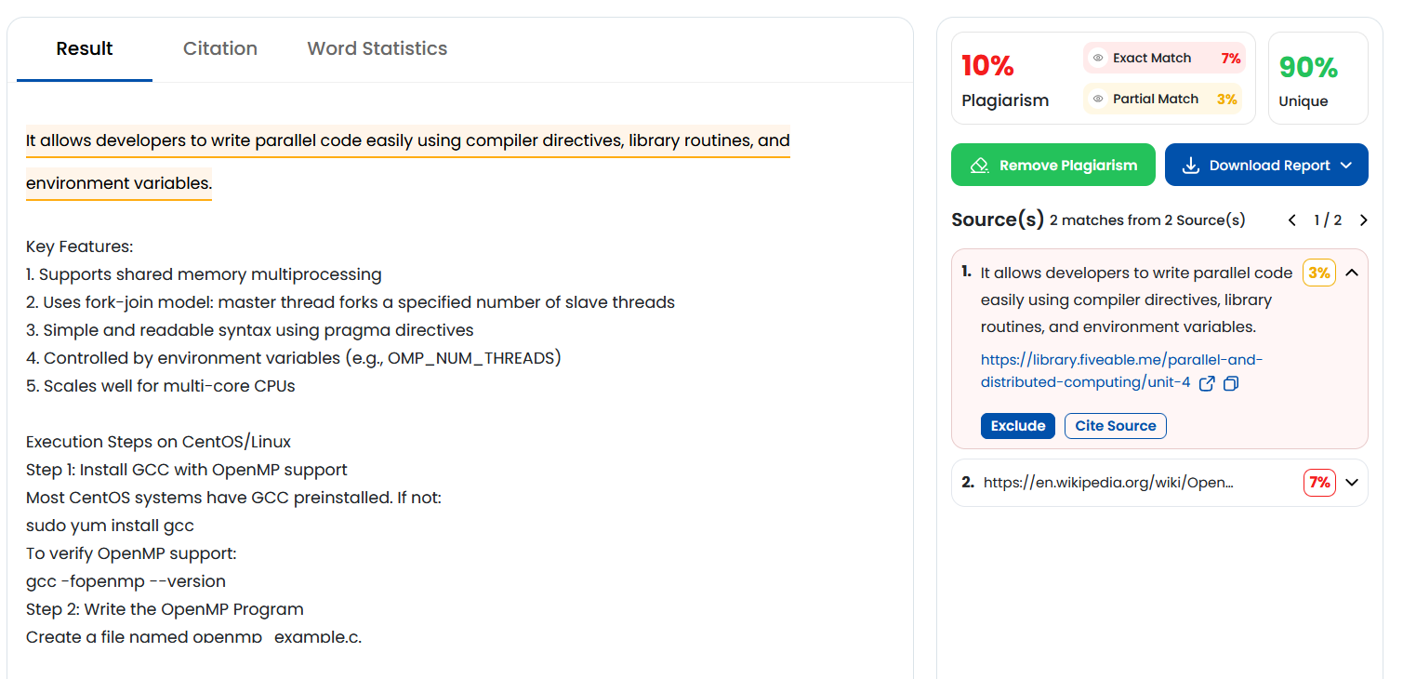
Date |  | 01/09/2025

