|  |  |
| --- | --- |
| **Ex No: 10**  **Date: 28th October 2024** | **Deploy multi-class (machine learning) classification of Iris dataset on AWS** |

**Objective:** The objective of this experiment is to classify Iris flowers into one of three species (Setosa, Versicolor, or Virginica) based on four physical features: sepal length, sepal width, petal length, and petal width. The experiment demonstrates the steps of building, training, and deploying a machine learning model using AWS SageMaker.

**Description:**

AWS SageMaker was used for building and deploying a classification model with the popular Iris dataset. This dataset contains 150 samples, each with four features and one label representing the flower species. The experiment involved five stages: data preparation, moving data into an S3 bucket, creating the model, training it, and deploying the model for predictions.

**Model**

The model chosen for this experiment is based on the XGBoost algorithm, known for its efficiency in handling classification tasks. In SageMaker, the built-in XGBoost algorithm is used with hyperparameters set for multi-class classification.

**Building the parts of the algorithm:**

1. **Data Preparation:**

* The Iris dataset is loaded, and the data is split into training (80%) and testing (20%) sets.
* The training and testing sets are saved as CSV files.

1. **Moving Data to S3:**

* Both CSV files are uploaded to an Amazon S3 bucket, ensuring the SageMaker environment can access the data.

1. **Creating the Model:**

* Using the XGBoost algorithm, the model is configured with specific hyperparameters: max_depth, eta, and objective set to multi:softmax for handling multi-class classification.

1. **Training the Model:**

* The model is trained on the uploaded data in the S3 bucket, and training progress is monitored through the SageMaker console.

1. **Deploying the Model:**

* The trained model is deployed to a SageMaker endpoint, enabling real-time predictions on new samples.

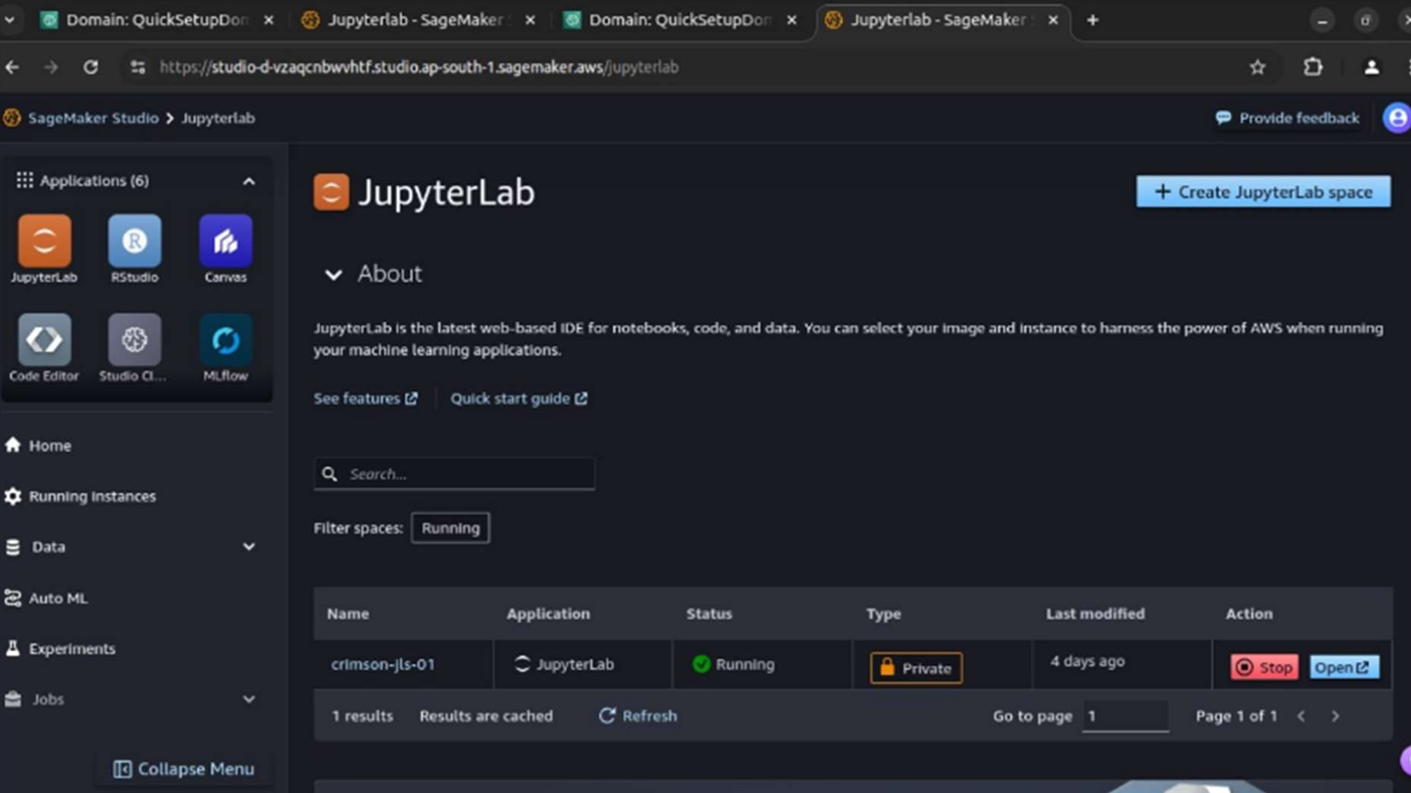

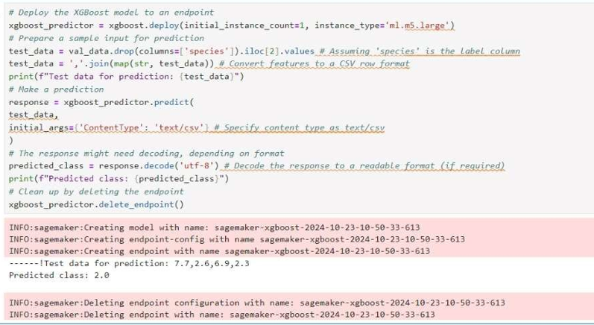

**Conclusion:**

The experiment concludes with the successful deployment of an XGBoost-based model capable of classifying Iris flowers with high accuracy. Observations indicate that using SageMaker simplifies model deployment and scales infrastructure requirements efficiently. For instance, the model classifies a sample based on the input values for petal and sepal measurements, returning the predicted species. The SageMaker framework streamlined the experiment from data preparation to model deployment, demonstrating a robust workflow for machine learning projects.

**GitHub Link:** [**https://github.com/aryapg/DeepLearning.git**](https://github.com/aryapg/DeepLearning.git)