### Feature Extraction form Image

### Monofractal, Multifractal, Gray level co-

### occurence Matrix

(MMG)

Laxmi Patidar (0801CS171037)

Pushpa Arya (0801CS183D12)

Sheetal Bhuriya (0801CS171074)

December 20, 2020

# Contents

1. Introduction 2

1.1 Feature Extraction . . . . . . . . . . . . . . . . . . 2

1.2 Monofractal Analysi. . . . . . . . . . . . . . . . . . . . . 2

1.3 Multifractal Analysi. . . . . . . . . . . . . . . . . . . . . 2

1.4 Gray Level Co-occurrence Matrix. . . . . . . . . . . . . 3

1. Mathematical Formulation 4

2.1 Monofractal Formulation . . . . .. . . . . . . . . . . . 4

2.2 Multifractal Formulation . . . . .. . . . . . . . . . . . 4

2.3 Gray level co-occurence Matrix Formulation. . . . . . . . . . . 5

1. Algorithm 8

3.2 Monofractal algorithm . . . . . . . . . . . . . . . . . . .8

3.2 Multifractal algorithm . . . . . . . . . . . . . . . . . . .7

3.3 GLCM algorithm . . . . . . . . . . . . . . . . . . . . . . .7

1. Documentation of API 10

4.1 Image Preprocessing . . . . . . . . . . . . . . . . . . . . . . . . . 10

4.2 Implementing the Monofractal algorithm . . . . . . . . . 10

4.3 Implementing the Multifractal algorithm . . . . . . . . . 10

4.4 Implementing the GLCM algorithm . . . . . . . . . . . 11

1. Example 12
   1. Example 1 12
   2. Example 2 13
2. Learning Outcome 14

6.1 ...... . . . . . . . . . . . . . . . . . . . . . . . . . . . 14

# Appendix A

# References 15

**Bibliography 16**

**Chapter 1 Introduction**

**1.1 Feature Extraction**

The main goal of feature extraction is to obtain the most relevant information from the original data(image). When the pre-processing has been done, some feature extraction technique is applied to the data(image) to obtain features, which is followed by application of classification and post processing techniques.The number of features is  same as the number of pixels in an image.

**1.2Monofractal Analysis**

Monofractal analysis was performed on binarized images by the regular non-overlapping box counting method. Monofractal box counting delivers two main parameters fractal dimension (FD) and lacunarity as respective measures of complexity and heterogeneity.The fractal dimension of natural objects is estimated as a negative slope of the straight part of the regression line . Lacunarity is a measure of heterogeneity within an object.

**1.3Multi fractal Analysis**

Multifractal is more appropriate for the description of irregular natural objects than monofractal analysis.Natural objects are usually neither universally nor statistically self-similar and possess an uneven distribution of complexity with FD fluctuating from point to point within an object. Multifractal analysis is able to describe the statistical properties of tissue images with such uneven and irregular spatial arrangements.

**1.4Grey Level Co-occurrence Matrix**

A gray level co-occurrence matrix(GLCM) contains information about the positions of pixels having similar gray level values. A co-occurrence matrixis a two-dimensional array, P, in which both the rows and the columns represent a set of possible image values.

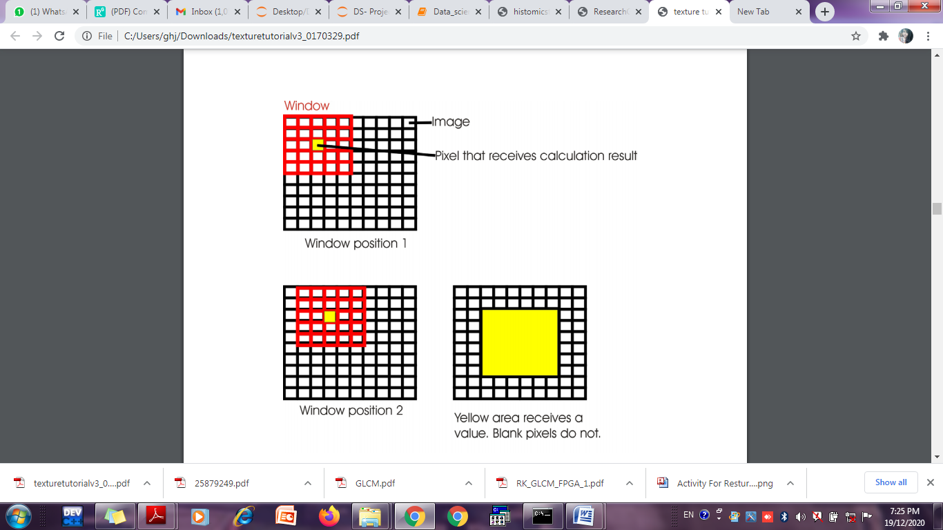

**Chapter-2**

**Mathematical Formulation**

**2.1 Monofractal Formulation**

Monofractal box counting delivers two main parameters:

1.)fractal dimension (FD) (complexity)

2.)lacunarity ( heterogeneity).

The box-counting method involves covering of the digital image with a grid of boxes with size (scale) ε expressed as the box size relative to image size. The space filling properties of the image are calculated as the count (N) of the minimum number of grid boxes needed to cover all parts of the image containing foreground pixels .FD defines the scaling rule by the relationship between the scale detail (counts, N) and box sizes (ε).

FD =−lim (logN(ε))/(log(ε))

ε→0

Lacunarity is a measure of heterogeneity within an object, estimated by pixel mass distribution, or when box-counting method is applied, by the number of pixels per all possible sizes of boxes (ε). Patterns having larger or more numerous gaps generally have higher lacunarity, while low values of lacunarity imply homogeneity based on similarly sized gaps and little rotational variance.

Lacunarity formula is :

λε=(σ/μ)^2

where σis the standard deviation and μis the mean of the

foreground pixels per box.

**2.2 Multifractal Formulation**

The standard method to test for

multifractal properties consists of calculations of the socalled

moments of order Q, for the measure P(i,ε), defined by:

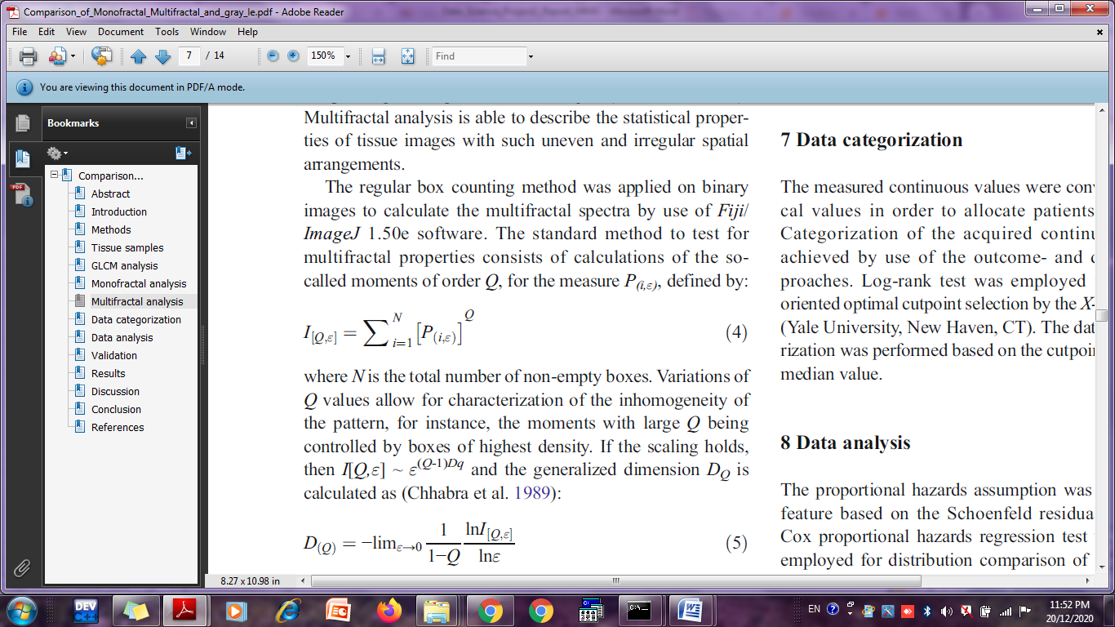

where N is the total number of non-empty boxes. Variations of

Q values allow for characterization of the inhomogeneity of

the pattern, for instance, the moments with large Q being

controlled by boxes of highest density. If the scaling holds,

then I[Q,ε] ~ ε(Q-1)Dq and the generalized dimension DQ is

calculated as



The structure S is divided into non-overlapping boxes Si of size ε

such that S = ∪ Si. Each box Si is characterized by the local

singularity measure μ (Si). The coarse Hölder exponent of each

subset Si is defined by the formula

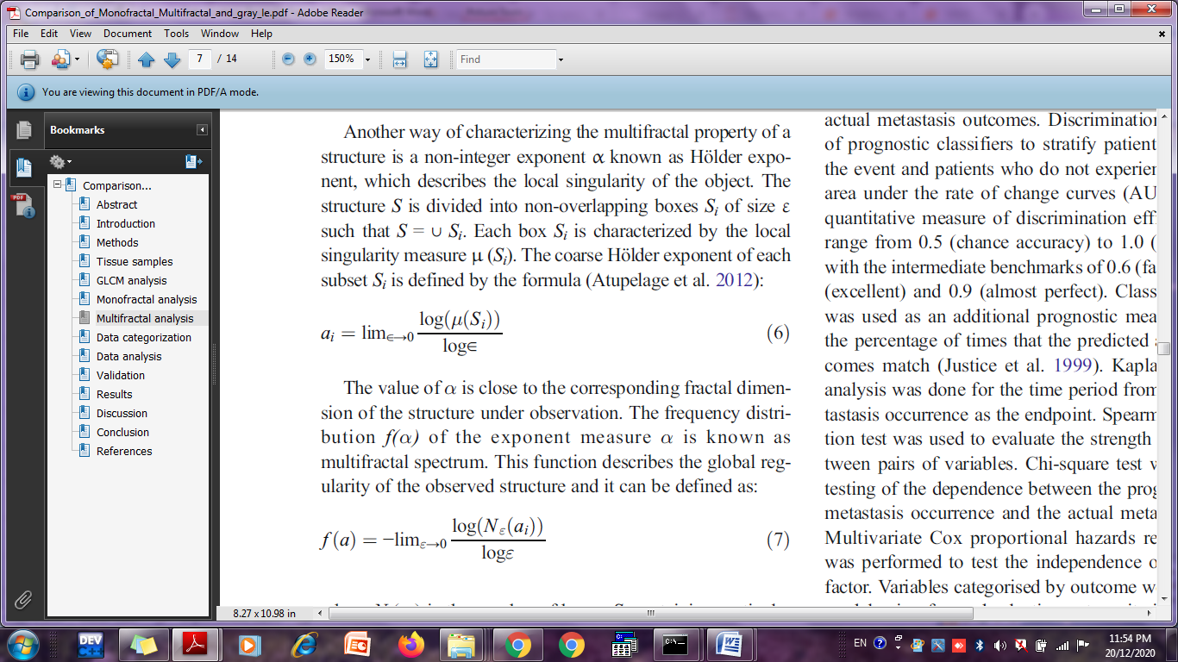

The value of α is close to the corresponding fractal dimension

of the structure under observation. The frequency distribution

f(α) of the exponent measure α is known as

multifractal spectrum.



where Nε(αi) is the number of boxes Si containing particular

values of αi

Calculated multifractal features in this study included 10

parameters: 1)Dqmax,

2)Q corresponding toDqmax,

3) f(α)max,

4) α corresponding to f(α)max,

5) slope DQ vs Q,

6) slope

α(Q),

7) slope f(α) vs (Q),

8) slope DQ(Q) from −1 do 3,

9) f(α) summed for Q > 0,

10) f(α)max - f(α) (for Q = 0)

**2.3 Gray level co-occurence Matrix Formulation**

The grey level co-occurrence matrix (GLCM) takes into account the arrangements of pairs of voxels to calculate textural indices. The GLCM is calculated from 8 different directions in 2D with a δδ-voxel distance (∥d∥−→‖d‖→) relationship between neighboured voxels. The index value is the average of the index over the 8 directions in space (X, Y). 8 textural indices can be computed from this matrix. An entry (i,j)(i,j) of GLCM for one direction is equal to:

GLCMΔx,Δy(i,j)=1/PairsROI ∑p=1∑q=1

{1 if(I(p,q)=i, I(p+Δx,q+Δy)=j)

{and I(p,q),I(p+Δx,q+Δy)∈ROI

{0 otherwise

Mean and range of the Correlation feature for GLCMs of all offsets. It is a measure of correlation between the intensity values of neighboring pixels. It is computed as follows:

**GLCM_Correlation** is the linear dependency of grey-levels in GLCM.

GLCM_Correlation=Average over 8directions(∑i∑j(i−μi)⋅(j−μj)⋅GLCM(i,j)σ.σj)

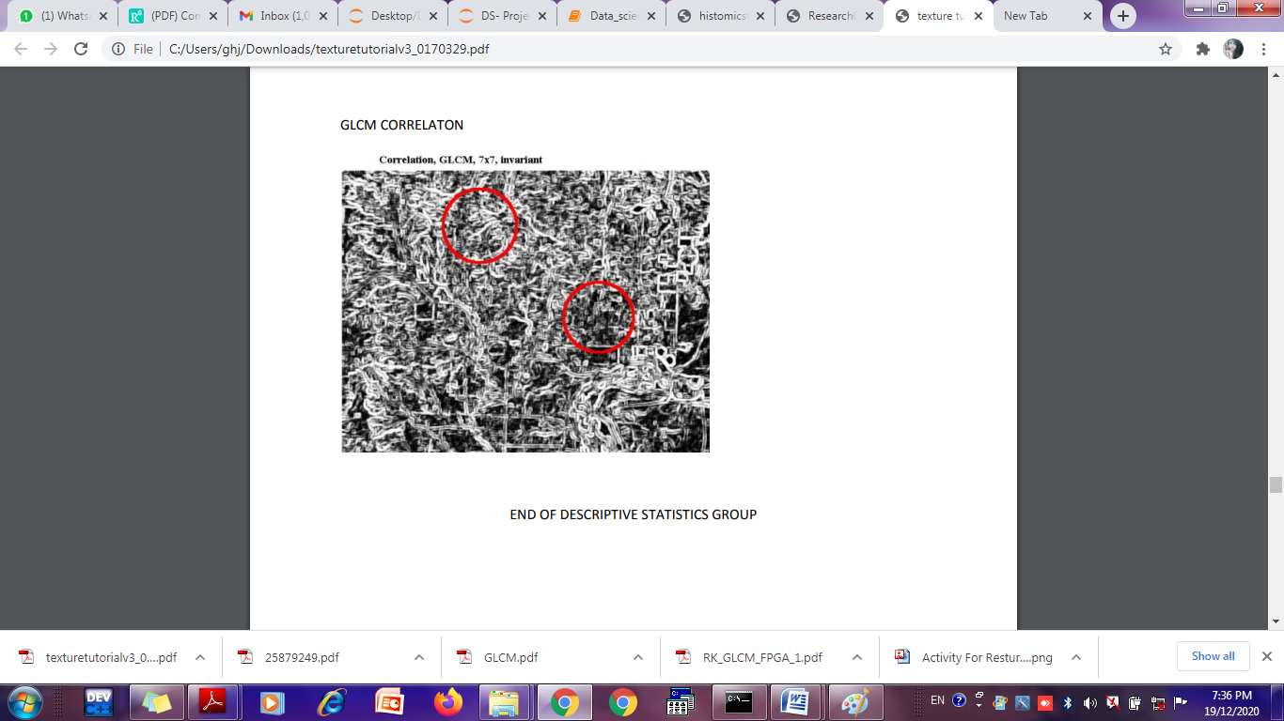

**GLCM_Dissimilarity**   is the variation of grey-level voxel pairs.

GLCM_Dissimilarity=Average over 8directions(∑i∑j|i−j|⋅GLCM(i,j))

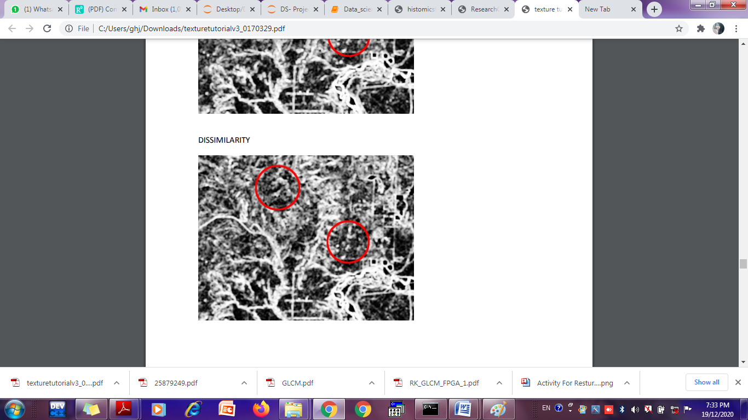

Mean and range of the first information measure of correlation feature for GLCMs of all offsets. It is computed as follows:

IMC1=HXY−HXY1max(HX,HY),where

HXY=−∑i,j=0levels−1p(i,j)log(p(i,j))

HXY1=−∑i,j=0levels−1p(i,j)log(px(i)py(j))

HX=−∑i=0levels−1px(i)log(px(i))

HY=−∑j=0levels−1py(j)log(py(j))

px(i)=∑j=1levelsp(i,j)

py(j)=∑j=1levelsp(i,

# Chapter 3 Algorithm

## 3.1 Monofractal algorithm

## 1. Conver image to binary form.

## 2. Calculate Fractal Dimension

## FD ¼ = −lim logN(ε0)/ log(ε)

## ε→0

## 3. Find deviation of foregraound pixels

## 4. Find Mean of Foreground pixels

λε = deviation/ mean

## 3.2 Multifractal algorithm

## Read the image

## Convert the image in to 2D Array(matrix)

## Find Moment of order Mu(m,n):z

Mu(m,n) =

Where Summation is Perform for all rows and columns in image

## 3.3 GLCM algorithm

The basic GLCM algorithm is as follow:

1. Count all pairs of pixels in which the first pixel has a value i, and its matching pair displaced from the first pixel by d has a value of j.

2. This count is entered in the ith row and jth column of the matrix Pd[i,j]

3. Note that Pd[i,j] is not symmetric, since the number of pairs of pixels having gray levels[i,j]does not necessarily equal the number of pixel pairs having gray levels [j,i].

4.The elements of Pd[i,j]can be normalized by dividing each entry by the total number of pixel pairs.

5. Summary of steps in creating a symmetrical normalized GLCM:

1. Create a framework matrix taking into account the bit depth
2. Decide on the spatial relation between the reference and neighbour pixel
3. Count the occurrences and fill in the framework matrix
4. Add the matrix to its transpose to make it symmetrical
5. Normalize the matrix to conceptually turn it into probabilities.

6. Normalized GLCM N[i,j], defined by:



# Chapter 4 Documentation of API

**4.1 Image preprocessing**

**Variables:**

* testing_image : testing_image to RGB
* training_gray : testing image to gray scale
* test_gray : test_image to gray scale
* **parameters** :
  1. testing_image: the testing image is adding scale invariance and rotational invariance to it.
* **attributes** :
  1. testing_image: the image formed after applying gaussian filter and creating gaussian pyramid. Gaussian pyramid involves applying repeated Gaussian blurring and downsampling an image until some stopping criteria are met.
  2. rotation_matrix: the rotation matrix is created.
  3. test_gray: test image that is converted to gray scale.
* **return attribute**: testing_image,test_gray

## 4.2 Implementing the Monofractal algorithm

**Fractal Dimension**

**Function used**

Fractal_dimension

**Parameters**

Array-image stored

max_box_size -maximum value of array where image is stored

min_box_size -minimum value of array where image is stored

n_samples –number of samples

plot –xlabel and ylabel

**Attributes**

scales- keeping scales at which Ns is changed

locs-locations of non zero pixels

NS- count the minimum amount of boxes touched

Coeffs- perform fit

fig, ax

**Lacunarity**

**Attributes**

img_array-storing image

mean-calulating mean

std-calculating standard deviation

lacunarity

**4.3 Implementing The Multifractyal algorithm**

Variable used

Data- to store array

Sum of row

Sumof column

**4.4 Implementing The Gray level co-occurrence matrix algorithm**

**Functions**

greycomatrix()-compute some GLCM properties each patch of image

suptitle()-display the patches and plot

**Attributes:**

grass_locations[]-select some patches from the image

grass_patches

sky_locations[]-select some patches from second image

sky_patches

xs = []-store GLCM properties patch

ys = []-store GLCM properties patch

fig- create the figure

ax- display original image with locations of patches

# Chapter 5 Example

## Example 1

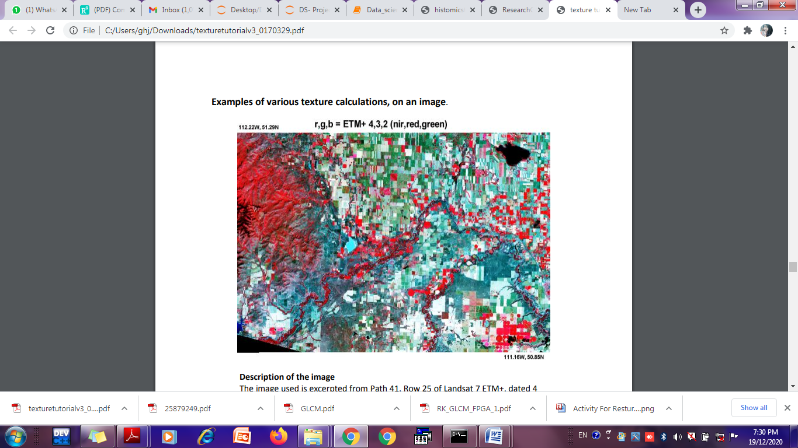

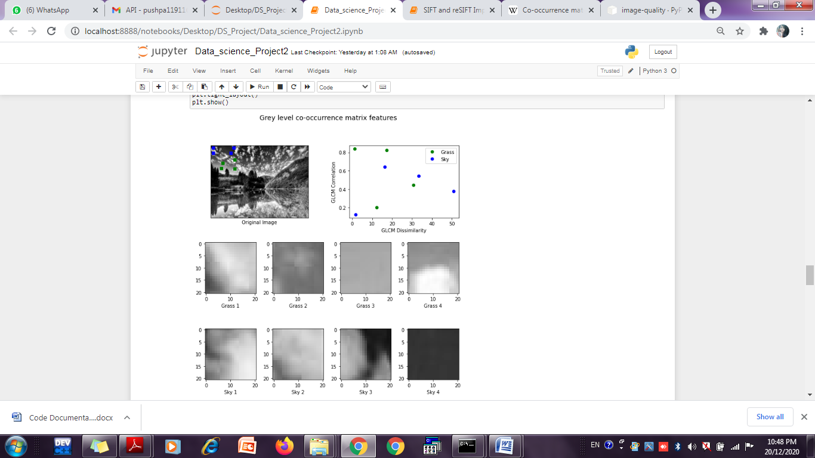

## Example 2

## 

[ 57, 54, 50, ..., 47, 47, 47],

[ 56, 53, 50, ..., 47, 47, 47],

[ 54, 52, 49, ..., 48, 47, 47],

...,

[156, 156, 156, ..., 47, 39, 35],

[148, 152, 156, ..., 32, 38, 43],

[151, 149, 147, ..., 34, 35, 32]], dtype=uint

# Chapter 6 Learning Outcome

# In our work we studied about feature extraction of image through monofractal, multifractal and gray level co-occurence matrix.we studied the algorithms thoroughly.Monofractal included two fractal dimension and lacunarity ,multifractal and glcm features were calculated.we found that co -occurrence classifiers were best performers in image classification than multifractal and monofractal.

# Besides comparision of feature extraction method the work also compared the outcome and data orientation classification methods.

# Appendix A

# References

# [1] https://ieeexplore.ieee.org/Xplore/home.jsp

# [2] https://en.wikipedia.org/wiki/Co-occurrence_matrix

# [3]https://www.researchgate.net/publication/306381584_Comparison_of_M onofractal_Multifractal_and_gray_level_Co-occurrence_matrix_algorithms_in_analysis_of_Breast_tumor_microscopic_images_for_prognosis_of_distant_metastasis_r

**Bibliography**

**[1]** Haralick, R.M. 1979. Statistical and Structural Approaches to Texture. Proceedings of the IEEE,vol. 67 pp.786-804. This is the basic reference that should generally be cited when working with GLCM texture.

**[2]**Haralick, R.M., K. Shanmugam and I. Dinstein. 1973. Textural Features for Image Classification. IEEE Transactions on Systems, Man and Cybernetics. SMC vol. 3 no. 6 pp.610-620. The original publication, although it is in a hard to access volume.

**[3]**R. M. Haralick, Proc. IEEE 67, 786 (1979)

**[4]**R. Haralick, K. Shanmugam, I. H. Dinstein, Systems, Man and

Cybernetics. IEEE Transactions on SMC-3, 610 (1973)