**V-SENSES A COVID-19 Testing Information System**



BIT 302 ASSIGNMENT 1

Team Member:

1. Name : I Putu Gede Arya Ramadika Utama(Team Leader)

Student Id : E1800177

Contact : +62 821 4436 5203

1. Name : Alden Rai Santosa

Student Id : E1800158

Contact : +62 896 3742 9043

## Table of Contents

Table of contents…………………………………………………………………………..1

Overview…………………………………………………………………………………..2

What is the motivation for this project? …………………………………………..2

Who the customer/user is/are? …………………………………………………….2

What the project will deliver? …………………………………………………......2

What it will cost? ……………………………………………………………….....3

How long it will take? ……………………………………………………………..4

Project Aims……………………………………………………………………………….5

Project Objectives…………………………………………………………………………5

Project Scope……………………………………………………………………………....6

Project Schedule…………………………………………………………………………...8

Work Breakdown Structure………………………………………………………..8

Milestones/Deliverable…………………………………………………………..10

Gant Chart………………………………………………………………………..12

Technical description of the proposed system……………………………………………13

Development Platform…………………………………………………………...13

Demonstration Platform…………………………………………………………14

Risk management plan…………………………………………………………………...15

## Overview

The Covid-19 pandemic is a new thing that has happened in the world since November 2019. Where it has become a major problem in various sectors of life, especially in health factors. Regarding this problem, We, I Putu Gede Arya Ramadika Utama, and Alden Rai Santosa will build an application to help the Ministry of Health to facilitate tracking and monitoring of covid-19 test result data that is more effective and efficient to save time and resources.

* **What Is The Motivation for This Project?**

Our motivation in building the V-sense project is to help the Ministry of Health in its efforts to trace tests that have been carried out in various test centers. With the hope that this project can assist in the process of managing and maintaining data from patient test results based on five types of patients and that is "Returnee", "Quarantined", "Close contact", "Infected", "Suspected". This will make it easier for the government or the health ministry to track down patients infected with the covid-19 virus. Not only that but this project will also reduce the risk of losing the patient's data since we invest a good amount of time in building data security to prevent unwanted data losses.

* **Who The Customers/User is/are?**

Customers/users are national and private institutions engaged in the health sector, such as the ministry of health, the health department, and others, of course, have the same goal, namely to assist the government in handling Covid-19 cases in terms of tracking test result data.

* **What The Project Will Deliver? Is it a new one or extension of existing one?**

This project provides convenience, convenience, and time efficiency in handling patient test result data. Where this project can help manage or store data to make it easier for the government to search or track patient test result data. This project is an extension of existing products, namely the existing covid-19 test centers. However, this project can help medical officers in storing, maintaining, and managing patient test result data and also reducing the risk of data loss.

* + **What it will cost?**

There are 6 types of costs that we will spend in developing this V-senses project, including project management costs, hardware, software, testing, software development, and other operational costs. For hardware costs, it covers the devices we use, namely 2 laptops, a router for internet connection (Wi-Fi), and server fees for hosting, so the total cost for hardware is as follows:

1. 2 pcs Laptop – RM 8100
2. Router – RM 142
3. Servers – RM 42

Total costs for Hardware: RM 8426

For software financing, we cover 9 licensed software that we use, namely Microsoft Excel, Microsoft Word, Adobe XD, PowerPoint, and domain fees, the total costs we spend on software are as follows:

1. Microsoft Office 365 – RM 608
2. Hosting and domain – RM 304

Total costs for Software: RM 912

Other costs include consumption costs, transportation costs, electricity, and Wi-Fi that we must pay are:

1. Wi-Fi – RM 292
2. Transportation – RM 442
3. Electricity – RM 1020

Total costs for others: RM 1754

For Software Development financing, we use the LOC (Line of Code) calculation to calculate the cost of software development expenses, where the estimated line in this project is 8000 lines and has approximately 20 pages on the webpage. The total costs we spend on Software Development are as follows:

1. LOC- RM 64000 (approximately RM 8/Line Of Code)
2. Testing- RM 7333 ((Hardware cost + Software cost + LOC)*0.1)

Total costs for Software Development: RM 71333

And lastly is the cost of Project Management which includes the Project Manager and Project Team Members. The fees are as follows:

1. Project Manager – RM 4000
2. Project Team Members RM 6100

Total costs for Project management: RM 10100

So the estimated cost that we will spend is approximately RM 92525. The estimated cost can be less or more depends on the situation in the future work of this project.

* + **How long it will take?**

We need approximately 3 months or 12 weeks to work on this project. It depends on the situation and conditions that we will face during the process of this project.

## **Project Aims**

This project aims to improve effectiveness and efficiency in accessing test result data for Covid-19 in order to help the Ministry of Health in monitoring the test results that have been carried out in various existing test centers. From the patient's point of view, this can help patients to obtain data on their test results more efficiently. Testers/officers can also provide reports of the tests they can do. Of course, all these things will have a positive effect in terms of effectiveness, efficiency, security, and avoid falsification of test result data, because with this system the test data that has been done will be stored in the system and can be monitored directly by the Ministry of Health.

## **Project Objectives**

To achieve the main objectives of this project, we have a short-term mission that must be completed. Here are some of our project objectives:

* + Build an application that is easy to use and understand by users.

By building a user-friendly system or application, it can have a positive impact on this project. Thus, this will increase the level of pleasure, comfort, and user experience when using the application or system of this project.

* Providing complete, fast, and precise services.

The complete service certainly makes it easier for users to obtain accurate data based on the results of tests that have been carried out. Fast service can help users find information about test results quickly so that they can be handled quickly based on their test results. The completeness and speed of information can help users to achieve proper and maximum handling according to their test results.

## **Project Scope**

|  |
| --- |
| **Project Title: V-Sense**  **Date:02/27/2021**  **Prepared by:** **I Putu Gede Arya Ramadika Utama** |
| **Project Justification:**  This project is based on a website that covers the scope of health in recording or recording data on the results of this covid-19 test. It is expected to assist the Ministry of Health in tracking tests that have been carried out in various test centers. This project involves 4 actors who can use this system, namely: tester, test center officer, test center manager, and patient  The personal data that we store is as follow:   1. User’s Data : Name, identity number, and address 2. Patient’s Data: patientType and symptoms. 3. Test Centre’s Data : Test Centre ID and test centre name 4. Test Covid Data : Test ID , Test date , result , resultDate 5. Test Equipment Data: name of test tool, kit id, availability of tool stock. |
| **Product Characteristics and Requirements:**   1. Research on government for COVID Testing Information System to know specific necessities, models, types, highlights, and so on 2. Research on regular property that applied online data framework for the government. 3. Provide services that can assist the government tracking and oversee information of the patient dependent on the type and manifestations. The COVID Testing Information System ought to be enlightening and supportive by showing all information that can be access by the patient, tester, test center officer and test center manager. 4. The web application will be tried with various browsers to ensure it is available and doesn't have any presentation issue. 5. The whole connection will be tried, to check whether the connection work appropriately or not. |
| **Summary of Project Deliverables**  **Project management-related deliverables:** Project Overview, project aims, project objectives, project scope, work breakdown structure, project schedule, cost baseline, status reports, final project presentation, final project report, lessons-learned report, and any other documents required to manage the project.  **Product-related deliverables:** research reports, design documents, software code, hardware, etc.   1. A web-based system that can be accessed by various users such as tester, test center officer, test center manager, and patient. 2. This system has several feature functions, namely, search to make it easier for patients to search for test result data, sort/ filters to make it easier for user(test manager , tester) can select specifically the data they want to see and views to allow users to view data. The second is the tester, the tester can record new tests and can update the test results, the third is the Test Center Manager, and the Test Center Manager can register the testers, record the testers and manage the test kit stock. 3. This project covers the scope of health in recording or recording data on the results of this covid-19 test which is expected to be able to assist the Ministry of Health in conducting tracking tests that have been carried out in various test centers |
| **Project Success Criteria:**  The project is considered successful if this project can be completed on time, which is 3 months (our target time), meets all the characteristics and requirements that we have listed in this report, and does not deviate from the project scope that we have created and can fulfill the objectives we have determined. |

## Project schedule

### **Work Breakdown Structure**

1. Initiating
   1. Identify key Stockholders
   2. Identifying Project Overview
   3. Conduct project kick-off meeting
2. Planning
   1. Hold team planning meeting
   2. Identifying Project Scope
   3. Create Work breakdown structure
   4. Project Schedule
      1. Determining task resources
      2. Determining task duration
      3. create milestone
      4. Create Gantt Chart
   5. Determine development Platform
   6. Determine Demonstration Platform
   7. Risk Management Plan
   8. Create Use case
   9. Expended use case
   10. Create Class Diagram
   11. Analysis class diagram
3. Executing
   1. Web Page Design
      1. Design Research
      2. Design Implementation.
   2. V-senses content
      1. Create login and signup for user
      2. Registering Test Center
      3. Record Tester
      4. Manage test kit stock
      5. Record new test
      6. Update test result
      7. View testing history
      8. Generate testing Report
   3. Prototype Testing
   4. System Debugging
4. Controlling and Monitoring
   1. Progress Reports
5. Closing Process
   1. Prepare final Report
   2. Prepare final project presentation

### **Milestones/Deliverable**













### **Gantt chart**

Prepare by: Alden Rai Santosa

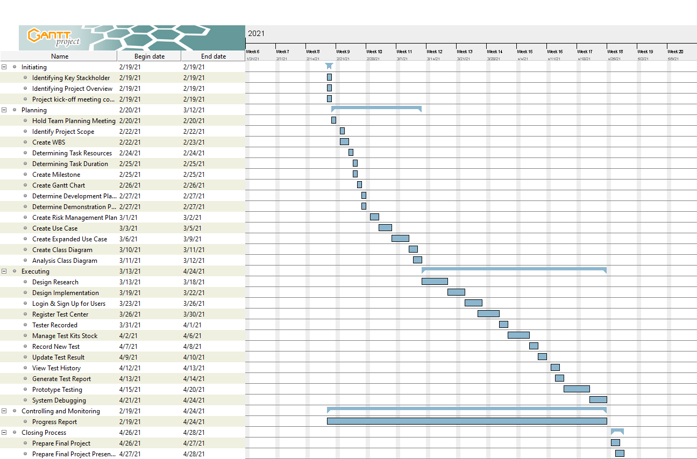

## **Technical description of the proposed system**

* Development Platform

1. Software:
   1. Microsoft Excel

It is going to be used for storing data which going to be inputted into the MySQL as the database.

* 1. Visual Studio Code

VSCode is needed to code the application using HTML, CSS and JavaScript.

* 1. Draw.io

It is needed to make diagrams such as Use Case diagram and UML Diagram

* 1. Adobe XD

It is needed to design the web display in order to give the big picture for the developer what to do when coding the front end

* 1. Power Point

It is needed to make presentation related to the process of making the web application

* 1. MySQL

It is needed as the database for storing data of the patient’s information, cost and many more.

* 1. phpMyAdmin

This tool is needed to connect to MySQL and it give a comfortable Graphical User Interface and complete services that is needed to develop the web base application.

* 1. Gantt Project

It is needed to create Gantt chart which is helpful in scheduling works for this project.

* 1. NodeJS

This platform is needed to run JavaScript code through the server side.

* Development Hardware

1. Hardware:
   1. Laptop

The development of this application will be done using laptop.

* 1. Wi-Fi

Wi-Fi is needed to open various sources from the internet to help in the development process since the tools that is needed mostly needs internet to be access.

* Demonstration Platform

1. Software:
   1. Web Browser (Google Chrome and Opera)

Since this project is about developing web based application, it needs to be open thought web browser. Thus, we choose Google Chrome and Opera as our main browser in order for us to open the web application and these browsers are commonly used by many user nowadays.

1. Hardware:
   1. Laptop and PC

The web application can only be access using laptop or PC.

### **Risk Management Plan**



***Probability and Impact Matrix***

|  |  |  |  |
| --- | --- | --- | --- |
| **High** |  |  | R2&R3 |
| **Medium** |  |  | R1 |
| **Low** |  |  | R4 |
| ***Probability***  ***Impact*** | **Low** | **Medium** | **High** |

**V-SENSES A Covid Testing Information System**



BIT 302 ASSIGNMENT 1

Team Member:

1. Name : I Putu Gede Arya Ramadika Utama(Team Leader)

Student Id : E1800177

Contact : +62 821 4436 5203

1. Name : Alden Rai Santosa

Student Id : E1800158

Contact : +62 896 3742 9043

### **Table Of Content**

Functional Requirement……………………………………………………………………………………….2

Non Functional Requirement………………………………………………………………………………….2

Use cases……………………………………………………………………………………………………….3

Analysis Class Diagram……………………………………………………………………………………….5

Extended Use Cases……………………………………………………………………………………….....6

System Sequence Diagram………………………………………………………………………………….13

Contract………………………………………………………………………………………………………..13

Reference……………………………………………………………………………………………………...14

### Functional Requirement:

1. Overall User(Test Centre Manager, Tester, Patient) Requirement:
   1. User can Login to the system by entering Username/ID and Password.
   2. User can Logout from the system by pressing logout button.
   3. User can view testing history.
2. Test Centre Manager Requirement:
   1. Test Centre Manager must have Record Tester Menu to add new tester.
   2. Test Centre Manager must have Register Test Centre Menu to register new Test Centre.
   3. Test Centre Manager can manage Test Kit Stock
   4. Test Centre Manager can Sign up to Login to the system
   5. Test Centre Manager must have sort/filter history.
3. Tester Requirement:
   1. Tester must have update menu to update test result
   2. Tester must have sort/filter history.
   3. Tester can record new test.

### Non-functional:

1. Integrity Requirement: Validation can be acquired by using login system to prevent unauthorized access. The user must enter the correct ID and Password in order for them to access the system.
2. Usability Requirement: The system is design to be user friendly so that the user can use the system without having problem in using it.
3. Efficiency Requirement: The system can execute the task in minimal time time and minimal hardware specification.
4. Portability: The system can be used in any web browser, such as Google Chrome, Opera, Mozilla Fox, and many more, and in any type of devices such as Laptop, PC, Mobile Phone and tab.

**Use Case :**

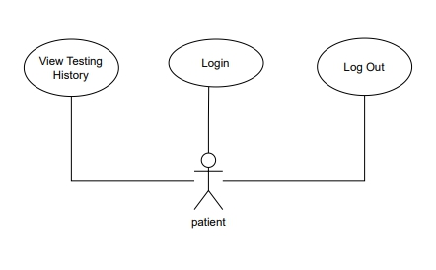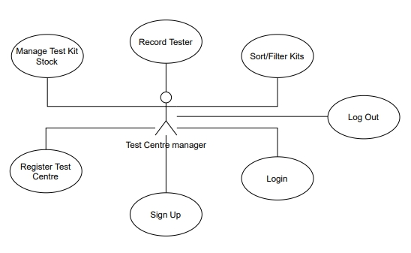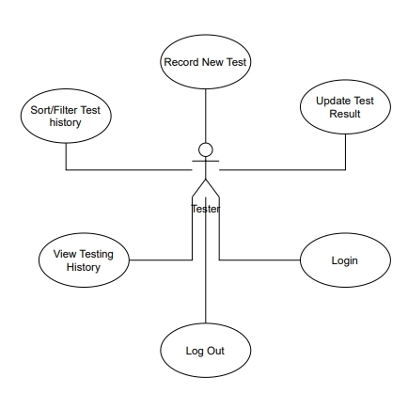

**Analysis Class Diagram**

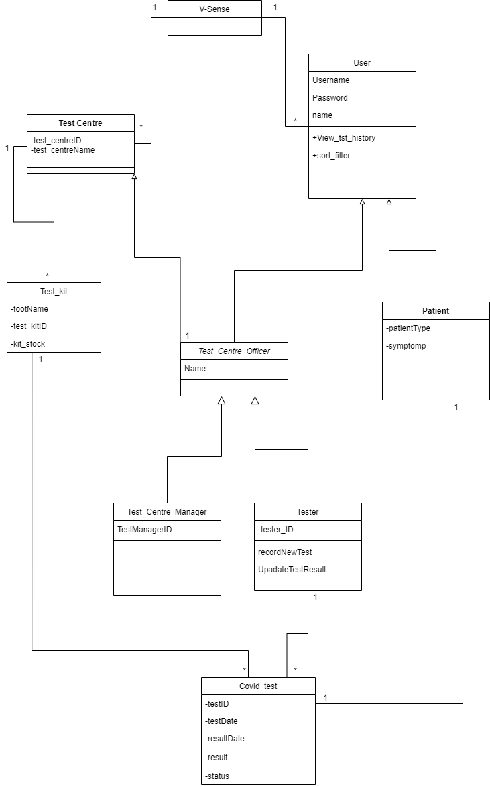

**Expended Use Cases**

1. **Login**

**Prepared by: I Putu Gede Arya Ramadika Utama**



1. **Sign Up**

**Prepared by: I Putu Gede Arya Ramadika Utama**



1. **Register Test Centre**

**Prepared by: I Putu Gede Arya Ramadika Utama**



1. **Record Tester**

**Prepared by: I Putu Gede Arya Ramadika Utama**



1. **Generate Test Report**

**Prepared by: I Putu Gede Arya Ramadika Utama**



1. **Logout**

**Prepared by: I Putu Gede Arya Ramadika Utama**



1. **View Testing History**

**Prepared by: Alden Rai Santosa**



1. **Record New Test**

**Prepared by: Alden Rai Santosa**



1. **Update Test Result**

**Prepared by: Alden Rai Santosa**



1. **Sort/Filter**

**Prepared by: Alden Rai Santosa**



**System Sequence Diagram**

1. **Sign Up**

Prepare by: I Putu Gede Arya Ramadika Utama

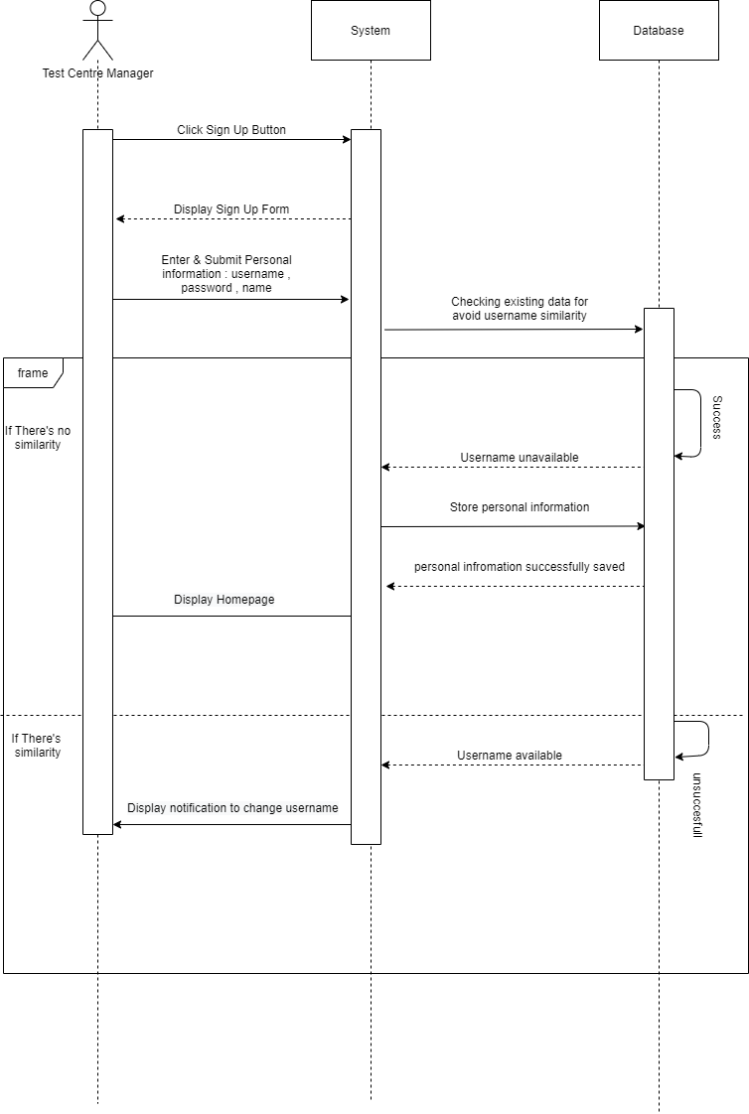

|  |  |
| --- | --- |
| **Name** | **Sign Up** |
| Responsible | Permit users to register so they can access the system |
| Pre-Condition | Username must be unique |
| Post-Condition | * Account has saved into the database * Display homepage |

1. **Login**

Prepare by: I Putu Gede Arya Ramadika Utama

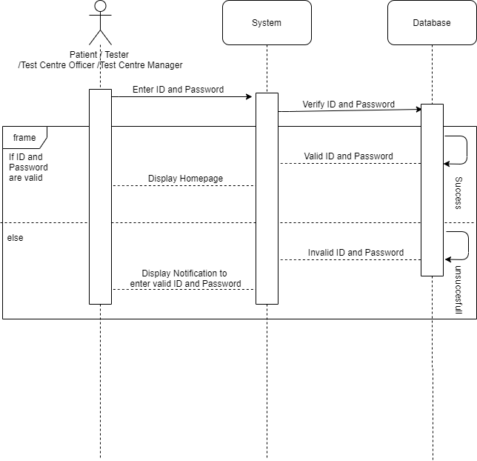

|  |  |
| --- | --- |
| **Name** | **Login** |
| Responsible | Permit authorized user to access the system |
| Pre-Condition | * Username and Password must be available |
| Post-Condition | * Username and Password is matched or valid * Display user dashboard |

1. **Record Tester**

Prepare by: I Putu Gede Arya Ramadika Utama

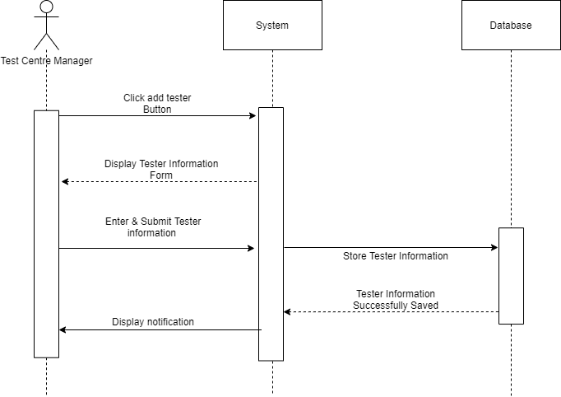

|  |  |
| --- | --- |
| **Name** | **Record Tester** |
| Responsible | Permit Test Centre manager to record new tester |
| Pre-Condition | * Test centre manager account must be available * TesterID and tester name must be available |
| Post-Condition | * Tester was successfully added into the system * Display dashboard |

1. **Register Test Centre**

Prepare by: I Putu Gede Arya Ramadika Utama

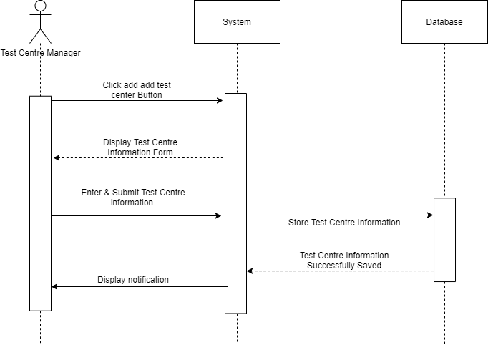

|  |  |
| --- | --- |
| **Name** | **Register Test Centre** |
| Responsible | Permit Test Centre manager to Register new test centre |
| Pre-Condition | * Test centre manager account must be available * Test centre ID and test centre name must be available |
| Post-Condition | * Test centre was successfully added into the system * Display dashboard |

1. **Generate Test Report**

Prepare by: I Putu Gede Arya Ramadika Utama

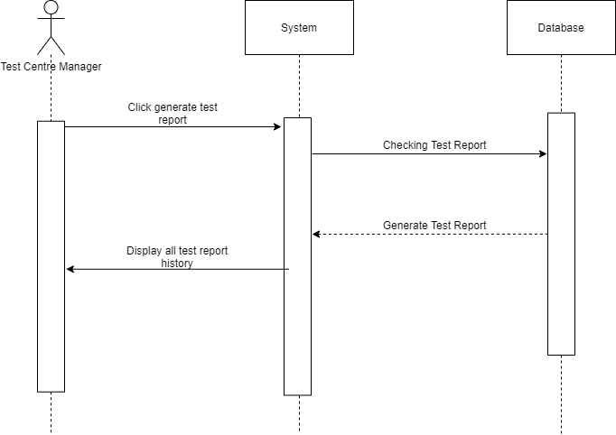

|  |  |
| --- | --- |
| **Name** | **Generate Report** |
| Responsible | Permit Test Centre manager to Generate Repor |
| Pre-Condition | * Test centre manager account must be available * Test Report must be available in the database |
| Post-Condition | * Display all test report history |

1. **Record New Test**

Prepare by: Alden Rai Santosa

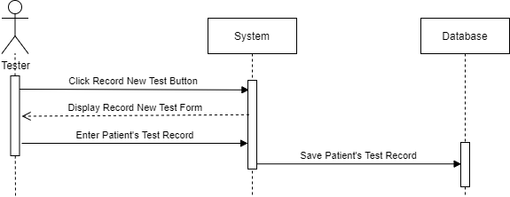

|  |  |
| --- | --- |
| Name | Record New Test |
| Responsible | Allow user to add record test of the patient to the database |
| Pre-Condition | Only Tester can record new test |
| Post-Condition | User can add test record to the database |

1. **Sort/Filter**

Prepare by: Alden Rai Santosa

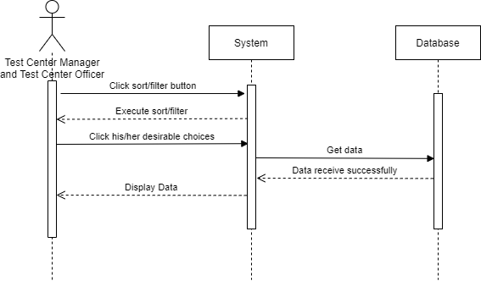

|  |  |
| --- | --- |
| Name | Sort/Filter |
| Responsible | Allow user to filter out selection based on date and type of patients |
| Pre-Condition | Only Test Centre Manager and Tester can use sort/filter |
| Post-Condition | User pick their selection based on what they have filtered |

1. **Update Test Result**

Prepare by: Alden Rai Santosa

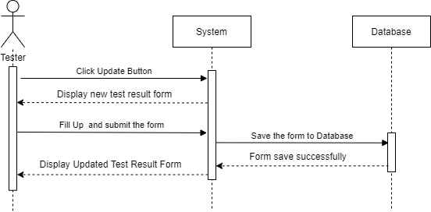

|  |  |
| --- | --- |
| Name | Update Test History |
| Responsible | Allow users to update patient's test history |
| Pre-Condition | 1. Only Tester can update test history  2. Must have the test report that want to be updated |
| Post-Condition | User can update test report |

1. **View Test History**

Prepare by: Alden Rai Santosa

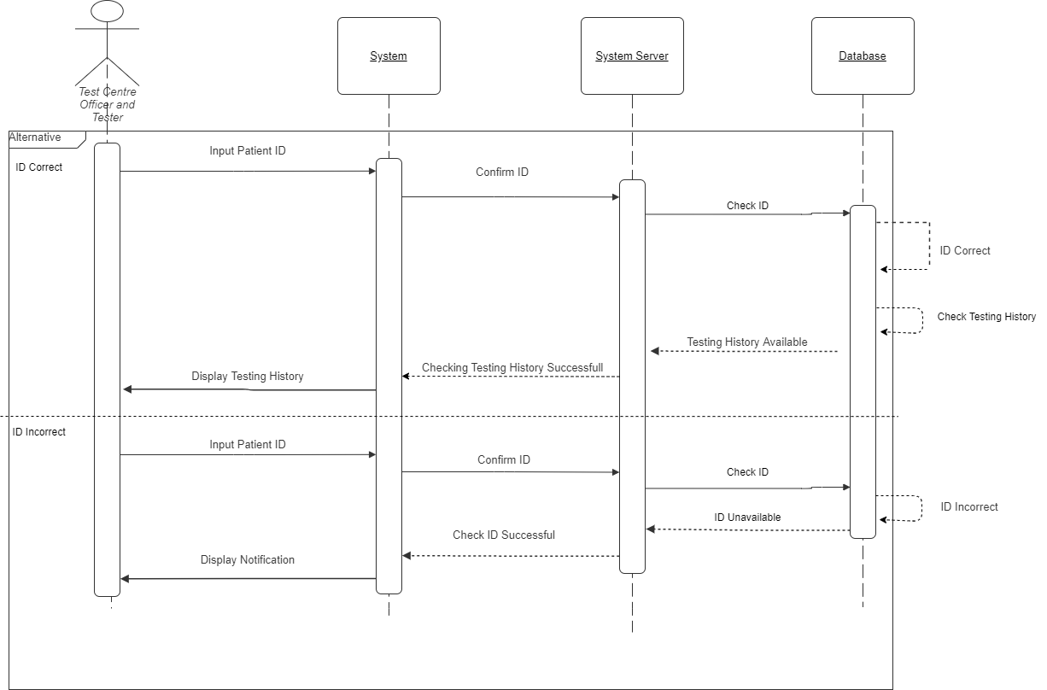

|  |  |
| --- | --- |
| Name | View Test History |
| Responsible | Allow users to view patient's tet history |
| Pre-Condition | Only Test Centre Officer and Tester can view test history |
| Post-Condition | Users can select patient's test history and view the data |

1. **Logout**

Prepare by: Alden Rai Santosa

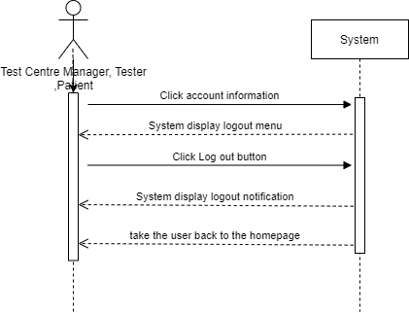

|  |  |
| --- | --- |
| Name | Log out |
| Responsible | Allow users to log out from the system |
| Pre-Condition | User still log in to the system |
| Post-Condition | Display Homepage |

**References**

* Eastwood, Brian .(2019 June 26).HOW TO DEVELOP A PROJECT SCOPE STATEMENT IN 8 STEPS.northeastern.edu. <https://www.northeastern.edu/graduate/blog/develop-project-scope-statement/>
* The Ultimate Guide… Gantt Chart. (2019).projectmanager.com. <https://www.projectmanager.com/gantt-chart>
* Eriksson, Ulf.(2021 April 5). Why is the difference between functional and Non-functional requirements important?.reqtest.com. <https://reqtest.com/requirements-blog/functional-vs-non-functional-requirements/#:~:text=What%20are%20those%2C%20and%20how,what%20the%20system%20should%20do.&text=One%20could%20also%20think%20of,attributes%20for%20of%20a%20system>.
* Jennifer Greene,PMP&Andrew Stellman,PMP(2014). **Head First PMP: Covers PMBOK Guide(5th ed).O’Reilly**