
SVKM’S NMIMS DEEMED-TO-BE UNIVERSITY
PROJECT REPORT
GESTURE-CONTROLLED GAME ARCADE
WITH SELFIE BOOTH
Course: Image and Video Processing
Submitted By
Arya Sanghvi — Roll No. F136
Juhi Ranka — Roll No. F110
Nevedhya Chhabda — Roll No. F116
Submitted To
Dr. Raj Gaurav Mishra
Programme: B.Tech Computer Engineering
Semester / Division: 5th Semester
Academic Year: 2026–2027

ABSTRACT
The Gesture-Controlled Game Arcade with Selfie Booth is a computer vision project that explores gesture-driven interaction and camera-based image processing. It proposes webcam-based hand tracking as an alternative to keyboard and mouse input. The system combines two arcade games, Neon Dodge and Gesture Pong, with a Selfie Booth that supports photo capture, filters, decorative frames and character-inspired face overlays. OpenCV can be used for webcam acquisition and image processing, MediaPipe for hand and face landmark detection, Pygame for rendering and game interaction, and NumPy for numerical operations on image arrays. The processing pipeline comprises frame acquisition, preprocessing, landmark detection, gesture interpretation, image filtering and transparent overlay composition. The project demonstrates the potential of image and video processing in interactive entertainment and touch-free human–computer interaction. Actual implementation status and performance must be established through testing.
Keywords: Computer Vision, OpenCV, MediaPipe, Gesture Recognition, Image Processing, Video Processing, Pygame, Face Overlays.

1. INTRODUCTION

1.1 Background of the Problem
Traditional computer games generally depend on keyboards, mice, touchscreens, or dedicated gaming controllers. Although these devices are effective, they require direct physical interaction. Computer vision offers an alternative by enabling computers to interpret visual information captured through cameras [1].
A webcam can capture a user’s hand movements, and image-processing algorithms can prepare the captured frames for analysis. Hand landmarks can then be used to estimate finger positions and identify gestures [2], [9]. These gestures can be mapped to game movements, selections, and other application actions.
The Gesture-Controlled Game Arcade combines this approach with a Selfie Booth. The gaming component focuses on hand-controlled interaction, while the Selfie Booth uses captured images to demonstrate image enhancement and visual effects.

1.2 Relevance of the Project
Gesture-based interaction is relevant to interactive entertainment, touch-free interfaces, educational demonstrations, and camera-driven applications. It provides an opportunity to explore how computers can interpret human movements without requiring conventional input devices for every action.
The project also demonstrates how video processing and image manipulation can be integrated into a single application. Live video supports hand tracking, while still images can be processed using filters, decorative frames, and face-aligned overlays.

1.3 Role of Image and Video Processing
Image and video processing is central to the proposed system. Webcam frames must be acquired, converted into suitable colour formats, and passed to computer-vision components.
Hand landmark detection provides information about the positions of fingers and joints. Gesture-recognition logic interprets these positions and generates actions. In the Selfie Booth, face landmarks can assist with positioning and scaling character-inspired overlays.
Image filters modify pixel values to create visual effects. Alpha compositing allows transparent images, such as frames and masks, to be combined with photographs [8].

1.4 Motivation
The project was selected to explore practical applications of image and video processing beyond conventional image enhancement. It combines real-time camera input, landmark detection, interactive graphics, and photographic effects.
It also highlights practical challenges such as inconsistent lighting, camera availability, tracking errors, processing latency, and the need for reliable interaction between computer-vision components and the graphical interface.

2. PROBLEM STATEMENT AND OBJECTIVES

2.1 Problem Statement
Conventional arcade games primarily use physical input devices such as keyboards, mice, or controllers. This project explores a webcam-based alternative in which hand gestures can control gameplay and interface navigation. It also extends camera input into a photographic experience through a Selfie Booth with image filters and visual overlays.

2.2 Objectives
The objectives of the project are:
- To capture live webcam frames and process them using suitable computer-vision libraries.
- To detect hand landmarks and interpret hand gestures for application interaction.
- To support gesture-controlled gameplay in Neon Dodge and Gesture Pong.
- To develop a Selfie Booth that supports photo capture and image effects.
- To investigate the use of face landmarks and transparent overlays for character-inspired mask effects.
- To integrate video acquisition, gesture recognition, image processing, and graphical rendering into a desktop application.

3. SCOPE OF THE PROJECT

3.1 Features Covered

The intended application consists of four main sections:

Neon Dodge: An arcade game in which the existing gameplay mechanics and movement controls are preserved.

Gesture Pong: A paddle-based game controlled through hand movements, allowing players to interact with the game using gestures.

Selfie Booth: A photographic mode for capturing images and applying visual effects. It may include a live camera preview, countdown-based capture, retaking photographs, filters, decorative frames, stickers, captions, photo strips, and local image saving. Character-inspired face masks are integrated into the Selfie Booth rather than appearing as a separate game.

Living Canvas: An interactive, gesture-controlled digital art experience in which users create dynamic visual effects through hand movements. The canvas may respond to fingertip positions, hand gestures, and movement trails, allowing users to draw, generate glowing particles, change colours, and create animated patterns in real time.

The application aims to provide an engaging, camera-based interactive experience by combining arcade gaming, gesture recognition, creative photography, and digital art within a unified interface. Existing gameplay and movement controls should remain functional, while the gesture-control system should provide consistent and responsive interaction across all four sections.

3.2 Features Outside the Scope
Space Shooter, Fruit Ninja, and Starfighter are excluded from the intended final arcade menu. The project does not aim to train a new deep-learning model or produce fully realistic three-dimensional character helmets.
The quality of face overlays depends on face detection, camera resolution, head orientation, and lighting conditions. The system is intended to demonstrate two-dimensional or landmark-aligned visual effects.

3.3 Input Types
The primary input is live webcam video. Individual frames are processed for hand tracking, gesture recognition, and, where supported, face tracking. Captured photographs are used for image enhancement and overlay composition.

3.4 Application Domain
The project belongs to the fields of computer vision, image and video processing, human–computer interaction, interactive entertainment, and camera-based photography.

4. DATASET / INPUT DESCRIPTION

4.1 Source of Input
The principal input source is a live webcam connected to the computer. Frames are captured while the application is running and passed to the processing pipeline.
The user acts as the input subject for hand and face tracking. A separate pre-labelled dataset is not necessarily required for the basic live-camera workflow because landmark detection can be provided by a pretrained computer-vision solution [2].

4.2 Dataset Description
Table 1: Input and dataset description
Item | Description / Status
Dataset name | Not applicable to the basic live-webcam pipeline unless a separate dataset is introduced.
Number of images and videos | To be recorded during actual testing.
Image resolution | To be verified from the camera configuration and captured frames.
Video frame rate and duration | To be measured during experimentation.
Image format | Depending on the implementation, captured photographs may be saved as PNG or JPEG.

OpenCV commonly represents webcam frames in BGR colour order. Conversion to RGB may be required by the landmark-detection or display components.

4.3 Sample Input Images

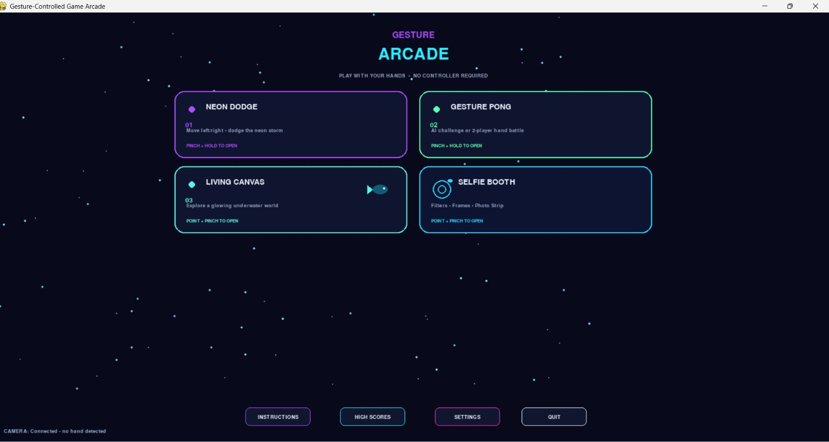


5. METHODOLOGY / PROPOSED APPROACH

5.1 Processing Pipeline
The proposed system follows these stages:
Step 1: Camera Initialization. The application initializes the webcam and verifies that valid frames can be obtained.
Step 2: Frame Acquisition. Video frames are read continuously while the application is active. Invalid frames are handled safely.
Step 3: Preprocessing. Frames are converted into the colour format required by the processing libraries. Image dimensions and orientation are adjusted where necessary.
Step 4: Hand Landmark Detection. A hand-landmark detector estimates the positions of important joints and fingertips.
Step 5: Gesture Recognition. The positions of landmarks are analysed to identify supported gestures. Stability checks can reduce accidental activations.
Step 6: Action Mapping. Recognized gestures are translated into game movement, paddle control, menu selection, or other supported actions.
Step 7: Graphical Rendering. Pygame renders the active game or interface and displays the appropriate visual feedback.
Step 8: Photo Capture and Processing. The Selfie Booth captures photographs and applies selected image filters or transparent overlays.
Step 9: Output. The processed photograph is previewed and saved locally when the user requests it and the feature is supported.

5.2 Block Diagram
Figure 3 presents the overall processing flow from webcam input to display and local saving.
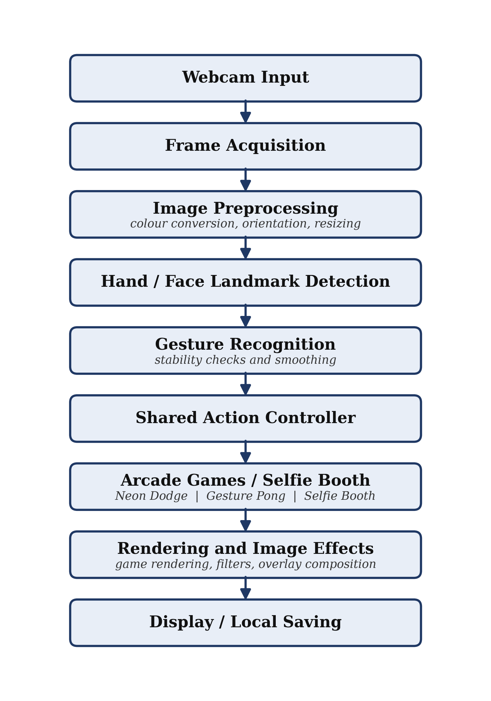
Figure 3: Block diagram of the proposed gesture-controlled arcade and Selfie Booth pipeline.

5.3 Algorithm Pseudocode
BEGIN

Initialize application
Initialize webcam
Initialize gesture controller
Initialize graphical interface

WHILE application is running:

Read webcam frame

IF frame is valid:

Preprocess frame
Detect hand landmarks

IF Selfie Booth requires face tracking:
Detect face landmarks

IF hand landmarks are available:
Estimate hand and fingertip positions
Recognize the current gesture
Update gesture stability state
Dispatch valid action to active screen

IF active screen is an arcade game:
Update game state
Render game

ELSE IF active screen is Selfie Booth:
Display camera preview
Apply selected image effects
Capture or save photograph when requested

ELSE:
Display camera-unavailable feedback

Update interface
Process exit requests

Release camera resources
Close application

END

6. TECHNIQUES / ALGORITHMS USED

6.1 Colour Space Conversion
OpenCV commonly uses BGR colour ordering for webcam frames. Some computer-vision and display components require RGB ordering. Conversion is therefore performed when required by the selected libraries.

6.2 Grayscale Conversion
Grayscale conversion represents an image using intensity rather than separate colour channels. It can be used as a photographic effect or as an intermediate representation for certain image-processing operations. A common approximation is:
Y = 0.299R + 0.587G + 0.114B
Here, R, G, and B represent the red, green, and blue channel intensities, while Y represents the resulting grayscale intensity.

6.3 Image Filtering and Colour Adjustment
Photographic effects can be produced by changing intensity, contrast, colour balance, and other pixel values. Grayscale effects remove colour information. Warm and cool effects adjust colour balance. Vintage and cyberpunk effects can combine colour transformations and contrast adjustments. A glow effect can combine a softened bright layer with the original image. The exact methods used should be confirmed against the implementation.

6.4 Alpha Compositing
Alpha compositing combines a foreground overlay with a background photograph:
I_{out} = α I_{overlay} + (1 − α) I_{background}
Here, α represents the opacity of the overlay. A value of zero represents transparency, while a value of one represents full opacity. This technique can be used for transparent frames, stickers, and character-inspired masks.

6.5 Hand Landmark Detection and Gesture Recognition
Hand landmarks represent important finger and joint positions. Relative landmark coordinates can be used to estimate finger configurations [2], [9]. For example, the distance between the thumb tip and index fingertip can be calculated using the Euclidean distance:
d = √[(x₁ − x₂)² + (y₁ − y₂)²]
Here, (x₁, y₁) and (x₂, y₂) represent the fingertip coordinates. A threshold can be used to determine whether the fingers are close enough to indicate a pinch.

6.6 Landmark Smoothing
Hand landmarks may fluctuate slightly between successive frames. Smoothing can reduce pointer jitter. One possible approach is exponential smoothing:
p_{t} = λ p_{current} + (1 − λ) p_{t−1}
Here, p_{t} is the smoothed position, p_{current} is the current measured position, p_{t−1} is the previous smoothed position, and λ controls responsiveness.

6.7 Video Frame Processing
Video processing involves reading successive frames and updating the application state. Tracking may fail if a hand or face becomes occluded, moves outside the camera frame, or is poorly illuminated. The application should handle missing frames and lost tracking without triggering unintended actions.

7. IMPLEMENTATION

7.1 Programming Language
Python is the intended primary programming language because it supports computer-vision libraries and desktop graphical applications [5].

7.2 Software and Libraries
- OpenCV: Webcam acquisition, frame processing, colour conversion, and image manipulation [1], [6].
- MediaPipe: Hand and face landmark detection, depending on the installed version and selected API [2], [9], [10].
- Pygame: Game loop, interface rendering, graphics, and input handling [3].
- NumPy: Numerical operations on image arrays [4], [11].
- Visual Studio Code: Development environment, if used for the implementation.
The actual dependency file should be consulted before listing exact library versions. Versions are therefore not stated in this report and are to be confirmed.

7.3 Hardware Requirements
The basic system requires a computer, compatible webcam, display, and sufficient processing resources. Performance depends on camera resolution, detection-model configuration, image-processing complexity, and available hardware.

7.4 Implementation Steps
- Initialize the graphical application and main menu.
- Initialize the webcam and verify successful frame delivery.
- Pass suitable frames to the hand-landmark detector.
- Interpret landmark coordinates and recognize configured gestures.
- Map gestures to game actions.
- Render the active game or interface.
- Implement the Selfie Booth preview and capture workflow.
- Apply filters and composite transparent overlays.
- Save photographs locally where supported.
- Release the camera and other resources during shutdown.

8. RESULTS AND DISCUSSION

8.1 Screenshot Evidence
The placeholders below are to be replaced with genuine screenshots from the running application. Items marked as conditional should be included only if the feature has been implemented and tested.
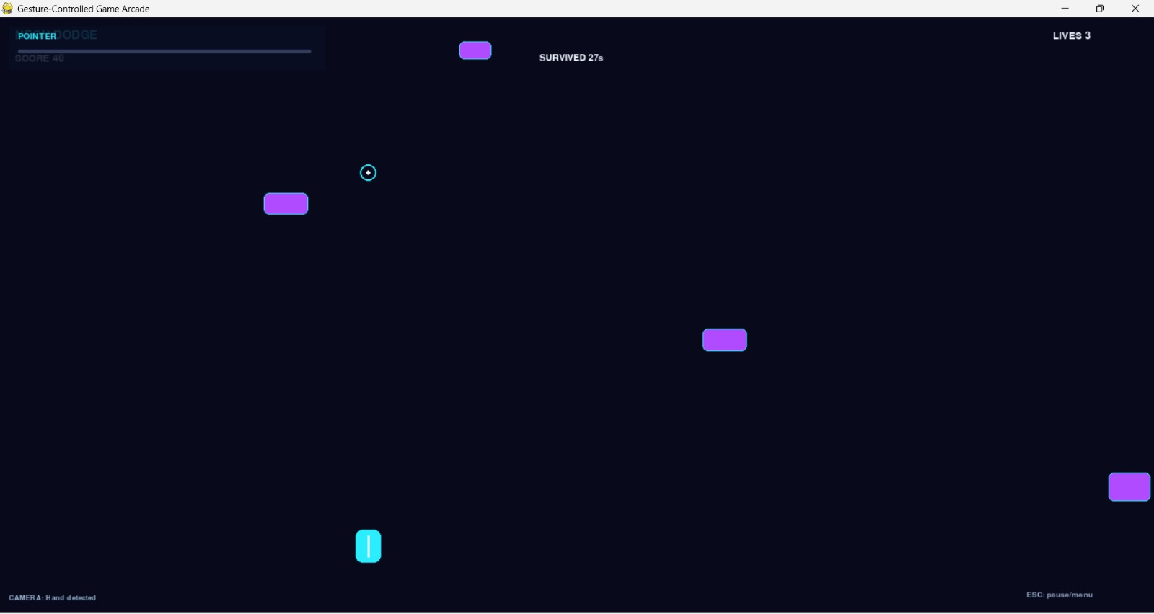
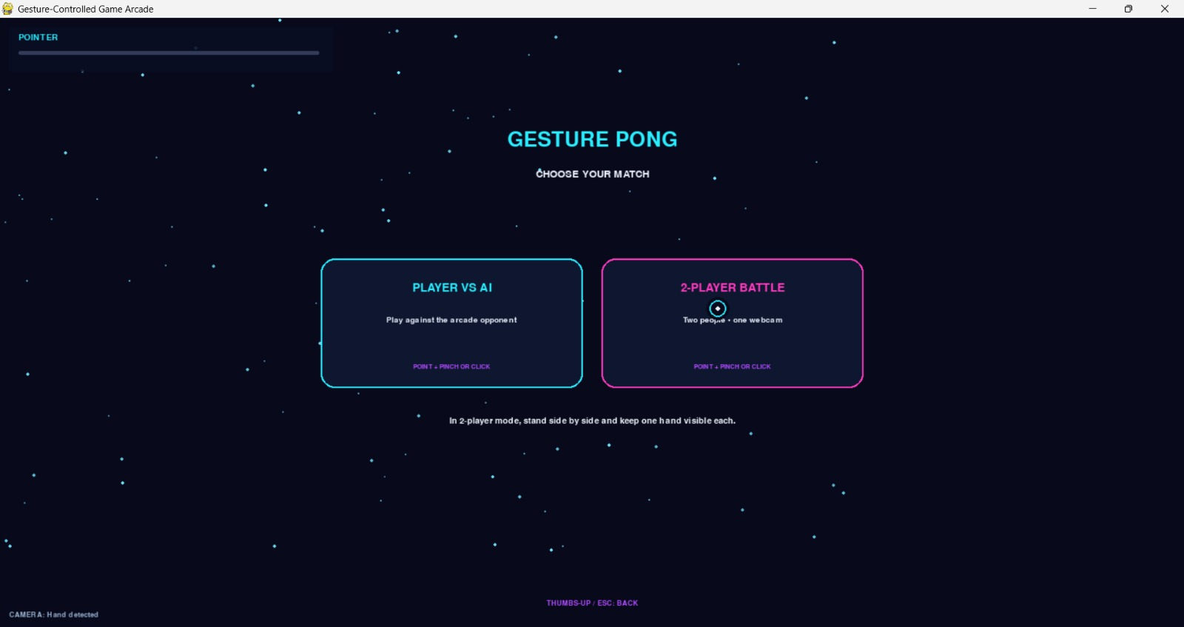
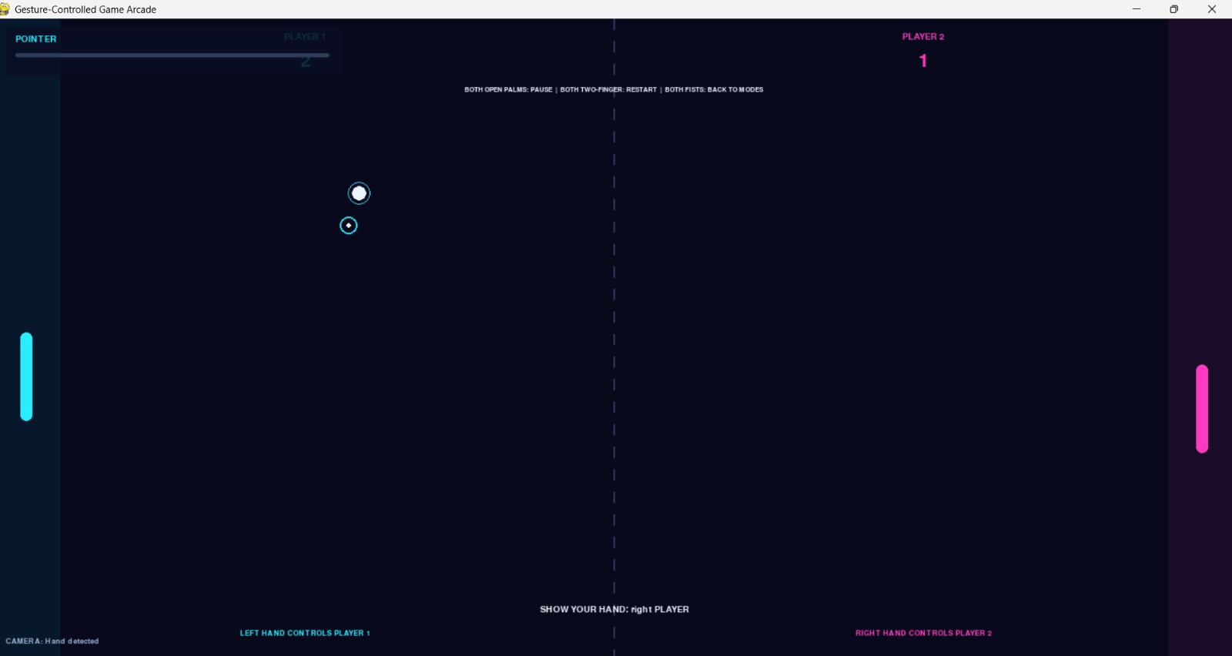

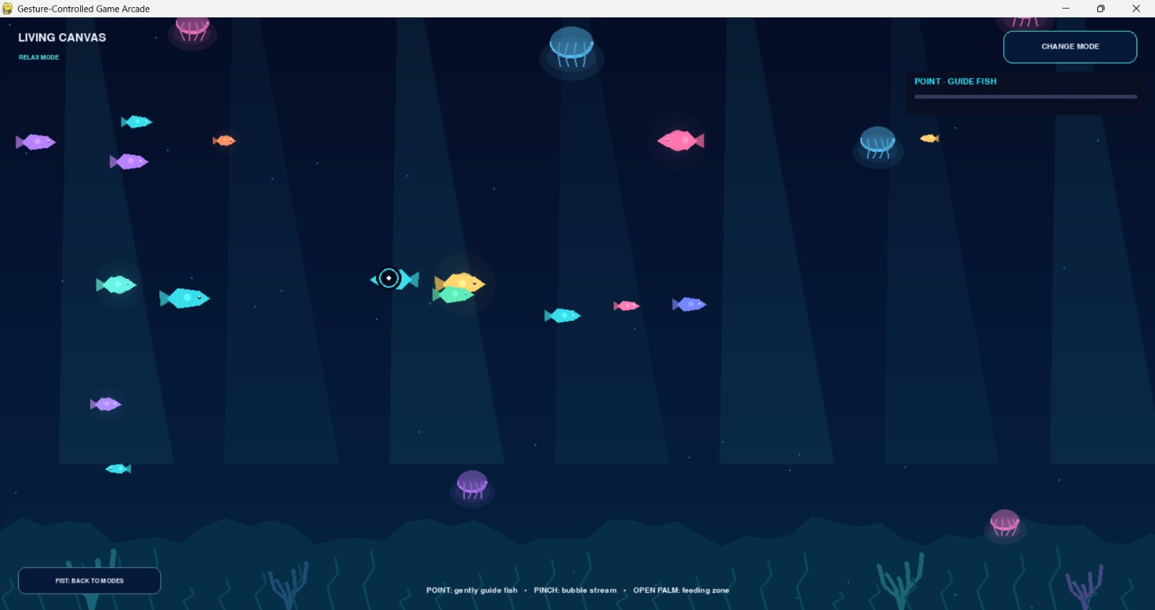
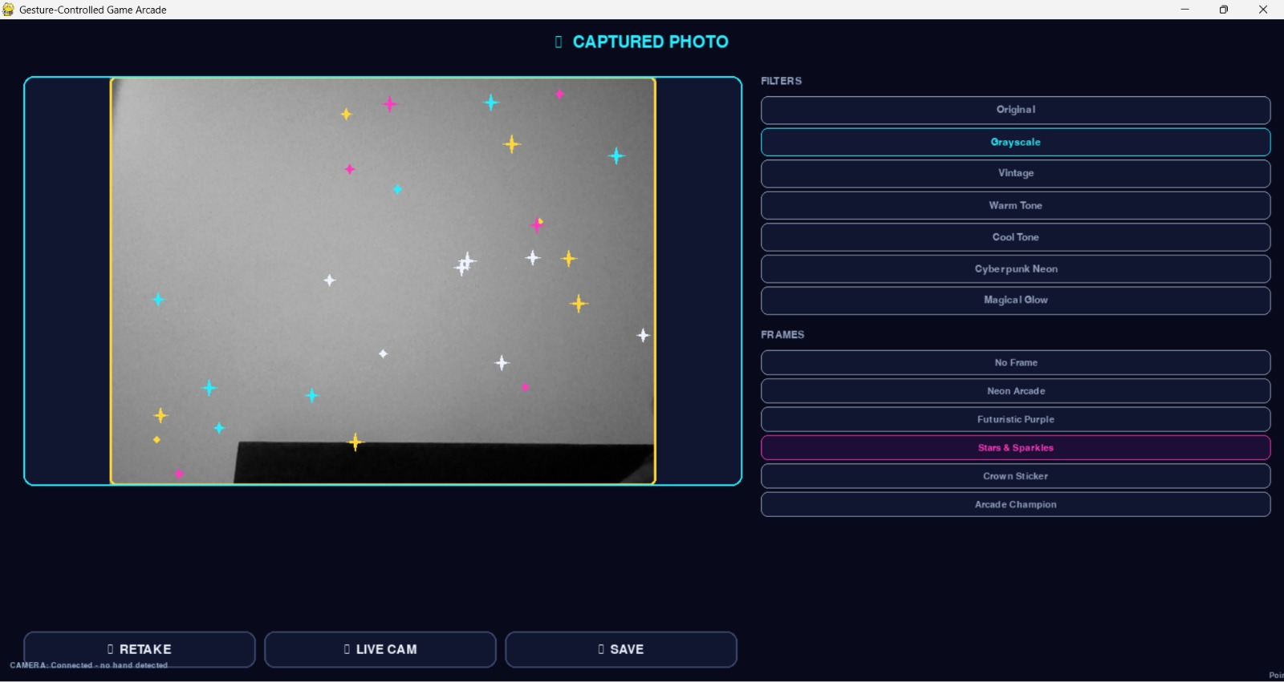
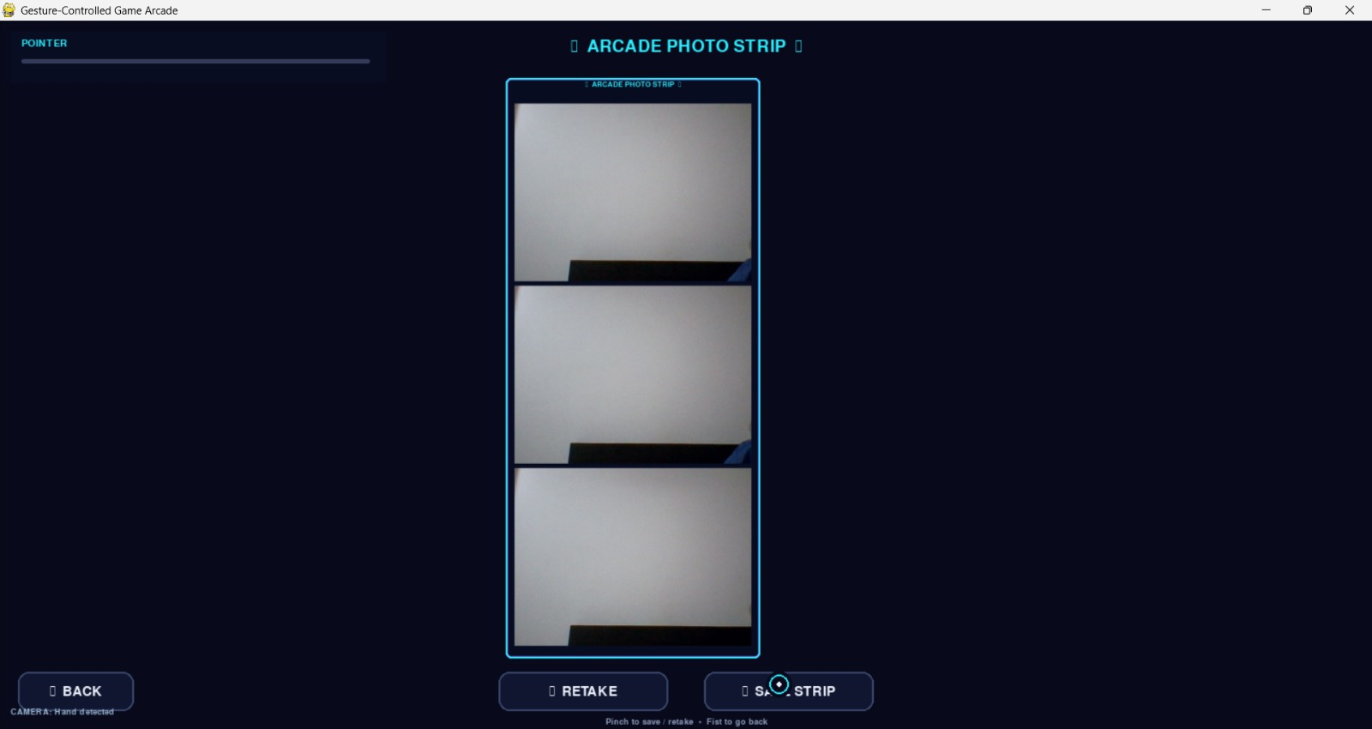

8.2 Qualitative Evaluation
Table 2: Qualitative evaluation checklist
Test Area | What to Verify | Observed Result
Webcam input | Valid frames arrive consistently | To be recorded
Hand detection | Landmarks appear in suitable lighting | To be recorded
Gesture control | Gestures trigger intended actions | To be recorded
Neon Dodge | Existing controls remain functional | To be recorded
Gesture Pong | Hand-controlled paddles work correctly | To be recorded
Photo capture | Captured image matches the preview | To be recorded
Filters and frames | Effects render correctly | To be recorded
Face overlays | Overlay alignment remains stable | To be recorded
Photo saving | Saved images open correctly | To be recorded

8.3 Quantitative Evaluation
The following measurements can be calculated during actual testing.

Gesture Recognition Success Rate
Success Rate = (Correct Recognitions ÷ Total Attempts) × 100

Average Processing Time
T_{avg} = (Σ T_{i}) ÷ N, i = 1, …, N
Here, T_{i} is the measured processing time for frame i, and N is the total number of measured frames.

Frames Per Second
FPS = Number of Processed Frames ÷ Elapsed Time in Seconds

Gesture Response Delay
Measure the elapsed time between performing a deliberate gesture and the corresponding action appearing on screen.
Table 3: Performance measurement table
Metric | Measured Result
Gesture recognition success rate | To be measured
Average frame-processing time | To be measured
Average FPS | To be measured
Gesture response delay | To be measured
Successful photo captures and saves | To be recorded
Tracking failures | To be recorded

8.4 Discussion
The project provides a framework for exploring the use of camera-based landmarks as interactive controls. It also demonstrates how image filters and alpha compositing can transform captured photographs.
Practical performance depends on camera reliability, lighting, hand visibility, detection latency, and implementation quality. Results must be based on actual experiments. Features that remain under development should not be described as verified achievements.

9. CHALLENGES / LIMITATIONS
The project may encounter the following challenges:
- Lighting conditions: Poor or uneven lighting can reduce the visibility of hands and faces.
- Occlusion: Overlapping fingers or hands outside the camera frame can make gestures difficult to detect.
- Gesture ambiguity: Similar hand configurations may be misclassified.
- Processing latency: Camera acquisition, landmark detection, image effects, and rendering compete for processing time.
- Camera availability: Webcam access may fail if another application is using the camera or frame reads are unsuccessful.
- Overlay alignment: Two-dimensional face overlays may become misaligned during large head turns.
- Hardware variation: Camera quality and processing performance differ between systems.
- Evaluation limitations: Reliable performance measurements require repeatable tests under different conditions.
The actual limitations encountered during development should be documented after testing.

10. CONCLUSION
The Gesture-Controlled Game Arcade with Selfie Booth explores the application of image and video processing to interactive gaming and camera-based photography. The proposed system combines webcam frame acquisition, hand landmark detection, gesture interpretation, graphical rendering, image filtering, and transparent image compositing.
Neon Dodge and Gesture Pong provide the gameplay component, while the Selfie Booth extends camera input into a photographic experience. Character-inspired face effects can demonstrate the use of face landmarks and transparent overlays.
The project provides practical learning in real-time video processing, landmark-based interaction, image manipulation, and the integration of computer-vision libraries into a graphical application. Future improvements may focus on tracking stability, processing speed, camera reliability, visual-effect quality, and systematic performance evaluation.
Final conclusions about functionality should reflect the features that were successfully implemented and tested.

11. REFERENCES
[1] OpenCV. OpenCV Documentation. Available at: https://docs.opencv.org/
[2] Google AI Edge. MediaPipe Documentation. Available at: https://ai.google.dev/edge/mediapipe/solutions/guide
[3] Pygame Community. Pygame Documentation. Available at: https://www.pygame.org/docs/
[4] NumPy Developers. NumPy Documentation. Available at: https://numpy.org/doc/
[5] Python Software Foundation. Python Documentation. Available at: https://docs.python.org/3/
[6] Bradski, G. (2000). “The OpenCV Library.” Dr. Dobb’s Journal of Software Tools.
[7] Szeliski, R. Computer Vision: Algorithms and Applications. Springer.
[8] Gonzalez, R. C., and Woods, R. E. Digital Image Processing. Pearson.
[9] Zhang, F., Bazarevsky, V., Vakunov, A., Tkachenka, A., Sung, G., Chang, C.-L., and Grundmann, M. (2020). “MediaPipe Hands: On-device Real-time Hand Tracking.” arXiv:2006.10214.
[10] Lugaresi, C., Tang, J., Nash, H., et al. (2019). “MediaPipe: A Framework for Building Perception Pipelines.” arXiv:1906.08172.
[11] Harris, C. R., Millman, K. J., van der Walt, S. J., et al. (2020). “Array programming with NumPy.” Nature, 585, 357–362.

