Hitika Ailani

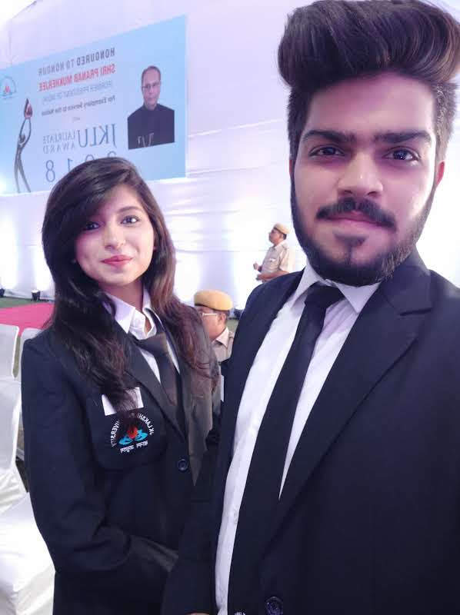

Quest to work and learn in a real

Professional and vying ambience that

will provide a scope for widening the

Spectrum of my knowledge.

## EDUCATION

Institute of Engineering and Technology, JK Lakshmipat University, Jaipur *2017-21 B.Tech Computer Science engineering specialization in Big Data Analytics*

* 7.294 (Till 4th semester)

Saint Anselm’s Sr. Sec. School, Jaipur *2017 12th Grade and CBSE Board*

* 89.6%

Saint Anselm’s Sr. Sec. School, Jaipur *2017*

*10th Grade and CBSE Board*

* 8.2 GPA

## CERTIFICATIONS

* RED HAT CERTIFIED SYSTEM ADMINISTRATOR at Red Hat Enterprise Linux 8
* RED HAT CERTIFIED SPECIALIST IN ANSIBLE AUTOMATION
* Certificate of participation in Techgig Virtual Campus League



* Certificate of participation in JAZBAA 1.0
* Certificate of acquiring 1st place in Techathon conducted by CSI, JK Lakshmipat University for the theme: Disruptive Ideas for Community Outreach

## AREA OF INTEREST

* Data Analytics
* DevOps
* Ansible
* Red Hat Linux
* Docker
* Web Development
* Machine Learning/Deep Learning

SKILLS

* Good Learner
* Leadership
* Teamwork
* Enthusiast

## WORK EXPERIENCE

Linux World Informatics *May2019-July2019 Smarter World:*

Integrating Artificial Intelligence, Machine Learning/Deep Learning with IoT using Real-Time Processing with Spark under the implementation of High Performance Distributed Computing/Storage for BigData – Hadoop Framework and Running Applications on Large Kubernetes Clusters of containerized Docker Engine deployed by DevOps – Ansible Playbook and Provisioned Over Hybrid Own Cloud Computing/AWS Using Python CGI monitored by Operational Intelligence Tool Splunk.

PROJECTS

Ignite India(I2) May2019-July2019

*Technologies Used:*

* IoT (Internet of Things)
* Python CGI
* Linux Server
* Python

The product I2 helps in efficiently managing the power consumed by each house so that their load do not exceeds its limit and people do not suffer power cuts. It will cut-off power of house whose load exceeds along with giving notification alerts.

Automating Servers using Voice *May2019-June2019*

*Technologies Used:*

* Ansible
* Python CGI
* Linux Server
* Hadoop
* Docker
* NLP
* ShellInABox

## EXTRA CURRICULAR INVOLVEMENT

* Member of Computer Society of India of JKLU
* Participated in Virtual Campus League 2018, an inter college National level programming/coding event organized by techgig.com – India’s biggest IT Communit

5/200 SFS Agarwal Farm Mansarover, Jaipur

8823013900

hitikaa26@gmail.com