PRACTICAL: 5
Objective:

To design and develop a user-friendly student registration form using HTML5 and JavaScript, with client-side validation for user inputs and clear error messages using Regular Expressions.

Theory:

- HTML5 form elements and input types are used to collect student registration details.
- JavaScript is used to validate the entered data on the client side.
- Regular Expressions are used to validate fields such as name, email, and mobile number.
- Password and confirm password fields are checked to ensure that both passwords match.
- A password strength meter can be used to indicate the strength of the entered password.
- Clear error messages help users identify and correct invalid inputs.
- Proper labels and form structure improve accessibility and user experience.

Code:
index.html
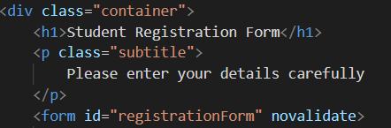
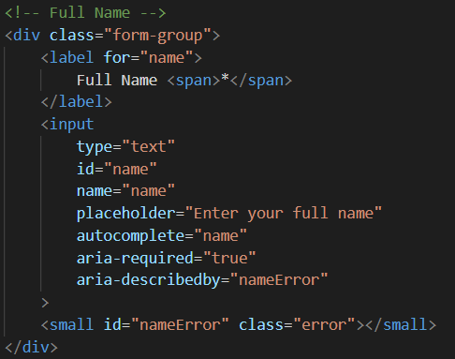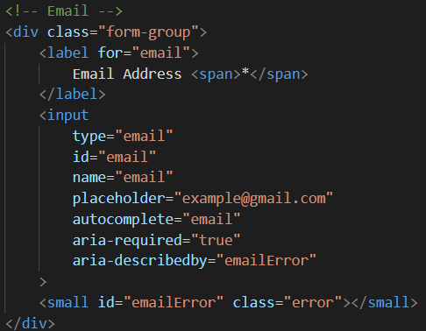
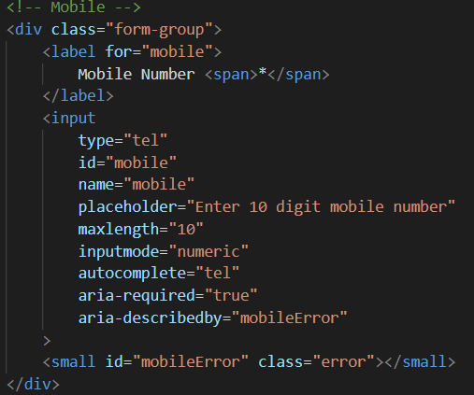
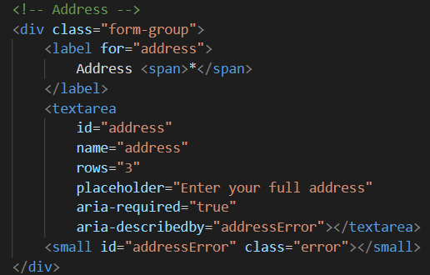
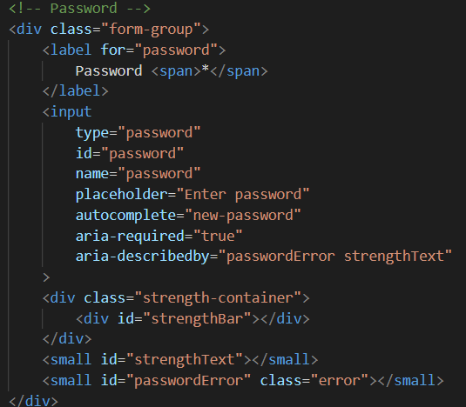
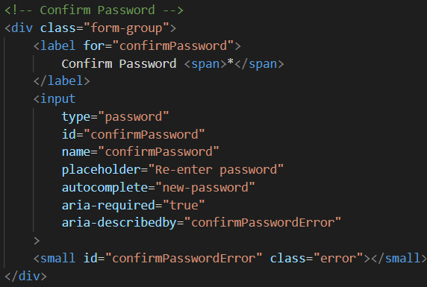
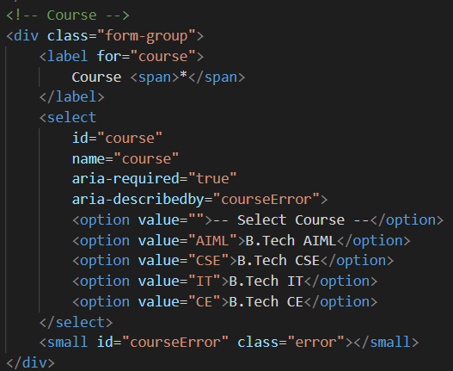
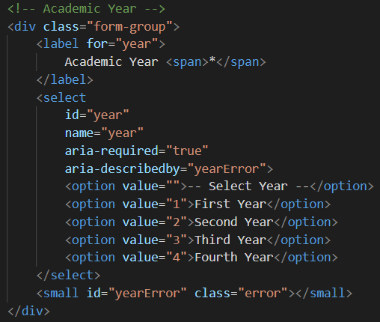
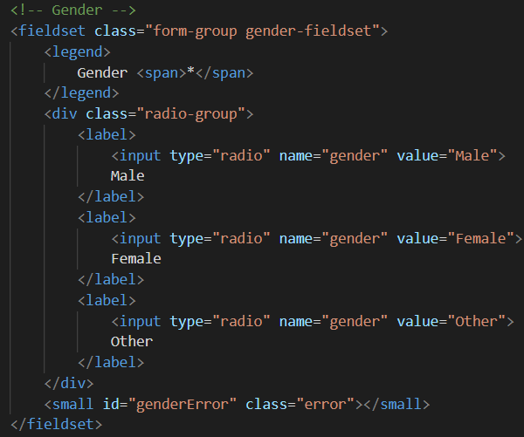
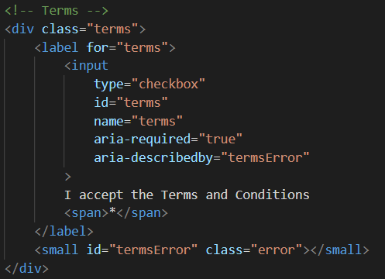
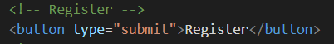
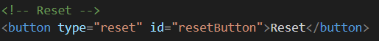
style.css
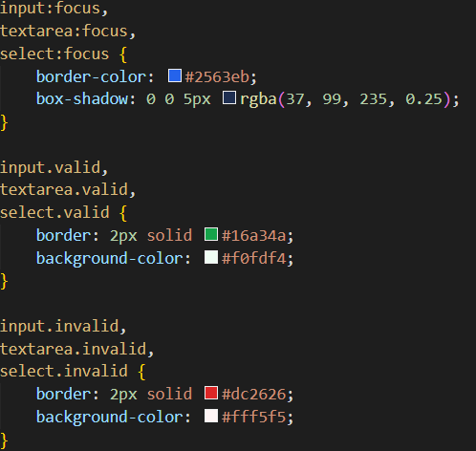
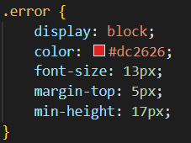
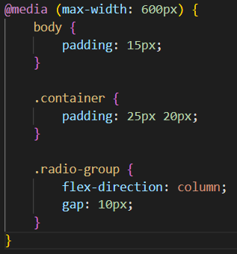
script,js
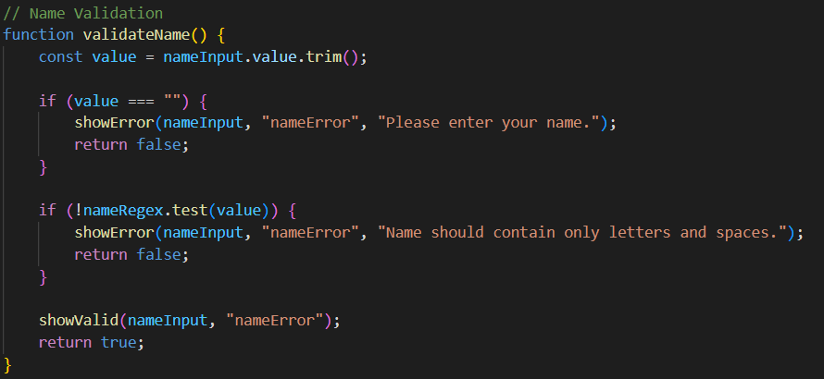

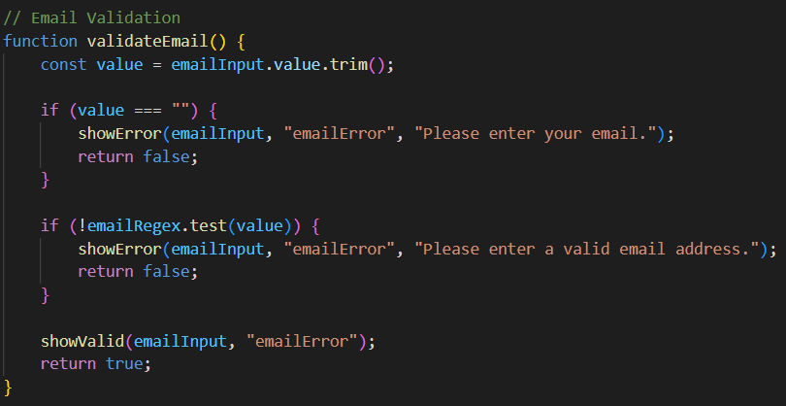

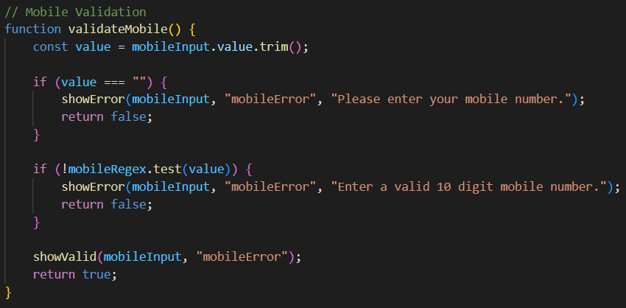

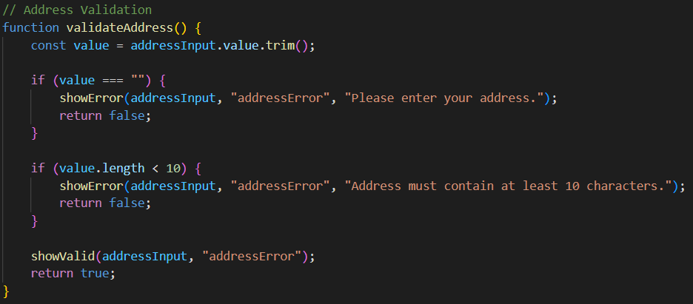

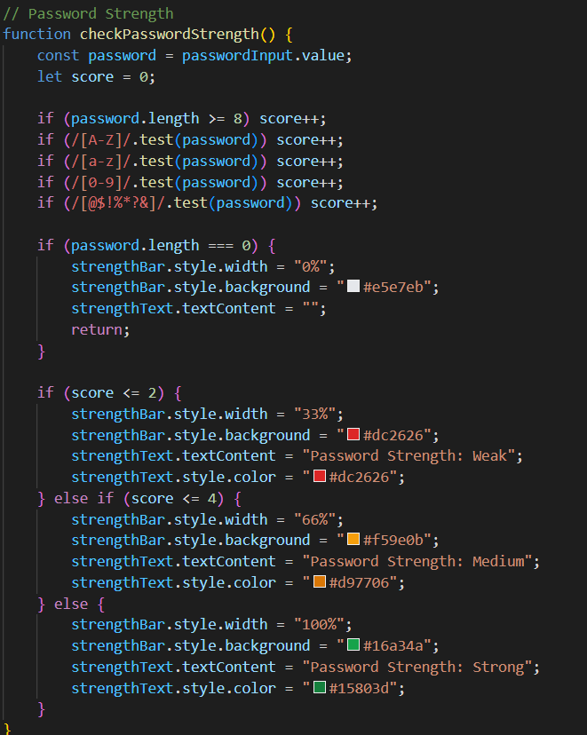
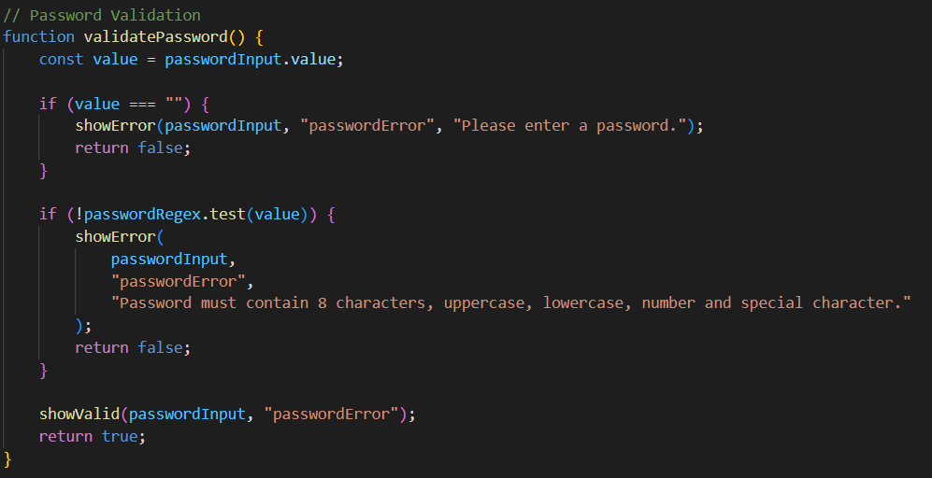

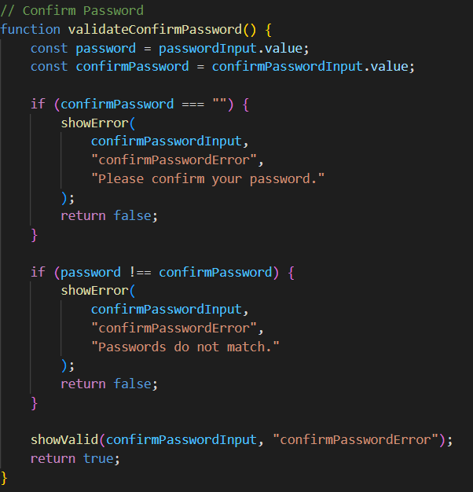
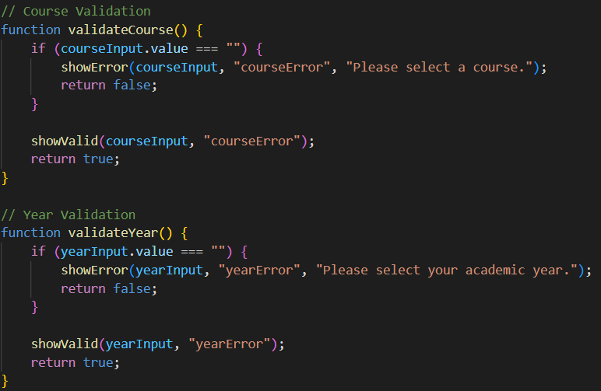

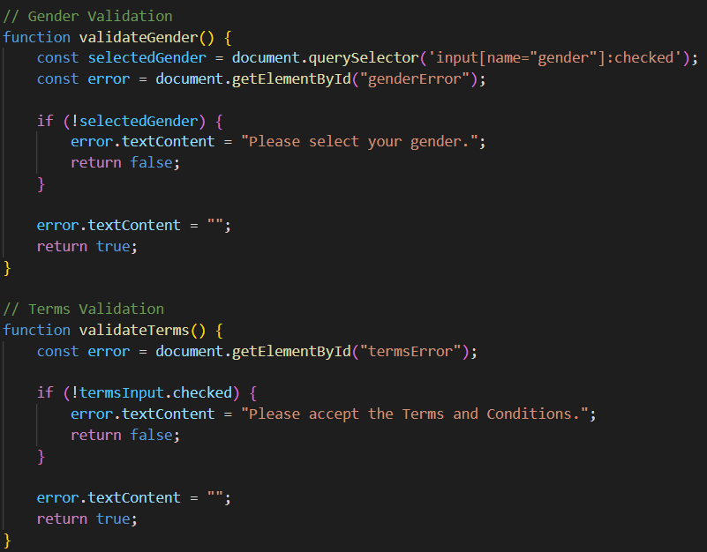
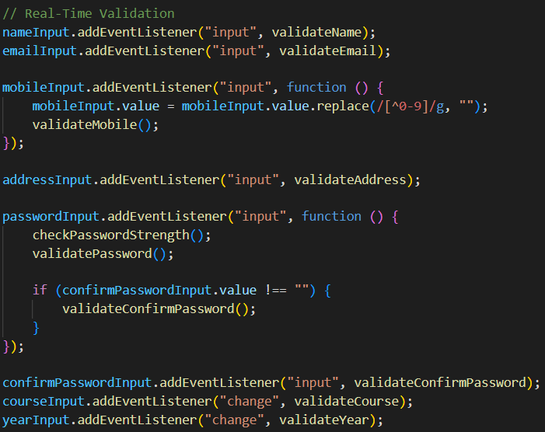
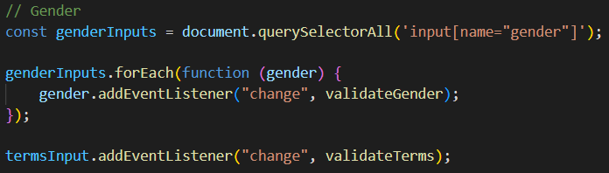

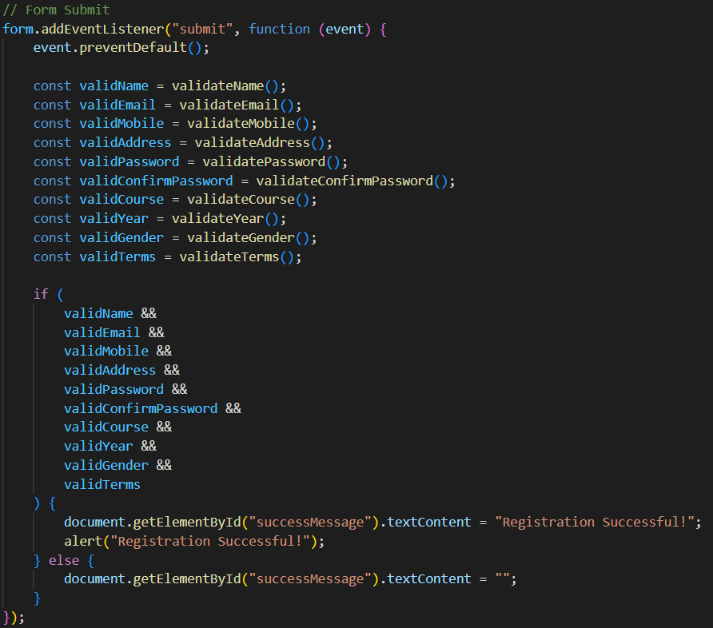

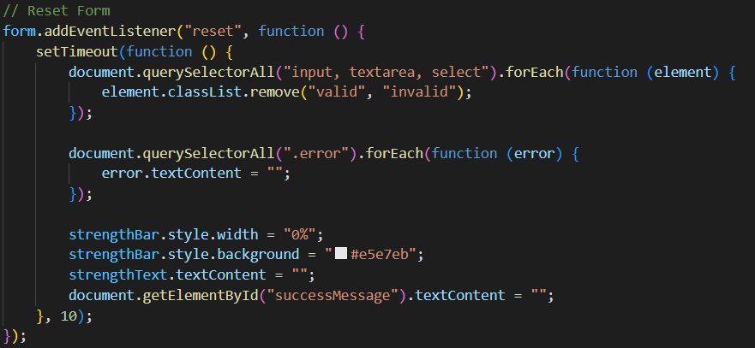

Output :-
Registration Form
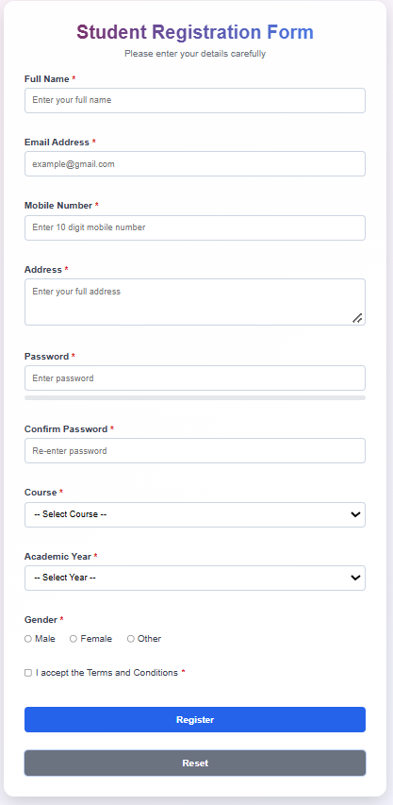

Required Field Validation
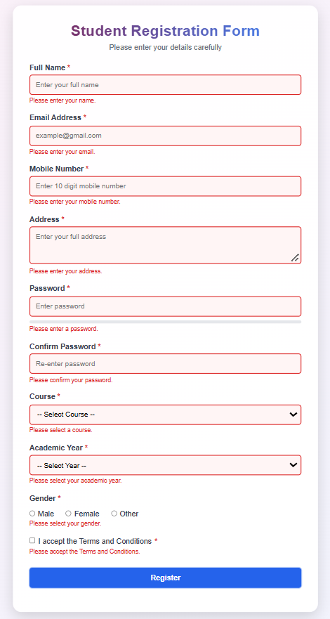

Invalid Email and Mobile Number
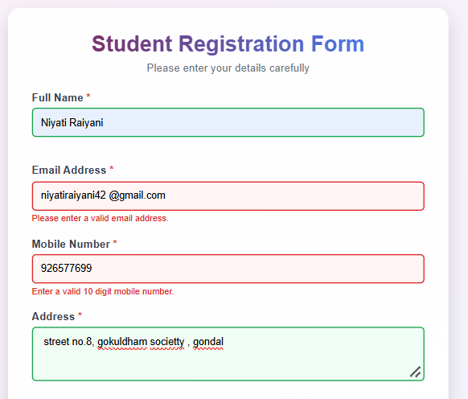
Password Strength & Confirm Password Validation
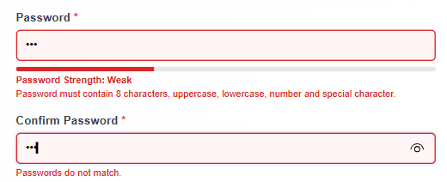

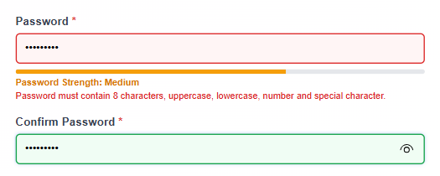

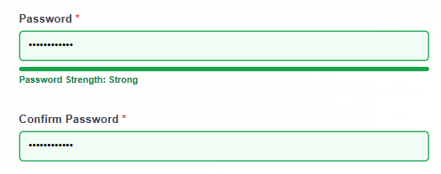

Valid Registration Form
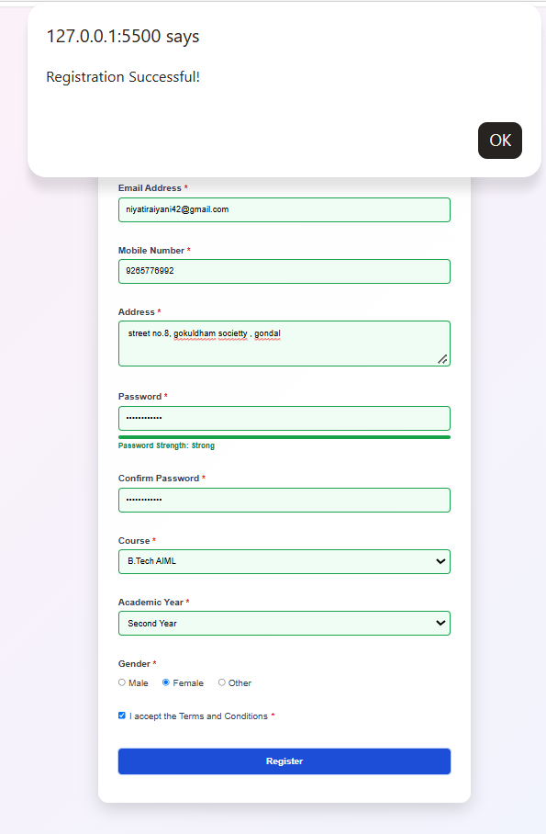
Successful Registration


Learning Outcome:

• Students will be able to design accessible forms with robust client-side validation.
• Implement JavaScript validation using Regular Expressions.
• Validate password, email, mobile number, and other form fields.
• Display clear and user-friendly error messages.

References:

• MDN Web Docs – HTML Forms and JavaScript Validation.
• JavaScript ES5/ES6 – Regular Expressions and Form Validation.
• HTML5 Documentation – Form Elements and Input Types.
• Classroom notes and Practical 5 guidelines.

