EXPPERIMENT 6
Jira Agile Project Management User Manual

1. Account Creation & Initial Setup
• Navigate to Jira: Visit Jira's official portal and select 'Get Jira for free'.
• Tier Limits: Jira Free tier supports up to 10 users, suitable for standard Scrum teams (typically 5 to 9 members).
• Account Registration: Enter work email, verify with the security code, input full name, create password, and enter business/organization domain.
• Work Type Selection: Select 'Software Development' and choose the 'Scrum' methodology.
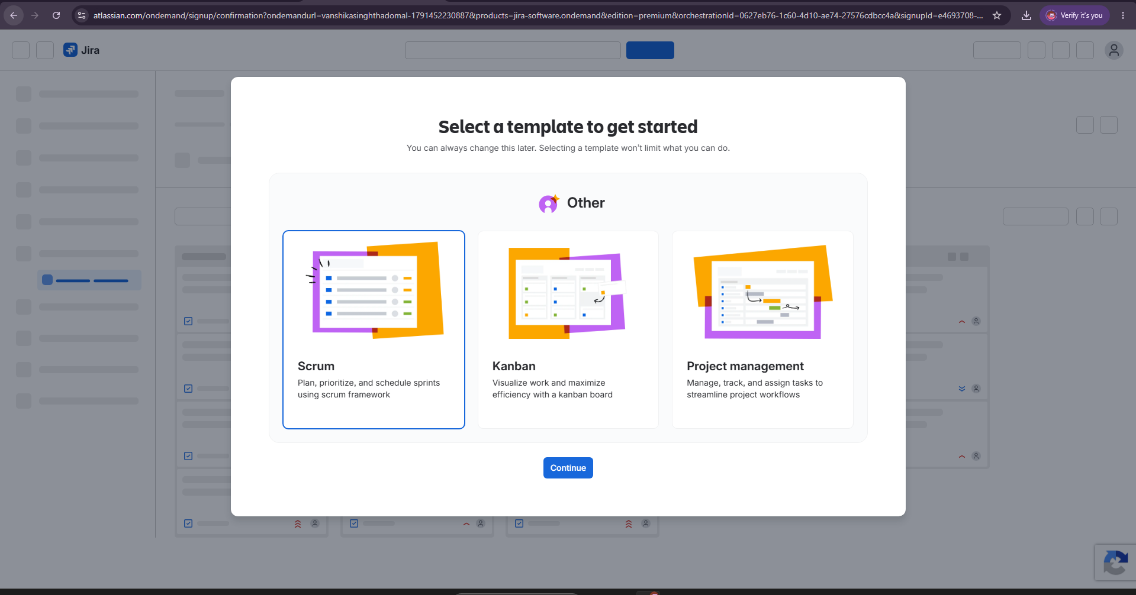
2. Project Creation & Team Member Invitations
• Project Name: Set the project name as 'Sheify Website Development'.
• Invite Collaborators: Navigate to the team icon in the top navigation bar, input collaborator email addresses, configure invite permissions, and click 'Add people'.

3. Work Breakdown Structure & Epic Management
The Scrum framework is organized hierarchically into four core layers:
1. Roadmap: Top-level strategic project goals.
2. Epics: Large initiatives broken into deliverables (managed by Product Owner).
3. User Stories: Functional requirement units that deliver customer value.
4. Tasks / Sub-tasks: Specific technical tasks completed by developers.
Configured Project Epics
• Epic 1 (Purple): 'Improve Customer Service' (assigned to Product Owner, dates set for June 01 - June 30).
• Epic 2 (Green): 'Increase Product Page Conversions'.
4. Backlog Refinement, Stories & Tasks [06:40 - 09:30]
In the Backlog view, the team creates and categorizes issues under the parent epics:
Issue Key | Issue Type | Summary / Requirement | Assigned Parent Epic
SWD-1 | Story | Provide live chat as a feature | Improve Customer Service
SWD-2 | Task | Add WhatsApp chat to our website | Improve Customer Service
SWD-3 | Task | Add Facebook messenger chat to our website | Improve Customer Service
SWD-4 | Story | Create a video based knowledge base | Improve Customer Service
SWD-5 | Story | Create a review based system for collecting reviews | Increase Product Page Conversions
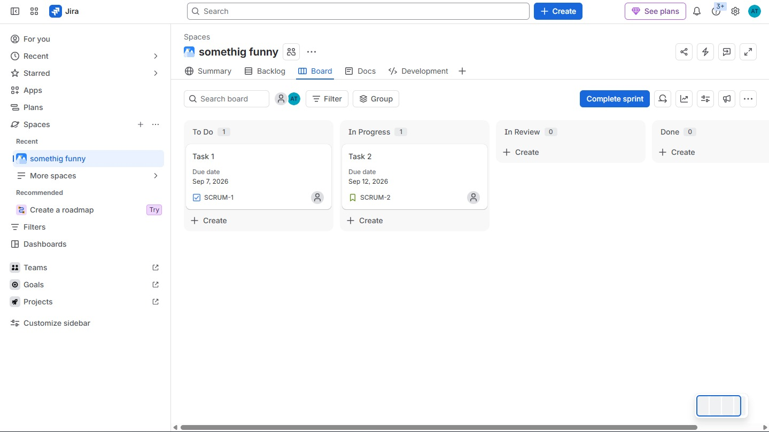

5. Sprint Planning, Execution & Custom Columns [09:55 - 12:50]
• Edit Sprint Parameters: Open the context menu on 'Scrum Sprint 1' -> Edit Sprint. Set dates (June 03 to July 01) and Sprint Goal ('Improving our customers experience on our website').
• Move Items into Sprint: Move SWD-1, SWD-2, and SWD-3 from Backlog into Scrum Sprint 1.
• Click 'Start Sprint': Transitions the sprint container into the live Active Board.
• Add Custom 'Review' Column: Click the '+' icon on the board header, enter 'Review', confirm, and place between 'In Progress' and 'Done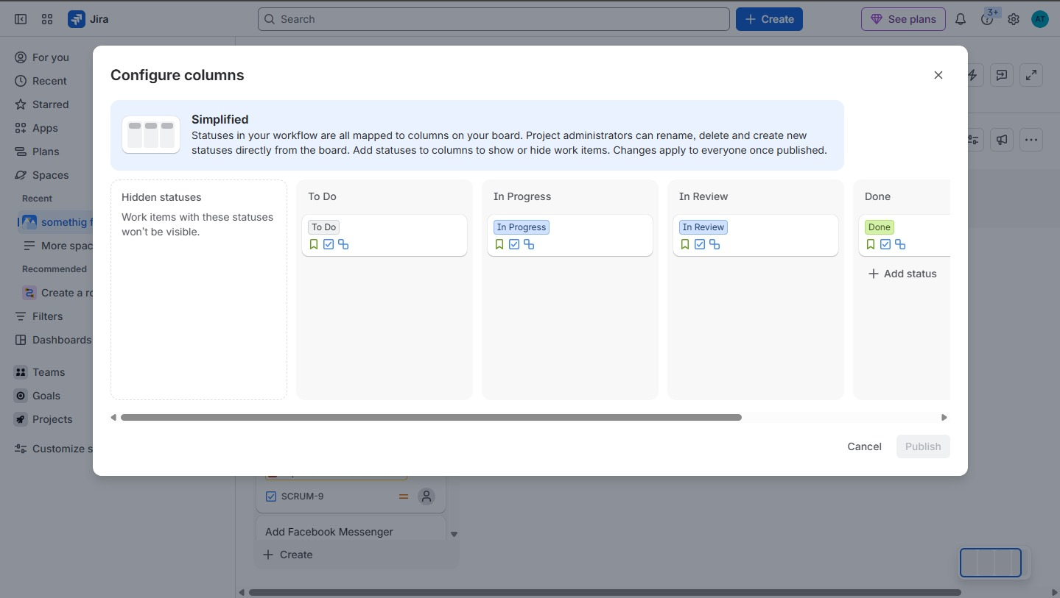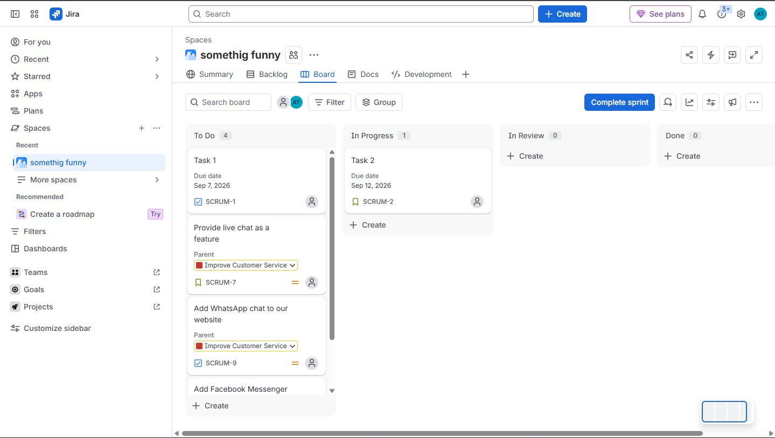

6. Jira Views, Reporting & Integrations
• Timeline View (Gantt): Visualizes epics, child stories, and task dependency arrows across months.
• List View & Issues Search: Spreadsheet-style grid view for rapid editing, filtering, and field auditing.
• Project Pages & Retrospectives: Integrated Confluence spaces for team sprint retrospectives.
• Dashboards & App Integrations: Add gadgets and integrate third-party apps like Slack, Google Forms, and TimeCamp for time tracking.
