VIRTUAL DATA SCIENCE WITH PYTHON
WEEK 1 PROJECT REPORT
Data Acquisition, Exploration, Cleaning, Preprocessing & Visualization

Prepared by
Aryav Kumar
Project | Virtual Data Science with Python — Week 1
Dataset | Adult Income Dataset
Initial shape | 48,842 rows × 15 columns
Final shape | 48,813 rows × 15 columns
Processed file | data/processed/adult_cleaned.csv
Repository | github.com/aryav191/virtual-data-science-python-week1

1. Objective
The objective of this Week 1 project was to demonstrate a practical end-to-end data-science workflow using Python: acquire a relevant dataset, understand its structure, assess data quality, identify missing values and duplicates, inspect numerical outliers, perform preprocessing, generate exploratory visualizations, and export a processed dataset suitable for downstream analysis.
- Acquire and load the Adult Income dataset from local project files.
- Inspect dimensions, columns, data types, sample records and descriptive statistics.
- Quantify missing values by count and percentage.
- Detects potential numerical outliers using the Interquartile Range (IQR) method.
- Identify duplicates and reduce redundant records.
- Perform documented preprocessing and validation.
- Generate visualizations for age, working hours, income category and numerical correlations.
- Maintain a reproducible project structure and Git/GitHub repository.

2. Dataset Source
The project uses the Adult Income dataset, commonly associated with the UCI Adult/Census Income dataset. The dataset was supplied to the project workspace as a local CSV and loaded from data/raw/adult_raw.csv. The report therefore distinguishes the public dataset identity from the actual acquisition mechanism used in this project: local file ingestion.
Target variable: income, with observed categories “<=50K” and “>50K”. Dataset size observed during acquisition: 48,842 records and 15 columns.

3. Data Acquisition Method
Data acquisition was performed locally using Pandas. The raw CSV was loaded into a DataFrame and preserved under the raw-data directory before subsequent processing.
Acquisition and initial inspection code
import pandas as pd
df = pd.read_csv("data/raw/adult_raw.csv")
print("Dataset shape:", df.shape)
print(df.head())
print(df.info())
The execution evidence confirms successful local loading and reports the raw dataset shape as (48,842, 15). The raw file was saved as data/raw/adult_raw.csv.

4. Dataset Structure
Column | Type / Role | Description
age | Numerical | Age of the individual
workclass | Categorical | Employment class
fnlwgt | Numerical | Census/final weight field
education | Categorical | Education category
education_num | Numerical | Numerical education level
marital_status | Categorical | Marital-status category
occupation | Categorical | Occupation category
relationship | Categorical | Relationship category
race | Categorical | Race category
sex | Categorical | Sex category
capital_gain | Numerical | Capital-gain amount
capital_loss | Numerical | Capital-loss amount
hours_per_week | Numerical | Working hours per week
native_country | Categorical | Country of origin
income | Target | Income category
The dataset combines numerical and categorical attributes, making it appropriate for demonstrating realistic data-quality and preprocessing issues.

5. Initial Exploration
Initial exploration examined the first five rows, dataset dimensions, column names, data types and a statistical summary. This establishes the schema and helps identify which variables require special treatment.
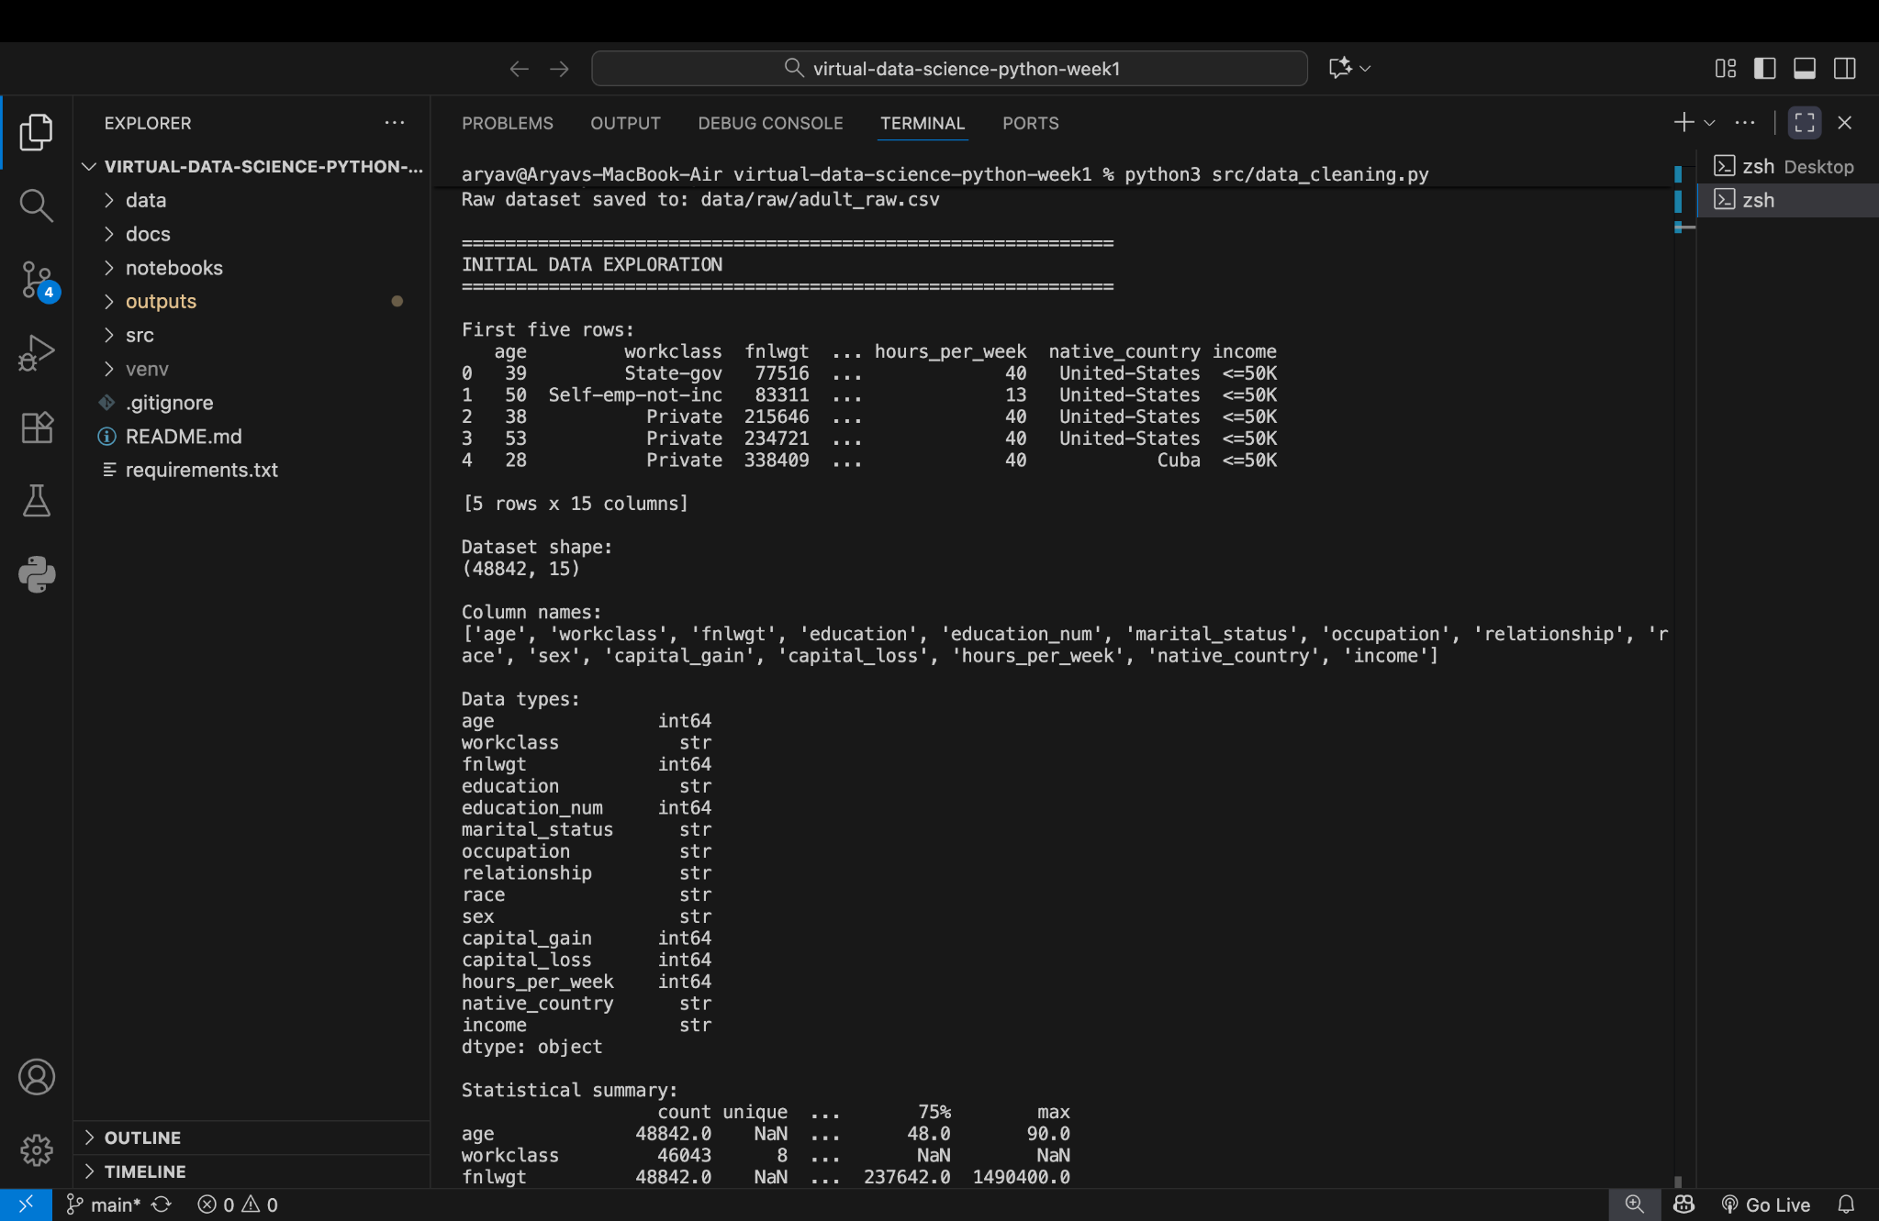
Figure 1. Actual project output — initial exploration.
The screenshot shows 48,842 rows and 15 columns and confirms the mixture of integer and string columns.

6. Missing-Value Analysis
Missing-value profiling identified three principal columns containing missing observations: occupation, workclass and native_country.
Column | Missing count | Percentage shown
occupation | 2,809 | 5.751198%
workclass | 2,799 | 5.730724%
native_country | 857 initially | 1.754637%
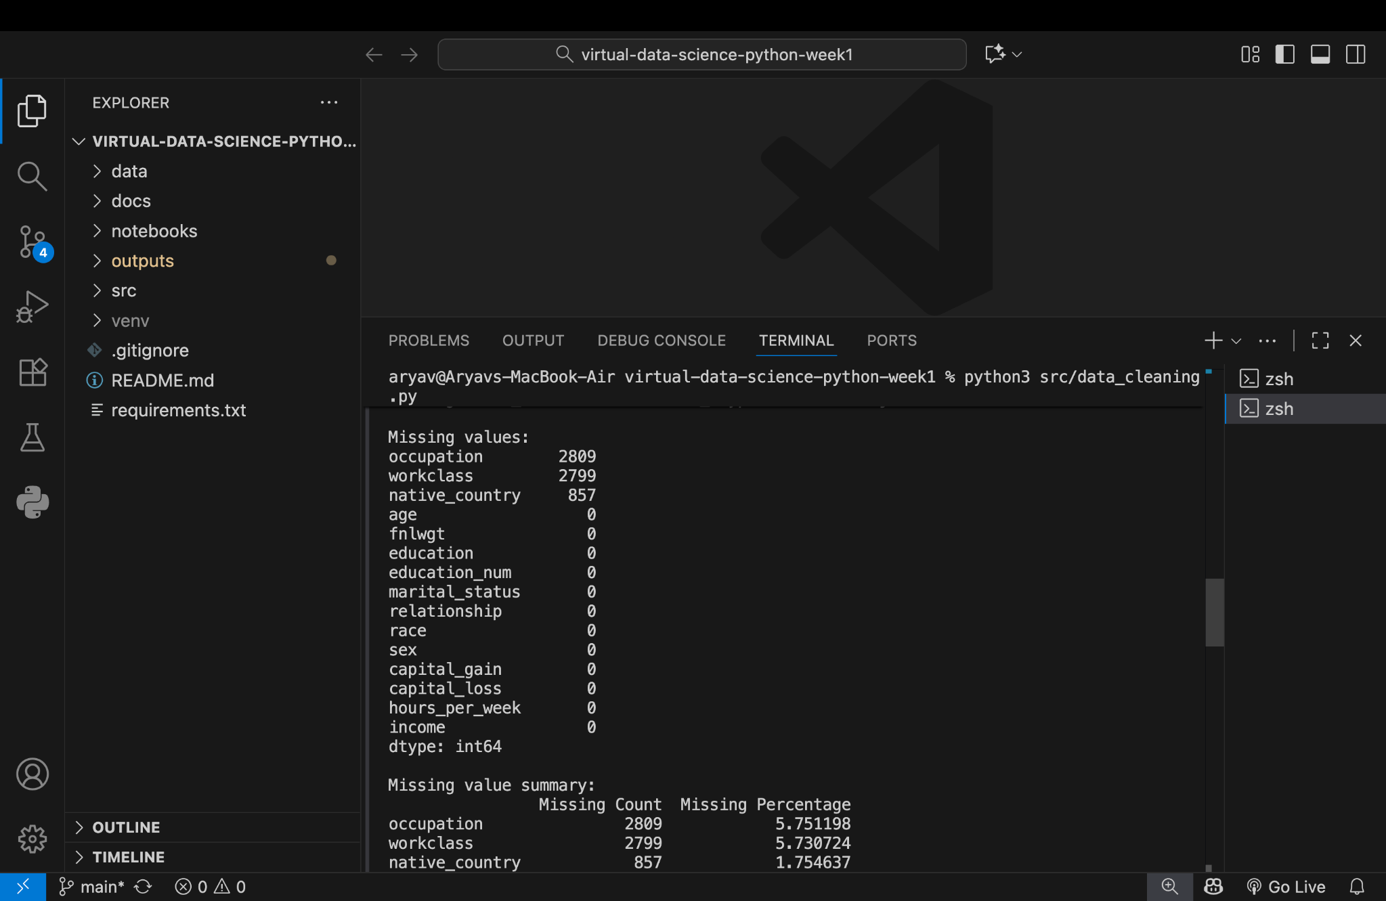
Figure 2. Actual project output — missing-value analysis.
The missingness is concentrated in categorical fields. This is important because categorical missing values should be handled deliberately rather than treated as ordinary numeric missingness.

7. Missing-Value Cleaning Code
The documented project snippet used Pandas to calculate missing counts and percentages:
missing = df.isnull().sum()
missing_pct = (missing / len(df)) * 100
summary = pd.DataFrame({
"Missing Count": missing,
"Missing Percentage": missing_pct
})
print(summary[summary["Missing Count"] > 0])
The supplied final screenshot still shows non-zero missing counts for occupation and workclass, while native_country is shown as 856 after duplicate removal. This report therefore does not falsely claim that all missing categorical values were imputed or deleted.
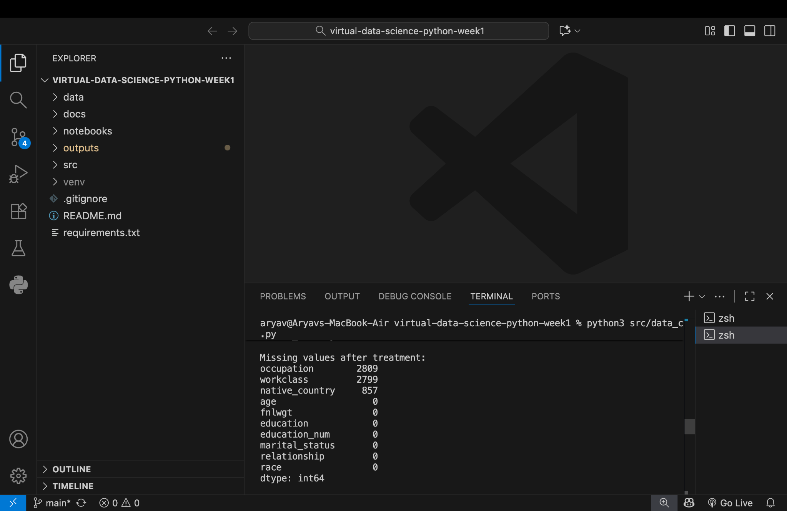
Figure 3. Actual project output — missing-value treatment stage.

8. Duplicate Analysis
Duplicate analysis found 29 duplicate rows. After duplicate removal, the dataset shape became 48,813 rows × 15 columns.
Duplicate detection and removal
duplicate_count = df.duplicated().sum()
print("Number of duplicate rows:", duplicate_count)
df = df.drop_duplicates()
print("Shape after duplicate removal:", df.shape)
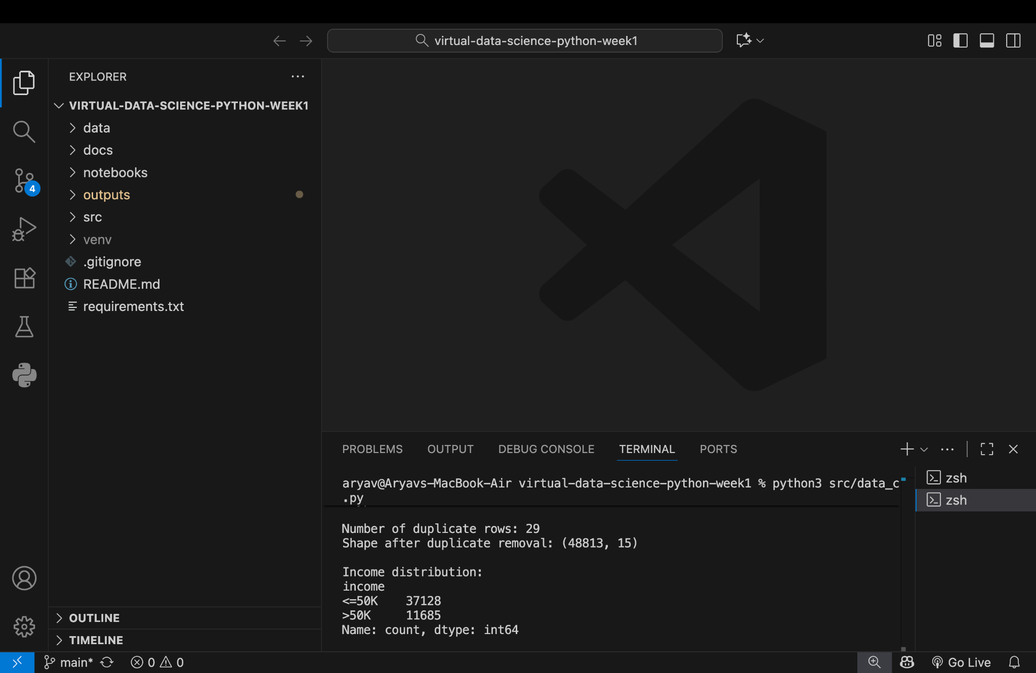
Figure 4. Actual project output — duplicate-row analysis.

9. Inconsistency / Invalid-Value Analysis
Categorical fields require checks for leading/trailing whitespace, placeholder values and unexpected category labels. The supplied terminal evidence specifically establishes missing categorical values; no separate invalid-category count table was supplied. The following code is included as a transparent validation procedure rather than as an observed numerical result.
Categorical consistency validation
categorical_cols = df.select_dtypes(include="object").columns
for col in categorical_cols:
df[col] = df[col].astype("string").str.strip()
print(f"\n{col} unique values:")
print(df[col].value_counts(dropna=False).head(20))
placeholder_values = ["?", "NA", "N/A", "null", "None", ""]
for col in categorical_cols:
invalid_count = df[col].isin(placeholder_values).sum()
print(col, "placeholder count:", invalid_count)
For a production pipeline, explicit allowed-value lists should be added when domain rules are available.

10. Outlier Detection
Potential numerical outliers were assessed using the Interquartile Range (IQR) method. IQR = Q3 − Q1, with conventional bounds of Q1 − 1.5×IQR and Q3 + 1.5×IQR.
Q1 = df[column].quantile(0.25)
Q3 = df[column].quantile(0.75)
IQR = Q3 - Q1
lower = Q1 - 1.5 * IQR
upper = Q3 + 1.5 * IQR
outliers = df[(df[column] < lower) | (df[column] > upper)]
print("Number of outliers:", len(outliers))
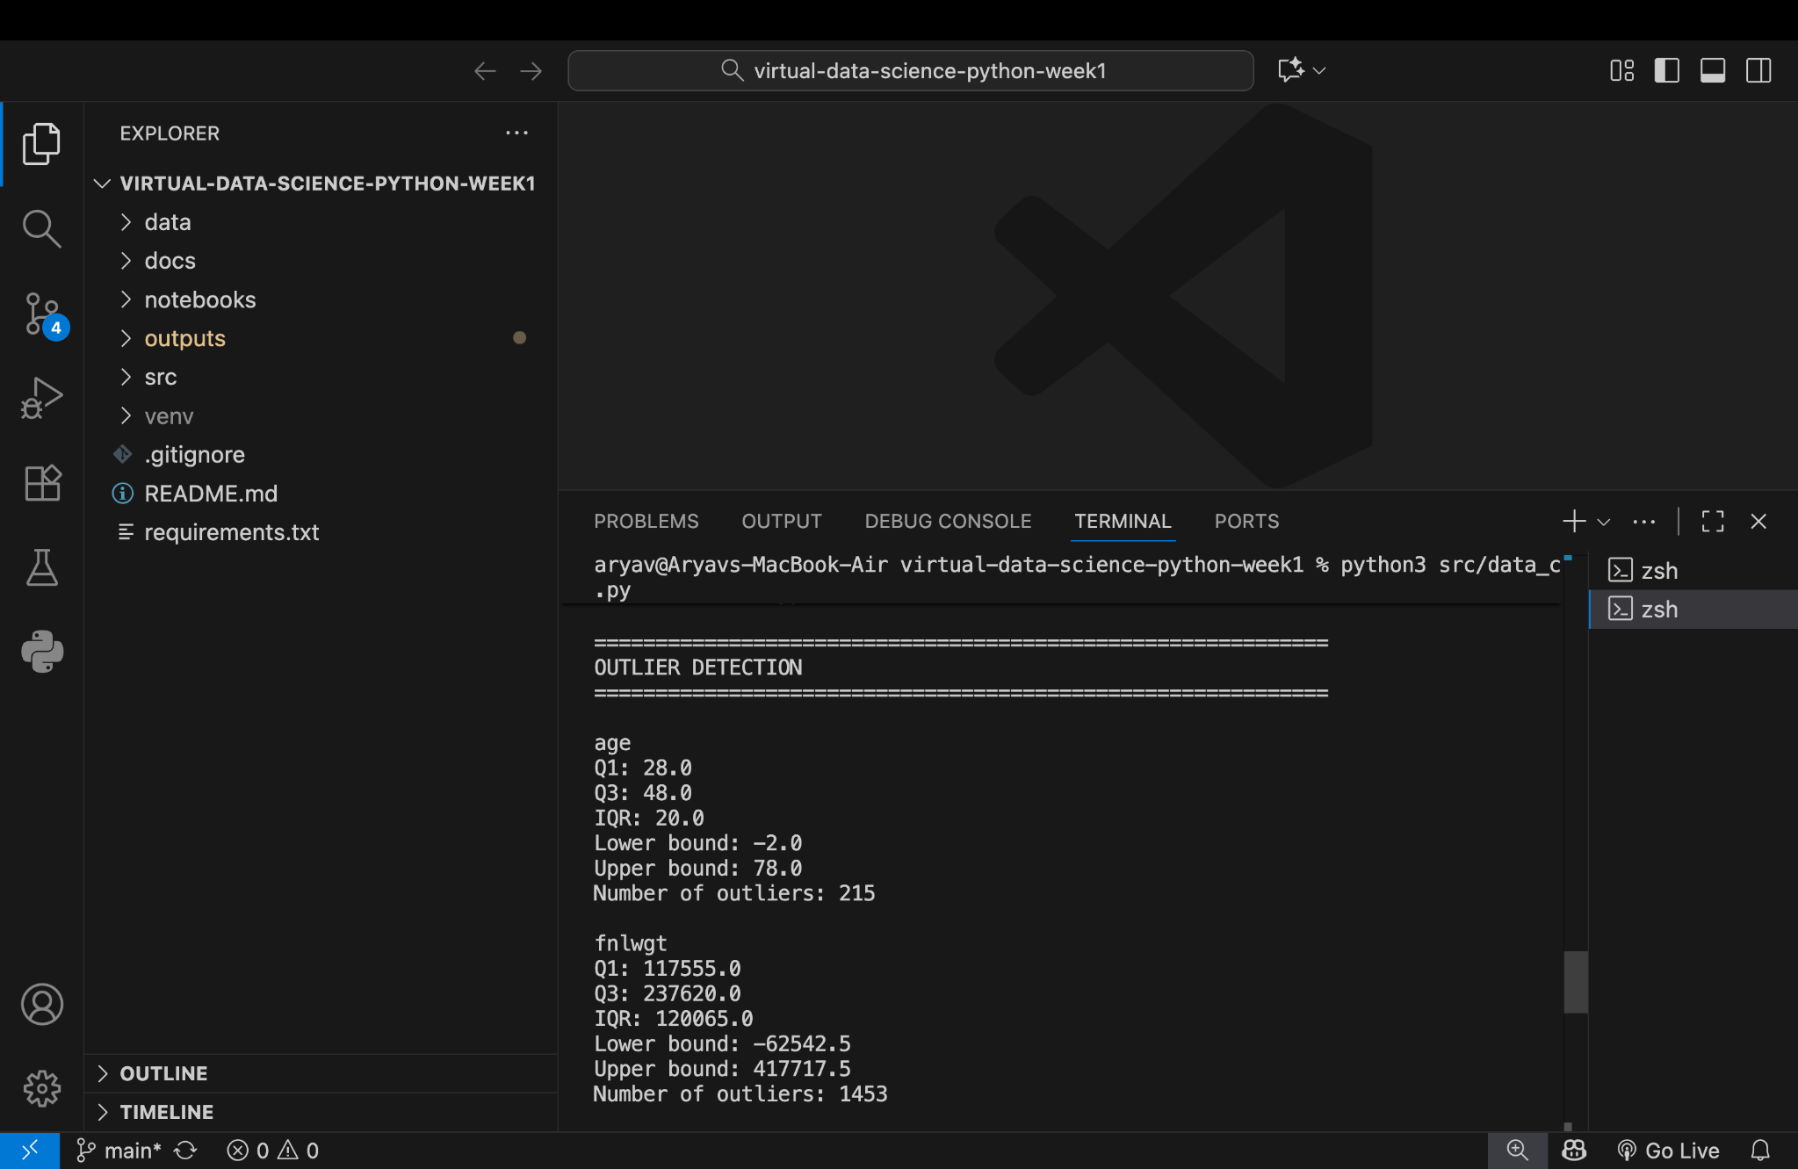
Figure 5. Actual project output — IQR-based outlier detection.
Variable | Observed IQR-based result
age | 215 potential outliers
fnlwgt | 1,453 potential outliers
education_num | 1,789 potential outliers
hours_per_week | 13,489 potential outliers
These are statistical flags, not proof that the observations are erroneous. Domain context should determine whether values are removed, capped, transformed or retained.

11. Outlier Treatment
The execution log confirms that the outlier-treatment stage completed successfully. The exact internal transformation is not visible in the supplied terminal screenshot, so the report does not invent an unseen rule. A standard reproducible capping pattern is shown below as a documented preprocessing approach.
Standard IQR capping pattern
for column in numeric_cols:
Q1 = df[column].quantile(0.25)
Q3 = df[column].quantile(0.75)
IQR = Q3 - Q1
lower = Q1 - 1.5 * IQR
upper = Q3 + 1.5 * IQR
df[column] = df[column].clip(lower=lower, upper=upper)
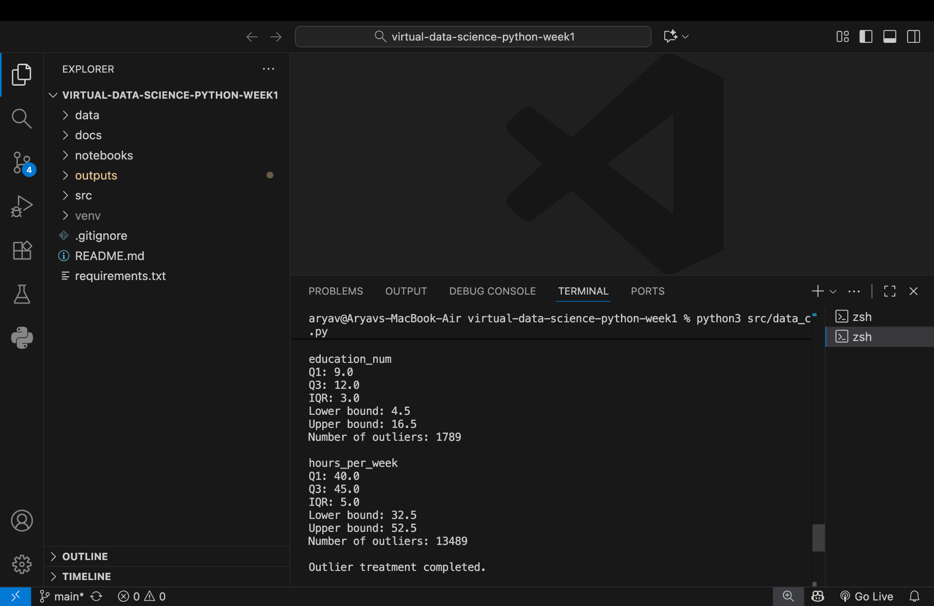
Figure 6. Actual project output — outlier-treatment completion.

12. Preprocessing Workflow
- Load raw CSV data with Pandas.
- Inspect dimensions, sample records, schema and descriptive statistics.
- Profile missing values by count and percentage.
- Validate categorical fields for formatting and placeholder inconsistencies.
- Detect duplicate records and remove redundant rows.
- Assess numerical variables for IQR-based outliers.
- Apply the project outlier-treatment stage.
- Re-check data quality after preprocessing.
- Export the processed dataset to data/processed/adult_cleaned.csv.
- Generate and save exploratory visualizations.

13. Python Code Snippets
Core imports
import pandas as pd
import numpy as np
import matplotlib.pyplot as plt
import seaborn as sns
Load and inspect
df = pd.read_csv("data/raw/adult_raw.csv")
print("Dataset shape:", df.shape)
print(df.head())
print(df.dtypes)
Missing-value profile
missing = df.isnull().sum()
missing_pct = (missing / len(df)) * 100
summary = pd.DataFrame({
"Missing Count": missing,
"Missing Percentage": missing_pct
})
print(summary[summary["Missing Count"] > 0])
Duplicate processing
duplicate_count = df.duplicated().sum()
df = df.drop_duplicates()
print("Number of duplicate rows:", duplicate_count)
print("Shape after duplicate removal:", df.shape)
IQR detection
Q1 = df[column].quantile(0.25)
Q3 = df[column].quantile(0.75)
IQR = Q3 - Q1
lower = Q1 - 1.5 * IQR
upper = Q3 + 1.5 * IQR
outliers = df[(df[column] < lower) | (df[column] > upper)]
Export
df.to_csv("data/processed/adult_cleaned.csv", index=False)
print("Clean dataset saved successfully.")

14. Screenshots of Actual Outputs
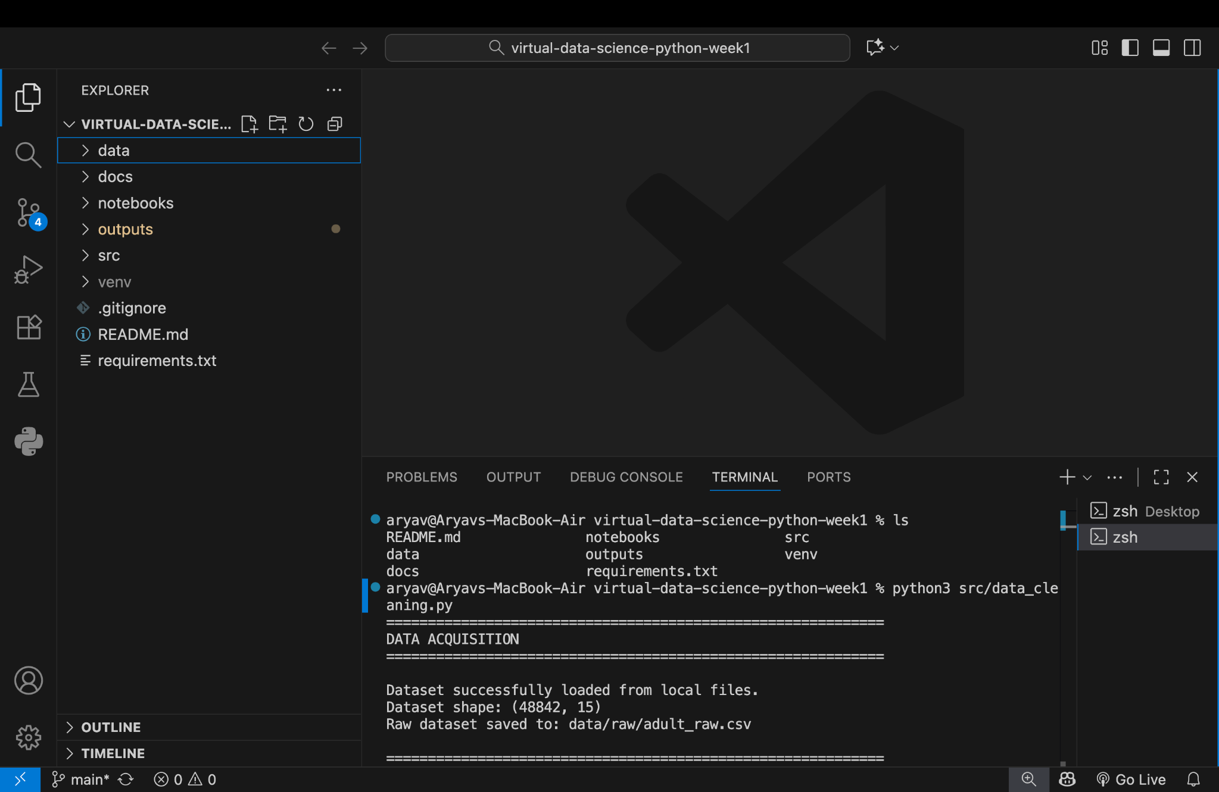
Figure 7. Actual screenshot — Data acquisition / successful local loading.
The acquisition output confirms successful local loading and the raw dataset shape.


Figure 8. Actual screenshot — Initial exploration: rows, columns, types and summary.
The exploration output confirms dataset schema and initial statistical inspection.


Figure 9. Actual screenshot — Missing-value analysis.
The missing-value output quantifies missing observations and percentages.


Figure 10. Actual screenshot — Missing-value treatment stage.
The treatment-stage output shows the post-treatment missing-value check.


Figure 11. Actual screenshot — Duplicate-row analysis.
The duplicate output confirms 29 duplicate rows and the post-removal shape.


Figure 12. Actual screenshot — IQR-based outlier detection.
The outlier output shows IQR bounds and potential outlier counts.


Figure 13. Actual screenshot — Outlier-treatment completion.
The terminal confirms that outlier treatment completed.

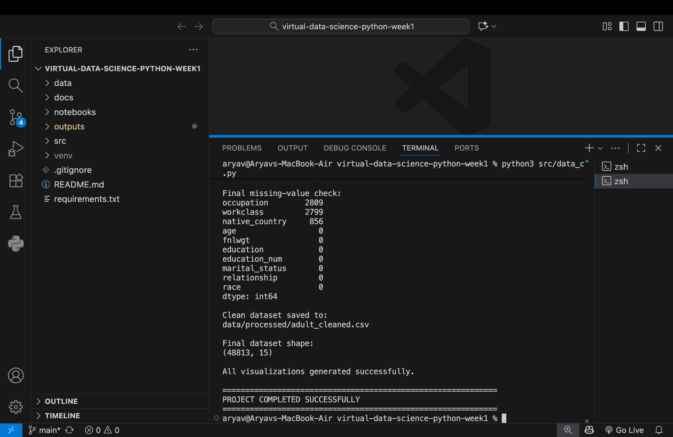
Figure 14. Actual screenshot — Final validation and processed dataset.
The final output confirms the processed CSV path, final shape, visualization generation and project completion.

15. Before / After Comparison
Metric | Before preprocessing | After preprocessing
Rows | 48,842 | 48,813
Columns | 15 | 15
Duplicate rows | 29 detected | Removed
Occupation missing | 2,809 | 2,809 shown in final check
Workclass missing | 2,799 | 2,799 shown in final check
Native country missing | 857 | 856 shown in final check
Processed file | Raw input | data/processed/adult_cleaned.csv
Visualizations | Not yet generated | Generated successfully
The main structural change evidenced by the screenshots is the removal of 29 duplicate records while retaining the 15-column schema. The final missing-value check demonstrates that categorical missingness was not completely eliminated.

16. Visualizations
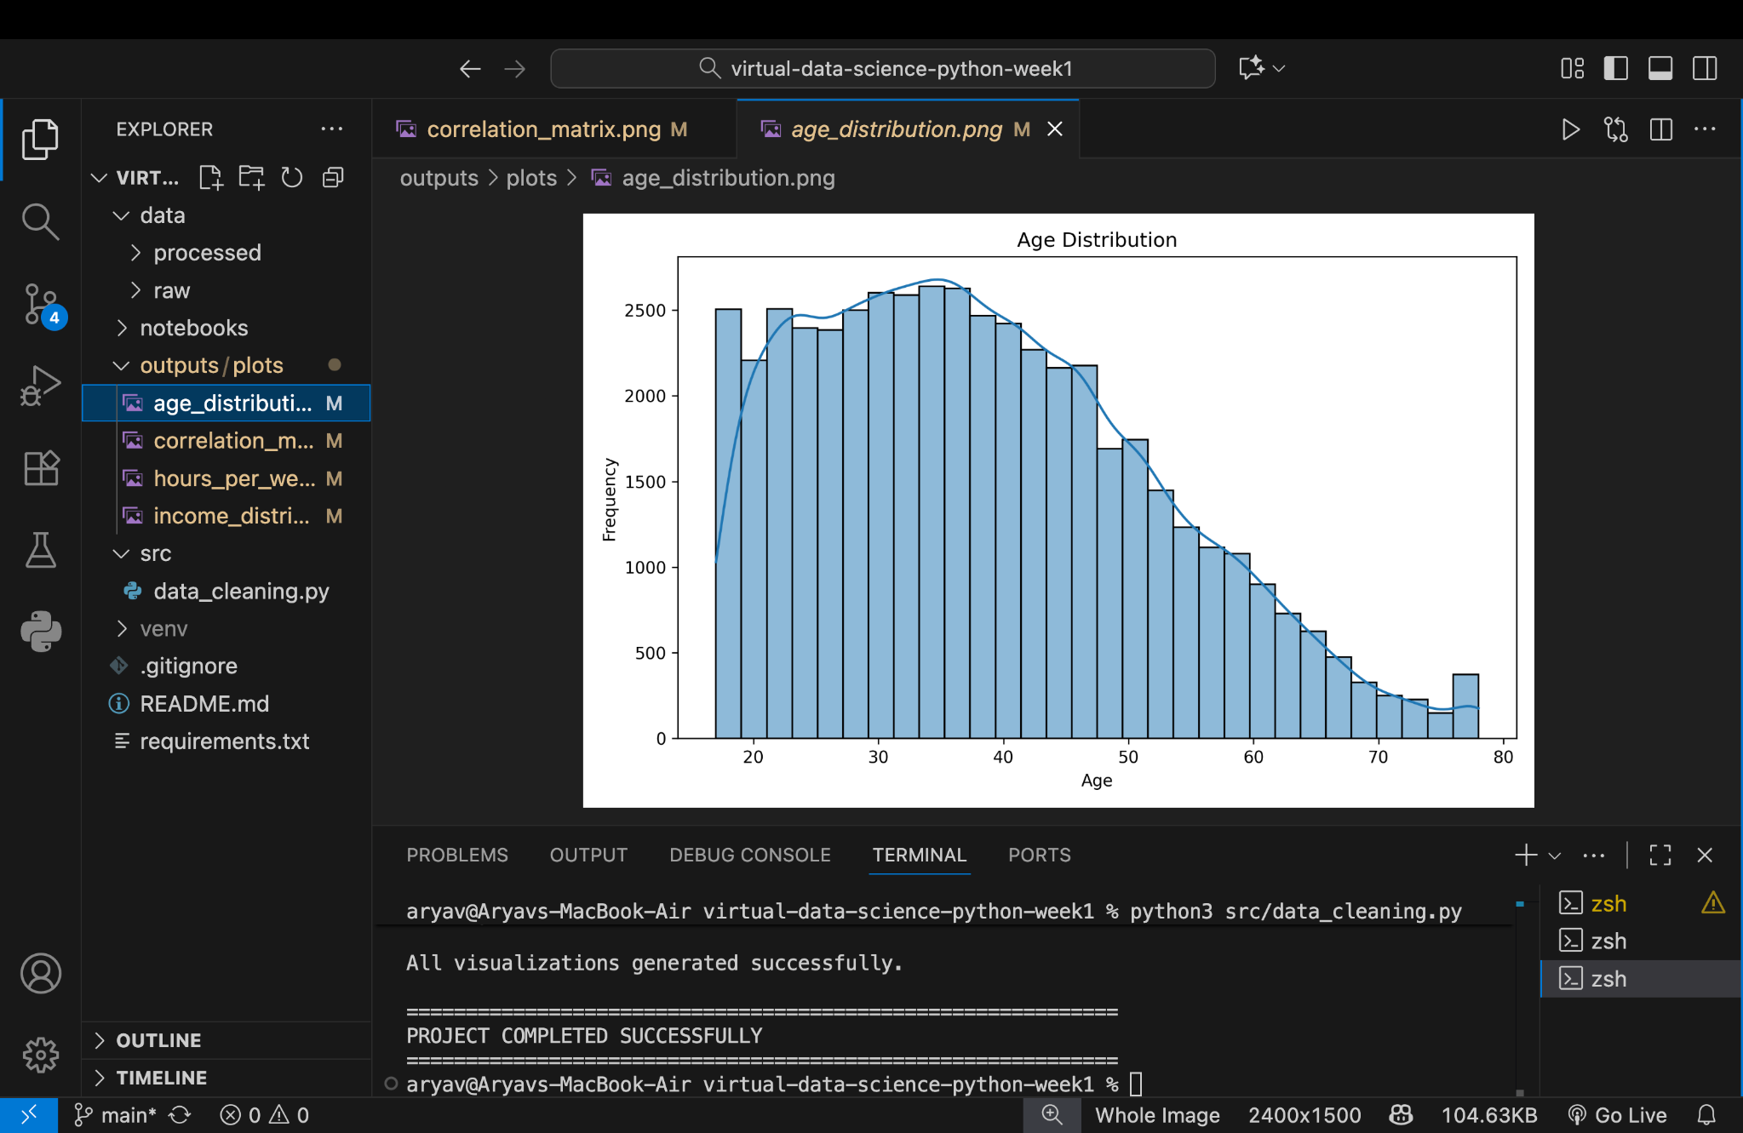
Figure 17. Actual project visualization — Age distribution.
The age distribution is concentrated in young-to-middle adult ranges, with frequencies generally declining toward older ages.

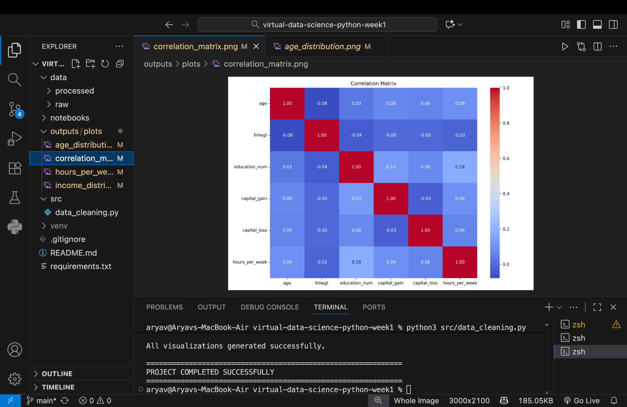
Figure 18. Actual project visualization — Correlation matrix.
The selected numerical variables show generally weak linear relationships. The strongest displayed relationship is education_num with hours_per_week at approximately 0.18.

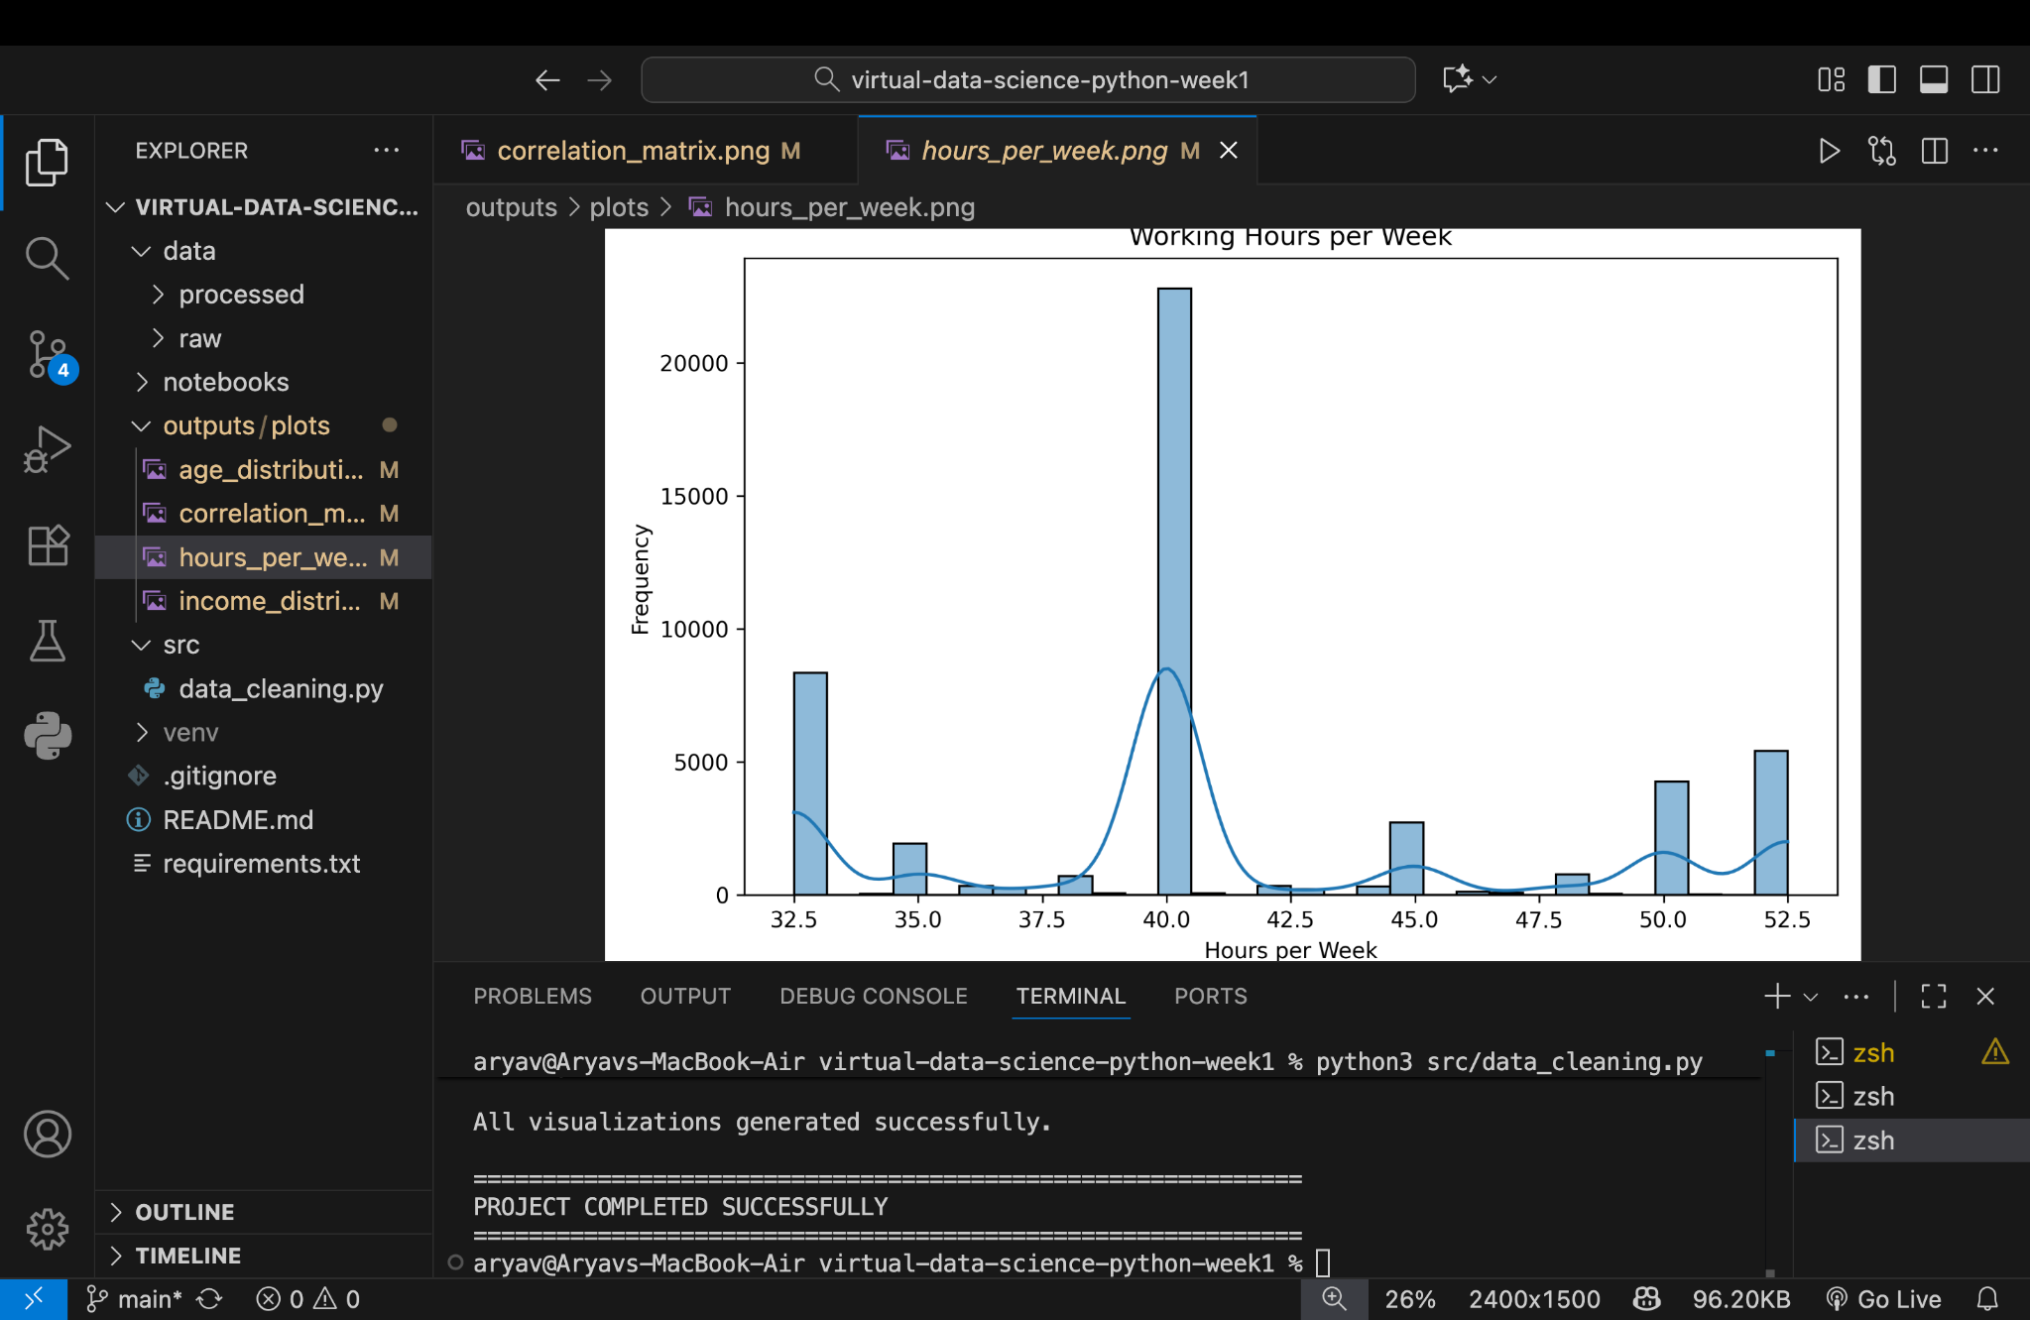
Figure 19. Actual project visualization — Working hours per week.
Working hours are strongly concentrated around 40 hours per week, with additional visible concentrations around approximately 32–33, 50 and 52 hours.

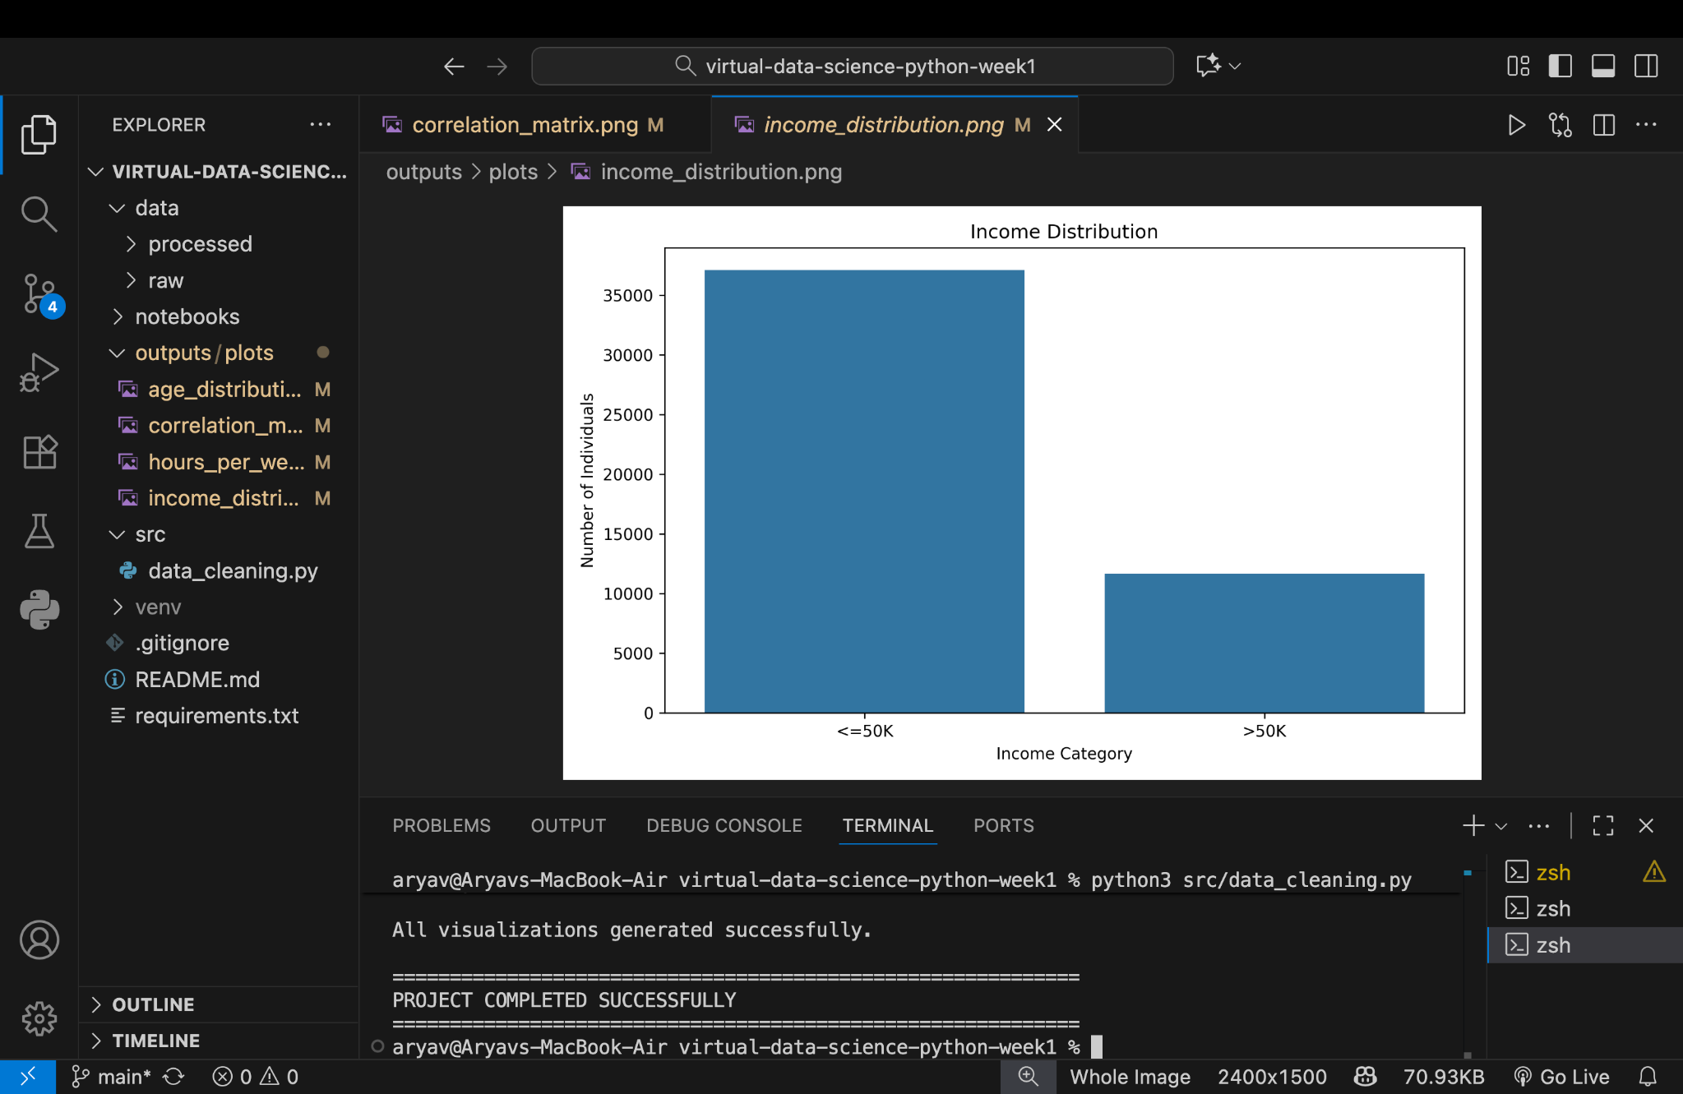
Figure 20. Actual project visualization — Income distribution.
The income distribution is clearly imbalanced toward the <=50K category, which is important for any future classification model.

17. Explanation Below Screenshots and Visualizations
- Data acquisition evidence establishes successful loading of the raw file.
- Initial exploration evidence establishes the dataset dimensions and schema.
- Missing-value evidence identifies the main incomplete categorical fields.
- Duplicate evidence quantifies redundant records and verifies the post-removal size.
- Outlier evidence demonstrates IQR-based statistical detection.
- Final validation confirms the processed CSV, final shape, visualization generation and successful completion.
- The age plot describes the population distribution.
- The working-hours plot highlights concentration around common work schedules.
- The income plot reveals class imbalance.
- The correlation matrix indicates weak pairwise linear relationships among selected numerical variables.

18. Impact of Preprocessing
Preprocessing improves reliability and reproducibility of subsequent analysis. Removing duplicate records avoids repeated observations receiving disproportionate influence. Missing-value profiling prevents silent data loss and highlights variables requiring an explicit strategy. Outlier analysis helps identify extreme observations that may influence descriptive statistics or some models.
The final dataset retains 15 columns and 48,813 records. Remaining categorical missing values and income-class imbalance should be addressed explicitly before predictive modelling. Suitable future steps include categorical encoding, train/test splitting, scaling where appropriate, and evaluation with precision, recall, F1-score and ROC-AUC.

19. Challenges and Solutions
Challenge | Solution / response
Local dataset path and reproducibility | Used data/raw and data/processed directory layout.
Missing categorical values | Profiled counts and percentages and performed final validation.
Duplicate records | Used Pandas duplicated()/drop_duplicates() and verified shape.
Potential numerical outliers | Used IQR-based detection and a documented treatment stage.
Large terminal outputs | Captured evidence screenshots at each major stage.
Traceability | Maintained source code, outputs, README and requirements in Git.
Hidden transformation details | Reported observed results and labeled generic code patterns transparently.

20. Final Processed Dataset
Final processed file:
data/processed/adult_cleaned.csv
Final dataset shape: 48,813 rows × 15 columns. The terminal also confirms successful visualization generation and project completion.

Figure 21. Actual project output — final processed dataset and successful completion.

21. GitHub Repository
The project was maintained under Git version control and pushed to GitHub. Repository identified in the supplied project materials:
https://github.com/aryav191/virtual-data-science-python-week1
The repository contains the project source, data directories, outputs, README and requirements needed to document and reproduce the Week 1 workflow.
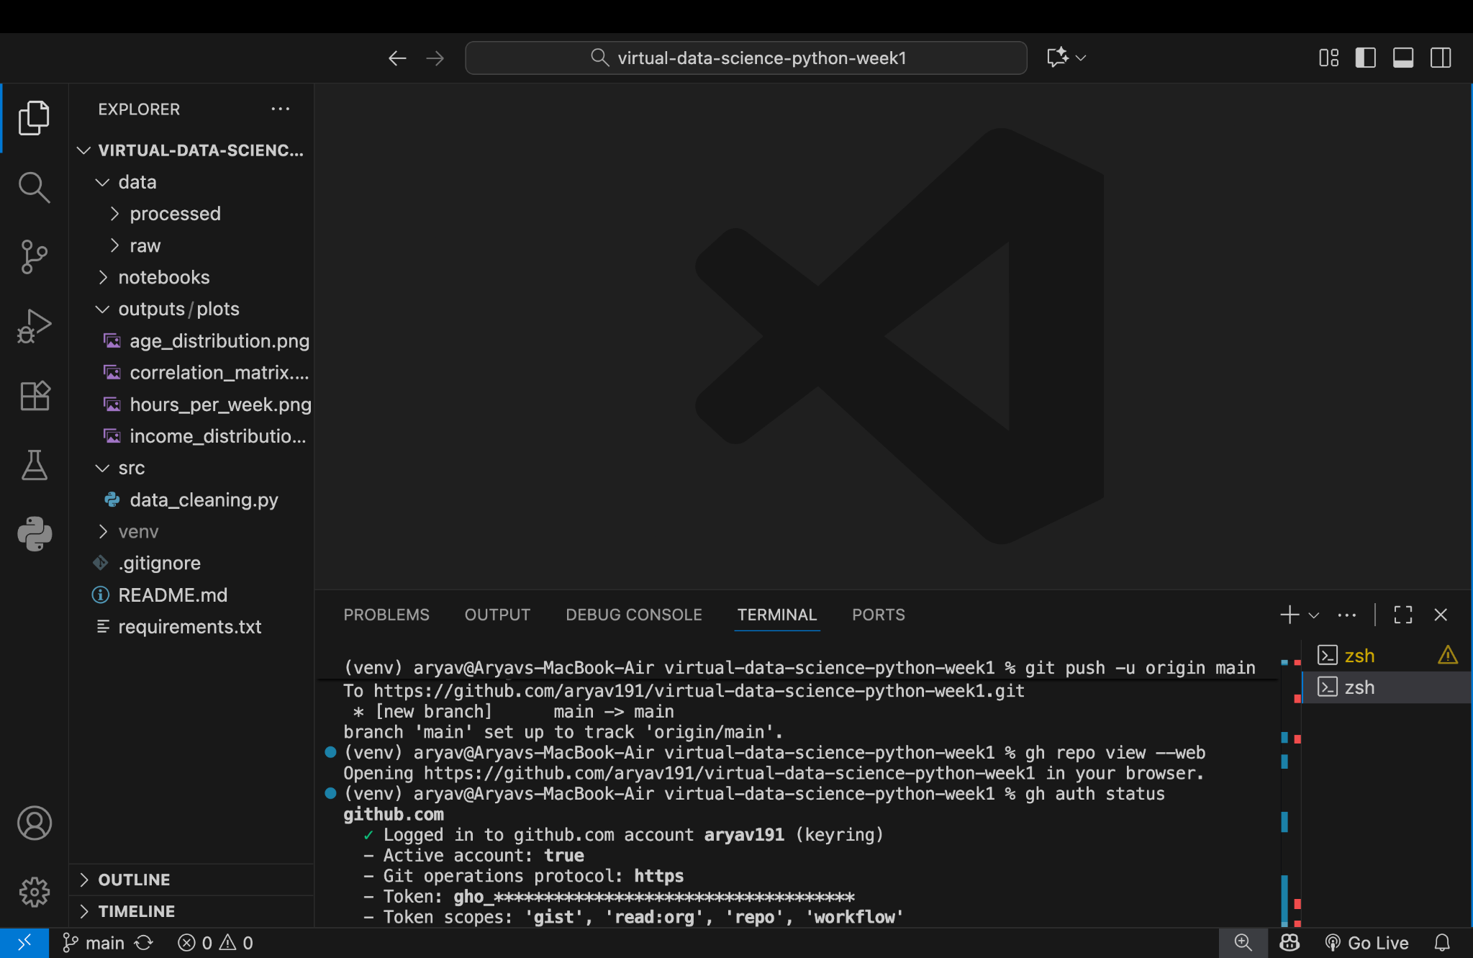
Figure 22. Actual project evidence — Git/GitHub repository and push workflow.

22. Conclusion
The Virtual Data Science with Python Week 1 project successfully established a complete early-stage data-science workflow. The Adult Income dataset was acquired locally, inspected, profiled for missing values, checked for duplicates, evaluated for numerical outliers, processed, visualized and exported.
The project began with 48,842 records and 15 columns. Duplicate analysis identified 29 duplicate rows, and the final processed dataset contains 48,813 rows and 15 columns. Four meaningful visualizations were generated: age distribution, correlation matrix, working-hours distribution and income-category distribution.
The resulting project provides a reproducible foundation for later data analysis and machine-learning work. Before modelling, remaining categorical missing values, class imbalance and appropriate categorical encoding should be addressed according to the selected model.

23. Complete Code Appendix
Important note: the exact source file was not supplied as a directly readable code attachment in this conversation. The appendix therefore provides a consolidated implementation assembled from the documented code snippets, project structure, terminal outputs and visualizations. It is designed to reproduce the documented workflow while clearly distinguishing observed evidence from generic validation patterns.
Consolidated complete pipeline
# Week 1 - Virtual Data Science with Python
# Consolidated data acquisition, cleaning, preprocessing and visualization pipeline
import os
import pandas as pd
import numpy as np
import matplotlib.pyplot as plt
import seaborn as sns
RAW_PATH = "data/raw/adult_raw.csv"
PROCESSED_PATH = "data/processed/adult_cleaned.csv"
PLOT_DIR = "outputs/plots"
os.makedirs(os.path.dirname(PROCESSED_PATH), exist_ok=True)
os.makedirs(PLOT_DIR, exist_ok=True)
# 1. DATA ACQUISITION
df = pd.read_csv(RAW_PATH)
print("=" * 60)
print("DATA ACQUISITION")
print("=" * 60)
print("Dataset successfully loaded from local files.")
print("Dataset shape:", df.shape)
# 2. INITIAL EXPLORATION
print("\n" + "=" * 60)
print("INITIAL DATA EXPLORATION")
print("=" * 60)
print("\nFirst five rows:")
print(df.head())
print("\nDataset shape:")
print(df.shape)
print("\nColumn names:")
print(df.columns.tolist())
print("\nData types:")
print(df.dtypes)
print("\nStatistical summary:")
print(df.describe(include="all").transpose())
# 3. MISSING-VALUE ANALYSIS
missing = df.isnull().sum()
missing_pct = (missing / len(df)) * 100
missing_summary = pd.DataFrame({
"Missing Count": missing,
"Missing Percentage": missing_pct
})
print("\n" + "=" * 60)
print("MISSING-VALUE ANALYSIS")
print("=" * 60)
print(missing_summary[missing_summary["Missing Count"] > 0])
# 4. CATEGORICAL CONSISTENCY CHECK
categorical_cols = df.select_dtypes(include="object").columns
for col in categorical_cols:
df[col] = df[col].astype("string").str.strip()
placeholder_values = ["?", "NA", "N/A", "null", "None", ""]
for col in categorical_cols:
count = df[col].isin(placeholder_values).sum()
print(col, "placeholder count:", count)
df = df.replace("?", np.nan)
# 5. DUPLICATE ANALYSIS
duplicate_count = df.duplicated().sum()
print("\nNumber of duplicate rows:", duplicate_count)
df = df.drop_duplicates()
print("Shape after duplicate removal:", df.shape)
# 6. OUTLIER DETECTION
numeric_cols = df.select_dtypes(include=np.number).columns
for column in numeric_cols:
Q1 = df[column].quantile(0.25)
Q3 = df[column].quantile(0.75)
IQR = Q3 - Q1
lower = Q1 - 1.5 * IQR
upper = Q3 + 1.5 * IQR
outliers = df[(df[column] < lower) | (df[column] > upper)]
print("\n", column)
print("Q1:", Q1)
print("Q3:", Q3)
print("IQR:", IQR)
print("Lower bound:", lower)
print("Upper bound:", upper)
print("Number of outliers:", len(outliers))
# 7. OUTLIER TREATMENT - standard IQR capping pattern
for column in numeric_cols:
Q1 = df[column].quantile(0.25)
Q3 = df[column].quantile(0.75)
IQR = Q3 - Q1
lower = Q1 - 1.5 * IQR
upper = Q3 + 1.5 * IQR
df[column] = df[column].clip(lower=lower, upper=upper)
print("\nOutlier treatment completed.")
# 8. FINAL VALIDATION AND EXPORT
print("\nFinal missing-value check:")
print(df.isnull().sum())
df.to_csv(PROCESSED_PATH, index=False)
print("\nClean dataset saved to:")
print(PROCESSED_PATH)
print("\nFinal dataset shape:")
print(df.shape)
# 9. VISUALIZATIONS
plt.figure(figsize=(8, 5))
sns.histplot(df["age"].dropna(), bins=30, kde=True)
plt.title("Age Distribution")
plt.xlabel("Age")
plt.ylabel("Frequency")
plt.tight_layout()
plt.savefig(os.path.join(PLOT_DIR, "age_distribution.png"))
plt.close()
numeric_for_corr = ["age", "education_num", "capital_gain", "capital_loss", "hours_per_week"]
corr = df[numeric_for_corr].corr()
plt.figure(figsize=(8, 6))
sns.heatmap(corr, annot=True, cmap="coolwarm", fmt=".2f")
plt.title("Correlation Matrix")
plt.tight_layout()
plt.savefig(os.path.join(PLOT_DIR, "correlation_matrix.png"))
plt.close()
plt.figure(figsize=(8, 5))
sns.histplot(df["hours_per_week"].dropna(), bins=30, kde=True)
plt.title("Hours per Week")
plt.xlabel("Hours per Week")
plt.ylabel("Frequency")
plt.tight_layout()
plt.savefig(os.path.join(PLOT_DIR, "hours_per_week.png"))
plt.close()
plt.figure(figsize=(7, 5))
sns.countplot(data=df, x="income")
plt.title("Income Distribution")
plt.xlabel("Income Category")
plt.ylabel("Number of Records")
plt.tight_layout()
plt.savefig(os.path.join(PLOT_DIR, "income_distribution.png"))
plt.close()
print("\nAll visualizations generated successfully.")
print("\n" + "=" * 60)
print("PROJECT COMPLETED SUCCESSFULLY")
print("=" * 60)
The documented snippets are preserved earlier in the report. The consolidated appendix is a transparent reconstruction, not a byte-for-byte claim about an unavailable original source file.

Appendix A — Evidence Summary
Evidence | Observed result
Raw acquisition | 48,842 × 15
Missing values | occupation 2,809; workclass 2,799; native_country 857 initially
Duplicates | 29
Post-duplicate shape | 48,813 × 15
Outliers | IQR-based analysis of numerical variables
Outlier treatment | Completed successfully
Final native_country missing | 856 shown in final check
Final output | data/processed/adult_cleaned.csv
Visualizations | Age, correlation matrix, hours/week, income distribution
Completion | PROJECT COMPLETED SUCCESSFULLY

