1. Project Selection & Team Formation
The project selected for this course is “Smart Queue Management System for Banks.”
The project aims to address common issues such as long waiting times, overcrowding, and inefficient customer flow management in bank branches by introducing a digital queue management solution.
This project was chosen because it solves a real-world problem using software engineering principles and demonstrates practical application of system analysis, requirement specification, and design using UML and CASE tools.

Team Formation and Assigned Roles
To ensure systematic development and effective collaboration, the project team was formed with clearly defined roles and responsibilities as follows:
Team Member | Assigned Role | Responsibilities
Aryavardhan Singh Shekhawat | Project Manager | Project planning, task allocation, progress tracking, coordination among team members
Risha Rasheed P M | Documentation Lead | Preparation of SRS, design documents, reports, and maintaining documentation consistency
Khushi R | Lead Developer 1 | System design logic, module planning, and technical implementation guidance
Kanan | Lead Developer 2 | System design logic, module planning, and technical implementation guidance
Devansh Khare | QA Lead | Requirement verification, review of documents, quality assurance, and validation of system design
These roles ensure clear accountability, efficient workflow, and timely completion of the Smart Queue Management System for Banks project.

2. Team Agreement Creation
A team agreement was created to define working norms, responsibilities, and collaboration rules for the development of the Smart Queue Management System for Banks. This agreement ensures smooth teamwork, accountability, and effective communication throughout the project lifecycle.
Team Working Norms
- All team members will actively participate in project-related activities.
- Tasks will be distributed equally among team members.
- Regular discussions will be conducted to track progress.
- All decisions will be made collectively by the team.
- Any issues or conflicts will be resolved through mutual discussion.
Communication Guidelines
- Team members will communicate through regular meetings and online platforms.
- Important updates and changes will be shared with all members.
- Deadlines will be respected and followed strictly.
Quality and Responsibility Agreement
- Each member is responsible for completing assigned tasks on time.
- Work submitted by any member will be reviewed by at least one other member.
- The team agrees to maintain academic honesty and originality.
This team agreement was accepted by all members to ensure disciplined, collaborative, and efficient project execution.

3. Problem Statement Development - Define project title, problem, solution, target users, and value proposition

Project Title : Smart Queue Management System for Banks

Problem Description:
Banks experience a high volume of customers daily for services such as cash deposits, withdrawals, account inquiries, and form submissions. Most banks still follow traditional queue systems where customers wait in long physical lines or rely on manual token distribution. This leads to overcrowding, increased waiting time, lack of transparency about queue status, and customer frustration. Customers are often unaware of their position in the queue or the expected waiting time. During peak hours, bank staff also find it difficult to manage queues efficiently, resulting in service delays and reduced productivity.

Proposed Solution:

The proposed Smart Queue Management System for Banks is a digital system designed to automate and optimize the queue handling process. The system allows customers to generate virtual tokens, view real-time queue status, and receive notifications when their turn is approaching. Bank tellers can easily call the next customer, while administrators can manage service counters and monitor queue flow through a centralized dashboard. This system minimizes physical crowding, ensures organized service delivery, and improves overall operational efficiency within bank branches.

Target Users:
- Bank Customers: To receive faster service with reduced waiting time and better transparency.
- Bank Tellers/Staff: To manage customer flow efficiently and reduce manual effort.
- Bank Managers/Admin: To monitor queue performance, manage counters, and improve service quality.

Value Proposition:
The Smart Queue Management System adds significant value by reducing customer waiting time, improving service efficiency, and enhancing customer satisfaction in banks. It enables better utilization of staff, provides transparency in queue operations, and supports data-driven decision-making for bank management. By replacing manual queue systems with an automated solution, banks can deliver faster, more organized, and customer-friendly services.

4. Stakeholder Analysis - Identify primary and secondary stakeholders
Stakeholder analysis involves identifying individuals or groups who have an interest in or are affected by the Smart Queue Management System for Banks. These stakeholders are categorized as primary and secondary based on their level of direct involvement with the system.

Primary Stakeholders:
Primary stakeholders are those who directly interact with and are most affected by the system.
- Bank Customers
Customers use the system to generate tokens, track their queue status, and receive notifications. Their main interest is reduced waiting time, transparency, and faster service.
- Bank Tellers / Service Staff
Tellers use the system to call customers, manage counters, and provide services efficiently. The system helps them reduce manual workload and organize customer flow.
- Bank Manager / Administrator
The administrator oversees the entire queue system, manages service counters, monitors performance, and ensures smooth operation within the bank branch.

Secondary Stakeholders:
Secondary stakeholders do not use the system directly on a daily basis but are indirectly affected by its implementation and outcomes.
- Bank Management
Senior management benefits from improved operational efficiency, customer satisfaction, and performance reports generated by the system.
- IT Support / Maintenance Team
The IT team is responsible for system installation, maintenance, troubleshooting, and ensuring system availability and security.
- Regulatory and Compliance Authorities
Although not direct users, regulatory bodies are concerned with orderly operations, customer safety, and compliance with banking standards.

5. Stakeholder Interests Documentation - Document stakeholder interests and influence
Stakeholder interests documentation identifies the expectations, needs, and level of influence of each stakeholder involved in the Smart Queue Management System for Banks. Understanding these interests helps in designing a system that satisfies user requirements and ensures successful project implementation.

Stakeholder Interests and Influence
- Bank Customers:
Interests: Less waiting time, clear queue status, convenience
Influence: Medium – Feedback affects system acceptance
- Bank Tellers / Service Staff:
Interests: Smooth workflow, reduced manual work
Influence: High – Daily users of the system
- Bank Manager / Administrator:
Interests: Efficient queue control, staff optimization
Influence: High – Decision-maker and system approver
- Bank Management:
Interests: Operational efficiency, improved service quality
Influence: High – Provides funding and strategic support
- IT Support Team:
Interests: System security, reliability, easy maintenance
Influence: Medium – Maintains system stability
- Regulatory Authorities:
Interests: Compliance with banking rules, customer safety
Influence: Low to Medium – Indirect regulatory control

6. Stakeholder Register Creation - Create formal stakeholder register
Stakeholder | Role | Interests | Influence Level
Bank Customers | End Users | Reduced waiting time, transparent queue status, faster service | Medium
Bank Tellers / Service Staff | System Users | Organized workflow, reduced manual effort, smooth service delivery | High
Bank Manager / Administrator | System Owner | Queue monitoring, staff optimization, service efficiency | High
Bank Management | Sponsor | Operational efficiency, customer satisfaction, performance insights | High
IT Support Team | Technical Support | System reliability, security, maintenance | Medium
Regulatory Authorities | Oversight Body | Compliance with banking norms, customer safety | Low to  Medium

7. Scope Definition - In-Scope - Document in-scope features
The in-scope features define the functionalities that are included in the Smart Queue Management System for Banks. These features are essential for efficient queue handling and service management within bank branches.

In-Scope Features
- Customer Token Generation: Customers can generate virtual tokens for bank services through the system.
- Real-Time Queue Monitoring: Customers and staff can view the current queue status and token position in real time.
- Service Counter Management: The system allows assignment and management of multiple service counters.
- Calling Next Customer: Bank tellers can call the next token electronically from the system.
- Notification System: Customers receive alerts when their turn is approaching.
- User Authentication: Secure login for bank staff and administrators.
- Admin Dashboard: Bank administrators can monitor queue flow, counters, and performance statistics.
- Basic Reports: Generation of simple reports such as number of customers served and waiting time.

8. Scope Definition - Out-of-Scope - Document out-of-scope features
The out-of-scope features define the functionalities that are not included in the Smart Queue Management System for Banks. These limitations help maintain a clear project boundary and avoid scope creep.

Out-of-Scope Features
- Online Banking Transactions
The system will not handle money transfers, deposits, withdrawals, or payments.
- Loan and Account Processing
Loan approvals, account creation, and KYC verification are not covered.
- ATM and Cash Machine Services
Queue management for ATMs is excluded.
- Appointment Scheduling
Advance appointment booking is not supported.
- Hospital or Non-Banking Services
The system is strictly limited to bank branch queue management.
- Customer Data Analytics Beyond Basic Reports
Advanced analytics and AI-based predictions are not included.
- Third-Party Financial System Integration
Integration with core banking or external financial platforms is excluded.

9. Scope Boundaries Document - Create scope boundaries document
The scope boundaries define the limits of the Smart Queue Management System for Banks by clearly specifying what the system will and will not do. This helps avoid ambiguity and ensures that the project remains focused on its intended objectives.

Included Within Scope:
- Management of customer queues inside bank branches
- Virtual token generation for bank customers
- Real-time display of queue status
- Calling customers through digital tokens
- Service counter allocation and monitoring
- Notifications to customers regarding their turn
- Administrative control and basic reporting

Excluded from Scope:
- Financial transactions such as deposits, withdrawals, or fund transfers
- Loan processing, account creation, and KYC services
- ATM and online banking services
- Advance appointment scheduling
- Integration with core banking systems
- Hospital or non-banking queue management

System Boundaries:
The system operates only within bank premises and focuses solely on queue management. It acts as a support system for customer service flow and does not interfere with banking operations or financial decision-making.

10. SRS Introduction Section - Document purpose, scope, definitions/acronyms

1. Purpose
The purpose of this Software Requirements Specification (SRS) document is to define the functional and non-functional requirements of the Smart Queue Management System for Banks. This document serves as a reference for developers, testers, project managers, and stakeholders to understand system behavior, features, and constraints before development begins.

2 Scope
The Smart Queue Management System for Banks is designed to automate and manage customer queues within bank branches. The system provides virtual token generation, real-time queue tracking, counter management, and notifications to improve service efficiency and reduce customer waiting time. The system does not perform banking transactions and is limited strictly to queue management operations inside bank premises.
Term / Acronym | Description
SRS | Software Requirements Specification
Token | A virtual number assigned to a customer in the queue
Queue | A waiting line of customers for bank services
Admin | Bank manager responsible for system management
Teller | Bank staff providing customer service
UI | User Interface

11. SRS Overall Description - Document product perspective, functions, user characteristics, constraints

1. Product Perspective
The Smart Queue Management System for Banks is a standalone, web-based application designed to manage customer queues within bank branches. It can be accessed through computers or display systems inside the bank. The system operates independently and does not integrate with core banking or financial transaction systems.

2. Product Functions
The major functions of the system include:
- Generation of virtual tokens for customers
- Real-time display of queue status
- Calling and serving customers in sequence
- Service counter allocation and management
- Notification alerts to customers
- Administrative monitoring and basic reporting

3. User Characteristics
- Bank Customers: Basic understanding of digital displays or mobile notifications
- Bank Tellers: Basic computer knowledge and system operation skills
- Bank Manager / Admin: Familiarity with administrative dashboards and reports

4. Constraints
- The system requires a stable internet connection
- Must comply with bank security and privacy policies
- Limited to queue management functions only
- Dependent on hardware such as display screens and terminals

12. Functional Requirements Documentation - Document FR-01 through FR-n with acceptance criteria
The functional requirements describe what the Smart Queue Management System for Banks must do to support efficient queue handling and service management.

FR-01: Customer Token Generation
Description:
The system shall allow bank customers to generate a virtual token for service.
Acceptance Criteria:
- Customer can successfully generate a token
- A unique token number is assigned
- Token is added to the active queue

FR-02: Display Queue Status
Description:
The system shall display the current queue status to customers and staff.
Acceptance Criteria:
- Queue list is visible on display screens
- Token order is accurate and updated in real time

FR-03: Call Next Token
Description:
The system shall allow bank tellers to call the next token in the queue.
Acceptance Criteria:
- Only the next valid token is called
- Token status changes to “In Service”

FR-04: Service Counter Management
Description:
The system shall support multiple service counters within a bank branch.
Acceptance Criteria:
- Counters can be added or removed by admin
- Each called token is linked to a counter

FR-05: Notification to Customers
Description:
The system shall notify customers when their turn is approaching.
Acceptance Criteria:
- Notification is triggered before the turn
- Notification content is clear and accurate

FR-06: User Authentication
Description:
The system shall provide secure login access for tellers and administrators.
Acceptance Criteria:
- Only authorized users can log in
- Invalid login attempts are rejected

FR-07: Admin Dashboard Access
Description:
The system shall provide an admin dashboard for monitoring queue activities.
Acceptance Criteria:
- Admin can view queue statistics
- Admin can manage counters and users

FR-08: Report Generation
Description:
The system shall generate basic operational reports.
Acceptance Criteria:
- Reports include number of customers served
- Reports can be viewed or downloaded

13. Non-Functional Requirements Documentation - Document NFR-01 through NFR-04
Non-functional requirements define the quality attributes and performance standards of the Smart Queue Management System for Banks.

NFR-01: Performance
The system shall respond to user actions such as token generation and queue updates within acceptable time limits.
- Acceptance Criteria:
  - Token generation response time ≤ 2 seconds
  - Queue status updates occur in near real time

NFR-02: Security
The system shall ensure secure access and protect user data.
- Acceptance Criteria:
  - Role-based login for staff and admin
  - Unauthorized access is prevented

NFR-03: Reliability & Availability
The system shall be available during bank working hours with minimal downtime.
- Acceptance Criteria:
  - System availability of at least 99%
  - Automatic recovery from minor failures

NFR-04: Usability
The system shall be easy to use by customers and bank staff.
- Acceptance Criteria:
  - Simple and intuitive user interface
  - Minimal training required for staff

14. Use Case Diagrams Creation - Create use case diagrams for appendices
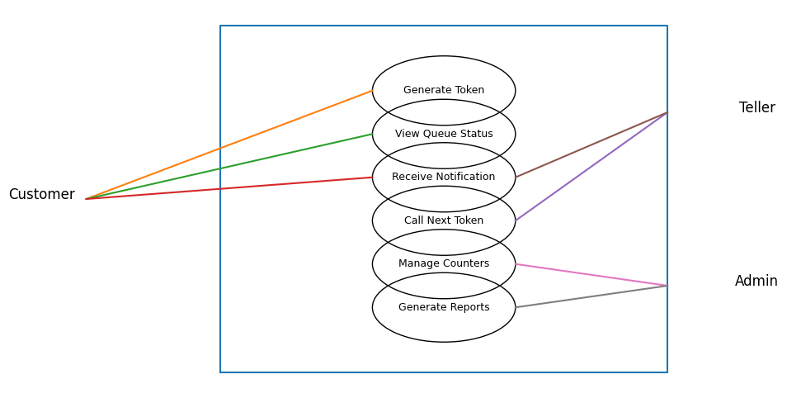
The use case diagram illustrates interactions between Customers, Tellers, and Admin with the Smart Queue Management System for Banks. It defines system boundaries and shows how each actor accesses specific functionalities related to queue management.
15. Glossary Development - Create project glossary
Term | Description
Smart Queue Management System | A digital system used to manage and monitor customer queues in bank branches
Bank Customer | A person visiting the bank to avail services
Token | A virtual queue number assigned to a customer
Queue | A waiting line of customers for bank services
Teller | Bank staff responsible for serving customers
Admin | Bank manager or authorized staff who manages the system
Service Counter | A designated desk where bank services are provided
Queue Status | Current position and progress of the queue
Notification | Alert sent to a customer when their turn approaches
Dashboard | Admin interface used to monitor queue performance
SRS | Software Requirements Specification document
UI (User Interface) | The visual interface through which users interact with the system
Authentication | Process of verifying user identity before system access
Report | Summary of queue statistics such as customers served and waiting time
16. Project Charter – Smart Queue Management System for Banks
Project Title
Smart Queue Management System for Banks

Project Overview
The Smart Queue Management System for Banks is a software-based solution aimed at automating and optimizing customer queue handling inside bank branches. The system replaces traditional physical queues and manual token systems with a digital queue management approach that provides virtual token generation, real-time queue monitoring, and notification alerts. The project focuses on improving customer experience, reducing waiting time, and enhancing operational efficiency for bank staff.

Project Objectives
The primary objectives of this project are:
- To reduce customer waiting time in bank branches
- To eliminate overcrowding caused by physical queues
- To provide transparency in queue status for customers
- To assist bank staff in managing queues efficiently
- To improve service delivery and customer satisfaction
- To develop a reliable and user-friendly queue management system using software engineering principles

Project Scope
The scope of this project includes the design and development of a Smart Queue Management System that supports:
- Virtual token generation for bank customers
- Real-time display of queue status
- Calling customers in an organized sequence
- Management of multiple service counters
- Notification alerts to customers when their turn approaches
- Administrative monitoring and basic reporting
The system is strictly limited to queue management and does not perform any financial or banking transactions.

Stakeholders
The key stakeholders involved in the project include:
- Bank Customers – End users who generate tokens and track queue status
- Bank Tellers / Service Staff – Users who call customers and manage counters
- Bank Manager / Administrator – System owner responsible for monitoring and control
- Bank Management – Sponsors interested in service efficiency and customer satisfaction
- IT Support Team – Responsible for system maintenance and support

Project Deliverables
The major deliverables of the project are:
- Software Requirements Specification (SRS) document
- Use Case Diagrams
- Class Diagram
- Sequence Diagrams
- Activity Diagrams
- Component Diagram
- Deployment Diagram
- System Design Document
- Final Mini Project Report

Assumptions
- Bank branches have basic digital infrastructure such as computers and display screens
- Users have basic knowledge of using digital systems
- Internet connectivity is available during bank working hours
- The system is used only for queue management purposes

Constraints
- The system does not integrate with core banking systems
- Financial transactions are outside the project scope
- The system must comply with basic security and privacy policies
- Project development is limited to the academic timeline

Risks
- Network connectivity issues may affect real-time updates
- Resistance to adoption by staff unfamiliar with digital systems
- Limited scalability due to academic project constraints

Project Timeline (High-Level)
- Requirement Analysis & SRS: Week 1–2
- System Design & Diagrams: Week 3–4
- Documentation & Review: Week 5
- Final Submission: Week 6

17. Stakeholder Register Submission
The stakeholder register is a formal document that identifies all stakeholders involved in the Smart Queue Management System for Banks along with their roles, interests, and influence levels. This register helps in understanding stakeholder expectations and managing their involvement throughout the project lifecycle.
Stakeholder | Role | Interests | Influence Level
Bank Customers | End Users | Reduced waiting time, transparent queue status, faster service | Medium
Bank Tellers / Service Staff | System Users | Organized workflow, reduced manual effort, smooth service delivery | High
Bank Manager / Administrator | System Owner | Queue monitoring, staff optimization, service efficiency | High
Bank Management | Project Sponsor | Operational efficiency, customer satisfaction, performance insights | High
IT Support Team | Technical Support | System reliability, security, maintenance | Medium
Regulatory Authorities | Oversight Body | Compliance with banking norms, customer safety | Low to Medium

The stakeholder register is reviewed and approved to ensure all relevant stakeholders are identified and their expectations are considered during system development.

18. Complete Software Requirements Specification (SRS) Document
The Software Requirements Specification (SRS) document for the Smart Queue Management System for Banks has been prepared by consolidating all previously defined sections, including the problem statement, stakeholder analysis, scope definition, functional requirements, non-functional requirements, use case descriptions, and glossary.
The complete SRS document includes:
- Introduction and purpose of the system
- Overall system description
- Functional requirements (FR-01 to FR-08)
- Non-functional requirements (NFR-01 to NFR-04)
- Scope definition and boundaries
- Use case diagrams
- Glossary of terms
The SRS document follows standard software engineering practices and serves as a baseline reference for system design and development.

19. Requirements Sign-off
The requirements sign-off confirms that all stakeholders have reviewed and approved the requirements specified in the Software Requirements Specification (SRS) document for the Smart Queue Management System for Banks. This approval indicates mutual agreement on system functionality, scope, and constraints.
Any changes to the requirements after this sign-off will follow a formal change management process.
ApprovedBy:
Name:____________________
Role:____________________
Signature:_______________
Date: ____________________

20. CASE Tool Setup
For the design phase of the Smart Queue Management System for Banks, a Computer-Aided Software Engineering (CASE) tool was selected to create and manage system diagrams efficiently.
Selected CASE Tool: StarUML
StarUML was installed and configured on the development system to support UML-based modeling. The tool is used to design various diagrams such as use case diagrams, class diagrams, sequence diagrams, activity diagrams, component diagrams, and deployment diagrams.
The CASE tool enables:
- Standard UML notation
- Clear visualization of system design
- Easy modification and version control of diagrams
- Improved understanding of system architecture
The successful installation and configuration of the CASE tool ensures a structured and systematic approach to system design.

21. Team Workspace Setup
A dedicated workspace was created within the CASE tool environment to support collaborative design and organized project structure for the Smart Queue Management System for Banks.
The workspace setup includes:
- A separate project file created for the system design
- Organized folders for different UML diagrams
- Clear naming conventions for diagrams and components
The workspace is structured to allow easy navigation and future updates to system diagrams. This setup supports team collaboration and ensures consistency across all design artifact

22. Project Structure Creation
The project structure within the CASE tool was designed to logically organize all UML diagrams related to the Smart Queue Management System for Banks.
The following structure was created:
- Use Case Diagrams
  - Customer Use Cases
  - Teller Use Cases
  - Admin Use Cases
- Class Diagrams
  - Core System Classes
  - Supporting Classes
- Sequence Diagrams
  - Token Generation Flow
  - Queue Management Flow
  - Notification Flow
  - Admin Monitoring Flow
- Activity Diagrams
  - Customer Activity Flow
  - Teller Workflow
- Component Diagram
  - System Architecture Components
- Deployment Diagram
  - System Deployment Environment
This structured approach ensures clarity, maintainability, and ease of understanding of the overall system design.

23. Actors Identification
Actors represent external entities that interact with the Smart Queue Management System for Banks. Identifying actors helps in understanding system interactions and defining use cases.
The following actors have been identified:
- Bank Customer
Initiates token generation, views queue status, and receives notifications.
- Bank Teller /Service Staff
Calls the next customer, serves customers, and manages service counters.
- Bank Manager/Administrator
Manages system users, service counters, monitors queue performance, and generates reports.
- Notification System
Sends alerts and notifications to customers when their turn is approaching.
These actors interact with the system to ensure smooth and efficient queue management within bank branches.

24. Use Case Definition
Based on the identified actors, the core use cases of the Smart Queue Management System for Banks are defined as follows:
- Generate Token
- View Queue Status
- Receive Notification
- Call Next Token
- Serve Customer
- Manage Service Counters
- User Authentication
- Monitor Queue Performance
- Generate Reports
These use cases collectively describe the primary functionalities of the system.

25. Use Case Relationships
Use case relationships illustrate how different use cases are connected using include and extend relationships.
- User Authentication is included in:
  - Call Next Token
  - Manage Service Counters
  - Monitor Queue Performance
  - Generate Reports
- Receive Notification extends:
  - Generate Token
- Serve Customer includes:
  - Call Next Token
These relationships help in modularizing system functionality and reducing redundancy.

26. Use Case Documentation
Use Case 1: Generate Token
Actor: Bank Customer
Precondition:Customer is present in the bank branch
Main Flow:
- Customer requests a new token.
- System generates a unique token number.
- Token is added to the active queue.
- Token number is displayed to the customer.
Alternative Flow:
- If the system is unavailable, token generation fails.
Postcondition:
Customer receives a valid token.

Use Case 2: Call Next Token
Actor:Bank Teller
Precondition:Teller is authenticated and queue is not empty
Main Flow:
- Teller selects “Call Next Token.”
- System identifies the next token in the queue.
- Token is assigned to a service counter.
- Token status is updated to “In Service.”
Alternative Flow:
- If the queue is empty, the system displays a message.
Postcondition:
Next customer is called for service.

Use Case 3: Monitor Queue Performance
Actor:Bank Manager/Administrator
Precondition:Admin is authenticated
Main Flow:
- Admin accesses the dashboard.
- System displays real-time queue statistics.
- Admin reviews performance metrics.
Alternative Flow:
- If no data is available, system displays default values.
Postcondition:
Queue performance is monitored successfully.
27. Class Identification
Classes represent the key entities of the Smart Queue Management System for Banks. Based on the system requirements and use cases, the following core classes have been identified:
- Customer
- Token
- Queue
- ServiceCounter
- Teller
- Admin
- Notification
- Report
These classes collectively model the structure and behavior of the system.

28. Class Attributes and Methods Definition

Class Name | Attributes | Methods
Customer | customerId  tokenNumber  notificationStatus | requestToken()  viewQueueStatus  ()receiveNotification()
Token | tokenId  tokenNumber  tokenStatus | generateToken()  updateStatus()
Queue | queueId  tokenList | addToken()  removeToken()  getNextToken()
ServiceCounter | counterId  counterStatus | assignToken()  releaseCounter()
Teller | tellerIdloginStatus | callNextToken()  serveCustomer()
Admin | adminId  accessLevel | manageCounters()  manageUsers()  generateReport()
Notification | notificationId  messageContent | sendNotification()
Report | reportId  reportType  reportData | createReport()  viewReport()

29. Class Relationships
The relationships among classes define how system components interact with each other:
- A Customer is associated with one Token
- A Queue contains multiple Tokens (Aggregation)
- A ServiceCounter is assigned one Token at a time
- A Teller operates one or more ServiceCounters
- An Admin manages ServiceCounters, Tellers, and Reports
- The Notification class communicates with the Customer
- The Report class is generated by the Admin
These relationships are represented in the class diagram using association and aggregation relationships.

30. Sequence Diagrams Creation
Sequence diagrams represent the chronological interaction between actors and system components for specific system operations. In the Smart Queue Management System for Banks, sequence diagrams are used to visualize how customers, bank staff, and the system communicate during queue-related activities.
The following sequence diagrams are created to capture critical system processes:
- Token Generation Process
- Calling and Serving the Next Customer
- Customer Notification Process
- Administrative Queue Monitoring Process
These diagrams help developers and stakeholders clearly understand the internal working of the system and identify responsibilities of each component.

31. Object Interactions Documentation

Sequence Diagram 1: Token Generation Process

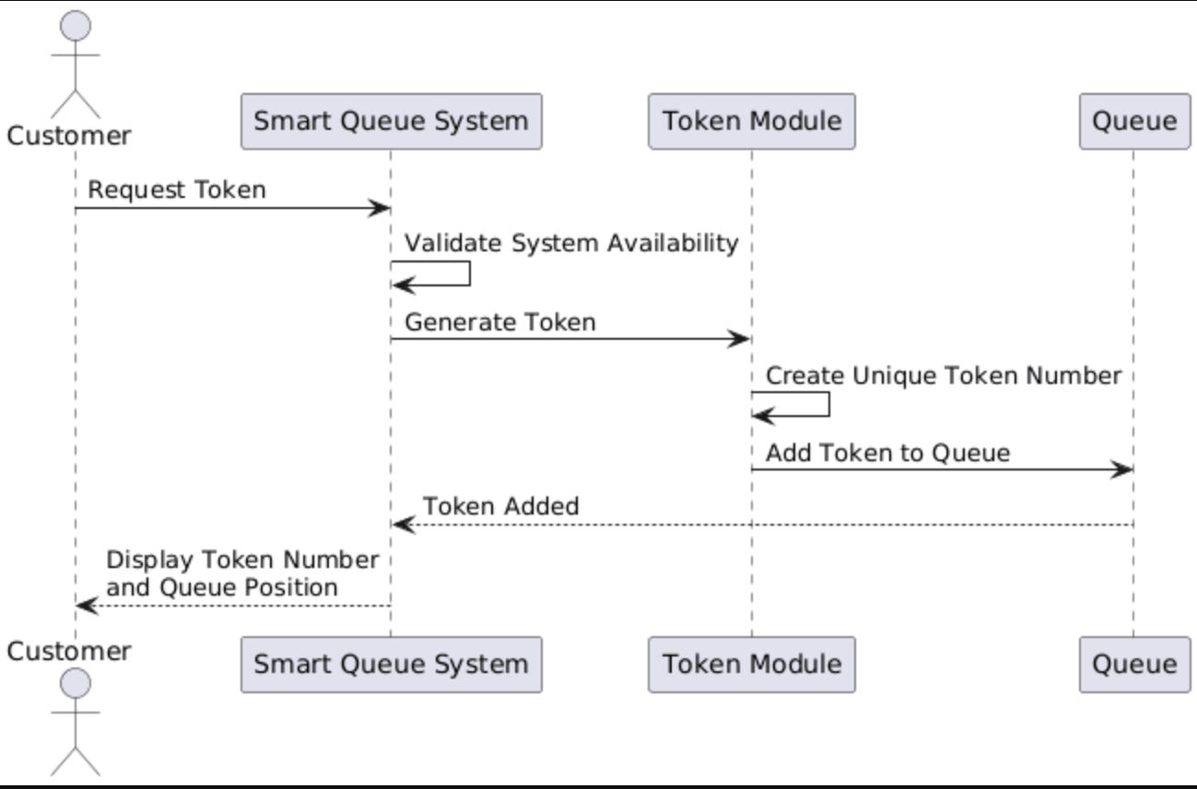

Detailed Interaction Flow:
- The customer arrives at the bank and requests a service token using the system.
- The Smart Queue System receives the request and validates system availability.
- The Token Module generates a unique token number.
- The generated token is added to the active queue.
- The system displays the token number and current queue position to the customer.
This interaction ensures that customers are added to the queue in a structured and transparent manner.

Sequence Diagram 2: Calling and Serving the Next Customer

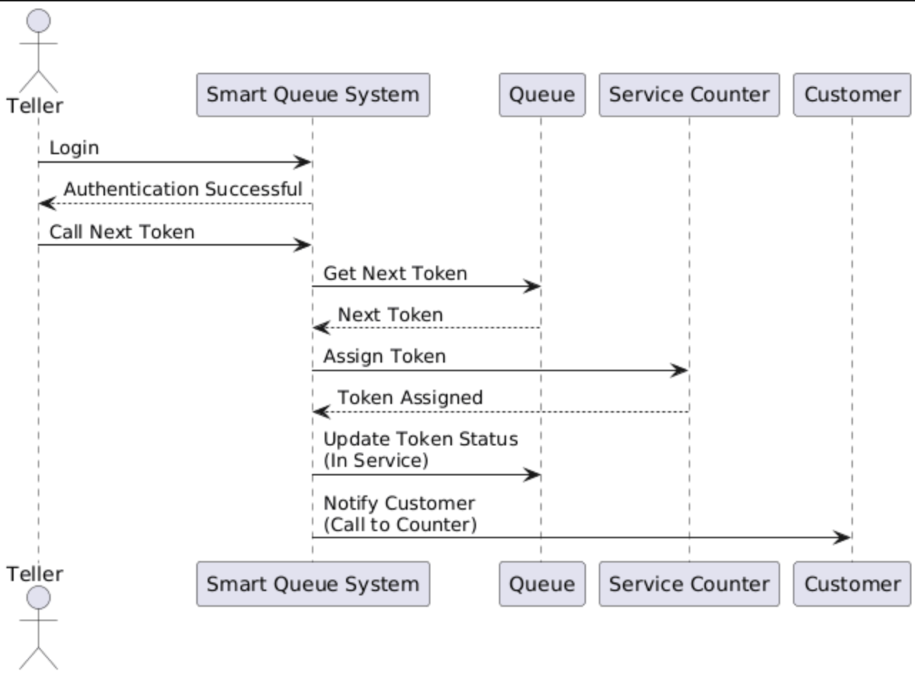

Detailed Interaction Flow:
- The teller logs into the system using secure authentication.
- The teller selects the option to call the next token.
- The system checks the queue and identifies the next available token.
- The token is assigned to an available service counter.
- The system updates the token status to “In Service.”
- The customer is notified and called to the assigned counter.
This sequence ensures fair service order and smooth customer handling by bank staff.

Sequence Diagram 3: Customer Notification Process

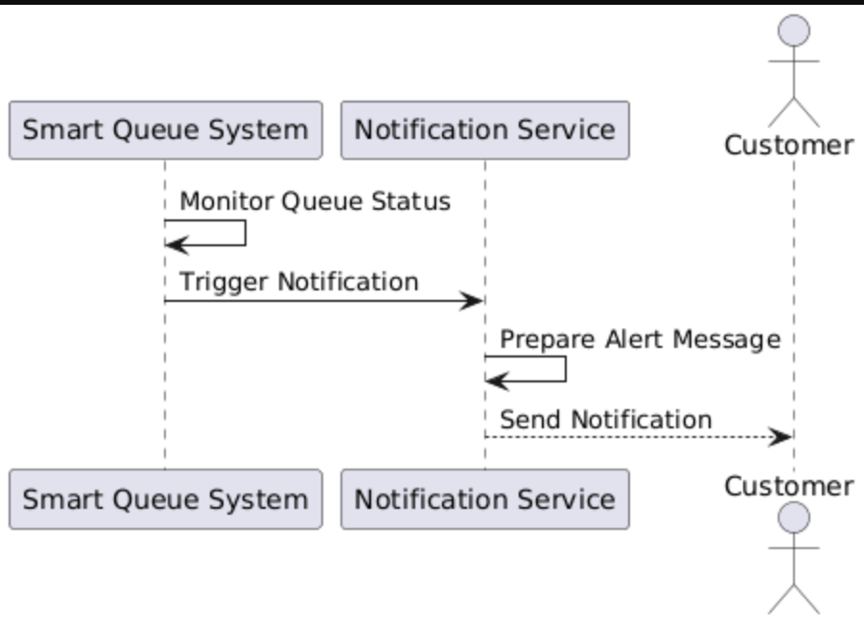
Detailed Interaction Flow:
- The system continuously monitors the queue status.
- When a customer’s turn is approaching, the system triggers a notification event.
- The Notification Service prepares and sends an alert message.
- The customer receives a notification informing them to be ready for service.
This process reduces unnecessary waiting and physical crowding in bank branches.

Sequence Diagram 4: Administrative Queue Monitoring Process

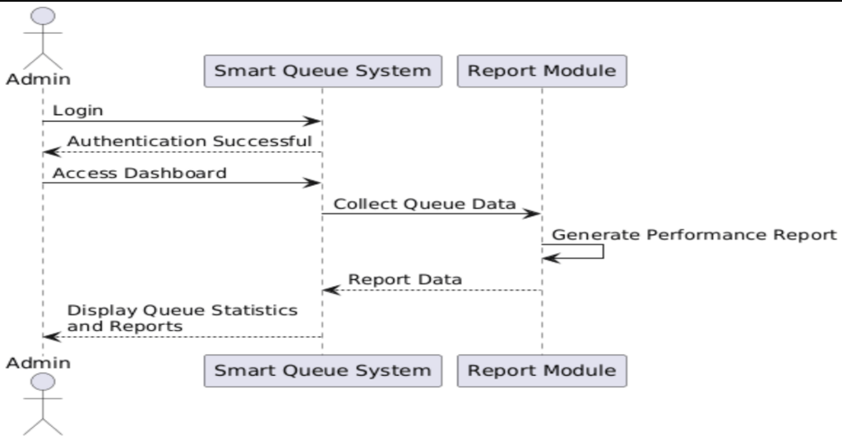
Detailed Interaction Flow:
- The admin logs into the system with administrative privileges.
- The admin accesses the monitoring dashboard.
- The system collects real-time queue data and service statistics.
- The Report Module generates performance reports.
- The admin reviews queue performance to identify delays or bottlenecks.
This sequence supports data-driven management decisions.

32. Alternative Flows Inclusion
Alternative flows represent exceptional conditions that may occur during normal system operation and show how the system handles them gracefully.
Alternative Flow 1: Empty Queue Scenario
- If the teller attempts to call the next token when the queue is empty, the system displays a message indicating that no customers are currently waiting.
Alternative Flow 2: System Downtime
- If the system is temporarily unavailable, token requests are not processed and a notification is shown to the user.
Alternative Flow 3: Notification Delivery Failure
- If a customer notification cannot be delivered due to technical issues, the system logs the failure and retries sending the notification.
Including these alternative flows improves system robustness and reliability.

33. Activity Diagrams Creation
Activity diagrams represent the workflow of actions performed by different actors in the system. For the Smart Queue Management System for Banks, activity diagrams are used to describe how customers and bank staff interact with the system during queue management.
Two activity diagrams are created:
- Customer Activity Flow
- Teller (Service Staff) Workflow

Activity Diagram 1: Customer Activity Flow
This diagram shows the steps a customer follows from entering the bank to receiving service.
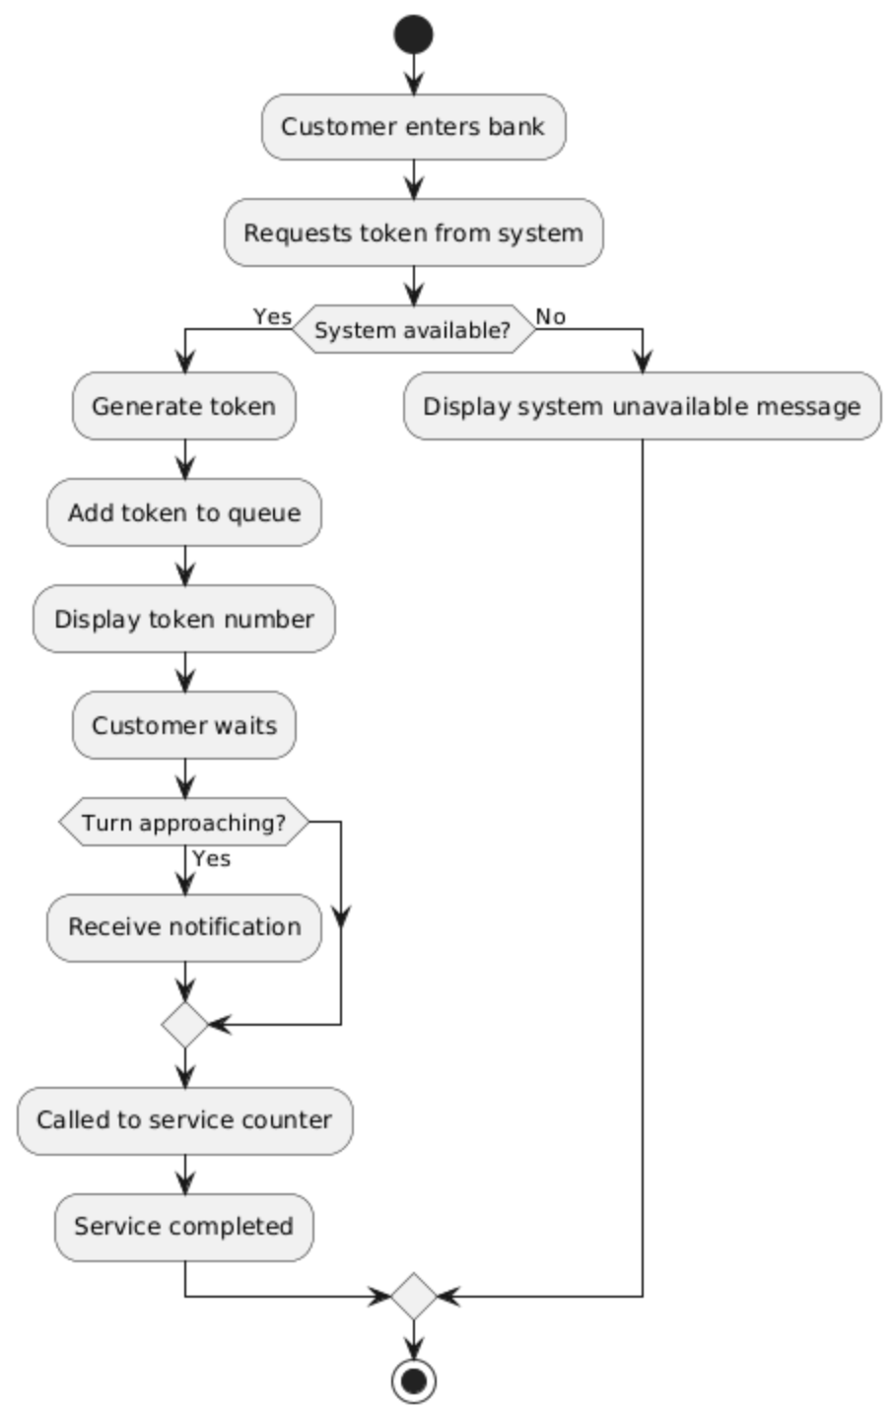

Activity Diagram 2: Teller Workflow
This diagram explains how a teller handles customers using the queue system.
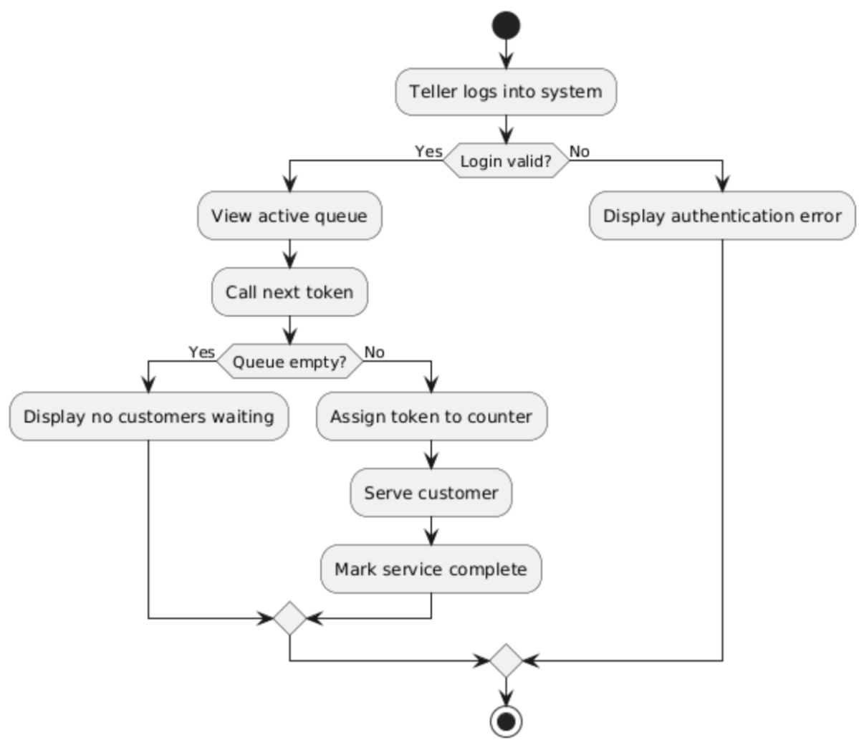

34. Workflow Documentation
Workflow documentation explains complex system processes using clear steps, decision points, and parallel activities. It helps in understanding how different components of the Smart Queue Management System for Banks work together in real-world scenarios.
Workflow 1: End-to-End Customer Service Workflow
- Customer enters the bank branch.
- Customer requests a virtual token using the queue system.
- System validates availability and generates a token.
- Token is placed in the active queue.
- Customer waits while monitoring queue status.
- System sends notification when the turn is near.
- Teller calls the token and assigns a service counter.
- Customer approaches the counter.
- Service is provided and completed.
- Token is removed from the queue.
This workflow ensures fair, transparent, and efficient service delivery.
Workflow 2: Teller Queue Handling Workflow
- Teller logs into the system securely.
- Teller views the current queue status.
- Teller calls the next available token.
- System checks for queue availability.
- Token is assigned to a service counter.
- Teller serves the customer.
- Service completion is updated in the system.
- Queue moves to the next token automatically.
This workflow improves teller productivity and reduces manual queue handling.

35. Component Diagram Creation
The component diagram represents the high-level software architecture of the Smart Queue Management System for Banks. It shows how different system components interact with each other to deliver queue management functionality.
Identified Components
- User Interface (Customer Display & Staff Dashboard)
- Queue Management Module
- Token Management Module
- Notification Service
- Reporting Module
- Authentication Module
- Database
These components work together to ensure smooth queue handling, secure access, and efficient service delivery.
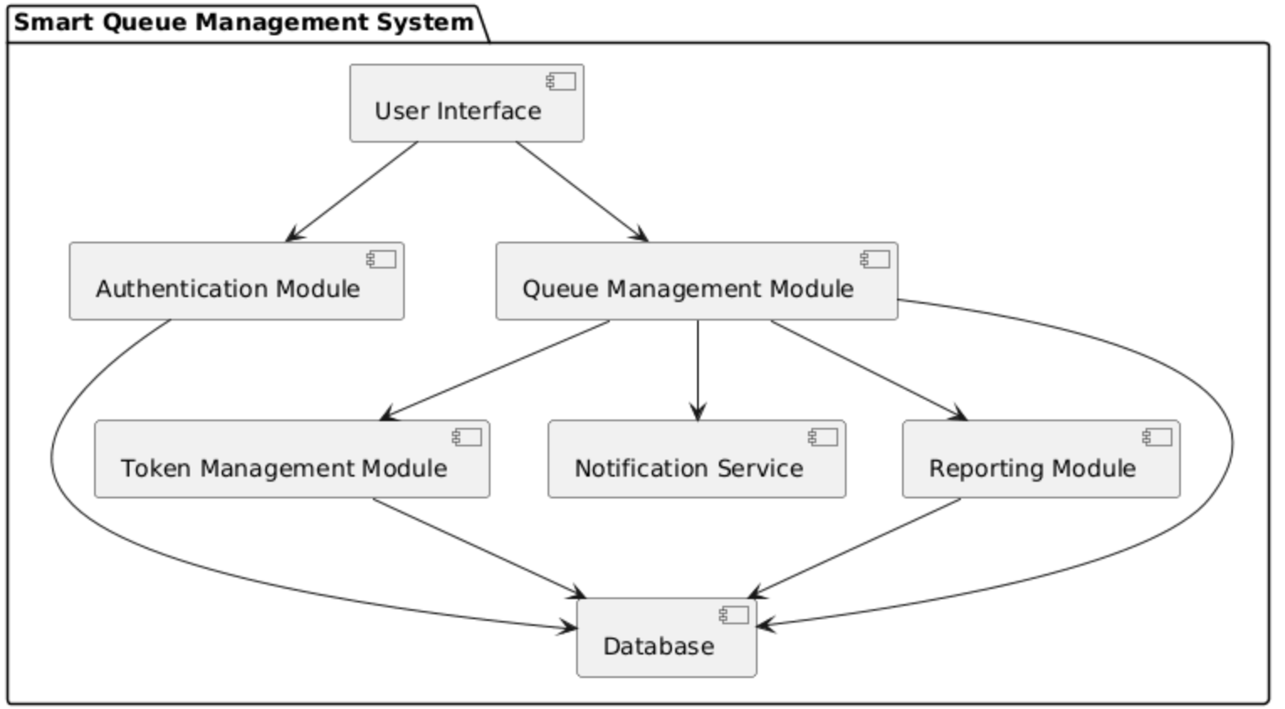
This diagram highlights the modular structure of the system and supports maintainability and scalability.

36. Deployment Diagram Creation
The deployment diagram illustrates the physical environment in which the Smart Queue Management System for Banks is deployed. It shows the hardware nodes and their connections.
Deployment Environment
- Customer Display / Client Device
- Bank Staff System
- Application Server
- Database Server
- Network (Internet / LAN)
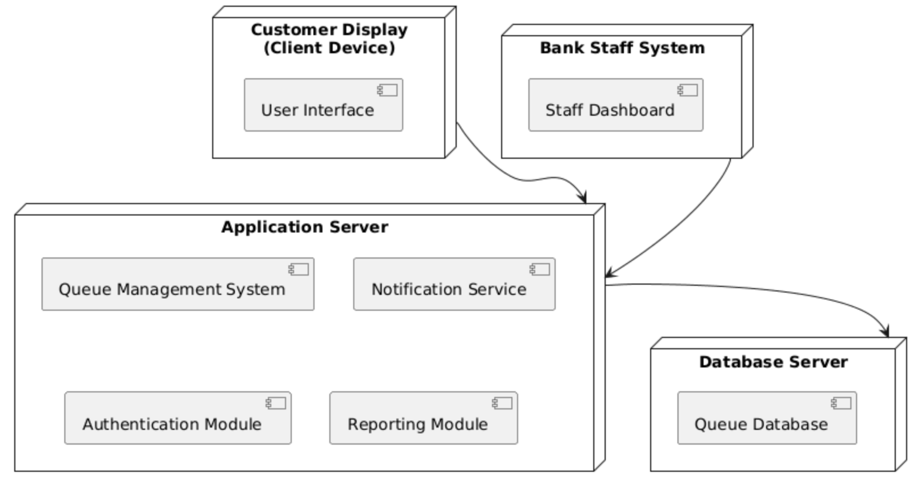
This deployment ensures secure communication between users, system services, and the database.

37. Design Document Creation
The design document explains the architectural and design decisions made during the development of the Smart Queue Management System for Banks. The system is designed using a modular and layered approach to improve maintainability, clarity, and scalability.
Design Decisions
- A modular architecture is used to separate queue management, token handling, notification, and reporting.
- UML diagrams are used to visually represent system structure and behavior.
- Security is handled through role-based authentication for staff and administrators.
- The database is centralized to maintain data consistency and integrity.
Assumptions
- The system is deployed within bank premises.
- Users have basic digital literacy.
- Internet or local network connectivity is available during working hours.
Limitations
- The system does not support financial transactions.
- Advanced analytics and AI-based predictions are not included.
- Integration with core banking systems is not supported.
Scalability Considerations
- The system can be extended to support multiple bank branches.
- Additional service counters can be added easily.
- Notification methods can be expanded (SMS, email, display alerts).
This design ensures that the Smart Queue Management System for Banks meets functional requirements while remaining simple, reliable, and suitable for academic implementation.

