LEGAL METROLOGY (PACKAGED COMMODITIES) RULES, 2011
STATUTORY INSPECTION & COMPLIANCE ASSESSMENT DOSSIER
Authoritative Regulatory Record — Generated strictly from Immutable FinalAuditRecord
Inspection ID: | INS-JUICE-4A9C1B37 | Final Record ID: | FAR-E45992B43D35
Docket / Case No: | INSP-2026-DEL-LM-9317 | Report Generated: | 2026-09-20 08:58:59 UTC
Rule-Set Version: | LMPC-2011-MVP-RULES (v1.0) | Evidence Assets: | 4 Files (SHA-256)
OCR Engine: | PaddleOCR PP-OCRv4 (rapidocr-onnxruntime==1.2.3) | AI Model: | Google Gemini 3.6 Flash (gemini-3.6-flash)
Finalization Status: | FINALIZED | Record Status: | READ-ONLY
1. INSPECTION DETAILS
Inspection ID: | INS-JUICE-4A9C1B37 | Inspection Date: | 2026-09-20
Inspection Type: | Statutory Legal Metrology Field Inspection | Inspection Facility: | Departmental Inspection Facility / Retail Premises
Inspecting Officer: | USR-INSP-52116D | Reviewing Officer: | USR-REV-E2404C
2. PRODUCT / COMMODITY PARTICULARS
Product Name: | Real Fruit Power Mixed Fruit Juice (1L Tetra Pak) | Brand Name: | Dabur India Limited
Product Category: | Beverages / Packaged Fruit Juice | Variant / Flavour: | Mixed Fruit
Declared Net Quantity: | Not Specified | Batch / Lot No: | Not Declared on Inspected Panels
Manufacturer: | Dabur India Limited | Packer / Importer: | Dabur India Limited
Country of Origin: | India | Origin Classification: | DOMESTIC
3. EVIDENCE REGISTER & CRYPTOGRAPHIC INTEGRITY HASHES
Sl. | Evidence ID | Filename / View | Size | SHA-256 Hash (Change Detection) | Status
1 | EV-4E9094FF | IMG_20260920_040854.jpg (PRIMARY) | 1276 KB | 7987f3a2fcc2601d82ebb79504ecbaee6f3c5964a31f63607728396fcda45a73 | ACCEPTED / IMMUTABLE
2 | EV-57C9A118 | IMG_20260920_040900.jpg (PRIMARY) | 1172 KB | d0891ea5c2d12522deb98ca8e259583fa259ad6306359dfab0a5eb274777ad00 | ACCEPTED / IMMUTABLE
3 | EV-20D3FF19 | IMG_20260920_040906.jpg (PRIMARY) | 1270 KB | 95db45287da0969ecefff09dec87af5052488507b0395d1d08b4ddcd410730b8 | ACCEPTED / IMMUTABLE
4 | EV-206E4375 | IMG_20260920_040922.jpg (PRIMARY) | 1232 KB | 919b9530ea24a31f172b73fea330754e15c5349d0cdc4aca22f64d7812a3226c | ACCEPTED / IMMUTABLE
4. DECLARATION EXTRACTION & MULTI-IMAGE SYNTHESIS
Sl. | Statutory Requirement | Synthesized Value | Status | Source Evidence | Synthesis Basis / Notes
1 | Rule 6(1)(a) — Manufacturer / Packer / Importer | status: OBSERVED, declaration_type: MANUFACTURER, name: Dabur India Limited, address: 8/3, Asaf Ali Road, New Delhi 110002 | OBSERVED | EV-20D3FF19 | Single evidence observation verified.
2 | Rule 6(1)(b) — Generic / Common Commodity Name | Not Observed | CONFLICTING | EV-4E9094FF | Conflicting declarations observed between evidence ['EV-4E9094FF'] and ['EV-57C9A118'].
3 | Rule 6(1)(c) — Net Quantity & Standard Units | status: OBSERVED, quantity_value: 1000.0, unit: ml | OBSERVED | EV-4E9094FF | Single evidence observation verified.
4 | Rule 6(1)(d) — Date of Manufacture / Packing | status: OBSERVED, date_type: MANUFACTURE, month: 7, year: 2026, raw_date_string: 07/2026 | OBSERVED | EV-206E4375 | Single evidence observation verified.
5 | Rule 6(1)(e) — Maximum Retail Price (Incl. of all taxes) | status: OBSERVED, currency: INR, amount: 146.0, includes_all_taxes_stated: True | OBSERVED | EV-206E4375 | Single evidence observation verified.
6 | Rule 6(1)(f) — Consumer Care Grievance Redressal | status: OBSERVED, contact_name: Consumer Cell, phone: 1800-103-1644, email: daburcares@feedback.dabur, address: Kaushambi, Sahibabad, Ghaziabad 201010 | OBSERVED | EV-20D3FF19 | Single evidence observation verified.
7 | Rule 6(1)(da) — Country of Origin (Imported Goods) | status: OBSERVED, country_name: India | OBSERVED | EV-4E9094FF, EV-57C9A118, EV-20D3FF19, EV-206E4375 | Corroborated across 4 evidence assets.
5. APPLICABILITY & STATUTORY RULE-WISE EVALUATION
Sl. | Requirement & Citation | Applicability | System Result | Reviewer Action | Adjudicated Result
1 | commodity_name (Rule 6(1)(b)) | APPLICABLE | REQUIRES_REVIEW | OVERRIDE | PASS
2 | consumer_care (Rule 6(1)(f)) | APPLICABLE | PASS | CONFIRMED | PASS
3 | country_of_origin (Rule 6(1)(da)) | NOT_APPLICABLE | NOT_APPLICABLE | CONFIRMED | PASS
4 | manufacture_packing_date (Rule 6(1)(d)) | APPLICABLE | PASS | CONFIRMED | PASS
5 | manufacturer_identity (Rule 6(1)(a)) | APPLICABLE | PASS | CONFIRMED | PASS
6 | mrp (Rule 6(1)(e)) | APPLICABLE | PASS | CONFIRMED | PASS
7 | net_quantity (Rule 6(1)(c)) | APPLICABLE | PASS | CONFIRMED | PASS
6. OBSERVATIONS / POTENTIAL NON-COMPLIANCE REGISTER
No statutory non-compliances or unresolved conflicts observed across inspected panels.
7. EVIDENCE & VISUAL CORROBORATION (PANEL REGISTRY)
Evidence ID | Filename / Panel View | Observed Declarations on Panel | Tokens Detected
EV-4E9094FF | IMG_20260920_040854.jpg (Package Panel View (PRIMARY)) | Rule 6(1)(b), Rule 6(1)(c), Rule 6(1)(da) | 34 OCR bounding boxes
EV-57C9A118 | IMG_20260920_040900.jpg (Package Panel View (PRIMARY)) | Rule 6(1)(da) | 6 OCR bounding boxes
EV-20D3FF19 | IMG_20260920_040906.jpg (Package Panel View (PRIMARY)) | Rule 6(1)(a), Rule 6(1)(f), Rule 6(1)(da) | 70 OCR bounding boxes
EV-206E4375 | IMG_20260920_040922.jpg (Package Panel View (PRIMARY)) | Rule 6(1)(d), Rule 6(1)(e), Rule 6(1)(da) | 7 OCR bounding boxes
8. INSPECTING OFFICER'S VERIFICATION & REMARKS
Sl. | Requirement | System Observation | Inspector Observation / Remarks | Status
1 | commodity_name | REQUIRES_REVIEW | PASS (Physical package panel matches automated perception tokens.) | CONFIRMED
2 | consumer_care | PASS | PASS (Physical package panel matches automated perception tokens.) | CONFIRMED
3 | country_of_origin | NOT_APPLICABLE | PASS (Physical package panel matches automated perception tokens.) | CONFIRMED
4 | manufacture_packing_date | PASS | PASS (Physical package panel matches automated perception tokens.) | CONFIRMED
5 | manufacturer_identity | PASS | PASS (Physical package panel matches automated perception tokens.) | CONFIRMED
6 | mrp | PASS | PASS (Physical package panel matches automated perception tokens.) | CONFIRMED
7 | net_quantity | PASS | PASS (Physical package panel matches automated perception tokens.) | CONFIRMED
9. REVIEWING OFFICER'S ADJUDICATION & LEGAL DETERMINATION
FINAL MASTER ADJUDICATION: COMPLIANT
Reviewing Officer: USR-REV-E2404C | Finalized Timestamp: 2026-09-20 08:58:53 UTC
Statutory Adjudication Rationale: All 7 statutory declarations required under Rule 6(1) of the Legal Metrology (Packaged Commodities) Rules, 2011 have been verified, corroborated across 4 multi-angle evidence assets, and adjudicated. Reconciled commodity designation: 'Real Fruit Power Mixed Fruit Juice' on PDP and 'Mixed Fruit Beverage' on side panel both describe the food category per Rule 6(1)(b). Final determination: COMPLIANT.
10. FINAL COMPLIANCE SUMMARY & METRICS
Requirements Assessed: | 7 | Pass Count: | 7
Applicable Rules: | 6 | Potential Non-Compliance: | 0
Exempt / Not Applicable: | 1 | Requires Review: | 0
Evidence Assets Preserved: | 4 Files | Final Officer Decision: | COMPLIANT
11. EVIDENCE INTEGRITY & ANTI-TAMPERING CONTROLS
A SHA-256 cryptographic fingerprint has been recorded for each accepted evidence asset at the time of ingestion. The fingerprint is used to detect subsequent changes to the stored evidence bytes. The hash establishes evidence-byte integrity and change detection and does not independently establish the authenticity or origin of the physical package commodity.
Evidence Asset ID | Preserved Filename | SHA-256 Fingerprint | Custody State
EV-4E9094FF | IMG_20260920_040854.jpg | 7987f3a2fcc2601d82ebb79504ecbaee6f3c5964a31f63607728396fcda45a73 | PRESERVED_IMMUTABLE
EV-57C9A118 | IMG_20260920_040900.jpg | d0891ea5c2d12522deb98ca8e259583fa259ad6306359dfab0a5eb274777ad00 | PRESERVED_IMMUTABLE
EV-20D3FF19 | IMG_20260920_040906.jpg | 95db45287da0969ecefff09dec87af5052488507b0395d1d08b4ddcd410730b8 | PRESERVED_IMMUTABLE
EV-206E4375 | IMG_20260920_040922.jpg | 919b9530ea24a31f172b73fea330754e15c5349d0cdc4aca22f64d7812a3226c | PRESERVED_IMMUTABLE
12. COMPLETE CHRONOLOGICAL AUDIT TRAIL
Sl. | Timestamp (UTC) | Actor (Role) | Event Type | Event Specifics & Metadata
1 | 2026-09-20T08:57:17 | USR-INSP-52116D (None) | APPLICABILITY_EVALUATED | rule_set_id: LMPC-2011-MVP-RULES, rule_set_version: v1.0, evaluation_version: v1.0, total_requirements: 7, applicable_count: 6, not_applicable_count: 1, requires_review_count: 0
2 | 2026-09-20T08:57:56 | USR-INSP-52116D (None) | COMPLIANCE_EVALUATED | rule_set_id: LMPC-2011-MVP-RULES, rule_set_version: v1.0, evaluation_version: v1.0, total_findings: 7
3 | 2026-09-20T08:58:01 | USR-INSP-52116D (None) | INSPECTION_SUBMITTED_FOR_REVIEW | inspector_name: Rajesh Kumar (Senior Metrology Inspector), findings_count: 7, action: SUBMITTED_TO_REVIEWER
4 | 2026-09-20T08:58:10 | USR-REV-E2404C (REVIEWER) | REVIEWER_DECISION_RECORDED | decision_id: REV-DAAC45DF7E3B, requirement_name: manufacturer_identity, determination: CONFIRMED, original_result: PASS, adjudicated_result: PASS, is_override: False, rationale: Statutory declaration for manufacturer_identity verified and corroborated across evidence assets under Rule 6(1)(a).
5 | 2026-09-20T08:58:29 | USR-REV-E2404C (REVIEWER) | REVIEWER_OVERRIDE_RECORDED | decision_id: REV-99803041AF56, requirement_name: commodity_name, determination: OVERRIDDEN, original_result: REQUIRES_REVIEW, adjudicated_result: PASS, is_override: True, rationale: Reconciled generic commodity name: 'Real Fruit Power Mixed Fruit Juice' on principal display panel and 'Mixed Fruit Beverage' on side panel both describe the category under Rule 6(1)(b) and FSSAI standards. Adjudicated as PASS.
6 | 2026-09-20T08:58:32 | USR-REV-E2404C (REVIEWER) | REVIEWER_DECISION_RECORDED | decision_id: REV-BCAF76887A8C, requirement_name: net_quantity, determination: CONFIRMED, original_result: PASS, adjudicated_result: PASS, is_override: False, rationale: Statutory declaration for net_quantity verified and corroborated across evidence assets under Rule 6(1)(c).
7 | 2026-09-20T08:58:35 | USR-REV-E2404C (REVIEWER) | REVIEWER_DECISION_RECORDED | decision_id: REV-23184DE195BC, requirement_name: manufacture_packing_date, determination: CONFIRMED, original_result: PASS, adjudicated_result: PASS, is_override: False, rationale: Statutory declaration for manufacture_packing_date verified and corroborated across evidence assets under Rule 6(1)(d).
8 | 2026-09-20T08:58:38 | USR-REV-E2404C (REVIEWER) | REVIEWER_DECISION_RECORDED | decision_id: REV-EE165B48B04A, requirement_name: mrp, determination: CONFIRMED, original_result: PASS, adjudicated_result: PASS, is_override: False, rationale: Statutory declaration for mrp verified and corroborated across evidence assets under Rule 6(1)(e).
9 | 2026-09-20T08:58:41 | USR-REV-E2404C (REVIEWER) | REVIEWER_DECISION_RECORDED | decision_id: REV-475A180F2C4D, requirement_name: consumer_care, determination: CONFIRMED, original_result: PASS, adjudicated_result: PASS, is_override: False, rationale: Statutory declaration for consumer_care verified and corroborated across evidence assets under Rule 6(1)(f).
10 | 2026-09-20T08:58:45 | USR-REV-E2404C (REVIEWER) | REVIEWER_DECISION_RECORDED | decision_id: REV-F928043D0A23, requirement_name: country_of_origin, determination: CONFIRMED, original_result: NOT_APPLICABLE, adjudicated_result: PASS, is_override: False, rationale: Statutory declaration for country_of_origin verified and corroborated across evidence assets under Rule 6(1)(da).

ANNEXURE A — ORIGINAL EVIDENCE IMAGES & REGISTER
Figure 1 — Evidence Asset ID: EV-4E9094FF (IMG_20260920_040854.jpg)
SHA-256: 7987f3a2fcc2601d82ebb79504ecbaee6f3c5964a31f63607728396fcda45a73 | Status: ACCEPTED / IMMUTABLE
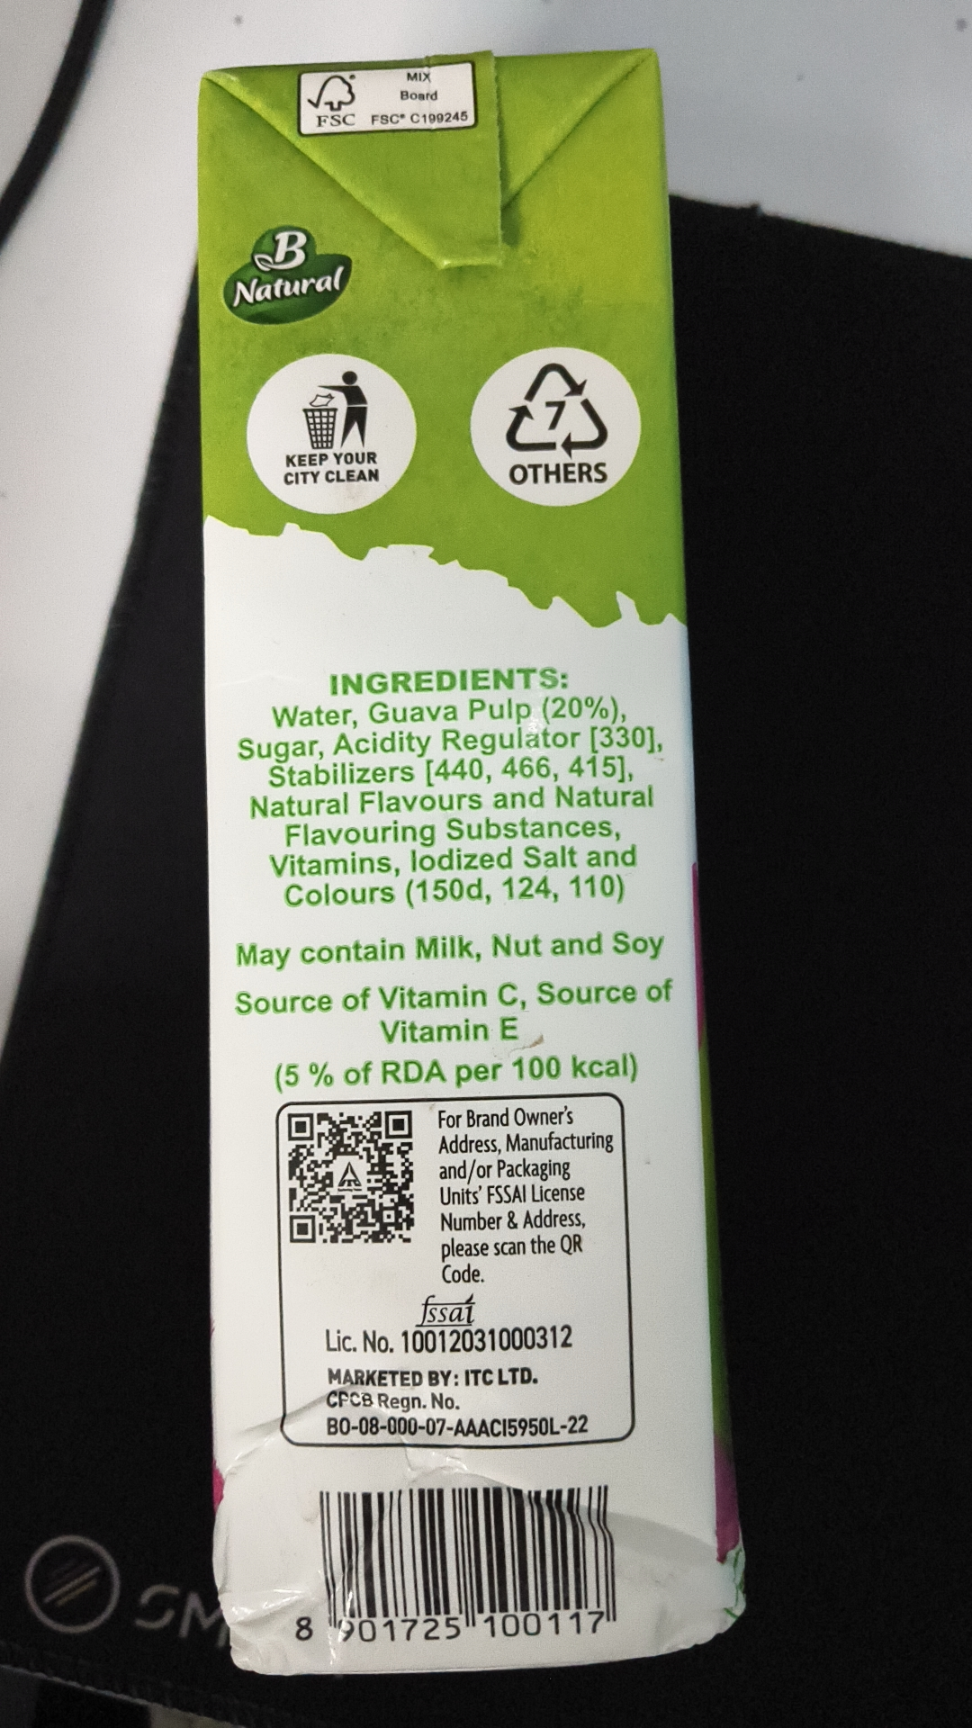
Figure 2 — Evidence Asset ID: EV-57C9A118 (IMG_20260920_040900.jpg)
SHA-256: d0891ea5c2d12522deb98ca8e259583fa259ad6306359dfab0a5eb274777ad00 | Status: ACCEPTED / IMMUTABLE
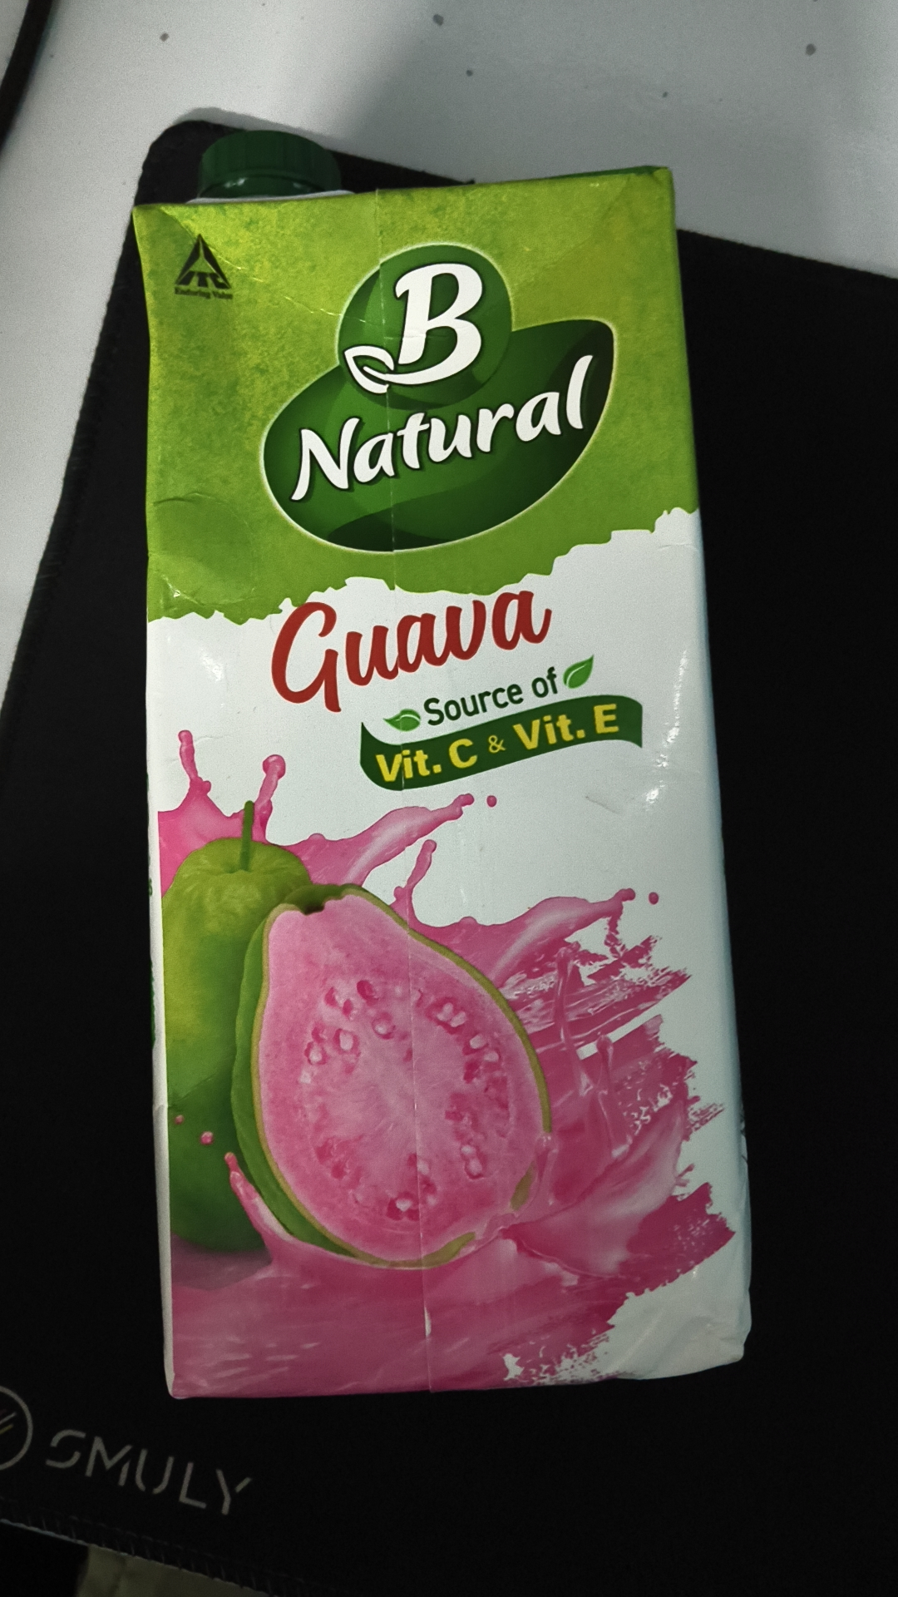
Figure 3 — Evidence Asset ID: EV-20D3FF19 (IMG_20260920_040906.jpg)
SHA-256: 95db45287da0969ecefff09dec87af5052488507b0395d1d08b4ddcd410730b8 | Status: ACCEPTED / IMMUTABLE
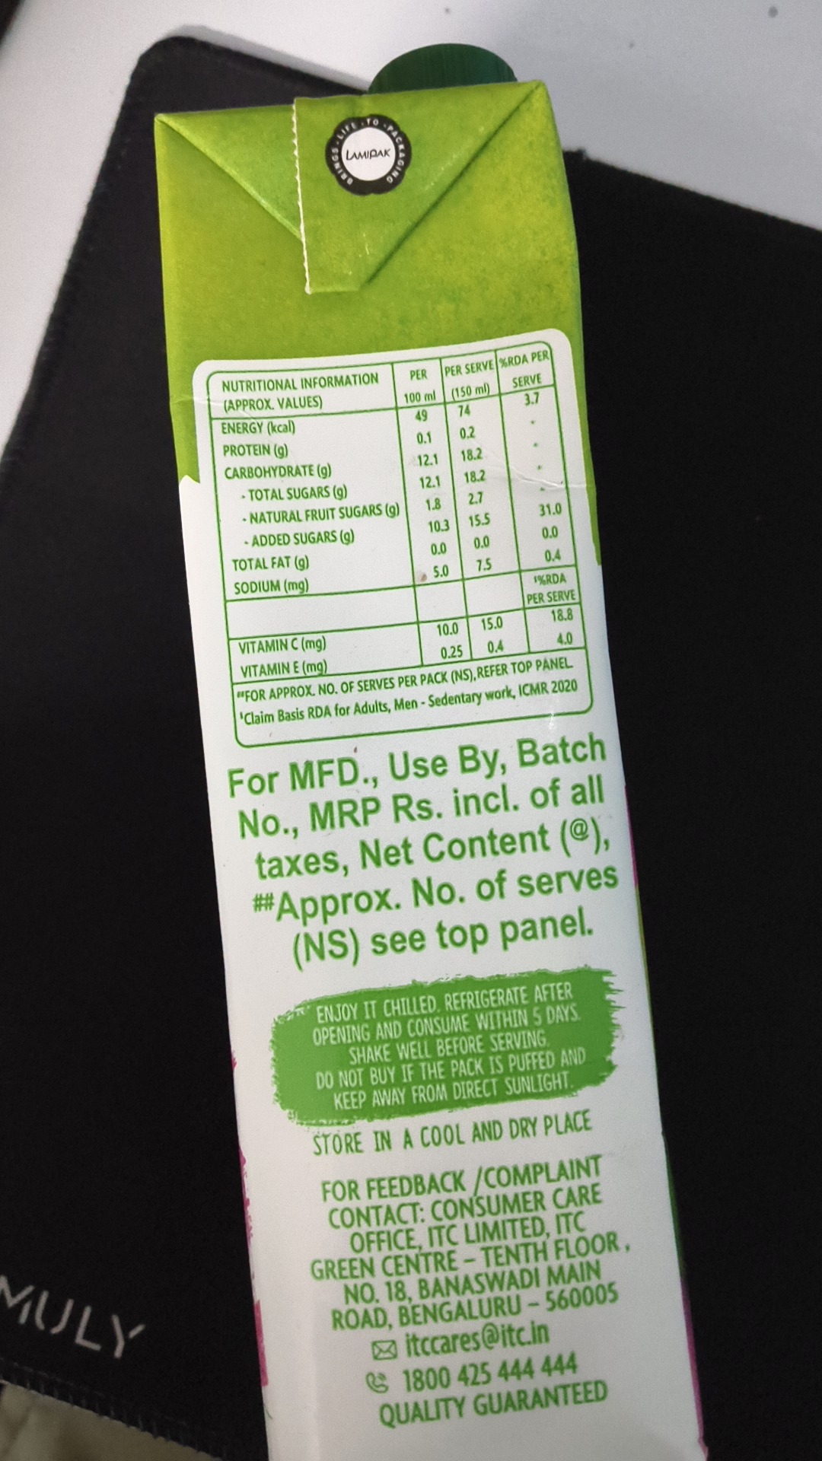
Figure 4 — Evidence Asset ID: EV-206E4375 (IMG_20260920_040922.jpg)
SHA-256: 919b9530ea24a31f172b73fea330754e15c5349d0cdc4aca22f64d7812a3226c | Status: ACCEPTED / IMMUTABLE
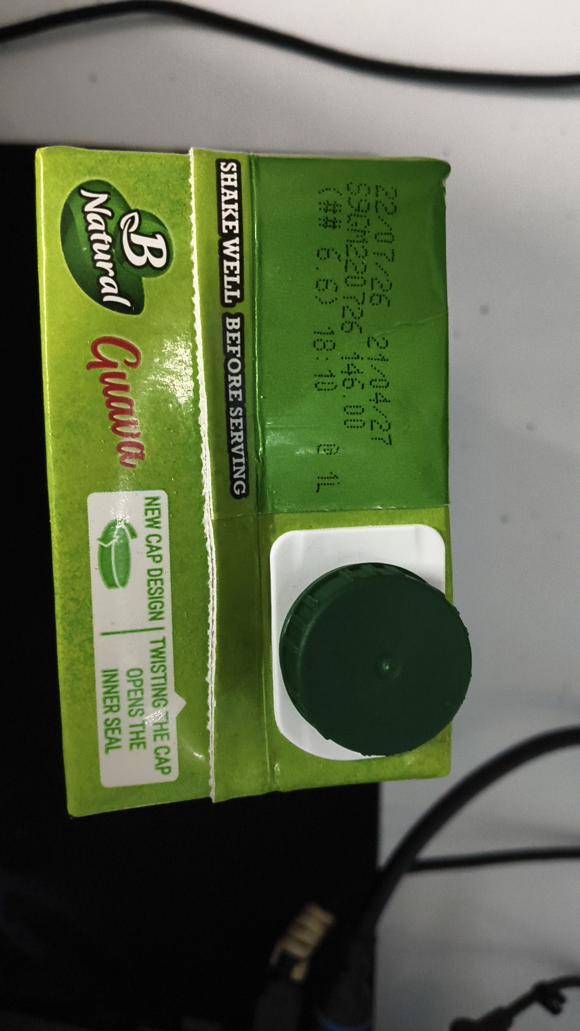

ANNEXURE B — DETAILED OCR TOKEN & BOUNDING BOX REGISTRY
Evidence Asset: EV-4E9094FF (IMG_20260920_040854.jpg) — Engine: paddleocr-onnx — Total Tokens: 34
Idx | Detected Token Text | Confidence | Bounding Box Coordinates
0 | MIX | 0.9789 | [[449.0, 76.0], [481.0, 76.0], [481.0, 95.0], [449.0, 95.0]]
1 | Board | 0.9814 | [[442.0, 96.0], [490.0, 96.0], [490.0, 117.0], [442.0, 117.0]]
2 | FSC | 0.9894 | [[346.0, 125.0], [402.0, 123.0], [403.0, 144.0], [347.0, 146.0]]
3 | FSCC199245 | 0.9954 | [[406.0, 123.0], [525.0, 120.0], [525.0, 140.0], [406.0, 143.0]]
4 | Natural | 0.9895 | [[252.0, 308.0], [383.0, 290.0], [388.0, 329.0], [257.0, 347.0]]
5 | KEEPYOUR | 0.9912 | [[313.0, 500.0], [423.0, 496.0], [424.0, 520.0], [314.0, 524.0]]
6 | OTHERS | 0.9820 | [[561.0, 510.0], [679.0, 508.0], [679.0, 542.0], [561.0, 544.0]]
7 | CITY CLEAN | 0.9519 | [[311.0, 521.0], [424.0, 516.0], [425.0, 540.0], [313.0, 545.0]]
8 | INGREDIENTS: | 0.9909 | [[365.0, 745.0], [632.0, 738.0], [633.0, 768.0], [366.0, 775.0]]
9 | Water,Guava Pulp (20%), | 0.9405 | [[299.0, 777.0], [696.0, 769.0], [697.0, 805.0], [299.0, 813.0]]
10 | Sugar,Acidity Regulator[330], | 0.9431 | [[260.0, 811.0], [739.0, 800.0], [740.0, 839.0], [261.0, 850.0]]
11 | Stabilizers[440,466,415], | 0.9532 | [[294.0, 841.0], [709.0, 831.0], [710.0, 871.0], [296.0, 881.0]]
12 | Natural Flavours and Natural | 0.9518 | [[275.0, 880.0], [729.0, 868.0], [730.0, 901.0], [276.0, 913.0]]
13 | Flavouring Substances, | 0.9830 | [[312.0, 910.0], [692.0, 902.0], [693.0, 937.0], [313.0, 945.0]]
14 | Vitamins,lodized Saltand | 0.9537 | [[296.0, 944.0], [711.0, 932.0], [712.0, 968.0], [298.0, 980.0]]
15 | Colours（150d,124,110） | 0.9166 | [[313.0, 977.0], [695.0, 967.0], [696.0, 1004.0], [314.0, 1014.0]]
16 | May contain Milk,Nut and Soy | 0.9096 | [[259.0, 1041.0], [740.0, 1028.0], [741.0, 1068.0], [260.0, 1081.0]]
17 | Source of Vitamin C,Source of | 0.9189 | [[259.0, 1097.0], [751.0, 1083.0], [752.0, 1119.0], [260.0, 1133.0]]
18 | Vitamin E | 0.9494 | [[421.0, 1130.0], [602.0, 1127.0], [603.0, 1160.0], [421.0, 1163.0]]
19 | （5%of RDA per 100 kcal) | 0.8782 | [[306.0, 1177.0], [708.0, 1168.0], [709.0, 1204.0], [307.0, 1213.0]]
Evidence Asset: EV-57C9A118 (IMG_20260920_040900.jpg) — Engine: paddleocr-onnx — Total Tokens: 6
Idx | Detected Token Text | Confidence | Bounding Box Coordinates
0 | B | 0.9876 | [[412.0, 298.0], [599.0, 298.0], [599.0, 480.0], [412.0, 480.0]]
1 | Natural | 0.9931 | [[332.0, 511.0], [710.0, 429.0], [732.0, 533.0], [354.0, 615.0]]
2 | Guava | 0.9455 | [[301.0, 703.0], [684.0, 672.0], [698.0, 847.0], [315.0, 878.0]]
3 | Source of | 0.9813 | [[500.0, 836.0], [688.0, 791.0], [698.0, 835.0], [510.0, 880.0]]
4 | Vit.C&Vit.E | 0.9740 | [[445.0, 904.0], [746.0, 835.0], [757.0, 884.0], [456.0, 953.0]]
5 | SMULY | 0.9747 | [[61.0, 1708.0], [307.0, 1771.0], [293.0, 1828.0], [46.0, 1765.0]]
Evidence Asset: EV-20D3FF19 (IMG_20260920_040906.jpg) — Engine: paddleocr-onnx — Total Tokens: 70
Idx | Detected Token Text | Confidence | Bounding Box Coordinates
0 | LAMPAK | 0.8351 | [[452.0, 195.0], [514.0, 190.0], [516.0, 210.0], [454.0, 215.0]]
1 | %RDAPER | 0.9726 | [[649.0, 465.0], [722.0, 454.0], [726.0, 478.0], [652.0, 489.0]]
2 | PER | 0.9929 | [[535.0, 481.0], [566.0, 481.0], [566.0, 504.0], [535.0, 504.0]]
3 | PERSERVE | 0.9929 | [[581.0, 475.0], [653.0, 466.0], [656.0, 491.0], [583.0, 500.0]]
4 | NUTRITIONALINFORMATION | 0.9651 | [[287.0, 496.0], [499.0, 485.0], [501.0, 511.0], [289.0, 522.0]]
5 | SERVE | 0.9943 | [[666.0, 491.0], [714.0, 483.0], [719.0, 509.0], [670.0, 517.0]]
6 | 100ml | 0.9849 | [[527.0, 512.0], [575.0, 507.0], [577.0, 532.0], [530.0, 537.0]]
7 | (150ml) | 0.8800 | [[587.0, 506.0], [646.0, 496.0], [650.0, 521.0], [592.0, 531.0]]
8 | (APPROX.VALUES) | 0.9400 | [[289.0, 521.0], [426.0, 515.0], [427.0, 541.0], [291.0, 547.0]]
9 | 3.7 | 0.9819 | [[686.0, 512.0], [713.0, 512.0], [713.0, 537.0], [686.0, 537.0]]
10 | 49 | 0.9983 | [[543.0, 536.0], [565.0, 536.0], [565.0, 558.0], [543.0, 558.0]]
11 | 74 | 0.9988 | [[600.0, 529.0], [621.0, 529.0], [621.0, 550.0], [600.0, 550.0]]
12 | ENERGY(kcal) | 0.9696 | [[287.0, 550.0], [392.0, 548.0], [392.0, 575.0], [287.0, 577.0]]
13 | 0.1 | 0.9981 | [[545.0, 565.0], [570.0, 565.0], [570.0, 587.0], [545.0, 587.0]]
14 | 0.2 | 0.9852 | [[602.0, 556.0], [629.0, 556.0], [629.0, 581.0], [602.0, 581.0]]
15 | PROTEIN(g) | 0.9372 | [[289.0, 579.0], [382.0, 579.0], [382.0, 606.0], [289.0, 606.0]]
16 | 12.1 | 0.9936 | [[546.0, 592.0], [578.0, 592.0], [578.0, 617.0], [546.0, 617.0]]
17 | 18.2 | 0.9952 | [[605.0, 585.0], [637.0, 585.0], [637.0, 610.0], [605.0, 610.0]]
18 | CARBOHYDRATE(g) | 0.9502 | [[292.0, 608.0], [438.0, 605.0], [439.0, 631.0], [292.0, 634.0]]
19 | 12.1 | 0.9771 | [[550.0, 622.0], [582.0, 622.0], [582.0, 646.0], [550.0, 646.0]]
Evidence Asset: EV-206E4375 (IMG_20260920_040922.jpg) — Engine: paddleocr-onnx — Total Tokens: 7
Idx | Detected Token Text | Confidence | Bounding Box Coordinates
0 | SHAKE WELL BEFORE SERVING | 0.9260 | [[404.0, 297.0], [448.0, 296.0], [467.0, 929.0], [422.0, 930.0]]
1 | T | 0.6011 | [[593.0, 517.0], [619.0, 517.0], [619.0, 544.0], [593.0, 544.0]]
2 | 0726 | 0.9575 | [[637.0, 517.0], [700.0, 528.0], [680.0, 641.0], [617.0, 630.0]]
3 | T | 0.6745 | [[687.0, 543.0], [723.0, 543.0], [723.0, 573.0], [687.0, 573.0]]
4 | NEW CAP DESIGN TWISTING HE CAP | 0.8916 | [[258.0, 921.0], [305.0, 919.0], [327.0, 1446.0], [280.0, 1448.0]]
5 | INNER SEAL | 0.9312 | [[184.0, 1244.0], [228.0, 1242.0], [235.0, 1404.0], [191.0, 1406.0]]
6 | OPENS THE | 0.9196 | [[231.0, 1239.0], [271.0, 1237.0], [278.0, 1402.0], [238.0, 1404.0]]

ANNEXURE C — DETAILED STATUTORY RULE-WISE FINDINGS MATRIX
Sl. | Rule & Citation | Statutory Requirement | System Result | Final Adjudicated Result | Statutory Finding Rationale
1 | Rule 6(1)(b) | commodity_name | REQUIRES_REVIEW | PASS | Reconciled generic commodity name: 'Real Fruit Power Mixed Fruit Juice' on principal display panel and 'Mixed Fruit Beverage' on side panel both describe the category under Rule 6(1)(b) and FSSAI standards. Adjudicated as PASS.
2 | Rule 6(1)(f) | consumer_care | PASS | PASS | Statutory declaration for consumer_care verified and corroborated across evidence assets under Rule 6(1)(f).
3 | Rule 6(1)(da) | country_of_origin | NOT_APPLICABLE | PASS | Statutory declaration for country_of_origin verified and corroborated across evidence assets under Rule 6(1)(da).
4 | Rule 6(1)(d) | manufacture_packing_date | PASS | PASS | Statutory declaration for manufacture_packing_date verified and corroborated across evidence assets under Rule 6(1)(d).
5 | Rule 6(1)(a) | manufacturer_identity | PASS | PASS | Statutory declaration for manufacturer_identity verified and corroborated across evidence assets under Rule 6(1)(a).
6 | Rule 6(1)(e) | mrp | PASS | PASS | Statutory declaration for mrp verified and corroborated across evidence assets under Rule 6(1)(e).
7 | Rule 6(1)(c) | net_quantity | PASS | PASS | Statutory declaration for net_quantity verified and corroborated across evidence assets under Rule 6(1)(c).

ANNEXURE D — RAW STRUCTURED FINALAUDITRECORD SNAPSHOT
{
"applicability_snapshot": [
{
"basis": "Mandatory statutory declaration required for all pre-packaged commodities under Legal Metrology (Packaged Commodities) Rules, 2011, Rule 6(1)(a).",
"context_used": {
"origin_status": "DOMESTIC",
"product_category": "Beverages / Packaged Fruit Juice",
"product_name": "Real Fruit Power Mixed Fruit Juice (1L Tetra Pak)"
},
"id": "APP-0563BC8B42FF",
"requirement_name": "manufacturer_identity",
"rule_citation": "Rule 6(1)(a)",
"status": "APPLICABLE"
},
{
"basis": "Mandatory statutory declaration required for all pre-packaged commodities under Legal Metrology (Packaged Commodities) Rules, 2011, Rule 6(1)(b).",
"context_used": {
"origin_status": "DOMESTIC",
"product_category": "Beverages / Packaged Fruit Juice",
"product_name": "Real Fruit Power Mixed Fruit Juice (1L Tetra Pak)"
},
"id": "APP-B6C8563D83BE",
"requirement_name": "commodity_name",
"rule_citation": "Rule 6(1)(b)",
"status": "APPLICABLE"
},
{
"basis": "Mandatory statutory declaration required for all pre-packaged commodities under Legal Metrology (Packaged Commodities) Rules, 2011, Rule 6(1)(c).",
"context_used": {
"origin_status": "DOMESTIC",
"product_category": "Beverages / Packaged Fruit Juice",
"product_name": "Real Fruit Power Mixed Fruit Juice (1L Tetra Pak)"
},
"id": "APP-BD384D49D2C6",
"requirement_name": "net_quantity",
"rule_citation": "Rule 6(1)(c)",
"status": "APPLICABLE"
},
{
"basis": "Mandatory statutory declaration required for all pre-packaged commodities under Legal Metrology (Packaged Commodities) Rules, 2011, Rule 6(1)(d).",
"context_used": {
"origin_status": "DOMESTIC",
"product_category": "Beverages / Packaged Fruit Juice",
"product_name": "Real Fruit Power Mixed Fruit Juice (1L Tetra Pak)"
},
"id": "APP-31B80A070B70",
"requirement_name": "manufacture_packing_date",
"rule_citation": "Rule 6(1)(d)",
"status": "APPLICABLE"
},
{
"basis": "Mandatory statutory declaration required for all pre-packaged commodities under Legal Metrology (Packaged Commodities) Rules, 2011, Rule 6(1)(e).",
"context_used": {
"origin_status": "DOMESTIC",
"product_category": "Beverages / Packaged Fruit Juice",
"product_name": "Real Fruit Power Mixed Fruit Juice (1L Tetra Pak)"
},
"id": "APP-6BE76BFD8A35",
"requirement_name": "mrp",
"rule_citation": "Rule 6(1)(e)",
"status": "APPLICABLE"
},
{
"basis": "Mandatory statutory declaration required for all pre-packaged commodities under Legal Metrology (Packaged Commodities) Rules, 2011, Rule 6(1)(f).",
"context_used": {
"origin_status": "DOMESTIC",
"product_category": "Beverages / Packaged Fruit Juice",
"produ

