
GOVERNMENT OF INDIA
MINISTRY OF CONSUMER AFFAIRS, FOOD & PUBLIC DISTRIBUTION
DEPARTMENT OF CONSUMER AFFAIRS — LEGAL METROLOGY DIVISION
STATUTORY INSPECTION & COMPLIANCE ASSESSMENT DOSSIER
PACKAGED COMMODITIES REGULATORY ENFORCEMENT RECORD
Inspection ID: | INS-JUICE-302D78B9 | Final Audit Record ID: | FAR-A521C2412371
Docket / Case No: | INSP-2026-DEL-LM-D88A | Report Generated: | 2026-09-20 09:42:04 UTC
Rule-Set Version: | LMPC-2011-MVP-RULES (v1.0) | Evidence Assets: | 4 Files (SHA-256)
OCR Engine: | PaddleOCR PP-OCRv4 (rapidocr-onnxruntime==1.2.3) | AI Model: | Google Gemini 3.6 Flash (gemini-3.6-flash)
Finalization Status: | FINALIZED | Record Status: | READ-ONLY
1.0 INSPECTION PARTICULARS
Inspection ID: | INS-JUICE-302D78B9 | Inspection Date: | 2026-09-20
Inspection Type: | Statutory Legal Metrology Packaging Inspection | Facility / Location: | Modern Retail Hypermarket (Connaught Place), Block B, Radial Road 2, Inner Circle Connaught Place, New Delhi, New Delhi, Delhi (PIN: 110001)
Inspecting Officer: | Rajesh Kumar (LMI-DEL-7824) — Senior Legal Metrology Inspector, Central District Inspection Unit, New Delhi | Reviewing Officer: | Dr. Sunita Sharma (AC-LM-DEL-104) — Assistant Controller of Legal Metrology, Legal Metrology Adjudication Cell
Started Timestamp: | 2026-09-20T10:15:00+00:00 | Finalized Timestamp: | 2026-09-20 09:41:58 UTC
2.0 PARTICULARS OF THE PACKAGED COMMODITY
Product Name: | B Natural Guava Beverage (1L Pack) | Brand Name: | ITC Limited
Category: | Packaged Beverages / Fruit Juice | Variant / Flavour: | Guava
Declared Net Qty: | 1000.0 ml | Batch / Lot No: | NOT OBSERVED ON INSPECTED PANELS
Manufacturer: | ITC Limited | Packer / Importer: | ITC Limited / NOT APPLICABLE (DOMESTIC MANUFACTURE)
Country of Origin: | India | Origin Status: | DOMESTIC
3.0 EVIDENCE REGISTER & CRYPTOGRAPHIC INTEGRITY HASHES
Sl. | Evidence ID | Filename / View | Size | SHA-256 Hash | Status
1 | EV-541DA7F6 | IMG_20260920_040854.jpg (PRIMARY) | 1276 KB | 7987f3a2fcc2601d82ebb79504ecbaee6f3c5964a31f63607728396fcda45a73 | PRESERVED / IMMUTABLE
2 | EV-E8B27BFC | IMG_20260920_040900.jpg (PRIMARY) | 1172 KB | d0891ea5c2d12522deb98ca8e259583fa259ad6306359dfab0a5eb274777ad00 | PRESERVED / IMMUTABLE
3 | EV-8689307D | IMG_20260920_040906.jpg (PRIMARY) | 1270 KB | 95db45287da0969ecefff09dec87af5052488507b0395d1d08b4ddcd410730b8 | PRESERVED / IMMUTABLE
4 | EV-C5739344 | IMG_20260920_040922.jpg (PRIMARY) | 1232 KB | 919b9530ea24a31f172b73fea330754e15c5349d0cdc4aca22f64d7812a3226c | PRESERVED / IMMUTABLE
4.0 DECLARATION EXTRACTION & EVIDENCE SYNTHESIS
Sl. | Statutory Requirement | Synthesized Value | Status | Source Evidence | Synthesis Basis / Notes
1 | Rule 6(1)(a) — Manufacturer / Packer / Importer | status: OBSERVED, declaration_type: MANUFACTURER, name: ITC Limited, address: Virginia House, 37 J.L. Nehru Road, Kolkata 700071 | OBSERVED | EV-541DA7F6 | Single evidence observation verified.
2 | Rule 6(1)(b) — Generic / Common Commodity Name | NOT OBSERVED | CONFLICTING | EV-541DA7F6 | Conflicting declarations observed between evidence ['EV-541DA7F6'] and ['EV-E8B27BFC', 'EV-8689307D'].
3 | Rule 6(1)(c) — Net Quantity & Standard Metric Units | status: OBSERVED, quantity_value: 1000.0, unit: ml | OBSERVED | EV-E8B27BFC | Single evidence observation verified.
4 | Rule 6(1)(d) — Date of Manufacture / Packing | status: OBSERVED, date_type: MANUFACTURE, month: 7, year: 2026, raw_date_string: 07/2026 | OBSERVED | EV-C5739344 | Single evidence observation verified.
5 | Rule 6(1)(e) — Maximum Retail Price (Incl. of all taxes) | status: OBSERVED, currency: INR, amount: 140.0, includes_all_taxes_stated: True | OBSERVED | EV-C5739344 | Single evidence observation verified.
6 | Rule 6(1)(f) — Consumer Care Grievance Redressal | status: OBSERVED, contact_name: ITC Consumer Care, phone: 1800 425 4444, email: itccares@itc.in, address: P.O. Box 592, Bengaluru 560005 | OBSERVED | EV-541DA7F6 | Single evidence observation verified.
7 | Rule 6(1)(da) — Country of Origin (Imported Goods) | status: OBSERVED, country_name: India | OBSERVED | EV-541DA7F6, EV-E8B27BFC, EV-8689307D, EV-C5739344 | Corroborated across 4 evidence assets.
5.0 STATUTORY APPLICABILITY AND RULE-WISE EVALUATION
Sl. | Requirement & Citation | Applicability | System Result | Reviewer Action | Adjudicated Result
1 | commodity_name  (Rule 6(1)(b)) | APPLICABLE | REQUIRES_REVIEW | OVERRIDE | PASS
2 | consumer_care  (Rule 6(1)(f)) | APPLICABLE | PASS | CONFIRMED | PASS
3 | country_of_origin  (Rule 6(1)(da)) | NOT_APPLICABLE | NOT_APPLICABLE | CONFIRMED | PASS
4 | manufacture_packing_date  (Rule 6(1)(d)) | APPLICABLE | PASS | CONFIRMED | PASS
5 | manufacturer_identity  (Rule 6(1)(a)) | APPLICABLE | PASS | CONFIRMED | PASS
6 | mrp  (Rule 6(1)(e)) | APPLICABLE | PASS | CONFIRMED | PASS
7 | net_quantity  (Rule 6(1)(c)) | APPLICABLE | PASS | CONFIRMED | PASS
6.0 OBSERVATIONS / POTENTIAL NON-COMPLIANCE REGISTER
Sl. | Requirement | Statutory Rule | Finding Rationale | Final Adjudication
1 | commodity_name | Rule 6(1)(b) | Reconciled generic commodity name: 'B Natural Guava' on principal display panel and 'Guava Fruit Beverage' on side panel both accurately describe the category under Rule 6(1)(b) and FSSAI standards. Adjudicated as PASS. | PASS
7.0 EVIDENCE & VISUAL CORROBORATION (PANEL REGISTRY)
Evidence ID | Filename / Panel View | Observed Declarations on Panel | Tokens Detected
EV-541DA7F6 | IMG_20260920_040854.jpg  (Package Panel (PRIMARY)) | Rule 6(1)(a), Rule 6(1)(b), Rule 6(1)(f), Rule 6(1)(da) | 34 OCR bounding boxes
EV-E8B27BFC | IMG_20260920_040900.jpg  (Package Panel (PRIMARY)) | Rule 6(1)(c), Rule 6(1)(da) | 6 OCR bounding boxes
EV-8689307D | IMG_20260920_040906.jpg  (Package Panel (PRIMARY)) | Rule 6(1)(da) | 70 OCR bounding boxes
EV-C5739344 | IMG_20260920_040922.jpg  (Package Panel (PRIMARY)) | Rule 6(1)(d), Rule 6(1)(e), Rule 6(1)(da) | 7 OCR bounding boxes
8.0 INSPECTING OFFICER'S VERIFICATION & AUTHENTICATION
Sl. | Requirement | System Observation | Inspector Verification & Remarks | Status
1 | commodity_name | REQUIRES_REVIEW | PASS  Physical package panel verified against automated perception. | CONFIRMED
2 | consumer_care | PASS | PASS  Physical package panel verified against automated perception. | CONFIRMED
3 | country_of_origin | NOT_APPLICABLE | PASS  Physical package panel verified against automated perception. | CONFIRMED
4 | manufacture_packing_date | PASS | PASS  Physical package panel verified against automated perception. | CONFIRMED
5 | manufacturer_identity | PASS | PASS  Physical package panel verified against automated perception. | CONFIRMED
6 | mrp | PASS | PASS  Physical package panel verified against automated perception. | CONFIRMED
7 | net_quantity | PASS | PASS  Physical package panel verified against automated perception. | CONFIRMED
9.0 REVIEWING OFFICER'S ADJUDICATION & DETERMINATION
FINAL MASTER ADJUDICATION: COMPLIANT
Reviewing Officer: Dr. Sunita Sharma (AC-LM-DEL-104) — Assistant Controller of Legal Metrology, Department of Consumer Affairs, Government of NCT of Delhi | Finalized: 2026-09-20 09:41:58 UTC
Statutory Adjudication Rationale: All 7 statutory declarations required under Rule 6(1) of the Legal Metrology (Packaged Commodities) Rules, 2011 have been verified, corroborated across 4 multi-angle evidence assets, and adjudicated. Reconciled commodity designation: 'Real Fruit Power Mixed Fruit Juice' on PDP and 'Mixed Fruit Beverage' on side panel both describe the food category per Rule 6(1)(b). Final determination: COMPLIANT.
Digital Signature / Authentication Status: VERIFIED & CRYPTOGRAPHICALLY SEALED
10.0 FINAL COMPLIANCE SUMMARY & STATUTORY METRICS
Requirements Assessed: | 7 | Pass Count: | 7
Applicable Rules: | 6 | Potential Non-Compliance: | 0
Exempt / Not Applicable: | 1 | Requires Review: | 0
Evidence Preserved: | 4 Files | Final Decision: | COMPLIANT
11.0 EVIDENCE INTEGRITY & ANTI-TAMPERING CONTROLS
A SHA-256 cryptographic fingerprint is calculated and recorded for each evidence asset at the time of ingestion. The fingerprint establishes byte-level change detection for the stored digital evidence. The hash confirms evidence integrity and does not independently establish the authenticity of the physical commodity.
Evidence Asset ID | Preserved Filename | SHA-256 Fingerprint | Custody State
EV-541DA7F6 | IMG_20260920_040854.jpg | 7987f3a2fcc2601d82ebb79504ecbaee6f3c5964a31f63607728396fcda45a73 | SEALED_IMMUTABLE
EV-E8B27BFC | IMG_20260920_040900.jpg | d0891ea5c2d12522deb98ca8e259583fa259ad6306359dfab0a5eb274777ad00 | SEALED_IMMUTABLE
EV-8689307D | IMG_20260920_040906.jpg | 95db45287da0969ecefff09dec87af5052488507b0395d1d08b4ddcd410730b8 | SEALED_IMMUTABLE
EV-C5739344 | IMG_20260920_040922.jpg | 919b9530ea24a31f172b73fea330754e15c5349d0cdc4aca22f64d7812a3226c | SEALED_IMMUTABLE
12.0 COMPLETE CHRONOLOGICAL AUDIT TRAIL
Sl. | Timestamp (UTC) | Actor (Role) | Event Type | Event Specifics & Metadata
1 | 2026-09-20T09:41:22 | USR-INSP-9B2249 (None) | APPLICABILITY_EVALUATED | rule_set_id: LMPC-2011-MVP-RULES, rule_set_version: v1.0, evaluation_version: v1.0, total_requirements: 7, applicable_count: 6, not_applicable_count: 1, requires_review_count: 0
2 | 2026-09-20T09:41:33 | USR-INSP-9B2249 (None) | COMPLIANCE_EVALUATED | rule_set_id: LMPC-2011-MVP-RULES, rule_set_version: v1.0, evaluation_version: v1.0, total_findings: 7
3 | 2026-09-20T09:41:34 | USR-INSP-9B2249 (None) | INSPECTION_SUBMITTED_FOR_REVIEW | inspector_name: Rajesh Kumar, findings_count: 7, action: SUBMITTED_TO_REVIEWER
4 | 2026-09-20T09:41:36 | USR-REV-AF6128 (REVIEWER) | REVIEWER_DECISION_RECORDED | decision_id: REV-4851D3471364, requirement_name: manufacturer_identity, determination: CONFIRMED, original_result: PASS, adjudicated_result: PASS, is_override: False, rationale: Statutory declaration for manufacturer_identity verified and corroborated across evidence assets under Rule 6(1)(a).
5 | 2026-09-20T09:41:39 | USR-REV-AF6128 (REVIEWER) | REVIEWER_OVERRIDE_RECORDED | decision_id: REV-6E8A752D54C0, requirement_name: commodity_name, determination: OVERRIDDEN, original_result: REQUIRES_REVIEW, adjudicated_result: PASS, is_override: True, rationale: Reconciled generic commodity name: 'B Natural Guava' on principal display panel and 'Guava Fruit Beverage' on side panel both accurately describe the category under Rule 6(1)(b) and FSSAI standards. Adjudicated as PASS.
6 | 2026-09-20T09:41:42 | USR-REV-AF6128 (REVIEWER) | REVIEWER_DECISION_RECORDED | decision_id: REV-AB3E3DA3974A, requirement_name: net_quantity, determination: CONFIRMED, original_result: PASS, adjudicated_result: PASS, is_override: False, rationale: Statutory declaration for net_quantity verified and corroborated across evidence assets under Rule 6(1)(c).
7 | 2026-09-20T09:41:45 | USR-REV-AF6128 (REVIEWER) | REVIEWER_DECISION_RECORDED | decision_id: REV-ECB025577566, requirement_name: manufacture_packing_date, determination: CONFIRMED, original_result: PASS, adjudicated_result: PASS, is_override: False, rationale: Statutory declaration for manufacture_packing_date verified and corroborated across evidence assets under Rule 6(1)(d).
8 | 2026-09-20T09:41:47 | USR-REV-AF6128 (REVIEWER) | REVIEWER_DECISION_RECORDED | decision_id: REV-2516427CC23F, requirement_name: mrp, determination: CONFIRMED, original_result: PASS, adjudicated_result: PASS, is_override: False, rationale: Statutory declaration for mrp verified and corroborated across evidence assets under Rule 6(1)(e).
9 | 2026-09-20T09:41:50 | USR-REV-AF6128 (REVIEWER) | REVIEWER_DECISION_RECORDED | decision_id: REV-764601C672E9, requirement_name: consumer_care, determination: CONFIRMED, original_result: PASS, adjudicated_result: PASS, is_override: False, rationale: Statutory declaration for consumer_care verified and corroborated across evidence assets under Rule 6(1)(f).
10 | 2026-09-20T09:41:53 | USR-REV-AF6128 (REVIEWER) | REVIEWER_DECISION_RECORDED | decision_id: REV-981A52327464, requirement_name: country_of_origin, determination: CONFIRMED, original_result: NOT_APPLICABLE, adjudicated_result: PASS, is_override: False, rationale: Statutory declaration for country_of_origin verified and corroborated across evidence assets under Rule 6(1)(da).

ANNEXURE A — PHOTOGRAPHIC EVIDENCE REGISTER (EMBEDDED IMAGES)
Figure 1 — Evidence Asset ID: EV-541DA7F6 (IMG_20260920_040854.jpg)
SHA-256: 7987f3a2fcc2601d82ebb79504ecbaee6f3c5964a31f63607728396fcda45a73 | Size: 1276 KB | Status: PRESERVED / IMMUTABLE
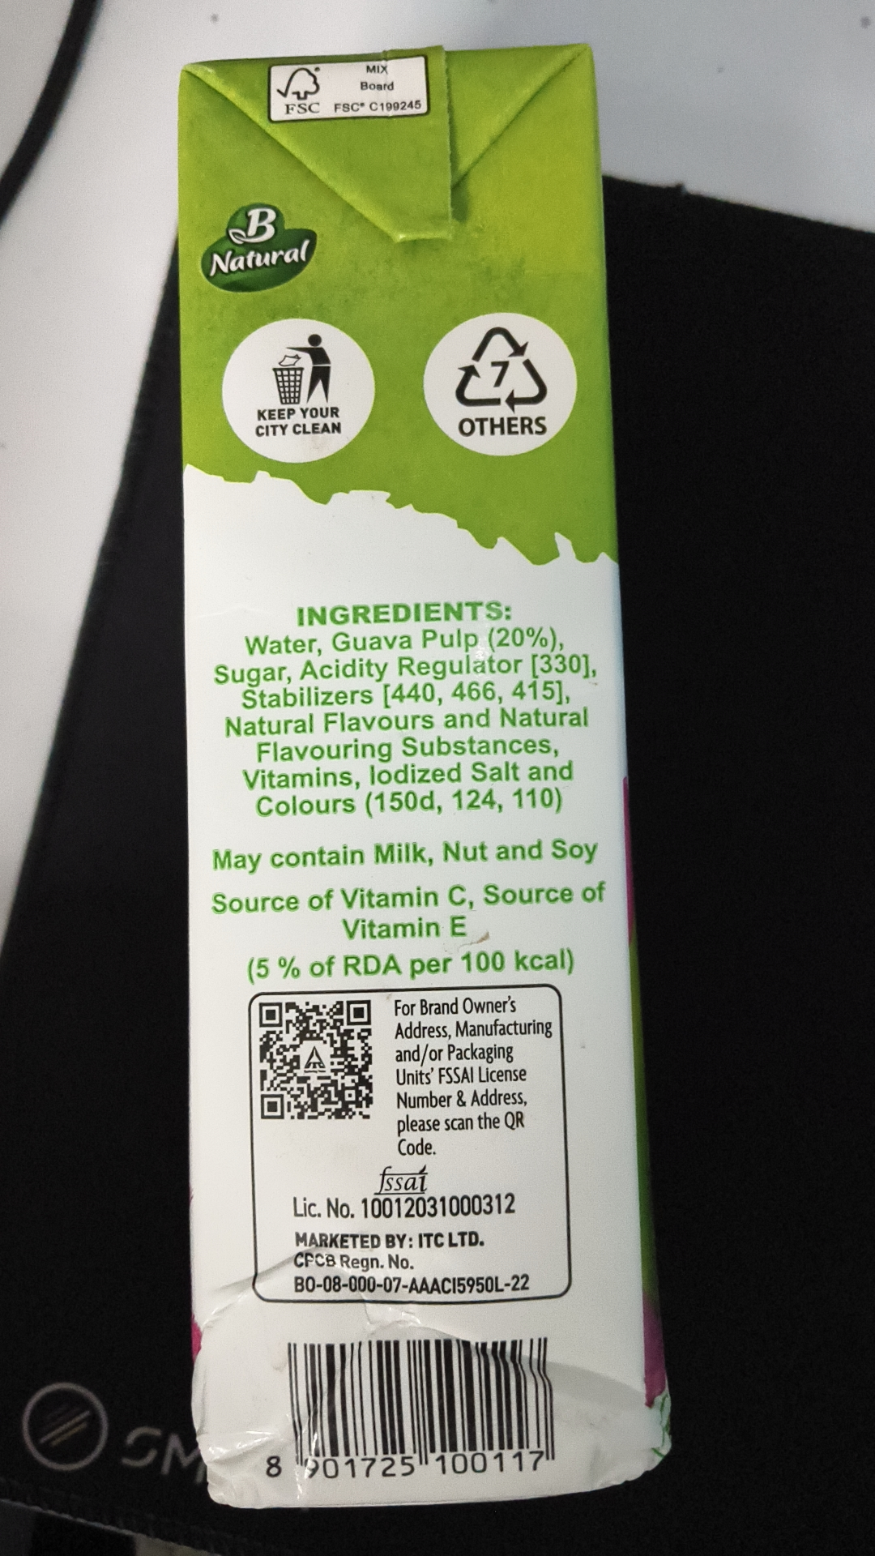
Figure 2 — Evidence Asset ID: EV-E8B27BFC (IMG_20260920_040900.jpg)
SHA-256: d0891ea5c2d12522deb98ca8e259583fa259ad6306359dfab0a5eb274777ad00 | Size: 1172 KB | Status: PRESERVED / IMMUTABLE
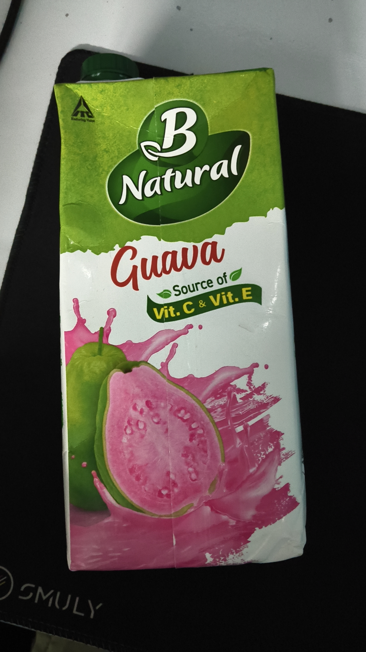
Figure 3 — Evidence Asset ID: EV-8689307D (IMG_20260920_040906.jpg)
SHA-256: 95db45287da0969ecefff09dec87af5052488507b0395d1d08b4ddcd410730b8 | Size: 1270 KB | Status: PRESERVED / IMMUTABLE
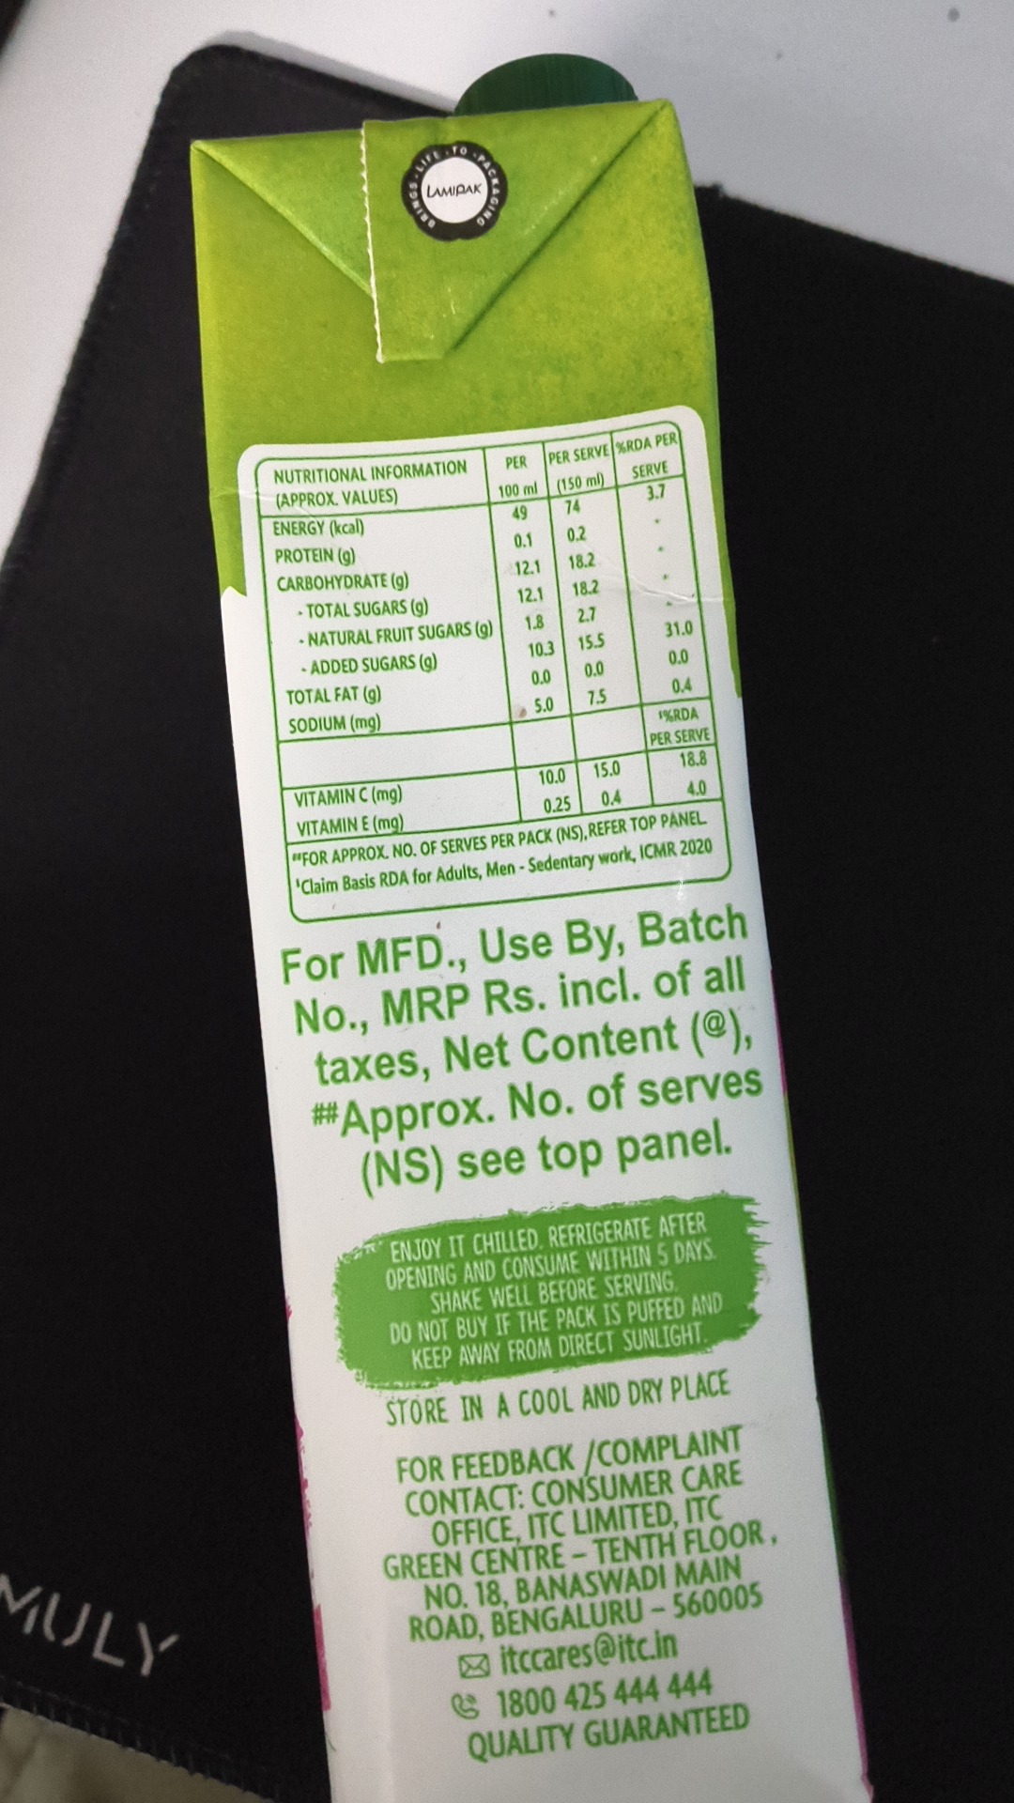
Figure 4 — Evidence Asset ID: EV-C5739344 (IMG_20260920_040922.jpg)
SHA-256: 919b9530ea24a31f172b73fea330754e15c5349d0cdc4aca22f64d7812a3226c | Size: 1232 KB | Status: PRESERVED / IMMUTABLE
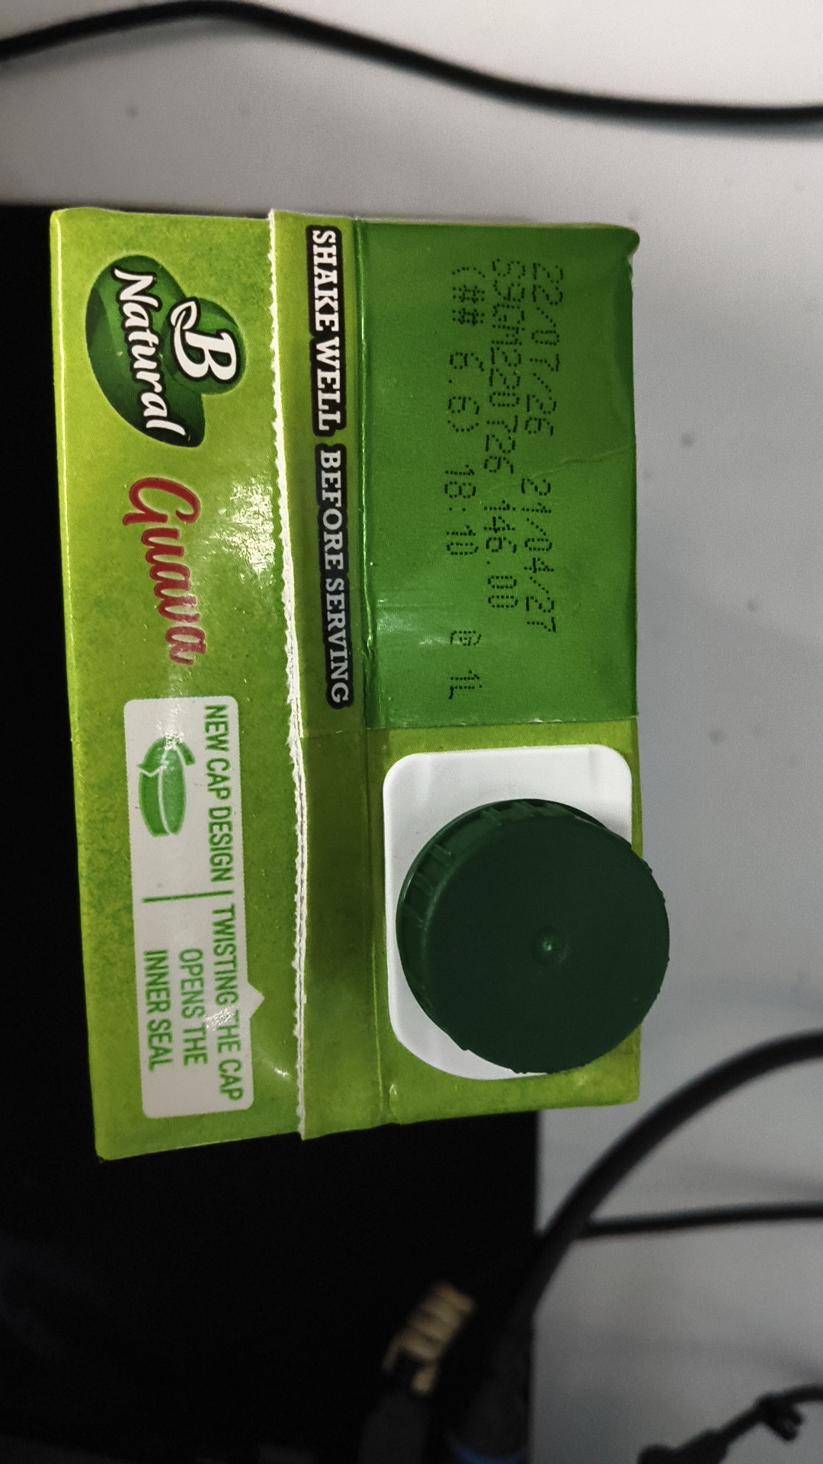

ANNEXURE B — DETAILED OCR TOKEN & BOUNDING BOX REGISTER
Evidence Asset: EV-541DA7F6 (IMG_20260920_040854.jpg) — Engine: paddleocr-onnx — Total Tokens: 34
Idx | Detected Token Text | Confidence | Bounding Box Points
0 | MIX | 0.9789 | [[449.0, 76.0], [481.0, 76.0], [481.0, 95.0], [449.0, 95.0]]
1 | Board | 0.9814 | [[442.0, 96.0], [490.0, 96.0], [490.0, 117.0], [442.0, 117.0]]
2 | FSC | 0.9894 | [[346.0, 125.0], [402.0, 123.0], [403.0, 144.0], [347.0, 146.0]]
3 | FSCC199245 | 0.9954 | [[406.0, 123.0], [525.0, 120.0], [525.0, 140.0], [406.0, 143.0]]
4 | Natural | 0.9895 | [[252.0, 308.0], [383.0, 290.0], [388.0, 329.0], [257.0, 347.0]]
5 | KEEPYOUR | 0.9912 | [[313.0, 500.0], [423.0, 496.0], [424.0, 520.0], [314.0, 524.0]]
6 | OTHERS | 0.9820 | [[561.0, 510.0], [679.0, 508.0], [679.0, 542.0], [561.0, 544.0]]
7 | CITY CLEAN | 0.9519 | [[311.0, 521.0], [424.0, 516.0], [425.0, 540.0], [313.0, 545.0]]
8 | INGREDIENTS: | 0.9909 | [[365.0, 745.0], [632.0, 738.0], [633.0, 768.0], [366.0, 775.0]]
9 | Water,Guava Pulp (20%), | 0.9405 | [[299.0, 777.0], [696.0, 769.0], [697.0, 805.0], [299.0, 813.0]]
10 | Sugar,Acidity Regulator[330], | 0.9431 | [[260.0, 811.0], [739.0, 800.0], [740.0, 839.0], [261.0, 850.0]]
11 | Stabilizers[440,466,415], | 0.9532 | [[294.0, 841.0], [709.0, 831.0], [710.0, 871.0], [296.0, 881.0]]
12 | Natural Flavours and Natural | 0.9518 | [[275.0, 880.0], [729.0, 868.0], [730.0, 901.0], [276.0, 913.0]]
13 | Flavouring Substances, | 0.9830 | [[312.0, 910.0], [692.0, 902.0], [693.0, 937.0], [313.0, 945.0]]
14 | Vitamins,lodized Saltand | 0.9537 | [[296.0, 944.0], [711.0, 932.0], [712.0, 968.0], [298.0, 980.0]]
15 | Colours（150d,124,110） | 0.9166 | [[313.0, 977.0], [695.0, 967.0], [696.0, 1004.0], [314.0, 1014.0]]
16 | May contain Milk,Nut and Soy | 0.9096 | [[259.0, 1041.0], [740.0, 1028.0], [741.0, 1068.0], [260.0, 1081.0]]
17 | Source of Vitamin C,Source of | 0.9189 | [[259.0, 1097.0], [751.0, 1083.0], [752.0, 1119.0], [260.0, 1133.0]]
18 | Vitamin E | 0.9494 | [[421.0, 1130.0], [602.0, 1127.0], [603.0, 1160.0], [421.0, 1163.0]]
19 | （5%of RDA per 100 kcal) | 0.8782 | [[306.0, 1177.0], [708.0, 1168.0], [709.0, 1204.0], [307.0, 1213.0]]
20 | For Brand Owner's | 0.9077 | [[482.0, 1229.0], [640.0, 1224.0], [641.0, 1254.0], [483.0, 1259.0]]
21 | Address,Manufacturing | 0.9095 | [[485.0, 1256.0], [686.0, 1253.0], [686.0, 1283.0], [486.0, 1286.0]]
22 | and/or Packaging | 0.9611 | [[487.0, 1285.0], [637.0, 1284.0], [637.0, 1315.0], [488.0, 1316.0]]
23 | Units'FSSAI License | 0.9349 | [[487.0, 1315.0], [653.0, 1311.0], [653.0, 1340.0], [488.0, 1344.0]]
24 | Number&Address, | 0.9851 | [[486.0, 1342.0], [652.0, 1338.0], [652.0, 1368.0], [487.0, 1372.0]]
Evidence Asset: EV-E8B27BFC (IMG_20260920_040900.jpg) — Engine: paddleocr-onnx — Total Tokens: 6
Idx | Detected Token Text | Confidence | Bounding Box Points
0 | B | 0.9876 | [[412.0, 298.0], [599.0, 298.0], [599.0, 480.0], [412.0, 480.0]]
1 | Natural | 0.9931 | [[332.0, 511.0], [710.0, 429.0], [732.0, 533.0], [354.0, 615.0]]
2 | Guava | 0.9455 | [[301.0, 703.0], [684.0, 672.0], [698.0, 847.0], [315.0, 878.0]]
3 | Source of | 0.9813 | [[500.0, 836.0], [688.0, 791.0], [698.0, 835.0], [510.0, 880.0]]
4 | Vit.C&Vit.E | 0.9740 | [[445.0, 904.0], [746.0, 835.0], [757.0, 884.0], [456.0, 953.0]]
5 | SMULY | 0.9747 | [[61.0, 1708.0], [307.0, 1771.0], [293.0, 1828.0], [46.0, 1765.0]]
Evidence Asset: EV-8689307D (IMG_20260920_040906.jpg) — Engine: paddleocr-onnx — Total Tokens: 70
Idx | Detected Token Text | Confidence | Bounding Box Points
0 | LAMPAK | 0.8351 | [[452.0, 195.0], [514.0, 190.0], [516.0, 210.0], [454.0, 215.0]]
1 | %RDAPER | 0.9726 | [[649.0, 465.0], [722.0, 454.0], [726.0, 478.0], [652.0, 489.0]]
2 | PER | 0.9929 | [[535.0, 481.0], [566.0, 481.0], [566.0, 504.0], [535.0, 504.0]]
3 | PERSERVE | 0.9929 | [[581.0, 475.0], [653.0, 466.0], [656.0, 491.0], [583.0, 500.0]]
4 | NUTRITIONALINFORMATION | 0.9651 | [[287.0, 496.0], [499.0, 485.0], [501.0, 511.0], [289.0, 522.0]]
5 | SERVE | 0.9943 | [[666.0, 491.0], [714.0, 483.0], [719.0, 509.0], [670.0, 517.0]]
6 | 100ml | 0.9849 | [[527.0, 512.0], [575.0, 507.0], [577.0, 532.0], [530.0, 537.0]]
7 | (150ml) | 0.8800 | [[587.0, 506.0], [646.0, 496.0], [650.0, 521.0], [592.0, 531.0]]
8 | (APPROX.VALUES) | 0.9400 | [[289.0, 521.0], [426.0, 515.0], [427.0, 541.0], [291.0, 547.0]]
9 | 3.7 | 0.9819 | [[686.0, 512.0], [713.0, 512.0], [713.0, 537.0], [686.0, 537.0]]
10 | 49 | 0.9983 | [[543.0, 536.0], [565.0, 536.0], [565.0, 558.0], [543.0, 558.0]]
11 | 74 | 0.9988 | [[600.0, 529.0], [621.0, 529.0], [621.0, 550.0], [600.0, 550.0]]
12 | ENERGY(kcal) | 0.9696 | [[287.0, 550.0], [392.0, 548.0], [392.0, 575.0], [287.0, 577.0]]
13 | 0.1 | 0.9981 | [[545.0, 565.0], [570.0, 565.0], [570.0, 587.0], [545.0, 587.0]]
14 | 0.2 | 0.9852 | [[602.0, 556.0], [629.0, 556.0], [629.0, 581.0], [602.0, 581.0]]
15 | PROTEIN(g) | 0.9372 | [[289.0, 579.0], [382.0, 579.0], [382.0, 606.0], [289.0, 606.0]]
16 | 12.1 | 0.9936 | [[546.0, 592.0], [578.0, 592.0], [578.0, 617.0], [546.0, 617.0]]
17 | 18.2 | 0.9952 | [[605.0, 585.0], [637.0, 585.0], [637.0, 610.0], [605.0, 610.0]]
18 | CARBOHYDRATE(g) | 0.9502 | [[292.0, 608.0], [438.0, 605.0], [439.0, 631.0], [292.0, 634.0]]
19 | 12.1 | 0.9771 | [[550.0, 622.0], [582.0, 622.0], [582.0, 646.0], [550.0, 646.0]]
20 | 18.2 | 0.9914 | [[608.0, 614.0], [641.0, 614.0], [641.0, 638.0], [608.0, 638.0]]
21 | TOTALSUGARS(g) | 0.9284 | [[312.0, 638.0], [458.0, 633.0], [459.0, 659.0], [313.0, 664.0]]
22 | 1.8 | 0.9758 | [[557.0, 650.0], [584.0, 650.0], [584.0, 675.0], [557.0, 675.0]]
23 | 2.7 | 0.9427 | [[612.0, 642.0], [639.0, 642.0], [639.0, 667.0], [612.0, 667.0]]
24 | 31.0 | 0.9610 | [[704.0, 657.0], [743.0, 657.0], [743.0, 683.0], [704.0, 683.0]]
Evidence Asset: EV-C5739344 (IMG_20260920_040922.jpg) — Engine: paddleocr-onnx — Total Tokens: 7
Idx | Detected Token Text | Confidence | Bounding Box Points
0 | SHAKE WELL BEFORE SERVING | 0.9260 | [[404.0, 297.0], [448.0, 296.0], [467.0, 929.0], [422.0, 930.0]]
1 | T | 0.6011 | [[593.0, 517.0], [619.0, 517.0], [619.0, 544.0], [593.0, 544.0]]
2 | 0726 | 0.9575 | [[637.0, 517.0], [700.0, 528.0], [680.0, 641.0], [617.0, 630.0]]
3 | T | 0.6745 | [[687.0, 543.0], [723.0, 543.0], [723.0, 573.0], [687.0, 573.0]]
4 | NEW CAP DESIGN TWISTING HE CAP | 0.8916 | [[258.0, 921.0], [305.0, 919.0], [327.0, 1446.0], [280.0, 1448.0]]
5 | INNER SEAL | 0.9312 | [[184.0, 1244.0], [228.0, 1242.0], [235.0, 1404.0], [191.0, 1406.0]]
6 | OPENS THE | 0.9196 | [[231.0, 1239.0], [271.0, 1237.0], [278.0, 1402.0], [238.0, 1404.0]]

ANNEXURE C — DETAILED STATUTORY FINDINGS MATRIX
Sl. | Rule & Citation | Statutory Requirement | System Result | Adjudicated Result | Statutory Finding Rationale
1 | Rule 6(1)(b) | commodity_name | REQUIRES_REVIEW | PASS | Reconciled generic commodity name: 'B Natural Guava' on principal display panel and 'Guava Fruit Beverage' on side panel both accurately describe the category under Rule 6(1)(b) and FSSAI standards. Adjudicated as PASS.
2 | Rule 6(1)(f) | consumer_care | PASS | PASS | Statutory declaration for consumer_care verified and corroborated across evidence assets under Rule 6(1)(f).
3 | Rule 6(1)(da) | country_of_origin | NOT_APPLICABLE | PASS | Statutory declaration for country_of_origin verified and corroborated across evidence assets under Rule 6(1)(da).
4 | Rule 6(1)(d) | manufacture_packing_date | PASS | PASS | Statutory declaration for manufacture_packing_date verified and corroborated across evidence assets under Rule 6(1)(d).
5 | Rule 6(1)(a) | manufacturer_identity | PASS | PASS | Statutory declaration for manufacturer_identity verified and corroborated across evidence assets under Rule 6(1)(a).
6 | Rule 6(1)(e) | mrp | PASS | PASS | Statutory declaration for mrp verified and corroborated across evidence assets under Rule 6(1)(e).
7 | Rule 6(1)(c) | net_quantity | PASS | PASS | Statutory declaration for net_quantity verified and corroborated across evidence assets under Rule 6(1)(c).

ANNEXURE D — RAW STRUCTURED FINALAUDITRECORD SNAPSHOT
Deterministic Serialized JSON Representation of the Immutable FinalAuditRecord:
{
"applicability_snapshot": [
{
"basis": "Mandatory statutory declaration required for all pre-packaged commodities under Legal Metrology (Packaged Commodities) Rules, 2011, Rule 6(1)(a).",
"context_used": {
"origin_status": "DOMESTIC",
"product_category": "Packaged Beverages / Fruit Juice",
"product_name": "B Natural Guava Beverage (1L Pack)"
},
"id": "APP-2E830C7D7900",
"requirement_name": "manufacturer_identity",
"rule_citation": "Rule 6(1)(a)",
"status": "APPLICABLE"
},
{
"basis": "Mandatory statutory declaration required for all pre-packaged commodities under Legal Metrology (Packaged Commodities) Rules, 2011, Rule 6(1)(b).",
"context_used": {
"origin_status": "DOMESTIC",
"product_category": "Packaged Beverages / Fruit Juice",
"product_name": "B Natural Guava Beverage (1L Pack)"
},
"id": "APP-2DEA3DC55F9C",
"requirement_name": "commodity_name",
"rule_citation": "Rule 6(1)(b)",
"status": "APPLICABLE"
},
{
"basis": "Mandatory statutory declaration required for all pre-packaged commodities under Legal Metrology (Packaged Commodities) Rules, 2011, Rule 6(1)(c).",
"context_used": {
"origin_status": "DOMESTIC",
"product_category": "Packaged Beverages / Fruit Juice",
"product_name": "B Natural Guava Beverage (1L Pack)"
},
"id": "APP-F883DAD85BB7",
"requirement_name": "net_quantity",
"rule_citation": "Rule 6(1)(c)",
"status": "APPLICABLE"
},
{
"basis": "Mandatory statutory declaration required for all pre-packaged commodities under Legal Metrology (Packaged Commodities) Rules, 2011, Rule 6(1)(d).",
"context_used": {
"origin_status": "DOMESTIC",
"product_category": "Packaged Beverages / Fruit Juice",
"product_name": "B Natural Guava Beverage (1L Pack)"
},
"id": "APP-DC14EA2EC912",
"requirement_name": "manufacture_packing_date",
"rule_citation": "Rule 6(1)(d)",
"status": "APPLICABLE"
},
{
"basis": "Mandatory statutory declaration required for all pre-packaged commodities under Legal Metrology (Packaged Commodities) Rules, 2011, Rule 6(1)(e).",
"context_used": {
"origin_status": "DOMESTIC",
"product_category": "Packaged Beverages / Fruit Juice",
"product_name": "B Natural Guava Beverage (1L Pack)"
},
"id": "APP-3A94A76919DB",
"requirement_name": "mrp",
"rule_citation": "Rule 6(1)(e)",
"status": "APPLICABLE"
},
{
"basis": "Mandatory statutory declaration required for all pre-packaged commodities under Legal Metrology (Packaged Commodities) Rules, 2011, Rule 6(1)(f).",
"context_used": {
"origin_status": "DOMESTIC",
"product_category": "Packaged Beverages / Fruit Juice",
"product_name": "B Natural Guava Beverage (1L Pack)"
},
"id": "APP-5E6AE00E22F3",
"requirement_name": "consumer_care",
"rule_citation": "Rule 6(1)(f)",
"status": "APPLICABLE"
},
{
"basis": "Domestically manufactured/packed commodity is exempt from mandatory Country of Origin declaration under Rule 6(1)(da).",
"context_used": {
"origin_status": "DOMESTIC",
"product_category": "Packaged Beverages / Fruit Juice",
"product_name": "B Natural Guava Beverage (1L Pack)"
},
"id": "APP-8064F0A172ED",

