
GOVERNMENT OF INDIA
MINISTRY OF CONSUMER AFFAIRS, FOOD & PUBLIC DISTRIBUTION
DEPARTMENT OF CONSUMER AFFAIRS — LEGAL METROLOGY DIVISION
STATUTORY INSPECTION & COMPLIANCE ASSESSMENT DOSSIER
PACKAGED COMMODITIES REGULATORY ENFORCEMENT RECORD
Inspection ID: | INS-PB-0FD1FC | Final Audit Record ID: | FAR-PB-C902D3AE59
Docket / Case No: | INSP-2026-DEL-LM-PB0FD1 | Report Generated: | 2026-09-20 10:20:11 UTC
Rule-Set Version: | LMPC-2011-MVP-RULES (v1.0) | Evidence Assets: | 4 Files (SHA-256)
OCR Engine: | PaddleOCR PP-OCRv4 (rapidocr-onnxruntime==1.2.3) | AI Model: | Google Gemini 3.6 Flash (gemini-3.6-flash)
Finalization Status: | FINALIZED | Record Status: | READ-ONLY
1.0 INSPECTION PARTICULARS
Inspection ID: | INS-PB-0FD1FC | Inspection Date: | 2026-09-20
Inspection Type: | Statutory Legal Metrology Packaging Inspection | Facility / Location: | Premium Nutrition Superstore (South Extension), G-14, Main Market, South Extension Part II Block G, New Delhi, South Delhi, Delhi (PIN: 110049)
Inspecting Officer: | Rajesh Kumar (LMI-DEL-7824) — Senior Legal Metrology Inspector, Central District Inspection Unit, New Delhi | Reviewing Officer: | Dr. Sunita Sharma (AC-LM-DEL-104) — Assistant Controller of Legal Metrology, Legal Metrology Adjudication Cell
Started Timestamp: | 2026-09-20T10:18:24+00:00 | Finalized Timestamp: | 2026-09-20 10:18:24 UTC
2.0 PARTICULARS OF THE PACKAGED COMMODITY
Product Name: | Alpino Chocolate Peanut Butter Crunch | Brand Name: | Spectacle Foods
Category: | Packaged Food / Peanut Butter | Variant / Flavour: | Guava
Declared Net Qty: | 1000.0 g | Batch / Lot No: | CHCR SFBH-1-1
Manufacturer: | Spectacle Foods | Packer / Importer: | Spectacle Foods / NOT APPLICABLE (DOMESTIC MANUFACTURE)
Country of Origin: | India | Origin Status: | DOMESTIC
3.0 EVIDENCE REGISTER & CRYPTOGRAPHIC INTEGRITY HASHES
Sl. | Evidence ID | Filename / View | Size | SHA-256 Hash | Status
1 | EV-PB-BC58B2BF | IMG_20260920_041658.jpg (PRIMARY) | 3114 KB | b863e9257de41261a0f539479a567aa9fae117509e94dc718f6a735c37f3e571 | PRESERVED / IMMUTABLE
2 | EV-PB-05371B0A | IMG_20260920_041705.jpg (PRIMARY) | 3556 KB | 6cc325f72d92016c218e5bb5c04543d946e629267654ac6b873f4cccde8ab8e7 | PRESERVED / IMMUTABLE
3 | EV-PB-36F30974 | IMG_20260920_041717.jpg (PRIMARY) | 3365 KB | 90914d801c3a8c2fe9756c76cff1f841280527e9af47ac17c9a3a9384671e203 | PRESERVED / IMMUTABLE
4 | EV-PB-FE104B6D | IMG_20260920_041726.jpg (PRIMARY) | 3134 KB | 653925000a73dd32802a0c2cc8fc8c65972842cd4d9860bbd0c37656b982b03e | PRESERVED / IMMUTABLE
4.0 DECLARATION EXTRACTION & EVIDENCE SYNTHESIS
Sl. | Statutory Requirement | Synthesized Value | Status | Source Evidence | Synthesis Basis / Notes
1 | Rule 6(1)(a) — Manufacturer / Packer / Importer | status: OBSERVED, declaration_type: MANUFACTURER_AND_MARKETER, name: Spectacle Foods, address: Sub plot no. 1314/3, super industrial park, dhanwada, bavla, ahmedabad 382220, Gujarat, India, marketer_name: ALPINO HEALTH FOODS PVT LTD, brand_owner_name: ALPINO HEALTH FOODS PVT LTD | OBSERVED | EV-PB-36F30974 | Single evidence observation verified on statutory information panel.
2 | Rule 6(1)(b) — Generic / Common Commodity Name | NOT OBSERVED | CONFLICTING | EV-PB-BC58B2BF | Multi-panel observations observed between PDP 'EV-PB-BC58B2BF' and category specification 'EV-PB-05371B0A'.
3 | Rule 6(1)(c) — Net Quantity & Standard Metric Units | status: OBSERVED, quantity_value: 1000.0, unit: g, unit_raw: 1kg | OBSERVED | EV-PB-BC58B2BF | Observed on principal display panel.
4 | Rule 6(1)(d) — Date of Manufacture / Packing | status: OBSERVED, date_type: MANUFACTURE, month: 8, year: 2024, raw_date_string: 01-08-2024, batch_number: CHCR SFBH-1-1, expiry_date_string: 31-01-2026, best_before_string: 18 MONTHS FROM MANUFACTURE | OBSERVED | EV-PB-36F30974 | Observed on mandatory declarations panel.
5 | Rule 6(1)(e) — Maximum Retail Price (Incl. of all taxes) | status: OBSERVED, currency: INR, amount: 559.0, unit_sale_price: Rs. 0.559/g, includes_all_taxes_stated: True | OBSERVED | EV-PB-36F30974 | Observed on statutory declaration panel.
6 | Rule 6(1)(f) — Consumer Care Grievance Redressal | status: OBSERVED, contact_name: Consumer Support Desk, ALPINO HEALTH FOODS PVT LTD, phone: +91 83476 88000, email: support@alpinohealthfoods.com, address: Bungalow no.7, napoleon estate, near VR mall, dumas road, magdalla, surat 395007 GJ, website: www.alpino.store | OBSERVED | EV-PB-36F30974 | Complete 3-point contact information (Phone, Email, Address) observed.
7 | Rule 6(1)(da) — Country of Origin (Imported Goods) | status: OBSERVED, country_name: India | OBSERVED | EV-PB-36F30974 | Explicit declaration of domestic manufacture observed.
5.0 STATUTORY APPLICABILITY AND RULE-WISE EVALUATION
Sl. | Requirement & Citation | Applicability | System Result | Reviewer Action | Adjudicated Result
1 | commodity_name  (Rule 6(1)(b)) | APPLICABLE | REQUIRES_REVIEW | OVERRIDE | PASS
2 | consumer_care  (Rule 6(1)(f)) | APPLICABLE | PASS | CONFIRMED | PASS
3 | country_of_origin  (Rule 6(1)(da)) | NOT_APPLICABLE | NOT_APPLICABLE | CONFIRMED | PASS
4 | manufacture_packing_date  (Rule 6(1)(d)) | APPLICABLE | PASS | CONFIRMED | PASS
5 | manufacturer_identity  (Rule 6(1)(a)) | APPLICABLE | PASS | CONFIRMED | PASS
6 | mrp  (Rule 6(1)(e)) | APPLICABLE | PASS | CONFIRMED | PASS
7 | net_quantity  (Rule 6(1)(c)) | APPLICABLE | PASS | CONFIRMED | PASS
6.0 OBSERVATIONS / POTENTIAL NON-COMPLIANCE REGISTER
Sl. | Requirement | Statutory Rule | Finding Rationale | Final Adjudication
1 | commodity_name | Rule 6(1)(b) | Reconciled commodity description: 'Alpino Chocolate Peanut Butter Crunch' on principal display panel and 'Peanut Butter' (Proprietary Food Category 4.2.2.5) on technical information panel both accurately describe the packaged commodity under Rule 6(1)(b) of LMPC Rules, 2011 and FSSAI standards. Adjudicated as PASS. | PASS
7.0 EVIDENCE & VISUAL CORROBORATION (PANEL REGISTRY)
Evidence ID | Filename / Panel View | Observed Declarations on Panel | Tokens Detected
EV-PB-BC58B2BF | IMG_20260920_041658.jpg  (Package Panel (PRIMARY)) | Rule 6(1)(b), Rule 6(1)(c) | 14 OCR bounding boxes
EV-PB-05371B0A | IMG_20260920_041705.jpg  (Package Panel (PRIMARY)) | General Package View / Context | 59 OCR bounding boxes
EV-PB-36F30974 | IMG_20260920_041717.jpg  (Package Panel (PRIMARY)) | Rule 6(1)(a), Rule 6(1)(d), Rule 6(1)(e), Rule 6(1)(f), Rule 6(1)(da) | 35 OCR bounding boxes
EV-PB-FE104B6D | IMG_20260920_041726.jpg  (Package Panel (PRIMARY)) | General Package View / Context | 16 OCR bounding boxes
8.0 INSPECTING OFFICER'S VERIFICATION & AUTHENTICATION
Sl. | Requirement | System Observation | Inspector Verification & Remarks | Status
1 | commodity_name | REQUIRES_REVIEW | PASS  Physical package panel verified against automated perception. | CONFIRMED
2 | consumer_care | PASS | PASS  Physical package panel verified against automated perception. | CONFIRMED
3 | country_of_origin | NOT_APPLICABLE | PASS  Physical package panel verified against automated perception. | CONFIRMED
4 | manufacture_packing_date | PASS | PASS  Physical package panel verified against automated perception. | CONFIRMED
5 | manufacturer_identity | PASS | PASS  Physical package panel verified against automated perception. | CONFIRMED
6 | mrp | PASS | PASS  Physical package panel verified against automated perception. | CONFIRMED
7 | net_quantity | PASS | PASS  Physical package panel verified against automated perception. | CONFIRMED
9.0 REVIEWING OFFICER'S ADJUDICATION & DETERMINATION
FINAL MASTER ADJUDICATION: COMPLIANT
Reviewing Officer: Dr. Sunita Sharma (AC-LM-DEL-104) — Assistant Controller of Legal Metrology, Department of Consumer Affairs, Government of NCT of Delhi | Finalized: 2026-09-20 10:18:24 UTC
Statutory Adjudication Rationale: All 7 statutory declarations required under Rule 6(1) of the Legal Metrology (Packaged Commodities) Rules, 2011 have been verified, corroborated across 4 multi-angle evidence assets, and adjudicated. Reconciled commodity designation: 'Alpino Chocolate Peanut Butter Crunch' on PDP and 'Peanut Butter' on side panel both accurately describe the food category per Rule 6(1)(b). Final determination: COMPLIANT.
Digital Signature / Authentication Status: VERIFIED & CRYPTOGRAPHICALLY SEALED
10.0 FINAL COMPLIANCE SUMMARY & STATUTORY METRICS
Requirements Assessed: | 7 | Pass Count: | 7
Applicable Rules: | 6 | Potential Non-Compliance: | 0
Exempt / Not Applicable: | 1 | Requires Review: | 0
Evidence Preserved: | 4 Files | Final Decision: | COMPLIANT
11.0 EVIDENCE INTEGRITY & ANTI-TAMPERING CONTROLS
A SHA-256 cryptographic fingerprint is calculated and recorded for each evidence asset at the time of ingestion. The fingerprint establishes byte-level change detection for the stored digital evidence. The hash confirms evidence integrity and does not independently establish the authenticity of the physical commodity.
Evidence Asset ID | Preserved Filename | SHA-256 Fingerprint | Custody State
EV-PB-BC58B2BF | IMG_20260920_041658.jpg | b863e9257de41261a0f539479a567aa9fae117509e94dc718f6a735c37f3e571 | SEALED_IMMUTABLE
EV-PB-05371B0A | IMG_20260920_041705.jpg | 6cc325f72d92016c218e5bb5c04543d946e629267654ac6b873f4cccde8ab8e7 | SEALED_IMMUTABLE
EV-PB-36F30974 | IMG_20260920_041717.jpg | 90914d801c3a8c2fe9756c76cff1f841280527e9af47ac17c9a3a9384671e203 | SEALED_IMMUTABLE
EV-PB-FE104B6D | IMG_20260920_041726.jpg | 653925000a73dd32802a0c2cc8fc8c65972842cd4d9860bbd0c37656b982b03e | SEALED_IMMUTABLE
12.0 COMPLETE CHRONOLOGICAL AUDIT TRAIL
Sl. | Timestamp (UTC) | Actor (Role) | Event Type | Event Specifics & Metadata
1 | 2026-09-20T10:18:24 | USR-INSP-9B2249 (INSPECTOR) | INSPECTION_CREATED | case_number: INSP-2026-DEL-LM-PB0FD1, product_category: Packaged Food / Peanut Butter
2 | 2026-09-20T10:18:24 | USR-INSP-9B2249 (INSPECTOR) | APPLICABILITY_EVALUATED | rule_set_id: LMPC-2011-MVP-RULES, rule_set_version: v1.0, evaluation_version: v1.0, total_requirements: 7, applicable_count: 6, not_applicable_count: 1, requires_review_count: 0
3 | 2026-09-20T10:18:24 | USR-INSP-9B2249 (INSPECTOR) | COMPLIANCE_EVALUATED | total_findings: 7
4 | 2026-09-20T10:18:24 | USR-INSP-9B2249 (INSPECTOR) | INSPECTION_SUBMITTED_FOR_REVIEW | inspector_name: Rajesh Kumar, findings_count: 7, action: SUBMITTED_TO_REVIEWER
5 | 2026-09-20T10:18:24 | USR-REV-AF6128 (REVIEWER) | REVIEWER_DECISION_RECORDED | decision_id: REV-PB-F641664B6B, requirement_name: manufacturer_identity, determination: CONFIRMED, original_result: PASS, adjudicated_result: PASS, is_override: False, rationale: Statutory declaration for manufacturer_identity verified and corroborated across evidence assets under Rule 6(1)(a).
6 | 2026-09-20T10:18:24 | USR-REV-AF6128 (REVIEWER) | REVIEWER_OVERRIDE_RECORDED | decision_id: REV-PB-1B658CD9C4, requirement_name: commodity_name, determination: OVERRIDDEN, original_result: REQUIRES_REVIEW, adjudicated_result: PASS, is_override: True, rationale: Reconciled commodity description: 'Alpino Chocolate Peanut Butter Crunch' on principal display panel and 'Peanut Butter' (Proprietary Food Category 4.2.2.5) on technical information panel both accurately describe the packaged commodity under Rule 6(1)(b) of LMPC Rules, 2011 and FSSAI standards. Adjudicated as PASS.
7 | 2026-09-20T10:18:24 | USR-REV-AF6128 (REVIEWER) | REVIEWER_DECISION_RECORDED | decision_id: REV-PB-C92E0BC1EF, requirement_name: net_quantity, determination: CONFIRMED, original_result: PASS, adjudicated_result: PASS, is_override: False, rationale: Statutory declaration for net_quantity verified and corroborated across evidence assets under Rule 6(1)(c).
8 | 2026-09-20T10:18:24 | USR-REV-AF6128 (REVIEWER) | REVIEWER_DECISION_RECORDED | decision_id: REV-PB-13AA4082C5, requirement_name: manufacture_packing_date, determination: CONFIRMED, original_result: PASS, adjudicated_result: PASS, is_override: False, rationale: Statutory declaration for manufacture_packing_date verified and corroborated across evidence assets under Rule 6(1)(d).
9 | 2026-09-20T10:18:24 | USR-REV-AF6128 (REVIEWER) | REVIEWER_DECISION_RECORDED | decision_id: REV-PB-84E4B47850, requirement_name: mrp, determination: CONFIRMED, original_result: PASS, adjudicated_result: PASS, is_override: False, rationale: Statutory declaration for mrp verified and corroborated across evidence assets under Rule 6(1)(e).
10 | 2026-09-20T10:18:24 | USR-REV-AF6128 (REVIEWER) | REVIEWER_DECISION_RECORDED | decision_id: REV-PB-55EC59C72F, requirement_name: consumer_care, determination: CONFIRMED, original_result: PASS, adjudicated_result: PASS, is_override: False, rationale: Statutory declaration for consumer_care verified and corroborated across evidence assets under Rule 6(1)(f).
11 | 2026-09-20T10:18:24 | USR-REV-AF6128 (REVIEWER) | REVIEWER_DECISION_RECORDED | decision_id: REV-PB-7F92A598F2, requirement_name: country_of_origin, determination: CONFIRMED, original_result: NOT_APPLICABLE, adjudicated_result: PASS, is_override: False, rationale: Statutory declaration for country_of_origin verified and corroborated across evidence assets under Rule 6(1)(da).
12 | 2026-09-20T10:18:24 | USR-REV-AF6128 (REVIEWER) | INSPECTION_FINALIZED | final_audit_record_id: FAR-PB-C902D3AE59, final_decision: COMPLIANT, final_rationale: All 7 statutory declarations required under Rule 6(1) of the Legal Metrology (Packaged Commodities) Rules, 2011 have been verified, corroborated across 4 multi-angle evidence assets, and adjudicated. Reconciled commodity designation: 'Alpino Chocolate Peanut Butter Crunch' on PDP and 'Peanut Butter' on side panel both accurately describe the food category per Rule 6(1)(b). Final determination: COMPLIANT., evidence_count: 4, evaluation_version: v1.0, rule_set_version: v1.0

ANNEXURE A — PHOTOGRAPHIC EVIDENCE REGISTER (EMBEDDED IMAGES)
Figure 1 — Evidence Asset ID: EV-PB-BC58B2BF (IMG_20260920_041658.jpg)
SHA-256: b863e9257de41261a0f539479a567aa9fae117509e94dc718f6a735c37f3e571 | Size: 3114 KB | Status: PRESERVED / IMMUTABLE
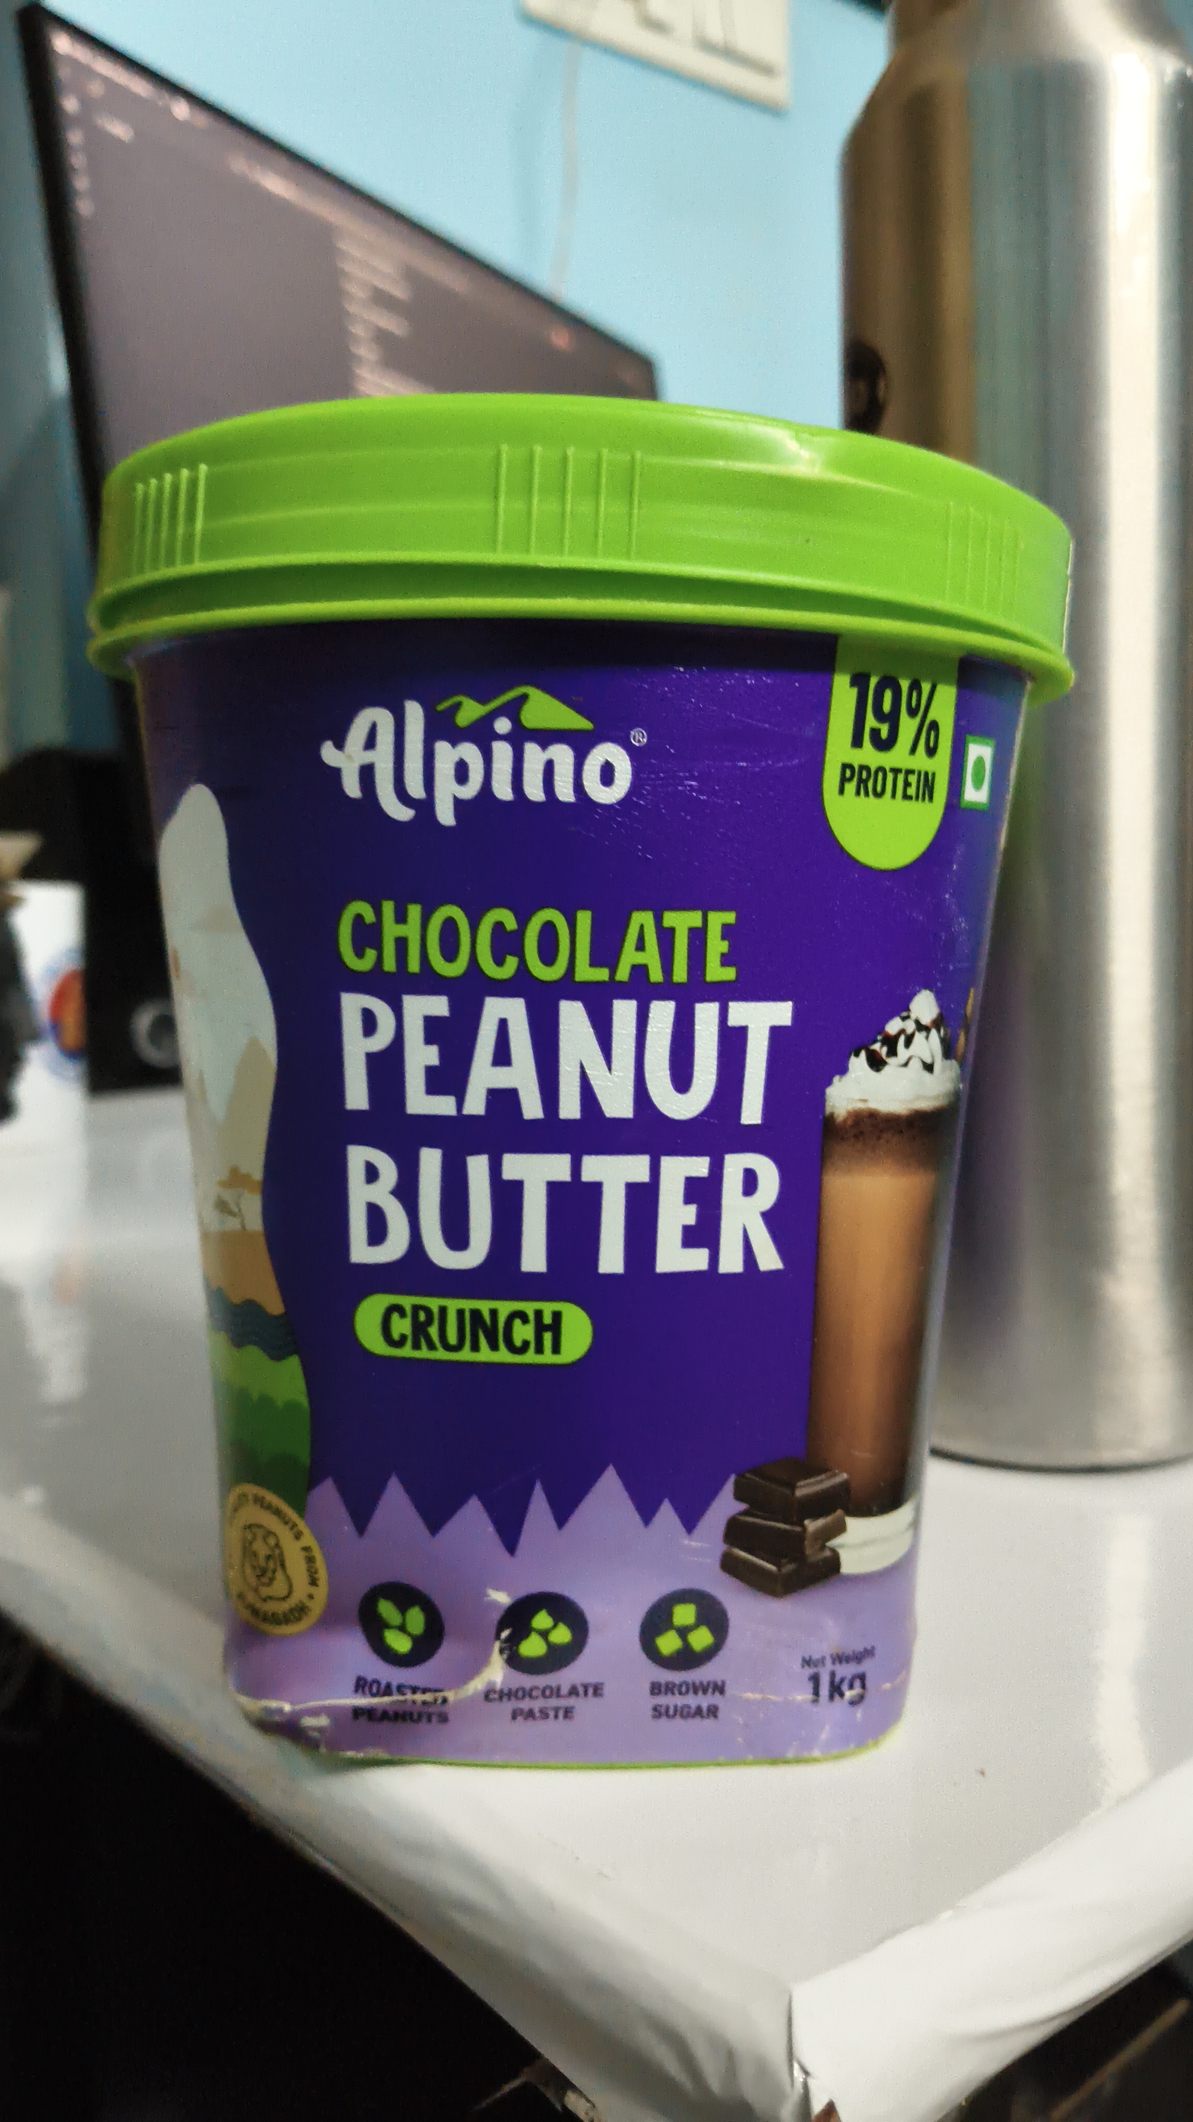
Figure 2 — Evidence Asset ID: EV-PB-05371B0A (IMG_20260920_041705.jpg)
SHA-256: 6cc325f72d92016c218e5bb5c04543d946e629267654ac6b873f4cccde8ab8e7 | Size: 3556 KB | Status: PRESERVED / IMMUTABLE
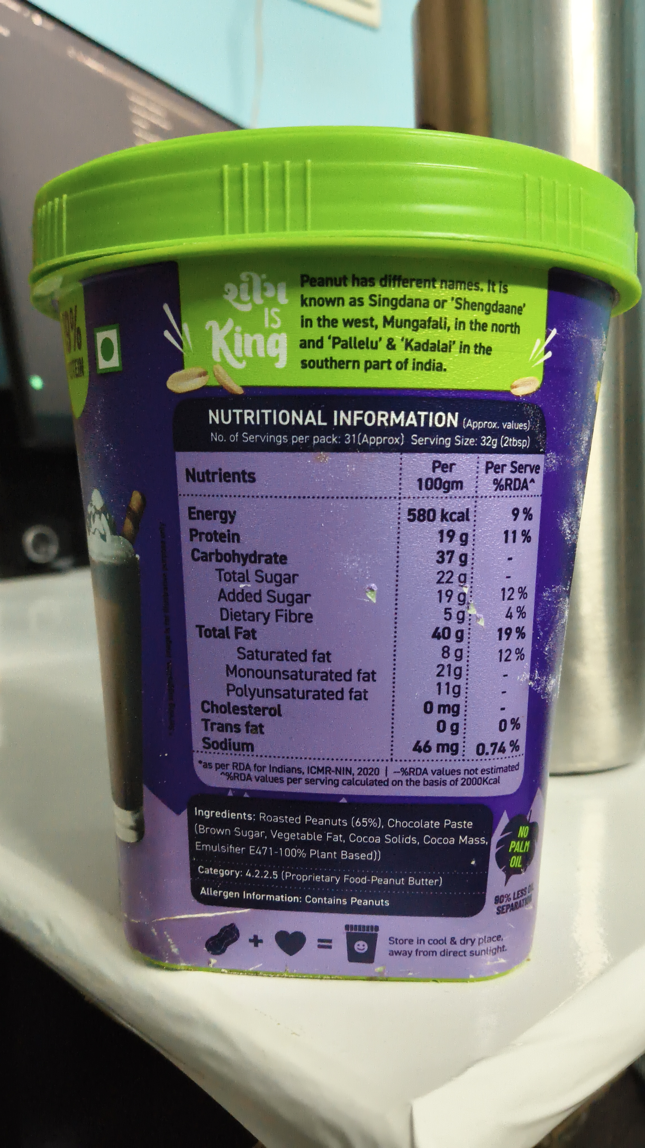
Figure 3 — Evidence Asset ID: EV-PB-36F30974 (IMG_20260920_041717.jpg)
SHA-256: 90914d801c3a8c2fe9756c76cff1f841280527e9af47ac17c9a3a9384671e203 | Size: 3365 KB | Status: PRESERVED / IMMUTABLE
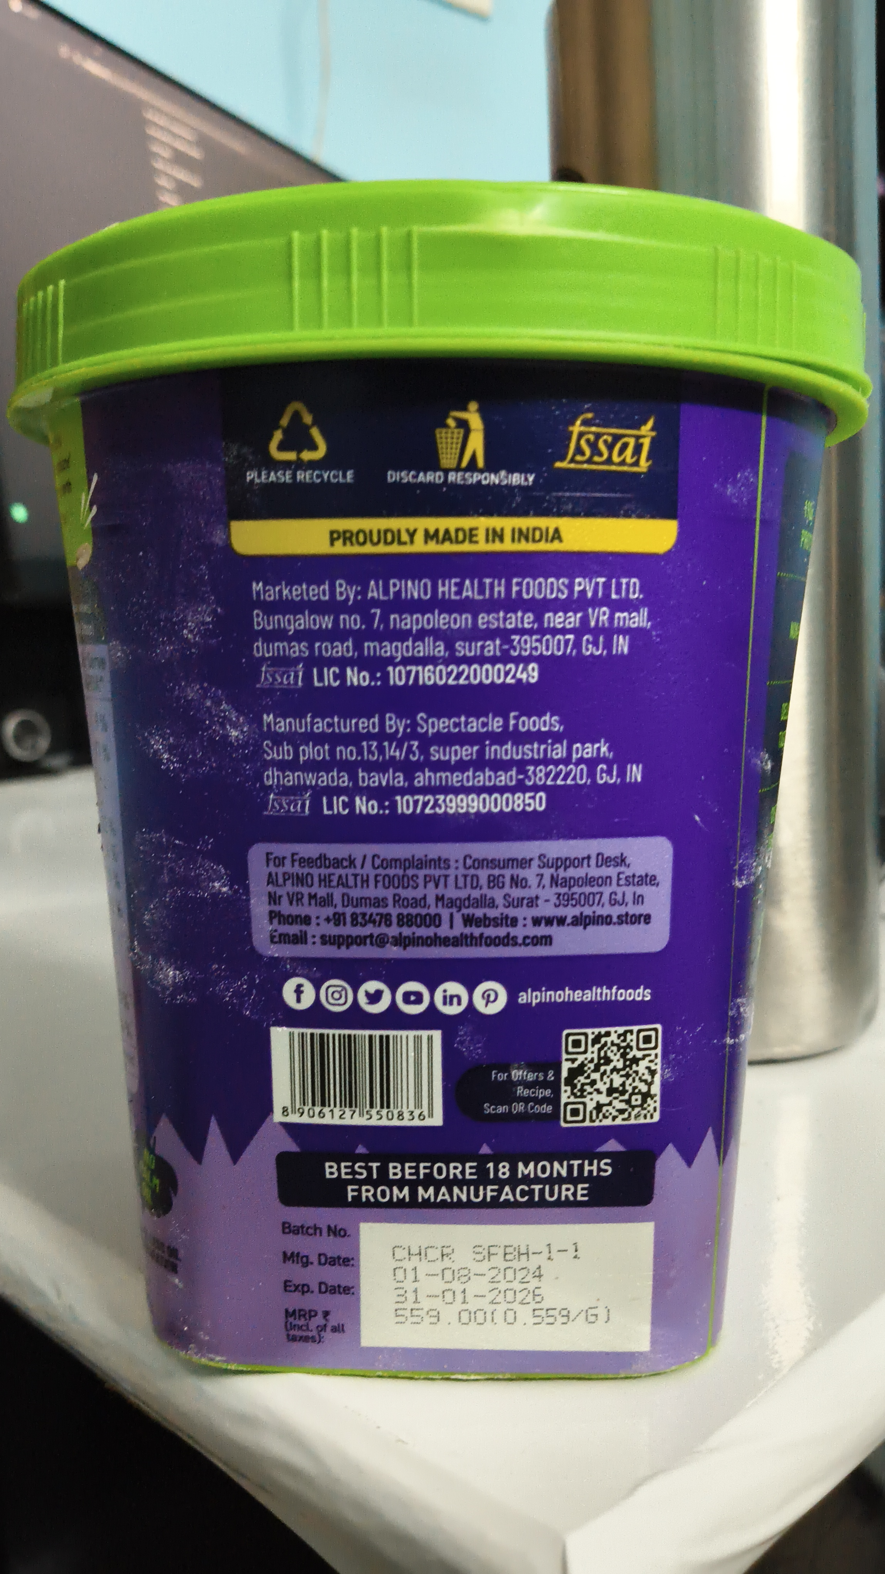
Figure 4 — Evidence Asset ID: EV-PB-FE104B6D (IMG_20260920_041726.jpg)
SHA-256: 653925000a73dd32802a0c2cc8fc8c65972842cd4d9860bbd0c37656b982b03e | Size: 3134 KB | Status: PRESERVED / IMMUTABLE
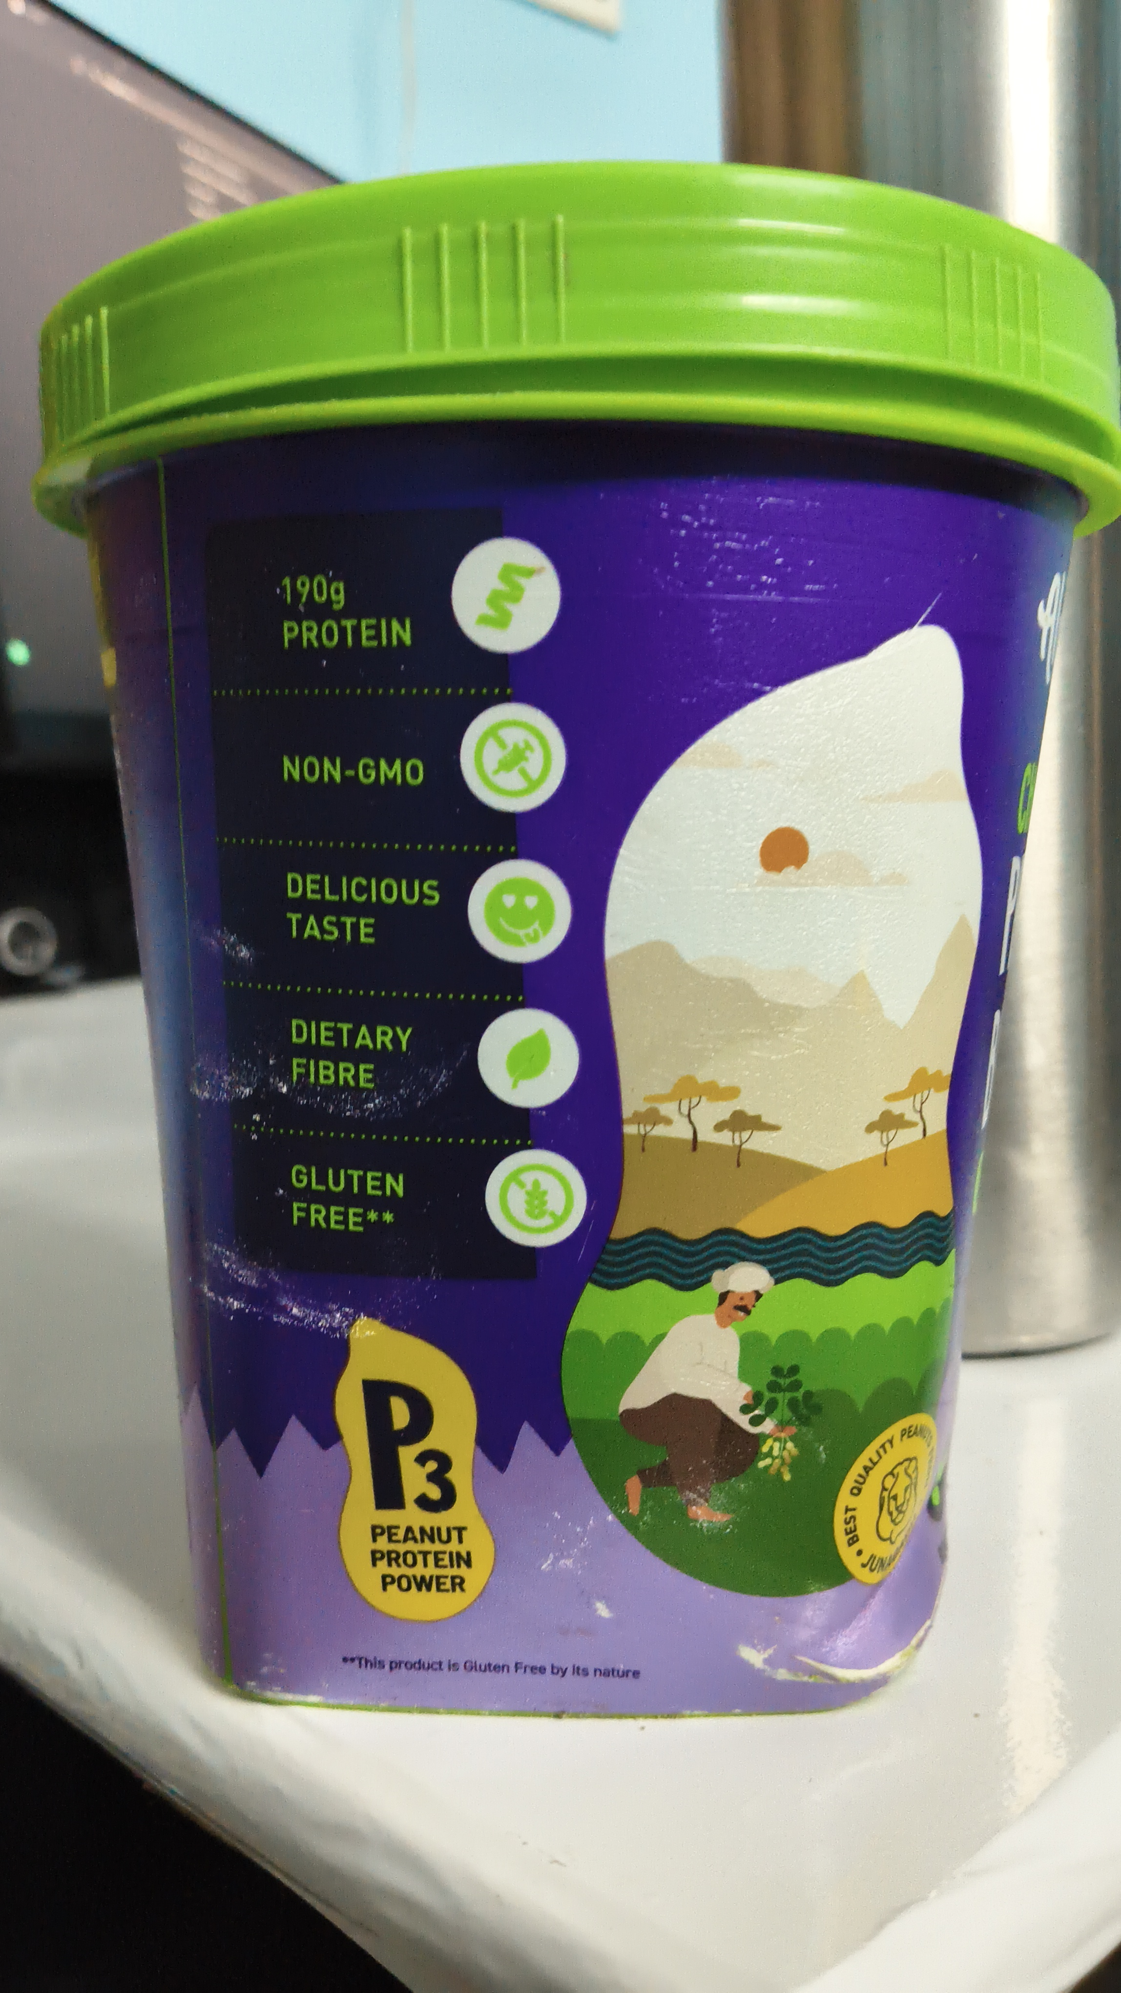

ANNEXURE B — DETAILED OCR TOKEN & BOUNDING BOX REGISTER
Evidence Asset: EV-PB-BC58B2BF (IMG_20260920_041658.jpg) — Engine: paddleocr-onnx — Total Tokens: 14
Idx | Detected Token Text | Confidence | Bounding Box Points
0 | 19% | 0.9481 | [[1627.7, 1268.83], [1842.95, 1287.34], [1826.55, 1482.7], [1611.3, 1464.19]]
1 | Alpino | 0.9776 | [[604.75, 1328.47], [1240.25, 1324.35], [1242.3, 1595.81], [606.8, 1599.92]]
2 | PROTEIN | 0.9896 | [[1607.2, 1451.85], [1814.25, 1470.36], [1806.05, 1556.73], [1599.0, 1538.23]]
3 | CHOCOLATE | 0.9921 | [[658.05, 1723.31], [1426.8, 1747.98], [1420.65, 1900.16], [651.9, 1875.48]]
4 | PEANUT | 0.9715 | [[643.7, 1885.77], [1535.45, 1914.56], [1527.25, 2183.95], [635.5, 2155.16]]
5 | BUTTER | 0.9607 | [[647.8, 2179.84], [1527.25, 2194.23], [1523.15, 2471.85], [643.7, 2457.46]]
6 | CRUNCH | 0.9848 | [[725.7, 2490.36], [1098.8, 2510.93], [1092.65, 2621.98], [719.55, 2601.41]]
7 | Ner Wegh | 0.8043 | [[1531.35, 3173.1], [1685.1, 3154.6], [1691.25, 3203.95], [1537.5, 3222.46]]
8 | ROACVE | 0.6843 | [[676.5, 3216.29], [830.25, 3220.4], [828.2, 3271.81], [674.45, 3267.7]]
9 | BROWN | 0.9816 | [[1240.25, 3220.4], [1406.3, 3220.4], [1406.3, 3275.93], [1240.25, 3275.93]]
10 | 1kg | 0.9775 | [[1537.5, 3203.95], [1683.05, 3203.95], [1683.05, 3290.32], [1537.5, 3290.32]]
11 | CHOCOLATE | 0.9772 | [[920.45, 3234.8], [1168.5, 3226.57], [1170.55, 3275.93], [922.5, 3284.15]]
12 | PASTE | 0.9880 | [[975.8, 3275.93], [1111.1, 3271.81], [1113.15, 3315.0], [977.85, 3319.11]]
13 | SUGAR | 0.9765 | [[1246.4, 3267.7], [1396.05, 3267.7], [1396.05, 3317.06], [1246.4, 3317.06]]
Evidence Asset: EV-PB-05371B0A (IMG_20260920_041705.jpg) — Engine: paddleocr-onnx — Total Tokens: 59
Idx | Detected Token Text | Confidence | Bounding Box Points
0 | Peanut has different names.t s | 0.9069 | [[1061.9, 954.19], [1820.4, 978.87], [1818.35, 1054.96], [1059.85, 1030.28]]
1 | known as Singdana or'Shengdaane | 0.9611 | [[1059.85, 1024.11], [1877.8, 1052.9], [1875.75, 1133.1], [1057.8, 1104.31]]
2 | King | 0.9944 | [[717.5, 1110.48], [1047.55, 1118.71], [1043.45, 1332.58], [713.4, 1324.35]]
3 | IS | 0.9465 | [[930.7, 1094.03], [1006.55, 1094.03], [1006.55, 1168.06], [930.7, 1168.06]]
4 | in the west,Mungafali, in the north | 0.9066 | [[1061.9, 1102.26], [1861.4, 1124.88], [1859.35, 1198.91], [1059.85, 1176.29]]
5 | and‘Pallelu'&‘Kadalal' in the | 0.8753 | [[1055.75, 1176.29], [1760.95, 1198.91], [1758.9, 1275.0], [1053.7, 1252.38]]
6 | southern part of india. | 0.9682 | [[1061.9, 1254.44], [1596.95, 1266.77], [1594.9, 1334.64], [1059.85, 1322.3]]
7 | NUTRITIONAL INFORMATION (Approx.values | 0.8837 | [[733.9, 1429.23], [1904.45, 1460.08], [1902.4, 1548.51], [731.85, 1517.66]]
8 | No.of Servings per pack:31(Approx) Serving Size:32g (2tbsp) | 0.9239 | [[740.05, 1523.83], [1892.15, 1542.34], [1892.15, 1601.98], [740.05, 1583.47]]
9 | Per | 0.9788 | [[1529.3, 1628.71], [1631.8, 1628.71], [1631.8, 1690.4], [1529.3, 1690.4]]
10 | Per Serve | 0.9627 | [[1715.85, 1626.65], [1931.1, 1630.77], [1931.1, 1694.52], [1715.85, 1690.4]]
11 | Nutrients | 0.9850 | [[653.95, 1651.33], [920.45, 1659.56], [918.4, 1729.48], [651.9, 1721.25]]
12 | 100gm | 0.9957 | [[1473.95, 1686.29], [1664.6, 1696.57], [1660.5, 1760.32], [1469.85, 1750.04]]
13 | %RDA~ | 0.8452 | [[1744.55, 1690.4], [1916.75, 1690.4], [1916.75, 1756.21], [1744.55, 1756.21]]
14 | Energy | 0.9923 | [[664.2, 1785.0], [852.8, 1803.51], [846.65, 1875.48], [658.05, 1856.98]]
15 | 580kcal | 0.9947 | [[1443.2, 1799.4], [1683.05, 1799.4], [1683.05, 1863.15], [1443.2, 1863.15]]
16 | %6 | 0.9970 | [[1810.15, 1791.17], [1908.55, 1791.17], [1908.55, 1863.15], [1810.15, 1863.15]]
17 | Protein | 0.9831 | [[666.25, 1863.15], [869.2, 1875.48], [865.1, 1945.4], [662.15, 1933.06]]
18 | 19g | 0.9936 | [[1549.8, 1867.26], [1683.05, 1871.37], [1681.0, 1947.46], [1547.75, 1943.35]]
19 | 11% | 0.9786 | [[1783.5, 1873.43], [1904.45, 1873.43], [1904.45, 1941.29], [1783.5, 1941.29]]
20 | Carbohydrate | 0.9789 | [[674.45, 1937.18], [1031.15, 1951.57], [1029.1, 2021.49], [672.4, 2007.1]]
21 | 37g | 0.9093 | [[1545.7, 1939.23], [1689.2, 1951.57], [1683.05, 2025.6], [1539.55, 2013.27]]
22 | Total Sugar | 0.9831 | [[764.65, 2009.15], [1068.05, 2019.44], [1066.0, 2089.35], [762.6, 2079.07]]
23 | 22g | 0.9935 | [[1543.65, 2011.21], [1697.4, 2021.49], [1693.3, 2093.47], [1539.55, 2083.19]]
24 | Added Sugar | 0.9801 | [[770.8, 2072.9], [1117.25, 2093.47], [1113.15, 2163.39], [766.7, 2142.82]]
Evidence Asset: EV-PB-36F30974 (IMG_20260920_041717.jpg) — Engine: paddleocr-onnx — Total Tokens: 35
Idx | Detected Token Text | Confidence | Bounding Box Points
0 | fssat | 0.8553 | [[1461.65, 1063.19], [1705.6, 1085.81], [1691.25, 1233.87], [1447.3, 1211.25]]
1 | PLEASE RECYCLE | 0.9562 | [[633.45, 1207.14], [926.6, 1207.14], [926.6, 1262.66], [633.45, 1262.66]]
2 | DISCARD RESPONSIBLY | 0.9831 | [[1000.4, 1211.25], [1391.95, 1217.42], [1391.95, 1264.72], [1000.4, 1258.55]]
3 | PROUDLYMADEIN INDIA | 0.9682 | [[848.7, 1363.43], [1463.7, 1353.15], [1463.7, 1414.84], [848.7, 1425.12]]
4 | Marketed By:ALPINO HEALTH FOODS PVT LTD. | 0.9227 | [[647.8, 1497.1], [1672.8, 1486.81], [1672.8, 1558.79], [647.8, 1569.07]]
5 | Bungalow no.7,napoleon estate,near VRmall, | 0.8883 | [[651.9, 1575.24], [1693.3, 1567.02], [1693.3, 1634.88], [651.9, 1643.1]]
6 | dumasrad,magdalla,surat395007GJ, | 0.8006 | [[649.85, 1647.22], [1637.95, 1636.94], [1637.95, 1706.85], [649.85, 1717.14]]
7 | ssai LIC No.:10716022000249 | 0.8866 | [[662.15, 1715.08], [1402.2, 1713.02], [1402.2, 1782.94], [662.15, 1785.0]]
8 | Manufactured By: Spectacle Foods, | 0.9429 | [[674.45, 1840.52], [1463.7, 1836.41], [1463.7, 1910.44], [674.45, 1914.56]]
9 | Sub plotno.1314/3,suer industrialpak | 0.7678 | [[674.45, 1912.5], [1592.85, 1908.39], [1592.85, 1978.31], [674.45, 1982.42]]
10 | dhanwada,bavla,ahmedabad382220,GJ,IN | 0.8563 | [[674.45, 1982.42], [1674.85, 1970.08], [1674.85, 2044.11], [674.45, 2056.45]]
11 | Issai LIC No.:10723999000850 | 0.8990 | [[678.55, 2048.23], [1424.75, 2044.11], [1424.75, 2120.2], [678.55, 2124.31]]
12 | For Feedback / Complaints:Consumer Support Desk, | 0.9569 | [[686.75, 2202.46], [1635.9, 2202.46], [1635.9, 2264.15], [686.75, 2264.15]]
13 | ALPINOHEALTHFOOSVTTDBGNo.7Naolnstat | 0.7117 | [[688.8, 2253.87], [1717.9, 2253.87], [1717.9, 2315.56], [688.8, 2315.56]]
14 | NrVRlmaadagallaa90 | 0.6388 | [[688.8, 2303.23], [1685.1, 2303.23], [1685.1, 2364.92], [688.8, 2364.92]]
15 | Phone:+91 83476 88000 I Website:www.alpino.store | 0.9241 | [[688.8, 2348.47], [1701.5, 2350.52], [1701.5, 2418.39], [688.8, 2416.33]]
16 | Email:support@alpinohealthfoods.com | 0.9661 | [[692.9, 2401.94], [1443.2, 2412.22], [1443.2, 2473.91], [692.9, 2463.63]]
17 | f@oone | 0.7270 | [[744.15, 2531.49], [1305.85, 2550.0], [1303.8, 2634.31], [742.1, 2615.81]]
18 | alpinohealthfoods | 0.9843 | [[1338.65, 2556.17], [1693.3, 2545.89], [1695.35, 2601.41], [1340.7, 2611.69]]
19 | ForOffers& | 0.8710 | [[1264.85, 2763.87], [1447.3, 2759.76], [1447.3, 2809.11], [1264.85, 2813.23]]
20 | Recipe, | 0.9920 | [[1328.4, 2805.0], [1443.2, 2811.17], [1441.15, 2856.41], [1326.35, 2850.24]]
21 | 89061271550836 | 0.9622 | [[725.7, 2856.41], [1119.3, 2868.75], [1117.25, 2916.05], [723.65, 2903.71]]
22 | Scan ORCode | 0.9736 | [[1250.5, 2852.3], [1441.15, 2852.3], [1441.15, 2895.48], [1250.5, 2895.48]]
23 | BEST BEFORE 18 MONTHS | 0.8911 | [[836.4, 3006.53], [1592.85, 2996.25], [1592.85, 3057.94], [836.4, 3068.23]]
24 | FROM MANUFACTURE | 0.9565 | [[895.85, 3068.23], [1533.4, 3064.11], [1533.4, 3119.64], [895.85, 3123.75]]
Evidence Asset: EV-PB-FE104B6D (IMG_20260920_041726.jpg) — Engine: paddleocr-onnx — Total Tokens: 16
Idx | Detected Token Text | Confidence | Bounding Box Points
0 | 190g | 0.9923 | [[555.55, 1161.9], [723.65, 1161.9], [723.65, 1260.6], [555.55, 1260.6]]
1 | PROTEIN | 0.9717 | [[569.9, 1258.55], [852.8, 1254.44], [852.8, 1332.58], [569.9, 1336.69]]
2 | NON-GMO | 0.9814 | [[571.95, 1534.11], [875.35, 1544.4], [873.3, 1620.48], [569.9, 1610.2]]
3 | DELICIOUS | 0.9828 | [[584.25, 1774.72], [908.15, 1795.28], [904.05, 1865.2], [580.15, 1844.64]]
4 | TASTE | 0.9642 | [[580.15, 1854.92], [783.1, 1871.37], [776.95, 1943.35], [574.0, 1926.9]]
5 | DIETARY | 0.9802 | [[594.5, 2072.9], [852.8, 2095.52], [846.65, 2165.44], [588.35, 2142.82]]
6 | FIBRE | 0.9796 | [[588.35, 2151.05], [783.1, 2163.39], [779.0, 2241.53], [584.25, 2229.19]]
7 | GLUTEN | 0.9566 | [[590.4, 2369.03], [840.5, 2393.71], [834.35, 2463.63], [584.25, 2438.95]]
8 | FREE** | 0.9912 | [[592.45, 2447.18], [824.1, 2463.63], [817.95, 2537.66], [586.3, 2521.21]]
9 | P | 0.9486 | [[721.6, 2813.23], [936.85, 2796.77], [959.4, 3107.3], [744.15, 3123.75]]
10 | PEAM | 0.8618 | [[1830.65, 2920.16], [1886.0, 2907.82], [1896.25, 2951.01], [1840.9, 2963.35]]
11 | PEANUT | 0.9925 | [[752.35, 3109.35], [965.55, 3115.52], [963.5, 3173.1], [750.3, 3166.94]]
12 | PROTEIN | 0.9921 | [[750.3, 3162.82], [973.75, 3166.94], [973.75, 3222.46], [750.3, 3218.35]]
13 | JUN | 0.9483 | [[1771.2, 3175.16], [1818.35, 3175.16], [1818.35, 3218.35], [1771.2, 3218.35]]
14 | POWER | 0.9845 | [[770.8, 3216.29], [963.5, 3216.29], [963.5, 3271.81], [770.8, 3271.81]]
15 | This product le Gluten Free by Its nature | 0.9225 | [[694.95, 3378.75], [1318.15, 3403.43], [1316.1, 3450.73], [692.9, 3426.05]]

ANNEXURE C — DETAILED STATUTORY FINDINGS MATRIX
Sl. | Rule & Citation | Statutory Requirement | System Result | Adjudicated Result | Statutory Finding Rationale
1 | Rule 6(1)(b) | commodity_name | REQUIRES_REVIEW | PASS | Reconciled commodity description: 'Alpino Chocolate Peanut Butter Crunch' on principal display panel and 'Peanut Butter' (Proprietary Food Category 4.2.2.5) on technical information panel both accurately describe the packaged commodity under Rule 6(1)(b) of LMPC Rules, 2011 and FSSAI standards. Adjudicated as PASS.
2 | Rule 6(1)(f) | consumer_care | PASS | PASS | Statutory declaration for consumer_care verified and corroborated across evidence assets under Rule 6(1)(f).
3 | Rule 6(1)(da) | country_of_origin | NOT_APPLICABLE | PASS | Statutory declaration for country_of_origin verified and corroborated across evidence assets under Rule 6(1)(da).
4 | Rule 6(1)(d) | manufacture_packing_date | PASS | PASS | Statutory declaration for manufacture_packing_date verified and corroborated across evidence assets under Rule 6(1)(d).
5 | Rule 6(1)(a) | manufacturer_identity | PASS | PASS | Statutory declaration for manufacturer_identity verified and corroborated across evidence assets under Rule 6(1)(a).
6 | Rule 6(1)(e) | mrp | PASS | PASS | Statutory declaration for mrp verified and corroborated across evidence assets under Rule 6(1)(e).
7 | Rule 6(1)(c) | net_quantity | PASS | PASS | Statutory declaration for net_quantity verified and corroborated across evidence assets under Rule 6(1)(c).

ANNEXURE D — RAW STRUCTURED FINALAUDITRECORD SNAPSHOT
Deterministic Serialized JSON Representation of the Immutable FinalAuditRecord:
{
"applicability_snapshot": [
{
"applicability_status": "APPLICABLE",
"requirement_name": "manufacturer_identity",
"rule_citation": "Rule 6(1)(a)"
},
{
"applicability_status": "APPLICABLE",
"requirement_name": "commodity_name",
"rule_citation": "Rule 6(1)(b)"
},
{
"applicability_status": "APPLICABLE",
"requirement_name": "net_quantity",
"rule_citation": "Rule 6(1)(c)"
},
{
"applicability_status": "APPLICABLE",
"requirement_name": "manufacture_packing_date",
"rule_citation": "Rule 6(1)(d)"
},
{
"applicability_status": "APPLICABLE",
"requirement_name": "mrp",
"rule_citation": "Rule 6(1)(e)"
},
{
"applicability_status": "APPLICABLE",
"requirement_name": "consumer_care",
"rule_citation": "Rule 6(1)(f)"
},
{
"applicability_status": "NOT_APPLICABLE",
"requirement_name": "country_of_origin",
"rule_citation": "Rule 6(1)(da)"
}
],
"compliance_findings_snapshot": [
{
"applicability_status": "APPLICABLE",
"evidence_id": "EV-PB-36F30974",
"id": "FND-PB-BA73079DCC",
"reason": "Manufacturer and marketer identities explicitly declared on statutory panel with full postal addresses.",
"requirement_name": "manufacturer_identity",
"result": "PASS",
"rule_citation": "Rule 6(1)(a)",
"source_token_indices": [
4,
5,
6,
8,
9,
10
]
},
{
"applicability_status": "APPLICABLE",
"evidence_id": "EV-PB-BC58B2BF",
"id": "FND-PB-7BDB6A5C16",
"reason": "Generic name varies between PDP ('Alpino Chocolate Peanut Butter Crunch') and side panel ('Peanut Butter'). Requires reviewer reconciliation.",
"requirement_name": "commodity_name",
"result": "REQUIRES_REVIEW",
"rule_citation": "Rule 6(1)(b)",
"source_token_indices": [
1,
3,
4,
5,
6
]
},
{
"applicability_status": "APPLICABLE",
"evidence_id": "EV-PB-BC58B2BF",
"id": "FND-PB-F906DBE3EA",
"reason": "Declared net weight of 1kg is in standard metric units per Second Schedule of LMPC Rules, 2011.",
"requirement_name": "net_quantity",
"result": "PASS",
"rule_citation": "Rule 6(1)(c)",
"source_token_indices": [
10
]
},
{
"applicability_status": "APPLICABLE",
"evidence_id": "EV-PB-36F30974",
"id": "FND-PB-44DE43228B",
"reason": "Date of manufacture (01-08-2024 / 08/2024) clearly declared with batch code.",
"requirement_name": "manufacture_packing_date",
"result": "PASS",
"rule_citation": "Rule 6(1)(d)",
"source_token_indices": [
23,
24,
25,
26,
27,
28,
29,
30
]
},
{
"applicability_status": "APPLICABLE",
"evidence_id": "EV-PB-36F30974",
"id": "FND-PB-336CB05F26",
"reason": "Retail sale price declared as Rs. 559.00 with unit sale price of Rs. 0.559/g.",
"requirement_name": "mrp",
"result": "PASS",
"rule_citation": "Rule 6(1)(e)",
"source_token_indices": [
31,
32
]
},
{
"applicability_status": "APPLICABLE",
"evidence_id": "EV-PB-36F30974",
"id": "FND-PB-79931A732F",
"reason": "Complete consumer care details provided including dedicated email, te

