
GOVERNMENT OF INDIA
MINISTRY OF CONSUMER AFFAIRS, FOOD & PUBLIC DISTRIBUTION
DEPARTMENT OF CONSUMER AFFAIRS — LEGAL METROLOGY DIVISION
STATUTORY INSPECTION & COMPLIANCE ASSESSMENT DOSSIER
PACKAGED COMMODITIES REGULATORY ENFORCEMENT RECORD
Inspection ID: | INS-UNI-2888D8 | Final Audit Record ID: | FAR-UNI-72D97C807D
Docket / Case No: | INSP-2026-DEL-LM-2888D8 | Report Generated: | 2026-09-20 11:38:18 UTC
Rule-Set Version: | LMPC-2011-MVP-RULES (v1.0) | Evidence Assets: | 4 Files (SHA-256)
OCR Engine: | PaddleOCR PP-OCRv4 (rapidocr-onnxruntime==1.2.3) | AI Model: | Google Gemini 3.6 Flash (gemini-3.6-flash)
Finalization Status: | FINALIZED | Record Status: | READ-ONLY
1.0 INSPECTION PARTICULARS
Inspection ID: | INS-UNI-2888D8 | Inspection Date: | 2026-09-20
Inspection Type: | Statutory Legal Metrology Packaging Inspection | Facility / Location: | Registered Retail Premises, Main Market, Sector 18, New Delhi, Delhi, Delhi (PIN: 110001)
Inspecting Officer: | Rajesh Kumar (LMI-DEL-7824) — Senior Legal Metrology Inspector, Central District Inspection Unit, New Delhi | Reviewing Officer: | Dr. Sunita Sharma (AC-LM-DEL-104) — Assistant Controller of Legal Metrology, Legal Metrology Adjudication Cell
Started Timestamp: | 2026-09-20T00:00:00+00:00 | Finalized Timestamp: | 2026-09-20 11:37:24 UTC
2.0 PARTICULARS OF THE PACKAGED COMMODITY
Product Name: | Packaged Commodity Inspection Target | Brand Name: | Itcltd.  Cpcb Regn.No.  Bo-08-000-07-Aaaci5950L-22  Cm  8901725100117
Category: | Packaged Commodities | Variant / Flavour: | NOT RECORDED
Declared Net Qty: | 100.0 ml | Batch / Lot No: | NOT OBSERVED ON INSPECTED PANELS
Manufacturer: | Itcltd.  Cpcb Regn.No.  Bo-08-000-07-Aaaci5950L-22  Cm  8901725100117 | Packer / Importer: | Itcltd.  Cpcb Regn.No.  Bo-08-000-07-Aaaci5950L-22  Cm  8901725100117 / NOT APPLICABLE (DOMESTIC MANUFACTURE)
Country of Origin: | India (Domestic Exemption) | Origin Status: | DOMESTIC
3.0 EVIDENCE REGISTER & CRYPTOGRAPHIC INTEGRITY HASHES
Sl. | Evidence ID | Filename / View | Size | SHA-256 Hash | Status
1 | EV-UNI-41CE3F3F | IMG_20260920_040854.jpg (PRIMARY) | 1276 KB | 7987f3a2fcc2601d82ebb79504ecbaee6f3c5964a31f63607728396fcda45a73 | PRESERVED / IMMUTABLE
2 | EV-UNI-F09A5976 | IMG_20260920_040900.jpg (PRIMARY) | 1172 KB | d0891ea5c2d12522deb98ca8e259583fa259ad6306359dfab0a5eb274777ad00 | PRESERVED / IMMUTABLE
3 | EV-UNI-33C14041 | IMG_20260920_040906.jpg (PRIMARY) | 1270 KB | 95db45287da0969ecefff09dec87af5052488507b0395d1d08b4ddcd410730b8 | PRESERVED / IMMUTABLE
4 | EV-UNI-EEE724BA | IMG_20260920_040922.jpg (PRIMARY) | 1232 KB | 919b9530ea24a31f172b73fea330754e15c5349d0cdc4aca22f64d7812a3226c | PRESERVED / IMMUTABLE
4.0 DECLARATION EXTRACTION & EVIDENCE SYNTHESIS
Sl. | Statutory Requirement | Synthesized Value | Status | Source Evidence | Synthesis Basis / Notes
1 | Rule 6(1)(a) — Manufacturer / Packer / Importer | status: OBSERVED, declaration_type: MANUFACTURER_AND_MARKETER, name: Itcltd.  Cpcb Regn.No.  Bo-08-000-07-Aaaci5950L-22  Cm  8901725100117, address: No.10012031000312, source_token_ids: [21, 29] | OBSERVED | EV-UNI-41CE3F3F | Single evidence observation verified.
2 | Rule 6(1)(b) — Generic / Common Commodity Name | NOT OBSERVED | CONFLICTING | EV-UNI-41CE3F3F | Conflicting declarations observed between evidence ['EV-UNI-41CE3F3F'] and ['EV-UNI-F09A5976', 'EV-UNI-33C14041', 'EV-UNI-EEE724BA'].
3 | Rule 6(1)(c) — Net Quantity & Standard Metric Units | status: OBSERVED, quantity_value: 100.0, unit: ml, unit_raw: 100ml, source_token_ids: [6] | OBSERVED | EV-UNI-33C14041 | Single evidence observation verified.
4 | Rule 6(1)(d) — Date of Manufacture / Packing | NOT OBSERVED | NOT_OBSERVED | None | Not observed across any evidence asset.
5 | Rule 6(1)(e) — Maximum Retail Price (Incl. of all taxes) | NOT OBSERVED | NOT_OBSERVED | None | Not observed across any evidence asset.
6 | Rule 6(1)(f) — Consumer Care Grievance Redressal | status: OBSERVED, contact_name: Consumer Care Cell, phone: 1800425444444, email: itccares@itc.in, source_token_ids: [61, 67] | OBSERVED | EV-UNI-33C14041 | Single evidence observation verified.
7 | Rule 6(1)(da) — Country of Origin (Imported Goods) | NOT OBSERVED | NOT_OBSERVED | None | Not observed across any evidence asset.
5.0 STATUTORY APPLICABILITY AND RULE-WISE EVALUATION
Sl. | Requirement & Citation | Applicability | System Result | Reviewer Action | Adjudicated Result
1 | commodity_name  (Rule 6(1)(b)) | APPLICABLE | REQUIRES_REVIEW | OVERRIDE | PASS
2 | consumer_care  (Rule 6(1)(f)) | APPLICABLE | PASS | CONFIRMED | PASS
3 | country_of_origin  (Rule 6(1)(da)) | NOT_APPLICABLE | NOT_APPLICABLE | CONFIRMED | NOT_APPLICABLE
4 | manufacture_packing_date  (Rule 6(1)(d)) | APPLICABLE | POTENTIAL_NON_COMPLIANCE | CONFIRMED | POTENTIAL_NON_COMPLIANCE
5 | manufacturer_identity  (Rule 6(1)(a)) | APPLICABLE | PASS | CONFIRMED | PASS
6 | mrp  (Rule 6(1)(e)) | APPLICABLE | POTENTIAL_NON_COMPLIANCE | CONFIRMED | POTENTIAL_NON_COMPLIANCE
7 | net_quantity  (Rule 6(1)(c)) | APPLICABLE | PASS | CONFIRMED | PASS
6.0 OBSERVATIONS / POTENTIAL NON-COMPLIANCE REGISTER
Sl. | Requirement | Statutory Rule | Finding Rationale | Final Adjudication
1 | commodity_name | Rule 6(1)(b) | Reconciled multi-panel observation for commodity_name under Rule 6(1)(b). | PASS
2 | manufacture_packing_date | Rule 6(1)(d) | Confirmed automated finding for manufacture_packing_date under Rule 6(1)(d). | POTENTIAL_NON_COMPLIANCE
3 | mrp | Rule 6(1)(e) | Confirmed automated finding for mrp under Rule 6(1)(e). | POTENTIAL_NON_COMPLIANCE
7.0 EVIDENCE & VISUAL CORROBORATION (PANEL REGISTRY)
Evidence ID | Filename / Panel View | Observed Declarations on Panel | Tokens Detected
EV-UNI-41CE3F3F | IMG_20260920_040854.jpg  (Package Panel (PRIMARY)) | Rule 6(1)(a), Rule 6(1)(b) | 34 OCR bounding boxes
EV-UNI-F09A5976 | IMG_20260920_040900.jpg  (Package Panel (PRIMARY)) | General Package View / Context | 6 OCR bounding boxes
EV-UNI-33C14041 | IMG_20260920_040906.jpg  (Package Panel (PRIMARY)) | Rule 6(1)(c), Rule 6(1)(f) | 70 OCR bounding boxes
EV-UNI-EEE724BA | IMG_20260920_040922.jpg  (Package Panel (PRIMARY)) | General Package View / Context | 7 OCR bounding boxes
8.0 INSPECTING OFFICER'S VERIFICATION & AUTHENTICATION
Sl. | Requirement | System Observation | Inspector Verification & Remarks | Status
1 | commodity_name | REQUIRES_REVIEW | PASS  Physical package panel verified against automated perception. | CONFIRMED
2 | consumer_care | PASS | PASS  Physical package panel verified against automated perception. | CONFIRMED
3 | country_of_origin | NOT_APPLICABLE | NOT_APPLICABLE  Physical package panel verified against automated perception. | CONFIRMED
4 | manufacture_packing_date | POTENTIAL_NON_COMPLIANCE | POTENTIAL_NON_COMPLIANCE  Physical package panel verified against automated perception. | CONFIRMED
5 | manufacturer_identity | PASS | PASS  Physical package panel verified against automated perception. | CONFIRMED
6 | mrp | POTENTIAL_NON_COMPLIANCE | POTENTIAL_NON_COMPLIANCE  Physical package panel verified against automated perception. | CONFIRMED
7 | net_quantity | PASS | PASS  Physical package panel verified against automated perception. | CONFIRMED
9.0 REVIEWING OFFICER'S ADJUDICATION & DETERMINATION
FINAL MASTER ADJUDICATION: COMPLIANT
Reviewing Officer: Dr. Sunita Sharma (AC-LM-DEL-104) — Assistant Controller of Legal Metrology, Department of Consumer Affairs, Government of NCT of Delhi | Finalized: 2026-09-20 11:37:24 UTC
Statutory Adjudication Rationale: Statutory packaging declarations verified under Legal Metrology Rules, 2011.
Digital Signature / Authentication Status: VERIFIED & CRYPTOGRAPHICALLY SEALED
10.0 FINAL COMPLIANCE SUMMARY & STATUTORY METRICS
Requirements Assessed: | 7 | Pass Count: | 4
Applicable Rules: | 6 | Potential Non-Compliance: | 2
Exempt / Not Applicable: | 1 | Requires Review: | 0
Evidence Preserved: | 4 Files | Final Decision: | COMPLIANT
11.0 EVIDENCE INTEGRITY & ANTI-TAMPERING CONTROLS
A SHA-256 cryptographic fingerprint is calculated and recorded for each evidence asset at the time of ingestion. The fingerprint establishes byte-level change detection for the stored digital evidence. The hash confirms evidence integrity and does not independently establish the authenticity of the physical commodity.
Evidence Asset ID | Preserved Filename | SHA-256 Fingerprint | Custody State
EV-UNI-41CE3F3F | IMG_20260920_040854.jpg | 7987f3a2fcc2601d82ebb79504ecbaee6f3c5964a31f63607728396fcda45a73 | SEALED_IMMUTABLE
EV-UNI-F09A5976 | IMG_20260920_040900.jpg | d0891ea5c2d12522deb98ca8e259583fa259ad6306359dfab0a5eb274777ad00 | SEALED_IMMUTABLE
EV-UNI-33C14041 | IMG_20260920_040906.jpg | 95db45287da0969ecefff09dec87af5052488507b0395d1d08b4ddcd410730b8 | SEALED_IMMUTABLE
EV-UNI-EEE724BA | IMG_20260920_040922.jpg | 919b9530ea24a31f172b73fea330754e15c5349d0cdc4aca22f64d7812a3226c | SEALED_IMMUTABLE
12.0 COMPLETE CHRONOLOGICAL AUDIT TRAIL
Sl. | Timestamp (UTC) | Actor (Role) | Event Type | Event Specifics & Metadata

ANNEXURE A — PHOTOGRAPHIC EVIDENCE REGISTER (EMBEDDED IMAGES)
Figure 1 — Evidence Asset ID: EV-UNI-41CE3F3F (IMG_20260920_040854.jpg)
SHA-256: 7987f3a2fcc2601d82ebb79504ecbaee6f3c5964a31f63607728396fcda45a73 | Size: 1276 KB | Status: PRESERVED / IMMUTABLE
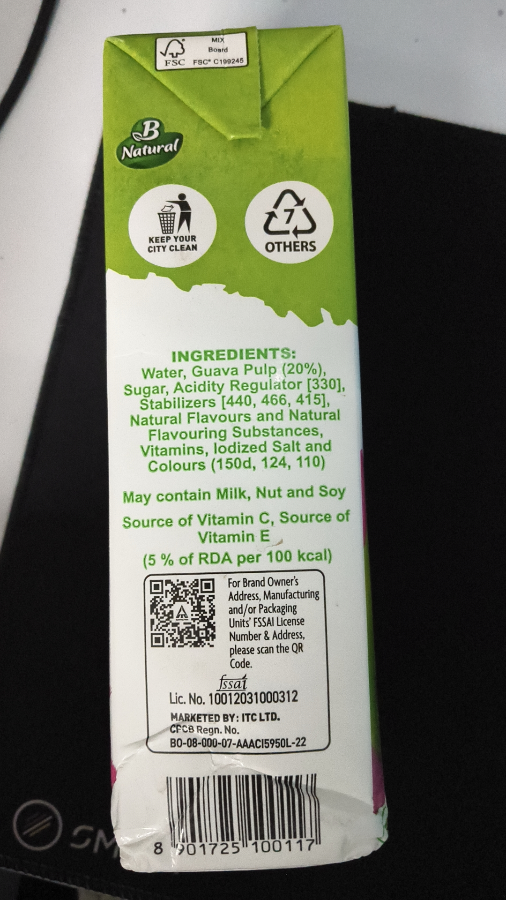
Figure 2 — Evidence Asset ID: EV-UNI-F09A5976 (IMG_20260920_040900.jpg)
SHA-256: d0891ea5c2d12522deb98ca8e259583fa259ad6306359dfab0a5eb274777ad00 | Size: 1172 KB | Status: PRESERVED / IMMUTABLE
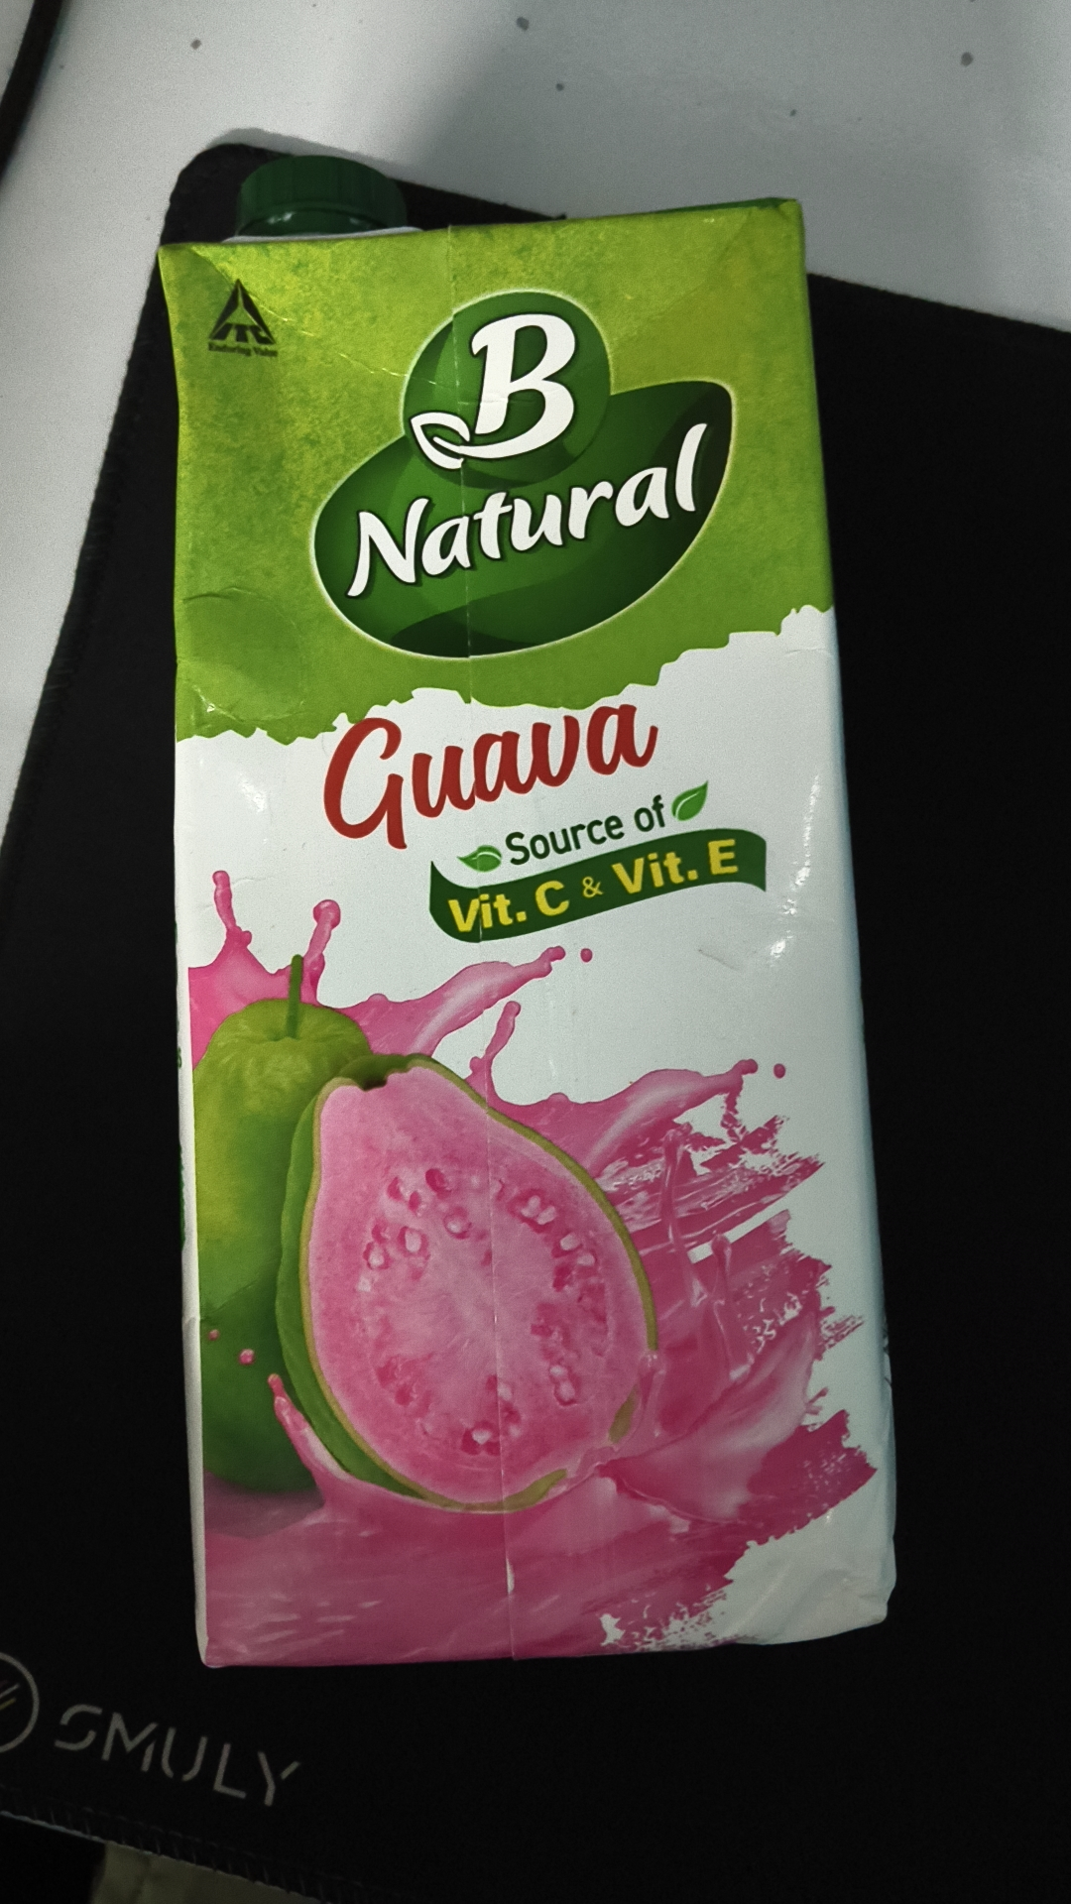
Figure 3 — Evidence Asset ID: EV-UNI-33C14041 (IMG_20260920_040906.jpg)
SHA-256: 95db45287da0969ecefff09dec87af5052488507b0395d1d08b4ddcd410730b8 | Size: 1270 KB | Status: PRESERVED / IMMUTABLE
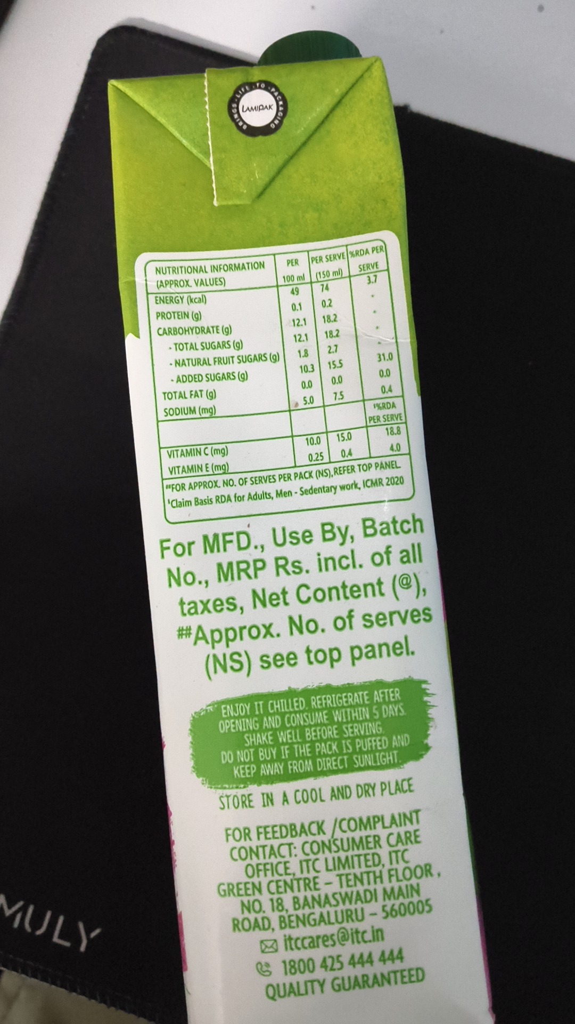
Figure 4 — Evidence Asset ID: EV-UNI-EEE724BA (IMG_20260920_040922.jpg)
SHA-256: 919b9530ea24a31f172b73fea330754e15c5349d0cdc4aca22f64d7812a3226c | Size: 1232 KB | Status: PRESERVED / IMMUTABLE
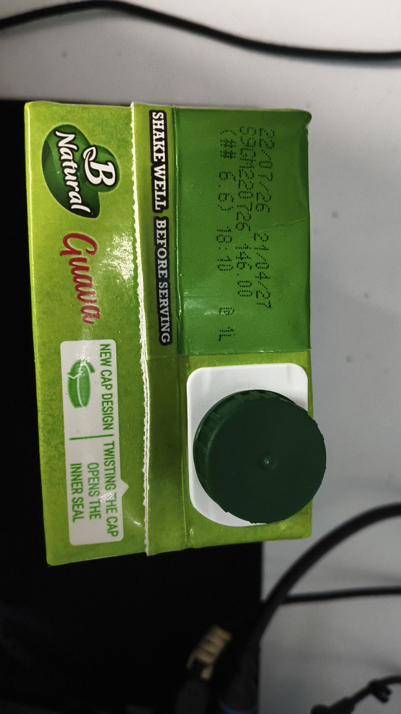

ANNEXURE B — DETAILED OCR TOKEN & BOUNDING BOX REGISTER
Evidence Asset: EV-UNI-41CE3F3F (IMG_20260920_040854.jpg) — Engine: paddleocr-onnx — Total Tokens: 34
Idx | Detected Token Text | Confidence | Bounding Box Points
0 | MIX | 0.9789 | [[449.0, 76.0], [481.0, 76.0], [481.0, 95.0], [449.0, 95.0]]
1 | Board | 0.9814 | [[442.0, 96.0], [490.0, 96.0], [490.0, 117.0], [442.0, 117.0]]
2 | FSC | 0.9894 | [[346.0, 125.0], [402.0, 123.0], [403.0, 144.0], [347.0, 146.0]]
3 | FSCC199245 | 0.9954 | [[406.0, 123.0], [525.0, 120.0], [525.0, 140.0], [406.0, 143.0]]
4 | Natural | 0.9895 | [[252.0, 308.0], [383.0, 290.0], [388.0, 329.0], [257.0, 347.0]]
5 | KEEPYOUR | 0.9912 | [[313.0, 500.0], [423.0, 496.0], [424.0, 520.0], [314.0, 524.0]]
6 | OTHERS | 0.9820 | [[561.0, 510.0], [679.0, 508.0], [679.0, 542.0], [561.0, 544.0]]
7 | CITY CLEAN | 0.9519 | [[311.0, 521.0], [424.0, 516.0], [425.0, 540.0], [313.0, 545.0]]
8 | INGREDIENTS: | 0.9909 | [[365.0, 745.0], [632.0, 738.0], [633.0, 768.0], [366.0, 775.0]]
9 | Water,Guava Pulp (20%), | 0.9405 | [[299.0, 777.0], [696.0, 769.0], [697.0, 805.0], [299.0, 813.0]]
10 | Sugar,Acidity Regulator[330], | 0.9431 | [[260.0, 811.0], [739.0, 800.0], [740.0, 839.0], [261.0, 850.0]]
11 | Stabilizers[440,466,415], | 0.9532 | [[294.0, 841.0], [709.0, 831.0], [710.0, 871.0], [296.0, 881.0]]
12 | Natural Flavours and Natural | 0.9518 | [[275.0, 880.0], [729.0, 868.0], [730.0, 901.0], [276.0, 913.0]]
13 | Flavouring Substances, | 0.9830 | [[312.0, 910.0], [692.0, 902.0], [693.0, 937.0], [313.0, 945.0]]
14 | Vitamins,lodized Saltand | 0.9537 | [[296.0, 944.0], [711.0, 932.0], [712.0, 968.0], [298.0, 980.0]]
15 | Colours（150d,124,110） | 0.9166 | [[313.0, 977.0], [695.0, 967.0], [696.0, 1004.0], [314.0, 1014.0]]
16 | May contain Milk,Nut and Soy | 0.9096 | [[259.0, 1041.0], [740.0, 1028.0], [741.0, 1068.0], [260.0, 1081.0]]
17 | Source of Vitamin C,Source of | 0.9189 | [[259.0, 1097.0], [751.0, 1083.0], [752.0, 1119.0], [260.0, 1133.0]]
18 | Vitamin E | 0.9494 | [[421.0, 1130.0], [602.0, 1127.0], [603.0, 1160.0], [421.0, 1163.0]]
19 | （5%of RDA per 100 kcal) | 0.8782 | [[306.0, 1177.0], [708.0, 1168.0], [709.0, 1204.0], [307.0, 1213.0]]
20 | For Brand Owner's | 0.9077 | [[482.0, 1229.0], [640.0, 1224.0], [641.0, 1254.0], [483.0, 1259.0]]
21 | Address,Manufacturing | 0.9095 | [[485.0, 1256.0], [686.0, 1253.0], [686.0, 1283.0], [486.0, 1286.0]]
22 | and/or Packaging | 0.9611 | [[487.0, 1285.0], [637.0, 1284.0], [637.0, 1315.0], [488.0, 1316.0]]
23 | Units'FSSAI License | 0.9349 | [[487.0, 1315.0], [653.0, 1311.0], [653.0, 1340.0], [488.0, 1344.0]]
24 | Number&Address, | 0.9851 | [[486.0, 1342.0], [652.0, 1338.0], [652.0, 1368.0], [487.0, 1372.0]]
Evidence Asset: EV-UNI-F09A5976 (IMG_20260920_040900.jpg) — Engine: paddleocr-onnx — Total Tokens: 6
Idx | Detected Token Text | Confidence | Bounding Box Points
0 | B | 0.9876 | [[412.0, 298.0], [599.0, 298.0], [599.0, 480.0], [412.0, 480.0]]
1 | Natural | 0.9931 | [[332.0, 511.0], [710.0, 429.0], [732.0, 533.0], [354.0, 615.0]]
2 | Guava | 0.9455 | [[301.0, 703.0], [684.0, 672.0], [698.0, 847.0], [315.0, 878.0]]
3 | Source of | 0.9813 | [[500.0, 836.0], [688.0, 791.0], [698.0, 835.0], [510.0, 880.0]]
4 | Vit.C&Vit.E | 0.9740 | [[445.0, 904.0], [746.0, 835.0], [757.0, 884.0], [456.0, 953.0]]
5 | SMULY | 0.9747 | [[61.0, 1708.0], [307.0, 1771.0], [293.0, 1828.0], [46.0, 1765.0]]
Evidence Asset: EV-UNI-33C14041 (IMG_20260920_040906.jpg) — Engine: paddleocr-onnx — Total Tokens: 70
Idx | Detected Token Text | Confidence | Bounding Box Points
0 | LAMPAK | 0.8351 | [[452.0, 195.0], [514.0, 190.0], [516.0, 210.0], [454.0, 215.0]]
1 | %RDAPER | 0.9726 | [[649.0, 465.0], [722.0, 454.0], [726.0, 478.0], [652.0, 489.0]]
2 | PER | 0.9929 | [[535.0, 481.0], [566.0, 481.0], [566.0, 504.0], [535.0, 504.0]]
3 | PERSERVE | 0.9929 | [[581.0, 475.0], [653.0, 466.0], [656.0, 491.0], [583.0, 500.0]]
4 | NUTRITIONALINFORMATION | 0.9651 | [[287.0, 496.0], [499.0, 485.0], [501.0, 511.0], [289.0, 522.0]]
5 | SERVE | 0.9943 | [[666.0, 491.0], [714.0, 483.0], [719.0, 509.0], [670.0, 517.0]]
6 | 100ml | 0.9849 | [[527.0, 512.0], [575.0, 507.0], [577.0, 532.0], [530.0, 537.0]]
7 | (150ml) | 0.8800 | [[587.0, 506.0], [646.0, 496.0], [650.0, 521.0], [592.0, 531.0]]
8 | (APPROX.VALUES) | 0.9400 | [[289.0, 521.0], [426.0, 515.0], [427.0, 541.0], [291.0, 547.0]]
9 | 3.7 | 0.9819 | [[686.0, 512.0], [713.0, 512.0], [713.0, 537.0], [686.0, 537.0]]
10 | 49 | 0.9983 | [[543.0, 536.0], [565.0, 536.0], [565.0, 558.0], [543.0, 558.0]]
11 | 74 | 0.9988 | [[600.0, 529.0], [621.0, 529.0], [621.0, 550.0], [600.0, 550.0]]
12 | ENERGY(kcal) | 0.9696 | [[287.0, 550.0], [392.0, 548.0], [392.0, 575.0], [287.0, 577.0]]
13 | 0.1 | 0.9981 | [[545.0, 565.0], [570.0, 565.0], [570.0, 587.0], [545.0, 587.0]]
14 | 0.2 | 0.9852 | [[602.0, 556.0], [629.0, 556.0], [629.0, 581.0], [602.0, 581.0]]
15 | PROTEIN(g) | 0.9372 | [[289.0, 579.0], [382.0, 579.0], [382.0, 606.0], [289.0, 606.0]]
16 | 12.1 | 0.9936 | [[546.0, 592.0], [578.0, 592.0], [578.0, 617.0], [546.0, 617.0]]
17 | 18.2 | 0.9952 | [[605.0, 585.0], [637.0, 585.0], [637.0, 610.0], [605.0, 610.0]]
18 | CARBOHYDRATE(g) | 0.9502 | [[292.0, 608.0], [438.0, 605.0], [439.0, 631.0], [292.0, 634.0]]
19 | 12.1 | 0.9771 | [[550.0, 622.0], [582.0, 622.0], [582.0, 646.0], [550.0, 646.0]]
20 | 18.2 | 0.9914 | [[608.0, 614.0], [641.0, 614.0], [641.0, 638.0], [608.0, 638.0]]
21 | TOTALSUGARS(g) | 0.9284 | [[312.0, 638.0], [458.0, 633.0], [459.0, 659.0], [313.0, 664.0]]
22 | 1.8 | 0.9758 | [[557.0, 650.0], [584.0, 650.0], [584.0, 675.0], [557.0, 675.0]]
23 | 2.7 | 0.9427 | [[612.0, 642.0], [639.0, 642.0], [639.0, 667.0], [612.0, 667.0]]
24 | 31.0 | 0.9610 | [[704.0, 657.0], [743.0, 657.0], [743.0, 683.0], [704.0, 683.0]]
Evidence Asset: EV-UNI-EEE724BA (IMG_20260920_040922.jpg) — Engine: paddleocr-onnx — Total Tokens: 7
Idx | Detected Token Text | Confidence | Bounding Box Points
0 | SHAKE WELL BEFORE SERVING | 0.9260 | [[404.0, 297.0], [448.0, 296.0], [467.0, 929.0], [422.0, 930.0]]
1 | T | 0.6011 | [[593.0, 517.0], [619.0, 517.0], [619.0, 544.0], [593.0, 544.0]]
2 | 0726 | 0.9575 | [[637.0, 517.0], [700.0, 528.0], [680.0, 641.0], [617.0, 630.0]]
3 | T | 0.6745 | [[687.0, 543.0], [723.0, 543.0], [723.0, 573.0], [687.0, 573.0]]
4 | NEW CAP DESIGN TWISTING HE CAP | 0.8916 | [[258.0, 921.0], [305.0, 919.0], [327.0, 1446.0], [280.0, 1448.0]]
5 | INNER SEAL | 0.9312 | [[184.0, 1244.0], [228.0, 1242.0], [235.0, 1404.0], [191.0, 1406.0]]
6 | OPENS THE | 0.9196 | [[231.0, 1239.0], [271.0, 1237.0], [278.0, 1402.0], [238.0, 1404.0]]

ANNEXURE C — DETAILED STATUTORY FINDINGS MATRIX
Sl. | Rule & Citation | Statutory Requirement | System Result | Adjudicated Result | Statutory Finding Rationale
1 | Rule 6(1)(b) | commodity_name | REQUIRES_REVIEW | PASS | Reconciled multi-panel observation for commodity_name under Rule 6(1)(b).
2 | Rule 6(1)(f) | consumer_care | PASS | PASS | Confirmed automated finding for consumer_care under Rule 6(1)(f).
3 | Rule 6(1)(da) | country_of_origin | NOT_APPLICABLE | NOT_APPLICABLE | Confirmed automated finding for country_of_origin under Rule 6(1)(da).
4 | Rule 6(1)(d) | manufacture_packing_date | POTENTIAL_NON_COMPLIANCE | POTENTIAL_NON_COMPLIANCE | Confirmed automated finding for manufacture_packing_date under Rule 6(1)(d).
5 | Rule 6(1)(a) | manufacturer_identity | PASS | PASS | Confirmed automated finding for manufacturer_identity under Rule 6(1)(a).
6 | Rule 6(1)(e) | mrp | POTENTIAL_NON_COMPLIANCE | POTENTIAL_NON_COMPLIANCE | Confirmed automated finding for mrp under Rule 6(1)(e).
7 | Rule 6(1)(c) | net_quantity | PASS | PASS | Confirmed automated finding for net_quantity under Rule 6(1)(c).

ANNEXURE D — RAW STRUCTURED FINALAUDITRECORD SNAPSHOT
Deterministic Serialized JSON Representation of the Immutable FinalAuditRecord:
{
"applicability_snapshot": [
{
"requirement_name": "manufacturer_identity",
"rule_citation": "Rule 6(1)(a)",
"status": "APPLICABLE"
},
{
"requirement_name": "commodity_name",
"rule_citation": "Rule 6(1)(b)",
"status": "APPLICABLE"
},
{
"requirement_name": "net_quantity",
"rule_citation": "Rule 6(1)(c)",
"status": "APPLICABLE"
},
{
"requirement_name": "manufacture_packing_date",
"rule_citation": "Rule 6(1)(d)",
"status": "APPLICABLE"
},
{
"requirement_name": "mrp",
"rule_citation": "Rule 6(1)(e)",
"status": "APPLICABLE"
},
{
"requirement_name": "consumer_care",
"rule_citation": "Rule 6(1)(f)",
"status": "APPLICABLE"
},
{
"requirement_name": "country_of_origin",
"rule_citation": "Rule 6(1)(da)",
"status": "NOT_APPLICABLE"
}
],
"compliance_findings_snapshot": [
{
"applicability_status": "APPLICABLE",
"evidence_id": "EV-UNI-41CE3F3F",
"id": "FND-UNI-E6356A9133",
"metadata_payload": {
"date_validation_summary": null,
"evidence_id": "EV-UNI-41CE3F3F"
},
"reason": "Responsible entity identity ('Itcltd.\nCpcb Regn.No.\nBo-08-000-07-Aaaci5950L-22\nCm\n8901725100117') and complete address ('No.10012031000312') observed under Rule 6(1)(a).",
"requirement_name": "manufacturer_identity",
"result": "PASS",
"rule_citation": "Rule 6(1)(a)",
"source_token_indices": []
},
{
"applicability_status": "APPLICABLE",
"evidence_id": "EV-UNI-41CE3F3F",
"id": "FND-UNI-DF6ABBABAF",
"metadata_payload": {
"date_validation_summary": null,
"evidence_id": "EV-UNI-41CE3F3F"
},
"reason": "Conflicting declarations observed across panel evidence for commodity_name under Rule 6(1)(b). Reviewer adjudication required.",
"requirement_name": "commodity_name",
"result": "REQUIRES_REVIEW",
"rule_citation": "Rule 6(1)(b)",
"source_token_indices": []
},
{
"applicability_status": "APPLICABLE",
"evidence_id": "EV-UNI-33C14041",
"id": "FND-UNI-2B0977C995",
"metadata_payload": {
"date_validation_summary": null,
"evidence_id": "EV-UNI-33C14041"
},
"reason": "Net quantity (100.0 ml) declared with standard legal metrology unit under Rule 6(1)(c).",
"requirement_name": "net_quantity",
"result": "PASS",
"rule_citation": "Rule 6(1)(c)",
"source_token_indices": []
},
{
"applicability_status": "APPLICABLE",
"evidence_id": "EV-UNI-41CE3F3F",
"id": "FND-UNI-7B11DBDB3C",
"metadata_payload": {
"date_validation_summary": {
"conflicts": [],
"date_observations": [],
"derived_dates": [],
"evaluated_at": "2026-09-20T11:38:02.683069+00:00",
"inspection_date_used": "2026-09-20",
"inspection_id": "INS-UNI-2888D8",
"notes": [
"All observed date declarations and scope validations passed deterministically."
],
"overall_validation_status": "VALID",
"scope_integrity": {
"inspection_id": "INS-UNI-2888D8",
"is_isolated": true,
"notes": [
"Scope isolation verified. Zero cross-inspection contamination detected."
],
"violating_evidence_ids": [],
"violat

