
GOVERNMENT OF INDIA
MINISTRY OF CONSUMER AFFAIRS, FOOD & PUBLIC DISTRIBUTION
DEPARTMENT OF CONSUMER AFFAIRS — LEGAL METROLOGY DIVISION
STATUTORY INSPECTION & COMPLIANCE ASSESSMENT DOSSIER
PACKAGED COMMODITIES REGULATORY ENFORCEMENT RECORD
Inspection ID: | INS-UNI-3CC278 | Final Audit Record ID: | FAR-UNI-A15F92AABB
Docket / Case No: | INSP-2026-DEL-LM-3CC278 | Report Generated: | 2026-09-20 11:49:48 UTC
Rule-Set Version: | LMPC-2011-MVP-RULES (v1.0) | Evidence Assets: | 4 Files (SHA-256)
OCR Engine: | PaddleOCR PP-OCRv4 (rapidocr-onnxruntime==1.2.3) | AI Model: | Google Gemini 3.6 Flash (gemini-3.6-flash)
Finalization Status: | FINALIZED | Record Status: | READ-ONLY
1.0 INSPECTION PARTICULARS
Inspection ID: | INS-UNI-3CC278 | Inspection Date: | 2026-09-20
Inspection Type: | Statutory Legal Metrology Packaging Inspection | Facility / Location: | Registered Retail Premises, Main Market, Sector 18, New Delhi, Delhi, Delhi (PIN: 110001)
Inspecting Officer: | Rajesh Kumar (LMI-DEL-7824) — Senior Legal Metrology Inspector, Central District Inspection Unit, New Delhi | Reviewing Officer: | Dr. Sunita Sharma (AC-LM-DEL-104) — Assistant Controller of Legal Metrology, Legal Metrology Adjudication Cell
Started Timestamp: | 2026-09-20T00:00:00+00:00 | Finalized Timestamp: | 2026-09-20 11:48:40 UTC
2.0 PARTICULARS OF THE PACKAGED COMMODITY
Product Name: | Packaged Commodity Inspection Target | Brand Name: | Alpino Health Foods Pvt Ltd.  Bungalow No.7
Category: | Packaged Commodities | Variant / Flavour: | NOT RECORDED
Declared Net Qty: | NOT RECORDED | Batch / Lot No: | NOT OBSERVED ON INSPECTED PANELS
Manufacturer: | Alpino Health Foods Pvt Ltd.  Bungalow No.7 | Packer / Importer: | Alpino Health Foods Pvt Ltd.  Bungalow No.7 / NOT APPLICABLE (DOMESTIC MANUFACTURE)
Country of Origin: | India (Domestic Exemption) | Origin Status: | DOMESTIC
3.0 EVIDENCE REGISTER & CRYPTOGRAPHIC INTEGRITY HASHES
Sl. | Evidence ID | Filename / View | Size | SHA-256 Hash | Status
1 | EV-UNI-4084D7C2 | IMG_20260920_041658.jpg (PRIMARY) | 3114 KB | b863e9257de41261a0f539479a567aa9fae117509e94dc718f6a735c37f3e571 | PRESERVED / IMMUTABLE
2 | EV-UNI-00B3FAC3 | IMG_20260920_041705.jpg (PRIMARY) | 3556 KB | 6cc325f72d92016c218e5bb5c04543d946e629267654ac6b873f4cccde8ab8e7 | PRESERVED / IMMUTABLE
3 | EV-UNI-27336E44 | IMG_20260920_041717.jpg (PRIMARY) | 3365 KB | 90914d801c3a8c2fe9756c76cff1f841280527e9af47ac17c9a3a9384671e203 | PRESERVED / IMMUTABLE
4 | EV-UNI-0548E76C | IMG_20260920_041726.jpg (PRIMARY) | 3134 KB | 653925000a73dd32802a0c2cc8fc8c65972842cd4d9860bbd0c37656b982b03e | PRESERVED / IMMUTABLE
4.0 DECLARATION EXTRACTION & EVIDENCE SYNTHESIS
Sl. | Statutory Requirement | Synthesized Value | Status | Source Evidence | Synthesis Basis / Notes
1 | Rule 6(1)(a) — Manufacturer / Packer / Importer | status: OBSERVED, declaration_type: MANUFACTURER_AND_MARKETER, name: Alpino Health Foods Pvt Ltd.  Bungalow No.7, address: NO HEALTH FOODS PVT LTD., source_token_ids: [4, 8, 24] | OBSERVED | EV-UNI-27336E44 | Single evidence observation verified.
2 | Rule 6(1)(b) — Generic / Common Commodity Name | NOT OBSERVED | CONFLICTING | EV-UNI-4084D7C2 | Conflicting declarations observed between evidence ['EV-UNI-4084D7C2'] and ['EV-UNI-00B3FAC3', 'EV-UNI-27336E44', 'EV-UNI-0548E76C'].
3 | Rule 6(1)(c) — Net Quantity & Standard Metric Units | NOT OBSERVED | CONFLICTING | EV-UNI-4084D7C2 | Conflicting declarations observed between evidence ['EV-UNI-4084D7C2'] and ['EV-UNI-00B3FAC3', 'EV-UNI-0548E76C'].
4 | Rule 6(1)(d) — Date of Manufacture / Packing | NOT OBSERVED | NOT_OBSERVED | None | Not observed across any evidence asset.
5 | Rule 6(1)(e) — Maximum Retail Price (Incl. of all taxes) | status: OBSERVED, currency: INR, amount: 559.0, includes_all_taxes_stated: False, source_token_ids: [31] | OBSERVED | EV-UNI-27336E44 | Single evidence observation verified.
6 | Rule 6(1)(f) — Consumer Care Grievance Redressal | status: OBSERVED, contact_name: Consumer Care Cell, phone: NOT RECORDED, email: support@alpinohealthfoods.com, source_token_ids: [12, 15, 16] | OBSERVED | EV-UNI-27336E44 | Single evidence observation verified.
7 | Rule 6(1)(da) — Country of Origin (Imported Goods) | NOT OBSERVED | NOT_OBSERVED | None | Not observed across any evidence asset.
5.0 STATUTORY APPLICABILITY AND RULE-WISE EVALUATION
Sl. | Requirement & Citation | Applicability | System Result | Reviewer Action | Adjudicated Result
1 | commodity_name  (Rule 6(1)(b)) | APPLICABLE | REQUIRES_REVIEW | OVERRIDE | PASS
2 | consumer_care  (Rule 6(1)(f)) | APPLICABLE | PASS | CONFIRMED | PASS
3 | country_of_origin  (Rule 6(1)(da)) | NOT_APPLICABLE | NOT_APPLICABLE | CONFIRMED | NOT_APPLICABLE
4 | manufacture_packing_date  (Rule 6(1)(d)) | APPLICABLE | POTENTIAL_NON_COMPLIANCE | CONFIRMED | POTENTIAL_NON_COMPLIANCE
5 | manufacturer_identity  (Rule 6(1)(a)) | APPLICABLE | PASS | CONFIRMED | PASS
6 | mrp  (Rule 6(1)(e)) | APPLICABLE | POTENTIAL_NON_COMPLIANCE | CONFIRMED | POTENTIAL_NON_COMPLIANCE
7 | net_quantity  (Rule 6(1)(c)) | APPLICABLE | REQUIRES_REVIEW | OVERRIDE | PASS
6.0 OBSERVATIONS / POTENTIAL NON-COMPLIANCE REGISTER
Sl. | Requirement | Statutory Rule | Finding Rationale | Final Adjudication
1 | commodity_name | Rule 6(1)(b) | Reconciled multi-panel observation for commodity_name under Rule 6(1)(b). | PASS
2 | manufacture_packing_date | Rule 6(1)(d) | Confirmed automated finding for manufacture_packing_date under Rule 6(1)(d). | POTENTIAL_NON_COMPLIANCE
3 | mrp | Rule 6(1)(e) | Confirmed automated finding for mrp under Rule 6(1)(e). | POTENTIAL_NON_COMPLIANCE
4 | net_quantity | Rule 6(1)(c) | Reconciled multi-panel observation for net_quantity under Rule 6(1)(c). | PASS
7.0 EVIDENCE & VISUAL CORROBORATION (PANEL REGISTRY)
Evidence ID | Filename / Panel View | Observed Declarations on Panel | Tokens Detected
EV-UNI-4084D7C2 | IMG_20260920_041658.jpg  (Package Panel (PRIMARY)) | Rule 6(1)(b), Rule 6(1)(c) | 14 OCR bounding boxes
EV-UNI-00B3FAC3 | IMG_20260920_041705.jpg  (Package Panel (PRIMARY)) | General Package View / Context | 59 OCR bounding boxes
EV-UNI-27336E44 | IMG_20260920_041717.jpg  (Package Panel (PRIMARY)) | Rule 6(1)(a), Rule 6(1)(e), Rule 6(1)(f) | 35 OCR bounding boxes
EV-UNI-0548E76C | IMG_20260920_041726.jpg  (Package Panel (PRIMARY)) | General Package View / Context | 16 OCR bounding boxes
8.0 INSPECTING OFFICER'S VERIFICATION & AUTHENTICATION
Sl. | Requirement | System Observation | Inspector Verification & Remarks | Status
1 | commodity_name | REQUIRES_REVIEW | PASS  Physical package panel verified against automated perception. | CONFIRMED
2 | consumer_care | PASS | PASS  Physical package panel verified against automated perception. | CONFIRMED
3 | country_of_origin | NOT_APPLICABLE | NOT_APPLICABLE  Physical package panel verified against automated perception. | CONFIRMED
4 | manufacture_packing_date | POTENTIAL_NON_COMPLIANCE | POTENTIAL_NON_COMPLIANCE  Physical package panel verified against automated perception. | CONFIRMED
5 | manufacturer_identity | PASS | PASS  Physical package panel verified against automated perception. | CONFIRMED
6 | mrp | POTENTIAL_NON_COMPLIANCE | POTENTIAL_NON_COMPLIANCE  Physical package panel verified against automated perception. | CONFIRMED
7 | net_quantity | REQUIRES_REVIEW | PASS  Physical package panel verified against automated perception. | CONFIRMED
9.0 REVIEWING OFFICER'S ADJUDICATION & DETERMINATION
FINAL MASTER ADJUDICATION: COMPLIANT
Reviewing Officer: Dr. Sunita Sharma (AC-LM-DEL-104) — Assistant Controller of Legal Metrology, Department of Consumer Affairs, Government of NCT of Delhi | Finalized: 2026-09-20 11:48:40 UTC
Statutory Adjudication Rationale: Statutory packaging declarations verified under Legal Metrology Rules, 2011.
Digital Signature / Authentication Status: VERIFIED & CRYPTOGRAPHICALLY SEALED
10.0 FINAL COMPLIANCE SUMMARY & STATUTORY METRICS
Requirements Assessed: | 7 | Pass Count: | 4
Applicable Rules: | 6 | Potential Non-Compliance: | 2
Exempt / Not Applicable: | 1 | Requires Review: | 0
Evidence Preserved: | 4 Files | Final Decision: | COMPLIANT
11.0 EVIDENCE INTEGRITY & ANTI-TAMPERING CONTROLS
A SHA-256 cryptographic fingerprint is calculated and recorded for each evidence asset at the time of ingestion. The fingerprint establishes byte-level change detection for the stored digital evidence. The hash confirms evidence integrity and does not independently establish the authenticity of the physical commodity.
Evidence Asset ID | Preserved Filename | SHA-256 Fingerprint | Custody State
EV-UNI-4084D7C2 | IMG_20260920_041658.jpg | b863e9257de41261a0f539479a567aa9fae117509e94dc718f6a735c37f3e571 | SEALED_IMMUTABLE
EV-UNI-00B3FAC3 | IMG_20260920_041705.jpg | 6cc325f72d92016c218e5bb5c04543d946e629267654ac6b873f4cccde8ab8e7 | SEALED_IMMUTABLE
EV-UNI-27336E44 | IMG_20260920_041717.jpg | 90914d801c3a8c2fe9756c76cff1f841280527e9af47ac17c9a3a9384671e203 | SEALED_IMMUTABLE
EV-UNI-0548E76C | IMG_20260920_041726.jpg | 653925000a73dd32802a0c2cc8fc8c65972842cd4d9860bbd0c37656b982b03e | SEALED_IMMUTABLE
12.0 COMPLETE CHRONOLOGICAL AUDIT TRAIL
Sl. | Timestamp (UTC) | Actor (Role) | Event Type | Event Specifics & Metadata

ANNEXURE A — PHOTOGRAPHIC EVIDENCE REGISTER (EMBEDDED IMAGES)
Figure 1 — Evidence Asset ID: EV-UNI-4084D7C2 (IMG_20260920_041658.jpg)
SHA-256: b863e9257de41261a0f539479a567aa9fae117509e94dc718f6a735c37f3e571 | Size: 3114 KB | Status: PRESERVED / IMMUTABLE
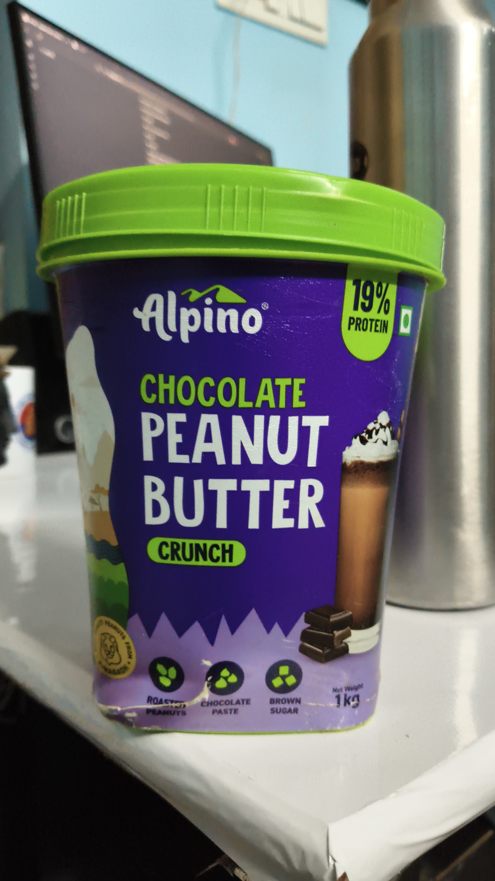
Figure 2 — Evidence Asset ID: EV-UNI-00B3FAC3 (IMG_20260920_041705.jpg)
SHA-256: 6cc325f72d92016c218e5bb5c04543d946e629267654ac6b873f4cccde8ab8e7 | Size: 3556 KB | Status: PRESERVED / IMMUTABLE
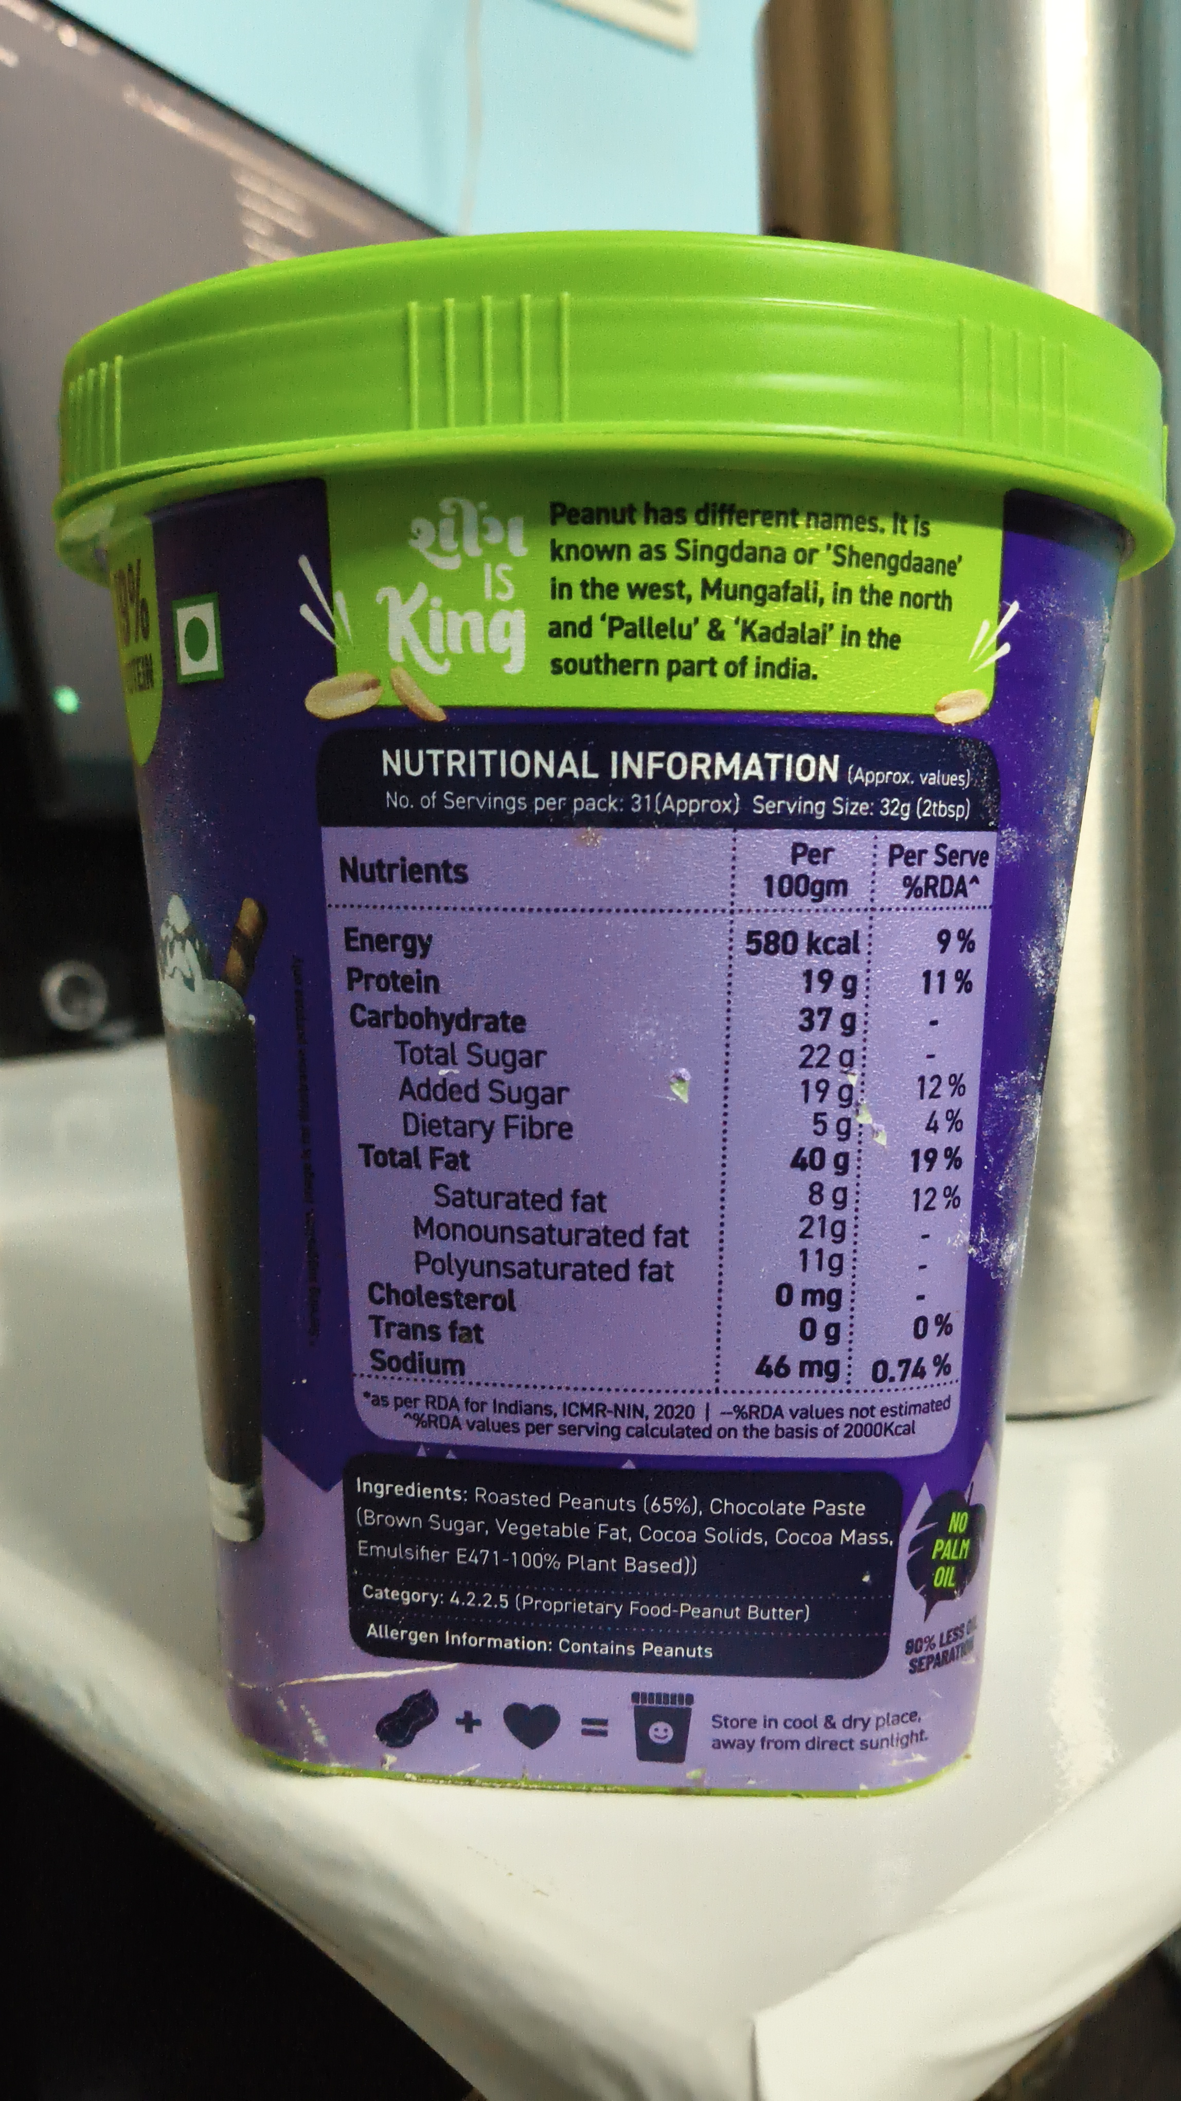
Figure 3 — Evidence Asset ID: EV-UNI-27336E44 (IMG_20260920_041717.jpg)
SHA-256: 90914d801c3a8c2fe9756c76cff1f841280527e9af47ac17c9a3a9384671e203 | Size: 3365 KB | Status: PRESERVED / IMMUTABLE
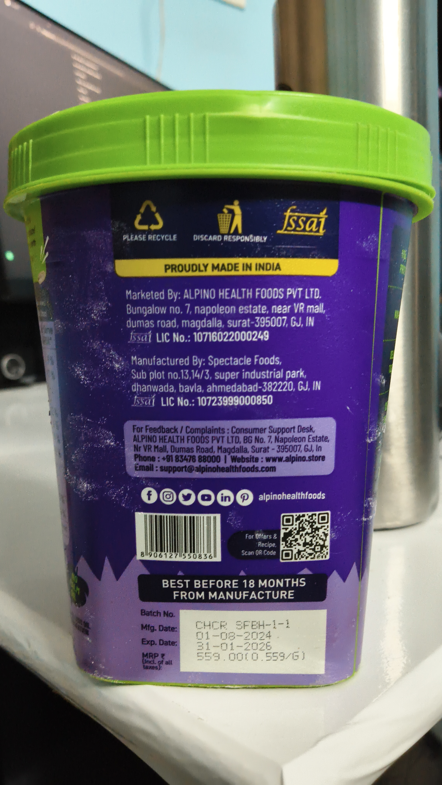
Figure 4 — Evidence Asset ID: EV-UNI-0548E76C (IMG_20260920_041726.jpg)
SHA-256: 653925000a73dd32802a0c2cc8fc8c65972842cd4d9860bbd0c37656b982b03e | Size: 3134 KB | Status: PRESERVED / IMMUTABLE
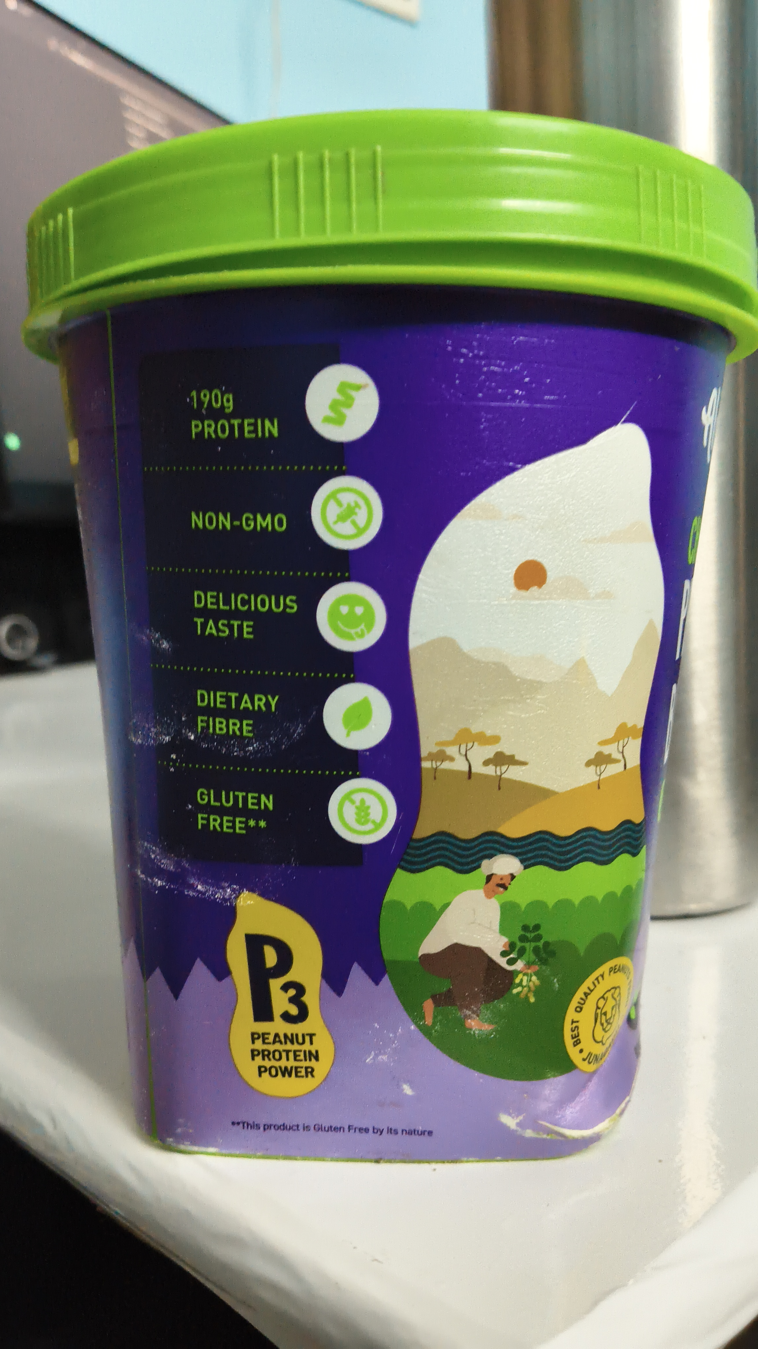

ANNEXURE B — DETAILED OCR TOKEN & BOUNDING BOX REGISTER
Evidence Asset: EV-UNI-4084D7C2 (IMG_20260920_041658.jpg) — Engine: paddleocr-onnx — Total Tokens: 14
Idx | Detected Token Text | Confidence | Bounding Box Points
0 | 19% | 0.9481 | [[1627.7, 1268.83], [1842.95, 1287.34], [1826.55, 1482.7], [1611.3, 1464.19]]
1 | Alpino | 0.9776 | [[604.75, 1328.47], [1240.25, 1324.35], [1242.3, 1595.81], [606.8, 1599.92]]
2 | PROTEIN | 0.9896 | [[1607.2, 1451.85], [1814.25, 1470.36], [1806.05, 1556.73], [1599.0, 1538.23]]
3 | CHOCOLATE | 0.9921 | [[658.05, 1723.31], [1426.8, 1747.98], [1420.65, 1900.16], [651.9, 1875.48]]
4 | PEANUT | 0.9715 | [[643.7, 1885.77], [1535.45, 1914.56], [1527.25, 2183.95], [635.5, 2155.16]]
5 | BUTTER | 0.9607 | [[647.8, 2179.84], [1527.25, 2194.23], [1523.15, 2471.85], [643.7, 2457.46]]
6 | CRUNCH | 0.9848 | [[725.7, 2490.36], [1098.8, 2510.93], [1092.65, 2621.98], [719.55, 2601.41]]
7 | Ner Wegh | 0.8043 | [[1531.35, 3173.1], [1685.1, 3154.6], [1691.25, 3203.95], [1537.5, 3222.46]]
8 | ROACVE | 0.6843 | [[676.5, 3216.29], [830.25, 3220.4], [828.2, 3271.81], [674.45, 3267.7]]
9 | BROWN | 0.9816 | [[1240.25, 3220.4], [1406.3, 3220.4], [1406.3, 3275.93], [1240.25, 3275.93]]
10 | 1kg | 0.9775 | [[1537.5, 3203.95], [1683.05, 3203.95], [1683.05, 3290.32], [1537.5, 3290.32]]
11 | CHOCOLATE | 0.9772 | [[920.45, 3234.8], [1168.5, 3226.57], [1170.55, 3275.93], [922.5, 3284.15]]
12 | PASTE | 0.9880 | [[975.8, 3275.93], [1111.1, 3271.81], [1113.15, 3315.0], [977.85, 3319.11]]
13 | SUGAR | 0.9765 | [[1246.4, 3267.7], [1396.05, 3267.7], [1396.05, 3317.06], [1246.4, 3317.06]]
Evidence Asset: EV-UNI-00B3FAC3 (IMG_20260920_041705.jpg) — Engine: paddleocr-onnx — Total Tokens: 59
Idx | Detected Token Text | Confidence | Bounding Box Points
0 | Peanut has different names.t s | 0.9069 | [[1061.9, 954.19], [1820.4, 978.87], [1818.35, 1054.96], [1059.85, 1030.28]]
1 | known as Singdana or'Shengdaane | 0.9611 | [[1059.85, 1024.11], [1877.8, 1052.9], [1875.75, 1133.1], [1057.8, 1104.31]]
2 | King | 0.9944 | [[717.5, 1110.48], [1047.55, 1118.71], [1043.45, 1332.58], [713.4, 1324.35]]
3 | IS | 0.9465 | [[930.7, 1094.03], [1006.55, 1094.03], [1006.55, 1168.06], [930.7, 1168.06]]
4 | in the west,Mungafali, in the north | 0.9066 | [[1061.9, 1102.26], [1861.4, 1124.88], [1859.35, 1198.91], [1059.85, 1176.29]]
5 | and‘Pallelu'&‘Kadalal' in the | 0.8753 | [[1055.75, 1176.29], [1760.95, 1198.91], [1758.9, 1275.0], [1053.7, 1252.38]]
6 | southern part of india. | 0.9682 | [[1061.9, 1254.44], [1596.95, 1266.77], [1594.9, 1334.64], [1059.85, 1322.3]]
7 | NUTRITIONAL INFORMATION (Approx.values | 0.8837 | [[733.9, 1429.23], [1904.45, 1460.08], [1902.4, 1548.51], [731.85, 1517.66]]
8 | No.of Servings per pack:31(Approx) Serving Size:32g (2tbsp) | 0.9239 | [[740.05, 1523.83], [1892.15, 1542.34], [1892.15, 1601.98], [740.05, 1583.47]]
9 | Per | 0.9788 | [[1529.3, 1628.71], [1631.8, 1628.71], [1631.8, 1690.4], [1529.3, 1690.4]]
10 | Per Serve | 0.9627 | [[1715.85, 1626.65], [1931.1, 1630.77], [1931.1, 1694.52], [1715.85, 1690.4]]
11 | Nutrients | 0.9850 | [[653.95, 1651.33], [920.45, 1659.56], [918.4, 1729.48], [651.9, 1721.25]]
12 | 100gm | 0.9957 | [[1473.95, 1686.29], [1664.6, 1696.57], [1660.5, 1760.32], [1469.85, 1750.04]]
13 | %RDA~ | 0.8452 | [[1744.55, 1690.4], [1916.75, 1690.4], [1916.75, 1756.21], [1744.55, 1756.21]]
14 | Energy | 0.9923 | [[664.2, 1785.0], [852.8, 1803.51], [846.65, 1875.48], [658.05, 1856.98]]
15 | 580kcal | 0.9947 | [[1443.2, 1799.4], [1683.05, 1799.4], [1683.05, 1863.15], [1443.2, 1863.15]]
16 | %6 | 0.9970 | [[1810.15, 1791.17], [1908.55, 1791.17], [1908.55, 1863.15], [1810.15, 1863.15]]
17 | Protein | 0.9831 | [[666.25, 1863.15], [869.2, 1875.48], [865.1, 1945.4], [662.15, 1933.06]]
18 | 19g | 0.9936 | [[1549.8, 1867.26], [1683.05, 1871.37], [1681.0, 1947.46], [1547.75, 1943.35]]
19 | 11% | 0.9786 | [[1783.5, 1873.43], [1904.45, 1873.43], [1904.45, 1941.29], [1783.5, 1941.29]]
20 | Carbohydrate | 0.9789 | [[674.45, 1937.18], [1031.15, 1951.57], [1029.1, 2021.49], [672.4, 2007.1]]
21 | 37g | 0.9093 | [[1545.7, 1939.23], [1689.2, 1951.57], [1683.05, 2025.6], [1539.55, 2013.27]]
22 | Total Sugar | 0.9831 | [[764.65, 2009.15], [1068.05, 2019.44], [1066.0, 2089.35], [762.6, 2079.07]]
23 | 22g | 0.9935 | [[1543.65, 2011.21], [1697.4, 2021.49], [1693.3, 2093.47], [1539.55, 2083.19]]
24 | Added Sugar | 0.9801 | [[770.8, 2072.9], [1117.25, 2093.47], [1113.15, 2163.39], [766.7, 2142.82]]
Evidence Asset: EV-UNI-27336E44 (IMG_20260920_041717.jpg) — Engine: paddleocr-onnx — Total Tokens: 35
Idx | Detected Token Text | Confidence | Bounding Box Points
0 | fssat | 0.8553 | [[1461.65, 1063.19], [1705.6, 1085.81], [1691.25, 1233.87], [1447.3, 1211.25]]
1 | PLEASE RECYCLE | 0.9562 | [[633.45, 1207.14], [926.6, 1207.14], [926.6, 1262.66], [633.45, 1262.66]]
2 | DISCARD RESPONSIBLY | 0.9831 | [[1000.4, 1211.25], [1391.95, 1217.42], [1391.95, 1264.72], [1000.4, 1258.55]]
3 | PROUDLYMADEIN INDIA | 0.9682 | [[848.7, 1363.43], [1463.7, 1353.15], [1463.7, 1414.84], [848.7, 1425.12]]
4 | Marketed By:ALPINO HEALTH FOODS PVT LTD. | 0.9227 | [[647.8, 1497.1], [1672.8, 1486.81], [1672.8, 1558.79], [647.8, 1569.07]]
5 | Bungalow no.7,napoleon estate,near VRmall, | 0.8883 | [[651.9, 1575.24], [1693.3, 1567.02], [1693.3, 1634.88], [651.9, 1643.1]]
6 | dumasrad,magdalla,surat395007GJ, | 0.8006 | [[649.85, 1647.22], [1637.95, 1636.94], [1637.95, 1706.85], [649.85, 1717.14]]
7 | ssai LIC No.:10716022000249 | 0.8866 | [[662.15, 1715.08], [1402.2, 1713.02], [1402.2, 1782.94], [662.15, 1785.0]]
8 | Manufactured By: Spectacle Foods, | 0.9429 | [[674.45, 1840.52], [1463.7, 1836.41], [1463.7, 1910.44], [674.45, 1914.56]]
9 | Sub plotno.1314/3,suer industrialpak | 0.7678 | [[674.45, 1912.5], [1592.85, 1908.39], [1592.85, 1978.31], [674.45, 1982.42]]
10 | dhanwada,bavla,ahmedabad382220,GJ,IN | 0.8563 | [[674.45, 1982.42], [1674.85, 1970.08], [1674.85, 2044.11], [674.45, 2056.45]]
11 | Issai LIC No.:10723999000850 | 0.8990 | [[678.55, 2048.23], [1424.75, 2044.11], [1424.75, 2120.2], [678.55, 2124.31]]
12 | For Feedback / Complaints:Consumer Support Desk, | 0.9569 | [[686.75, 2202.46], [1635.9, 2202.46], [1635.9, 2264.15], [686.75, 2264.15]]
13 | ALPINOHEALTHFOOSVTTDBGNo.7Naolnstat | 0.7117 | [[688.8, 2253.87], [1717.9, 2253.87], [1717.9, 2315.56], [688.8, 2315.56]]
14 | NrVRlmaadagallaa90 | 0.6388 | [[688.8, 2303.23], [1685.1, 2303.23], [1685.1, 2364.92], [688.8, 2364.92]]
15 | Phone:+91 83476 88000 I Website:www.alpino.store | 0.9241 | [[688.8, 2348.47], [1701.5, 2350.52], [1701.5, 2418.39], [688.8, 2416.33]]
16 | Email:support@alpinohealthfoods.com | 0.9661 | [[692.9, 2401.94], [1443.2, 2412.22], [1443.2, 2473.91], [692.9, 2463.63]]
17 | f@oone | 0.7270 | [[744.15, 2531.49], [1305.85, 2550.0], [1303.8, 2634.31], [742.1, 2615.81]]
18 | alpinohealthfoods | 0.9843 | [[1338.65, 2556.17], [1693.3, 2545.89], [1695.35, 2601.41], [1340.7, 2611.69]]
19 | ForOffers& | 0.8710 | [[1264.85, 2763.87], [1447.3, 2759.76], [1447.3, 2809.11], [1264.85, 2813.23]]
20 | Recipe, | 0.9920 | [[1328.4, 2805.0], [1443.2, 2811.17], [1441.15, 2856.41], [1326.35, 2850.24]]
21 | 89061271550836 | 0.9622 | [[725.7, 2856.41], [1119.3, 2868.75], [1117.25, 2916.05], [723.65, 2903.71]]
22 | Scan ORCode | 0.9736 | [[1250.5, 2852.3], [1441.15, 2852.3], [1441.15, 2895.48], [1250.5, 2895.48]]
23 | BEST BEFORE 18 MONTHS | 0.8911 | [[836.4, 3006.53], [1592.85, 2996.25], [1592.85, 3057.94], [836.4, 3068.23]]
24 | FROM MANUFACTURE | 0.9565 | [[895.85, 3068.23], [1533.4, 3064.11], [1533.4, 3119.64], [895.85, 3123.75]]
Evidence Asset: EV-UNI-0548E76C (IMG_20260920_041726.jpg) — Engine: paddleocr-onnx — Total Tokens: 16
Idx | Detected Token Text | Confidence | Bounding Box Points
0 | 190g | 0.9923 | [[555.55, 1161.9], [723.65, 1161.9], [723.65, 1260.6], [555.55, 1260.6]]
1 | PROTEIN | 0.9717 | [[569.9, 1258.55], [852.8, 1254.44], [852.8, 1332.58], [569.9, 1336.69]]
2 | NON-GMO | 0.9814 | [[571.95, 1534.11], [875.35, 1544.4], [873.3, 1620.48], [569.9, 1610.2]]
3 | DELICIOUS | 0.9828 | [[584.25, 1774.72], [908.15, 1795.28], [904.05, 1865.2], [580.15, 1844.64]]
4 | TASTE | 0.9642 | [[580.15, 1854.92], [783.1, 1871.37], [776.95, 1943.35], [574.0, 1926.9]]
5 | DIETARY | 0.9802 | [[594.5, 2072.9], [852.8, 2095.52], [846.65, 2165.44], [588.35, 2142.82]]
6 | FIBRE | 0.9796 | [[588.35, 2151.05], [783.1, 2163.39], [779.0, 2241.53], [584.25, 2229.19]]
7 | GLUTEN | 0.9566 | [[590.4, 2369.03], [840.5, 2393.71], [834.35, 2463.63], [584.25, 2438.95]]
8 | FREE** | 0.9912 | [[592.45, 2447.18], [824.1, 2463.63], [817.95, 2537.66], [586.3, 2521.21]]
9 | P | 0.9486 | [[721.6, 2813.23], [936.85, 2796.77], [959.4, 3107.3], [744.15, 3123.75]]
10 | PEAM | 0.8618 | [[1830.65, 2920.16], [1886.0, 2907.82], [1896.25, 2951.01], [1840.9, 2963.35]]
11 | PEANUT | 0.9925 | [[752.35, 3109.35], [965.55, 3115.52], [963.5, 3173.1], [750.3, 3166.94]]
12 | PROTEIN | 0.9921 | [[750.3, 3162.82], [973.75, 3166.94], [973.75, 3222.46], [750.3, 3218.35]]
13 | JUN | 0.9483 | [[1771.2, 3175.16], [1818.35, 3175.16], [1818.35, 3218.35], [1771.2, 3218.35]]
14 | POWER | 0.9845 | [[770.8, 3216.29], [963.5, 3216.29], [963.5, 3271.81], [770.8, 3271.81]]
15 | This product le Gluten Free by Its nature | 0.9225 | [[694.95, 3378.75], [1318.15, 3403.43], [1316.1, 3450.73], [692.9, 3426.05]]

ANNEXURE C — DETAILED STATUTORY FINDINGS MATRIX
Sl. | Rule & Citation | Statutory Requirement | System Result | Adjudicated Result | Statutory Finding Rationale
1 | Rule 6(1)(b) | commodity_name | REQUIRES_REVIEW | PASS | Reconciled multi-panel observation for commodity_name under Rule 6(1)(b).
2 | Rule 6(1)(f) | consumer_care | PASS | PASS | Confirmed automated finding for consumer_care under Rule 6(1)(f).
3 | Rule 6(1)(da) | country_of_origin | NOT_APPLICABLE | NOT_APPLICABLE | Confirmed automated finding for country_of_origin under Rule 6(1)(da).
4 | Rule 6(1)(d) | manufacture_packing_date | POTENTIAL_NON_COMPLIANCE | POTENTIAL_NON_COMPLIANCE | Confirmed automated finding for manufacture_packing_date under Rule 6(1)(d).
5 | Rule 6(1)(a) | manufacturer_identity | PASS | PASS | Confirmed automated finding for manufacturer_identity under Rule 6(1)(a).
6 | Rule 6(1)(e) | mrp | POTENTIAL_NON_COMPLIANCE | POTENTIAL_NON_COMPLIANCE | Confirmed automated finding for mrp under Rule 6(1)(e).
7 | Rule 6(1)(c) | net_quantity | REQUIRES_REVIEW | PASS | Reconciled multi-panel observation for net_quantity under Rule 6(1)(c).

ANNEXURE D — RAW STRUCTURED FINALAUDITRECORD SNAPSHOT
Deterministic Serialized JSON Representation of the Immutable FinalAuditRecord:
{
"applicability_snapshot": [
{
"requirement_name": "manufacturer_identity",
"rule_citation": "Rule 6(1)(a)",
"status": "APPLICABLE"
},
{
"requirement_name": "commodity_name",
"rule_citation": "Rule 6(1)(b)",
"status": "APPLICABLE"
},
{
"requirement_name": "net_quantity",
"rule_citation": "Rule 6(1)(c)",
"status": "APPLICABLE"
},
{
"requirement_name": "manufacture_packing_date",
"rule_citation": "Rule 6(1)(d)",
"status": "APPLICABLE"
},
{
"requirement_name": "mrp",
"rule_citation": "Rule 6(1)(e)",
"status": "APPLICABLE"
},
{
"requirement_name": "consumer_care",
"rule_citation": "Rule 6(1)(f)",
"status": "APPLICABLE"
},
{
"requirement_name": "country_of_origin",
"rule_citation": "Rule 6(1)(da)",
"status": "NOT_APPLICABLE"
}
],
"compliance_findings_snapshot": [
{
"applicability_status": "APPLICABLE",
"evidence_id": "EV-UNI-27336E44",
"id": "FND-UNI-A8EDB7385E",
"metadata_payload": {
"date_validation_summary": null,
"evidence_id": "EV-UNI-27336E44"
},
"reason": "Responsible entity identity ('Alpino Health Foods Pvt Ltd.\nBungalow No.7') and complete address ('NO HEALTH FOODS PVT LTD.') observed under Rule 6(1)(a).",
"requirement_name": "manufacturer_identity",
"result": "PASS",
"rule_citation": "Rule 6(1)(a)",
"source_token_indices": []
},
{
"applicability_status": "APPLICABLE",
"evidence_id": "EV-UNI-4084D7C2",
"id": "FND-UNI-3281FD7CDD",
"metadata_payload": {
"date_validation_summary": null,
"evidence_id": "EV-UNI-4084D7C2"
},
"reason": "Conflicting declarations observed across panel evidence for commodity_name under Rule 6(1)(b). Reviewer adjudication required.",
"requirement_name": "commodity_name",
"result": "REQUIRES_REVIEW",
"rule_citation": "Rule 6(1)(b)",
"source_token_indices": []
},
{
"applicability_status": "APPLICABLE",
"evidence_id": "EV-UNI-4084D7C2",
"id": "FND-UNI-CF23CC0237",
"metadata_payload": {
"date_validation_summary": null,
"evidence_id": "EV-UNI-4084D7C2"
},
"reason": "Conflicting declarations observed across panel evidence for net_quantity under Rule 6(1)(c). Reviewer adjudication required.",
"requirement_name": "net_quantity",
"result": "REQUIRES_REVIEW",
"rule_citation": "Rule 6(1)(c)",
"source_token_indices": []
},
{
"applicability_status": "APPLICABLE",
"evidence_id": "EV-UNI-4084D7C2",
"id": "FND-UNI-FF2A47D27D",
"metadata_payload": {
"date_validation_summary": {
"conflicts": [],
"date_observations": [
{
"confidence": null,
"date_type": "BEST_BEFORE_DURATION",
"derivation_method": null,
"evidence_id": "EV-UNI-27336E44",
"extraction_method": "DETERMINISTIC_REGEX_PARSER",
"extraction_version": "v1.0",
"field_name": "best_before_duration",
"normalized_date": null,
"observation_status": "OBSERVED",
"ocr_result_id": null,
"ocr_token_ids": [],
"raw_text": "BEST BEFORE 18 MONTHS",
"source_observations": []
}
],

