Predicting Collision-Energy-Dependent Fragmentation Extent from Molecular Structure: Development and External Evaluation of MURU-WUR-v2
Aryav Thakur Internal research draft; not submitted to a journal.

Abstract
Background and objective. Collision-induced dissociation changes product-ion distributions. We tested whether molecular structure improves a compact fragmentation-extent prediction beyond a descriptor model and transfers to a separately sampled MSnLib population. Methods. MURU-WUR-v2 predicts a one-scale trajectory of the precursor-including, intensity-weighted fragment-mass fraction, μ, from 12 Tier A descriptors and radius-2 Morgan count features. A frozen shared energy-response profile maps the predicted molecular scale to μ. The candidate was selected in a multi-experiment, scaffold-grouped development program. After an earlier MSnLib sample was exposed and excluded, one outcome-blind replacement sample was evaluated at recorded numeric collision-energy settings 20 and 60; their physical units are unresolved. We compared the frozen candidate with a separately selected Tier A ridge using a whole-scaffold bootstrap. Results. Of 1,794 measured compounds, 5 were outside either model's profile support. The primary analysis included 1,789 compounds in 1,687 scaffold groups. Pooled trajectory RMSE was 0.12961 for MURU and 0.13353 for the reference (ratio 0.97067; 95% scaffold-bootstrap interval 0.95236–0.98927), a 2.93% relative reduction. The interval excluded one but remained above the prespecified 0.95 practical target. Tail-error improvement was not demonstrated, and the least-similar structural quartile had a ratio of 1.0083. Conclusion. Under the frozen endpoint and energy map, the result met the study's category of modest external confirmation. It did not meet the practical-improvement criterion, establish a tail-risk benefit, or show improved performance in the least-similar quartile. The energy map is not a physical cross-instrument calibration.
Keywords: tandem mass spectrometry; collision-induced dissociation; fragmentation extent; molecular descriptors; Morgan fingerprints; external validation; scaffold bootstrap

1. Introduction
Tandem mass spectrometry (MS/MS) isolates a precursor ion, activates it, and measures product ions by mass-to-charge ratio. In collision-induced dissociation (CID), energy is transferred through collisions with a neutral gas; the observed product-ion distribution depends on precursor structure and charge, collision conditions, and instrument settings. Higher-energy collision-induced dissociation (HCD) is commonly used on Orbitrap platforms. Fragmentation can involve competing bond cleavages, rearrangements, charge retention or migration, and sequential decomposition, so a measured spectrum is an aggregate outcome rather than a direct image of one reaction pathway (A. R. Johnson, E. E. Carlson. Collision-induced dissociation mass spectrometry: A powerful tool for natural product structure elucidation. Analytical Chemistry. Vol. 87, pg. 10668–10678, 2015. https://doi.org/10.1021/acs.analchem.5b01543.).
Collision energy influences both precursor survival and the production and secondary breakdown of fragments. Thermo instruments distinguish normalized collision energy (NCE), a dimensionless setting normalized to precursor mass and charge, from absolute collision energy. NCE is only approximately equivalent to collision energy in eV for a reference ion; the delivered energy depends on precursor mass and charge (Thermo Fisher Scientific. Q Exactive HF Software Manual: HCD normalized and absolute collision energy. 2018. https://documents.thermofisher.com/TFS-Assets/CMD/manuals/man-1372090-q-exactive-hf-soft-man1372090-en.pdf.). Energy-dependent spectra therefore cannot safely be pooled or compared by treating a numeric energy label as a universal physical unit.
Predicting how much a molecule fragments as energy changes is scientifically useful as a compact description of the response trajectory. It may support controlled comparison of fragmentation behavior and help characterize an energy-dependent aspect of a prediction system. It is a narrower task than predicting a complete tandem mass spectrum. Full-spectrum approaches predict fragment identities or masses and relative intensities and may support candidate ranking or identification. MURU-WUR-v2 instead predicts a scalar summary of the mass distribution of all observed ions, including the precursor; it does not predict fragment formulas, pathways, peak intensities, or a complete spectrum.
Computational MS/MS methods span rule-based fragmentation, probabilistic fragmentation trees, formula and structure ranking, and machine-learning approaches. CFM-ID models competing fragmentation events and has developed through successive ESI-MS/MS prediction versions (F. Allen, R. Greiner, D. Wishart. Competitive fragmentation modeling of ESI-MS/MS spectra for putative metabolite identification. Metabolomics. Vol. 11, pg. 98–110, 2015. https://doi.org/10.1007/s11306-014-0676-4.), (F. Wang, J. Liigand, S. Tian, D. Arndt, R. Greiner, D. S. Wishart. CFM-ID 4.0: More accurate ESI-MS/MS spectral prediction and compound identification. Analytical Chemistry. Vol. 93, pg. 11692–11700, 2021. https://doi.org/10.1021/acs.analchem.1c01465.). Neural systems such as MassFormer, ICEBERG and FIORA use molecular graphs and learned representations to predict spectra or fragmentation events (A. Young, H. Röst, B. Wang. Tandem mass spectrum prediction for small molecules using graph transformers. Nature Machine Intelligence. Vol. 6, pg. 404–416, 2024. https://doi.org/10.1038/s42256-024-00816-8.), (Y. Nowatzky, F. F. Russo, J. Lisec, A. Kister, K. Reinert, T. Muth, P. Benner. FIORA: Local neighborhood-based prediction of compound mass spectra from single fragmentation events. Nature Communications. Vol. 16, Article 2298, 2025. https://doi.org/10.1038/s41467-025-57422-4.), (S. Goldman, J. Li, C. W. Coley. Generating molecular fragmentation graphs with autoregressive neural networks. Analytical Chemistry. Vol. 96, pg. 3419–3428, 2024. https://doi.org/10.1021/acs.analchem.3c04654.), (R. Wang, M. Manjrekar, B. Mahjour, J. Avila-Pacheco, J. Provenzano, E. Reynolds, M. Lederbauer, E. Mashin, S. Goldman, M. Wang, J.-K. Weng, D. L. Plata, C. B. Clish, C. W. Coley. Neural spectral prediction for structure elucidation with tandem mass spectrometry. bioRxiv preprint, 2025. https://doi.org/10.1101/2025.05.28.656653. Not peer reviewed as of the source record consulted.). FIORA models local bond neighborhoods and predicts fragment probabilities, while ICEBERG uses autoregressive neural networks to generate fragmentation graphs (Y. Nowatzky, F. F. Russo, J. Lisec, A. Kister, K. Reinert, T. Muth, P. Benner. FIORA: Local neighborhood-based prediction of compound mass spectra from single fragmentation events. Nature Communications. Vol. 16, Article 2298, 2025. https://doi.org/10.1038/s41467-025-57422-4.), (S. Goldman, J. Li, C. W. Coley. Generating molecular fragmentation graphs with autoregressive neural networks. Analytical Chemistry. Vol. 96, pg. 3419–3428, 2024. https://doi.org/10.1021/acs.analchem.3c04654.), (R. Wang, M. Manjrekar, B. Mahjour, J. Avila-Pacheco, J. Provenzano, E. Reynolds, M. Lederbauer, E. Mashin, S. Goldman, M. Wang, J.-K. Weng, D. L. Plata, C. B. Clish, C. W. Coley. Neural spectral prediction for structure elucidation with tandem mass spectrometry. bioRxiv preprint, 2025. https://doi.org/10.1101/2025.05.28.656653. Not peer reviewed as of the source record consulted.). These systems address a richer output than the endpoint studied here. Their performance therefore provides context for the field, but cannot be compared directly to MURU's scalar RMSE as if both solved the same task.
Molecular machine learning commonly represents a compound through physicochemical descriptors and structural fingerprints. Morgan or extended-connectivity fingerprints encode local atom environments at successive radii, and count variants retain multiplicity information (D. Rogers, M. Hahn. Extended-connectivity fingerprints. Journal of Chemical Information and Modeling. Vol. 50, pg. 742–754, 2010. https://doi.org/10.1021/ci100050t.). Such features can be used as model inputs without implying a specific causal fragmentation mechanism. The MURU development program compared descriptor-only, fingerprint-only, and joint representations and selected a ridge model combining standardized Tier A descriptors with log-transformed Morgan counts. Its target was the compound scale parameter of a shared empirical energy-response profile.
The motivation for the present work is not a claim that scalar fragmentation-extent prediction replaces full-spectrum prediction. Rather, the scalar endpoint makes it possible to ask a bounded question about whether structure carries predictive information across collision-energy levels, how that information transfers to a separate library, and where its limits appear. Evaluation on held-out scaffolds reduces direct analogue leakage, while a separately sampled replacement population, drawn under recorded exposure controls, tests transport beyond the development records. Scaffold separation alone does not guarantee structural novelty; nearest-training similarity must also be examined (G. W. Bemis, M. A. Murcko. The properties of known drugs. 1. Molecular frameworks. Journal of Medicinal Chemistry. Vol. 39, pg. 2887–2893, 1996. https://doi.org/10.1021/jm9602928.), (R. J. Bajusz, A. Rácz, K. Héberger. Why is Tanimoto index an appropriate choice for fingerprint-based similarity calculations? Journal of Cheminformatics. Vol. 7, Article 20, 2015. https://doi.org/10.1186/s13321-015-0069-3.).
The research question was: Does a frozen joint structural model predict the precursor-including fragmentation-extent trajectory with lower error than the frozen Tier A ridge on a separately sampled MSnLib population, and how does the paired difference vary across energy rungs and structural-similarity quartiles? The development hypothesis was that joint descriptor and local structural features would reduce scaffold-held-out pooled trajectory error relative to Tier A alone; one development admission criterion was later restated under A-3 after outcomes were visible, as described below. The external practical criterion was fixed in advance at a candidate/reference P1 ratio of 0.95 or lower, with the direction and tail rule specified by the confirmation protocol. The scope is limited to positive-mode HCD data, two measured MSnLib rungs, the MURU scalar endpoint, a fixed deployment energy map, and support-qualified compounds.

2. Materials and Methods

2.1 Study design and evidence hierarchy
This computational study contains (i) historical WUR Stage 3 context, (ii) a scaffold-held-out WUR-v2 development program, (iii) one frozen external evaluation on a separately sampled MSnLib replacement population, and (iv) a distinct collision-energy-interface adjudication study. The stages answer related but non-interchangeable questions. The external population was not used to select or refit the candidate; the study's frozen classification calls its result modest external confirmation. The frozen protocol labels the external MSnLib settings as HCD NCE 20 and 60, while the peer-reviewed MSnLib paper describes its library MS2 settings as 20 eV and 60 eV. The MSnLib primary article reports 20 eV and 60 eV for its ID-X MS2 library acquisition (C. Brungs, R. Schmid, S. Heuckeroth, A. Mazumdar, M. Drexler, P. Šácha, P. C. Dorrestein, D. Petras, L.-F. Nothias, V. Veverka, R. Nencka, Z. Kameník, T. Pluskal. MSnLib: efficient generation of open multi-stage fragmentation mass spectral libraries. Nature Methods. 22(10):2028–2031, 2025. https://doi.org/10.1038/s41592-025-02813-0.). The nine source archives used here lack the native method metadata needed to reconcile those descriptions. We therefore call them recorded numeric settings 20 and 60 and leave their physical units unresolved. The frozen map remains a numerical adapter; it is not validated energy calibration. The confirmation protocol also assumed ID-X NCE equaled IQ-X NCE under A0, but its absolute-agreement anchor gate failed: A0 median |Δμ| at setting 20 was 0.0501 against a 0.05 limit, A1 pooled RMSD was 0.0811 against 0.08, and A2 median |Δμ| at setting 20 was 0.0506. The primary comparative analysis nevertheless used frozen A0; this gate failure limits absolute-transfer interpretation. A previous MSnLib sample was exposed by an accidental parser-preflight decode before scoring. That sample was not analyzed for the outcome and was permanently excluded; a replacement population was selected under a new frozen protocol. The replacement population was evaluated once and is now exposed. Exposure controls excluded recorded compound keys and scaffolds; this does not imply zero chemical similarity to the development set or prove that every unrecorded exposure was absent. No third sample, replacement draw, repair, or post-result tuning is authorized by the frozen study record (A. Thakur. MURU-WUR-v2 development protocol, final candidate freeze and final report. MURU-ConjectureLab-v1 repository, frozen release commit bfa153e828e08b3c7e674ef7fe9d6818d14a2b61, 2026. Files: MURU_WUR_V2_DEVELOPMENT_PROTOCOL.md; MURU_WUR_V2_FINAL_CANDIDATE_FREEZE.md; MURU_WUR_V2_FINAL_REPORT.md.), (A. Thakur. MURU-WUR-v2 MSnLib Confirmation Study 2 protocol, freeze and result. MURU-ConjectureLab-v1 repository, 2026. Files: MURU_V2_MSNLIB_CONFIRMATION_PROTOCOL_V2.md; MURU_V2_MSNLIB_CONFIRMATION_V2_FREEZE.md; MURU_V2_MSNLIB_CONFIRMATION_V2_RESULT.md.), (A. Thakur. MURU-WUR-v2 MSnLib Confirmation Study 2 analysis code and frozen outputs. MURU-ConjectureLab-v1 repository, 2026. Files: scripts/wur_v2_confirmation_v2/11_external_analysis.py; artifacts/wur_v2_confirmation_v2/result/external_analysis.json; artifacts/wur_v2_confirmation_v2/result/measured_mu.csv.), (A. Thakur. MURU-WUR-v2 exposure and data registry. MURU-ConjectureLab-v1 repository, 2026. File: MURU_V2_EXPOSURE_AND_DATA_REGISTRY.md.).

2.2 Development and external populations
WUR-v2 development used 1,325 positive-mode compounds drawn from the MassBank/LCSB multi-collision-energy acquisition collection and WUR spectral records (A. Elapavalore, T. Kondić, R. R. Singh, B. A. Shoemaker, P. A. Thiessen, J. Zhang, E. E. Bolton, E. L. Schymanski. Adding open spectral data to MassBank and PubChem using open source tools to support non-targeted exposomics of mixtures. Environmental Science: Processes & Impacts. Vol. 25, pg. 1788–1801, 2023. https://doi.org/10.1039/D3EM00181D.), (S. Neumann, R. Meier, M. Wenk, A. Elapavalore, T. Nishioka, T. Schulze, M. Stravs, H. Tsugawa, F. Matsuda, E. L. Schymanski. MassBank: an open and FAIR mass spectral data resource. Nucleic Acids Research. Vol. 54, pg. D601–D606, 2026. https://doi.org/10.1093/nar/gkaf1193.). Primary evaluation used grouped out-of-fold predictions from five scaffold-disjoint folds. Bemis–Murcko scaffolds were computed on stereo-stripped parents; acyclic compounds were assigned compound-specific groups. Model development was a multi-experiment program (13 experiment families), not a single model test. The selected model, V2_TA_MORGAN_JOINT, was admitted under the documented simplicity rule among models within 1% of the best observed candidate. After development outcomes and five adversarial reviews were visible, but before any external outcome access, amendment A-3 restated admission criterion c4 for joint models containing Tier A. The literal original c4 was not met by EXP08B: three of five corrected fingerprint-permutation controls had P1 ratios slightly below 1. A-3 instead required each permuted model to lose to the unpermuted candidate and the mean permuted ratio not to beat the empty-fingerprint null beyond bootstrap noise. The five permutations lost to EXP08B by about 11%; their mean ratio was 1.0003 versus the empty-block null of 0.9989. EXP08B was admitted under the revised criterion. This post-results amendment is retained as a development-selection limitation, not hidden as a prospective rule (A. Thakur. MURU-WUR-v2 development protocol, final candidate freeze and final report. MURU-ConjectureLab-v1 repository, frozen release commit bfa153e828e08b3c7e674ef7fe9d6818d14a2b61, 2026. Files: MURU_WUR_V2_DEVELOPMENT_PROTOCOL.md; MURU_WUR_V2_FINAL_CANDIDATE_FREEZE.md; MURU_WUR_V2_FINAL_REPORT.md.), (A. Thakur. MURU-WUR-v2 review adjudication and statistical review records. MURU-ConjectureLab-v1 repository, 2026.). The development comparator was a Tier A ridge refitted within the same evaluation design (A. Thakur. MURU-WUR-v2 development protocol, final candidate freeze and final report. MURU-ConjectureLab-v1 repository, frozen release commit bfa153e828e08b3c7e674ef7fe9d6818d14a2b61, 2026. Files: MURU_WUR_V2_DEVELOPMENT_PROTOCOL.md; MURU_WUR_V2_FINAL_CANDIDATE_FREEZE.md; MURU_WUR_V2_FINAL_REPORT.md.).
The MSnLib external evaluation frame comprised 1,794 compounds with measured μ at both recorded numeric settings. Five compounds were excluded because at least one model's implied normalized profile coordinate fell outside the fitted profile's knot support. The scored analysis contained 1,789 compounds in 1,687 Bemis–Murcko scaffold groups; the largest group contained seven compounds. The per-compound observations are repeated measures at two energy rungs, not independent samples. Uncertainty for the primary contrast was estimated by resampling the whole scaffold groups; the generic bootstrap inference framework is described by Efron and Tibshirani (B. Efron, R. J. Tibshirani. Bootstrap methods for standard errors, confidence intervals, and other measures of statistical accuracy. Statistical Science. Vol. 1, pg. 54–75, 1986. https://doi.org/10.1214/ss/1177013815.).
The replacement population was drawn once from an outcome-blind eligible universe after excluding project-exposed compound keys and scaffolds listed in the exposure registry. This operational exclusion defines the study's exposure control; it is not a claim that every analogue was absent. Fixed-rung scan headers were screened before any peak arrays were decoded. In the frozen final population, all 6,004 allowlisted scans were decoded, no spectrum was empty or nonpositive, and every included compound had both rungs. The exact count flow and exposure history are shown in Figure 1 and Supplementary Table S1 (A. Thakur. MURU-WUR-v2 MSnLib Confirmation Study 2 protocol, freeze and result. MURU-ConjectureLab-v1 repository, 2026. Files: MURU_V2_MSNLIB_CONFIRMATION_PROTOCOL_V2.md; MURU_V2_MSNLIB_CONFIRMATION_V2_FREEZE.md; MURU_V2_MSNLIB_CONFIRMATION_V2_RESULT.md.), (A. Thakur. MURU-WUR-v2 MSnLib Confirmation Study 2 analysis code and frozen outputs. MURU-ConjectureLab-v1 repository, 2026. Files: scripts/wur_v2_confirmation_v2/11_external_analysis.py; artifacts/wur_v2_confirmation_v2/result/external_analysis.json; artifacts/wur_v2_confirmation_v2/result/measured_mu.csv.), (A. Thakur. MURU-WUR-v2 exposure and data registry. MURU-ConjectureLab-v1 repository, 2026. File: MURU_V2_EXPOSURE_AND_DATA_REGISTRY.md.).
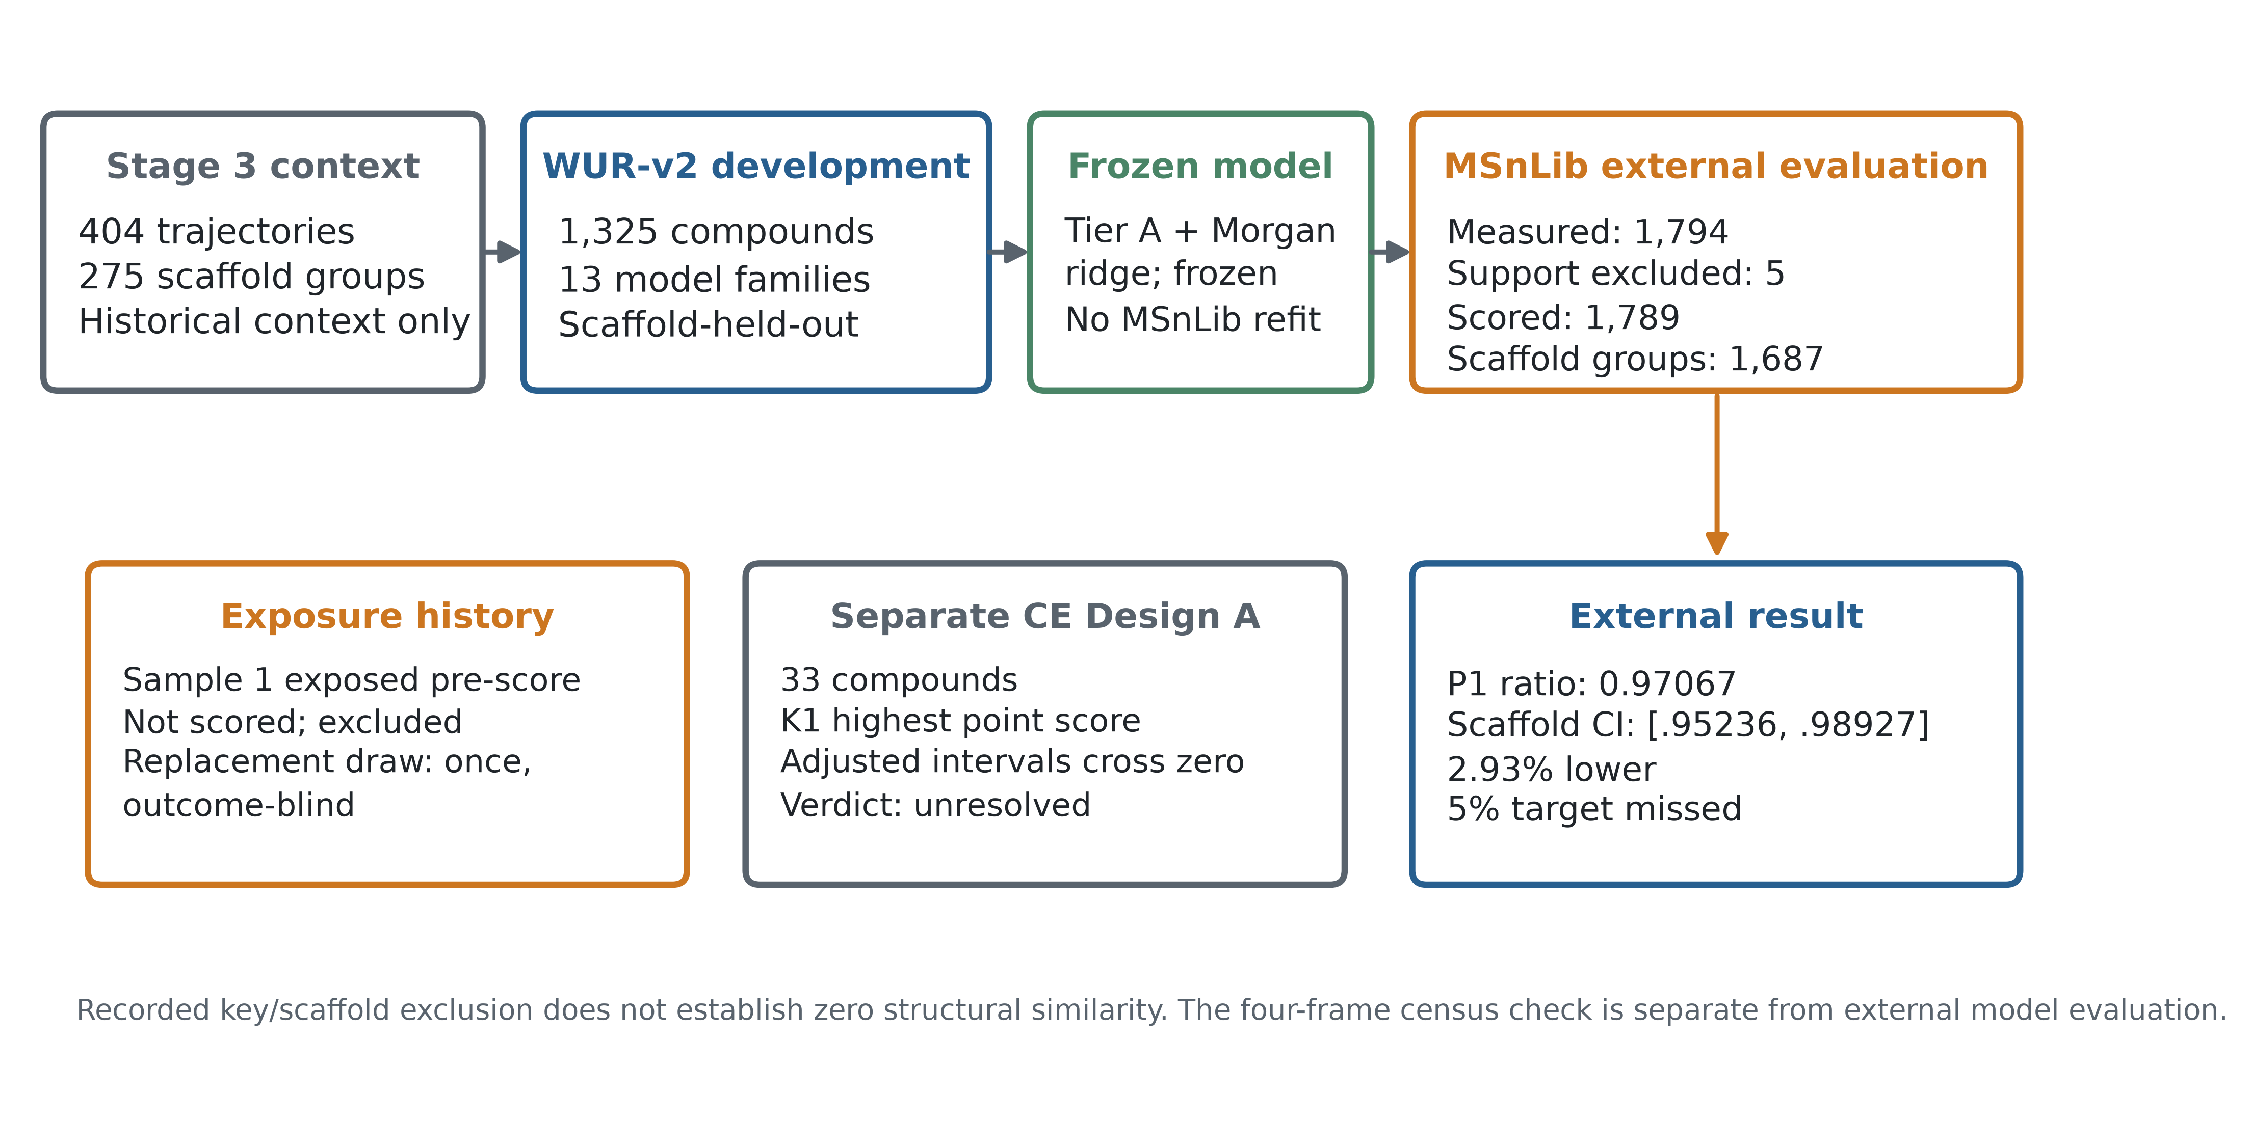
Figure 1. Study design and population flow. Development and external evaluation are separated; the exposed first sample is shown as excluded history, and CE Design A is a separate study.

2.3 Fragmentation-extent endpoint
After the frozen base preprocessing (zero relative-intensity cutoff, precursor included, raw intensities), a spectrum with peak masses m_j, intensities I_j, and precursor denominator m_prec had endpoint:
μ = [Σ_j (I_j × m_j)] / [m_prec × Σ_j I_j].
All centroid peaks were included, including the precursor peak; there was no intensity cutoff. For each compound and fixed energy rung, the median μ across matched scans from the allowed wells was used as the measured value. In the WUR development path, the denominator is the declared MassBank PRECURSOR_M/Z; in the MSnLib validation path, it is the structure-derived [M+H]+ mass passed to spectrum_mu. The same formula is used, but the denominator source differs and the study does not assert the two values are identical. This ratio is a mass-weighted extent proxy on a roughly 0-to-1 scale, not a fraction of cleaved bonds, an ion count, a survival yield, or a mechanistic pathway assignment. The data-processing code permits values slightly above one due to observed mass and measurement details; no logit or Beta likelihood was assumed in the model development (A. Thakur. MURU-WUR-v2 development protocol, final candidate freeze and final report. MURU-ConjectureLab-v1 repository, frozen release commit bfa153e828e08b3c7e674ef7fe9d6818d14a2b61, 2026. Files: MURU_WUR_V2_DEVELOPMENT_PROTOCOL.md; MURU_WUR_V2_FINAL_CANDIDATE_FREEZE.md; MURU_WUR_V2_FINAL_REPORT.md.), (A. Thakur. MURU-WUR-v2 MSnLib Confirmation Study 2 protocol, freeze and result. MURU-ConjectureLab-v1 repository, 2026. Files: MURU_V2_MSNLIB_CONFIRMATION_PROTOCOL_V2.md; MURU_V2_MSNLIB_CONFIRMATION_V2_FREEZE.md; MURU_V2_MSNLIB_CONFIRMATION_V2_RESULT.md.), (A. Thakur. MURU-WUR-v2 MSnLib Confirmation Study 2 analysis code and frozen outputs. MURU-ConjectureLab-v1 repository, 2026. Files: scripts/wur_v2_confirmation_v2/11_external_analysis.py; artifacts/wur_v2_confirmation_v2/result/external_analysis.json; artifacts/wur_v2_confirmation_v2/result/measured_mu.csv.), (A. Thakur. MURU-WUR-v2 exposure and data registry. MURU-ConjectureLab-v1 repository, 2026. File: MURU_V2_EXPOSURE_AND_DATA_REGISTRY.md.).

2.4 Structures, molecular standardization, and representations
Compound identity was based on the first InChIKey block of the parent structure. The parent was the largest organic fragment and was neutralized where a neutral form existed; permanent cations retained charge. Stereochemistry was removed from the features. Acyclic compounds were assigned compound-specific scaffold groups in the frozen split audit (A. Thakur. MURU-WUR-v2 development split and population audit. MURU-ConjectureLab-v1 repository, frozen release commit bfa153e828e08b3c7e674ef7fe9d6818d14a2b61, 2026.). The representation protocol did not perform additional tautomer union beyond the standard InChI connectivity behavior. The chosen representative SMILES was sourced from the LCSB structure for LCSB-primary keys or selected lexicographically from deposited WUR SMILES otherwise (A. Thakur. MURU-WUR-v2 development protocol, final candidate freeze and final report. MURU-ConjectureLab-v1 repository, frozen release commit bfa153e828e08b3c7e674ef7fe9d6818d14a2b61, 2026. Files: MURU_WUR_V2_DEVELOPMENT_PROTOCOL.md; MURU_WUR_V2_FINAL_CANDIDATE_FREEZE.md; MURU_WUR_V2_FINAL_REPORT.md.).
Tier A comprised 12 fixed descriptors: precursor m/z, total atom count, rotatable-bond count, ring count, aromatic-ring count, RDBE, TPSA, heteroatom fraction, and N, O, S, and halogen counts. Both models divided descriptor values by frozen descriptor-specific scale constants. The joint candidate then standardized its Tier A block using means and standard deviations estimated in each training fold; the Tier A reference used the scaled descriptors without this additional standardization. The Morgan representation used RDKit 2026.03.5, radius 2, 2,048 hashed count features, no chirality, and log1p transformation. The candidate multiplied the Morgan block by 0.1; each transformation was fitted or applied within the relevant training boundary (A. Thakur. MURU-WUR-v2 development protocol, final candidate freeze and final report. MURU-ConjectureLab-v1 repository, frozen release commit bfa153e828e08b3c7e674ef7fe9d6818d14a2b61, 2026. Files: MURU_WUR_V2_DEVELOPMENT_PROTOCOL.md; MURU_WUR_V2_FINAL_CANDIDATE_FREEZE.md; MURU_WUR_V2_FINAL_REPORT.md.), (RDKit. Morgan fingerprint implementation and documentation, version 2026.03.5. https://www.rdkit.org/docs/.).

2.5 Shared energy-response model and candidate
The model predicts a compound-specific log scale ℓ_i = log(g_i) from molecular features. For the joint ridge candidate, the design vector was the concatenation of standardized Tier A features and 0.1 times the log-transformed Morgan count vector. In implementation, ridge regression estimates coefficients and an intercept by minimizing a curvature-weighted squared error over the training compounds:
(b̂₀, β̂) = argmin_(b₀,β) {Σ_i w_i (ℓ_i − b₀ − x_iᵀβ)² + α‖β‖²}.
Here x_i is the model-specific feature vector after the transformations above; b₀ is the unpenalized intercept fitted by scikit-learn's Ridge; β is the coefficient vector; w_i is the frozen curvature weight; and α is the ridge penalty selected by nested grouped validation. The curvature weight is the normalized inverse estimated variance of log(g_i): the variance estimate is residual variance divided by the sum of squared finite-difference sensitivities of the fitted profile to log(g_i), with the frozen 10⁻⁹ lower bounds applied before inversion; weights are normalized to mean one. Candidate tuning considered α ∈ {0.1, 0.3, 1, 3, 10, 30, 100, 300} and Morgan block weight in {0.1, 0.3, 1.0}; the deployed final candidate has α = 0.3 and block weight 0.1. The Tier A reference tuning grid was {0.01, 0.1, 1, 10, 100} and selected α = 0.1. Nested selection used grouped inner folds. The training population contains 1,325 compounds. These are not identical model classes differing only by the Morgan block: they differ in features, scaling and selected penalty. Therefore the paired external contrast estimates the performance difference between the frozen candidate and the development-selected Tier A reference applied without external refitting; it does not isolate a causal contribution of fingerprints alone (A. Thakur. MURU-WUR-v2 development protocol, final candidate freeze and final report. MURU-ConjectureLab-v1 repository, frozen release commit bfa153e828e08b3c7e674ef7fe9d6818d14a2b61, 2026. Files: MURU_WUR_V2_DEVELOPMENT_PROTOCOL.md; MURU_WUR_V2_FINAL_CANDIDATE_FREEZE.md; MURU_WUR_V2_FINAL_REPORT.md.), (D. C. Montgomery, E. A. Peck, G. G. Vining. Introduction to linear regression analysis, 5th ed. Wiley, 2012.).
A frozen shared monotone response profile Φ maps normalized coordinate u to μ:
μ̂_i(E) = Φ((E / 30) / ĝ_i), where ĝ_i = exp(ℓ̂_i).
Φ is represented by 60 fixed knots on the log-u coordinate and fitted by decreasing isotonic regression using development data only. The frozen collapse alternates profile fitting and per-compound scale estimation three times; each scale is selected on the 241-point log-scale grid from −1.6 to 1.6 with parabolic refinement, followed by geometric-mean centering. The same profile and scale parameterization are used by candidate and reference; the structural model predicts g_i, not the curve shape. The historical development code and frozen candidate JSON define the complete profile values and coefficients. The external profile coordinate is supported only within the knot range; a compound was excluded from the primary analysis if either model was unsupported at either rung.

2.6 Energy coordinate and reference model
A separate WFSR library paper reports normalized HCD settings on an Orbitrap IQ-X (F. Padilla-González, S. Rizzo, C. Dirks, W. Bergkamp, S. Rasker, I. Aloisi. Creation of an Open-Access High-Resolution Tandem Mass Spectral Library of 1000 Food Toxicants. Analytical Chemistry. 97(43):23822–23830, 2025. https://doi.org/10.1021/acs.analchem.5c03020.). The WUR acquisition context describes its HCD ladder as normalized settings (15, 30, 45, 60, 75, 90) and its stepped ladder as SCE (25, 38, 59). The exported MassBank collision-energy field itself contains numeric values without unit semantics; the interpretation comes from publication and instrument context, not the field alone. The frozen development adapter maps the LCSB nominal coordinate E_LCSB to the WUR coordinate T(E_LCSB) = a + bE_LCSB, with a = −5.95552603907965 and b = 0.8618030610784555. For external deployment the adapter applies the inverse to the recorded numeric rung: E_LCSB = (rung − a)/b. The confirmation protocol calls the MSnLib values NCE 20 and 60 and assumes ID-X NCE equals IQ-X NCE under the frozen A0 adapter. However, the peer-reviewed MSnLib primary paper describes the ID-X MS2 settings as 20 eV and 60 eV. The nine evaluated source archives do not include method files establishing which energy mode was configured. We therefore report numeric settings 20 and 60 and treat their physical convention as unresolved. The A0 anchor gate failed its absolute-agreement thresholds: A0 median |Δμ| at setting 20 was 0.0501 versus the 0.05 limit; A1 pooled RMSD was 0.0811 versus 0.08; A2 median |Δμ| at setting 20 was 0.0506. The frozen primary comparison remains a model-to-model comparison under A0 on the same measured endpoint, but it does not establish absolute trajectory agreement or physical cross-instrument energy transfer. The affine adapter is computational, not a physical eV-to-NCE conversion (Thermo Fisher Scientific. Q Exactive HF Software Manual: HCD normalized and absolute collision energy. 2018. https://documents.thermofisher.com/TFS-Assets/CMD/manuals/man-1372090-q-exactive-hf-soft-man1372090-en.pdf.), (A. Thakur. MURU-WUR-v2 MSnLib Confirmation Study 2 protocol, freeze and result. MURU-ConjectureLab-v1 repository, 2026. Files: MURU_V2_MSNLIB_CONFIRMATION_PROTOCOL_V2.md; MURU_V2_MSNLIB_CONFIRMATION_V2_FREEZE.md; MURU_V2_MSNLIB_CONFIRMATION_V2_RESULT.md.), (A. Thakur. MURU-WUR-v2 MSnLib Confirmation Study 2 analysis code and frozen outputs. MURU-ConjectureLab-v1 repository, 2026. Files: scripts/wur_v2_confirmation_v2/11_external_analysis.py; artifacts/wur_v2_confirmation_v2/result/external_analysis.json; artifacts/wur_v2_confirmation_v2/result/measured_mu.csv.), (Thermo Fisher Scientific. Orbitrap Exploris 240 Software Manual: normalized and absolute HCD collision energy. https://docs.thermofisher.com/.).

2.7 Prediction metrics and primary inference
Let e_iE = μ̂_i(E) − μ_i(E) for compound i and observed energy rung E. The primary P1 metric is pooled root mean square error over all scored compound-rung cells:
P1 = √[Σ_i Σ_E e_iE² / N_cells].
The candidate/reference ratio is P1_C/P1_R; ratios below one favor the candidate. P1 is cell-weighted; each compound contributes two observed cells. We also report the mean per-compound RMSE (MRMSE), median, Q90, Q95, CVaR95 (mean of the largest 5% of compound RMSE values), AF (proportion with compound RMSE > 0.20), and AF_max (proportion with any rung absolute error > 0.30). The 0.20 and 0.30 thresholds are frozen engineering failure thresholds, not physical constants. Under the frozen decision rule, the result was classified as failed to transfer if the candidate/reference P1 ratio was at least 1.00 or if the upper 95% confidence limit for the candidate-minus-reference AF difference exceeded +0.03; this +0.03 threshold is a protocol decision boundary, not a clinical or physical standard. A whole-scaffold bootstrap sampled 1,687 groups with replacement for 10,000 replicates (seed 20261011). Each sampled group contributed all of its compounds and two rung observations; each replicate recomputed pooled P1 for both models and their ratio. Percentile endpoints were the 2.5th and 97.5th empirical quantiles. The interval describes sampling uncertainty across observed scaffold groups conditional on the frozen model, endpoint, eligible sample, and energy map. The predeclared 5% practical criterion corresponds to ratio ≤ 0.95; statistical evidence that the ratio is below 1 does not satisfy that practical criterion (A. Thakur. MURU-WUR-v2 MSnLib Confirmation Study 2 protocol, freeze and result. MURU-ConjectureLab-v1 repository, 2026. Files: MURU_V2_MSNLIB_CONFIRMATION_PROTOCOL_V2.md; MURU_V2_MSNLIB_CONFIRMATION_V2_FREEZE.md; MURU_V2_MSNLIB_CONFIRMATION_V2_RESULT.md.), (A. Thakur. MURU-WUR-v2 MSnLib Confirmation Study 2 analysis code and frozen outputs. MURU-ConjectureLab-v1 repository, 2026. Files: scripts/wur_v2_confirmation_v2/11_external_analysis.py; artifacts/wur_v2_confirmation_v2/result/external_analysis.json; artifacts/wur_v2_confirmation_v2/result/measured_mu.csv.), (A. Thakur. MURU-WUR-v2 exposure and data registry. MURU-ConjectureLab-v1 repository, 2026. File: MURU_V2_EXPOSURE_AND_DATA_REGISTRY.md.).
Per-rung RMSE and novelty-quartile results are descriptive secondary analyses. Novelty quartiles were frozen using each compound's maximum Morgan-count Tanimoto similarity to any of 1,325 development compounds; Q1 contains the lowest similarities and is therefore the most novel. No quartile-specific uncertainty interval was computed. Tail differences are described with the scaffold-bootstrap interval for AF; Q90, Q95 and CVaR95 are descriptive point summaries, and no tail advantage is inferred when these values are similar (A. Thakur. MURU-WUR-v2 MSnLib Confirmation Study 2 protocol, freeze and result. MURU-ConjectureLab-v1 repository, 2026. Files: MURU_V2_MSNLIB_CONFIRMATION_PROTOCOL_V2.md; MURU_V2_MSNLIB_CONFIRMATION_V2_FREEZE.md; MURU_V2_MSNLIB_CONFIRMATION_V2_RESULT.md.), (A. Thakur. MURU-WUR-v2 MSnLib Confirmation Study 2 analysis code and frozen outputs. MURU-ConjectureLab-v1 repository, 2026. Files: scripts/wur_v2_confirmation_v2/11_external_analysis.py; artifacts/wur_v2_confirmation_v2/result/external_analysis.json; artifacts/wur_v2_confirmation_v2/result/measured_mu.csv.), (A. Thakur. MURU-WUR-v2 exposure and data registry. MURU-ConjectureLab-v1 repository, 2026. File: MURU_V2_EXPOSURE_AND_DATA_REGISTRY.md.).

2.8 Comparator benchmark and CE-interface adjudication
The separate comparator benchmark included FIORA-OS v0.1.0, ICEBERG 2.1, GLACIER, and MURU on a common 1,327-compound population (1,254 scaffold groups). Its preregistered primary inputs were model-specific: FIORA-OS used native NCE, while ICEBERG and GLACIER used ev_primary. The full-spectrum systems' predicted peak lists were reduced to the same precursor-including μ endpoint with the frozen spectrum_mu function; the benchmark then compared pooled two-rung P1 values. Thus, the comparator metric is error on μ, not cosine similarity, full-spectrum accuracy, or structure-identification accuracy. ICEBERG and GLACIER were evaluated under a mapped-energy convention and a separate raw-NCE diagnostic. This matched-endpoint comparison remains conditional on the tested energy inputs and does not isolate architecture or training-data effects (A. Thakur. MURU public comparator benchmark preregistration, record chain and result. MURU-ConjectureLab-v1 repository, 2026.).
The separate CE Design A analysis compared three energy conventions on an independent population of 33 compounds. K1 raw NCE had the highest observed composite score (0.557070), but its Bonferroni-adjusted intervals against K2 and K3 included zero. Under the frozen rule, the result was INTERFACE_UNRESOLVED. It does not determine the physical energy unit of any dataset and does not rerank the comparator benchmark (Thermo Fisher Scientific. Orbitrap Exploris 240 Software Manual: normalized and absolute HCD collision energy. https://docs.thermofisher.com/.), (A. Thakur. MURU collision-energy-interface adjudication Design A preregistration and result. MURU-ConjectureLab-v1 repository, 2026.).

2.9 Reproducibility and software
Frozen release commit: bfa153e828e08b3c7e674ef7fe9d6818d14a2b61. External analysis script: scripts/wur_v2_confirmation_v2/11_external_analysis.py. A detached worktree at that release was used to rerun the frozen script against the committed result inputs. It reproduced the external point estimates, bootstrap limits, novelty ratios, and decision exactly. The release and recovered Phase 2 reconstruction records list Python 3.13.12, NumPy 2.5.2, SciPy 1.18.0, pandas 3.0.5, scikit-learn 1.9.0, RDKit 2026.03.5, and pymzML 2.6.1. The reviewer archive reproduces statistics from committed measured-μ values and frozen model outputs; it does not rerun raw mzML parsing or retrain the model. Third-party MSnLib mzML files are not redistributed. The archive includes rights-cleared derived inputs and source instructions, subject to the original data terms. The model's structure-derived Morgan representation is deterministic and can be rebuilt from committed structures; the prior reproducibility audit noted the rebuilt representation was not present in the historical tracked set, a packaging issue addressed by recording the command and version here (A. Thakur. MURU-WUR-v2 development protocol, final candidate freeze and final report. MURU-ConjectureLab-v1 repository, frozen release commit bfa153e828e08b3c7e674ef7fe9d6818d14a2b61, 2026. Files: MURU_WUR_V2_DEVELOPMENT_PROTOCOL.md; MURU_WUR_V2_FINAL_CANDIDATE_FREEZE.md; MURU_WUR_V2_FINAL_REPORT.md.), (A. Thakur. MURU-WUR-v2 reproducibility manifest and full-repository regression verification. MURU-ConjectureLab-v1 repository, 2026.).

2.10 Data rights and ethics
The work reanalyzes chemical structures and mass spectra; it includes no human or animal subjects. The MSnLib raw archives are third-party data and are not bundled in the reviewer archive. Source acquisition instructions, original source citations, and file hashes are supplied. No raw spectra should be redistributed unless the relevant source license permits it. Project-owned analysis code and derived tables are identified in the release manifest.

3. Results

3.1 Study populations and exclusions
The fixed MSnLib population included 1,794 measured compounds, with no incomplete two-rung cases. Five compounds were outside at least one model's supported profile coordinate and were excluded from the primary score, leaving 1,789 compounds across 1,687 scaffold groups. All 1,789 compounds were evaluated at both recorded numeric settings (20 and 60), for 3,578 compound-rung cells. A sensitivity analysis including the five support-excluded compounds gave P1 values of 0.12947 for MURU and 0.13336 for the reference and did not change the interpretation. The external population is not blind after analysis: it is now permanently exposed and cannot be reused for confirmation (A. Thakur. MURU-WUR-v2 MSnLib Confirmation Study 2 protocol, freeze and result. MURU-ConjectureLab-v1 repository, 2026. Files: MURU_V2_MSNLIB_CONFIRMATION_PROTOCOL_V2.md; MURU_V2_MSNLIB_CONFIRMATION_V2_FREEZE.md; MURU_V2_MSNLIB_CONFIRMATION_V2_RESULT.md.), (A. Thakur. MURU-WUR-v2 MSnLib Confirmation Study 2 analysis code and frozen outputs. MURU-ConjectureLab-v1 repository, 2026. Files: scripts/wur_v2_confirmation_v2/11_external_analysis.py; artifacts/wur_v2_confirmation_v2/result/external_analysis.json; artifacts/wur_v2_confirmation_v2/result/measured_mu.csv.), (A. Thakur. MURU-WUR-v2 exposure and data registry. MURU-ConjectureLab-v1 repository, 2026. File: MURU_V2_EXPOSURE_AND_DATA_REGISTRY.md.).

3.2 Model-development experiments
The development search comprised 13 experiment families. It considered descriptor baselines, Morgan-only models, additional structural representations, hybrid feature blocks, residual models, nonlinear alternatives, trust/abstention features and an attempted shape extension. The selected candidate was the joint Tier A plus Morgan-count ridge model, chosen under the simplicity rule among near-best candidates. Amendment A-3 restated the permutation-control admission rule after the development results and five adversarial reviews were visible but before external outcomes were accessed. The literal original c4 failed for EXP08B (three of five corrected permutation ratios were below 1); the amended rule evaluated whether the permuted fingerprint block lost to the unpermuted model and whether its mean was distinguishable from the empty-block null beyond bootstrap noise. All five permutations lost to EXP08B by about 11%, and the mean ratio 1.0003 was close to the empty-block null of 0.9989. EXP08B was admitted under the revised interpretation. The amendment does not change the frozen candidate or outcome values, but means development selection was not wholly governed by the original literal criterion. On scaffold-held-out development predictions, its P1 was 0.1160 versus 0.1305 for the development-selected Tier A reference (ratio 0.8886). The release records a ten-arm simultaneous interval of [0.860, 0.918]. The Phase 2 report and reviewer package were recovered from a local audit worktree during Phase 4, but they confirm that the original max-T script, seed, serialized resamples, and selection ledger were not recovered. The interval remains a historical reported value; it is not treated as independently reproduced inferential evidence. The point estimates and selection history are retained as frozen development records (A. Thakur. MURU-WUR-v2 development protocol, final candidate freeze and final report. MURU-ConjectureLab-v1 repository, frozen release commit bfa153e828e08b3c7e674ef7fe9d6818d14a2b61, 2026. Files: MURU_WUR_V2_DEVELOPMENT_PROTOCOL.md; MURU_WUR_V2_FINAL_CANDIDATE_FREEZE.md; MURU_WUR_V2_FINAL_REPORT.md.), (A. Thakur. MURU-WUR-v2 development split and population audit. MURU-ConjectureLab-v1 repository, frozen release commit bfa153e828e08b3c7e674ef7fe9d6818d14a2b61, 2026.), (A. Thakur. MURU-WUR-v2 review adjudication and statistical review records. MURU-ConjectureLab-v1 repository, 2026.).

3.3 Primary external MSnLib evaluation
MURU achieved P1 = 0.1296115 and the Tier A reference achieved P1 = 0.1335276. The paired ratio was 0.970672, with a 95% whole-scaffold bootstrap interval of [0.952361, 0.989267]. At full stored precision, candidate and reference P1 were 0.12961151072591617 and 0.13352761116871245; the ratio was 0.9706719800607511 and its 95% interval was [0.9523611879747089, 0.9892672061846276]. This corresponds to a 2.93% relative reduction in pooled RMSE. The interval lies below one but entirely above the prespecified 0.95 practical threshold; the result therefore meets the frozen classification of MODEST EXTERNAL CONFIRMATION, not practically meaningful improvement. The detached-release reconstruction reproduced the frozen values (A. Thakur. MURU-WUR-v2 MSnLib Confirmation Study 2 protocol, freeze and result. MURU-ConjectureLab-v1 repository, 2026. Files: MURU_V2_MSNLIB_CONFIRMATION_PROTOCOL_V2.md; MURU_V2_MSNLIB_CONFIRMATION_V2_FREEZE.md; MURU_V2_MSNLIB_CONFIRMATION_V2_RESULT.md.), (A. Thakur. MURU-WUR-v2 MSnLib Confirmation Study 2 analysis code and frozen outputs. MURU-ConjectureLab-v1 repository, 2026. Files: scripts/wur_v2_confirmation_v2/11_external_analysis.py; artifacts/wur_v2_confirmation_v2/result/external_analysis.json; artifacts/wur_v2_confirmation_v2/result/measured_mu.csv.), (A. Thakur. MURU-WUR-v2 exposure and data registry. MURU-ConjectureLab-v1 repository, 2026. File: MURU_V2_EXPOSURE_AND_DATA_REGISTRY.md.).
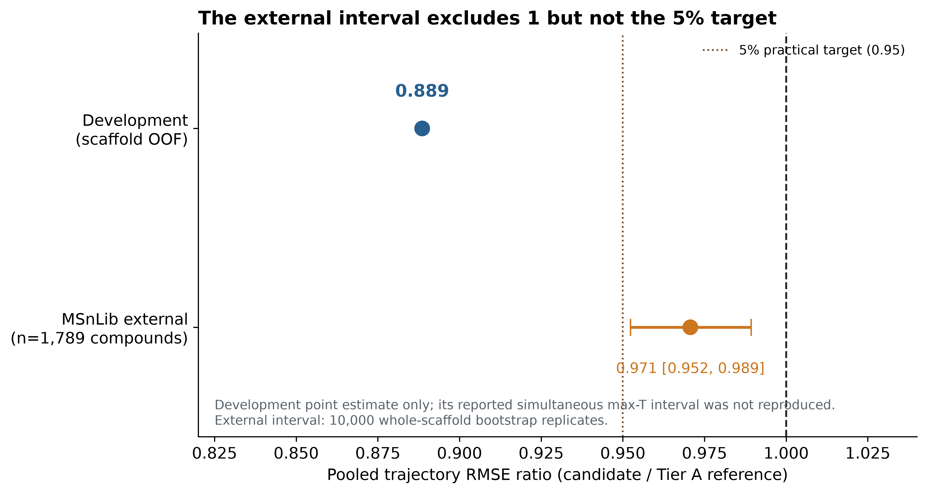
Figure 2. Candidate/reference pooled trajectory RMSE ratios in development and external evaluation. Only the MSnLib interval is shown because the frozen-output scaffold bootstrap is reproducible from the committed analysis inputs.

3.4 Per-energy-rung performance
At recorded setting 20, candidate RMSE was 0.16438 and reference RMSE was 0.16736 (ratio 0.9822). At recorded setting 60, candidate RMSE was 0.08111 and reference RMSE was 0.08747 (ratio 0.9273). Both rungs favored the candidate, with a larger point difference at setting 60. The reference residuals had positive means at both settings (+0.0354 and +0.0207), while candidate mean residuals were −0.0077 and +0.0033. Thus some of the pooled difference accompanies a smaller systematic offset under the fixed map; this does not establish that the map is physically calibrated (A. Thakur. MURU-WUR-v2 MSnLib Confirmation Study 2 protocol, freeze and result. MURU-ConjectureLab-v1 repository, 2026. Files: MURU_V2_MSNLIB_CONFIRMATION_PROTOCOL_V2.md; MURU_V2_MSNLIB_CONFIRMATION_V2_FREEZE.md; MURU_V2_MSNLIB_CONFIRMATION_V2_RESULT.md.), (A. Thakur. MURU-WUR-v2 MSnLib Confirmation Study 2 analysis code and frozen outputs. MURU-ConjectureLab-v1 repository, 2026. Files: scripts/wur_v2_confirmation_v2/11_external_analysis.py; artifacts/wur_v2_confirmation_v2/result/external_analysis.json; artifacts/wur_v2_confirmation_v2/result/measured_mu.csv.), (A. Thakur. MURU-WUR-v2 exposure and data registry. MURU-ConjectureLab-v1 repository, 2026. File: MURU_V2_EXPOSURE_AND_DATA_REGISTRY.md.).

3.5 Structural novelty
All four frozen quartiles are shown in Figure 4 and Supplementary Table S5. The most novel quartile, Q1 (maximum training-set similarity <0.281; n = 449), had candidate P1 = 0.12768 and reference P1 = 0.12663, ratio = 1.0083. The candidate therefore had slightly higher error in this subset. Q2, Q3 and Q4 ratios were 0.9655, 0.9593 and 0.9528, respectively. These are descriptive stratum estimates without quartile-specific confidence intervals. The main external advantage did not appear in the least-similar quarter (A. Thakur. MURU-WUR-v2 MSnLib Confirmation Study 2 protocol, freeze and result. MURU-ConjectureLab-v1 repository, 2026. Files: MURU_V2_MSNLIB_CONFIRMATION_PROTOCOL_V2.md; MURU_V2_MSNLIB_CONFIRMATION_V2_FREEZE.md; MURU_V2_MSNLIB_CONFIRMATION_V2_RESULT.md.), (A. Thakur. MURU-WUR-v2 MSnLib Confirmation Study 2 analysis code and frozen outputs. MURU-ConjectureLab-v1 repository, 2026. Files: scripts/wur_v2_confirmation_v2/11_external_analysis.py; artifacts/wur_v2_confirmation_v2/result/external_analysis.json; artifacts/wur_v2_confirmation_v2/result/measured_mu.csv.), (A. Thakur. MURU-WUR-v2 exposure and data registry. MURU-ConjectureLab-v1 repository, 2026. File: MURU_V2_EXPOSURE_AND_DATA_REGISTRY.md.).
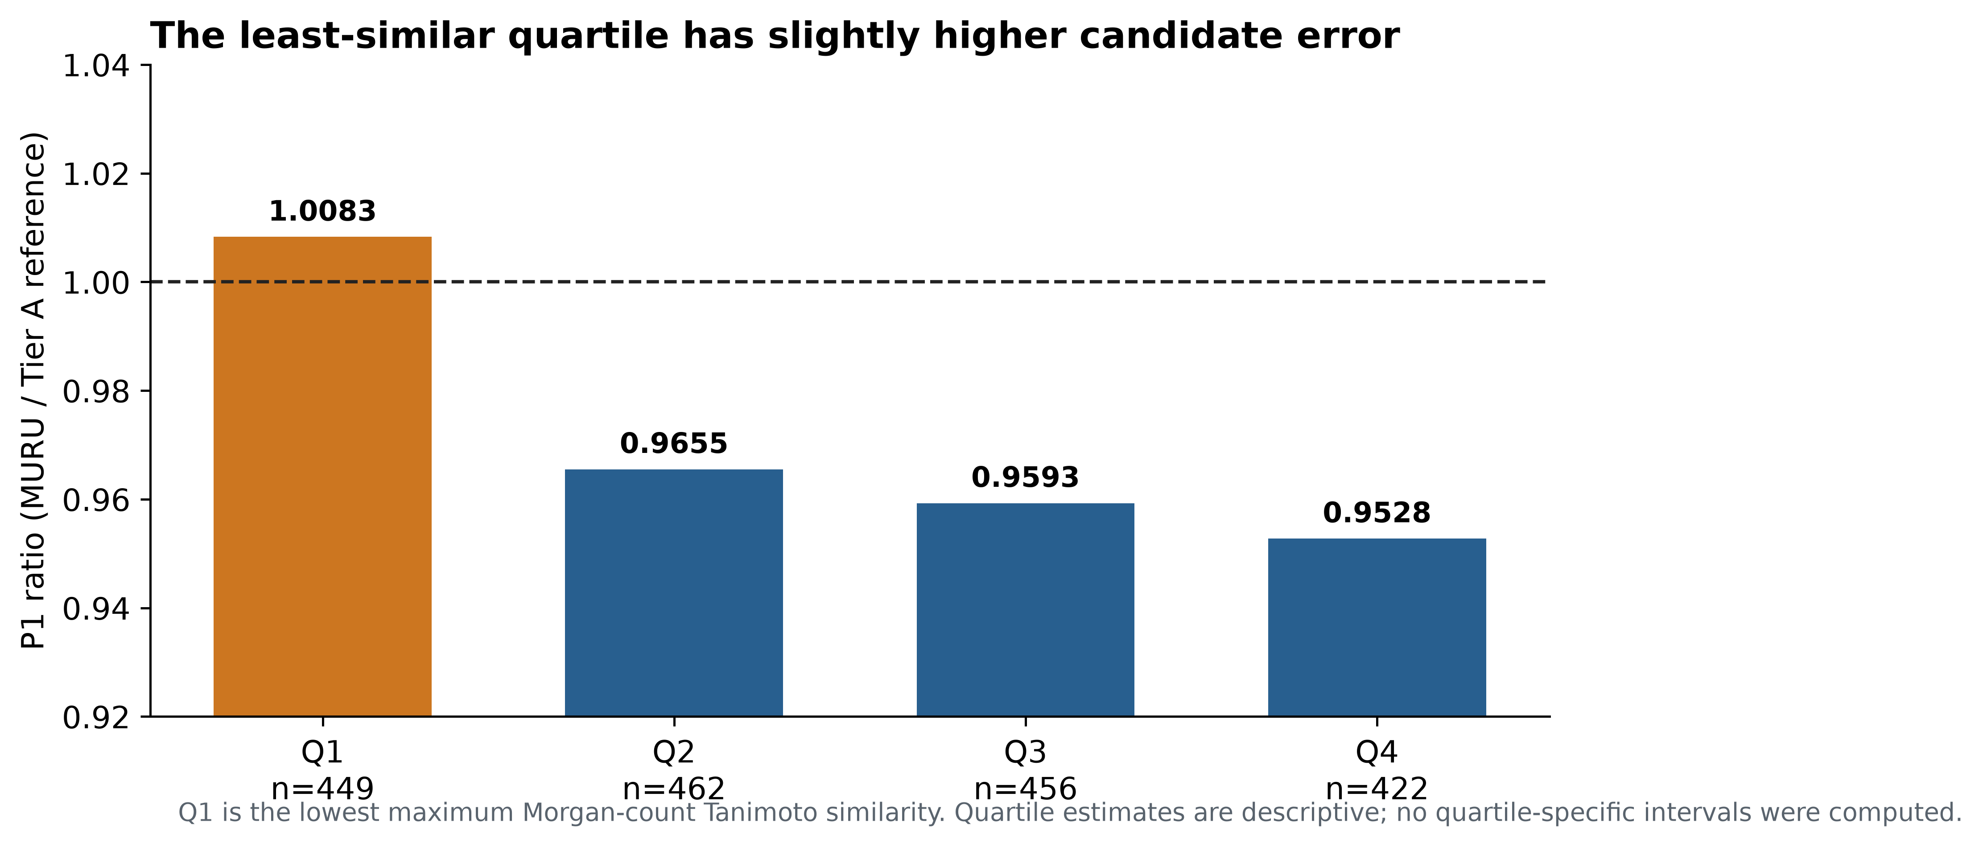
Figure 4. P1 ratio across all four structural-novelty quartiles. Q1 is the least-similar, most novel quartile; values above one indicate higher candidate error.

3.6 Error distributions and tail performance
MURU and reference MRMSE values were 0.11214 and 0.11752; median compound RMSE values were 0.09956 and 0.10752. The candidate/reference Q90 values were 0.20705 and 0.20659; Q95 values were 0.23151 and 0.23486; and CVaR95 values were 0.26568 and 0.26486. AF was 11.85% for MURU and 11.79% for the reference. The bootstrap AF difference was +0.00056, with 95% interval [−0.01453, +0.01554], below the protocol's +0.03 adverse-tail override. These results do not demonstrate tail-risk improvement. The point estimates show little to no difference in upper-tail behavior (A. Thakur. MURU-WUR-v2 MSnLib Confirmation Study 2 protocol, freeze and result. MURU-ConjectureLab-v1 repository, 2026. Files: MURU_V2_MSNLIB_CONFIRMATION_PROTOCOL_V2.md; MURU_V2_MSNLIB_CONFIRMATION_V2_FREEZE.md; MURU_V2_MSNLIB_CONFIRMATION_V2_RESULT.md.), (A. Thakur. MURU-WUR-v2 MSnLib Confirmation Study 2 analysis code and frozen outputs. MURU-ConjectureLab-v1 repository, 2026. Files: scripts/wur_v2_confirmation_v2/11_external_analysis.py; artifacts/wur_v2_confirmation_v2/result/external_analysis.json; artifacts/wur_v2_confirmation_v2/result/measured_mu.csv.), (A. Thakur. MURU-WUR-v2 exposure and data registry. MURU-ConjectureLab-v1 repository, 2026. File: MURU_V2_EXPOSURE_AND_DATA_REGISTRY.md.).
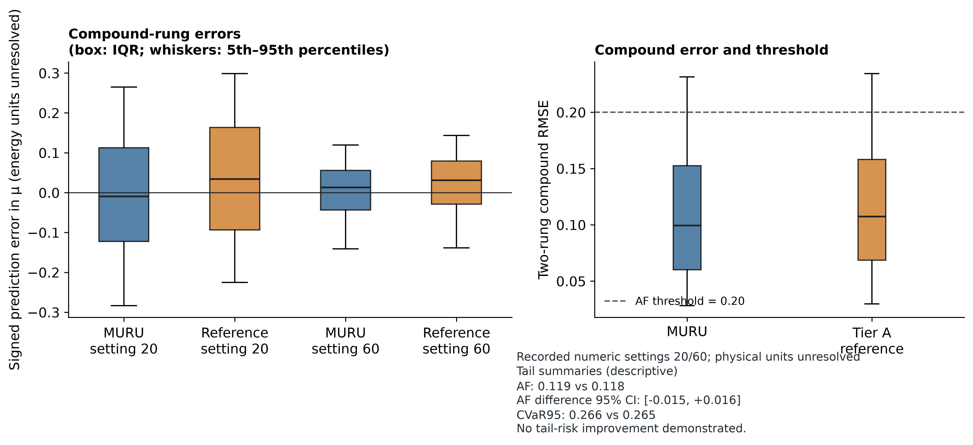
Figure 3. Per-rung RMSE and compound error summaries. Upper-tail measures are descriptive; AF's scaffold-bootstrap difference interval includes zero.

3.7 Comparator analyses and energy-interface adjudication
Under the comparator benchmark's model-specific primary input conditions, P1 was 0.12652 for MURU, 0.20455 for FIORA-OS, 0.16208 for ICEBERG 2.1, and 0.13839 for GLACIER. The corresponding MURU/comparator ratios were 0.6185, 0.7806, and 0.9143. The full-spectrum systems' predicted peaks were reduced to the same μ endpoint before scoring, but the systems differ in model class, training data, preprocessing, and energy conventions. In the raw-NCE diagnostic, ICEBERG and GLACIER ratios were 1.076 and 1.238, respectively, favoring the comparator point estimates. The benchmark therefore supports only a conditional comparison of μ predictions under tested energy inputs; it does not rank full-spectrum accuracy or establish convention-independent superiority (A. Thakur. MURU public comparator benchmark preregistration, record chain and result. MURU-ConjectureLab-v1 repository, 2026.), (A. Thakur. MURU collision-energy-interface adjudication Design A preregistration and result. MURU-ConjectureLab-v1 repository, 2026.), (A. Thakur. MURU-WUR-v2 reproducibility manifest and full-repository regression verification. MURU-ConjectureLab-v1 repository, 2026.), (R.-X. Wang, R. Wang, C. W. Coley. GLACIER: Rethinking Mass Spectrum Prediction as an Object Detection Problem. arXiv:2606.29161, 2026. Preprint; not peer reviewed as of 2 November 2026.).
In Design A, the three mappings ranked K1 > K2 > K3 in every descriptive cut. K1's pooled composite score was 0.557070. Its contrasts with K2 and K3 were +0.042318 and +0.050333, but the primary Bonferroni-adjusted intervals [−0.012660, +0.099083] and [−0.007439, +0.109993] crossed zero. The frozen decision was INTERFACE_UNRESOLVED. This independent 33-compound study shows a consistent descriptive ordering but does not identify a physical energy convention (A. Thakur. MURU collision-energy-interface adjudication Design A preregistration and result. MURU-ConjectureLab-v1 repository, 2026.).
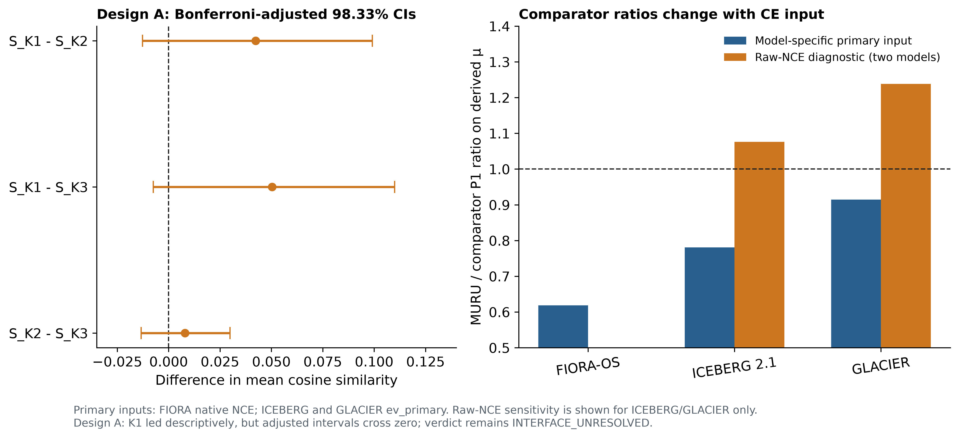
Figure 5. CE Design A adjusted contrasts and comparator benchmark sensitivity. Ratios below one favor MURU under the tested convention; diagnostic reversals and the unresolved Design A result preclude a convention-independent ranking.

3.8 Reproducibility findings
The frozen MSnLib analysis script was executed in a fresh detached worktree at the release commit using committed inputs and model artifacts. It returned 1,789 scored compounds, 1,687 groups, the same candidate and reference P1 values, the same bootstrap ratio interval, the same per-rung values, all four novelty ratios, and the same frozen decision. The bootstrap used 10,000 resamples and seed 20261011. The reproducibility boundary is statistical reconstruction from the committed measured-μ table and frozen model JSON; raw mzML retrieval and parsing are not included in this rerun. The repository's Phase 1 whole-suite test record contains 11 pre-existing failures and 14 errors (identical at the comparison base), including a newly identified unpinned lxml dependency and tests requiring absent large synthetic benchmark artifacts; these are not used to validate the scientific result (A. Thakur. MURU-WUR-v2 reproducibility manifest and full-repository regression verification. MURU-ConjectureLab-v1 repository, 2026.).

4. Discussion
The central result is a small but statistically directional external difference for the frozen scalar endpoint: the MURU candidate's pooled two-rung RMSE was 2.93% lower than that of the development-selected Tier A reference. The 95% scaffold-bootstrap interval excludes one, but every value in the interval is above 0.95. The prespecified practical-improvement criterion therefore failed. Calling this a modest confirmation reflects the frozen decision rule and the limited size of the effect; it does not imply operational benefit.
The development estimate was appreciably larger than the external estimate (ratio 0.889 versus 0.971), and the development tail-failure reduction did not transfer. The development comparison is also less confirmatory than a strictly prospective account would imply: A-3 restated one admission criterion after the results and review diagnostics were visible. The frozen development numbers remain unchanged, but their selection history should be read with this amendment and the unreproduced max-T provenance in view. Several explanations remain compatible with these observations. Development model selection involved multiple candidate families, even though grouped nested validation and a simplicity rule were used. The external population differs in source, library construction and the measured energy rungs. Model representation and selection also differ between candidate and reference: the candidate includes a Morgan count block and has its own selected ridge penalty; the reference is a separate Tier A ridge. The paired evaluation identifies their overall predictive difference under the frozen pipeline, not the fingerprint block's causal effect. Source shift, residual confounding, the fit of the zero-parameter map, and selection optimism could each affect the magnitude. None is separately identified by this comparison.
The adverse Q1 finding is important. Q1 is defined by low maximum Morgan-count similarity to the development compounds, and the candidate/reference ratio of 1.008 indicates slightly worse point performance there. The other three quartiles favor the candidate, but no subgroup intervals were computed, so this pattern should be treated as descriptive. It does not establish a sharp applicability threshold. It does show why an average external gain cannot be generalized to the structural frontier represented by this library's least-similar compounds.
No improvement in tail risk was demonstrated. Candidate and reference Q90 and CVaR95 values are nearly equal, Q95 differs only slightly, and the AF contrast interval includes zero. In particular, the candidate's AF point estimate is marginally higher. The data support a typical-error reduction more readily than any reduction in severe failures, but the distinction is descriptive: the uncertainty interval for AF does not establish equality or harm.
One additional source of possible distribution shift is the precursor denominator: WUR uses the declared MassBank value, whereas MSnLib uses structure-derived [M+H]+. The endpoint formula is the same, but the two denominator values were not asserted to be identical; this difference was not separately quantified and should not be attributed to model performance.
Energy interpretation is a major limitation. The numeric adapter is computationally reproducible and was not fit to the MSnLib outcomes, but its physical interpretation is not validated. The MSnLib publication describes its Orbitrap ID-X MS2 settings as 20 eV and 60 eV, whereas the frozen MURU protocol labels the selected numeric values NCE 20 and 60. The evaluated archives do not contain the instrument method files needed to resolve that discrepancy. The protocol’s A0 assumption that ID-X NCE equals IQ-X NCE was tested against anchors, but the absolute-agreement gate failed at A0, A1, and A2 by the recorded small margins. Thus, the external scalar comparison remains a reproducible comparison of two frozen prediction pipelines using the same adapter and measured μ records; the evidence does not establish physical cross-instrument energy equivalence or absolute trajectory calibration. Public comparator rankings also depend on model-specific energy inputs, and raw-NCE diagnostics reverse two rankings. These results cannot establish convention-independent comparator superiority.
The comparator benchmark reduced full-spectrum systems' predicted peaks to the same scalar μ endpoint before calculating P1. Its model-specific primary conditions were native NCE for FIORA-OS and ev_primary for ICEBERG and GLACIER; the raw-NCE diagnostic was computed only for the latter two. This supports a comparison of μ prediction error on the frozen common population, conditional on the tested energy mapping and preprocessing. It does not measure prediction of fragment identities, individual intensities, complete spectra, or candidate structures. The benchmark also does not isolate architecture, training data, or the contribution of any MURU feature block.
The earlier sample exposure must remain part of the research history. A parser-preflight error decoded and surfaced one outcome from sample 1 before its planned look. That sample was not scored; it was permanently excluded and replaced under a new protocol. Sample 2 was drawn once, used for the frozen analysis and is now exposed. This provenance weakens any casual use of “blind” for the overall project and prevents another confirmatory use of this library population. It does not change the recorded sample-2 calculations, but it constrains how independent the full development history can be represented.
The development simultaneous max-T interval [0.860, 0.918] remains a historical reported value. Phase 2 reports, evidence, and the census verifier were recovered from a local audit worktree; the user-recorded audit commit object was not recoverable in the inspected Git database. The recovered CI provenance report confirms that the max-T script, exact seed, serialized resamples, and selection ledger were not recovered, so the interval is not treated as reproduced. The external scaffold-bootstrap interval is reproducible from committed frozen measured-μ values and model outputs. It supports a separately sampled external comparison under the frozen protocol, subject to the documented exposure and energy-interface limitations.
Future work should predefine a physically interpretable energy interface, use independently collected spectra with documented instrument-specific CE semantics, and retain enough chemically remote compounds to estimate performance at the structural frontier. A prospective study should freeze the model, endpoint, support rule, comparator, energy mapping and subgroup estimands before access to outcomes. If the intended scientific use is complete spectrum simulation or structure identification, those outputs need separate benchmarks with matched test compounds and clearly documented CE settings. The present result supports further independent study of a compact fragmentation-extent endpoint; it does not support using MURU as a universal MS/MS predictor.

5. Conclusion
On the frozen MSnLib population and fixed deployment energy map, MURU-WUR-v2 achieved a lower pooled fragmentation-extent RMSE than the Tier A reference, with a ratio of 0.9707 (95% scaffold-bootstrap interval 0.9524–0.9893). The gain was statistically directional but smaller than the prespecified 5% practical-improvement threshold. No tail-risk advantage was demonstrated, and performance did not improve in the least-similar structural quartile. The defensible conclusion is modest external confirmation for this two-rung, positive-mode scalar endpoint, with unresolved source-specific energy units, a failed absolute-agreement anchor gate, and limited transfer to the least-similar chemistry.

Declarations
Author contributions. Aryav Thakur: project ownership, study design and computational research. Specific contribution allocation should be confirmed by the author before any external circulation.
Acknowledgments. No acknowledgments are recorded in the verified project files.
Data availability. Frozen source records, derived measured-μ tables, model artifacts and analysis code are included in the MURU-ConjectureLab-v1 repository at the release commit listed above. Third-party MSnLib raw archives are not redistributed here. Instructions and source identifiers are provided in the supporting information.
Code availability. Analysis source is present in the repository. Phase 3 figure and table generation scripts are included in this package. The release branch remains the source of frozen scientific results; this publication branch adds documentation and reproducibility outputs.
Competing interests. No competing-interest statement has been verified. The author should confirm this declaration before external circulation.
Ethical considerations. No human participants or animals were involved; no institutional review approval was applicable to the computational reanalysis described here.
Research limitations. This study addresses a precursor-including scalar endpoint on positive-mode HCD data at two external recorded numeric settings whose physical units remain unresolved. It does not validate full-spectrum prediction, identification accuracy, transfer across instruments, negative-mode performance, or universal calibration. The external population is exposed after the single frozen look. The energy interface is unresolved; the most novel quartile shows no candidate advantage; and the historical development max-T calculation could not be reconstructed because its source script, seed, resamples, and selection ledger were not recovered.
AI-assisted research and drafting record. AI tools assisted with repository inspection, analysis-code authoring, generation of figures and tables, literature discovery, drafting and editing of this internal manuscript and supporting information. Frozen experimental outcomes were not altered. All factual, scientific and authorship statements require owner review before any external use. This is an internal AI-assisted draft and has not been submitted to a journal.

References
1. A. R. Johnson, E. E. Carlson. Collision-induced dissociation mass spectrometry: A powerful tool for natural product structure elucidation. Analytical Chemistry. Vol. 87, pg. 10668–10678, 2015. https://doi.org/10.1021/acs.analchem.5b01543. 2. Thermo Fisher Scientific. Q Exactive HF Software Manual: HCD normalized and absolute collision energy. 2018. https://documents.thermofisher.com/TFS-Assets/CMD/manuals/man-1372090-q-exactive-hf-soft-man1372090-en.pdf. 3. F. Allen, R. Greiner, D. Wishart. Competitive fragmentation modeling of ESI-MS/MS spectra for putative metabolite identification. Metabolomics. Vol. 11, pg. 98–110, 2015. https://doi.org/10.1007/s11306-014-0676-4. 4. F. Wang, J. Liigand, S. Tian, D. Arndt, R. Greiner, D. S. Wishart. CFM-ID 4.0: More accurate ESI-MS/MS spectral prediction and compound identification. Analytical Chemistry. Vol. 93, pg. 11692–11700, 2021. https://doi.org/10.1021/acs.analchem.1c01465. 5. A. Young, H. Röst, B. Wang. Tandem mass spectrum prediction for small molecules using graph transformers. Nature Machine Intelligence. Vol. 6, pg. 404–416, 2024. https://doi.org/10.1038/s42256-024-00816-8. 6. Y. Nowatzky, F. F. Russo, J. Lisec, A. Kister, K. Reinert, T. Muth, P. Benner. FIORA: Local neighborhood-based prediction of compound mass spectra from single fragmentation events. Nature Communications. Vol. 16, Article 2298, 2025. https://doi.org/10.1038/s41467-025-57422-4. 7. S. Goldman, J. Li, C. W. Coley. Generating molecular fragmentation graphs with autoregressive neural networks. Analytical Chemistry. Vol. 96, pg. 3419–3428, 2024. https://doi.org/10.1021/acs.analchem.3c04654. 8. R. Wang, M. Manjrekar, B. Mahjour, J. Avila-Pacheco, J. Provenzano, E. Reynolds, M. Lederbauer, E. Mashin, S. Goldman, M. Wang, J.-K. Weng, D. L. Plata, C. B. Clish, C. W. Coley. Neural spectral prediction for structure elucidation with tandem mass spectrometry. bioRxiv preprint, 2025. https://doi.org/10.1101/2025.05.28.656653. Not peer reviewed as of the source record consulted. 9. D. Rogers, M. Hahn. Extended-connectivity fingerprints. Journal of Chemical Information and Modeling. Vol. 50, pg. 742–754, 2010. https://doi.org/10.1021/ci100050t. 10. G. W. Bemis, M. A. Murcko. The properties of known drugs. 1. Molecular frameworks. Journal of Medicinal Chemistry. Vol. 39, pg. 2887–2893, 1996. https://doi.org/10.1021/jm9602928. 11. R. J. Bajusz, A. Rácz, K. Héberger. Why is Tanimoto index an appropriate choice for fingerprint-based similarity calculations? Journal of Cheminformatics. Vol. 7, Article 20, 2015. https://doi.org/10.1186/s13321-015-0069-3. 12. A. Thakur. MURU-WUR-v2 development protocol, final candidate freeze and final report. MURU-ConjectureLab-v1 repository, frozen release commit bfa153e828e08b3c7e674ef7fe9d6818d14a2b61, 2026. Files: MURU_WUR_V2_DEVELOPMENT_PROTOCOL.md; MURU_WUR_V2_FINAL_CANDIDATE_FREEZE.md; MURU_WUR_V2_FINAL_REPORT.md. 13. A. Thakur. MURU-WUR-v2 MSnLib Confirmation Study 2 protocol, freeze and result. MURU-ConjectureLab-v1 repository, 2026. Files: MURU_V2_MSNLIB_CONFIRMATION_PROTOCOL_V2.md; MURU_V2_MSNLIB_CONFIRMATION_V2_FREEZE.md; MURU_V2_MSNLIB_CONFIRMATION_V2_RESULT.md. 14. A. Thakur. MURU-WUR-v2 MSnLib Confirmation Study 2 analysis code and frozen outputs. MURU-ConjectureLab-v1 repository, 2026. Files: scripts/wur_v2_confirmation_v2/11_external_analysis.py; artifacts/wur_v2_confirmation_v2/result/external_analysis.json; artifacts/wur_v2_confirmation_v2/result/measured_mu.csv. 15. A. Thakur. MURU-WUR-v2 exposure and data registry. MURU-ConjectureLab-v1 repository, 2026. File: MURU_V2_EXPOSURE_AND_DATA_REGISTRY.md. 16. A. Elapavalore, T. Kondić, R. R. Singh, B. A. Shoemaker, P. A. Thiessen, J. Zhang, E. E. Bolton, E. L. Schymanski. Adding open spectral data to MassBank and PubChem using open source tools to support non-targeted exposomics of mixtures. Environmental Science: Processes & Impacts. Vol. 25, pg. 1788–1801, 2023. https://doi.org/10.1039/D3EM00181D. 17. S. Neumann, R. Meier, M. Wenk, A. Elapavalore, T. Nishioka, T. Schulze, M. Stravs, H. Tsugawa, F. Matsuda, E. L. Schymanski. MassBank: an open and FAIR mass spectral data resource. Nucleic Acids Research. Vol. 54, pg. D601–D606, 2026. https://doi.org/10.1093/nar/gkaf1193. 18. B. Efron, R. J. Tibshirani. Bootstrap methods for standard errors, confidence intervals, and other measures of statistical accuracy. Statistical Science. Vol. 1, pg. 54–75, 1986. https://doi.org/10.1214/ss/1177013815. 19. A. Thakur. MURU-WUR-v2 development split and population audit. MURU-ConjectureLab-v1 repository, frozen release commit bfa153e828e08b3c7e674ef7fe9d6818d14a2b61, 2026. 20. RDKit. Morgan fingerprint implementation and documentation, version 2026.03.5. https://www.rdkit.org/docs/. 21. D. C. Montgomery, E. A. Peck, G. G. Vining. Introduction to linear regression analysis, 5th ed. Wiley, 2012. 22. Thermo Fisher Scientific. Orbitrap Exploris 240 Software Manual: normalized and absolute HCD collision energy. https://docs.thermofisher.com/. 23. A. Thakur. MURU public comparator benchmark preregistration, record chain and result. MURU-ConjectureLab-v1 repository, 2026. 24. A. Thakur. MURU collision-energy-interface adjudication Design A preregistration and result. MURU-ConjectureLab-v1 repository, 2026. 25. A. Thakur. MURU-WUR-v2 reproducibility manifest and full-repository regression verification. MURU-ConjectureLab-v1 repository, 2026. 26. A. Thakur. MURU-WUR-v2 review adjudication and statistical review records. MURU-ConjectureLab-v1 repository, 2026. 27. R.-X. Wang, R. Wang, C. W. Coley. GLACIER: Rethinking Mass Spectrum Prediction as an Object Detection Problem. arXiv:2606.29161, 2026. Preprint; not peer reviewed as of 2 November 2026. 28. C. Brungs, R. Schmid, S. Heuckeroth, A. Mazumdar, M. Drexler, P. Šácha, P. C. Dorrestein, D. Petras, L.-F. Nothias, V. Veverka, R. Nencka, Z. Kameník, T. Pluskal. MSnLib: efficient generation of open multi-stage fragmentation mass spectral libraries. Nature Methods. 22(10):2028–2031, 2025. https://doi.org/10.1038/s41592-025-02813-0. 29. F. Padilla-González, S. Rizzo, C. Dirks, W. Bergkamp, S. Rasker, I. Aloisi. Creation of an Open-Access High-Resolution Tandem Mass Spectral Library of 1000 Food Toxicants. Analytical Chemistry. 97(43):23822–23830, 2025. https://doi.org/10.1021/acs.analchem.5c03020.

