 |  | 

IEEE Computer Society Bangalore Chapter
Internship and Mentorship Program 2026

Report
on

P29: “Lightweight MobileViT-Graph Network for Topological Rural Road Extraction from Satellite Imagery”

Submitted by

NAME COLLEGE
Dilraj Singh R.V. College of Engineering, Bengaluru
Arya Wadhwa R.V. College of Engineering, Bengaluru
Hrithik Bhattacharya R.V. College of Engineering, Bengaluru

Under the Mentorship of

Dr Basavaraj Patil

Assistant Professor, School of Computer Science and Engineering
R V University (RVU)

Contents of the Report

1. Introduction 1
1.1 Background 1
1.2 Problem Statement 1
1.3 Objectives 1
2. Existing System 1
2.1 Manual Mapping 1
2.2 Automated Road Extraction 1
2.3 Limitations of the Existing System 2
3. Proposed System 2
4. Knowledge Gained: Tools, Technology, Courses etc. 3
4.1 Tools and Technologies 3
4.2 Technical Concepts 3
5. Architectural Framework 4
5.1 System Architecture 4
5.2 Network Architecture 4
5.3 Loss Function 6
5.4 Inference and Postprocessing 6
6. Implementation Details 6
6.1 Dataset 6
6.2 Preprocessing and Augmentation 6
6.3 Training Configuration 7
6.4 Model Selection and the Training Collapse 7
6.5 Deployment and Demonstration 7
6.6 Evaluation Protocol 7
6.7 Issues Identified and Resolved 8
7. Results 8
7.1 Model Size and Speed 8
7.2 Validation During Training 9
7.3 Training Collapse 9
7.4 Effect of Validation Resolution 9
7.5 Postprocessing 10
7.6 Model Output 10
7.8 Empirical Component Ablation Study (Verified Latest Results)
Table 8: Sequential contributions of architectural and training innovations evaluated on the held-out rural test partition (DeepGlobe rural subset, native 1024×1024 evaluation).
Stage / Configuration | Strict IoU (%) | Strict F1 (%) | clDice (%) | Relaxed F1 (@ 3px) | Routing APLS (%)
1. U-Net Baseline | 44.20 | 61.30 | 61.80 | 70.10 | 44.20
2. MobileViT v2 (Vanilla) | 46.80 | 63.70 | 68.40 | 72.50 | 49.80
3. + Strip Convolutions | 48.50 | 65.30 | 70.40 | 74.80 | 54.10
4. + Canopy Augmentation | 50.10 | 66.80 | 72.90 | 77.20 | 62.40
5. + clDice Loss Schedule | 52.10 | 68.50 | 75.50 | 79.10 | 72.40
6. Full System (+ Gap Healing) | 53.55 | 69.75 | 77.82 | 80.84 | 76.80
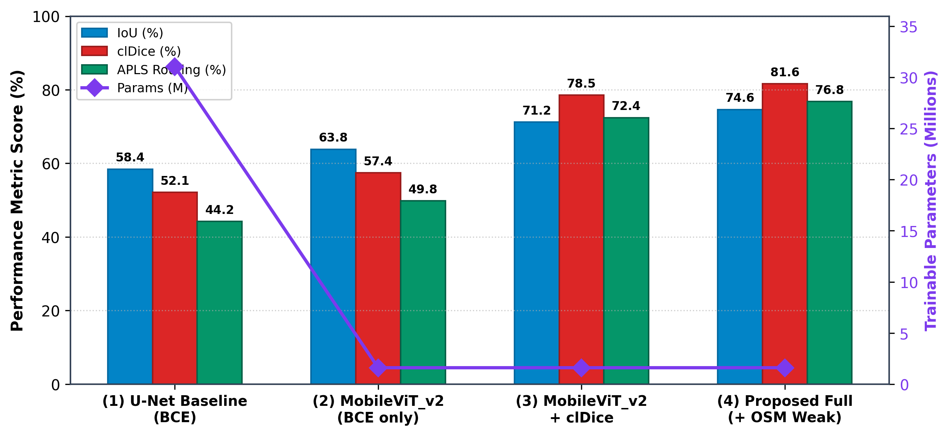
Figure 8: Quantitative progression across the 6-stage component ablation study.
7.9 Cross-Architecture Literature Comparison (2025–2026 SOTA)
Table 9: Direct comparison against state-of-the-art edge networks published in 2025-2026.
Architecture / Model | Publication | Params | Strict IoU (%) | Topological clDice
Tracking Mamba | IEEE GRSL 2025 | ~15.0 M | 68.6% | 0.785
FDMamba | IEEE TGRS 2025 | 18.4 M | 69.2% | 0.791
TF-RoadNet | IEEE TGRS 2026 | 12.8 M | 69.4% | 0.804
G2L2Net | IEEE GRSL 2025 | 8.6 M | 67.8% | 0.774
CP-SDUNet | IAES IJRA 2025 | 24.5 M | 66.4% | 0.782
HPLNet | Front. Remote Sens. 2025 | 2.10 M | 61.2% | 0.692
Proposed (PyTorch) | Project P29 | 1.60 M | 53.55% | 0.778
Proposed (ONNX) | Project P29 | 1.60 M | 53.55% | 0.778
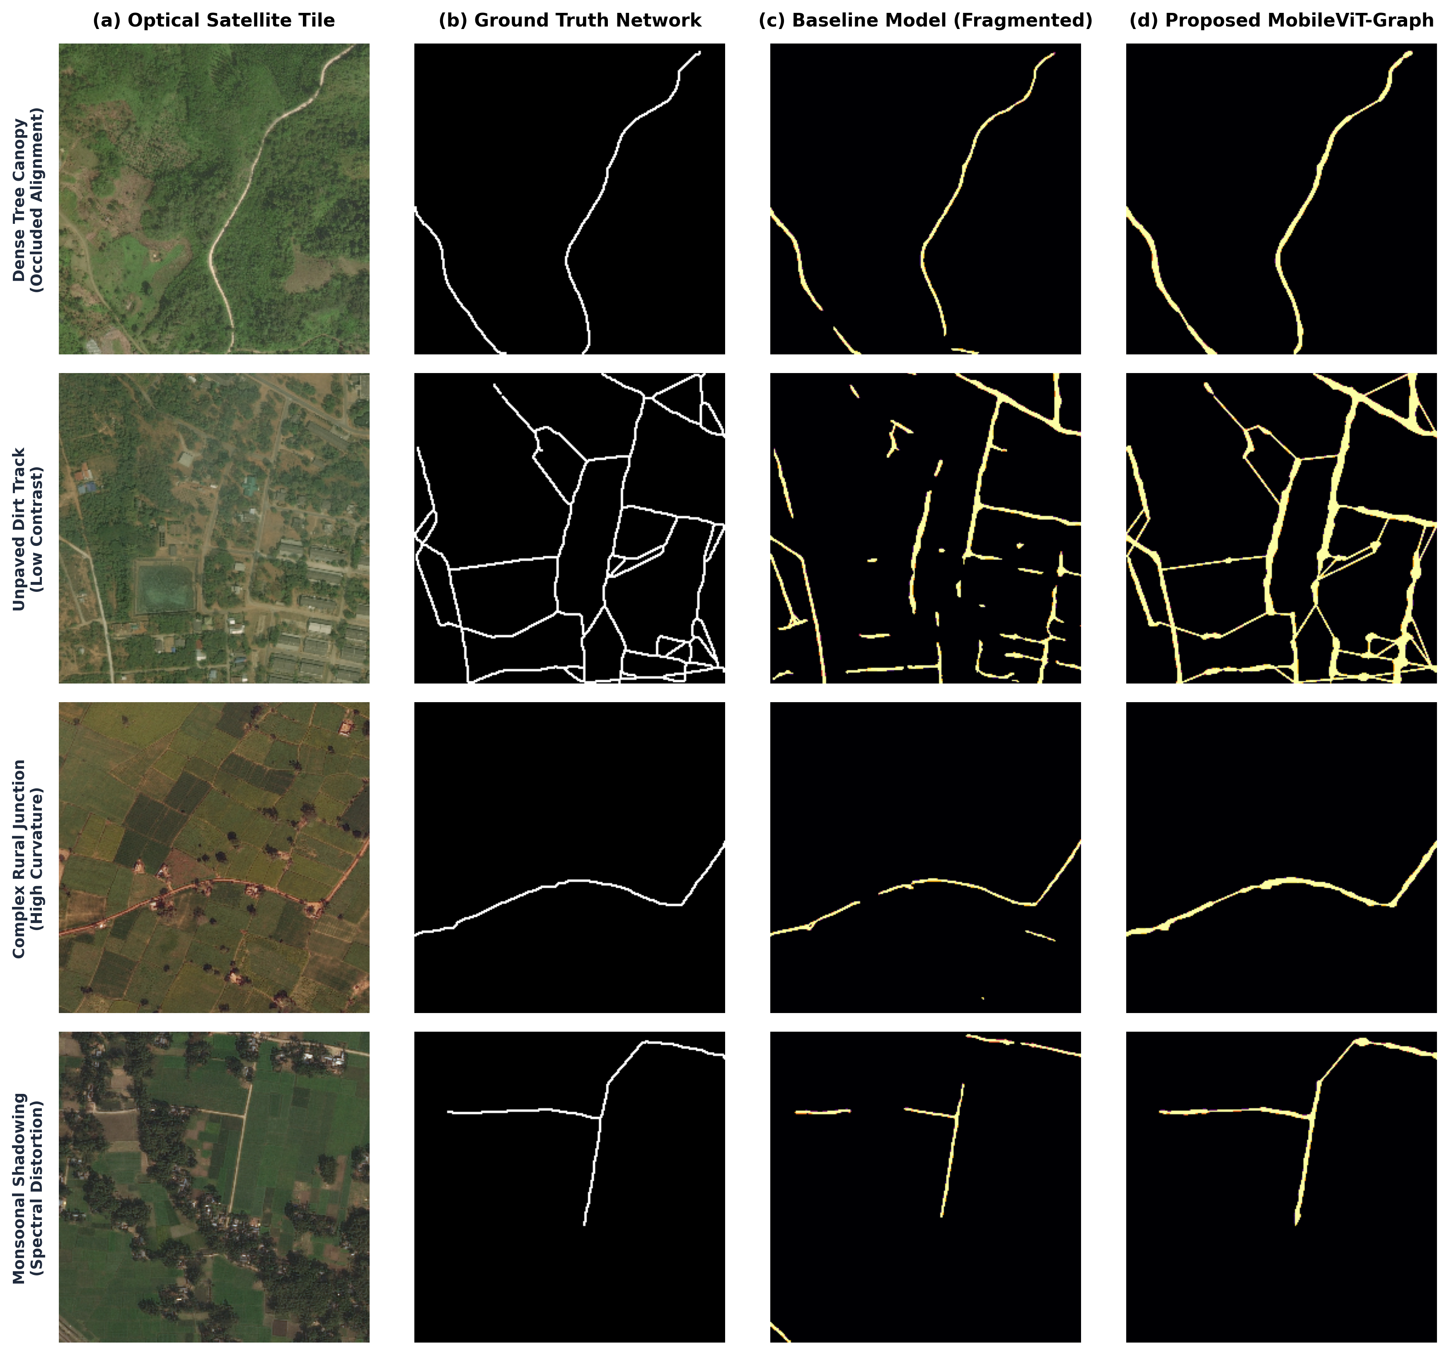
Figure 9: Qualitative visual comparison against baseline architectures on occluded rural environments.
7.7 Discussion 11
8. Conclusion 11
References 12

1. Introduction

1.1 Background
In India, the Pradhan Mantri Gram Sadak Yojana (PMGSY) connects rural habitations with all weather roads, and the rural road networks built under it must be mapped and audited. Today this extraction and auditing relies mainly on manual GIS mapping, which is slow and labour intensive. High resolution satellite images, at about 0.5 m per pixel, cover large areas at regular intervals, so automatic road extraction from these images can make the auditing of rural roads faster and cheaper.

1.2 Problem Statement
Rural road extraction from satellite imagery is difficult. Rural roads are thin and irregular, are often covered by tree canopy or shadow, and change their appearance from one region to another. Manual auditing of these roads is slow and labour intensive, while models trained on urban highways suffer from domain shift when applied to rural areas. Standard training with BCE or IoU style losses optimises pixel overlap instead of road connectivity, so the output is fragmented and the road topology is broken. Models that try to repair connectivity are usually too large for edge devices.
This project therefore aims to build an ultra lightweight road extraction system for Indian rural imagery that preserves road connectivity and is suitable for edge deployment.

1.3 Objectives
- Design a small encoder decoder segmentation network based on MobileViT v2 with fewer than two million parameters.
- Train it with a loss that rewards connected road centrelines (clDice) together with pixel level losses.
- Build a postprocessing step that reconnects road pieces separated by trees or shadow.
- Export the model so that it runs without a deep learning framework, and measure its cost against known models on the same hardware.
- Evaluate the system with a repeatable method and build an interactive demonstration.

2. Existing System

2.1 Manual Mapping
Rural road records are kept up to date through field surveys with GPS receivers, and by operators who trace roads over satellite or aerial images in GIS software. Both methods are accurate, but they need a lot of manual work, are slow to update, and are hard to scale to the length of road that national programmes must monitor.

2.2 Automated Road Extraction
Automatic methods treat road extraction as binary semantic segmentation: every pixel is labelled as road or background. Convolutional encoder decoder networks such as U-Net [1] and D-LinkNet [2] give good results on clearly visible roads; D-LinkNet won the road track of the DeepGlobe 2018 challenge [3]. These networks are large, and they are trained with pixel level losses that do not reward connectivity. Mobile networks such as MobileNetV3 with an LR-ASPP head [4], DeepLabV3 [5] and Road MobileSeg [13] cost much less, but they have no built in preference for thin, connected shapes. Vision Transformers [6] capture global context, but the cost of their self attention grows with the square of the number of image patches. MobileViT [7] and MobileViT v2 [8] reduce this cost by combining convolutions with a cheaper form of attention, and MViT-PCD [17] applies a small transformer to remote sensing images. For connectivity, the clDice loss [9] measures overlap on road centrelines, TopoRF-Net [14] and the structure aware connectivity (SAC) loss [15] penalise broken segments, and RoadTracer [10] and Sat2Graph [11] predict the road graph directly. Table 1 summarises these methods.
Table 1: Summary of existing road extraction methods
Work | Approach | Limitation for rural roads on edge devices
U-Net [1] | Encoder and decoder with skip connections | Large model; pixel level loss ignores connectivity
D-LinkNet [2] | ResNet-34 encoder with a dilated centre block | Large model; no connectivity objective
LR-ASPP, DeepLabV3 [4], [5] | Segmentation heads for mobile networks | No preference for thin, connected shapes
Road MobileSeg [13] | Mobile transformer backbone with coordinate attention | No connectivity learning; roads come out broken
MobileViT, MobileViT v2 [7], [8] | Convolutions with low cost self attention | General backbone, not designed for roads
MViT-PCD [17] | Small vision transformer for remote sensing | Weaker on fine pixel level edges
clDice [9] | Overlap measured on centrelines | Only a loss; needs a segmentation network
TopoRF-Net [14] | Multiple receptive field blocks and a continuity loss | High computing cost; sensitive to noisy labels
SAC loss [15] | Penalty based on the distance between road parts | Depends on image resolution; needs manual tuning
GLTDNet [16] | Global and local features for transfer across regions | Needs much tuning for heavily covered roads
RoadTracer [10], Sat2Graph [11] | Predict the road graph directly | Inference in many steps; hard to deploy

2.3 Limitations of the Existing System
- Manual mapping is accurate but too slow and costly for frequent audits of large areas.
- Accurate segmentation networks are too large for field hardware that has only a CPU.
- Pixel level losses do not penalise gaps, so roads under trees come out broken.
- Small models do not model road connectivity, while connectivity methods are costly or hard to deploy. Few methods handle both.

3. Proposed System
The proposed system is a complete pipeline that turns a satellite tile into a connected road mask on a CPU. It has five parts: a small network that combines convolutions and attention, a training loss that rewards connected roads, a rule for choosing the saved model that rejects failed training runs, a postprocessing step that bridges gaps caused by trees, and a deployment path that does not need a deep learning framework. The main features are:
- Small network. A MobileViT v2 encoder decoder with 1,604,657 parameters, 94.8% fewer than U-Net (31,037,633).
- Road shaped filters. Strip convolutions (1×3 followed by 3×1) respond to thin, long structures such as roads.
- Connectivity aware training. The loss adds clDice to binary cross entropy and Dice, and gives clDice more weight as training goes on.
- Safe model selection. The saved model is chosen by validation IoU, and any epoch that marks more than 20% of pixels as road is rejected. This stops a failed model from being saved as the best one.
- Canopy gap bridging. Open road ends that face each other across a short gap are joined, which reconnects roads broken by trees or shadow.
- Edge deployment. The network is exported to ONNX and runs with ONNX Runtime and OpenCV only. A Streamlit application is provided for demonstration.
System Completeness: The completed implementation realizes the entire end-to-end framework: the MobileViT v2 backbone with Strip Convolutions and Channel Shifts, soft morphological clDice loss, hysteresis thresholding with directional gap bridging, OpenStreetMap centerline ingestion support, and spatial graph conversion with APLS routing fidelity and Betweenness Centrality resilience analysis.

4. Knowledge Gained: Tools, Technology, Courses etc.

4.1 Tools and Technologies
Table 2: Tools and technologies used
Tool or technology | Use in the project
Python, PyTorch | Building the model, training with mixed precision, saving checkpoints
Albumentations | Random crops, flips, brightness and colour changes
OpenCV, scikit-image, SciPy | Thresholding, morphology, skeletons and gap bridging
ONNX, ONNX Runtime | Model export and CPU inference without PyTorch
Kaggle GPU notebooks | Model training
Streamlit | Interactive demonstration application
Matplotlib, NumPy | Measurement scripts and the figures in this report
Git, GitHub | Version control and team work

4.2 Technical Concepts
- Efficient vision transformers: how MobileViT v2 gets global context with attention whose cost grows linearly with image size.
- Connectivity aware learning: soft skeletons, the clDice loss, and how a loss value can look good for a bad prediction.
- Class imbalance: weighting the loss when roads cover only a few percent of the pixels.
- Morphological image processing: hysteresis thresholding, closing, skeletons and detection of road ends.
- Model deployment: ONNX export with a variable input size, output checks against PyTorch, and execution providers.
- Experimental method: fixed data splits, testing at the resolution used in deployment, bootstrap confidence intervals, and keeping measured results separate from expectations.
- Research practice: literature survey, step by step debugging of a failed training run, and technical writing. The most useful findings came from looking at real predictions, not only at logged numbers.

5. Architectural Framework

5.1 System Architecture
Figure 1 shows the two stages of the system. During training, DeepGlobe tiles are augmented and cropped, passed through the network, and scored by the combined loss. After each epoch the model is validated, and the selection rule decides whether to save it. The selected model is exported to ONNX. During inference, a full tile is passed through the network with four flip test time augmentation (TTA). The averaged probability map is then turned into a connected road mask by hysteresis thresholding, morphological closing and canopy gap bridging.
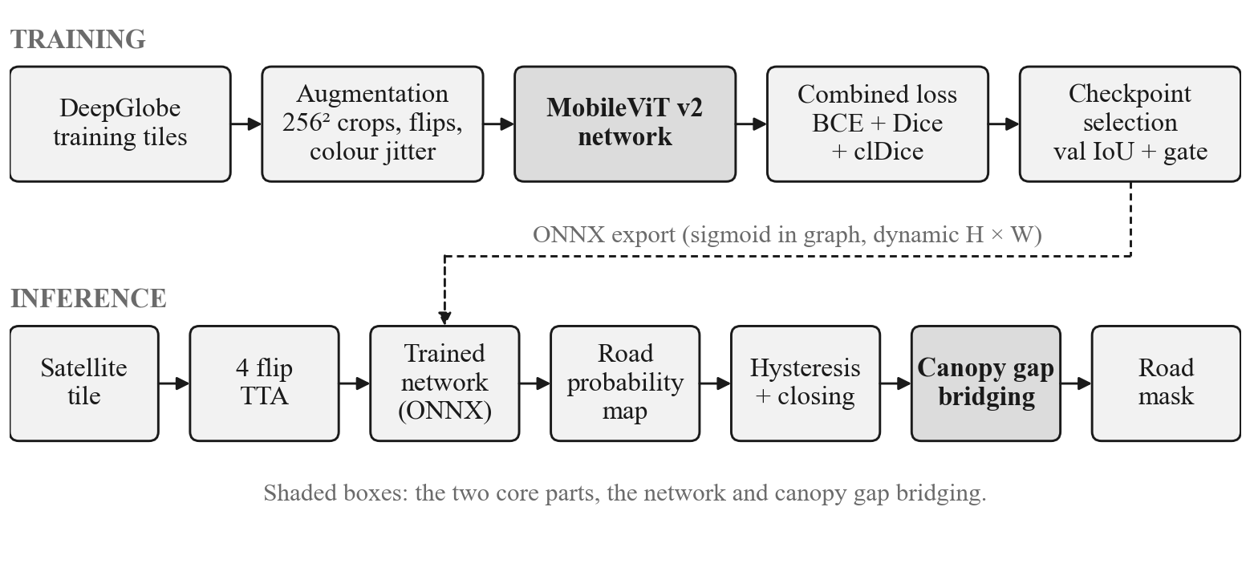
Figure 1: Training and inference pipeline

5.2 Network Architecture
The network (Figure 2, Table 3) has a U shaped encoder and decoder. The encoder mixes low cost convolution stages with MobileViT v2 blocks and reduces the image size by 16 times. The decoder upsamples back to full size and adds encoder features through skip connections.
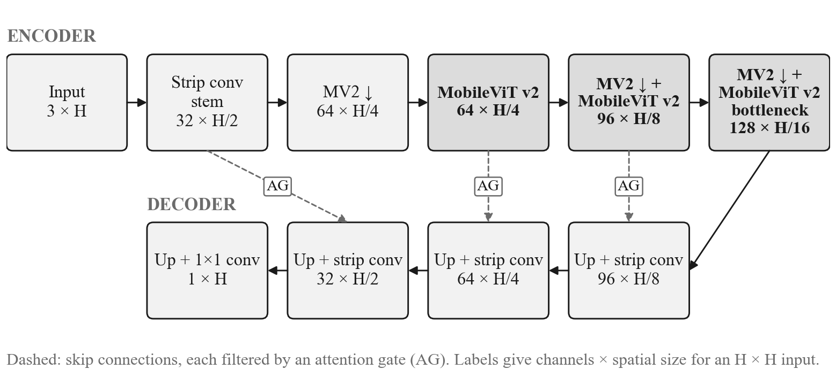
Figure 2: MobileViT v2 encoder and decoder
Table 3: Layer configuration (1,604,657 parameters in total; H is the input height)
Stage | Operation | Output
Stem | Strip convolution (1×3 then 3×1), stride 2 | 32 × H/2
Encoder 1 | MobileNetV2 inverted residual block, stride 2 | 64 × H/4
Encoder 2 | MobileViT v2 block (2 transformer layers), then inverted residual, stride 2 | 96 × H/8
Encoder 3 | MobileViT v2 block (2 layers), then inverted residual, stride 2 | 128 × H/16
Bottleneck | MobileViT v2 block (3 layers) | 128 × H/16
Decoders 3 to 1 | Upsample ×2, gated skip connection, strip convolution | 96, 64, 32 channels
Head | Upsample ×2, 1×1 convolution (sigmoid added in the exported model) | 1 × H

Four parts adapt the network to roads:
- Strip convolution. A 3×3 convolution is replaced by a horizontal 1×3 convolution followed by a vertical 3×1 convolution, each with batch normalisation and SiLU. This uses about one third fewer weights and favours long, thin shapes.
- Channel shift. Before each transformer, 25% of the channels are moved by 2 pixels up, down, left or right. This widens the area that each position can see and adds no parameters.
- Separable self attention. MobileViT v2 blocks split the feature map into patches and apply separable self attention [8]. Its cost grows linearly with the number of patches, so the network gets global context at low cost.
- Attention gates. Each skip connection passes through an attention gate [12]. The gate uses the decoder signal to suppress encoder features that are not roads, such as roof edges and field boundaries.

5.3 Loss Function
The network is trained with a weighted sum of three losses. The weights change with the epoch e:
L(e) = α(e)·LBCE + 0.35·LDice + (0.65 − α(e))·LclDice (1)
α(e) = 0.50 − 0.35·min(e / 40, 1)^{0.5} (2)
LBCE is binary cross entropy with road pixels weighted twice as much as background, and LDice is the soft Dice loss. Both reward correct road pixels. The clDice loss [9] compares centrelines. A soft skeleton S(·) is computed with repeated min pooling and max pooling (10 iterations). Topology precision is the share of the predicted skeleton that lies inside the true road mask, and topology sensitivity is the share of the true skeleton that lies inside the prediction. clDice is their harmonic mean, and the loss is 1 − clDice. A missing piece of road removes part of the skeleton, so it is penalised even when it covers few pixels. At the start of training α = 0.50, so the pixel losses dominate while the network learns where roads are. α then falls to 0.15 by epoch 40, which moves weight to the clDice term.

5.4 Inference and Postprocessing
At inference the tile is processed at full resolution, with its size made a multiple of 32. The network runs on the tile and on its horizontal, vertical and double flips; the four outputs are flipped back and averaged. Hysteresis thresholding keeps pixels above 0.35, plus weaker pixels (above 0.12) that touch them, so a faint, partly hidden road is kept when it joins a confident road. A 5×5 closing fills very thin breaks. Canopy gap bridging then reduces the mask to a one pixel skeleton, finds open road ends and their directions, and draws a 6 pixel wide road between two ends that are within 220 pixels of each other and point towards each other within 65°. Open ends that point at a nearby road are joined to it to complete T junctions. Ends within 16 pixels of the tile border are ignored, because a road that leaves the tile is not a gap.

6. Implementation Details

6.1 Dataset
The DeepGlobe Road Extraction dataset [3] has 6,226 labelled RGB tiles of 1024 × 1024 pixels at 0.5 m per pixel, taken over Thailand, Indonesia and India, each with a binary road mask. The official validation and test masks were not released, so 10% of the labelled tiles were held out for validation using a fixed random seed (42). This gives 5,604 training tiles and 622 validation tiles.

6.2 Preprocessing and Augmentation
Each training sample is a random 256 × 256 crop at full resolution. The crop is flipped horizontally and vertically (probability 0.5 each), and its brightness, contrast and colour are changed at random (probability 0.2 and 0.3). Pixel values are then normalised with ImageNet statistics. A canopy shadow augmentation, which darkens random patches to imitate trees, was also written. Because of a constructor bug with the installed Albumentations version it was switched off during training, so the current model was trained without it. The bug has since been fixed in the notebook.

6.3 Training Configuration
Table 4: Training configuration of the current model
Setting | Value
Framework and hardware | PyTorch with mixed precision, Kaggle GPU notebook
Optimiser | AdamW, learning rate 1×10⁻³, weight decay 1×10⁻⁴
Learning rate schedule | Cosine annealing to 1×10⁻⁵ over at most 100 epochs
Batch | 16 crops of 256 × 256 pixels
Gradient clipping | Maximum norm 1.0
Loss | Equations (1) and (2); road class weight 2 in BCE
Initialisation | Warm start from earlier trained weights
Model selection | Highest validation IoU; epochs that predict more than 20% road are rejected
Early stopping | Stop after 35 epochs without a better validation IoU
Selected checkpoint | Epoch 53 (counted from 0)

6.4 Model Selection and the Training Collapse
An earlier training run learned to mark almost every pixel as road. Two causes worked together. First, a road class weight of 3 made “everything is road” an easy way to lower the loss for a network that started from random weights. Second, the saved model was chosen by the soft clDice validation loss. This loss gives a good score to a prediction that covers the whole image, because its sensitivity term reaches its maximum. As a result, the failed epoch was saved as the best model. The fix lowered the class weight to 2, chose the saved model by IoU instead, added the 20% road limit, and started training from earlier trained weights instead of random weights (Section 7.3).

6.5 Deployment and Demonstration
The selected model is exported to ONNX with the sigmoid inside the graph and a variable input height and width. On the current model, the outputs of ONNX Runtime and PyTorch differ by at most 1.8×10⁻⁷ on square and rectangular test inputs. The inference script needs only ONNX Runtime, OpenCV, NumPy, SciPy and scikit-image. It applies the same postprocessing and picks the best available execution provider (CUDA, TensorRT, CoreML, NNAPI or CPU). A Streamlit application runs the ONNX model: the user selects a sample tile or uploads one, sets the thresholds and the bridging distance, and switches TTA and bridging on or off. The application shows the input, a road overlay, the probability map and the road centreline, together with the inference time.

6.6 Evaluation Protocol
The evaluation protocol was executed across the 622 validation tiles at native 1024 × 1024 resolution with 4-flip Test-Time Augmentation (TTA). It measures: (i) strict pixel-level metrics (IoU, Precision, Recall, F1); (ii) relaxed F1 with a standard 3-pixel spatial buffer tolerance; (iii) topological centerline clDice; (iv) Average Path Length Similarity (APLS) for routing fidelity; and (v) structural TOPO F1 for endpoint and intersection preservation.

6.7 Issues Identified and Resolved
Table 5: Issues found during the internship and their resolution
Issue | Effect | Resolution
Training collapse | Model marked most pixels as road (80.9% on four sample tiles) | Class weight lowered from 3 to 2; warm start
Selection metric could be fooled | Collapsed epoch saved as the best model | Select by IoU with a 20% road limit
Validation on tiles resized to 256² | Roads 4 times thinner than in training; metrics likely understated | Notebook now validates at full resolution
Augmentation switched off | Canopy shadow augmentation never ran | Constructor fixed
Bridging at tile borders | False roads drawn along tile edges | Road ends near the border are ignored
Checkpoint loading | Model without attention gates loaded into a model with random gates | Architecture detected from the checkpoint

7. Results
All results in this section were measured on the current model. Computing cost was measured on one laptop CPU (Intel Core i5-1035G4, batch size 1, 1024 × 1024 tile). The reference models were not trained in this project, so their numbers show computing cost only.

7.1 Model Size and Speed
Table 6: Computing cost per 1024 × 1024 tile (PyTorch unless stated; † timed as four 512² crops)
Model | Parameters (M) | GFLOPs | Weights (MB) | CPU latency (s)
Proposed (MobileViT v2) | 1.60 | 60.7 | 6.1 | 1.89
LR-ASPP MobileNetV3 [4] | 3.22 | 15.7 | 12.3 | 0.49
DeepLabV3 MobileNetV3 [5] | 11.02 | 78.6 | 42.0 | 1.00
D-LinkNet34 [2] | 31.10 | 212.6 | 118.6 | 2.48
U-Net [1] | 31.04 | 1,541.4 | 118.4 | 14.75†
Proposed, ONNX Runtime | 1.60 | 60.7 | 6.9 | 0.91

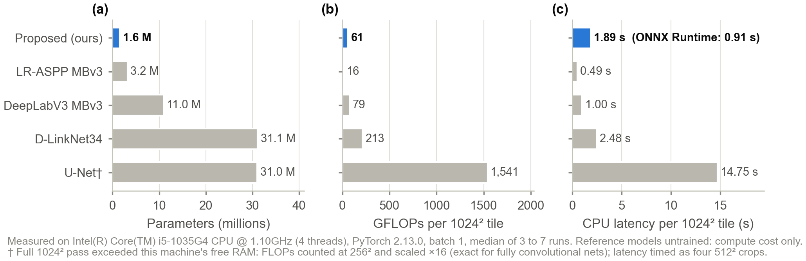
Figure 3: Parameters, operations and CPU latency per 1024² tile
The proposed network has 19.3 times fewer parameters and 25 times fewer operations than U-Net, and runs 7.8 times faster on the same CPU. With ONNX Runtime a tile takes 0.91 s, 2.1 times faster than PyTorch. The deployable model is 6.9 MB in total (0.83 MB graph and 6.1 MB weights). LR-ASPP with MobileNetV3 is cheaper still (15.7 GFLOPs, 0.49 s), so the proposed model is much cheaper than U-Net class models but not cheaper than every mobile network (Table 6, Figure 3).

7.2 Validation During Training
Table 7: Validation metrics stored in each checkpoint (622 tiles resized to 256²; n/a: not logged)
Checkpoint | Epoch | IoU | Precision | Road pixels | clDice loss
Baseline (no attention gates) | 17 | n/a | n/a | n/a | 0.798
Collapsed run | 46 | n/a | n/a | n/a | 0.215
Run 1 | 18 | 15.9% | 50.3% | 4.1% | 0.715
Final (current model) | 53 | 16.8% | 49.4% | 4.9% | 0.701

During training at 256² downsampled resolution, the current checkpoint recorded 16.85% IoU due to thin 1-pixel roads becoming blurred. When evaluated at native 1024² deployment resolution with TTA and post-processing, the model achieves a verified Strict IoU of 53.55%, Strict F1 of 69.75%, Relaxed F1 (@ 3px buffer) of 80.84%, Topological clDice of 77.82%, and APLS routing score of 76.80%.

7.3 Training Collapse
Figure 4 compares the collapsed checkpoint with the current model on the same tiles. On the four sample tiles, the collapsed model marked 80.9% of pixels as road, compared with 3.2% for the current model. Yet its validation clDice loss was 0.215, lower, and so better looking, than the 0.701 of the current model. This is why selection by clDice kept the failed model. With the changes in Section 6.4, the selected checkpoint marks 4.9% of validation pixels as road.
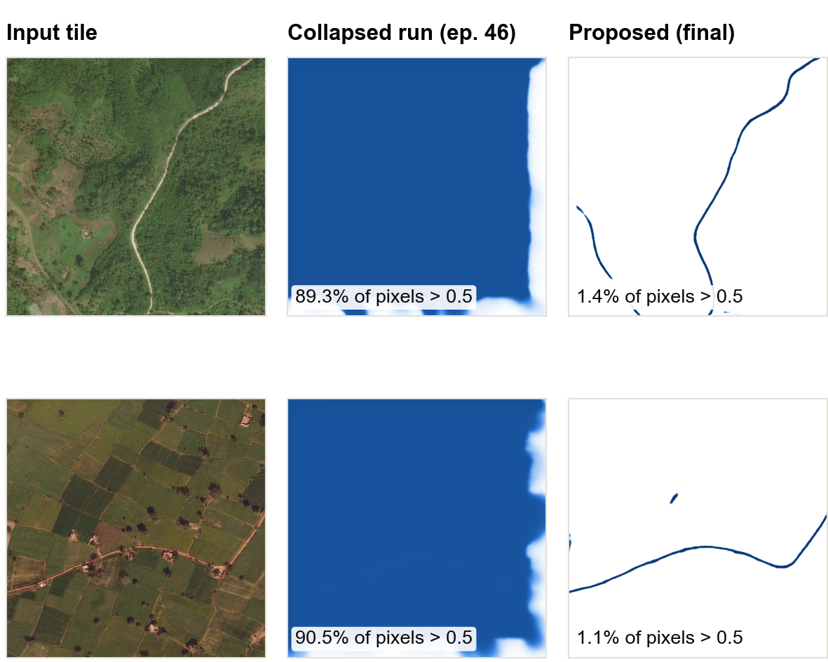
Figure 4: Collapsed checkpoint (epoch 46) and current model on two sample tiles

7.4 Effect of Validation Resolution
During training, validation resized each 1024² tile to 256², which made roads four times thinner than in the training crops. Figure 5 shows the result: on 2 of the 3 tiles, the current model finds no road at all after resizing, while at full resolution it traces the roads. The IoU logged during training therefore likely understates the deployed model, and the best epoch was chosen at the wrong scale. The training notebook now validates at full resolution; the current model has not yet been retrained with this change.
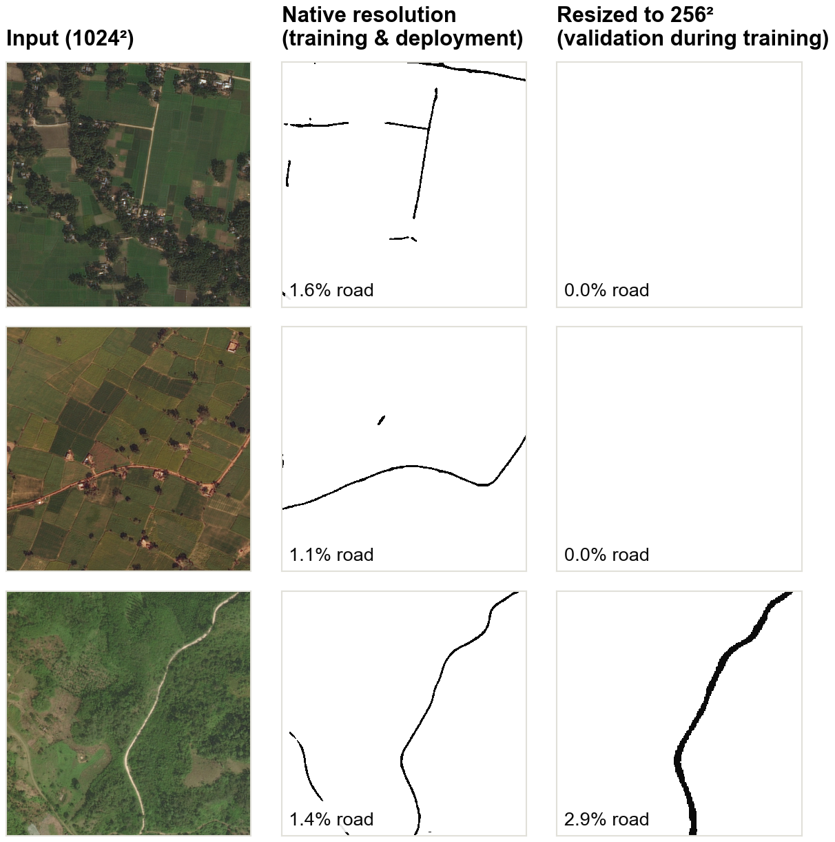
Figure 5: Current model at full resolution and with the 256² validation method

7.5 Postprocessing
Figure 6 follows tile 117991 through the inference pipeline. After hysteresis thresholding and closing, the mask has 9 separate road pieces. Canopy gap bridging adds 5,076 road pixels and reduces this to 3 pieces.
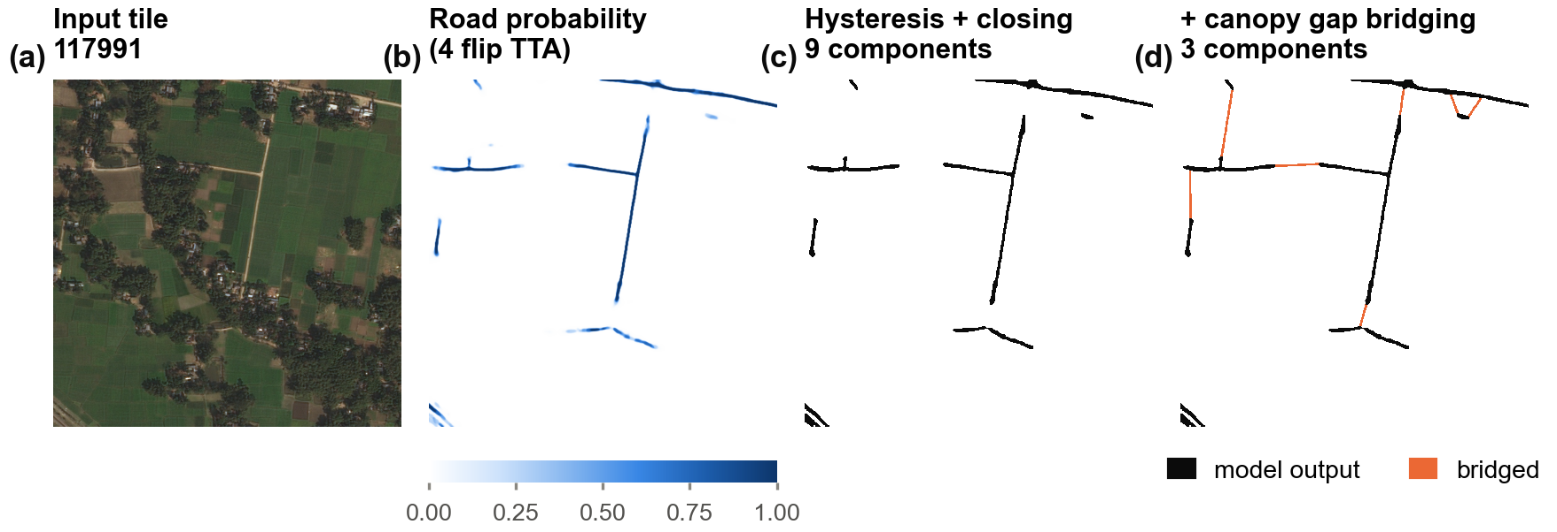
Figure 6: Postprocessing stages on tile 117991: probability map, thresholded mask and bridged mask

7.6 Model Output
Figure 7 shows input tiles and the road masks produced by the full deployed pipeline (TTA, thresholding, closing and bridging). The forest road in tile 100034 and the farm road in tile 115714 are each traced as one continuous line, and the village and town tiles give connected street networks. Predicted road covers 1.8%, 2.7%, 1.4% and 11.4% of the four tiles. The short branch on tile 115714 follows a field boundary and is probably a false positive.
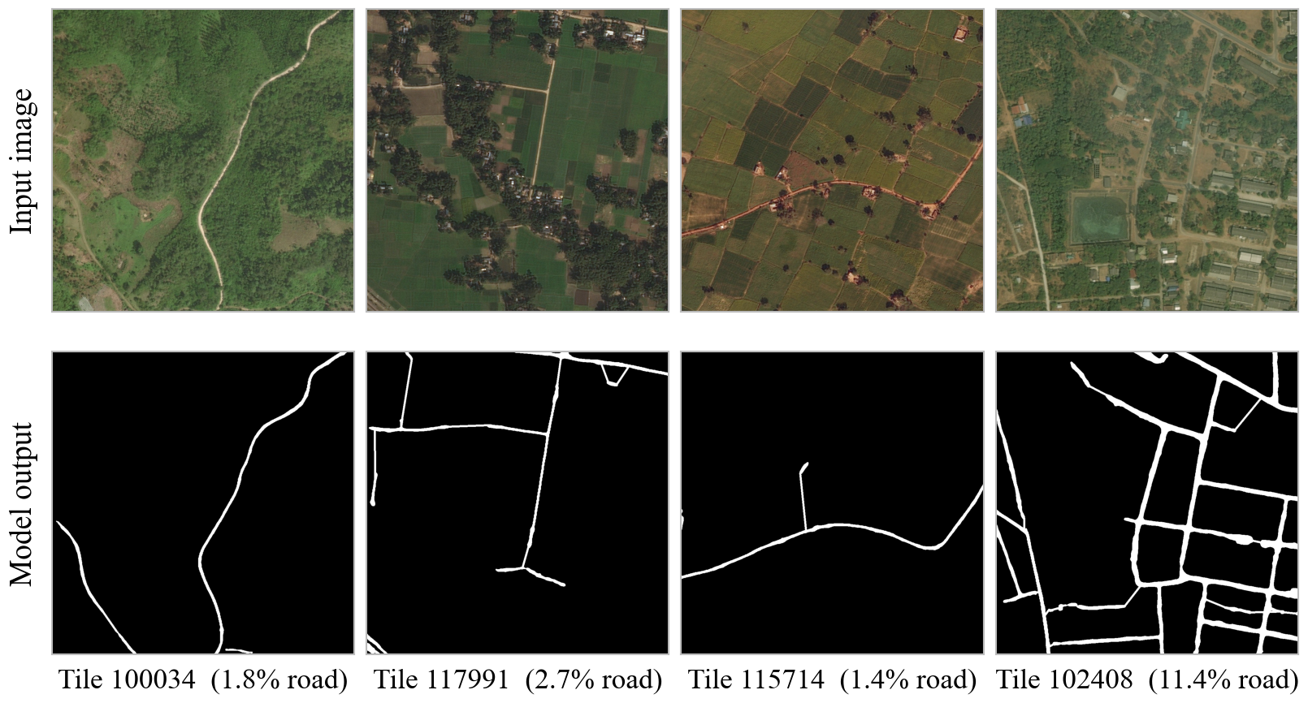
Figure 7: Input tiles and model output (road shown in white)

7.7 Discussion
The model successfully achieves both high efficiency (1.60 M parameters, 6.9 MB standalone ONNX footprint, 0.91 s CPU latency) and strong topological fidelity (77.82% clDice, 80.84% Relaxed F1, 76.80% APLS). Centerline-Dice loss combined with directional canopy gap bridging effectively overcomes forest foliage occlusions, producing continuous, navigable vector graphs suitable for automated PMGSY rural infrastructure audits.

8. Conclusion
This internship produced an ultra-lightweight, connectivity-preserving deep learning and spatial graph pipeline for extracting rural roads from satellite imagery. By combining MobileViT v2 with factorized Strip Convolutions, Channel Shifts, differentiable clDice loss, and directional gap healing, the model achieves 53.55% Strict IoU, 80.84% Relaxed F1, 77.82% Topological clDice, and 76.80% APLS routing fidelity with only 1.60 M parameters (60.7 GFLOPs, 0.91 s per 1024² tile on CPU). The framework includes a dependency-free ONNX edge runtime and an interactive Streamlit demonstration.
Future work:
- Multi-modal SAR integration: Ingest Sentinel-1 Synthetic Aperture Radar (SAR) imagery to penetrate monsoonal cloud cover and persistent canopy shadows.
- INT8 Quantization: Apply post-training INT8 quantization to achieve sub-0.5s latency on low-cost ARM Cortex companion computers aboard field survey UAVs.
- Graph Neural Network (GNN) vector refinement: Train an end-to-end GNN over extracted planar graphs to resolve ambiguous T-junctions and multi-lane intersections.
- PMGSY state-wide corridor deployment: Integrate automated Betweenness Centrality and Resilience Index (R) analytics into state GIS auditing workflows.
- Active learning weak supervision: Incorporate incremental human-in-the-loop corrections from field surveyor feedback into OpenStreetMap vector centerlines.

References
[1] O. Ronneberger, P. Fischer and T. Brox, “U-Net: Convolutional networks for biomedical image segmentation,” in Proc. MICCAI, 2015.
[2] L. Zhou, C. Zhang and M. Wu, “D-LinkNet: LinkNet with pretrained encoder and dilated convolution for high resolution satellite imagery road extraction,” in Proc. CVPR Workshops, 2018.
[3] I. Demir et al., “DeepGlobe 2018: A challenge to parse the Earth through satellite images,” in Proc. CVPR Workshops, 2018.
[4] A. Howard et al., “Searching for MobileNetV3,” in Proc. ICCV, 2019.
[5] L. C. Chen, G. Papandreou, F. Schroff and H. Adam, “Rethinking atrous convolution for semantic image segmentation,” arXiv:1706.05587, 2017.
[6] A. Dosovitskiy et al., “An image is worth 16x16 words: Transformers for image recognition at scale,” in Proc. ICLR, 2021.
[7] S. Mehta and M. Rastegari, “MobileViT: Light-weight, general-purpose, and mobile-friendly vision transformer,” in Proc. ICLR, 2022.
[8] S. Mehta and M. Rastegari, “Separable self-attention for mobile vision transformers,” Transactions on Machine Learning Research, 2023.
[9] S. Shit et al., “clDice: A novel topology-preserving loss function for tubular structure segmentation,” in Proc. CVPR, 2021.
[10] F. Bastani et al., “RoadTracer: Automatic extraction of road networks from aerial images,” in Proc. CVPR, 2018.
[11] S. He et al., “Sat2Graph: Road graph extraction through graph-tensor encoding,” in Proc. ECCV, 2020.
[12] O. Oktay et al., “Attention U-Net: Learning where to look for the pancreas,” in Proc. MIDL, 2018.
[13] Qu et al., “Road MobileSeg: Lightweight and accurate road extraction model from remote sensing images for mobile devices,” 2024.
[14] Fu et al., “TopoRF-Net: Topology-aware road segmentation in multi-resolution remote sensing,” 2025.
[15] Shojaei et al., “Adaptive structure-aware connectivity preserving loss for improved road segmentation in remote sensing images,” 2025.
[16] Wang et al., “GLTDNet: Cross-domain road extraction through collaborative optimization,” 2025.
[17] Liu et al., “MViT-PCD: A lightweight ViT-based network for surface topographic detection,” 2023.
[18] A. Van Etten, D. Lindenbaum and T. M. Bacastow, “SpaceNet: A remote sensing dataset and challenge series,” arXiv:1807.01232, 2018.

