Flight-testing a fruit-fly connectome as an aircraft yaw damper
  - Code and data: https://github.com/aryawidjaja/flight-test-the-fly
Mutaqin Aryawijaya, Independent researcher (mutaqin@aryawijaya.com, ORCID 0009-0008-5199-2413)
October 2026
Abstract
Flight-control laws are assessed by their frequency response, stability margins, gust rejection and behaviour under failure; connectome-derived controllers have so far been shown mainly in time-domain demonstrations. We applied these tests to a spiking model of the fruit fly’s visual yaw pathway, a 20,556-neuron FlyWire subcircuit from the T4/T5 motion detectors to the descending neuron DNa02, with the aircraft’s yaw rate imposed directly as the firing rate of artificial T4/T5 sources, and compared it with rewired copies and a classical yaw damper. Under sinusoidal yaw, the right-minus-left DNa02 firing rate followed the yaw rate with coherence 0.98 at 1 Hz and with the stabilizing sign. It ranked first against 19 degree-preserving rewirings (median 0.31; p = 0.05) and narrowly first against 19 cell-type-preserving rewirings, which leave every input to the HS, VS, H2 and DNa02 cells unchanged. Closed around the rudder of a simulated six-degree-of-freedom Cessna 172 in moderate turbulence and tuned under the same margin rule as the yaw damper, it reduced RMS yaw rate by 19%, against 57% for the damper. Of 11 wirings it had the lowest RMS yaw rate and the lowest RMS sideslip on both aircraft models. The three rewired controllers that came closest on yaw rate in the Cessna model were saturated relays flying skidding turns. No lesion-study flight departed, so the pre-specified departure test could not separate the wirings; under random neuron loss the real wiring’s mean RMS yaw rate rose toward the bare airframe’s but not above it, partly because the loss often silenced its one active readout neuron, and silencing its six HS cells returned it to the bare airframe’s yaw rate. Flight-control tests can therefore measure what a connectome’s wiring contributes to a controller, and they expose failure modes, such as relay-like skidding, that a single performance score hides.

1 Introduction
A complete synaptic wiring diagram of an adult fruit-fly brain is now public [1, 2], and a leaky integrate-and-fire network run directly on an earlier release of that diagram (v630), with one free parameter, reproduces a range of measured sensorimotor responses [3]. A model of this kind can be placed in a feedback loop with a machine. That raises an engineering question that is easy to state and has rarely been tested with engineering tools: how a piece of real wiring behaves as a controller.
Aeronautics has a standard way of answering this question for a new flight-control law. Its frequency response is measured, its gain and phase margins are checked against minimum values [4], its rejection of gusts is evaluated in standard turbulence models [5], and its behaviour is examined as its components fail. We applied this procedure to the yaw axis, which needs a short vocabulary. The yaw rate r is how fast the nose swings left or right. Sideslip β is the angle between the nose and the oncoming air; a plane that turns with its rudder held over “skids” with large sideslip. Gusts excite the Dutch roll, a lightly damped oscillation in which yaw and sideslip trade back and forth. A yaw damper is the classical autopilot that measures r and moves the rudder to oppose it.
The fly’s own yaw stabilization offers a natural test case. When a fly turns, the image of the world slides across both eyes. Direction-selective T4 and T5 neurons in the optic lobe signal this motion, and their a and b subtypes prefer front-to-back and back-to-front motion, respectively [6, 7]. Horizontal-system (HS) tangential cells are excited by front-to-back motion on their own side [8], and activating HS cells on one side turns the fly toward that side [9]. Among the descending neurons that carry commands to the body [10], the right-minus-left difference in DNa02 activity predicts turning velocity in walking flies [11]. Chained together, these facts predict an optomotor reflex that opposes an imposed rotation. In tethered flight this response has delays of tens of milliseconds [12].
Several recent projects place connectome models in a flight loop, usually with time-domain demonstrations and sometimes with shuffled-wiring controls [13, 14, 15]; shuffled controls are also standard in the connectome-modelling literature [3]. Descending-neuron dynamics have been measured in real insects [16], and the fly’s yaw optomotor response has been identified behaviourally [12]. We could not find prior work that measures the frequency response of a connectome-model controller, its gain and phase margins by breaking the loop, its behaviour in standard Dryden turbulence [5], or curves of its degradation under graded neuron loss toward departure, nor work that compares a connectome rudder loop with a classical yaw damper under an identical tuning budget.
We tested four hypotheses, fixed before any brain or flight simulation: that the circuit tracks yaw rotation coherently and with the stabilizing sign, and better than rewired copies (H1); that, closed around a rudder, it lowers RMS yaw rate against the bare airframe and beats the median rewired copy given the same tuning, on a two-state model (H2) and on a six-degree-of-freedom simulator (H3); and that it degrades more gracefully than rewired copies as neurons are silenced (H4). The goal was not to beat the yaw damper, but to measure how a controller taken from a connectome behaves and whether its real wiring matters. H1, H2 and H3 were supported: the real wiring encoded yaw rate with the stabilizing sign and, in closed loop, damped yaw motion more than any of the ten rewired copies tested (rank 1 of 11, p = 0.091) but far less than the classical yaw damper. H4 could not be tested, because no flight departed.

2 Methods

2.1 Connectome subcircuit
We used the FlyWire connectome, materialization v783 [1], with its cell-type annotations [2] and the signed connectivity table distributed with the whole-brain model of Shiu et al. [3]. Keeping only connections of at least 5 synapses, we took as sources 𝒮 all T4a–d and T5a–d cells and as targets 𝒯 the descending neurons DNa02 and DNg02_{a–h}, and kept every neuron that lies on a directed path of at most 4 hops from a source to a target,
$$V=\left\{ i: d(S​→​i)+d(i​→​T)≤4 \right\} (1)$$
where d is the shortest directed hop count, together with every connection of at least 5 synapses among those neurons, recurrent ones included. The subcircuit holds 20,556 neurons: 12,056 T4/T5 cells and 8,500 others, among them 6 HS, 16 VS and 2 H2 cells, 2 DNa02 cells (one per side) and 22 DNg02 cells. It has 283,576 connections, of which 251,358 are simulated; the 32,218 connections onto T4/T5 cells are dropped because those cells are replaced by input sources (Section 2.3). T4/T5 cells supply 83% of all synapses onto HS cells, and 99.97% of that input comes from the front-to-back a subtypes.

2.2 Neuron model
All non-input neurons follow the leaky integrate-and-fire model of Shiu et al. [3], unchanged. Each neuron i has a membrane potential v_{i} and a synaptic variable g_{i},
$$τ_{m}\frac{dv_{i}}{dt}=v_{0}−v_{i}+g_{i}, τ_{s}\frac{dg_{i}}{dt}=−g_{i}, (2)$$
and a spike of presynaptic neuron j arrives after a fixed delay,
$$\begin{matrix}g_{i}←g_{i}+w_{syn} W_{ji} \text{at} t_{j}^{spk}+t_{dly}, \\ v_{i}>v_{th} ⇒ v_{i}←v_{reset}, g_{i}←0,\end{matrix} (3)$$
where W_{ji} is the synapse count from j to i, signed by the presynaptic neurotransmitter (GABAergic and glutamatergic neurons inhibitory, others excitatory). After a spike, v and g stop evolving for t_{ref} (g still receives synaptic input). Parameters are listed in Table 1. The network was simulated in Brian 2 with exact integration of the linear dynamics.
Table 1. Model and controller parameters. The neuron parameters are those of the published whole-brain model; the input and readout parameters were fixed before any brain or flight simulation, except the washout, which was fixed after the pilot runs (Section 2.9).
Parameter | Value
Resting and reset potential, v₀, v_{reset} | −52, −52 mV
Threshold, v_{th} | −45 mV
Membrane time constant, τ_{m} | 20 ms
Synaptic time constant, τ_{s} | 5 ms
Refractory period, t_{ref} | 2.2 ms
Synaptic delay, t_{dly} | 1.8 ms
Weight per synapse, w_{syn} | 0.275 mV
Integration step, Δt | 0.1 ms
T4/T5 baseline rate, r_{base} | 10 Hz
Input gain, γ | 1 Hz per °/s
Control step, T_{c} | 10 ms
Washout time constant, τ_{w} (fly and damper) | 1 s

2.3 Visual input encoding
We take r > 0 as a nose-right rotation. A nose-right turn moves the visual world front-to-back across the left eye and back-to-front across the right eye; T4a/T5a prefer front-to-back and T4b/T5b back-to-front motion [6, 7]. Each T4/T5 cell c was therefore replaced by an independent Poisson source with rate
$$λ_{c}(t)=r_{base}+γ max\left(0, s_{c} r(t)\right), (4)$$
with r in degrees per second, s_{c} = +1 for left T4a/T5a and right T4b/T5b cells, s_{c} = −1 for left T4b/T5b and right T4a/T5a cells, and s_{c} = 0 for the vertical-motion c and d subtypes. In each integration step Δt a source fires with probability λ_{c}Δt. This encoding is piecewise linear (half-wave rectified) in r for each cell and ignores the temporal-frequency tuning of real motion detectors (Section 4.5).

2.4 Readout and controllers
The controller output is the rudder command u ∈ [−1, 1], with u > 0 commanding a nose-right moment and |u| = 1 equal to 16° of rudder. The brain and the aircraft advance in lockstep with control step T_{c}. In closed loop the T4/T5 sources are driven by the sampled yaw rate, r(t) = r_{k} for t ∈ [kT_{c}, (k + 1)T_{c}) (sample-and-hold). Let Δ_{k} = ν_{R,k} − ν_{L,k} be the right-minus-left DNa02 firing rate (Hz) over that window, driven by r_{k}, and b its mean over a 1 s warm-up without rotation before each flight. The fly controller is
$$\begin{matrix}x_{k}=Δ_{k−1}−b, a=e^{−T_{c}/τ_{w}}, \\ ℓ_{k}=a ℓ_{k−1}+(1−a) x_{k}, \\ u_{k}=sat\left(εK (x_{k}−ℓ_{k})\right),\end{matrix} (5)$$
with ℓ₀ = 0 and u₀ = 0: a discrete washout (high-pass) filter followed by a gain K ≥ 0 and saturation to [−1, 1]. The readout is causal: u_{k} uses window k − 1, the one that has just ended, and is held over step k, which adds one step of transport delay. The readout sign ε ∈ {±1} was fixed at ε = +1 by the biology above, under which Δ > 0 commands a nose-right turn [9, 11]. The classical yaw damper uses the same washout on the measured yaw rate,
$$\begin{matrix}ℓ_{k}=a ℓ_{k−1}+(1−a) r_{k}, \\ u_{k}=sat\left(−K (r_{k}−ℓ_{k})\right),\end{matrix} (6)$$
a pole-matched discretization, C(z) = −Ka(z − 1)/(z − a), of −Kτ_{w}s/(τ_{w}s + 1) (before saturation). The two controllers therefore differ only in the sensor, the processing between sensor and washout, and the fly’s one-step (10 ms) readout delay. Each gain was chosen from a grid of the same size: for the fly, 11 values: 0 and 10 log-spaced values from 0.0001 to 0.720 per Hz; for the damper, 11 values: 0 and 10 log-spaced values from 1 to 7197 per rad/s (each grid had 9 values before the widening described in Section 2.9).

2.5 Aircraft and turbulence
The aircraft is the JSBSim [17] Cessna 172 model (c172x), trimmed in level flight at 4,000 ft and 100 kt true airspeed (V = 51.4 m/s) and linearized numerically by JSBSim. Two aircraft models were used. The first is the two-state yaw–sideslip (Dutch-roll) approximation,
$$\begin{aligned}{\dot{β}}_{i}&=\frac{Y_{β}}{V} β−r+\frac{Y_{u}}{V} u, \\ \dot{r}&=N_{β} β+N_{r} r+N_{u} u, \\ β&=β_{i}−\frac{v_{g}}{V},\end{aligned} (7)$$
with Y_{β}/V = −0.144 s⁻¹, N_{β} = 3.82 s⁻², N_{r} = −0.629 s⁻¹, N_{u} = 0.711 s⁻² and Y_{u}/V = −0.0110 s⁻¹ per unit command, where v_{g} is the lateral gust velocity. Here β_{i} = v/V is the inertial sideslip and β = β_{i} − v_{g}/V the aerodynamic sideslip used everywhere else (by the controllers and in all metrics). The model is discretized exactly with a zero-order hold. Its Dutch roll has ω_{n} = 1.98 rad/s and damping ratio ζ = 0.195, against 2.13 rad/s and 0.158 in the full linearization; the bare airframe already meets the MIL-F-8785C Level 1, Category B (cruise) Dutch-roll requirements [5], so the comparison is about gust rejection, not about rescuing an unstable aircraft. The lateral gust is Dryden turbulence [5], white noise of unit intensity shaped by
$$\begin{matrix}H_{v}(s)=σ_{v}\sqrt{T} \frac{1+\sqrt{3} Ts}{(1+Ts)^{2}}, \\ T=L_{v}/V,\end{matrix} (8)$$
with the moderate-turbulence values at this altitude, σ_{v} = 3.22 m/s and L_{v} = 533 m (T = 10.4 s), discretized exactly so that the gust variance is σ_{v}², and started from its stationary distribution. The second is the full nonlinear six-degree-of-freedom (6-DOF) JSBSim model, run at 200 Hz, with JSBSim’s MIL-spec turbulence at moderate severity. That option implements a first-order Markov approximation on each axis [18]: it has the same σ but a different spectral shape from Eq. (8), and it adds longitudinal, vertical and rotational gusts, and its gusts start from zero, so the two models do not see like-for-like turbulence. On the two-state model the gust is an external signal and is identical for every controller on a given seed. JSBSim’s gust filter depends on each aircraft’s airspeed, so on a given seed different controllers meet slightly different gust histories (Fig. 4). In the six-degree-of-freedom runs a fixed aileron PID loop holds the wings level, identically for every controller: δ_{a} = sat(δ_{a,trim} − K_{P}φ − K_{D}p − K_{I}∫φ dt) with K_{P} = 0.6, K_{D} = 0.08, K_{I} = 0.1, bank angle φ, roll rate p, and sat clipping to [−1, 1]; elevator and throttle are fixed at trim, and the controller under test moves only the rudder. A flight counts as a departure from controlled flight if any one of |φ| > 60°, |β| > 20° or |r| > 60°/s alone holds continuously for more than 1 s.

2.6 Null models
The primary null rewires the simulated graph while preserving its degree sequence and signs. Pairs of connections exchange their postsynaptic partners (double-edge swaps), 10E accepted swaps in all (E = number of connections), rejecting swaps that would create a self-connection or a duplicate pair. Each neuron keeps its in-degree, its out-degree, the multiset of its outgoing weights and its sign. In the secondary, cell-type-preserving null a swap is allowed only between connections whose postsynaptic neurons share side and cell type (unannotated cells form one class per side), so every presynaptic neuron also keeps its number of connections into each (side, type) class. Many classes have one member (1,596 of 2,233, including every HS, VS and H2 cell and each DNa02); the 42% of connections that point into them cannot move, so in each rewiring about 60% of connections are unchanged, against 2% for the degree-preserving null (chance level 2%; both measured on rewiring seed 0). This null therefore tests only the remaining ~40% of the wiring. We built 19 rewirings of each kind (seeds 0–18); the closed-loop experiments used the first 10 degree-preserving rewirings and the lesion experiment the first 3. In the closed-loop and lesion experiments we call the degree-preserving rewirings “scrambled wirings”.

2.7 Experimental protocol
Open-loop frequency response. Each wiring was driven by stepped sines r(t) = 100 sin(2πft) °/s at 13 frequencies from 0.1 to 20 Hz (twelve log-spaced values plus 1 Hz, each adjusted so a cycle spans a whole number of 5 ms bins), each after a 1 s warm-up and for at least 10 cycles and 2 s, with 5 Poisson seeds. Firing rates were binned at 5 ms. The analysis window starts at drive onset, with no settling period discarded. Gain and phase come from a lock-in projection over whole cycles,
$$\begin{matrix}\hat{x}(f)=\frac{2}{N}\sum_{n=0}^{N−1}{\left(x_{n}−\overset{‾}{x}\right)} e^{−j2πft_{n}}, \\ H(f)=\hat{Δ}(f) / \hat{r}(f),\end{matrix} (9)$$
where x_{n} is the signal (Δ or r) in bin n, t_{n} the bin time, x̄ the mean over the window and N the number of bins in a whole number of cycles, so the gain |H| is in Hz of Δ per °/s and a phase of 180° means Δ opposes the rotation. For the figures, seeds were averaged as complex H, H̄ = (1/n) Σ_{s}H_{s}; the pre-specified H1 statistics (Table 2) are the seed means of per-seed coherence and of per-seed gain, (1/n) Σ_{s}|H_{s}|. Coherence, the fraction of the output’s power at f that is linearly explained by the input (1 for a noiseless linear system, near 0 for an unrelated one), was estimated as a finite-window magnitude-squared coherence (Welch’s method, one-cycle Hann segments, 50% overlap),
$$C_{rΔ}(f)=\frac{|P_{rΔ}(f)|^{2}}{P_{rr}(f) P_{ΔΔ}(f)}, (10)$$
and compared with the coherence of a sine against white noise analysed identically (the noise reference is the 95th percentile for a single seed). With this estimator spectral leakage caps the coherence of a deterministic half-wave-rectified response near 0.96, so a value near 1 shows a consistent response, not a linear one.
Loop margins. Gain and phase margins say how much extra gain, or extra delay, the closed loop tolerates before it oscillates. We measured them by breaking the loop at the actuator: a probe d is added to the command and
$$\begin{matrix}u_{plant}=sat(u_{ctrl}+d), \\ L(jω)=− {\hat{u}}_{ctrl}(ω) / {\hat{u}}_{plant}(ω),\end{matrix} (11)$$
$$\begin{matrix}GM=−20\log_{10}|L(jω_{180})|, \\ PM={180}^{∘}−|{wrap}_{[−{180}^{∘}, {180}^{∘})}∠L(jω_{c})|, \\ \text{where} |L(jω_{c})|=1,\end{matrix} (12)$$
where ω₁₈₀ is any crossing of −180° (mod 360°) and ω_{c} a gain crossing; the worst crossing of each kind is reported, and a loop with |L| < 1 at every tested frequency has no phase margin to measure (PM = ∞). The same protocol was applied to every controller: 17 sines from 0.05 to 33.3 Hz plus the Nyquist frequency (50 Hz), amplitude 0.1, 20 s settling and at least 40 s of whole cycles, on the two-state model without turbulence. Each |L| was compared with a noise floor: the lock-in amplitude of u_{ctrl} at the two adjacent DFT bins, divided by |û_{plant}|. If |L| ≥ 1 at the lowest frequency, a crossing could lie below the grid and the gain was declared inadmissible. These margins are finite-amplitude, single-seed injected return-ratio estimates on the two-state model (18-point grid, seed 0, A = 0.1), not proofs of stability: the brain is stochastic and the actuator saturates. During the measurement the actuator was saturated in at most 0.37% of steps for the real wiring at its selected gain, but in 58–60% for the three scrambled controllers that became relays (Section 3.3).
Tuning and testing. Every controller received the same rule and the same budget. The figure of merit is the RMS yaw rate of a flight,
$${RMS}_{r}=(\frac{1}{N}\sum_{k=1}^{N}{r_{k}^{2}})^{1/2} (13)$$
over its N control steps (RMS sideslip is defined the same way). Over the 10 training seeds (0–9) of 60 s flights in moderate turbulence, the gain was
K*=argminK∈A 110s​RMSr(K,s),A={0}∪{K>0: no departure,GM≥6 dB, PM≥45∘}, (14)
where the margin thresholds are the 6 dB / 45° row of MIL-F-9490D Table III (0.06 Hz ≤ f_{M} < first aeroelastic mode, V_{0min}–V_{0max}) [4], as reproduced in its background report [19] and stated by Mansur et al. [20], applied at every crossing. We use them as a screening threshold on a linear model at one loading; the specification additionally requires nonlinear effects and the most adverse loading across the envelope, which we did not test. Margins measured on the two-state model were reused for the six-degree-of-freedom model. K = 0 is the bare airframe and is always admissible. The gain grids could be widened under a pre-specified rule, whose application is described in Section 2.9. All closed-loop results are on 20 held-out test seeds (100–119) never used in tuning.
Lesions. Neurons were drawn uniformly from all subcircuit neurons, input sources (59%) and both DNa02 readout cells included, and silenced in nested fractions (0%, 5%, 10%, 20%, 40%, 60%, 80%), with the same neurons silenced in every wiring for a given test seed. A silenced neuron never spikes, so it reaches neither its targets nor the readout. For each test seed one seed value drives the turbulence, the Poisson input and the lesion draw. The chance that at least one DNa02 cell is silenced is ≈ 1 − (1 − f)² at fraction f (36% at 20%, 64% at 40%), so part of the fade toward the bare airframe is loss of the readout itself. Each wiring kept its tuned gain, with no retuning (only the warm-up offset b is re-measured). Targeted lesions silenced all HS cells, all T4 cells, all T5 cells, or the top 5%, 10%, 20% of neurons by betweenness centrality (directed, unweighted, on each wiring’s own simulated graph; ties broken by degree). Flights used the six-degree-of-freedom model.

2.8 Statistical analysis
The real wiring was compared with a null model by a one-sided Monte Carlo null-graph rank test. The null ensemble consists of degree- and sign-preserving double-edge swaps on the simulated graph of the extracted node set (Section 2.6), so the test is conditioned on the node set extracted from the real graph:
$$p=\frac{1+\#\{ j: Z_{j} \text{at least as extreme as} Z_{real} \}}{1+n_{null}}, (15)$$
where Z_{j} is the statistic (for example, 1 Hz coherence) of null rewiring j and Z_{real} that of the real wiring. This counts ties against the real wiring and cannot fall below 1/(1 + n_{null}) [21]. For two controllers A and B we formed the per-seed paired difference d_{s} = RMS_{r}(A, s) − RMS_{r}(B, s) and report its mean with a 95% percentile bootstrap interval (10,000 resamples of seeds). Where no flight departed, we report the Wilson 95% upper bound on the departure probability.
Decision rules. H1 required (a) coherence above 0.5 at every frequency up to 2 Hz, (b) cos(phase) < 0 at every frequency up to 1 Hz, and (c) that the real wiring’s 1 Hz coherence and gain each exceed those of the 19 degree-preserving rewirings in the rank test of Eq. (15), rejecting when p ≤ α = 0.05 (the smallest p 19 nulls allow). H2 and H3 required the bootstrap interval for real − bare to lie below 0 on the two-state and the six-degree-of-freedom model, respectively; H2b required the same for real − median of the 10 scrambled wirings, each seed’s median taken across wirings; this is a paired difference conditional on these ten tuned rewirings. We also report the real wiring’s rank among all 11 wirings by mean RMS yaw rate, whose rank-test p (Eq. (15)) cannot fall below 1/11. The H4 statistic is the normalized area under the curve of the probability of no departure against lesion fraction f,
$$AUC=\frac{1}{f_{max}−f_{min}}\int_{f_{min}}^{f_{max}}{P_{\text{no dep}}}(f) df, (16)$$
where P_{no dep}(f) is the fraction of the 20 test seeds without departure at fraction f, and f_{min}, f_{max} are the smallest and largest fractions; it is computed by the trapezoid rule. H4 required the bootstrap interval of AUC(real) − mean AUC(scrambled) to lie above 0.
Secondary and exploratory analyses. Mean RMS yaw rate against lesion fraction and a closed-loop comparison in which each scrambled wiring’s readout sign was taken from its own open-loop response were pre-specified secondary analyses. RMS sideslip was recorded under the protocol but not used as a test statistic. The cell-type-preserving null was added later as a secondary analysis (Section 2.9). The 1 Hz amplitude sweep, the delay fit and the γ = 4 arm were exploratory, and the input-gain sweep and the full-brain comparison were planned checks. None of these analyses enters a hypothesis verdict.

2.9 Protocol and amendments
The hypotheses, metrics, thresholds, seed splits and departure criterion were written down before any brain or flight simulation. A first addendum, also written before any simulation, replaced the plan’s one-state yaw model with the two-state model of Eq. (7), made the T4/T5 cells Poisson sources, and fixed the input sign map and the readout sign. A second addendum followed two pilot runs: a 1 Hz open-loop smoke run of the real wiring, and a training-seed gain sweep of the yaw damper whose unconstrained optimum was an unstable, chattering gain. It added the margin constraint (motivated by that damper result), the washout, the null size (19), the 1 Hz test frequency and the minimum of 10 cycles per frequency. A third note added the exploratory γ = 4 arm after a 3 s closed-loop plumbing run with a placeholder gain on test seed 100 (used for no tuning or selection) had shown DNa02 nearly silent at turbulence-level yaw rates, and before the open-loop sweep was analysed. Phase 2 tuning runs that had started before the reviews described next were cancelled and their outputs discarded. The notes were first committed together on 3 October; their earlier times come from the working log.
Three separate AI-assisted reviews of the code and literature (neural model, flight dynamics, citations), which are not independent replication or peer review, ran after the first open-loop analysis had been seen. They found six problems, and each fix was logged before the affected experiments were rerun. (1) The original degree-preserving null had been built on all extracted connections, before the connections onto the T4/T5 cells were dropped; rewiring moved this mostly inhibitory input onto simulated neurons, giving a null (shuffle seed 0) a net signed weight of −259,558 against −64,901 for the real wiring. The null was rebuilt on the simulated connections only (net weight −64,901), and only the rebuilt null is reported. (2) The readout used spikes from the same control step, which is not causal; it now uses the previous window (Eq. (5)). (3) Lesioned readout cells had still been read out; they are now silent. (4) The yaw damper had been admitted on analytic margins while the fly controllers were admitted on injected ones; a single injection protocol now serves every controller. (5) JSBSim’s turbulence generator gave identical turbulence for seeds 0 and 1; project seeds are now offset by +1 (Section 2.10). (6) The grid-widening rule was narrowed, as described next. The cell-type-preserving null was added after the reviews as a secondary analysis.
The pre-specified grid-widening rule, “if any controller’s unconstrained best gain lies on the upper edge of its grid, widen every grid” (narrowed before the rerun, on the reviews’ advice, to apply only to the upper edge, because K = 0 is the bare reference), was triggered once during tuning. When it triggered, before any widened run, we fixed the extension at two points at the same log spacing for every grid and allowed no further widening.

2.10 Software and reproducibility
The connectome is FlyWire v783. All simulations ran on GitHub-hosted ubuntu-24.04 runners (image 20260927.320.1) under CPython 3.11.17, with Brian 2.9.0, JSBSim 1.3.1, NumPy 2.2.6 and SciPy 1.17.1 from the committed uv.lock (196 jobs); the lock file and the extracted subcircuit had identical hashes at every simulation commit. Every run is deterministic for a given seed: Poisson seeds 0–4 for the open-loop measurements, rewiring seeds 0–18, training seeds 0–9 and test seeds 100–119. JSBSim’s turbulence generator maps seeds 0 and 1 to the same stream, so project seed s is passed to it as s + 1; because its random-number generator is implementation-defined, all reported six-degree-of-freedom flights were run on Linux. The experiments were sharded across free GitHub Actions runners; each analysis step re-derives its numbers from the per-job outputs and ends with an assertion-based self-check, and every result number in this paper is read from a generated summary file that records the source of each value (protocol constants appear in the prose).
Use of AI tools. Claude Opus 5.5 (Anthropic), used through Claude Code, assisted with writing and reviewing the simulation and analysis code, running and checking the analyses, checking the literature and citations, building the web viewer, and drafting and editing the text. The author designed the study, made the methodological decisions, and checked the results and the final text.

3 Results

3.1 Open-loop frequency response (H1)
The open-loop test asked whether the subcircuit’s output follows yaw rotation with the sign a stabilizing reflex needs, and whether this depends on its wiring. The right-minus-left DNa02 rate of the real wiring followed the stimulus closely (Fig. 1). Coherence was 0.968–0.998 at every frequency up to 2 Hz, far above both the pre-specified threshold of 0.5 and the noise-only level. The phase was 177.0–179.9° up to 1 Hz, so Δ falls when the nose swings right: under the readout sign of Section 2.4 this is negative feedback. The gain was flat at 0.666–0.686 Hz per °/s up to about 5 Hz and fell, relative to 1 Hz, by 0.5 dB at 7.7 Hz and 4.7 dB at 20 Hz. An exploratory fit to the phase from 2.9 Hz upward gives an effective high-frequency phase-slope delay of 21.6 ms at 100 °/s (free intercept 183°, 5 points, RMS residual 8°); it is a slope, not a measured latency. A pure delay of this size would cost about 2.6° of phase at the aircraft’s Dutch-roll frequency; the measured lag there was at most 1.2°.
All three parts of H1 held (Table 2). At 1 Hz the real wiring ranked first of 20 against the degree-preserving null on both coherence and gain, p = 0.05, the smallest value 19 rewirings allow. Most rewirings lost the response almost entirely: their median gain was 11% of the real wiring’s. Under degree-preserving rewiring, 12 of 19 nulls had the destabilizing sign at low frequency, and among the 7 with 1 Hz coherence above 0.5, 5 did. The cell-type-preserving null, which by construction leaves every input to the HS, VS, H2 and DNa02 cells untouched (about 60% of connections are unchanged), kept most of the response: all 19 of its rewirings kept the stabilizing sign, with median coherence 0.953 and gain 0.55. Rewiring the remaining connections within cell type and side lowered gain and coherence by a small but consistent amount; the real wiring still ranked first on both (p = 0.05). Whether the neuron-level wiring of the core T4/T5 → HS → DNa02 pathway matters is not tested by this null. In open loop, then, the subcircuit behaves as a yaw-rate sensor with the stabilizing sign, and degree-preserving rewiring removes most of that behaviour.
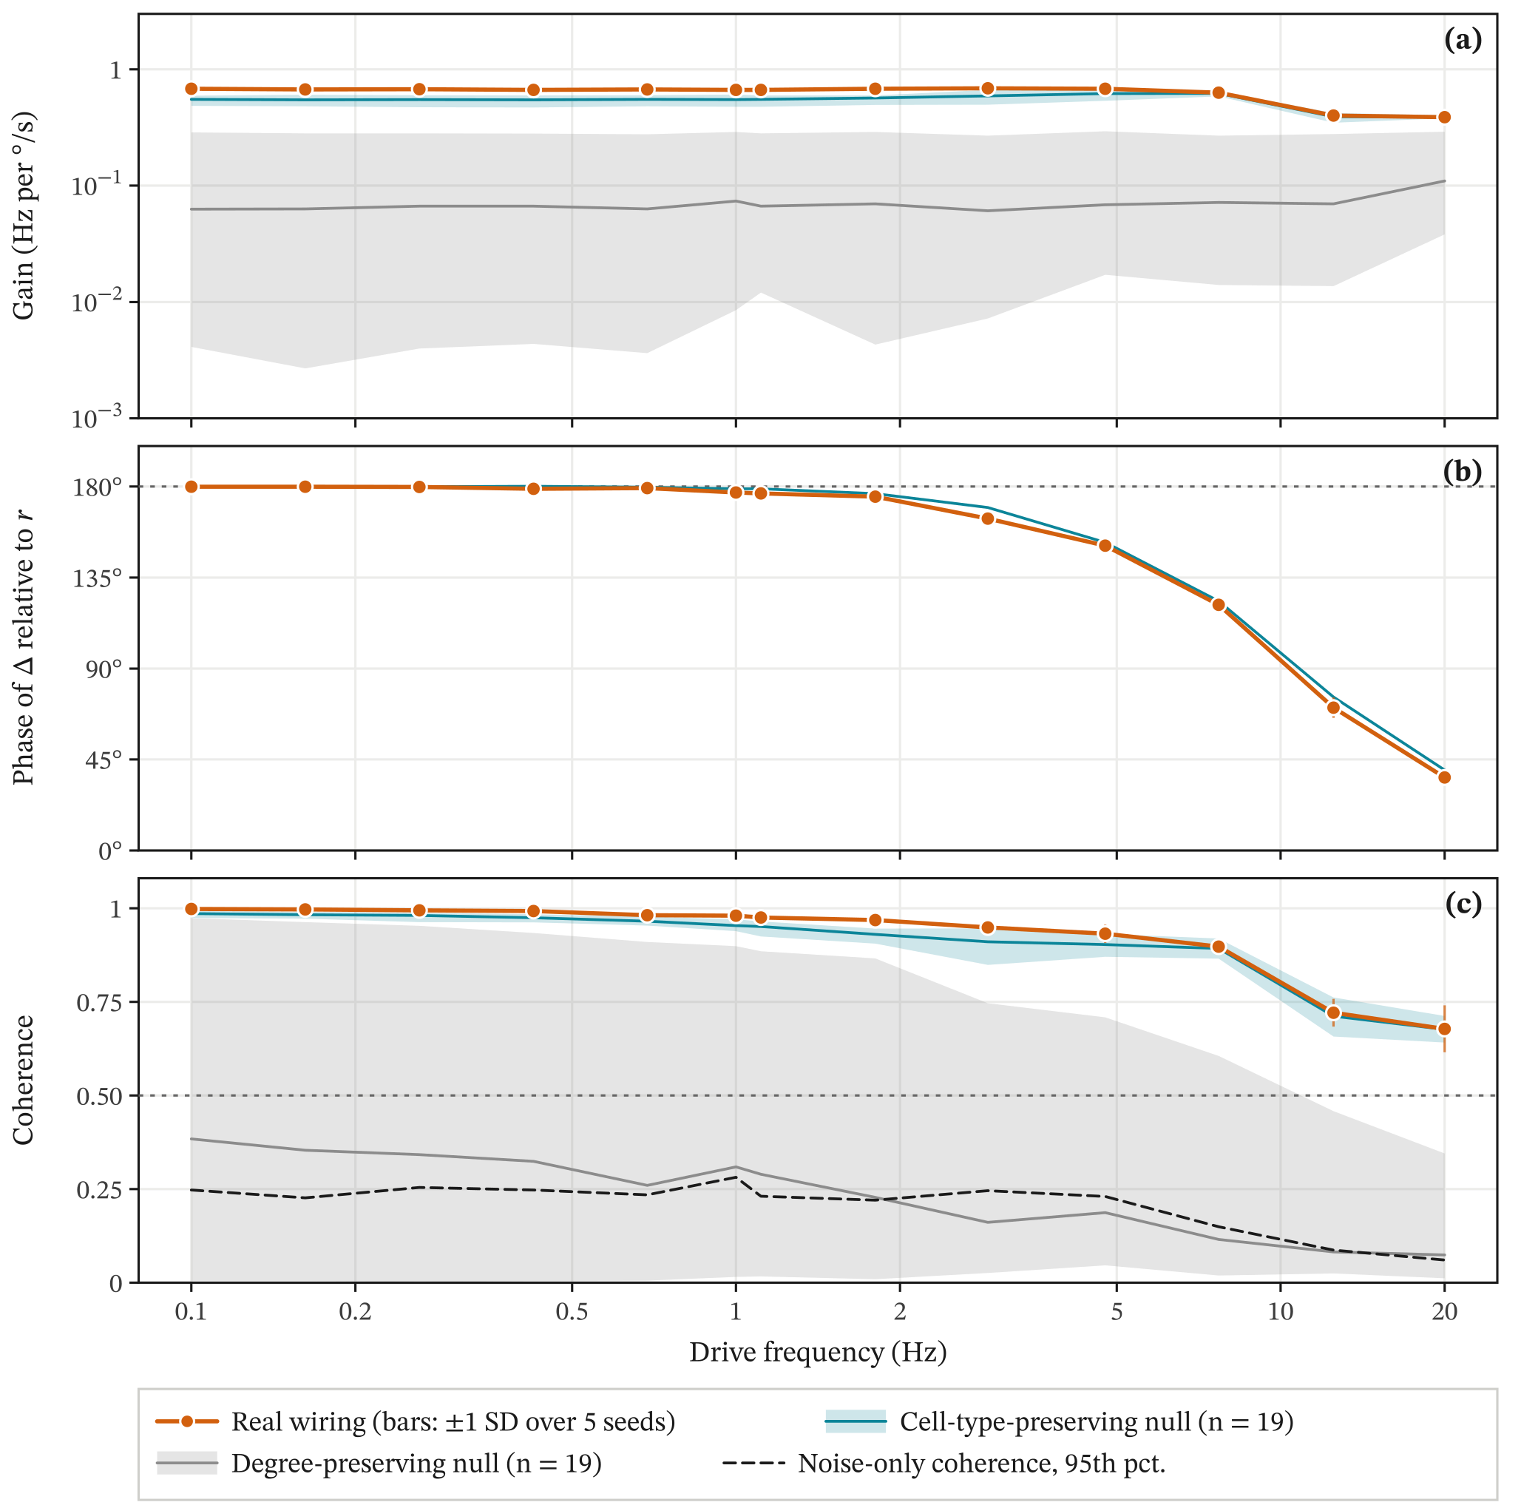
Figure 1. Open-loop frequency response of the real wiring and of both null models. Right-minus-left DNa02 rate Δ in response to yaw rate r (100 °/s stepped sines, mean of 5 seeds). (a) Gain, (b) phase of Δ relative to r (180° opposes the rotation), (c) coherence. Vertical bars on the real wiring: ±1 SD over the 5 seeds. In (a) and (c), bands span the minimum to maximum of the 19 rewirings of each null and thin lines are their medians. Panel (b) shows the cell-type-preserving median only (no band), because most degree-preserving rewirings have too little coherence for a phase to be defined; its dotted line marks 180°. The dotted line in (c) is the H1 threshold; the dashed line is the 95th percentile of the coherence of a sine against white noise, computed for a single seed.
Table 2. Pre-specified H1 test at 1 Hz. The real wiring against 19 rewirings of each null. Rank 1 is the highest value; p from Eq. (15).
Measure | Real | Null median | Null max. | Rank | p
Degree-preserving null
Coherence | 0.980 | 0.309 | 0.898 | 1 of 20 | 0.05
Gain (Hz per °/s) | 0.666 | 0.075 | 0.290 | 1 of 20 | 0.05
Cell-type-preserving null
Coherence | 0.980 | 0.953 | 0.970 | 1 of 20 | 0.05
Gain (Hz per °/s) | 0.666 | 0.550 | 0.609 | 1 of 20 | 0.05

3.2 Closed-loop gust rejection (H2, H2b and H3)
The closed-loop tests asked whether the circuit, wired to the rudder, reduces the aircraft’s yaw response to gusts, and whether the real wiring does so better than scrambled wirings given the same tuning. The tuning rule selected K = 0.0139 per Hz for the real wiring and K = 7.2 per rad/s for the yaw damper, on both models. At this gain the fly loop’s largest measured |L| was 0.55 (at 0.34 Hz, phase +6°), so |L| < 1 at every tested frequency and no phase margin applies. Its nominal gain margin is 34 dB at the 0.06 Hz phase crossing, where |L| = 0.019 is near the measurement noise floor (up to 0.012). Above about 3 Hz |L| falls below the noise floor at several grid points (3.6, 5.9, 33, 50 Hz) and the phase there is unresolved, so a crossing in that range cannot be ruled out. |L| was at most 0.06 at every tested frequency from 2 Hz up, so the gain margin would remain well above the 6 dB threshold even if the phase crossed −180° at any of those frequencies. These are finite-amplitude, single-seed estimates on the two-state model (Section 2.7). The damper had 31.9 dB and 61.3°. The fly loop is admissible because its gain is low. No controller departed controlled flight on any test seed.
The real wiring reduced RMS yaw rate on both models (Table 3, Fig. 2). On the six-degree-of-freedom model the paired difference real − bare was −0.73 [95% CI −0.81, −0.64] °/s, a 19% reduction; on the two-state model it was −0.45 [95% CI −0.53, −0.36] °/s (14%). H2 and H3 were supported. Real − median scrambled was −0.72 [95% CI −0.80, −0.64] °/s and −0.44 [95% CI −0.53, −0.36] °/s. The interval excludes 0 on both models, so H2b was supported as pre-specified; the real wiring also had the lowest mean RMS yaw rate of all 11 wirings on both models, although with 10 rewirings that rank cannot reach p below 1/11 ≈ 0.091. Three caveats temper this. First, H2b is a paired difference conditional on these ten tuned rewirings, not an estimate over all possible rewirings. Second, the tuning rule set K = 0 (no rudder command, so the controller flies as the bare airframe) for five of 10 scrambled wirings on the two-state model and three on the six-degree-of-freedom model, which pulls the median scrambled controller toward the bare airframe. On the two-state model the median scrambled wiring equals the bare airframe on 16 of 20 seeds, and H2b nearly repeats H2 (−0.44 against −0.45 °/s), so the per-wiring ranking is the more informative comparison. Finally, the scrambled wiring with the lowest mean RMS yaw rate came within 4% of the real wiring on the six-degree-of-freedom model (scrambled 08) and 10% on the two-state model (scrambled 02); Section 3.3 shows how the closest ones achieved this. When each scrambled wiring’s readout sign was instead taken from its own open-loop response, the real wiring still ranked first (real − median −0.62 [−0.69, −0.56] and −0.42 [−0.50, −0.35] °/s).
The classical yaw damper was far better: 57% and 52% less RMS yaw rate than the bare airframe, and damper − real of −1.51 [95% CI −1.63, −1.39] and −1.15 [95% CI −1.27, −1.04] °/s. On sideslip the picture differs. The real wiring lowered RMS sideslip against the bare airframe on both models (−0.25 [−0.28, −0.21]° and −0.08 [−0.11, −0.05]°), and on the two-state model its mean RMS sideslip (1.63°) was below the yaw damper’s (1.76°), whose difference from bare there was 0.05 [−0.03, 0.13]°. An exploratory arm with a four-fold stronger input gain (γ = 4, two-state model only) reached 2.08 °/s, a difference from bare of −1.01 [−1.17, −0.87] °/s. The real wiring is therefore a yaw damper that helps on every test seed, but a much weaker one than the classical design.
Table 3. Closed-loop performance in moderate turbulence. Mean RMS yaw rate and RMS sideslip on 20 held-out test seeds, with 95% bootstrap intervals over seeds. For the 10 scrambled wirings the range of their means is given. Bare: no yaw controller; on the six-degree-of-freedom model the wings-level roll hold common to every controller stays on.
 | Two-state model |  | JSBSim 6-DOF
Controller | RMS r (°/s) | RMS β (°) | RMS r (°/s) | RMS β (°)
No yaw controller (bare) | 3.09 [2.90, 3.29] | 1.71 [1.62, 1.81] | 3.92 [3.72, 4.12] | 2.01 [1.91, 2.12]
Yaw damper | 1.50 [1.42, 1.58] | 1.76 [1.68, 1.85] | 1.69 [1.59, 1.79] | 1.73 [1.64, 1.81]
Fly, real wiring | 2.65 [2.50, 2.81] | 1.63 [1.55, 1.72] | 3.19 [3.05, 3.33] | 1.77 [1.69, 1.85]
Fly, scrambled wirings | 2.91–3.09 | 1.67–1.71 | 3.31–3.94 | 1.99–7.41
Rank of real among wirings | 1 of 11 | 1 of 11 | 1 of 11 | 1 of 11
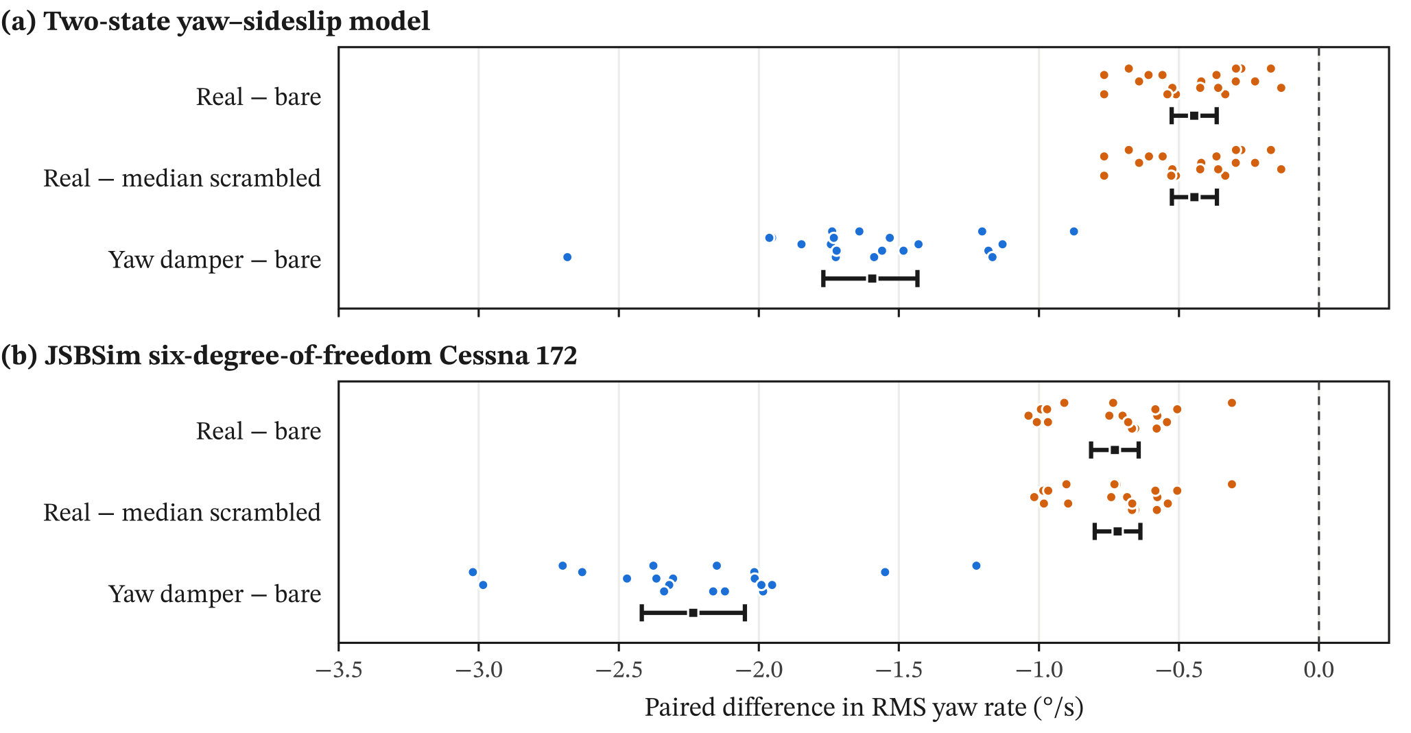
Figure 2. Paired differences in RMS yaw rate on the 20 held-out test seeds. Small dots: one per seed. Squares and bars: mean and 95% percentile bootstrap interval. Negative values favour the first-named controller. The real wiring helps on every seed; the yaw damper helps much more.

3.3 Scrambled controllers that reduce yaw rate by skidding (secondary analysis)
The scrambled wirings that came closest to the real wiring on yaw rate were not better yaw dampers. The tuning rule chose each gain by RMS yaw rate on the training gusts alone, and that statistic barely penalizes a slow, steady turn, so a controller can score well by holding the rudder over and letting the aircraft skid round. On the six-degree-of-freedom model, scrambled wirings 01, 02 and 08 selected K = 0.268 per Hz, a value reached only after the grid widening. At this gain the command is saturated in 100% of control steps for each: the controller has become a relay that slams the rudder to one stop or the other. In the replayed flights, the sparse DNa02 spike train passed through the washout keeps the relay mostly on one side, holding a steady rudder deflection, so the aircraft flies a slow, skidding turn. RMS yaw rate, the pre-specified statistic, barely penalizes a slow steady turn; RMS sideslip does. Across all test seeds only RMS sideslip was checked: averaged over the seeds, these three controllers had RMS sideslip of 7.1–7.4°, against 2.01° for the bare airframe, 1.73° for the yaw damper and 1.77° for the real wiring (Fig. 3). By RMS sideslip, a measure recorded under the protocol but not used as a test statistic, the real wiring ranks first of 11 on both models.
The replay of test seed 100 shows the mechanism directly (Fig. 4, Table 4; it is also the scenario replayed in the viewer above). Scrambled wiring 08 held a mean rudder of +11.5° with the rudder saturated in 100% of steps, turned the heading by +64° (to the right) in 60 s at a mean sideslip of −7.2°, and ended 1.72 km right of the bare airframe’s path. The real wiring and the yaw damper stayed within 21 m of it. The scrambled controller with the lowest RMS yaw rate is therefore not a usable yaw damper, and the near-tie on RMS yaw rate in Section 3.2 is an artefact of that metric.
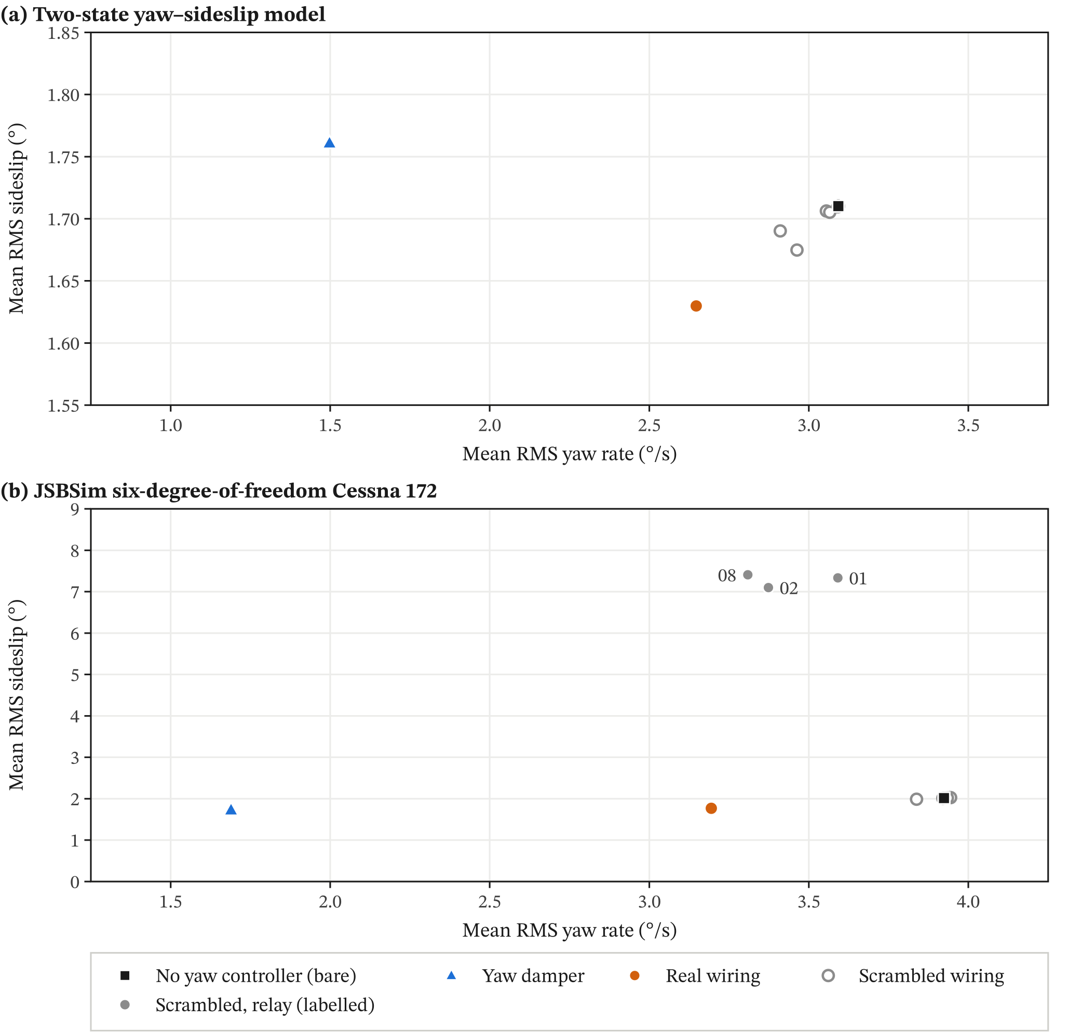
Figure 3. RMS sideslip against RMS yaw rate for every controller. Means over the 20 test seeds. A good yaw damper sits low on both axes. Filled grey points are scrambled wirings whose rudder was saturated in more than 90% of steps (relays); several scrambled wirings with K = 0 coincide with the bare airframe. Note the different sideslip scales: the axis in (a) is expanded, while (b) must also hold the relays. Bare: no yaw controller; on the six-degree-of-freedom model the wings-level roll hold common to every controller stays on.
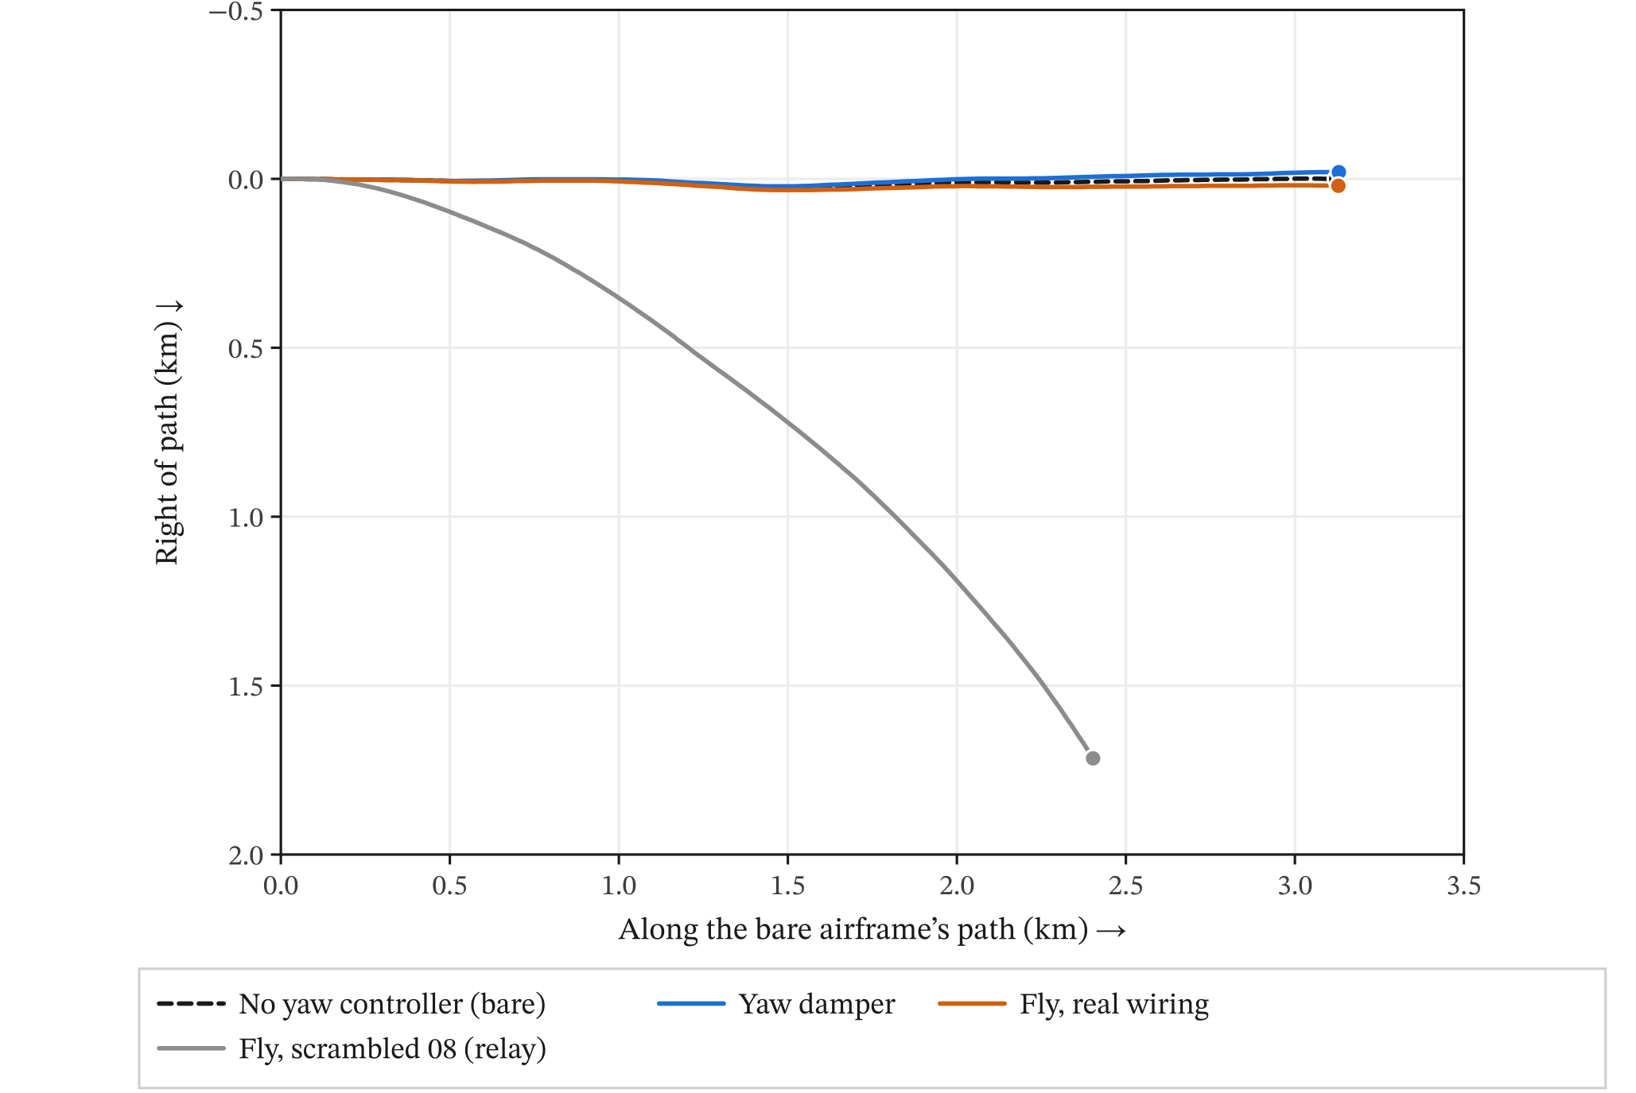
Figure 4. Ground tracks of the six-degree-of-freedom flights on test seed 100. Same turbulence random seed for all. JSBSim’s gust filter depends on each aircraft’s airspeed, so the gust histories differ slightly: at most about 0.06 m/s for the controllers shown, 0.47 m/s for the skidding relay. Plan view from above. Scrambled wiring 08 had the lowest training RMS yaw rate of the ten scrambled wirings, but it flies as a relay: the rudder sits at its stop, the aircraft skids in a steady right turn and ends 1.72 km off course (Section 3.3). The frame is aligned with the bare airframe’s start-to-end path, which runs left to right, so a turn to the right appears as a track bending downward; both axes have the same scale. Dots mark the end of each 60 s flight. Bare: no yaw controller; on the six-degree-of-freedom model the wings-level roll hold common to every controller stays on.
Table 4. Rudder use and flight path on test seed 100. Computed from the replayed flights: mean rudder deflection (commanded deflection relative to trim), fraction of steps with the rudder at its stop, heading change over the flight (+ = right), final offset to the right (+) of the bare airframe’s path, and mean sideslip. Bare: no yaw controller; on the six-degree-of-freedom model the wings-level roll hold common to every controller stays on.
Flight | Mean rudder (°) | Saturated | Heading (°) | Offset (m) | Mean β (°)
Six-degree-of-freedom model
No yaw controller (bare) | 0.00 | 0% | −5.2 | 0 | 0.05
Yaw damper | 0.00 | 0% | −5.1 | −20 | 0.02
Real wiring | +0.14 | 3% | −4.1 | +21 | −0.05
Scrambled 08 | +11.47 | 100% | +63.8 | +1715 | −7.20
Scrambled 00 | +0.08 | 1% | −4.7 | +12 | 0.00
Two-state model
No yaw controller (bare) | 0.00 | 0% | −1.7 | 0 | −0.04
Yaw damper | −0.01 | 0% | −2.7 | 0 | 0.00
Real wiring | +0.12 | 2% | −1.4 | +10 | −0.11
Scrambled 02 | +0.39 | 15% | +0.3 | +34 | −0.29
Scrambled 00 | 0.00 | 0% | −1.7 | 0 | −0.03

3.4 Neuron loss (H4)
The lesion experiment asked how the controller degrades as its neurons are silenced, and whether the real wiring degrades more gracefully than scrambled wirings. No flight departed controlled flight: 0 of the 1,040 flights of the lesion experiment (960 with neurons silenced), across 4 wirings, every lesion condition and 20 test seeds. Every AUC in Eq. (16) is therefore 1, and the difference is 0, with a degenerate bootstrap interval (no departures). The bare Cessna with its wings-level hold does not depart in moderate turbulence, so H4 could not be tested as pre-specified; the Wilson 95% upper bound on the departure probability in each cell is 0.16.
The pre-specified secondary measure, mean RMS yaw rate, was informative (Fig. 5). As neurons were silenced at random, the real wiring’s mean RMS yaw rate rose from 3.19 °/s to the bare airframe’s 3.92 °/s, losing 38% of its benefit at 5% and reaching the bare value (to two decimals) by 60%; the increase by 80% was 0.73 [0.64, 0.81] °/s. Its worst mean in any lesion condition was 3.92 °/s, so its mean RMS yaw rate stayed at or below the bare value in every condition. One of 240 lesioned flights was slightly worse than bare on the same seed (seed 108 at 5%: 3.387 against 3.372 °/s). Its difference from the mean of the scrambled wirings stayed below zero up to 60% silenced (95% intervals) and approached zero beyond, as all controllers converged on the bare airframe. Two of the three scrambled wirings in this experiment (01 and 02) are the relay controllers of Section 3.3, and they behaved differently: under some lesions their mean RMS yaw rate was above the bare airframe’s, up to 5.07 and 5.49 °/s. The neuron-loss replay in the viewer above shows the real wiring at 0%, 40% and 80% random loss and with its HS cells silenced.
Part of this fade is loss of the readout itself. In the intact replays of test seed 100 the right DNa02 fired no spikes on either aircraft model, while the left fired 153 in 60 s (2.55 Hz), so the rudder command came from the left DNa02 alone. Silencing the left DNa02 therefore switches the controller off unless the lesion lets the right one fire. At 5% the left DNa02 was silenced on 6 of 20 seeds (about 1 expected); five of these flights were identical to the bare airframe, and on the other (seed 103) the controller still steered, so the right DNa02 must have fired. These five switched-off seeds account for 55% of the 38% of benefit lost at 5%; the other 15 seeds lost 21%. The number of flights identical to the bare airframe rose with the lesion fraction: 5, 5, 9, 15, 18 and 20 of 20 at 5%, 10%, 20%, 40%, 60% and 80%. At the higher fractions some of them (1 at 20%, 3 at 40%, 3 at 60%, 2 at 80%) kept an intact left DNa02 and were switched off by loss upstream. The lesion curve therefore mixes loss of processing with loss of the single active readout cell.
Targeted lesions locate the function (Table 5). Silencing the six HS cells returned the real wiring exactly to the bare airframe’s RMS yaw rate; HS cells were necessary for its closed-loop effect in this model. Silencing all T4 or all T5 cells left part of the function (3.59 and 3.75 °/s), and in both cases the real wiring stayed below the scrambled mean (−1.03 [−1.13, −0.93] and −0.72 [−0.81, −0.63] °/s). With HS silenced the real wiring was worse than the scrambled mean (+0.30 [0.20, 0.39] °/s), because the relay wirings do not depend on HS. The hub lesions are uninformative by construction: the top-betweenness sets of the real wiring contain both DNa02 readout neurons and all 6 HS cells, so silencing them removes the readout itself, and every wiring then flew exactly like the bare airframe. Under random neuron loss, then, the real wiring’s mean degrades toward the bare airframe but not beyond it, and HS cells were necessary for its effect.
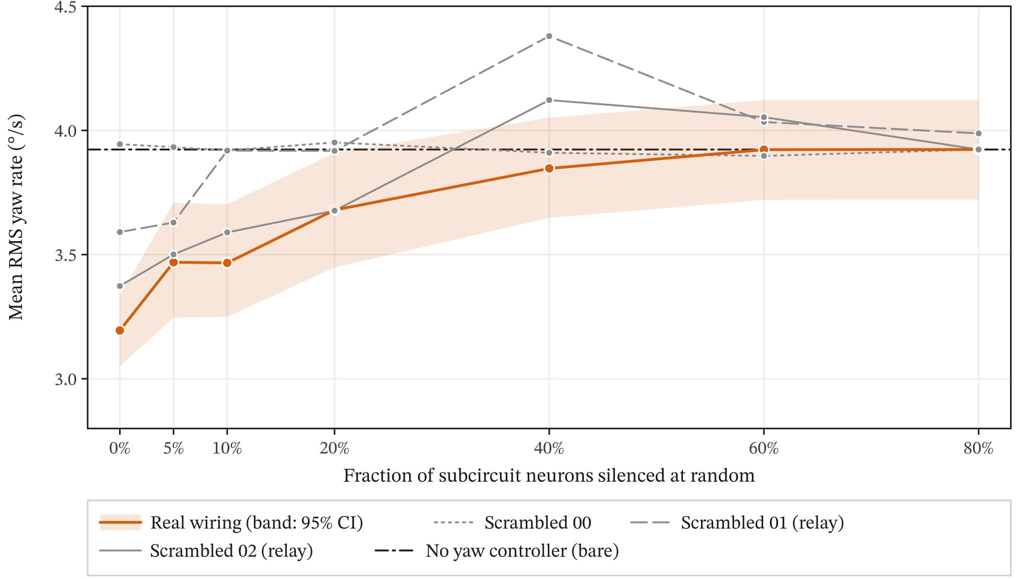
Figure 5. Mean RMS yaw rate against the fraction of neurons silenced at random. Mean over 20 test seeds (nested sets, the same neurons in every wiring), on the six-degree-of-freedom model. Each wiring keeps its tuned gain. The shaded band is the 95% bootstrap interval for the real wiring; the dash-dotted line is the bare airframe. The yaw damper, for reference, flies at 1.69 °/s. Bare: no yaw controller; on the six-degree-of-freedom model the wings-level roll hold common to every controller stays on.
Table 5. Targeted lesions. Mean RMS yaw rate (°/s) over 20 test seeds on the six-degree-of-freedom model, and the paired difference between the real wiring and the mean of the scrambled wirings with its 95% bootstrap interval. The bare airframe flies at 3.92 °/s; no flight departed.
Silenced | Real | Scr. 00 | Scr. 01 | Scr. 02 | Real − scr. mean
None | 3.19 | 3.94 | 3.59 | 3.37 | −0.44 [−0.51, −0.37]
All HS cells | 3.92 | 3.93 | 3.57 | 3.39 | +0.30 [0.20, 0.39]
All T4 cells | 3.59 | 3.92 | 5.07 | 4.88 | −1.03 [−1.13, −0.93]
All T5 cells | 3.75 | 3.92 | 3.98 | 5.49 | −0.72 [−0.81, −0.63]
Hubs, top 5% | 3.92 | 3.92 | 3.92 | 3.92 | 0.000 [0.000, 0.000]
Hubs, top 10% | 3.92 | 3.92 | 3.92 | 3.92 | 0.000 [0.000, 0.000]
Hubs, top 20% | 3.92 | 3.92 | 3.92 | 3.92 | 0.000 [0.000, 0.000]

3.5 Amplitude dependence and full-brain check (exploratory and planned checks)
Two further analyses asked whether the open-loop results, measured at large amplitude in an isolated subcircuit, carry over to the conditions of the closed-loop flights. The open-loop measurements used 100 °/s, but in turbulence the bare airframe yaws at about 3–4 °/s RMS (3.1 on the two-state, 3.9 on the six-degree-of-freedom model). In an exploratory sweep at 1 Hz, coherence fell from 0.98 at 100 °/s to 0.67 at 3 °/s, while the lock-in gain rose to 1.2–1.4 Hz per °/s, partly a noise bias at low coherence and partly nonlinearity. The real wiring still had the highest coherence of the 20 wirings (real and degree-preserving) at every amplitude. At rest, DNa02 fired at 1.4 Hz on the left and 0.0 Hz on the right, so at turbulence-level yaw rates a single readout neuron per side operates near threshold and the signal reaching the rudder is sparse and partly rectified. This is consistent with the low loop gain of Section 3.2 and with the improvement seen at a stronger input gain. In a planned sensitivity check across input gains γ from 0.5 to 4, coherence up to 2 Hz stayed above 0.83.
In a planned check of what the subcircuit leaves out, the real wiring was also run inside the whole v783 brain (all connections, with no 5-synapse cutoff, and all 12,246 T4/T5 cells as sources, against 12,056 in the subcircuit) at 0.5, 2.0 and 8.0 Hz (2 seeds). The subcircuit kept the full brain’s phase to within 3.9°, but its gain was 15–17% lower at 0.5–2 Hz and 36% lower at 8 Hz. The large-amplitude characterization therefore describes the circuit under strong drive: at turbulence-level yaw rates its output is weaker and noisier. The subcircuit’s lower gain combines the restored weak connections, the extra neurons and the extra sources of the whole brain, and is not attributable to isolation alone.

4 Discussion

4.1 Principal findings
Treated as a flight-control element and driven at large amplitude (100 °/s), this model of the fly’s visual yaw pathway behaves like a delayed rate sensor; at the few-degrees-per-second yaw rates of turbulence its output becomes noisy and partly rectified (Section 3.5). It tracks yaw rotation coherently from 0.1 to several hertz, with the sign a stabilizing reflex needs and an effective high-frequency phase-slope delay of about 22 ms. That property depends on the wiring: rewiring that keeps every neuron’s degree and sign but scrambles which cell types connect on which side removes most of the response. Most of it survives a rewiring that respects cell type and side, but that rewiring leaves the core T4/T5 → HS → DNa02 connections intact, so it shows only that the remaining connections contribute a small, consistent increment.
Closed around a rudder, the circuit is a weak but real yaw damper. It improves on the bare airframe on every test seed, and it ranks first among the wirings on yaw rate and on sideslip, but the classical yaw damper, tuned by the same rule with the same budget, removes about three times (six-degree-of-freedom) to three and a half times (two-state) as much yaw motion. Under random neuron loss the real wiring’s mean RMS yaw rate stayed at or below the bare airframe’s in every condition (one of 240 lesioned flights was slightly worse), partly because losing its single active readout neuron switches it off; relay-type scrambled controllers had mean RMS yaw rate above the bare airframe’s under some lesions.

4.2 What limits the fly controller
Latency is unlikely to be the main limit: at 100 °/s the circuit’s phase lag near the Dutch-roll frequency is at most 1.2°, and its measured |L| never exceeded 0.55 (Section 3.2). The evidence points instead to signal strength: in turbulence the T4/T5 input is small, the single DNa02 neuron on each side fires near threshold (in the intact replays only the left one fired), and the RMS-optimal gain (which the margin rule did not bind) is low because higher gain adds more spike noise to the rudder than it removes yaw motion; the exploratory stronger-input arm is consistent with this.

4.3 Comparison with prior work and with flies
The model’s effective phase-slope delay is of the same order as the delays of tens of milliseconds measured for the optomotor response in tethered flight [12]; this comparison is qualitative only. Behavioural yaw linear filters exist [12] but differ in stimulus, output (wingbeat amplitude) and processing stages, and descending-neuron impulse responses used roll stimuli [16], so we compare only delays. Earlier connectome flight-loop projects reported time-domain behaviour, sometimes against shuffled wiring [13, 14, 15]. The frequency-response, margin, turbulence and lesion measurements reported here complement such demonstrations, and they use the same kind of shuffled-wiring control.

4.4 Evaluating connectome controllers
The relay controllers carry a methodological lesson. Our primary metric, RMS yaw rate, together with a pre-specified rule to widen the gain grid, admitted controllers that reduce yaw rate by holding the rudder over and skidding in a steady turn. The margin constraint did not exclude them: measured by injection on the two-state model, where a saturated loop yields only a describing-function margin, they showed gain margins of 7.5–12.1 dB. Similarly, the departure-based lesion test could not discriminate between wirings because nothing departed. In both cases the pre-specified statistic was blind to a difference that a second measure, sideslip or mean RMS yaw rate, revealed.

4.5 Limitations
The conclusions are about this model of the wiring, not about real flies. The whole-brain model was validated on gustatory and grooming circuits, not on visual neurons [3], and on connectome release v630; we run it on v783. The model omits gap junctions, which carry much of the coupling between HS and H2 cells, and it treats graded-potential neurons such as T4/T5, HS and VS cells as spiking ones [3, 22]. Our input encoding is piecewise linear (half-wave rectified) in r for each cell and ignores the temporal-frequency tuning and pattern dependence of motion detectors. DNa02’s steering role is established in walking [11], and its role in flight is inferred from connectivity. The subcircuit underestimates the full brain’s gain, by up to 36% at 8 Hz. Loop margins were measured on the two-state model only and reused for the six-degree-of-freedom model, whose turbulence model differs in spectral shape. With 10 scrambled wirings in closed loop the smallest attainable p is 0.091, so the closed-loop ranking is suggestive rather than significant at 0.05 on its own. All flights used one aircraft loading (2,480 lb, centre of gravity 45.5 in aft of the datum and 4.2 in right of the centreline, from the default seat masses); a longitudinal shift of the centre of gravity changes the fin’s moment arm and hence the yaw damping, and a lateral offset mainly changes trim; neither was varied. The margin thresholds were applied as a screening rule, not as a full MIL-F-9490D compliance test (Section 2.7).

4.6 Future work
A future protocol should constrain mean rudder, sideslip or heading drift, and measure margins on the plant being flown. A discriminating lesion test would need a harsher plant or turbulence level, and hub sets that exclude the readout neurons. More closed-loop rewirings would let the per-wiring ranking reach conventional significance, and a null that rewires the core T4/T5 → HS → DNa02 connections neuron by neuron would test whether their neuron-level wiring matters. Both controllers studied here are inner-loop yaw dampers whose washout passes steady turns, so neither tries to hold heading or track. The natural next study places each inside conventional heading and track loops, measures path error and recovery from discrete disturbances, and tests whether other connectome pathways, such as the VS cells that respond to roll and pitch, can drive the ailerons and elevator, each compared with a conventional controller tuned by the same rule.

5 Conclusions
A spiking model of the fruit fly’s visual yaw pathway, taken directly from the connectome and tested with the methods used to assess a flight-control law, behaved as a delayed yaw-rate sensor with the stabilizing sign and, closed around a rudder, as a weak yaw damper that ranked first among the wirings tested, although with too few rewirings for that rank alone to be significant. Its function depended on its wiring and, in this model, required the HS cells, and under random neuron loss its mean RMS yaw rate rose toward the bare airframe’s value without exceeding it, in part because the loss often silenced its one active readout neuron. The same tests exposed scrambled controllers that scored well on the primary metric by skidding, which argues for judging connectome controllers, like any flight-control law, on several measures and on the airframe they fly.

Declarations

Data and code availability
Code, result files and the replays shown in the viewer are available at github.com/aryawidjaja/flight-test-the-fly, archived on Zenodo as release v1.0.0 (doi:10.5281/zenodo.23156035). Closed-loop simulations ran at commit 393e70e, open-loop at e5f90c0, gain tuning at bab4588 and d98adb0 and lesions at ab35844 (47, 510, 432 and 104 result files). These commits are archived privately, not on a public branch; the analysis scripts were re-run on the public code from the stored per-job results, and the simulations themselves were not re-run. The FlyWire connectome and its annotations are available from their original publications [1, 2].

Acknowledgements and licences
Wiring data: the FlyWire Consortium, connectome v783, CC BY 4.0 [1, 2]. Neuron model and connectivity table: Shiu et al., MIT licence [3]. Flight dynamics: JSBSim [17].

AI assistance
Generative AI: Claude Opus 5.5 (Anthropic), used through Claude Code, assisted with writing and reviewing the simulation and analysis code, running and checking the analyses, checking the literature and citations, building the web viewer, and drafting and editing the text. The author designed the study, made the methodological decisions, checked the results and the text, and takes full responsibility for the content.

Competing interests
The author declares no competing interests.

References
- Dorkenwald S, et al. (2024). Neuronal wiring diagram of an adult brain. Nature 634:124–138. doi:10.1038/s41586-024-07558-y
- Schlegel P, et al. (2024). Whole-brain annotation and multi-connectome cell typing of Drosophila. Nature 634:139–152. doi:10.1038/s41586-024-07686-5
- Shiu PK, et al. (2024). A Drosophila computational brain model reveals sensorimotor processing. Nature 634:210–219. doi:10.1038/s41586-024-07763-9
- US Air Force (6 June 1975). MIL-F-9490D, Flight Control Systems – Design, Installation and Test of Piloted Aircraft, General Specification for, §3.1.3.6.1, Table III.
- US Department of Defense (5 November 1980). MIL-F-8785C, Military Specification: Flying Qualities of Piloted Airplanes. everyspec.com/MIL-SPECS/MIL-SPECS-MIL-F/MIL-F-8785C_5295
- Maisak MS, et al. (2013). A directional tuning map of Drosophila elementary motion detectors. Nature 500:212–216. doi:10.1038/nature12320
- Shinomiya K, et al. (2019). Comparisons between the ON- and OFF-edge motion pathways in the Drosophila brain. eLife 8:e40025. PMC6338461
- Schnell B, et al. (2010). Processing of horizontal optic flow in three visual interneurons of the Drosophila brain. J Neurophysiol 103:1646–1657. doi:10.1152/jn.00950.2009
- Haikala V, et al. (2013). Optogenetic control of fly optomotor responses. J Neurosci 33:13927–13934. PMC6618655
- Namiki S, et al. (2018). The functional organization of descending sensory-motor pathways in Drosophila. eLife 7:e34272. PMC6019073
- Rayshubskiy A, et al. (2025). Neural circuit mechanisms for steering control in walking Drosophila. eLife 13:RP102230. doi:10.7554/eLife.102230
- Theobald JC, Ringach DL, Frye MA (2010). Dynamics of optomotor responses in Drosophila to perturbations in optic flow. J Exp Biol 213:1366–1375. PMC2846167
- ClutchMedia775 (2026). fly-brain-drone. Software repository, commit d017a6c, accessed 3 Oct 2026. github.com/ClutchMedia775/fly-brain-drone
- leohio (2026). connectome-fly-closedloop. Software repository, commit 56eae22. github.com/leohio/connectome-fly-closedloop
- Jin Z, Zhu Y, Zhang C, Sui Y (2026). Whole-brain connectomic graph model enables whole-body locomotion control in fruit fly (FlyGM). arXiv:2602.17997v3 (14 Jun 2026). arxiv.org/abs/2602.17997v3
- Leibbrandt R, Nicholas S, Nordström K (2021). The impulse response of optic flow-sensitive descending neurons to roll m-sequences. J Exp Biol 224:jeb242833. doi:10.1242/jeb.242833
- Berndt JS, Coconnier B, De Marco A, McLeod S (2026). JSBSim – An Open Source Flight Dynamics Software Library, v1.3.1. Software. doi:10.5281/zenodo.20258622; github.com/JSBSim-Team/jsbsim
- Yeager JC (1998). Implementation and testing of turbulence models for the F18-HARV simulation. NASA/CR-1998-206937. ntrs.nasa.gov/citations/19980028448
- Boeing Co. (1975). Background Information and User’s Guide for MIL-F-9490D. AFFDL-TR-74-116 (NTIS AD-A029 074); reproduces the stability-margin table of the specification. acgsc.org
- Mansur MH, Lusardi JA, Tischler MB, Berger T (2009). Achieving the best compromise between stability margins and disturbance rejection performance. American Helicopter Society 65th Annual Forum, Grapevine, TX. sjsu.edu/researchfoundation/docs/AHS_2009_Mansur.pdf
- Phipson B, Smyth GK (2010). Permutation P-values should never be zero: calculating exact P-values when permutations are randomly drawn. Stat Appl Genet Mol Biol 9(1):Article 39. doi:10.2202/1544-6115.1585
- Pokusaeva VO, Satapathy R, Symonova O, Joesch M (2024). Bilateral interactions of optic-flow sensitive neurons coordinate course control in flies. Nat Commun 15:8830. doi:10.1038/s41467-024-53173-w

