Agnieszka Rybak

Web Advanced: JavaScript

Spring 2019

**Title: CEDAW’s promise to counter gender discrimination**

*Abstract: The goal of this project is to create CEDAW map that would give users the power to look at the UN treaty and laws related to domestic violence, harassment, property, employment rights, discrimination, and equality. This project accomplished this goal through data visualizations, data tools, and data stories which are all displayed to the user in a clear and informative manner. I believe that CEDAW map is an application which can be successfully expanded upon and I suggest possible direction in which to make that expansion.*

**Project Concept:**

The Convention on the Elimination of all Forms of Discrimination Against Women (CEDAW) is considered as the most comprehensive code of women’s rights at the international level, with its focus on socioeconomic, civil, political and cultural rights in all spheres of women’s lives. It is often called, the “Bill of Rights” for women everywhere. The United Nations General Assembly adopted CEDAW on December 18, 1979, and countries began to implement it on September 3, 1981. The treaty provides a theoretical framework that identifies barriers to women’s advancement, assess needs, set goals, and suggest measures to be taken for action and international standard for protecting and promoting women’s rights.

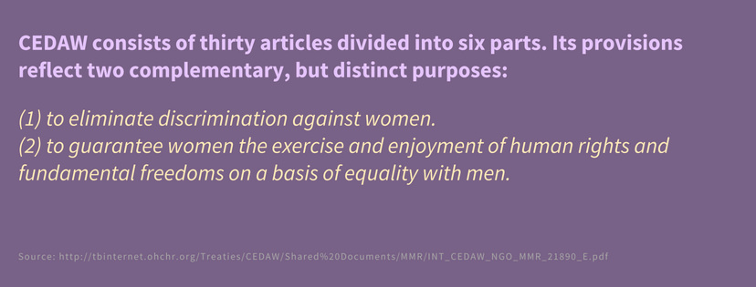

To achieve its goals, CEDAW requests countries that have ratified the treaty to combat discrimination in all areas including public actions, laws, and policies, and require sanctions on acts of private actors, including within the family, community, and commercial arenas. CEDAW appoints a Committee that deals with monitoring the implementation of the provisions by state parties as well as the possibility for individuals around the world to complain to the CEDAW Committee. In other words, CEDAW’s ratification represents a vital reaffirmation of nation’s commitment to the human rights of women, and a momentous step forward for women around the world.

Today, it is time to examine as to whether the promise of CEDAW was delivered as initially intended. To rightly assess the success of CEDAW, it is imperative to ask the following questions: 1) Which countries have laws that promote gender equality? 2) Which countries have laws preventing domestic violence against women? 3) Which countries grant equal rights for men and women on property ownership? 4) Which countries have laws prohibiting sexual harassment at work and public space?

Using data from the World Bank and the UN snapshot of how women's rights are legislated around the world. Women’s rights issues covered in this project are work, constitution, domestic violence, sexual harassment, and property which are important indicators to understand women global well-being.

Additionally, to add a much more in-depth dimension and urgency towards women’s rights issues across the globe, I used the Gender Gap Index to identify the best and worst places for women. The Gender Gap Index measures the differences between women and men, especially as reflected in social, political, intellectual, cultural, or economic attainments or attitudes.**Project**

**Technologies**

In order to build the map/application, I made use of several resources in addition to basic programming. The main part of the website is comprised entirely of HTML, CSS, JavaScript and jQuery. To build visualizations, I used CARTO APIs.

*Leaflet*

Leaflet is a JavaScript library for making interactive maps. It can interface with Mapbox for the base map layer but is also usable with numerous other map creation services such as OpenStreetMap. In addition to the standard library, Leaflet offers a growing list of plugins to add enhancements to map interactions such as InfoWindow (aka pop up text on mouse hover).

*CARTO*

Carto is a cloud computing platform that provides web mapping tools that can be displayed in a web browser. CARTO is excellent for displaying trajectory data (data that is displayed in motion over time), whereas Leaflet is best for creating interactive visualizations of stationary data. For this reason, we used CARTO for the dynamic dataset in our system.

*Design*

In order to build the map/application, I made use of several resources in addition to basic programming. The website and its features are made up of a combination of HTML, CSS, and JavaScript in different areas. The basic site pages consist of primarily HTML and CSS with most of the framework coming from Bootstrap. Bootstrap was a critical framework letting me to quickly create navigation bar and other page elements which allowed me to focus more on creating the data visualizations and features. The visualizations themselves are done with JavaScript and make use of CARTO’s SQL API. This API allows interacting with tables and data inside CARTO.

*Implementation*

Initially, the map was designed to operate entirely off the CARTO visualization architecture to offload most of the processing of the data. While this was an easy way to visualize my data, I quickly hit a wall in terms of features, customizations, and performance. I kept the CARTO implementation for the dynamic data as I found it to be the most useful resource for that dataset. Thus, the map contains eight layers in total. Data for each layer was cleaned, re-organized and geocoded using GeoCarto feature.

* For “the women’s equality treaty layer,” I created InfoWindow (aka pop up text on mouse hover) to show each country’s name.
* For "women's rights around the world by issue layers,” I created bubbles in a different color to show identified full, partial and non-positive and no data responses.
* For “the best and worst places for women layer,” I used polygon pattern fill with the opacity at 75 % so that other layers could be visible and to add more in-depth dimension to the map.

**Future Work**

The project, in its current state, is an interesting way to visualize CEDAW and laws related to domestic violence, harassment, property, employment rights, discrimination, and equality. Although seemingly incomplete, this project map presents an opportunity for further research and fine-tuning to build on what has already been assembled here.

There are several recommendations for future work that would increase the usability and functionality of CEDAW map.

*Add Time Animation*

This feature will make a map more interesting and interactive. User won’t have to do anything to see changes over time.

*Add Chart Wheel Visualization*

This feature will show data in more interesting way.