Agnieszka Rybak

Web Advanced: JavaScript

Spring 2019

**Title: CEDAW’s promise to counter gender discrimination**

*Abstract: The project looks at CEDAW, laws related to domestic violence, harassment, property, employment rights, discrimination and equality.*

The Convention on the Elimination of all Forms of Discrimination Against Women (CEDAW) is considered as the most comprehensive code of women’s rights at international level, with its focus on socioeconomic, civil, political and cultural rights in all spheres of women’s lives. It is often called, the “Bill of Rights” for women everywhere. CEDAW was adopted by the United Nations General Assembly on December 18, 1979, and countries began to implement it on September 3, 1981. The treaty provides a theoretical framework that identifies barriers to women’s advancement, assess needs, set goals, and suggest measures to be taken for action and international standard for protecting and promoting women’s rights.

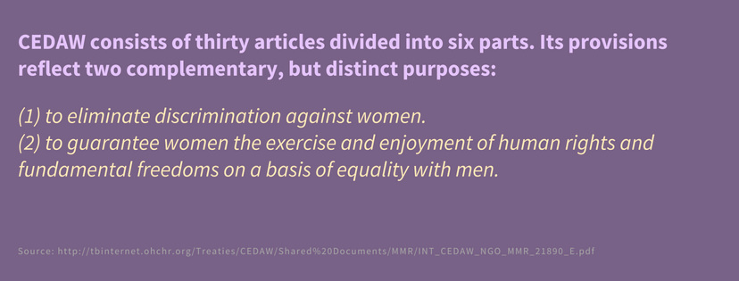

To achieve its goals, CEDAW requests countries that have ratified the treaty to combat discrimination in all areas including public actions, laws and policies, and require sanctions on acts of private actors, including within the family, community, and commercial arenas. CEDAW appoints a Committee that deals with monitoring the implementation of the provisions by state parties as well as the possibility for individuals around the world to complain to the CEDAW Committee. In other words, CEDAW’s ratification represents an important reaffirmation of nation’s commitment to the human rights of women, and a momentous step forward for women around the world.

Today, it is time to examine as to whether the promise of CEDAW was delivered as initially intended. To rightly assess the success of CEDAW, it is imperative to ask the following questions: 1) Which countries have laws that promote gender equality? 2) Which countries have laws preventing domestic violence against women? 3) Which countries grant equal rights for men and women on property ownership? 4) Which countries have laws prohibiting sexual harassment at work and public space?

Using data from the World Bank and the UN, I created an interactive map to answer above raised questions and provide a snapshot of how women's rights are legislated around the world. Women’s rights issues covered in this project are work, constitution, domestic violence, sexual harassment, and property which are important indicators to understand women global well-being.

Additionally, to add a much more in-depth dimension and urgency towards women’s rights issues across the globe, I used the Gender Gap Index to identify the best and worst places for women. The Gender Gap Index measures the differences between women and men, especially as reflected in social, political, intellectual, cultural, or economic attainments or attitudes.

Chose the API that you're going to use and start to pull data from the API.

* I will be using Carto.js library.