CASE STUDY

Achint Tiwary
Repo - Link
Created Azure Virtual Machine

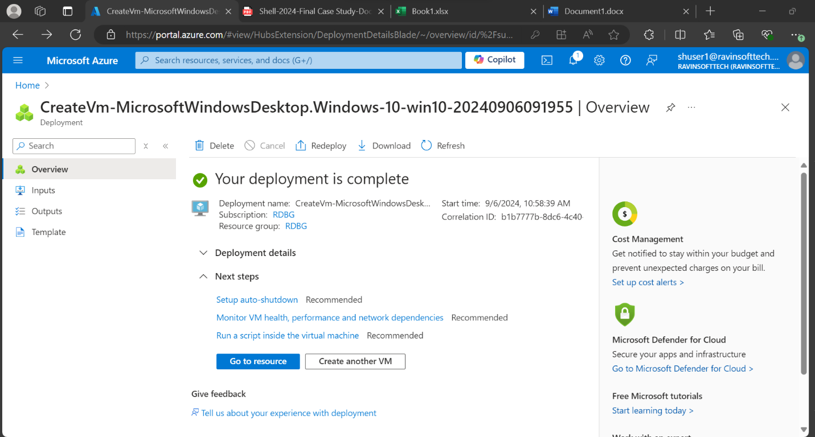

Created Project on Azure Devops

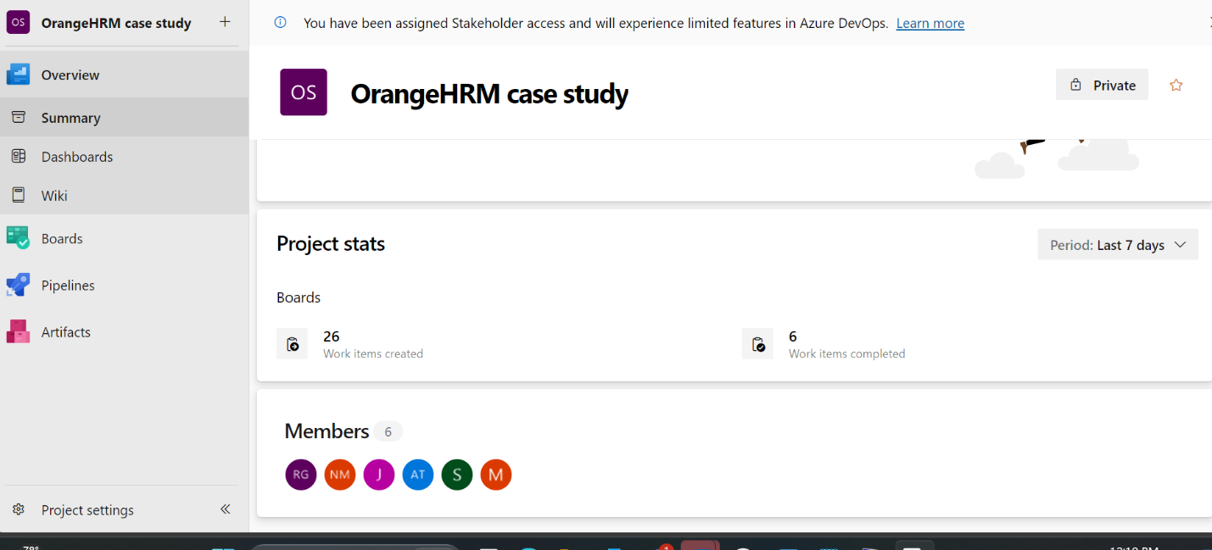

Created 5 User stories in Product Backlog

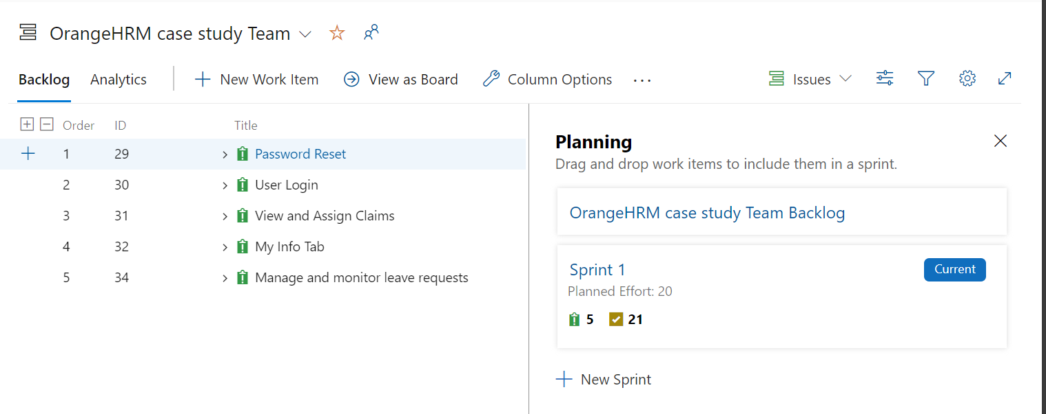

Created Sprint Backlog & User Stories

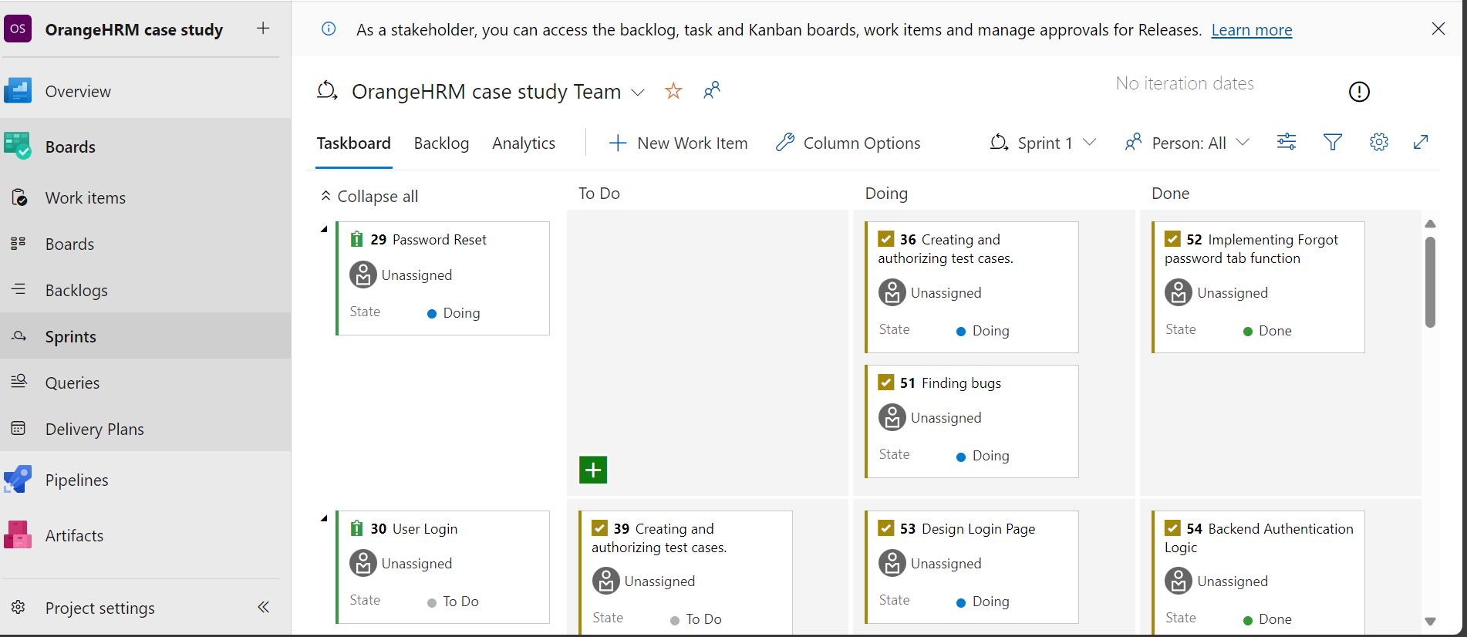

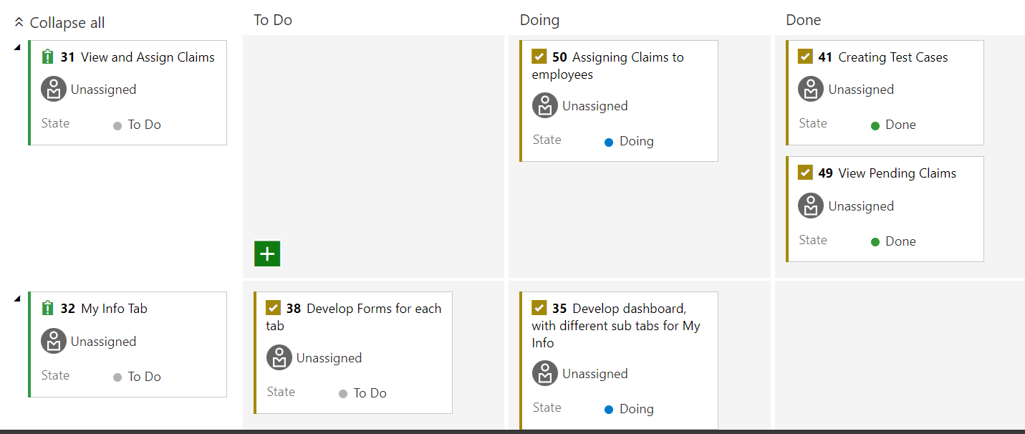

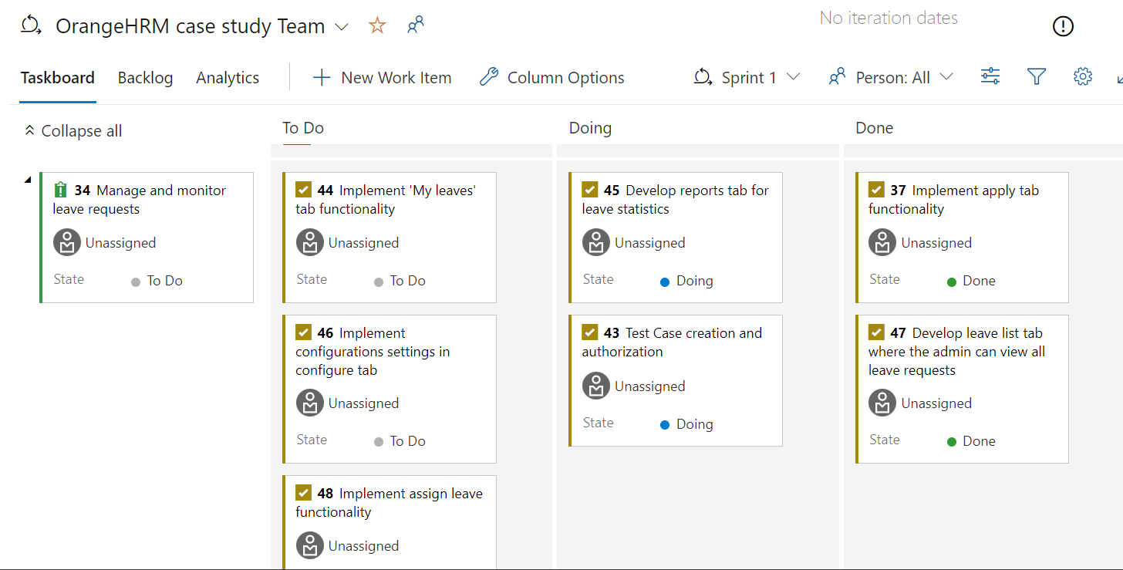

Created Test Cases for the User Stories:-

Test#001: Scenario: Successful login with valid credentials
Given I am on the OrangeHRM login page
When I enter "Admin" as the username
And I enter "admin123" as the password
And I click on the "Login" button
Then I should be redirected to the OrangeHRM dashboard
And I should see the welcome message on the dashboard

Test#002: Scenario: Unsuccessful login with invalid password
Given I am on the OrangeHRM login page
When I enter "Admin" as the username
And I enter "wrongPassword" as the password
And I click on the "Login" button
Then I should see an error message "Invalid credentials"
And I should remain on the login page

Test#003: Scenario: Unsuccessful login with empty username
Given I am on the OrangeHRM login page
When I leave the username field blank
And I enter "admin123" as the password
And I click on the "Login" button
Then I should see an error message "Username cannot be empty"
And I should remain on the login page

Test#004: Scenario: Unsuccessful login with empty password
Given I am on the OrangeHRM login page
When I enter "Admin" as the username
And I leave the password field blank
And I click on the "Login" button
Then I should see an error message "Password cannot be empty"
And I should remain on the login page

Test#005: Scenario: Clicking "Forgot Your Password" redirects to forgot password screen
Given I am on the OrangeHRM login page
When I click on the "Forgot your password?" link
Then I should be redirected to the OrangeHRM password reset page
And I should see a form to enter the username or email for password recovery

Test#006: Scenario: View all claims
Given I am logged into the system as an admin
When I navigate to the "Claims" section
And I click on "Employee Claims"
Then I should see a list of all claims

Test#007: Scenario: View claim details
Given I am logged into the system as an admin
And a list of claims is available
When I click on a specific employee claim
Then I should see the detailed information of the selected claim

Test#008: Scenario: Assign claim to an employee
Given I am logged into the system as an admin
And a list of unassigned claims is available
When I select an unassigned claim
And I click on "Assign Claim"
And I select an employee from the list
And I click "Assign"
Then the claim should be assigned to the selected employee
And the status should be updated accordingly

Test#009: Scenario: Filter claims by status
Given I am logged into the system as an admin
And a list of claims is available
When I select a status filter "Pending"
Then I should see only the claims with the status "Pending"

Test#010: Scenario: Search claims by employee name
Given I am logged into the system as an admin
And a list of claims is available
When I enter an employee name in the search bar
And I click on the search icon
Then I should see the claims related to the entered employee name

Test#011: Scenario: Search claims by reference ID
Given I am logged into the system as an admin
And a list of claims is available
When I enter a reference ID in the search bar
And I click on the search icon
Then I should see the claims related to the entered reference ID

Test#012: Scenario: Search claims by date range
Given I am logged into the system as an admin
And a list of claims is available
When I select the "From Date" and "To Date" fields
And I enter the desired date range
And I click on the search icon
Then I should see the claims within the specified date range

Test#013: Scenario: Search claims by event name
Given I am logged into the system as an admin
And a list of claims is available
When I enter an event name in the search bar
And I click on the search icon
Then I should see the claims related to the entered event name

Test#014: Scenario: HR Manager views a claim’s detail
Given the HR Manager is logged into the system
And the HR Manager navigates to the claims section
When the HR Manager views the list of all pending claims
And the HR Manager selects a claim with an amount of 0 Rs
Then the system should display an error message indicating that the claim amount must be greater than 0 Rs
And the claim should be flagged for review or correction

Test#015: Scenario: Accessing the My Info tab
Given the user is logged in to the website
When the user navigates to the "My Info" tab
Then the dashboard should display personal details, contact details, emergency contact, jobs, salary, and other information related to the user in the form of a vertical dashboard

Test#016: Scenario: Viewing Personal Detail
Given the user is on the "My Info" tab on the website
When the user selects the "Personal Details" tab
Then the personal details form should display the user's current personal information as prefilled fields on the form

Test#017: Scenario: Updating Personal Details
Given the user is on the "Personal Details" form in the My Info section
When the user updates the personal information with previously filled data
And submits the form
Then the updated personal information should be saved successfully
And a confirmation message should be displayed
And the same should be reflected across the system

Test#018: Scenario: Viewing Contact Details
Given the user is on the "My Info" tab
When the user selects the "Contact Details" tab
Then the contact details form should display the user's current contact information

Test#019: Scenario: Updating Contact Details
Given the user is on the "Contact Details" form
When the user updates the contact information with valid data
And submits the form
Then the updated contact information should be saved successfully
And a confirmation message should be displayed

Test#020: Scenario: Filling the Contact Details form
Given the user is on the "Contact Details" tab
When the user fills the fields such as contact number
Then the form should accept 10 digit numeric value only

Test#021: Scenario: Filling the personal details form
Given the user is on the "Personal Details" tab
When the user fills the fields such as Name, Driver License, Employee ID etc
Then the form should accept valid input for each accordingly

Test#022: Scenario: Admin successfully applies for leave
Given the admin user navigates to leave section from the side-menu navbar
When the admin navigates to the 'Apply' tab
And selects a leave type, start date, end date and enters a reason
And clicks on the 'Apply' button
Then the leave request should be successfully recorded in the system
And the leave should appear under the 'My Leaves' tab

Test#023: Scenario: Admin views leave history with filtering options
Given the admin user navigates to leave section from the side-menu navbar
When the admin navigates to the 'My leaves' tab
And applies filters by date range, leave status, and leave type
Then the filtered leave history should be displayed correctly

Test#024: Scenario: Admin generates, and exports leave reports
Given the admin user navigates to leave section from the side-menu navbar
When the admin navigates to the 'Reports' tab
And generates a report based on leave type, leave status, department or employee
And exports the report as a PDF
Then the report should be generated correctly and available for download as a PDF

Test#025: Scenario: Admin views and filters leave reports
Given the admin user navigates to leave section from the side-menu navbar
When the admin navigates to the 'Leave list' tab
And sorts the leave requests by status, leave type, employee name or sub-unit
Then the leave requests should be displayed according to the selected filters and sorting options

Test#026: Scenario: Admin attempts to apply leave for past dates
Given the admin user navigates to leave section from the side-menu navbar
When the Admin navigates to the "Apply" tab
And selects a past date for leave
Then an error message should be displayed
And the leave request should not be submitted

Test#027: Scenario: Admin views pending leave requests
Given the admin user navigates to leave section from the side-menu navbar
When the Admin navigates to the "Leave List" tab
And filters by "Pending Approval" status
Then all pending leave requests should be displayed accurately

Test#028: Scenario: Successfully request a password reset link
Given the user is on the "forgot password page"
When the user enters a registered email address "user@example.com"
And user clicks the submit button
Then the system should send a password reset link to mail address and the system should display confirmation message password reset link sent

Test#030: Scenario: Request password reset with an unregistered email address
Given the user is on the "Forgot Password" page
When the user enters an unregistered email address "unknown@example.com"
And the user clicks the "Submit" button
Then the system should display an error message "Email address is not registered."

Test#031: Scenario: Successfully reset password using the reset link
Given the user has received a password reset link at "user@example.com"
And the user clicks the password reset link
When the user enters a new password "NewPassword123" and confirms it
And the user clicks the "Submit" button
Then the system should display a confirmation message "Your password has been successfully reset."
And the user should be able to log in with the new password

Test#032: Scenario: Reset password with mismatched confirmation
Given the user has received a password reset link at "user@example.com"
And the user clicks the password reset link
When the user enters a new password "NewPassword123" and confirms it with "DifferentPassword123"
And the user clicks the "Submit" button
Then the system should display an error message "Passwords do not match."

TestCase#033: Scenario: In Contact details, email should be verified
Given the user is on My Info Tab, in contact details,
When the user attempts to enter email,
Then the email address validity should be checked.

Created a bug report

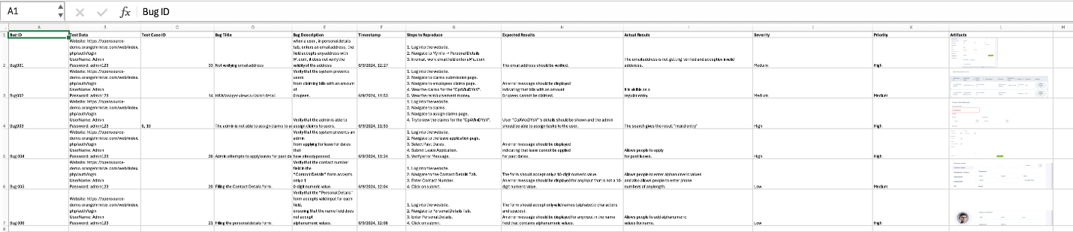

Created a Requirement Traceability Matrix for the same

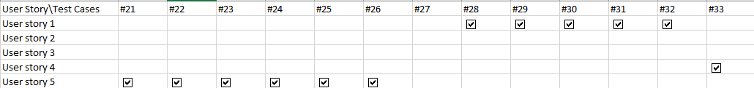

Created a Github repository
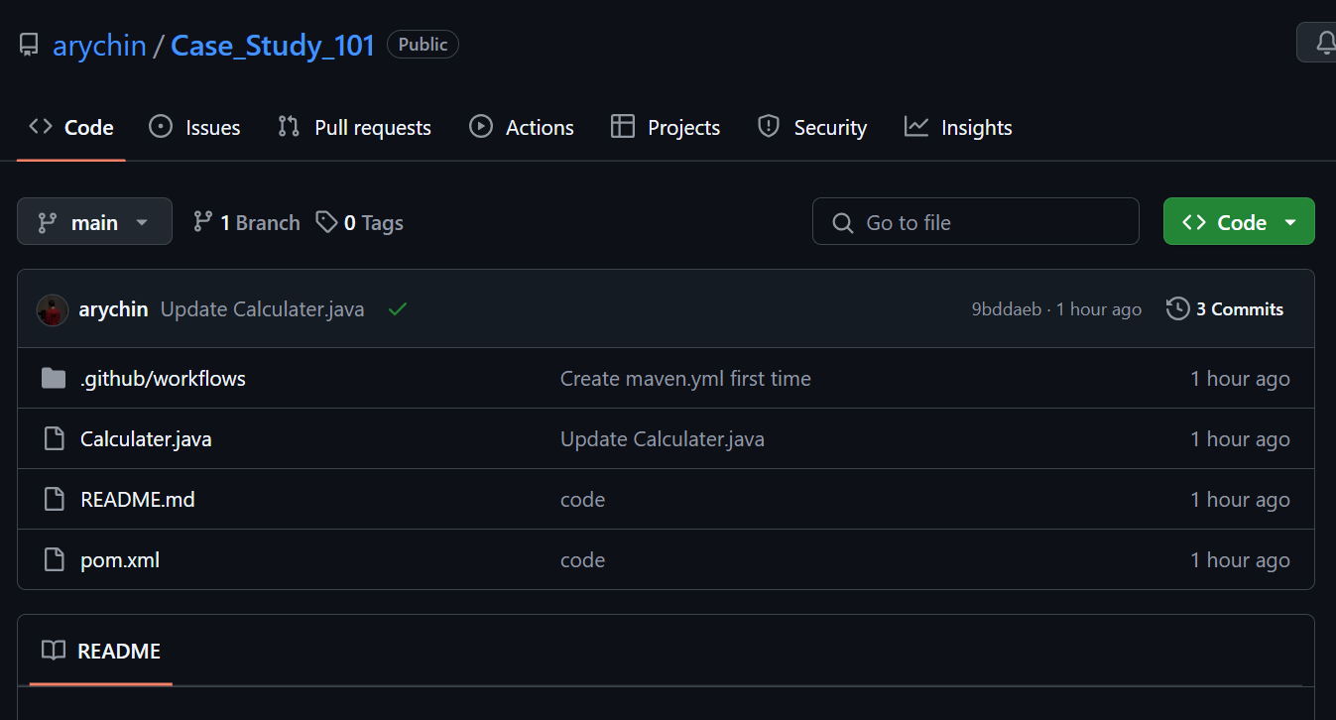

Created Github Workflow with Github Actions
~ CI/CD Pipeline
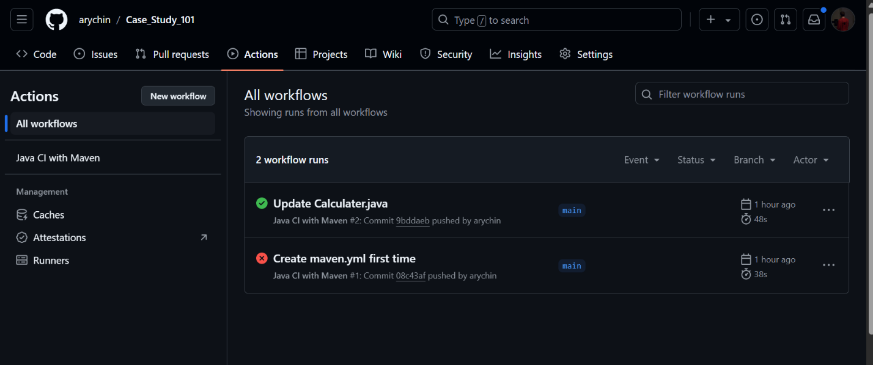

Coding Standards
