Final project CV-101
Font Recognition
This document will describe my work and thoughts during the project,
The first thing to do is to get a clear definition of the problem we are dealing with,

THE PROBLEM:

our problem is to recognize 5 different types of fonts in Images,
Hence the problem will be define as :
Given an image , set of words and for each word set of letters :
- for each letter match the correct font
I am assuming, for now that I am not interested in finding which letter is l_{i,}
And that each l_{i} belongs to one of 5 classes

More formally:

given an Image X_{n} a word W_{i}^{n} and a character c_{j} є W_{i}^{n:}
classify c_{j} to the right class f_{i} є F , where F is group of fonts types.

I am assuming and may use this assumptions later that:
- for each word all the characters belongs to the same font.
- All the fonts belong to pre-known group of fonts

THE DATA:

The data contain 998 different images with 7434 words ind total of 30520 characters

In this dataset there are 5 different types of font and they are:
Titillium Web , Alex Brush, Open Sans, Sansation, Ubuntu Mono

DATA SPLITS,

I will divide the data into three sub-splits

- Train data
- Validation data
- Test data

I can split the data in some different ways:
split by images, split by words, split by characters ,
every split got its own benefits and cons,

for instance divide by images get the benefit that words in the training and test set are nor sharing the same background so there is improvement is the generative of the model, but on the other hand the number of words in each image are not the same,

in general I would try to split the data in such way that the will be the most unified distribution as possible
The best same portion of images in each set as same font-ratio and same characters-ratio
If In the test set there will be big amount of one font or miss certain character it can lead to bias model.

So first I will plot the disterbution of the fonts:

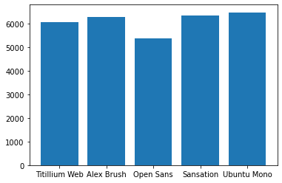

As we can see the all data is well disterbute by fonts, although Ubuntu Mono as 20 % more data then Open Sans , Point to keep in mind
I will try to keep this unified matter also in the test&val test set

I did some research on data and get the following conclusions:

I have 92 different types of characters with the follwing disterbution:
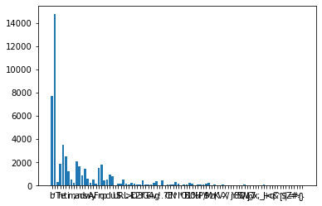

here we got a liitle problem:
There are 14,736 occurences of “ ‘ ” but only 1 occurrence of “ < ”
and if take a look only on letters the thing os not much nicer, there are 7712 occurences of “b”
but only 100 +- of “B” , “P” ,”E” and “H”

now this itself may not be such a problem because we don’t want to learn the characters, but its can lead to unstable model
other problem is that for instance for the charcter “!” there are 7 samples of Ubuntu Mono and only one of Open Sans
or there are 5 samples of “*” in font Open Sans and None in Titillium Web nor Sansation.

