diffloop: a computational framework for identifying and analyzing differential DNA loops from sequencing data
Caleb A. Lareau^{1,2,3} and Martin J. Aryee ^{1,2,3}*

1. Department of Biostatistics, Harvard T.H. Chan School of Public Health, 677 Huntington Ave. Boston, MA 02115. USA.
2. Department of Pathology, Massachusetts General Hospital, 55 Fruit St. Boston, MA 02114. USA.
3. Broad Institute of MIT and Harvard, 415 Main St, Cambridge, MA 02142. USA.

* Lead Contact / To whom correspondence should be addressed.
Tel: 617-643-4240. Fax: 617-726-5684. Email: aryee.martin@mgh.harvard.edu

GRAPHICAL ABSTRACT
HIGHLIGHTS
- diffloop identifies differential loops akin to differential genes from RNA-Seq data
- Functionality for loop quality control, annotation, and visualization
- diffloop is available as an open source package in the R/Bioconductor ecosystem
- Analysis of ENCODE POL2 ChIA-PET data reveal > 2,600 genome-wide differential loops

SUMMARY/ABSTRACT
The three-dimensional architecture of DNA within the nucleus is a key determinant of interactions between genes, regulatory elements, and transcriptional machinery. To systematically assess variance in DNA looping architecture between samples, we introduce diffloop, an R/Bioconductor package that provides a suite of functions for the quality control, statistical testing, annotation, and visualization of DNA loops. We demonstrate the functionality of this package by detecting differences in DNA loops between ENCODE ChIA-PET datasets and relate differential loops to broad epigenetic and transcriptomic differences that define the MCF-7 and K562 cell states.
MAIN TEXT
The organization of DNA within the nucleus into hierarchical three-dimensional (3D) structures plays a key role in regulating gene expression by determining the accessibility of genes to the transcriptional machinery as well as the proximity of genes to their distal regulatory elements. Differences in 3D architecture, such as the presence or absence of “loops” between specific enhancers and their target genes, are associated with transcriptional variation in both normal and disease states (Matharu and Ahituv, 2015). Intriguingly, several recent studies have implicated pathogenic alterations in genome topology with a diverse set of phenotypes including cancers and autoimmune diseases (Flavahan et al., 2016; Hnisz et al., 2016; Wang et al., 2013).

Recent experimental techniques that couple chromatin conformation capture (3C) (Dekker et al., 2002) with high-throughput sequencing have made the genome-wide identification of 3D interactions feasible. One such technique, Chromatin Interaction Analysis by Paired-End Tag Sequencing (ChIA-PET), uses chromatin immunoprecipitation to capture interactions mediated by specific structural, regulatory, or transcriptional machinery proteins and is especially suited for high-resolution identification of 3D interactions. In addition, the high-throughput chromosome conformation capture (Hi-C) assay, which yields a potentially complete map of DNA proximity, can also be used to identify DNA loops (Durand et al., 2016; Rao et al., 2014).

In order to fully explore the role that 3D genome organization plays in determining normal and pathogenic cell states, statistical tools are needed to identify differences in topology in a similar manner to which differential expression analysis is applied to transcriptional data. Additionally, the systematic integration of biological prior knowledge, such as the location of active enhancer regions, into topology analyses can provide annotation and insight into the regulatory role of a loop. Examples of loop annotation categories include enhancer-promoter (Matharu and Ahituv, 2015) and disrupted neighborhoods (Hnisz et al., 2016). Moreover, a computational framework that facilitates integration of other genomic data (e.g. DNA variation, RNA transcription, DNA and histone modification, etc.) in 3D genome analyses will help resolve the functional implication of DNA looping and relate these topological features to phenotypic variation.

To address these needs, we have developed diffloop, an R/Bioconductor (Huber et al., 2015) package that implements statistical testing for differential DNA looping between samples from ChIA-PET and other 3D assays. diffloop additionally provides functionality for quality control and visualization of differential DNA topological features and facilitates a platform for integrative analysis with other types of genomic data. To demonstrate the utility of diffloop, we compare differences in DNA topology between three cancer cell lines using RNA Polymerase II ChIA-PET data from the ENCODE project including five samples representing the MCF-7 breast cancer cell line (N=2), the K562 leukemia cell line (N=2) (Consortium, 2012). Supplemental Table 1 (A) provides an overview of these samples.

Across the union of our four samples considered for our analyses, we observed 87,456 anchor pairs (loops) involving 24,576 autosomal loci. As we wanted to exclude bias related to copy number variation (CNV) in these cancer genomes, we removed all interactions that were associated with anchors in known CNV regions in either of the MCF-7 or K562 cell lines. CNVs are known to affect chromatin interaction counts (Wu and Michor, 2016) and likely to bias differential looping analysis, especially in cancer genomes. In order to exclude such bias, we only considered interactions where neither anchor overlapped one of the nearly 500 CNV regions for either the MCF-7 or K562 cell lines (Consortium, 2012). Across all samples, we observed that over 9,000 of anchor regions overlapping a CNV region by at least 1 base and removed all loops involving at least one of these anchors, leading to 57,744 CNV-free loops in the K562 and MCF-7 samples.

We next filtered the observed interactions to retain only those that support valid loops suitable for differential analysis through a two-step process. First, we identified statistically significant loops by retaining only those anchor pairs whose interaction counts were significantly higher than that expected based on the background chromatin interaction frequency. diffloop combines counts across samples and assigns statistical significance to each putative loop using the method developed by Phanstiel et al. for the Mango ChIA-PET preprocessing pipeline (Phanstiel et al., 2015). We retained 23,935 loops in our combined K562 and MCF-7 samples that were significant at an FDR of 0.01 from the Mango model. Finally, we excluded anchor pairs not supported by at least two samples with two PETs each as proposed in other loop analyses (Ji et al., 2016), retaining 9,320 loops. Retaining loops with sufficiently high PET counts is analogous to filtering for genes that have a reasonable expression level in differential expression analyses (Love et al., 2014).

To identify differential loops between cell types, diffloop applies an analogous statistical test as implement in edgeR (Robinson et al., 2010) where counts are modeled using the negative binomial distribution and an empirical Bayes procedure is used to moderate the degree of overdispersion. The counts matrix, rather than representing reads mapped to genes or transcripts as is typical in an expression analysis, instead contains PETs (i.e. paired-end reads). We test for statistically significant differential loop strength (i.e PET count) between sample groups using the empirically derived variance. Analogous to differential expression analyes, the counts matrix is scaled according to the total depth of each sample using a size factor correction identical to that employed in DESeq2 (Love et al., 2014).

At an FDR of 1%, we identified 2,633 differential loops between the cell types, including 1,974 loops that were annotated as enhancer-promoter loops. Supplemental Table 2 summarizes the top 5 differential enhancer-promoter loops unique to each cell line. To characterize the topological differences more systematically, we identified pathways enriched for genes involved in differential enhancer-promoter looping. We assessed MsigDB hallmark gene sets (Subramanian et al., 2005) using a Wilcoxon rank sum test, which yielded nine pathways enriched (FDR q < 0.01) for genes with differential enhancer-promoter loops have existing evidence of relevance to the two cell types and cancers. Genes related to estrogen response such as GREB1 and XBP1 (Sengupta et al., 2010; Sun et al., 2007), for example, are linked by several strong loops to unique enhancers in the MCF-7 breast cancer cell line. Conversely, targets associated with c-MYC transcription factor, which plays a well-documented role in leukemia (Delgado and Leon, 2010), and heme metabolism were enriched in K562. These results suggest that differential topology analyses can systematically uncover known and novel regulatory loops related to disease and other phenotypes of interest.

Figure 1 shows two examples of regions with differential looping with corresponding tracks for the active enhancer mark, H3K27 acetylation (H3K27ac). Panel (A) shows a dynamic 3D landscape with many differential loops present more strongly in the K562 leukemia cell line than the MCF-7 breast cancer cell line. Most prominently, several unique enhancer-promoter loops (red) link the MTHFR promoter with nearby enhancers. Several of the enhancers are also linked by enhancer-enhancer loops (purple). Consistent with the increased looping the MTHFR gene is expressed at a higher level in the K562 (leukemia) cell line relative to MCF-7 (breast cancer) cell line (FDR = 2.95 x 10⁻¹¹). Notably, variants near this gene have been associated with increased risk for a variety of leukemias.(Moon et al., 2007; Rossen et al., 1985) Conversely, Panel (B) shows a more active three-dimensional regulatory system in the MCF-7 cell line near the NFKBIA gene, which has been linked to breast cancer (Curran et al., 2002) and is overexpressed in MCF-7 compared to K562 (FDR = 0.0211).

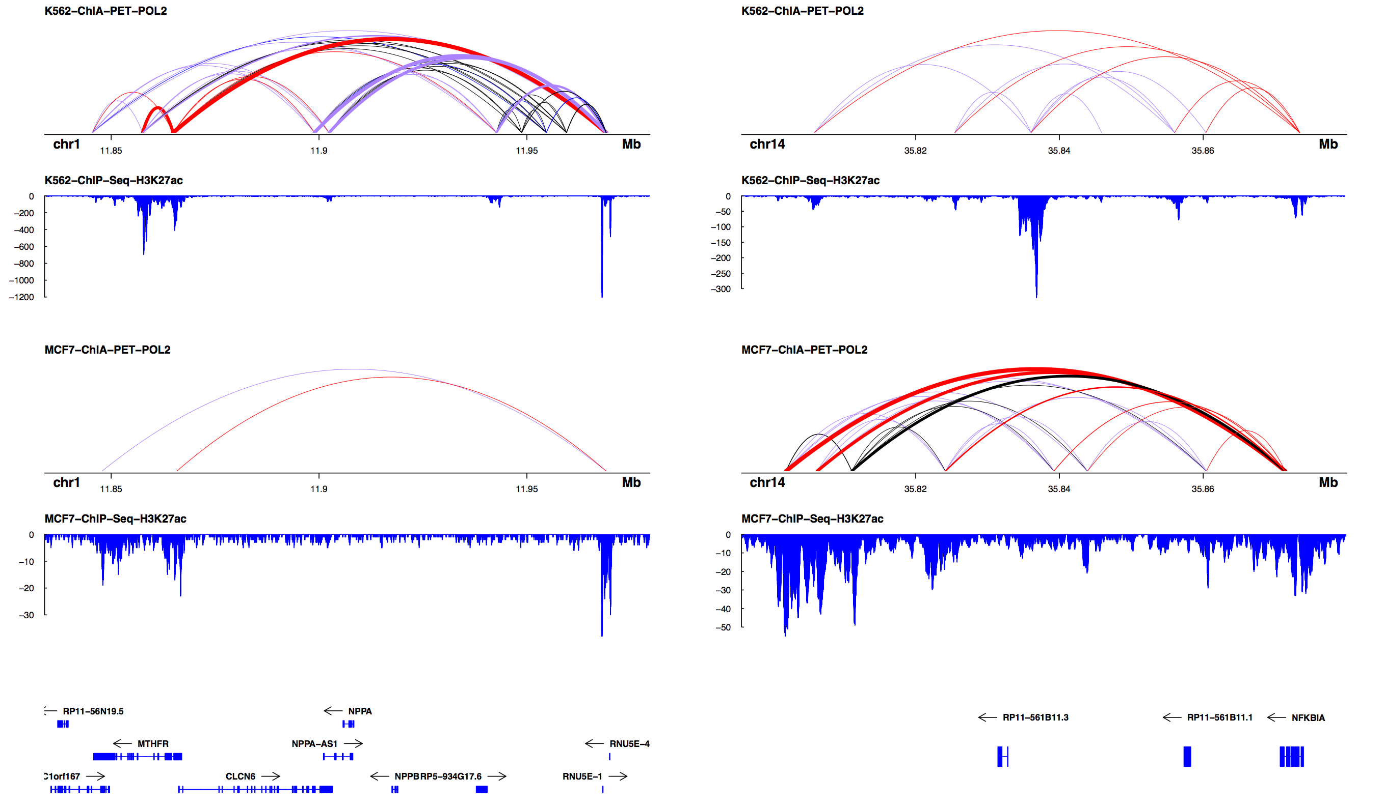

Figure 1: Sample visualizations of differential looping. Each panel shows the combined POL2 ChIA-PET replicates for the K562 and MCF-7 cell lines as well as the cell type-specific H3K27ac ChIP-Seq track. Line widths are indicative of the number of PETs supporting a loop while colors represent biological annotation (red: enhancer-promoter; purple: enhancer-enhancer; black: no special annotation). MTHFR (A) and NFKBIA (B) have variable topological and epigenetic landscapes between the two cell lines and have been implicated in leukemia and breast cancer, respectively.

From examining differential loops such as those displayed in Figure 1, we next sought to characterize the relationship between looping and transcription with a focus on the role of enhancer-promoter interactions. Figure 2 (A) summarizes differential expression in MCF-7 vs. K562 as a function of loop strength. The panel depicts that differences in enhancer-promoter loop strength between the cell types is strongly positively correlated with differences in gene expression level. Of the pairs of enhancer-promoter loops/transcripts where both the loop and gene expression were statistically significantly differential (FDR < 0.01; N = 230), 96.1% agreed in direction.

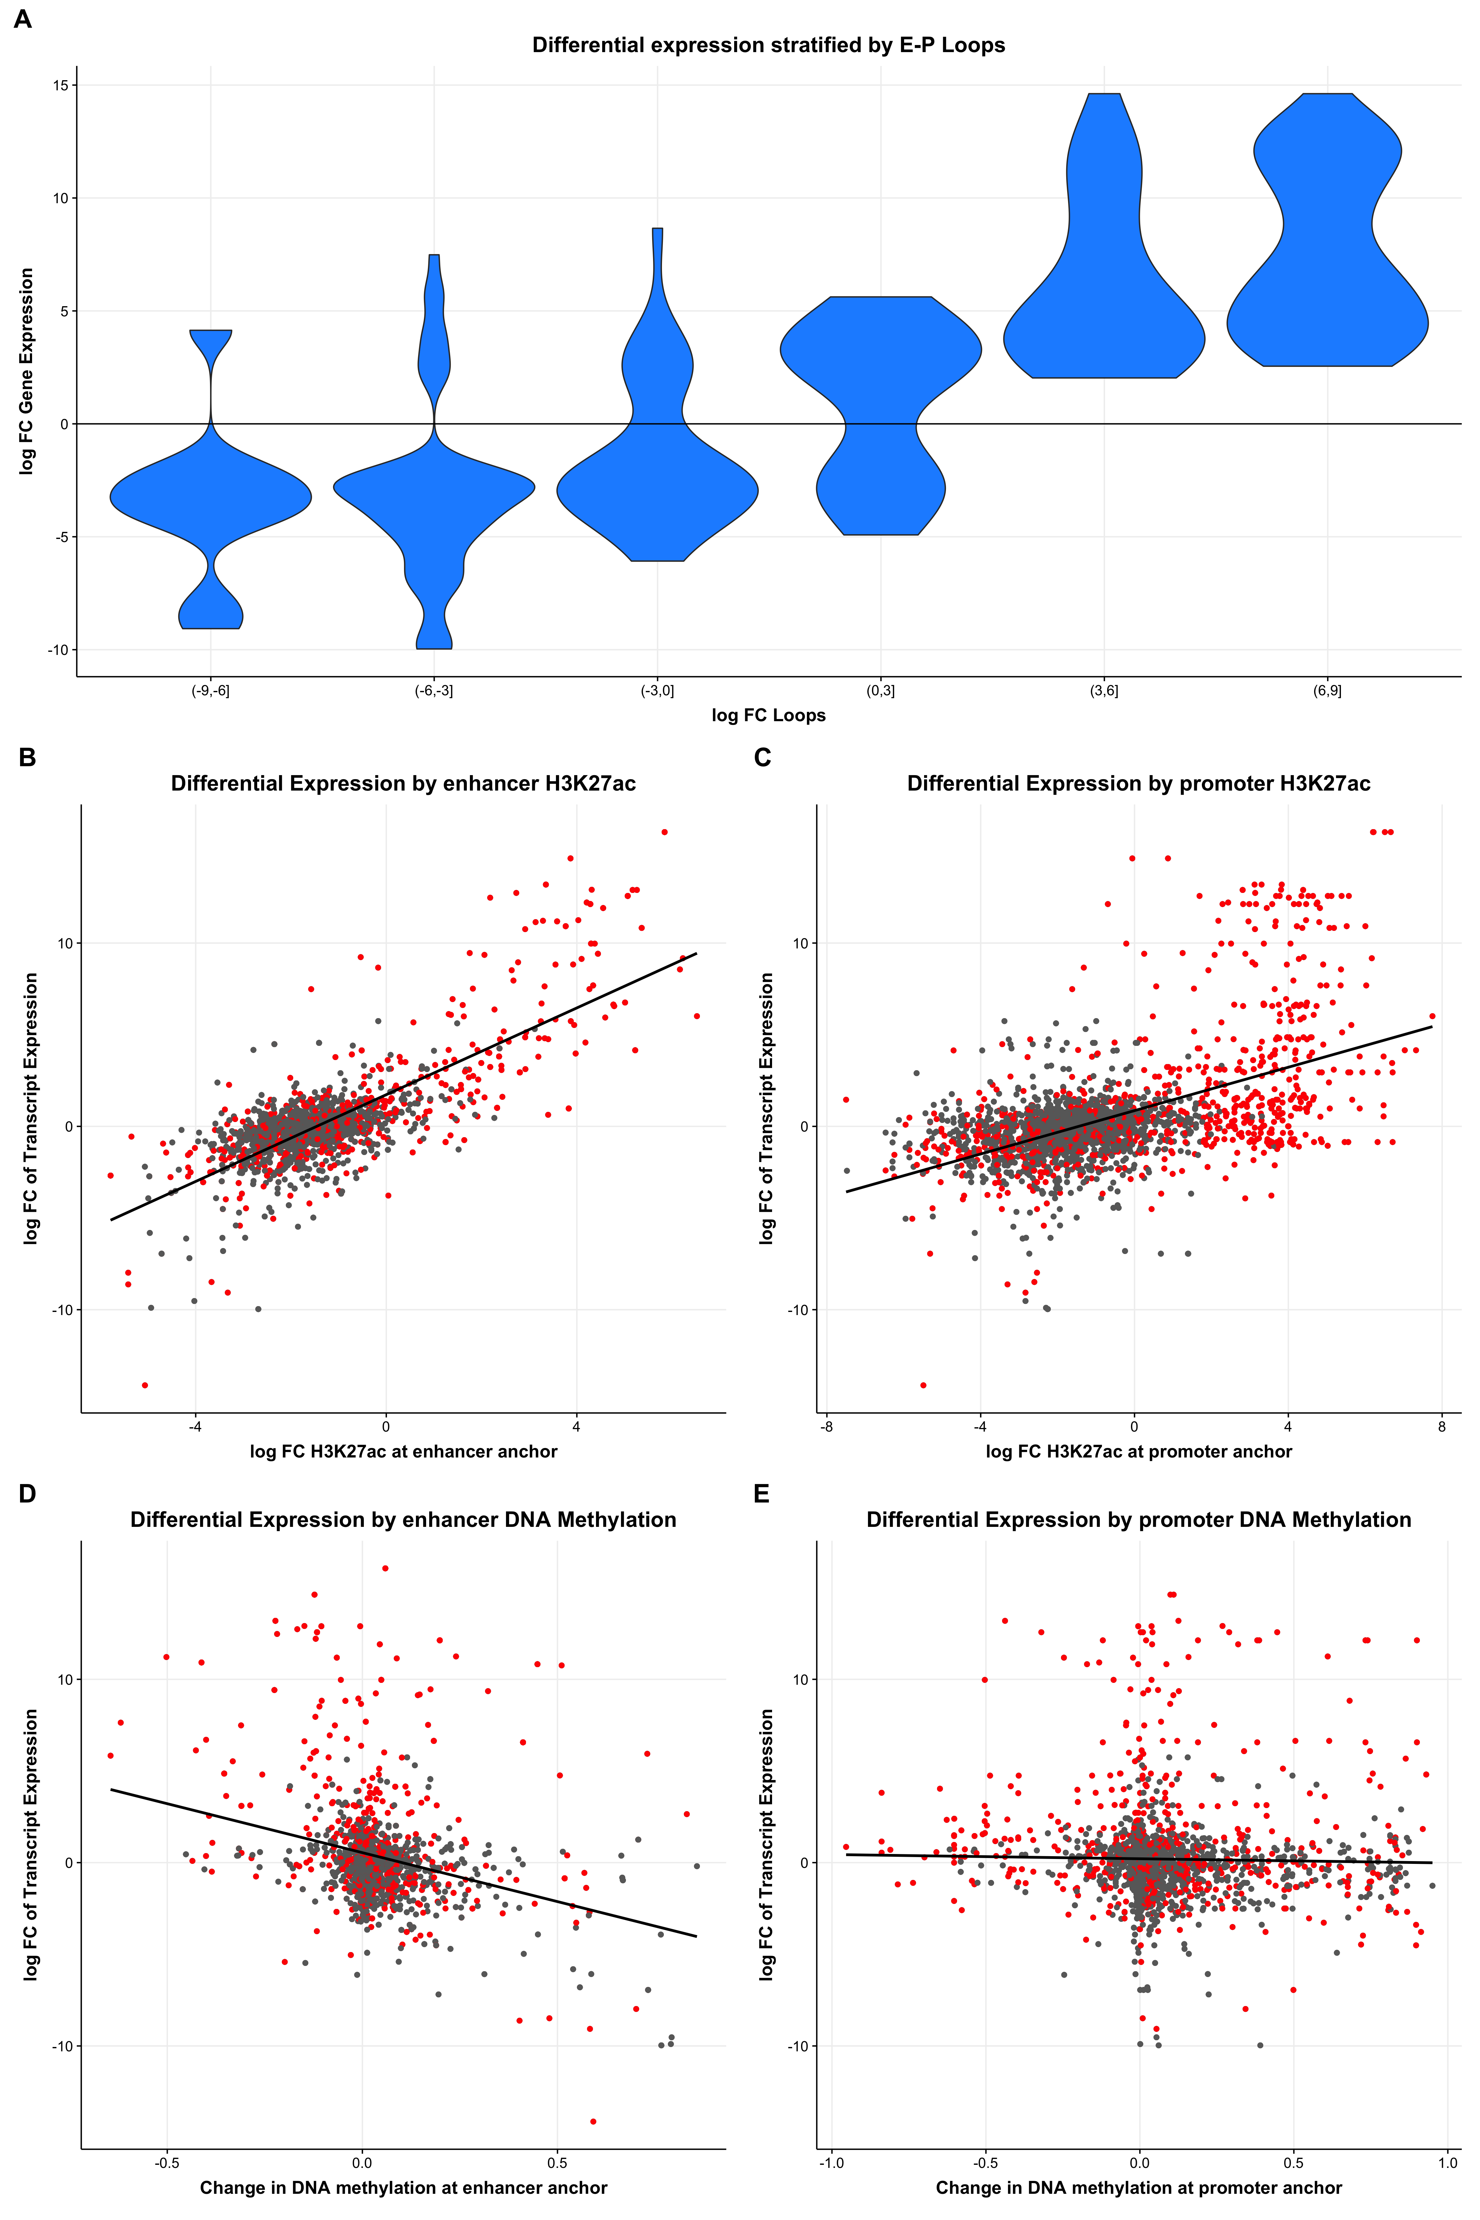

Figure 2: Effects of differential looping on transcription. (A) All loops that uniquely map to a single promoter region of differentially expressed transcript (FDR < 0.01). Increasing enhancer-promoter loop strength (loops logFC) is positively correlated with increased relative gene expression (RNA logFC). Next, we linked enhancer-promoter loops to their corresponding genes and assessed the effects of H3K27ac (B) distally and (C) proximal to the transcription start site. Similarly, the (D) distal and (E) proximal effects of DNA methylation were plotted against the expression fold-difference of the corresponding gene. Differential loops (FDR q < 0.01) are highlighted in red in panels (B) - (E).

As both H3K27 acetylation and DNA methylation are known to correlate with transcription (Bell et al., 2011), we sought to investigate whether these marks might play different roles at gene promoters vs. distal enhancers. Figure 2 shows that, as expected, both distal (B) and promoter (C) changes in H3K27ac are positively correlated with expression whereas both distal (D) and promoter (E) changes in DNA methylation were negatively correlated with expression. Interestingly, the effect of epigenetic alterations was far more pronounced at the distal enhancer region compared to the promoter region. In particular, we note that variation in distal DNA methylation had a stronger correlation with gene expression than variation at the promoter. We note that in Figure 2, differential loops (indicated in red) did not appear to deviate from the overall trend of epigenetic values at enhancers/promoters correlated with the transcriptional outcomes.

An estimated 40% of enhancer regions affect genes that are not the closest (in one-dimension) (Li et al., 2012) implying analysis of the spatial organization of the genome is vital to understanding what epigenetic modifications affect transcriptional processes. Moreover, characterizing the variable nature of the 3D genome is vital for mechanistically bridging epigenetic changes like histone modifications and DNA methylation to their transcriptional effects. While 3C-derived assays have provided a means to localize distal regulatory regions in the topological landscape to specific genes, statistically rigorous and computationally flexible tools are needed to fully characterize the 3D genome and assess topological changes. Our sample analyses of the POL2 ChIA-PET data suggest that topological variability occurs genome-wide, and our novel framework diffloop provides an appropriate statistical framework to elucidate differential features.

AVAILABILITY and ACCESSION NUMBERS
diffloop, is available from R/Bioconductor: https://bioconductor.org/packages/release/bioc/html/diffloop.html. This package requires R > = 3.3.0 and depends on several R/Bioconductor packages including GenomicRanges, rtracklayer, and ggplot2. Version 1.3.2 of diffloop was used for all analyses described in this manuscript. All data used in this study are made freely available through GEO at the accession numbers specified in the Materials and Methods section. Code to reproduce analyses, figures, and tables are available through Github: https://github.com/aryeelab/diffloop_paper/

SUPPLEMENTARY DATA
Supplementary File 1. Supplementary information regarding methods and functions used for the paper and analyses with diffloop.

FUNDING
This work was supported by the National Science Foundation [Graduate Research Fellowship #DGE1144152 to C.A.L.]. M.J.A. is supported by a Massachusetts General Hospital Department of Pathology startup fund. Funding for open access charge: Massachusetts General Hospital.

ACKNOWLEGEMENTS
We thank D.Day, D. Hnisz, and members of the R. Young Lab for their useful discussion and insight.
REFERENCES
Bell, J.T., Pai, A.A., Pickrell, J.K., Gaffney, D.J., Pique-Regi, R., Degner, J.F., Gilad, Y., and Pritchard, J.K. (2011). DNA methylation patterns associate with genetic and gene expression variation in HapMap cell lines. Genome Biol 12, R10.
Consortium, E.P. (2012). An integrated encyclopedia of DNA elements in the human genome. Nature 489, 57-74.
Curran, J.E., Weinstein, S.R., and Griffiths, L.R. (2002). Polymorphic variants of NFKB1 and its inhibitory protein NFKBIA, and their involvement in sporadic breast cancer. Cancer Lett 188, 103-107.
Dekker, J., Rippe, K., Dekker, M., and Kleckner, N. (2002). Capturing chromosome conformation. Science 295, 1306-1311.
Delgado, M.D., and Leon, J. (2010). Myc roles in hematopoiesis and leukemia. Genes Cancer 1, 605-616.
Durand, N.C., Robinson, J.T., Shamim, M.S., Machol, I., Mesirov, J.P., Lander, E.S., and Aiden, E.L. (2016). Juicebox Provides a Visualization System for Hi-C Contact Maps with Unlimited Zoom. Cell Syst 3, 99-101.
Flavahan, W.A., Drier, Y., Liau, B.B., Gillespie, S.M., Venteicher, A.S., Stemmer-Rachamimov, A.O., Suva, M.L., and Bernstein, B.E. (2016). Insulator dysfunction and oncogene activation in IDH mutant gliomas. Nature 529, 110-114.
Hnisz, D., Weintraub, A.S., Day, D.S., Valton, A.L., Bak, R.O., Li, C.H., Goldmann, J., Lajoie, B.R., Fan, Z.P., Sigova, A.A., et al. (2016). Activation of proto-oncogenes by disruption of chromosome neighborhoods. Science 351, 1454-1458.
Huber, W., Carey, V.J., Gentleman, R., Anders, S., Carlson, M., Carvalho, B.S., Bravo, H.C., Davis, S., Gatto, L., Girke, T., et al. (2015). Orchestrating high-throughput genomic analysis with Bioconductor. Nat Methods 12, 115-121.
Ji, X., Dadon, D.B., Powell, B.E., Fan, Z.P., Borges-Rivera, D., Shachar, S., Weintraub, A.S., Hnisz, D., Pegoraro, G., Lee, T.I., et al. (2016). 3D Chromosome Regulatory Landscape of Human Pluripotent Cells. Cell Stem Cell 18, 262-275.
Li, G., Ruan, X., Auerbach, R.K., Sandhu, K.S., Zheng, M., Wang, P., Poh, H.M., Goh, Y., Lim, J., Zhang, J., et al. (2012). Extensive promoter-centered chromatin interactions provide a topological basis for transcription regulation. Cell 148, 84-98.
Love, M.I., Huber, W., and Anders, S. (2014). Moderated estimation of fold change and dispersion for RNA-seq data with DESeq2. Genome Biol 15, 550.
Matharu, N., and Ahituv, N. (2015). Minor Loops in Major Folds: Enhancer-Promoter Looping, Chromatin Restructuring, and Their Association with Transcriptional Regulation and Disease. PLoS Genet 11, e1005640.
Moon, H.W., Kim, T.Y., Oh, B.R., Min, H.C., Cho, H.I., Bang, S.M., Lee, J.H., Yoon, S.S., and Lee, D.S. (2007). MTHFR 677CC/1298CC genotypes are highly associated with chronic myelogenous leukemia: a case-control study in Korea. Leuk Res 31, 1213-1217.
Phanstiel, D.H., Boyle, A.P., Heidari, N., and Snyder, M.P. (2015). Mango: a bias-correcting ChIA-PET analysis pipeline. Bioinformatics 31, 3092-3098.
Rao, S.S., Huntley, M.H., Durand, N.C., Stamenova, E.K., Bochkov, I.D., Robinson, J.T., Sanborn, A.L., Machol, I., Omer, A.D., Lander, E.S., et al. (2014). A 3D map of the human genome at kilobase resolution reveals principles of chromatin looping. Cell 159, 1665-1680.
Robinson, M.D., McCarthy, D.J., and Smyth, G.K. (2010). edgeR: a Bioconductor package for differential expression analysis of digital gene expression data. Bioinformatics 26, 139-140.
Rossen, R.D., Laughter, A.H., Orson, F.M., Flagge, F.P., Cashaw, J.L., and Sumaya, C.V. (1985). Human peripheral blood monocytes release a 30,000 dalton factor (30 KD MF) that stimulates immunoglobulin production by activated B cells. J Immunol 135, 3289-3297.
Sengupta, S., Sharma, C.G., and Jordan, V.C. (2010). Estrogen regulation of X-box binding protein-1 and its role in estrogen induced growth of breast and endometrial cancer cells. Horm Mol Biol Clin Investig 2, 235-243.
Subramanian, A., Tamayo, P., Mootha, V.K., Mukherjee, S., Ebert, B.L., Gillette, M.A., Paulovich, A., Pomeroy, S.L., Golub, T.R., Lander, E.S., et al. (2005). Gene set enrichment analysis: a knowledge-based approach for interpreting genome-wide expression profiles. Proc Natl Acad Sci U S A 102, 15545-15550.
Sun, J., Nawaz, Z., and Slingerland, J.M. (2007). Long-range activation of GREB1 by estrogen receptor via three distal consensus estrogen-responsive elements in breast cancer cells. Mol Endocrinol 21, 2651-2662.
Wang, S., Wen, F., Wiley, G.B., Kinter, M.T., and Gaffney, P.M. (2013). An enhancer element harboring variants associated with systemic lupus erythematosus engages the TNFAIP3 promoter to influence A20 expression. PLoS Genet 9, e1003750.
Wu, H.J., and Michor, F. (2016). A computational strategy to adjust for copy number in tumor Hi-C data. Bioinformatics.

