**Supplemental Experimental Procedures for *diffloop***

**ENCODE ChIA-PET Data**

All ChIA-PET data in this study was generated as part of the ENCODE Project and downloaded from the Sequence Read Archive (SRA)(Consortium, 2012). The format of raw ChIA-PET data is .fastq files that correspond to paired-end reads from a sequencing experiment. For our preprocessing, we used the default parameters in Mango (Phanstiel et al., 2015) except for specifying that all interactions be preserved (reportallpairs = TRUE) and ChIP peaks be extended by 1,000 base pairs (peakslop = 1000) rather than the default 500 bp. Additionally, we specified linker sequences previously described in the ENCODE ChIA-PET protocol, (Consortium, 2012) which also correspond to the default parameters in Mango. **Table 1** provides an overview of the ChIA-PET samples used in this study, including the raw read counts, the location of the data on GEO, as well as the number of PETs used in *diffloop* after data processing with Mango.

**Quality Control in diffloop**

We filtered amplified or deleted copy number variation (CNV) regions in either of K562 or MCF-7 using the **removeRegion()** function to reduce the chance that genome alterations would bias differential loop calls. We next retained only those loops whose interaction counts were significantly higher than that expected based on the background chromatin interaction frequency using a threshold of 0.01 on q-values generated by the **mangoCorrection()** function. *diffloop* aggregates count data across all samples, providing more power to call valid loops than analyzing each sample individually. In order to further reduce the multiple testing burden, we further restricted loops to those with a minimum of 2 samples with at least 2 PETs per loop (similar as to what was used previously (Ji et al., 2016)) using the **filterLoops()** function. The low counts associated with the discarded loops would preclude meaningful inference about between group differences.

One peculiar feature of the data was the presence of “discordant” loops that were highly variable between the replicates. Setting a threshold of five or more counts in one replicate but zero in the other identified 337 such loops. Some of these discordant loops appear significantly differential as a result of the variance shrinkage performed in the association model. For example, while a loop with counts of 45 and 0 for one group and 0 and 0 for another is classified as differential, this finding is unlikely to be reliable. Many (166 of 337 or 49%) of these identified discordant loops (such as the example noted above) were removed using the **filterLoops()** function since they don’t meet the criterion of being present in 2+ samples.

**Differential Expression Analyses**

Paired 75 base pair reads from PolyA RNA-Seq for each of the K562 and MCF-7 cell lines from the ENCODE Project were processed (GEO series GSE33480). These data included two samples for K562 (GSM958729) and three samples for MCF-7 (GSM958745). An additional replicate was processed for K562 (GSM646524) for a balanced differential expression analysis. Each samples’ reads were individually aligned using Tophat v1.0.14 (Trapnell et al., 2009) and hg19 RefSeq reference transcriptome counts were generated using HTSeq 0.6.1.(Anders et al., 2015) Differential expression was performed using DESeq2 v1.11.45 (Love et al., 2014) to determine variable gene expression between the two cancer cell lines. Enhancer-promoter loops that uniquely linked to a single transcription start site were annotated with the summary statistics from DESeq2 using the **annotateLoops.dge()** function. While this function has additional parameters to handle loops that do not clearly link to a single transcription start site, all analyses including transcription annotation retained only enhancer-promoter loops where the “promoter” anchor mapped to within 1kb of a single transcription start site in the hg19 Refseq build.

**Integration of DNA Methylation and ChIP-Seq Data**

*diffloop* provides means for integration of processed epigenetic data as shown in **Figure 2.** To demonstrate this functionality, raw probe intensities from the Illumina 450k array were processed using minfi v1.3.1(Aryee et al., 2014) and exported as .bedgraph format files for both the K562 and MCF-7 cell lines. Per-anchor methylation was computed by averaging the Beta methylation estimates across all CpGs contained in the specific anchor using the **annotateAnchors.bed()** function. Bigwigs H3K27ac were downloaded from GEO accessions as specified in **Supplemental Table 1.** Similar to the methylation values, per-anchor intensities for the ChIP-Seq and chromatin accessibility were computed by averaging over all values contained in the specific anchor using the **annotateAnchors.bigwig()** function.

**Visualization**

Within the *diffloop* package infrastructure, several functions related to the **loopPlot()** function call enable the visualization of differential loops for selected samples. For the specific plots shown in **Figure 2** that also show epigenetic tracks (i.e. H3K27ac), we visualize these samples using a shiny app available at dnalandscaper.aryeelab.org. On this site, a detailed explanation of how one can visualize their own looping samples in the browser is available in the “Guide” page.

**Gene set enrichment**

Using the full set of loops that were examined in differential testing, we assessed MsigDB hallmark gene sets (Subramanian et al., 2005) using a Wilcoxon rank sum test, which yieldednine pathways enriched (FDR q < 0.1) for genes with differential enhancer-promoter loops have existing evidence of relevance to the two cell types and cancers. For loops stronger in MCF7, four pathways were significantly enriched with the following FDR q-values: ESTROGEN_RESPONSE_EARLY (q = 7.05E-09), TNFA_SIGNALING_VIA_NFKB (q = 4.97E-06), P53_PATHWAY (0.019), ESTROGEN_RESPONSE_LATE (q = 0.022). For loops stronger in K562, the following pathways were significantly enriched: MYC_TARGETS_V1 (q = 0.00017), E2F_TARGETS (q = 0.00017), G2M_CHECKPOINT (q = 0.00017), REACTIVE_OXIGEN_SPECIES_PATHWAY (q = 0.0089), HEME_METABOLISM (q = 0.087). These results suggest that variable looping affects pathways genome-wide that are in part responsible for variation in cellular phenotypes.

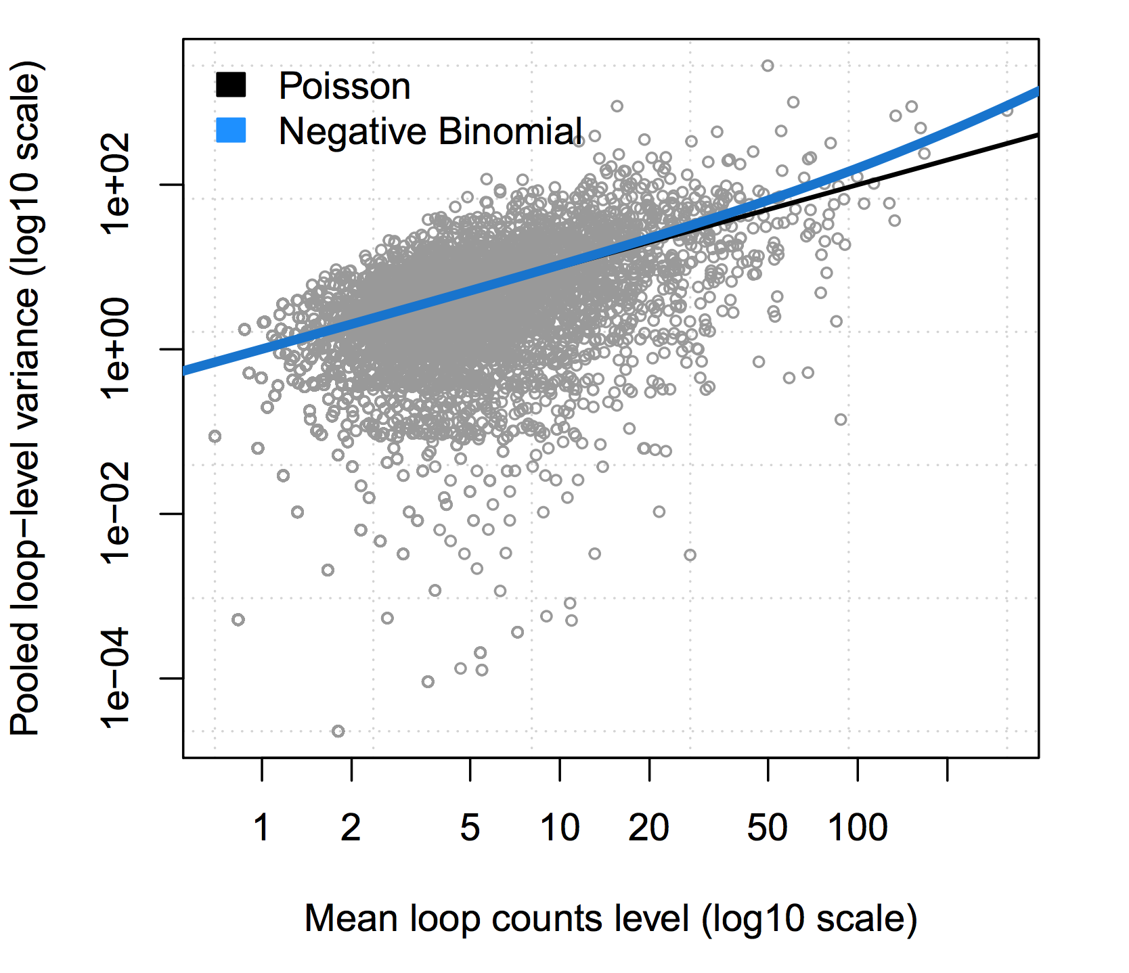

**Figure S1.** While the Negative Binomial line does not significantly deviate from the Poisson line for the loop counts data considered here, we note a similar pattern in RNA-Seq data for low counts in the displayed range while the variance deviates more significantly from the mean at larger count values. We expect that similar behavior will be observed at higher ChIA-PET counts and therefore implemented the negative binomial as the default model in diffloop.

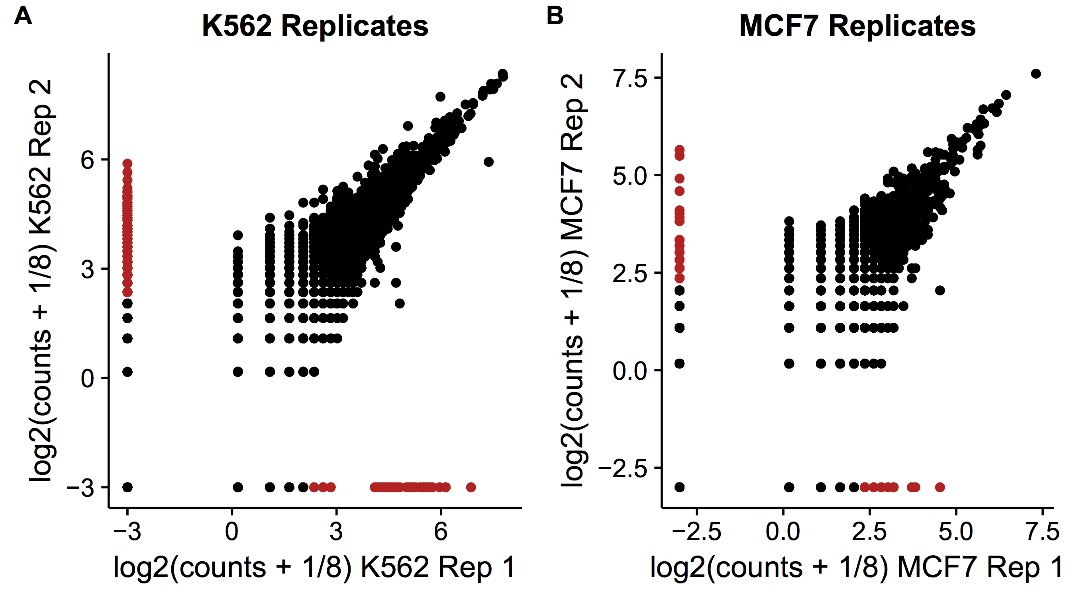

**Figure S2.** The concordance between the (A) K562 and (B) MCF-7 replicates is shown where the 337 loops marked in red between the two samples identified after Mango bias correction. These loops each had one replicate with 0 PET counts and the other replicate with 5 or more counts. As 337 of these loops were present after our initial filtering steps of preprocessing by removing CNV regions and biased loops using the Mango correction, these were a feature of our dataset when performing the principal component analyses. However, 166 of the 337 were filtered when restricting loops such that 2 samples had at least 2 PETs supporting the loop. While some of these ”discordant” loops appear in downstream association analyses, using the **filterLoops()** function can minimize these features from appearing in downstream analyses.

|  |  |  |
| --- | --- | --- |
| **GEO Sources of ENCODE Epigenetic and RNA-Seq Data used in Integrative Analyses** | | |
| **Data Type** | **K562** | **MCF-7** |
| 450k Methylation Arrays | GSM999341 | GSM999373 |
| CNV Regions | GSM999287 | GSM999333 |
| DNase BigWig | GSM736629 | GSM736581 |
| H3K27ac BigWig | GSM733656 | GSM945854 |
| H3K27ac Peaks | GSM733656 | GSM946850 |
| RAD21 BigWig | GSM803447 | GSM1010791 |
| RNA-Seq Data | GSM646524,GSM958729 | GSM958745 |

**Supplemental Table S1**: Published data used in this manuscript for sample analysis with *diffloop*. (A) Accession of GEO sequencing reads for each of the ChIA-PET samples with summary statistics. (B) Accessions of the epigenetic, genetic, and transcriptomic data used for downstream analyses in *diffloop*.

|  |  |  |  |  |  |  |  |  |  |
| --- | --- | --- | --- | --- | --- | --- | --- | --- | --- |
| **Region** | **k562_r1** | **k562_r2** | **mcf7_r1** | **mcf7_r2** | **Width** | **logFC** | **PValue** | **FDR** | **Promoter Gene(s)** |
| chr6:26193587-26208554 | 169 | 242 | 0 | 0 | 8724 | -10.23 | 2.03E-50 | 1.30E-47 | HIST1H3D, HIST1H2AD, HIST1H2BF, HIST1H4E |
| chr17:56403949-56417755 | 155 | 213 | 0 | 0 | 8477 | -10.07 | 1.58E-46 | 7.20E-44 | BZRAP1 |
| chr6:74221945-74234813 | 127 | 190 | 0 | 0 | 6750 | -9.85 | 1.88E-41 | 6.91E-39 | EEF1A1 |
| chr7:100024885-100035440 | 91 | 133 | 0 | 0 | 6621 | -9.35 | 1.12E-31 | 2.28E-29 | ZCWPW1, MEPCE, PPP1R35 |
| chr2:85763824-85776025 | 75 | 125 | 0 | 0 | 7324 | -9.18 | 7.70E-29 | 1.31E-26 | MAT2A |
| chr12:52582290-52599042 | 0 | 0 | 55 | 103 | 11460 | 9.97 | 2.14E-64 | 2.05E-61 | KRT80 |
| chr14:38051267-38066780 | 0 | 0 | 62 | 87 | 11045 | 9.90 | 8.59E-62 | 7.47E-59 | TTC6 |
| chr3:161087371-161126836 | 0 | 0 | 49 | 68 | 35464 | 9.55 | 4.61E-51 | 3.39E-48 | SPTSSB |
| chr17:39676448-39706653 | 0 | 0 | 40 | 74 | 22387 | 9.50 | 7.60E-50 | 4.55E-47 | KRT15, KRT19 |
| chr20:45984705-46003273 | 0 | 0 | 52 | 56 | 11916 | 9.44 | 5.29E-48 | 2.66E-45 | ZMYND8 |

**Supplemental Table S2**: Top differential loops between MCF-7 and K562. The 5 most significant differential enhancer-promoter loops between these two cell types both more prevalent in MCF-7 and more prevalent in K562 are displayed. The region specified spans the anchors per loop. Annotation is listed alongside the summary statistics of each loop, which includes the number of reads that support each loop per sample. The final column lists all the genes of all promoter regions within 1kb of the loop anchor. The strongest shown in this table represent binary chromatin states between the two cell lines.

**REFERENCES**

Anders, S., Pyl, P.T., and Huber, W. (2015). HTSeq--a Python framework to work with high-throughput sequencing data. Bioinformatics *31*, 166-169.

Aryee, M.J., Jaffe, A.E., Corrada-Bravo, H., Ladd-Acosta, C., Feinberg, A.P., Hansen, K.D., and Irizarry, R.A. (2014). Minfi: a flexible and comprehensive Bioconductor package for the analysis of Infinium DNA methylation microarrays. Bioinformatics *30*, 1363-1369.

Consortium, E.P. (2012). An integrated encyclopedia of DNA elements in the human genome. Nature *489*, 57-74.

Ji, X., Dadon, D.B., Powell, B.E., Fan, Z.P., Borges-Rivera, D., Shachar, S., Weintraub, A.S., Hnisz, D., Pegoraro, G., Lee, T.I.*, et al.* (2016). 3D Chromosome Regulatory Landscape of Human Pluripotent Cells. Cell Stem Cell *18*, 262-275.

Love, M.I., Huber, W., and Anders, S. (2014). Moderated estimation of fold change and dispersion for RNA-seq data with DESeq2. Genome Biol *15*, 550.

Phanstiel, D.H., Boyle, A.P., Heidari, N., and Snyder, M.P. (2015). Mango: a bias-correcting ChIA-PET analysis pipeline. Bioinformatics *31*, 3092-3098.

Subramanian, A., Tamayo, P., Mootha, V.K., Mukherjee, S., Ebert, B.L., Gillette, M.A., Paulovich, A., Pomeroy, S.L., Golub, T.R., Lander, E.S.*, et al.* (2005). Gene set enrichment analysis: a knowledge-based approach for interpreting genome-wide expression profiles. Proc Natl Acad Sci U S A *102*, 15545-15550.

Trapnell, C., Pachter, L., and Salzberg, S.L. (2009). TopHat: discovering splice junctions with RNA-Seq. Bioinformatics *25*, 1105-1111.