FAQ

How do I submit a “Database Access Request” (for Oracle, SQL, TBDP, MYSQL, Postgress, DB2, EIG App support, VDW, MDW, FDW, NDW, TOMS, VROR, Cloud (Azure, AWS)?

Direct Link to 1TS –
Step 1:
Please click the direct link to open Data Access Request or copy/paste the link into your browser if the link does not open directly.
https://tmna.service-now.com/1ts/?id=1ts_sc_category&sys_id=1ae1294d1b440c1400802f876e4bcbe9&catalog_id=99b029851b440c1400802f876e4bcb96&index=4&layer=1&hsc=false#catModal
Or

You can also access the form through the Data Enablement site. Click on “Access Request Form” at the top of the site.
Data Enablement and Global Compliance Link:
DE Microsite (toyota.com)
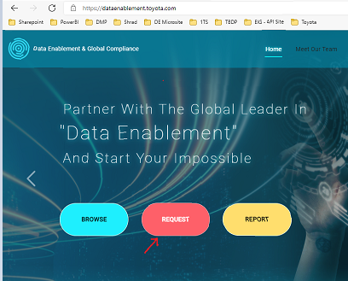

Or

If you still face any issues in opening the direct link, please go through 1TS
Toyota service link -
https://tmna.service-now.com/1ts/?id=1tslanding

New Request → Enterprise → Data Management

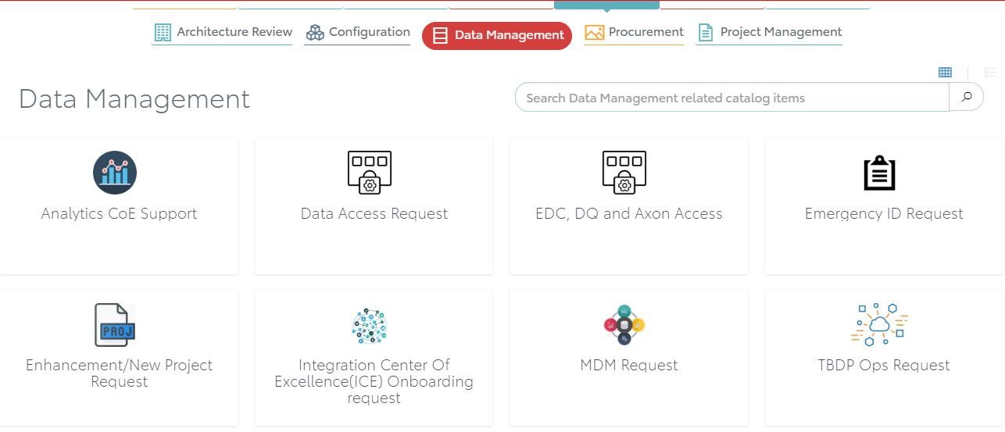

Step 1:
Select the “Data Access Request” option.
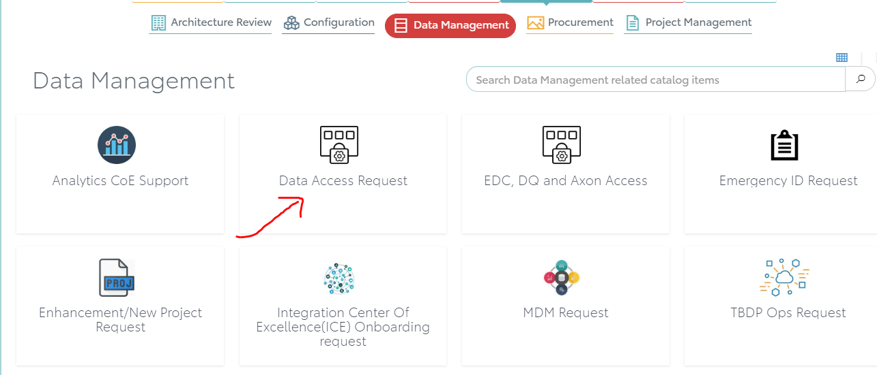

Step 2:

Once you select the “Data Access Request” form, you will be redirected to Data marketplace homepage. Search what you are looking for in the search window at the top. If you find what you are looking for then “Add to cart”, “Proceed to checkout” and “Submit Order”
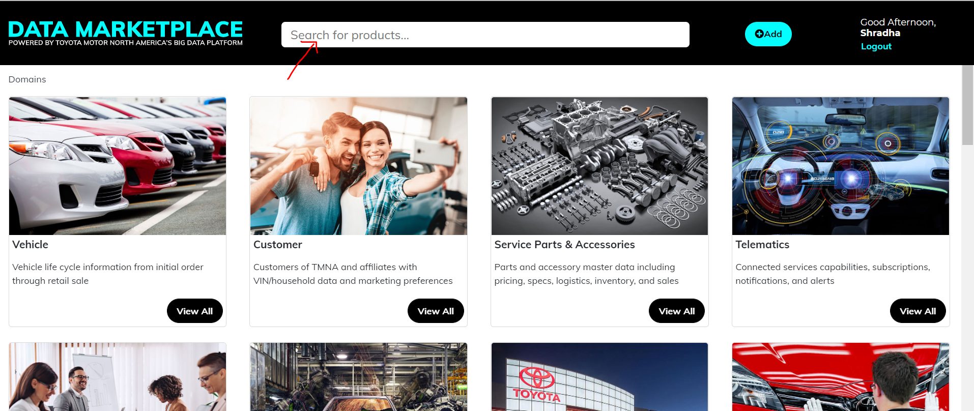

Step 3:
If you don’t find what you are looking for then a message will show up- “Can’t find what you are looking for? Click Here” Click to go to the Data Access Request form.

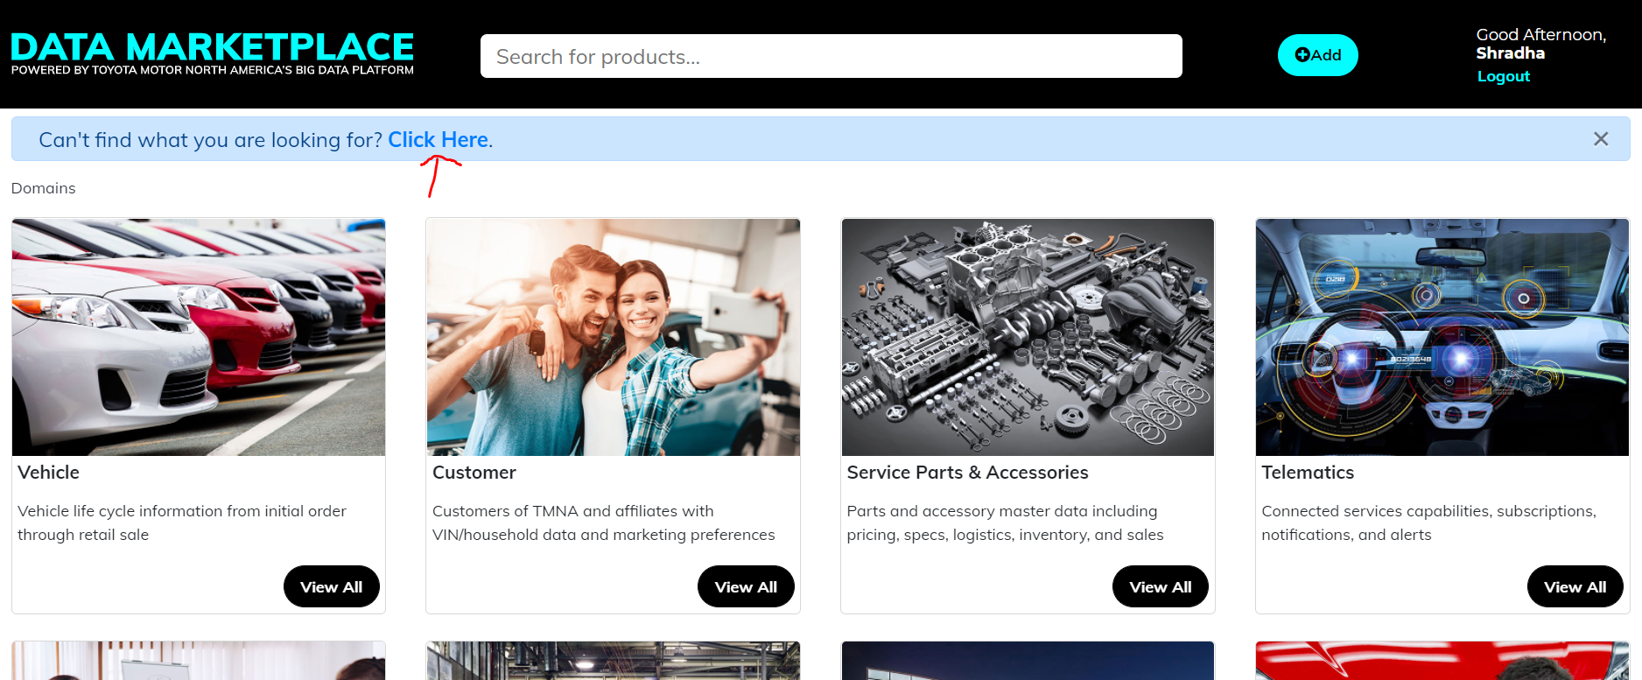

If you don’t get the message, you could also scroll down to the bottom of the page to go to “Data Access Request” form.

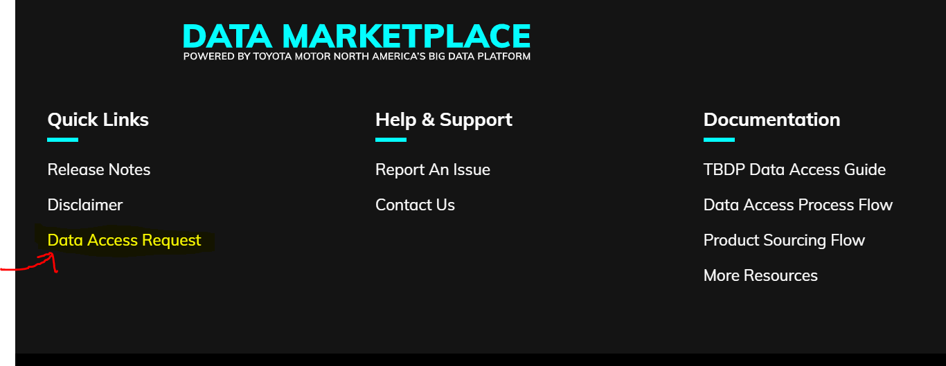

Please complete all the mandatory fields (identified with *) on the form.
Click on the “Data Domain help document” link to know which domain to select for the request.

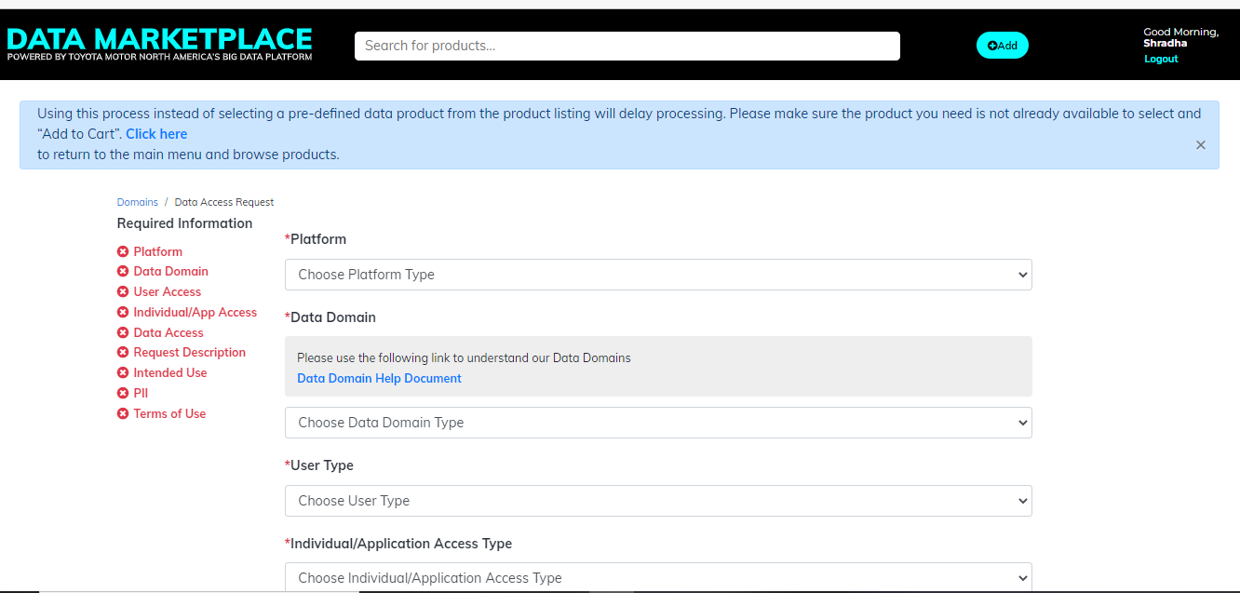

Step 4:
Answer the below question as “Yes” if you are requesting access to any customer information.
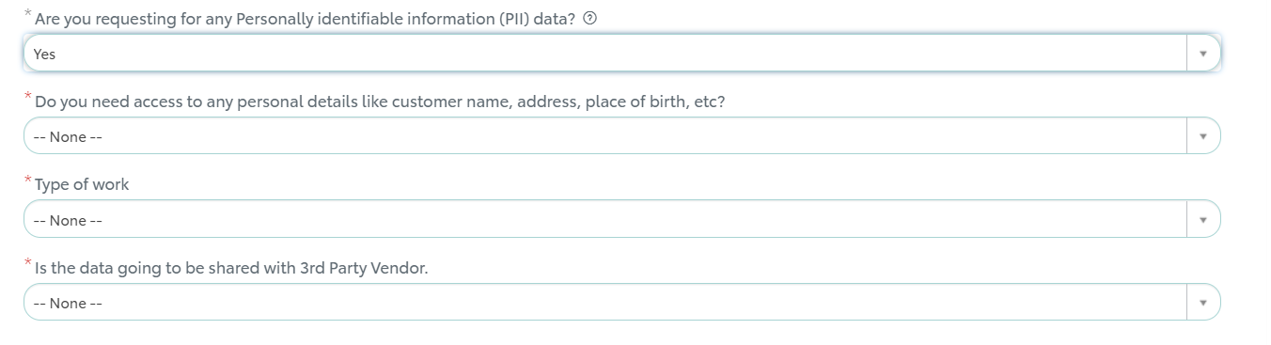

Step 5:
Click check mark on “I have read and accepted the Terms of Use” and Click “Submit Order”.
Once submitted RITM ticket number will be generated.
You should get an email with the request details.

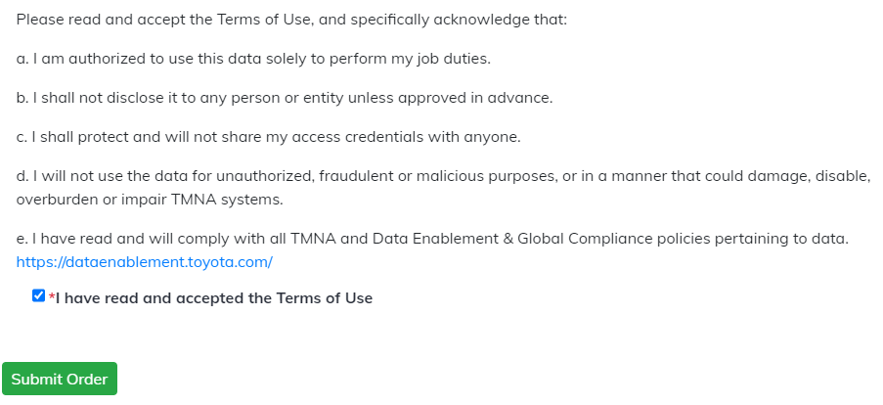
Congratulations you have completed the request submission. Thank You.
You can also check out the status of your submitted request through 1TS (One Toyota Service).

How do I submit a “Gateway Access Request” (for PowerBI, Tableau, Alteryx)?

Direct Link to 1TS –
Step 1:
Please click the direct link to open Data Access Request or copy/paste the link into your browser if the link does not open directly.
https://tmna.service-now.com/1ts/?id=1ts_sc_category&sys_id=1ae1294d1b440c1400802f876e4bcbe9&catalog_id=99b029851b440c1400802f876e4bcb96&index=4&layer=1&hsc=false#catModal
Or

You can also access the form through the Data Enablement and Global Compliance site. Click on “Access Request Form” at the top of the site.
Data Enablement and Global Compliance Link:
https://dataenablement.toyota.com/


Or

If you still face any issues in opening the direct link, please go through 1TS
Toyota service link -
https://tmna.service-now.com/1ts/?id=1tslanding

New Request → Enterprise → Data Management

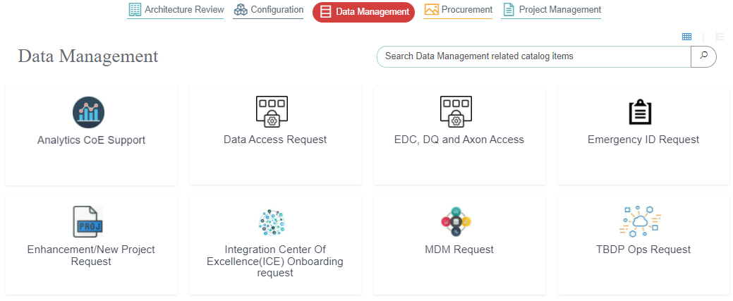

Step 1:
Select the “Data Access Request” option.

Once you select the “Data Access Request” form, you will be redirected to Data marketplace. For Gateway access you will have to select platform as “Gateway Access Request (PowerBI, Tableau, Alteryx, etc)” in the Data Access Request form.


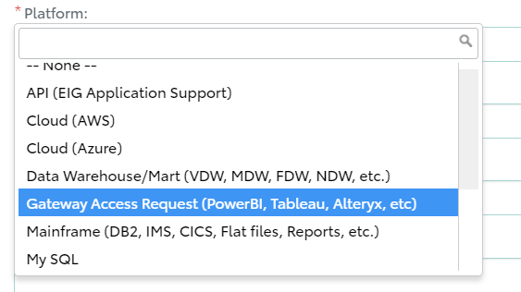

Step 2: Click here to see the next steps

How do I submit a “Enhancement/New Project” Request (for TBDP Onboarding, EDC, DQ, Data Extract, Warehouse Enhancement, Analytics, Data Science, Data Security Setup, etc.)?

Direct Link to 1TS –
Step 1:
Please click the direct link to open Data Access Request or copy/paste the link into your browser if the link does not open directly.
https://tmna.service-now.com/1ts/?id=1ts_sc_category&sys_id=1ae1294d1b440c1400802f876e4bcbe9&catalog_id=99b029851b440c1400802f876e4bcb96&index=4&layer=1&hsc=false#catModal
Or

You can also access the form through the Data Enablement and Global Compliance site. Click on “Access Request Form” at the top of the site.
Data Enablement and Global Compliance Link:
https://dataenablement.toyota.com/


Or

If you still face any issues in opening the direct link, please go through 1TS
Toyota service link -
https://tmna.service-now.com/1ts/?id=1tslanding

New Request → Enterprise → Data Management



Step 1:
You should see below New Project / Enhancement Request Form.
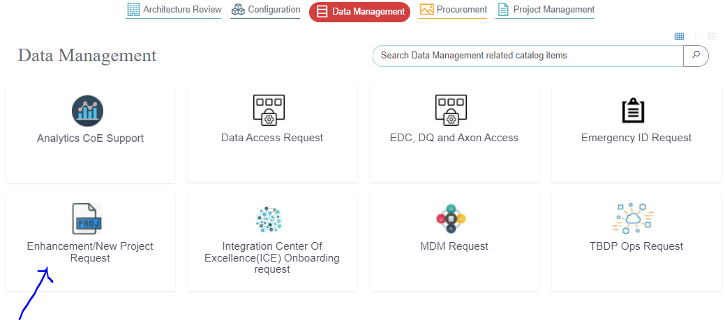
Step 2:
Please select the appropriate project category from the drop-down list.
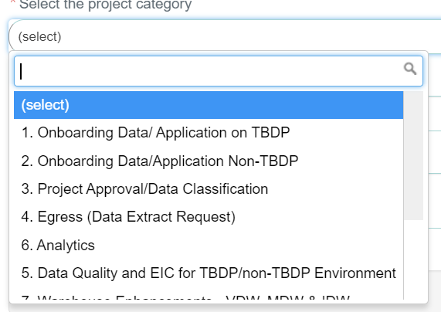
Step 3:
Add a project title and detailed description for your request
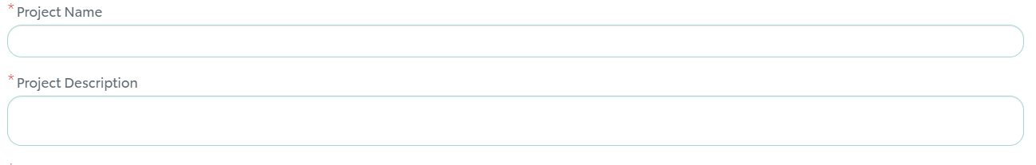
Step 4:
Select one domain as appropriate to your project.
We have added help document for Data Domain selection, please click on the “?” symbol to learn more about it.
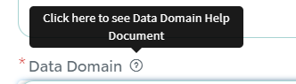
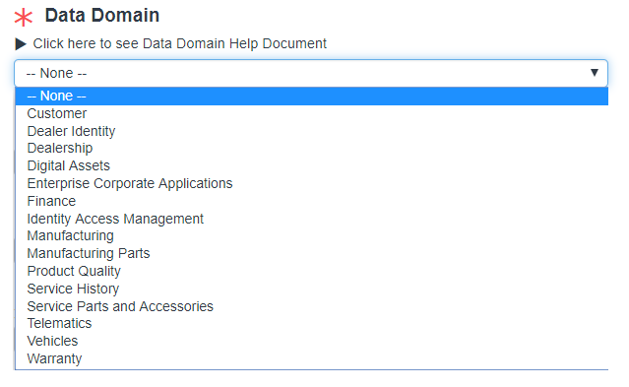
Step 5:
Project ID and Department ID are optional fields. However, the project request might require funding and if your request has funding available it is better to provide this information now.
Add applicable attachments and Business Justification (why the Project/Enhancement is needed).
Once information is filled in click “Next”.

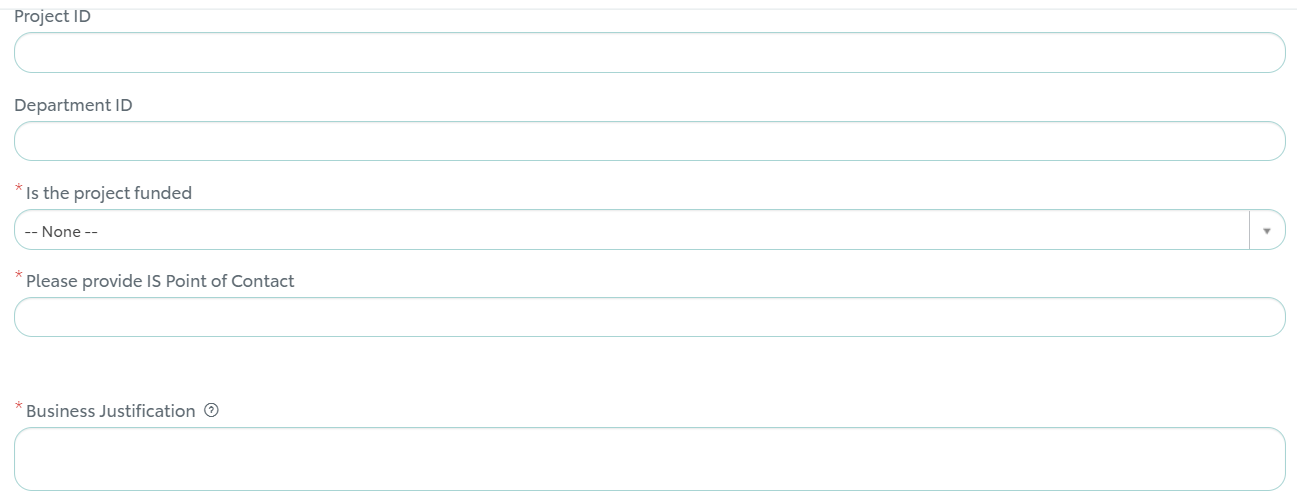

Step 6:
Select “Choose Options” if you want to change any values otherwise click “Next”
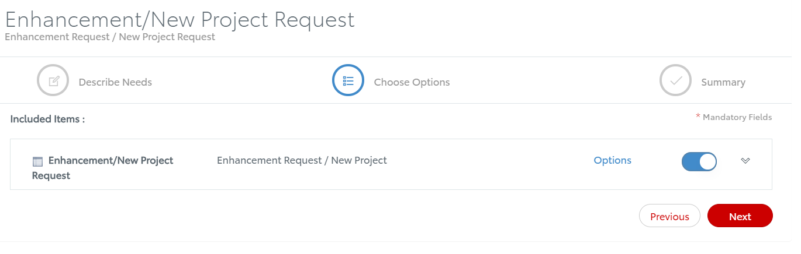
Step 7:
Click on “Order Now” to complete your request submission.
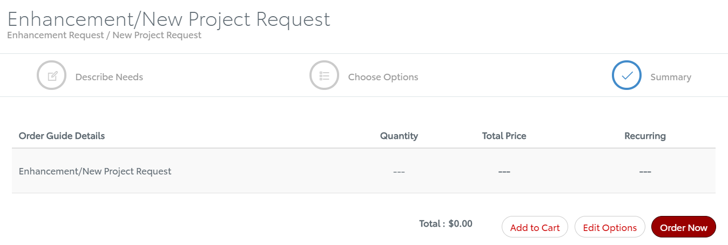
Step 8:
Please update the “Request For” information at this page if you are submitting a request on someone’s behalf.
You can also add attachments on this page.
Once you are done attaching and filling in all the necessary details, click on “Checkout”
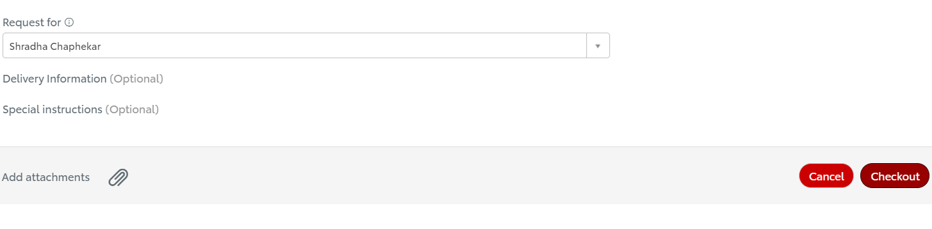
You should get an email with the request details.
Congratulations you have completed the request submission. Data Enablement and Global Compliance team will soon get back to you on your request. Thank You.
You can also check out the status of your submitted request on 1TS (One Toyota Service).

How do I get access to Informatica Enterprise Data Catalog (EDC), Axon and/or Informatica Data Quality (DQ)?

Direct Link to 1TS –
Step 1:
Please click the direct link to open Data Access Request or copy/paste the link into your browser if the link does not open directly.
https://tmna.service-now.com/1ts/?id=1ts_sc_category&sys_id=1ae1294d1b440c1400802f876e4bcbe9&catalog_id=99b029851b440c1400802f876e4bcb96&index=4&layer=1&hsc=false#catModal
Or

You can also access the form through the Data Enablement and Global Compliance site. Click on “Access Request Form” at the top of the site.
Data Enablement and Global Compliance Link:
https://dataenablement.toyota.com/


Or

If you still face any issues in opening the direct link, please go through 1TS
Toyota service link -
https://tmna.service-now.com/1ts/?id=1tslanding

New Request → Enterprise → Data Management

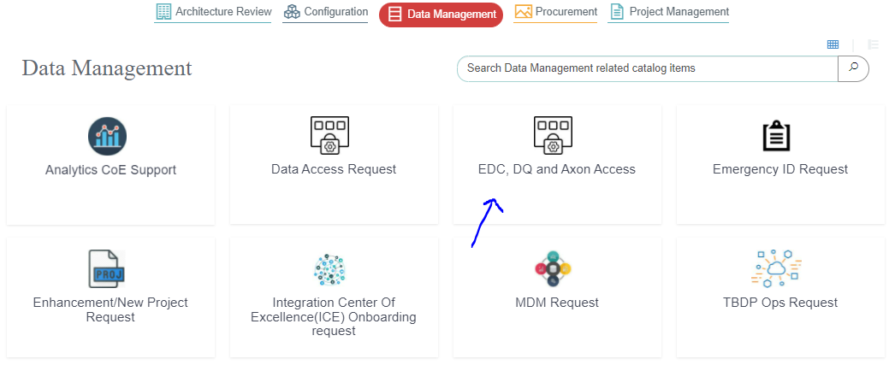
Step 2:
Fill in all the mandatory field in the form
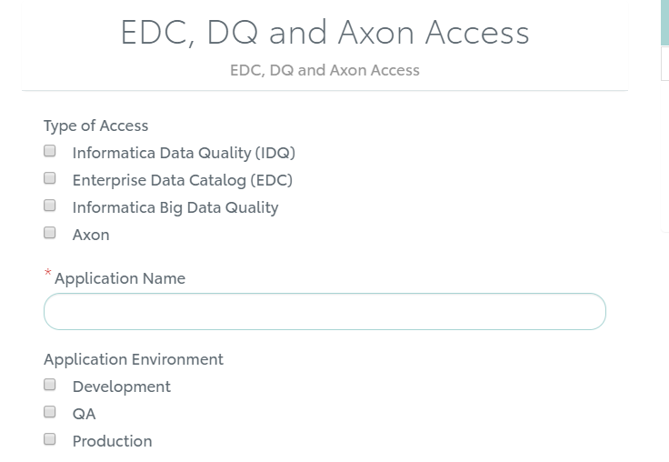
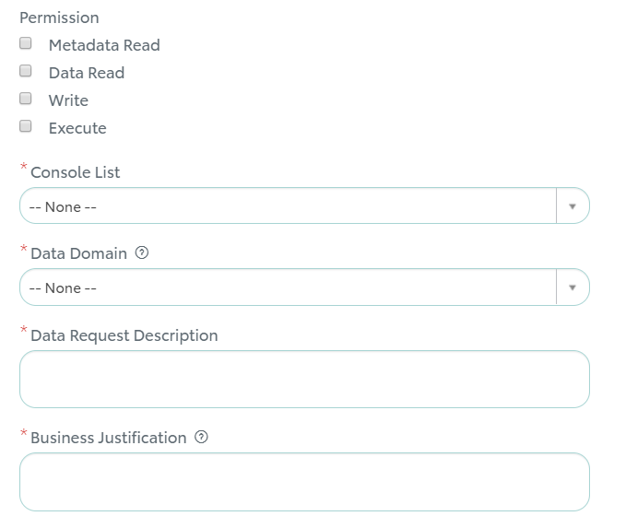

Step 3:
Click on “Order Now” on the same page to complete the request.

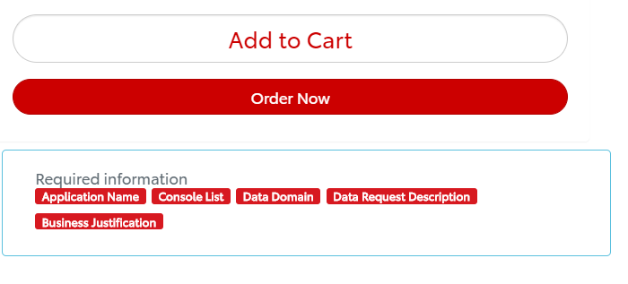

Step 4:
Click “Proceed to Checkout” to submit the order

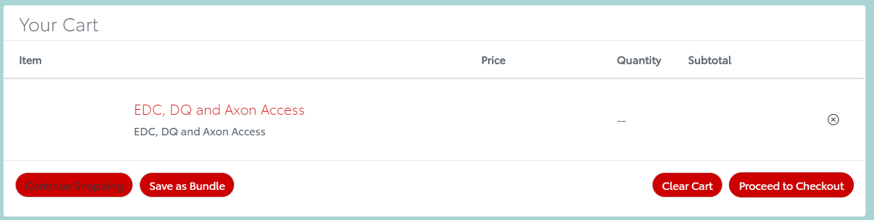

Step 5:
Please update the “Request For” information at this page if you are submitting a request on someone’s behalf.
You can also add attachments on this page.
Once you are done attaching and filling in all the necessary details, click on “Checkout”

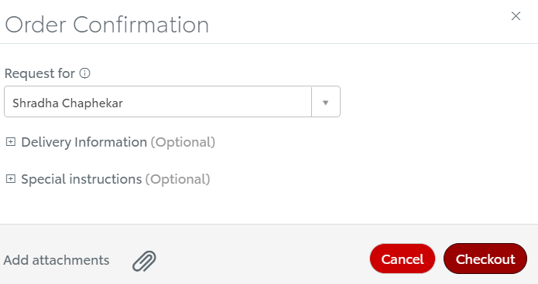

Step 6:
You should get an email with the request details.
Congratulations you have completed the request submission. Data Enablement and Global Compliance team will soon get back to you on your request. Thank You.
You can also check out the status of your submitted request through 1TS (One Toyota Service).

How do I submit an “Emergency ID Request”?

Direct Link to 1TS –
Step 1:
Please click the direct link to open Data Access Request or copy/paste the link into your browser if the link does not open directly.
https://tmna.service-now.com/1ts/?id=1ts_sc_category&sys_id=1ae1294d1b440c1400802f876e4bcbe9&catalog_id=99b029851b440c1400802f876e4bcb96&index=4&layer=1&hsc=false#catModal
Or

You can also access the form through the Data Enablement and Global Compliance site. Click on “Access Request Form” at the top of the site.
Data Enablement and Global Compliance Link:
https://dataenablement.toyota.com/


Or

If you still face any issues in opening the direct link, please go through 1TS
Toyota service link -
https://tmna.service-now.com/1ts/?id=1tslanding

New Request → Enterprise → Data Management

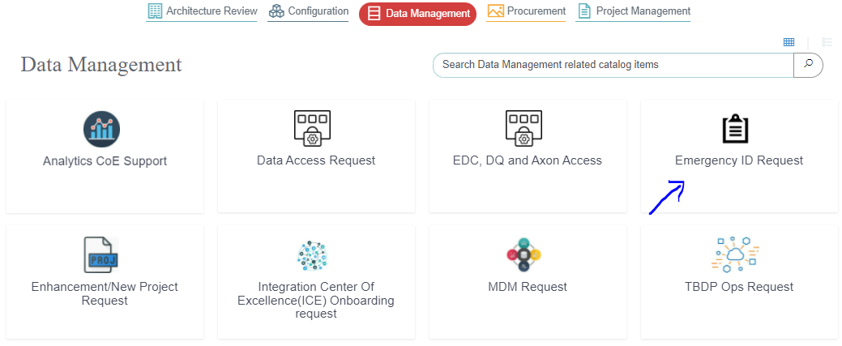

*Important Information Before you submit Emergency ID request
ID Types & Access
- Read Only IDs – Access to only query a database, no ability to insert, update, or delete the data
  - Production Non-Mission Critical and SubProd (QA, TRAIN, STAGE, TEST)
    - End users
    - Application Support Teams
    - Data Scientist/Analyst/Stewards/Architects
  - Production Mission Critical
    - Application Support Team – full time access
    - Data Scientist/Analyst/Stewards/Architects - only for a specified timeframe upon approval from app owner
- Full Access – Ability to complete direct data changes, build DB objects
  - Development/POC
    - Application Support Team – full time access
- Emergency IDs – Access to complete necessary direct data changes into a database – Requires Request Form and Approval
  - Production – Auto Expires after 24 hours
    - Application Support Team Only
  - QA/STAGE/TEST/TRAIN (Environment used for UAT/Training) – Auto Expires after 3 days
    - Application Support Team Only
Who is involved in EID
- Application Support Team - Responsible for developing and executing scripts
- Application Users – Responsible for testing and confirming data updates and impact to system
- Application Support Manager – First approver on the data access request
- Data Steward – Second approver on the data access request
- Database Administrator – Execution of task to setup the EID and provide to Application Support Team
Step 1:
Select “Emergency ID Request” form


Step 2:
If the default phone number is not your preferred contact information, please enter an ‘Alternate Contact Number’ so that you can be reached if the approvers or DBAs have any issues or questions
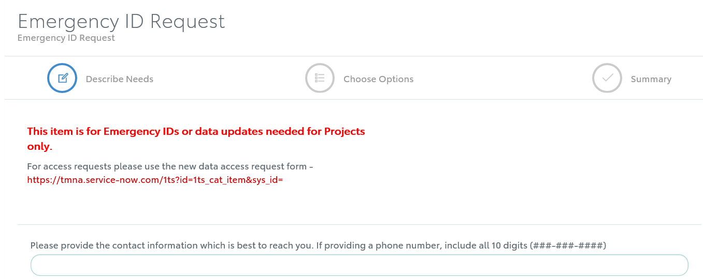
Step 3:
Enter the name of the database or the database server and schema that you are requesting access to.
Select if this is related to an emergency or is it actually associated to a project implementation activity
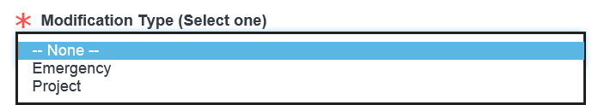
Select the impacted environment for this request
  - Remember Production auto expires after 24 hours and Sub Prod expires after 3 days
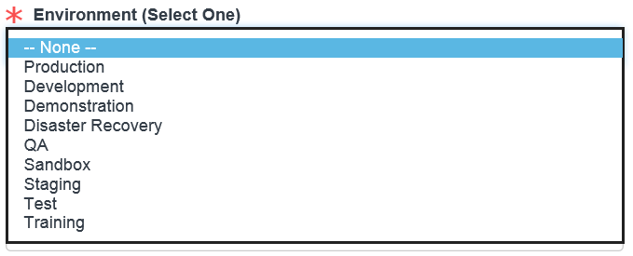
Select the data domain that the application supports – examples: Workday is Corporate Identity, eBoM and GALC are Manufacturing
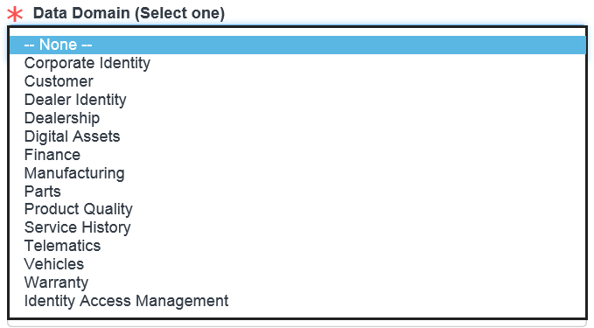
All EID Requests should be associated to:
  - A Change (RFC)
  - An Incident (INC)
  - A Work Request (REQ/RITM).
This is a required field and should have a valid value for reference to see the original details associated with the EID Request.
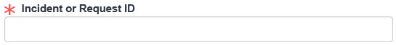
Search for and select the impacted application. This information will support KPI reporting, Audit Support, and Long Term Problem Solving
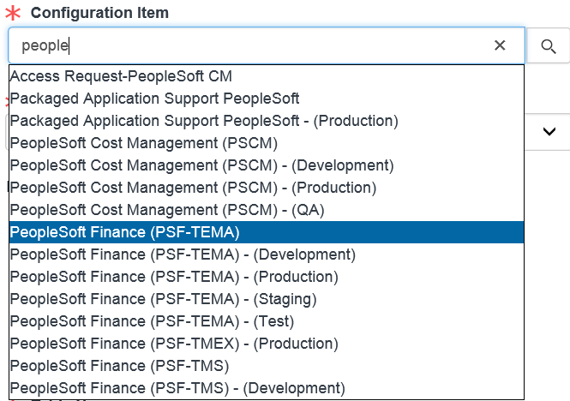
Select the database type for the database access being requested. This controls the task assignment to the appropriate DBA group once the request is approved.

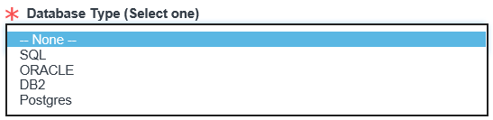
This identifies the type of access needed for the database and listed tables on the request.
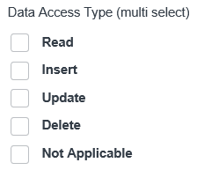
List all tables that you need access to for this request. Access is not allowed for the full schema/database. These should match to your SQL script.
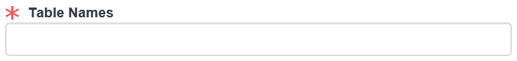
Please enter the following information in this field
- For Incidents
  - Description of issue
  - Possible root cause
  - Short term countermeasure if any available outside of just the data update
  - Possible long term countermeasure
- For Projects
  - Brief description of project
  - Why the back-end update is needed
- For Requests
  - Brief description of Request
  - Why the back-end update is needed
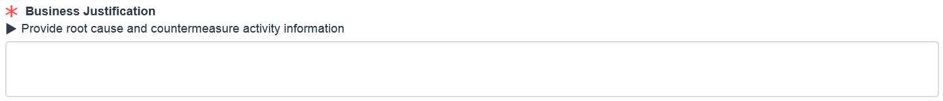
Enter any additional notes or comments that you think would be relevant if this request was pulled by an auditor. If this is for a simple SQL script, you can paste it in here instead of attaching a script file. If it is sensitive information, it should be attached in a password secured file, with the password e-mailed to your supervisor and to the data stewards group e-mail Dataenablement@toyota.com.
You may include information about any testing in Sub Prod environments.
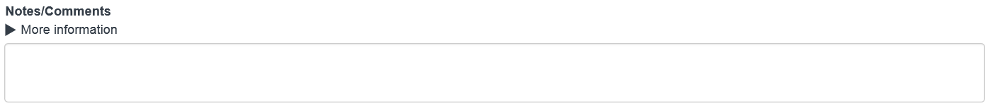
All EID Requests require that the SQL script be provided. If it is a large script, you must attach a file. For some applications, there is a requirement to have business e-mail approval, so it can be attached here as well. To do this, you will get PAPERCLIP icon at the end of the form and after you are done entering all the details on the form click Next.
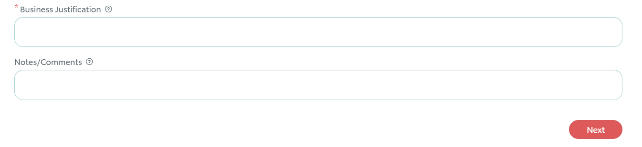
Step 4:
Click Next.
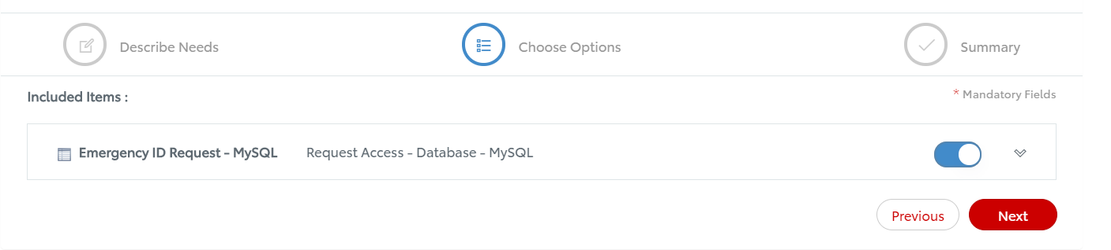
Click “Order Now” to finalize your request.
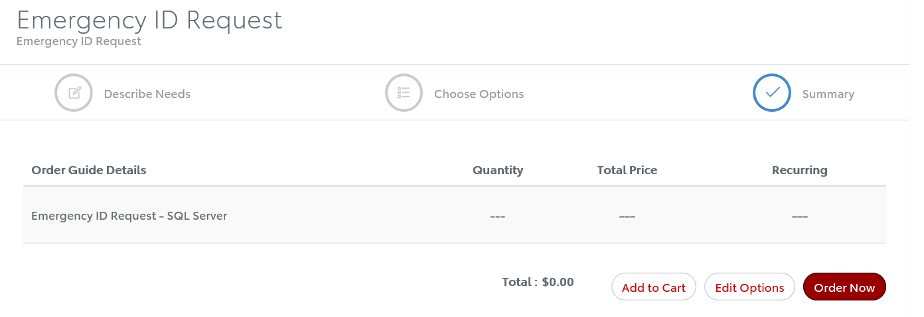
Browse and attach your file on this page and click the X to close the box. If it is sensitive information, it should be attached in a password secured file, with the password e-mailed to your supervisor and to the data stewards group e-mail Dataenablement@toyota.com.
If you are requesting on someone’s behalf update name here in the “Request for” field.
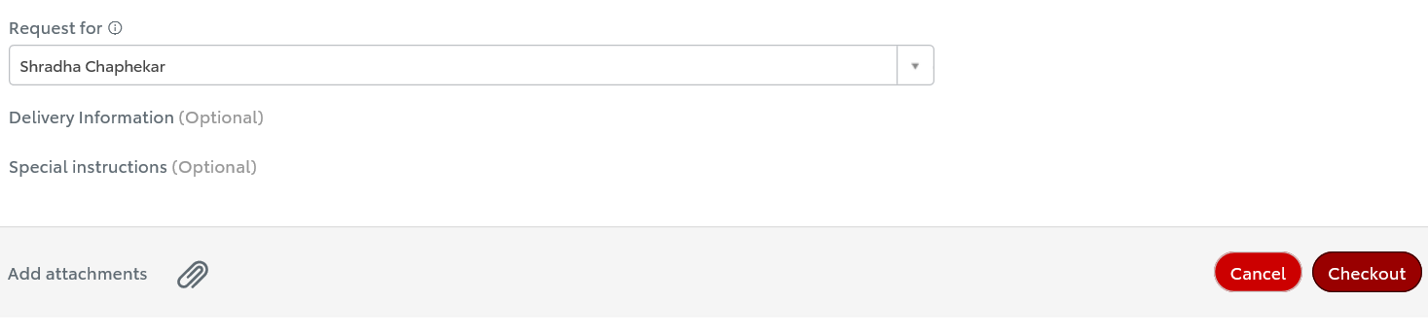

Example – good justification
TMMWV is doing some "clean up" and will be obsoleting around 11,000 parts. These are parts that are no longer required to be stocked or no longer used at the plant. They should be doing this every year but they are catching up for FY19. There are several steps to the process to do this on the front end. 1) They want to set the status to discontinued for these parts so they can still be issued but the parts can't be ordered from the vendor. At this time a comment will also be entered. Example: FY19 Obsolescence Strategy. 2) Physically remove the part from the bins and do an express issue. 3) Change the bin location to NSTK 0 0 0 or OBSL. This will be confirmed and the same location will be used for all the parts. We have been requested to see if a script can be used to automate steps 1 and 3. WV will still do step 2 from the front end. The request is based on the volume and amount of time it would take to do all of this through the front end.
This access is being requested to complete Part 1 for changing the status of TMMWV inventory items to discontinue. In part one, we will be changing the status of all the attached inventory items to the status of Discontinued and inserting a comment on the comments table. In addition to this, I will also be conducting a bin to bin transfer to move TMIPC bin locations to vertical bin locations. This list is also attached as well.
Example – bad justification
Need an Emergency ID to update Minor Model Code for VA Ideas on Production. Query attached. Thank you!

Completing the EID Request Form – Other considerations
- Just like code changes, SQL update scripts should be tested. If you are unable to recreate the issue and test in a lower environment, this needs to be explained in the notes/comments.
- If this is a true emergency needing immediate attention, please text or call your supervisor’s and the data steward’s phone number.
- When developing an application, all configurations should have front end access to update values. It should not be the practice to maintain the tables via SQL.
- Read only access or application ID access should be requested using the Data Access Request Form - https://tmna.service-now.com/is/order.do?label=enterprise_services&category=31d2edfc0f2139004758e388b1050e97
- Please visit our Data Enablement and Global Compliance site for more information on Data Policies and Procedures plus information on who we are - https://dataenablement.toyota.com/

Where should I look to get update on the progress of my ticket?

You will need console view access to view the status of your ticket. Please follow below steps to obtain console view access.

- Click below link.
Link- https://tmna.service-now.com/1ts/?id=1ts_sc_category&sys_id=8ff02dc51b440c1400802f876e4bcb79&catalog_id=99b029851b440c1400802f876e4bcb96&index=0&layer=1&hsc=false#catModal
And search for “console”
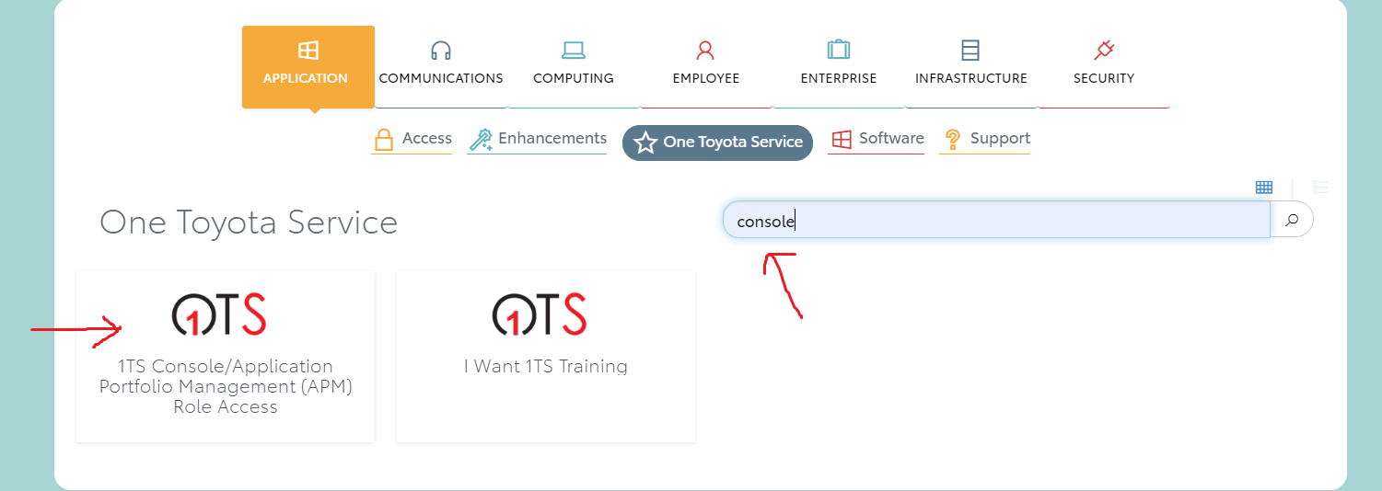
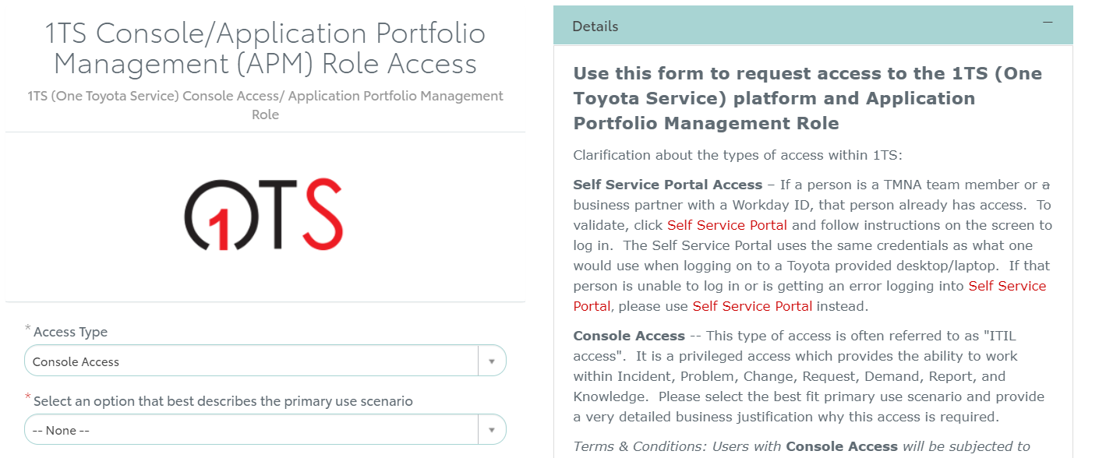

- Fill in the information
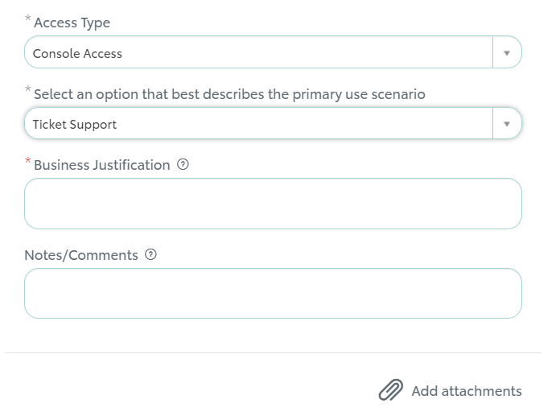
- Click on “Order Now” and then click “Checkout”
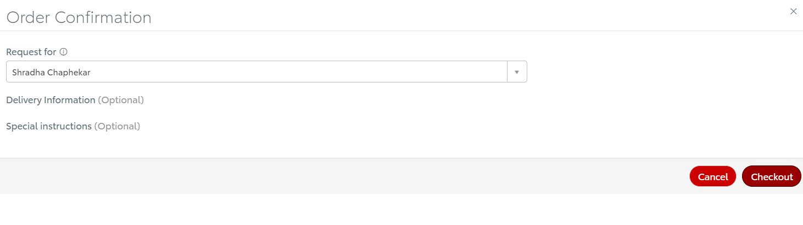
Once you have the console view access, go to 1TS
- 1TS Link- https://tmna.service-now.com/1ts/

- Go to console view
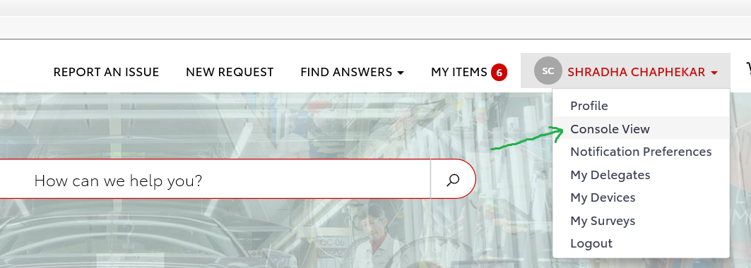
- Search for “items” in the search window and click on it to browse for tickets
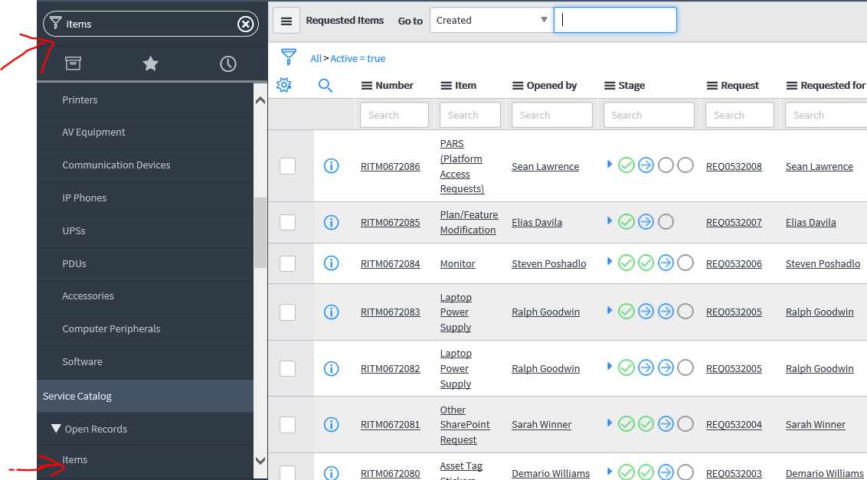
- Browse for the ticket number

- Click on the ticket number and scroll all the way down and click “Load related items” to see who the ticket is Assigned to.
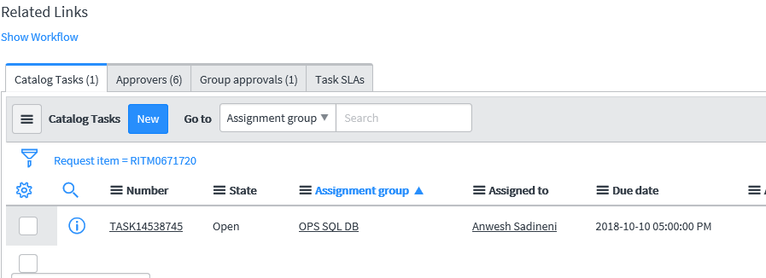

Check with the “Assigned To” person to check on the status of your request.

How do I identify the team working on my request?

- You will first need console view access (Please refer to question 6)
- Once you have console view access, follow below step by step process to find out with which group the ticket is pending
Step 1:
Go to 1TS and select Console View
- 1TS Link- https://tmna.service-now.com/1ts/
- Go to console view


Step 2:
Search for “items” in the search window and press enter to browse for tickets


Step 3:
Browse for the ticket number you want to check on and press enter
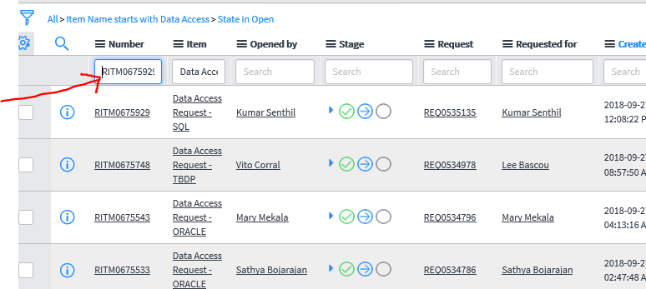

Step 4:
Click on the ticket number to open the ticket
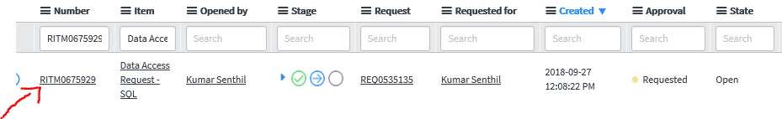

Step 5:
Scroll all the way down and click “Load related items” to see the Assignment group.
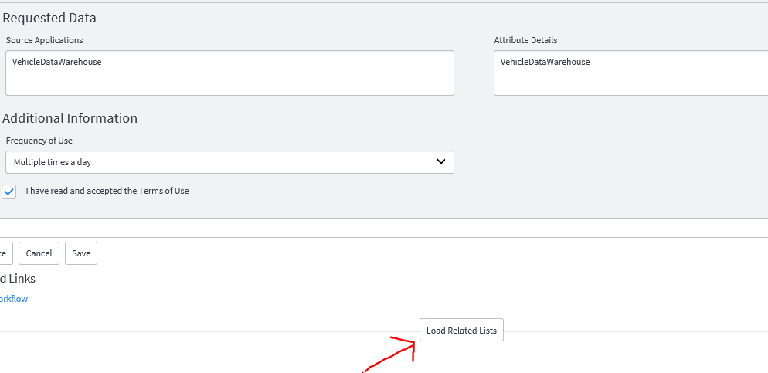



How long will it take to complete my request?

The SLA applies after the requestor’s supervisor and the Data Steward have approved the request.
Group Name | SLA
TBDP | 1 week
Oracle | 1 Week
SQL | 4 Days

Who is the approver on the ticket I recently submitted?

Step 1:
Go to 1TS - https://tmna.service-now.com/1ts/

Step 2:
At the top right click on “MY ITEMS” and click “My Requests”

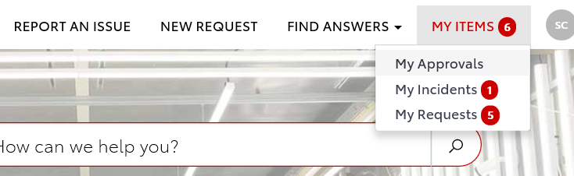
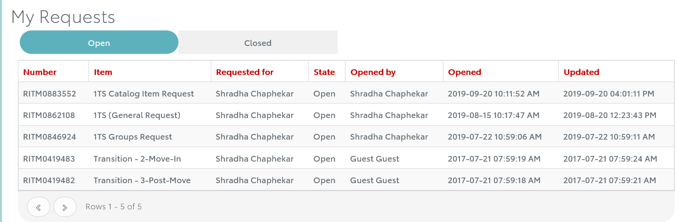
Step 3:
Click on the ticket number to find out more details about your request.
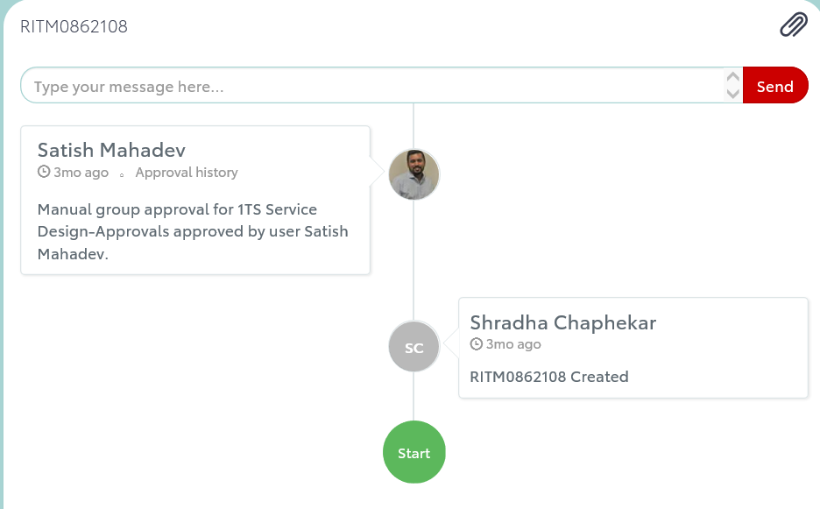

What is the difference between “Project Description” and “Business Justification”?

Project/Data Description: What you need?
Please provide details about your request that expand on any information already included in the form. The more details provided, the more likely that your request will be completed quickly and accurately.
E.g., Need to ingest sales and marketing data in TBDP – this is okay, but if you explained exactly what sales and marketing data needed to be ingested, it would speed up the process.
Business Justification: Why you need it?
Please provide details of how this request will support your job function.
E.g., Need to develop reports on sales and marketing data through TBDP using PowerBI to calculate the profit/loss on sales.

How do I access TBDP now that I have access?

Please find below the respective URLs for Hue & Atscale access.
TBDP User Guide AWS
Dataset_Access_Guide.pdf (toyota.com)

Hue (On Prem)
TBDP Dev Hue URL - https://tbdp-hue.dev.toyota.com
TBDP QA Hue URL -https://tbdp-hue.qa.toyota.com
TBDP Prod Hue URL -https://tbdp-hue.toyota.com
Atscale (On Prem)
TBDP Dev Atscale URL – http://ddc-lbdcd6496.tmm.na.corp.toyota.com:10500
TBDP QA Atscale URL – http://tbdp-atscale.qa.toyota.com:10500
TBDP Prod Atscale URL – http://tbdp-atscale.toyota.com:10500

If you have any issues accessing Atscale / Hive, please reach out to the Data Security or Big Data team.
Data Security – DE-DataSecurity-Analyst@toyota.com

Big Data Admin –TBDP-Hadoop-Admins@internal.toyota.com
Dec

Once you have access and you need training on how to access data in hive/AtScale you can contact TBDP team – bigdata@toyota.com

What is the process to onboard a “New Project” in TBDP (Toyota Big Data Platform)?

Once the project request is approved in the system, the request will be added to the EDM Backlog.
Please find below the steps followed the request is added to the EDM backlog.

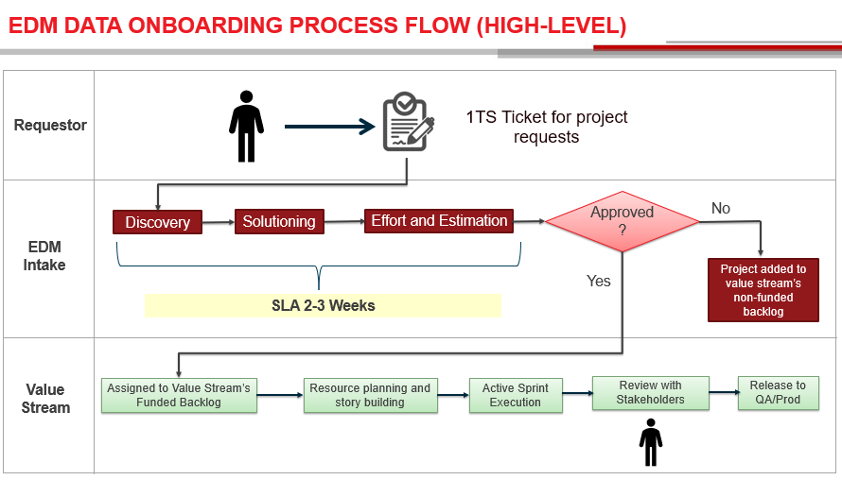

How do I get access to database server?

Access to database servers is restricted to DBAs only. Hence, there really is no request for getting this access.

There is a PARS request for access to Windows and Unix Servers. However, when a request is made for access and the server also happens to be hosting SQL or Oracle database, the request is typically denied.

Oracle and SQL Server DBAs get access using Oracle DBA and SQL DBA categories within the PARS request process. This request gives both server and database access to the DBAs.

Please follow the below link to submit PARS Access.
https://tmna.service-now.com/1ts/?id=1ts_sc_category&sys_id=96d025c51b440c1400802f876e4bcb9c&catalog_id=99b029851b440c1400802f876e4bcb96&index=0&layer=0&hsc=true

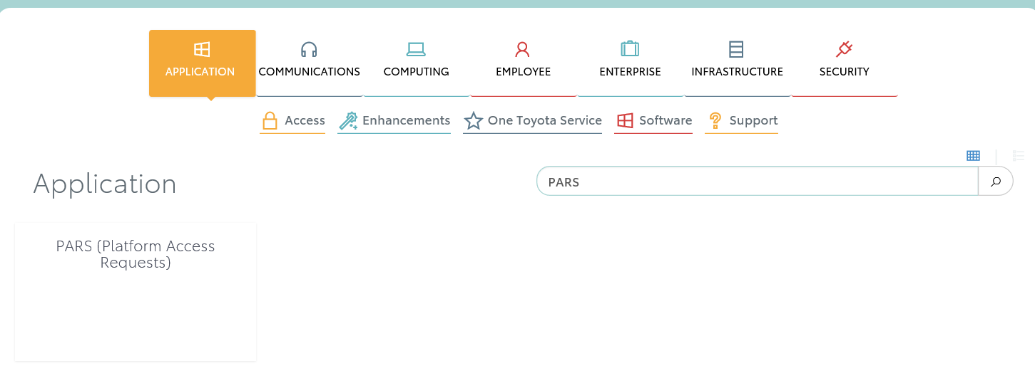
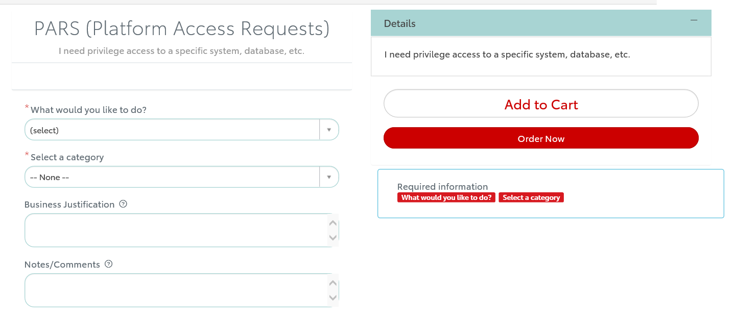

How do developers submit access request to TBDP Environment, Bit Bucket Repository, AMS support and database creation?

This form is only for TBDP support team who is working on development effort of onboarding data into TBDP.

Direct Link to 1TS –
Step 1:
Please click the direct link to open Data Access Request or copy/paste the link into your browser if the link does not open directly.
https://tmna.service-now.com/1ts/?id=1ts_sc_category&sys_id=1ae1294d1b440c1400802f876e4bcbe9&catalog_id=99b029851b440c1400802f876e4bcb96&index=4&layer=1&hsc=false#catModal
Or

You can also access the form through the Data Enablement and Global Compliance site. Click on “Access Request Form” at the top of the site.
Data Enablement and Global Compliance Link:
https://dataenablement.toyota.com/


Or

If you still face any issues in opening the direct link, please go through 1TS
Toyota service link -
https://tmna.service-now.com/1ts/?id=1tslanding

New Request → Enterprise → Data Management



Step 1:

Select the “TBDP Request” option.
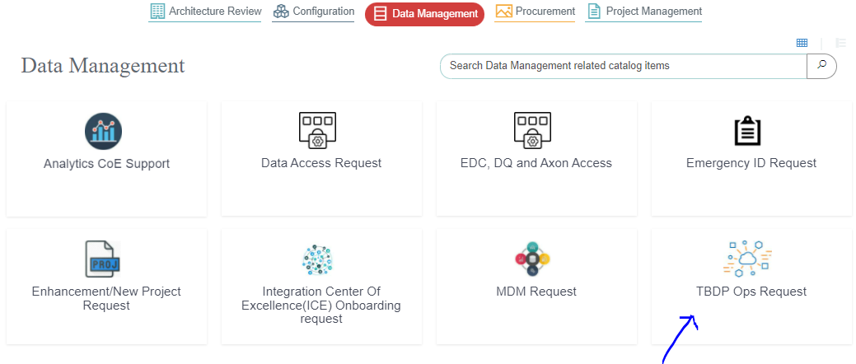
Step 2:
Please complete all the mandatory fields (identified with *) on the form.
You can submit request for multiple users in one form.
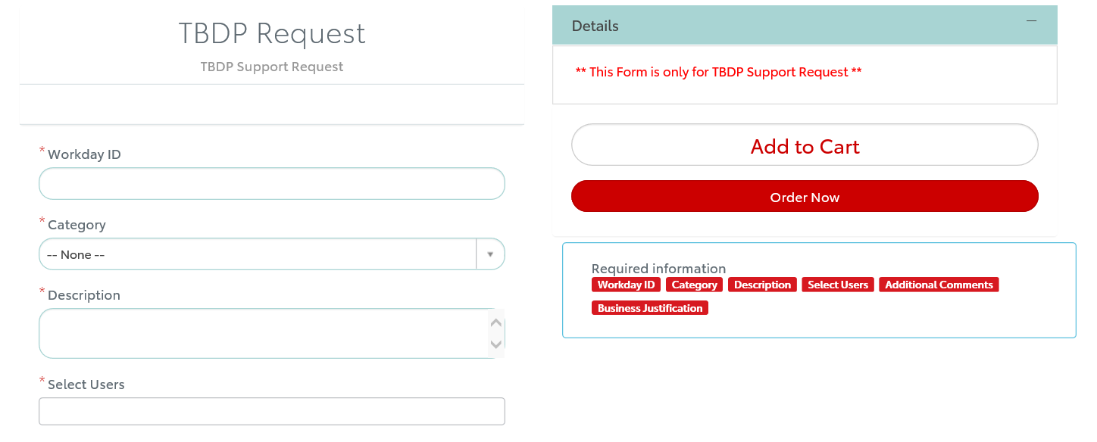

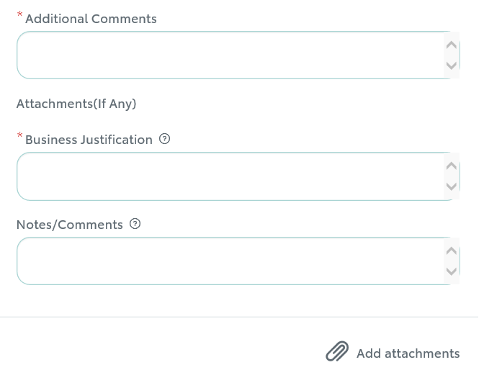

Step 3:
After your done filling out all the mandatory fields, click on “Oder now” and then proceed to “Checkout”

Please update the “Request For” information at this page if you are submitting a request on someone’s behalf.
Once you are done filling in all the necessary details, click on “Checkout”

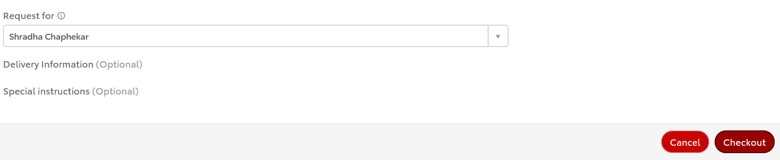

Step 4: You should get an email once the request is submitted with the ticket number.

Congratulations you have successfully submitted TBDP support request form.
Data Security team or Big Data Admin team will soon get back to you on your request.
You can also check out the status of your submitted request through 1TS (One Toyota Service).

How do I submit request for MDM (Master Data Management)?

Direct Link to 1TS –
Step 1:
Please click the direct link to open Data Access Request or copy/paste the link into your browser if the link does not open directly.
https://tmna.service-now.com/1ts/?id=1ts_sc_category&sys_id=1ae1294d1b440c1400802f876e4bcbe9&catalog_id=99b029851b440c1400802f876e4bcb96&index=4&layer=1&hsc=false#catModal
Or

You can also access the form through the Data Enablement and Global Compliance site. Click on “Access Request Form” at the top of the site.
Data Enablement and Global Compliance Link:
https://dataenablement.toyota.com/


Or

If you still face any issues in opening the direct link, please go through 1TS
Toyota service link -
https://tmna.service-now.com/1ts/?id=1tslanding

New Request → Enterprise → Data Management



Step 1:
Select item “MDM Request”
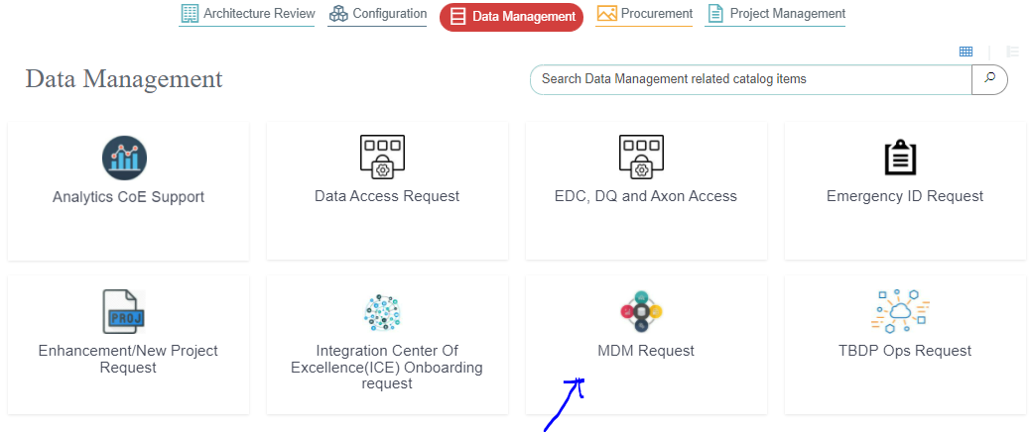

Step 2:
Please fill the information in the mandatory fields marked in star.
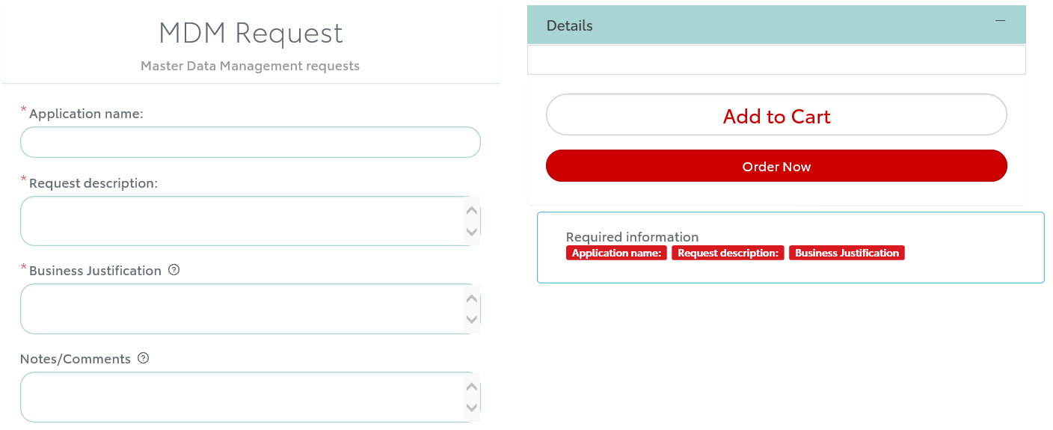
Step 3:

After your done filling out all the mandatory fields, click on “Order Now”.
Please update the “Request For” information at this page if you are submitting the request on someone’s behalf.
Once you are done filling in all the necessary details, click on “Checkout”

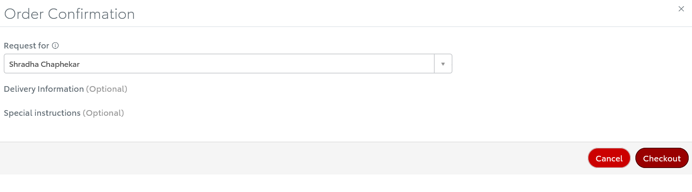

Step 5: You should get an email once the request is submitted with the ticket number.

Congratulations you have successfully submitted MDM request.
MDM team will soon get back to you on your request.
You can also check out the status of your submitted request through 1TS (One Toyota Service).

What are the different requests that EDM team support?

Please find below the link to download “EDM-OneIntake-1TS Request_Process_Flow” diagram that will showcase list of requests that we provision and the approval process for it.
EDM-OneIntake-1TS Request Process Flow

1TS Direct link to access EDM request form:
https://tmna.service-now.com/1ts/?id=1ts_sc_category&sys_id=1ae1294d1b440c1400802f876e4bcbe9&catalog_id=99b029851b440c1400802f876e4bcb96&index=4&layer=1&hsc=false#catModal



How do I submit access request for NDW or FDW database?

Direct Link to 1TS –
Step 1:
Please click the direct link to open Data Access Request or copy/paste the link into your browser if the link does not open directly.
https://tmna.service-now.com/1ts/?id=1ts_sc_category&sys_id=1ae1294d1b440c1400802f876e4bcbe9&catalog_id=99b029851b440c1400802f876e4bcb96&index=4&layer=1&hsc=false#catModal
Or

You can also access the form through the Data Enablement and Global Compliance site. Click on “Access Request Form” at the top of the site.
Data Enablement and Global Compliance Link:
https://dataenablement.toyota.com/


Or

If you still face any issues in opening the direct link, please go through 1TS
Toyota service link -
https://tmna.service-now.com/1ts/?id=1tslanding

New Request → Enterprise → Data Management



Step 1:
Select the “Data Access Request” option.


Step 2:
You will be redirected to Data Marketplace homepage.
In the Data Access Request form, Platform field select Data Warehouse/Mart (VDW, MDW, FDW, NDW, etc) and in Data Warehouse/Mart field select the access you need FDW or NDW.
Click here to see the next steps

Step 3: Please complete all the mandatory fields (identified with *) on the form and submit it. Once the request is fulfilled you will get an email that the access is processed.

