**Lab Report – 8**

Name: Aryan Gupta

Roll No.:2021113012

Group Number: 8

**Part-A**

Aim: To verify the working of a tri-state buffer.

Components Used: Arduino Uno, wires, LED, resistor, given implementation of a tri-state buffer.

Procedure:

1. Give enable and input to the buffer from Arduino.
2. Tabulate the output for various values of enable and input.

Theory :

The tri-state buffer (Fig 1) functions just as a regular digital buffer where the value at its input is propagated to its output. But it has an additional capability that allows us to configure its output to a Hi-Z (high impedance) state.

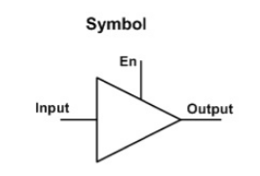

When the output of the buffer is in Hi-Z state it is basically disconnected (isolated) from the rest of the electric circuit. This makes it very useful when connecting multiple devices on a single bus, as its isolation prevents the occurrence of a short circuit event.

Reference Circuit:

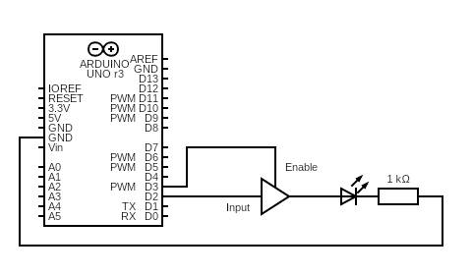

Conclusion: The tri-state buffer works as expected.

Tinkercad Link:

<https://www.tinkercad.com/things/dZOb0D53WFm-l8-p1/editel?sharecode=liCNLA0O8pX9peZUhvOPEH1rUzz-uchrvkjSI8RkoAU>

**Part-B**

Aim: To manage the flow of data between 2 shift registers using tri-state buffers.

Components Used: Arduino Uno, wires, LEDs, resistors, given implementation of a tri-state buffer.

Reference Circuit:

Procedure:

1. Give input, OR clock and SR clock to the first register using Arduino.
2. Connect each output of the first register to a buffer.
3. Connect those buffers to the input of the second register.
4. Give OR clock and SR clock to the second register using Arduino.
5. Connect the enables of the buffers to Arduino.
6. Enable each buffer one by one in sync with the SR clock of the second

register to convert the parallel output of the first register into a serial input for the second register.

Conclusion: The circuit works as expected. The output of second register is the same as expected output from the first register with the given input.

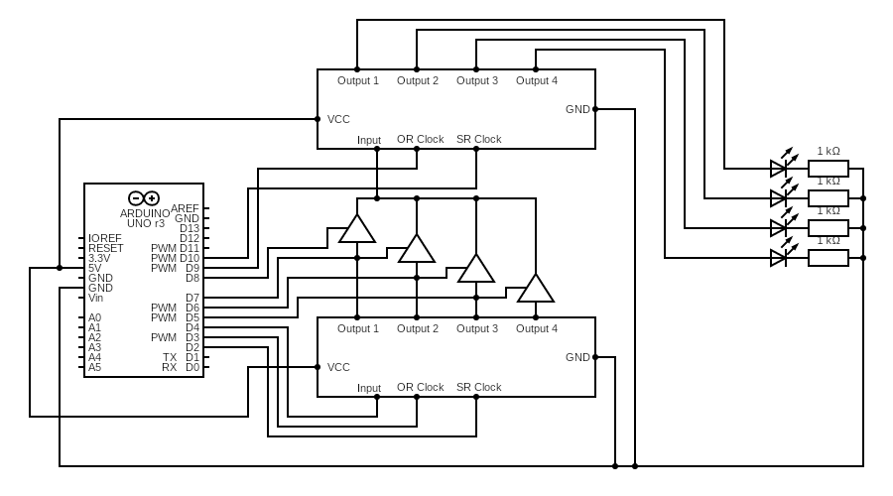

Conclusion:

From this experiment, we achieved the passage of data(output) of one register as a input to the another register via bus and understood the data flow control using tristate buffers.

(O1-O3 are leds of shift register 1 & 2)

Tinkercad Link:

<https://www.tinkercad.com/things/7bTd0cKvnNo-copy-of-data-transfer-using-tri-state-buffer/editel?sharecode=qsa0bSjJyxvu9DZh2CP27eo8UqE0DntZMSpeRH3CDY8>