Lab Report: 3

Name: **Aryan Gupta**

Roll number: **2021113012**

Group: **8**

# PART: A

**Aim:**

To construct and test the working of a 4:1 Multiplexer using basic logic gates and select lines through Arduino on tinkercad.

**Electronic components used:**

Arduino UNO R3, Hex Inverter (74HC04), OR gate (74HC32), Breadboards, 1k Ω Resistors, Triple input AND gate (74HC11), LED’s, connecting wires

**Reference Circuit:**

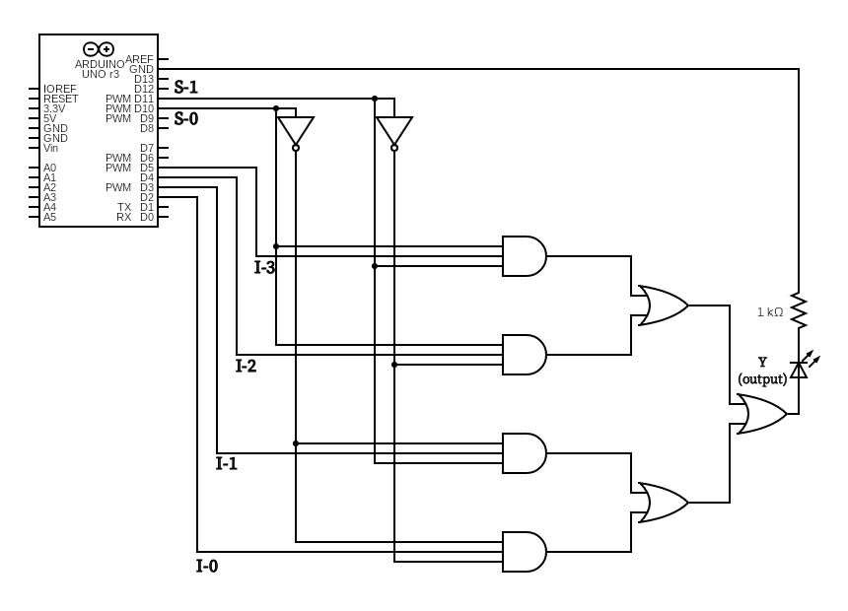

**Procedure:**

1. Assemble the circuit on the breadboard as shown
2. Connect the respective logic gates
3. Now take OR of the out of the AND gates.
4. Run the simulation after entering the code
5. Change the values by inputing as HIGH or LOW
6. Note down the values for the various observations

**Observation:**

|  |  |  |  |  |  |  |  |
| --- | --- | --- | --- | --- | --- | --- | --- |
| **i0** | **i1** | **i2** | **i3** | **S1** | **S0** | **Effective output** | **Output LED** |
| 1 | 0 | 0 | 0 | 0 | 0 | i0 | ON |
| 0 | 1 | 0 | 0 | 0 | 1 | i1 | ON |
| 0 | 0 | 1 | 0 | 1 | 0 | i2 | ON |
| 0 | 0 | 0 | 1 | 1 | 1 | i3 | ON |

**Conclusion / Result:**

Based on the select lines, the Multiplexer provides a single output for the corresponding inputs – i0, i1, i2 and i3

**TinkerCAD simulation:**

https://www.tinkercad.com/things/flNjOmj17pr-lab-3-a/editel?sharecode=tDV6aBqExPJKEDkR01ggKK1Vy1VR7lWWX37jLRrNtRU

# PART: B

**Aim:**

To construct and test the working of a 1:4 Demultiplexer using basic logic gates and select lines through Arduino on tinkercad

**Electronic components used:**

Arduino UNO R3, Breadboards, Hex Inverter (74HC04), Triple input AND gate (74HC11), OR gate (74HC32), LED’s, 1k Ω Resistors, connecting wires

**Reference Circuit:**

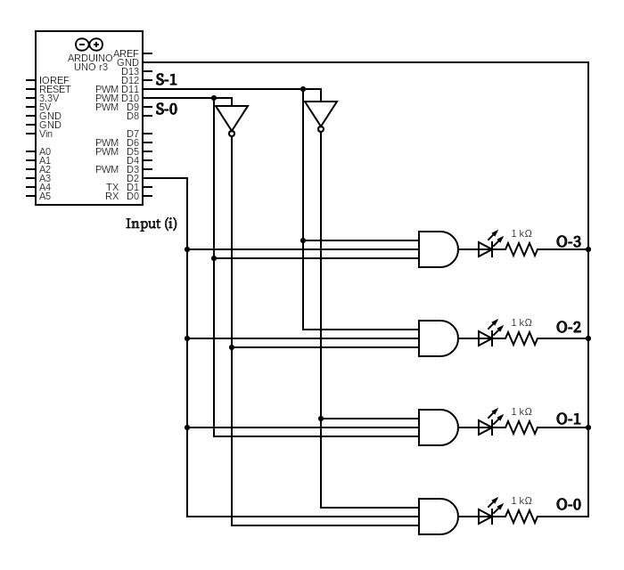

**Procedure:**

1. Assemble the circuit on the breadboard
2. Connect the logic gates
3. Now make the circuit with 4 output LEDs
4. Run the simulation after entering the code
5. Enter different values for S0 and S1 in order to select the output line
6. Note down the values for the various observations

**Observation:**

|  |  |  |  |  |  |  |  |  |
| --- | --- | --- | --- | --- | --- | --- | --- | --- |
| **Input**  **(i)** | **S1** | **S0** | **O0** | **O1** | **O2** | **O3** | **Output Line** | **Output LED** |
| 1 | 0 | 0 | 1 | 0 | 0 | 0 | O0 | ON |
| 1 | 0 | 1 | 0 | 1 | 0 | 0 | O1 | ON |
| 1 | 1 | 0 | 0 | 0 | 1 | 0 | O2 | ON |
| 1 | 1 | 1 | 0 | 0 | 0 | 1 | O3 | ON |

**Conclusion / Result:**

Based on the select lines, the Demultiplexer provides an output on the desired line. It passes the input as it is on the desired output line

**TinkerCAD simulation:**

https://www.tinkercad.com/things/91uj7NSUfY8-lab-3-b/editel?sharecode=Wu71vtUwOEotQTQgt2C-Fw5PatdyVceEI33KYd4IFnI

# PART: C

**Aim:**

To construct and test the working of a Combined 4:1

Multiplexer and 1:4 Demultiplexer circuit using basic logic gates and select lines through Arduino on tinkercad

**Electronic components used:**

Arduino UNO R3, Breadboards, Hex Inverter (74HC04), Triple input AND gate (74HC11), OR gate (74HC32), LED’s, 1k Ω Resistors, connecting wires

**Reference Circuit:**

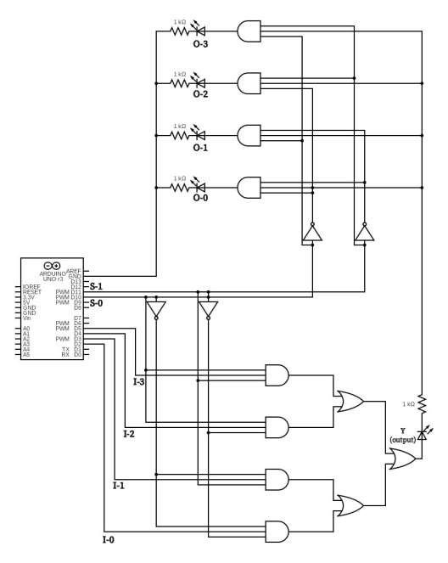

**Procedure:**

1. Assemble the circuit on the breadboard
2. Connect the various logic gates
3. Now take OR of the AND outputs,This is the output of multiplexer (y)
4. Now make the demultiplexer circuit
5. Run the simulation after entering the code
6. Enter different values for S0 and S1 in order to select from the various possible inputs and pass the same input to the demultiplexer
7. Note down the values for the various observations

**Observation:**

|  |  |  |  |  |  |  |
| --- | --- | --- | --- | --- | --- | --- |
| **i0** | **i1** | **i2** | **i3** | **S1** | **S0** | **Effective output** |
| 1 | 0 | 0 | 0 | 0 | 0 | O0 |
| 0 | 1 | 0 | 0 | 0 | 1 | O1 |
| 0 | 0 | 1 | 0 | 1 | 0 | O2 |
| 0 | 0 | 0 | 1 | 1 | 1 | O3 |

**Conclusion / Result:**

The output from the multiplexer is given as input to the demultiplexer. Based on the select lines, the Demultiplexer provides the corresponding output line based on the input.

**TinkerCAD simulation:**

**https://www.tinkercad.com/things/eARRKST6k6y-copy-of-lab-3-a/editel?sharecode=fEMEmIKpVLz2a1Y3gtIZQwpiCgG6V0mywIlt4gvYbt4**