LAB REPORT :6

:Aryan Gupta

:2021113012

:Group 8

**PART-1**

7 Segment Display

Electronic Components Used :

Arduino Uno R3, Breadboard, 555 timer,74hc93 ripple counter, CD4511 7 segment decoder, 7-segment display, LED , wires, resistors

Reference Circuit :

Procedure :

1.)The timer, used to generate periodic pulses, was designed

Using the *555 timer*, with Arduino as the power source

2.)the timer output was passed to the ripple counter, which consisted of the *IC 74HC93*. The outputs Q1 and Q2 were passed as reset R1 and R2.

3.)the outputs Q0,Q1,Q2,Q3 were passed through the IC CD4511, which is the 7 segment decoder.

4.)the respective a-g pins of the IC were connected to the corresponding pins of the 7 segment display.

**Conclusion :**

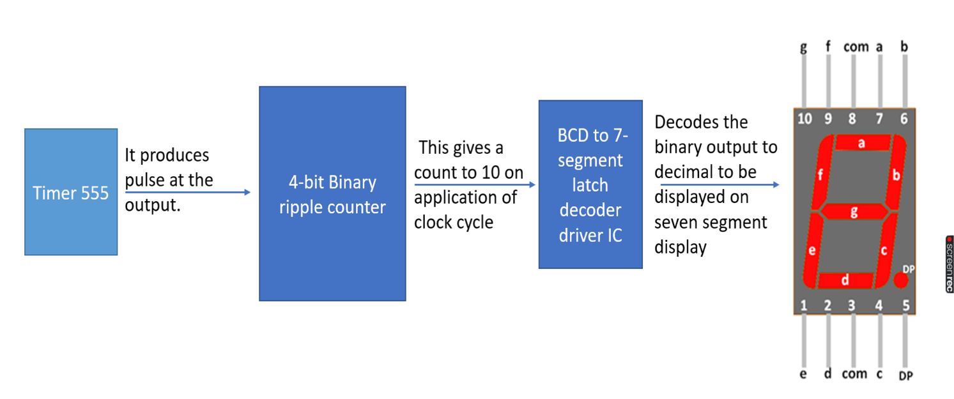

The layout explains the basis and procedure followed in the experiment. The experiment achieves to build a decade counter, also known as a binary coded decimal which counts till ten and resets after the count of nine.

Link of the TinkerCAD simulation :

https://www.tinkercad.com/things/bbk1O5Wr2o2-lab-6-p1/editel?sharecode=58h9PomkDY5Yq3lxsAJ82bk4w4HWB9MOK6HAYmZIZn4

PART-2A

Shift register

AIM:

Using the circuit made above write the code to count from 0 to 255 and glow the 8 LEDs in order.

Electronic Components Used:

Arduino Uno R3, Breadboard, 74HC595 shift register, LED , wires, resistors

Reference Circuit:

This is reference to the circuit:

Procedure:

1.)The circuit was setup with the help of Arduino.

2.)The shift CLK input signal (D12) and Output clk signal (D11) were passed as synchronous Clock signals, with transitioned periodically

3.)the inputs D(13) were passed into the shift register.

4.)the outputs of the register(q1-q8) were connected to the LEDs representing the bits of the answer.

5.)the code passed the numbers from 0-255, which were then shown in their binary representation using the LEDs.

Conclusion:

The shift register is used to control 8 outputs at a time while only taking a few inputs channels. The input is passed as a single integer, while the IC 74HC595 outputs its binary representation. The IC can be thus described as *"8-bit serial-in, a serial or parallel-out shift register with output latches “*

Link of the TinkerCad Simulation:

https://www.tinkercad.com/things/6jSfLHJFa7S-lab-6-2a/editel?sharecode=Lf6pfB5m-bJD8O9jQhpUmB7me_BMkAt5y1H5Htlf19E

**Part 2B**

Shift register

Objective:

Using the circuit made above write the code to take input from the user (range 0-7) and glow the corresponding LED.

Electronics Components Used:

Arduino Uno R3, Breadboard, 74HC595 shift register, LED , wires, resistors

Reference Circuit:

(PC; lab manual)

Procedure:

1.)The circuit was setup with the help of Arduino.

2.)The shift CLK input signal (D12) and Output clock signal (D11) were passed as synchronous Clock signals, with transitioned periodically

3.)the inputs D(13) were passed into the shift register.

4.)the outputs of the register(q1-q3) were connected to the LEDs representing the bits of the answer.

5.)input in the range 0-7 was taken from the user, which was then shown in its binary representation using the LEDs.

Observation**:**

The shift register is used to control 8 outputs at a time while only taking a few inputs channels. The input is passed as a single integer, while the IC 74HC595 outputs its binary representation. The IC can be thus described as *"8-bit serial-in, a serial or parallel-out shift register with output latches “*

Link of the Tinkercad simulation:

https://www.tinkercad.com/things/h77nvI3DMfU-copy-of-lab-6-2b/editel?sharecode=rMSFAjOmxwOwF52_zdcl7FJIAIT5-S7GzP86CnWd9GM