LAB REPORT :7

:Aryan Gupta

:2021113012

:Group 8

**AIM:**

To implement and verify the operation of a Binary cell for RAM based on RS flipflop.

**Electronic Components Used:**

Arduino Uno R3, Breadboard, 74HC11,74HC04,74HC02 ICs, LED , wires, resistors, slide switches

**Reference Circuit:**

(PC: lab 7)

**Procedure:**

1.)the inputs line input, select, read/write were provided through slide switches.

2.)the power supply was provided through Power supply on tinkerCAD.

3.)the input line and negated input line were connected to 2 Triple input AND gates, which provided inputs to the RS latch.

4.)the other 2 inputs of the triple input AND gates were provided by the select line and read/write.

5.)the select line, inverted read/write line, Q output of the RS latch were connected to another triple input AND gate, which gave the final output.

**Conclusion:**

The Binary cell of RAM has three inputs and a single output. The inputs are labelled “Select”, “Read/write”, and “Input”. The output line is labelled “Output”.When the cell is selected and the “Read/write” line is set to high, signifying a “write” operation, the value placed into the cell will depend solely on the state of the “Input” line. The reason for this is that the and gates that guard the R and S inputs of the flip-flop will both have two of their inputs set high: the “select” and “Read/write” inputs. Thus, if “Input” is high, S (set) will receive a high and the flip-flop will store a “1”. If, on the other hand, “Input” is low, then R (reset) which receives a negated version of “Input” will go high and the flip-flop will reset to “0”.

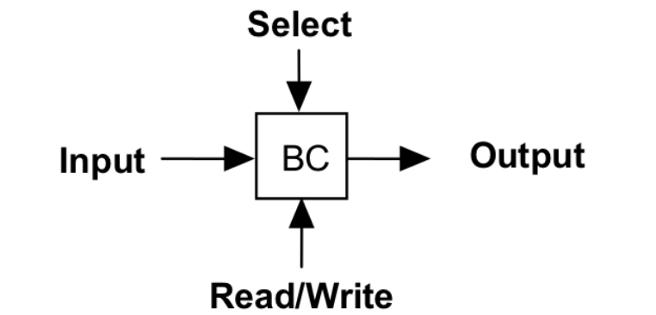

the following is the input – output table:

|  |  |  |  |  |
| --- | --- | --- | --- | --- |
| **Select** | R/W | Input | Q(t+1) | Output |
| 0 | X | X | Q(t) | 0 |
| 1 | 0 | X | Q(t) | Q(t) |
| 1 | 1 | 0 | 0 | 0 |
| 1 | 1 | 1 | 1 | 0 |

**Link of the TinkerCad Simulation:**

https://www.tinkercad.com/things/80Y8EbFZeh8-lab-7/editel?sharecode=2-_PeALUbAm6RMvgYTQ1zV43QCHe5RF7UBXkRXJCMyk