Implement a scroll behavior where the video uses sticky to pin to the top of the screen, keeping exactly 20% of its height visible as the user scrolls down.
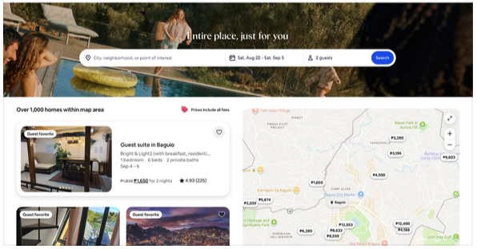

When a user clicks on a specific place, it should smoothly animate and expand to reveal more details (accordion style). Refer to the image below:
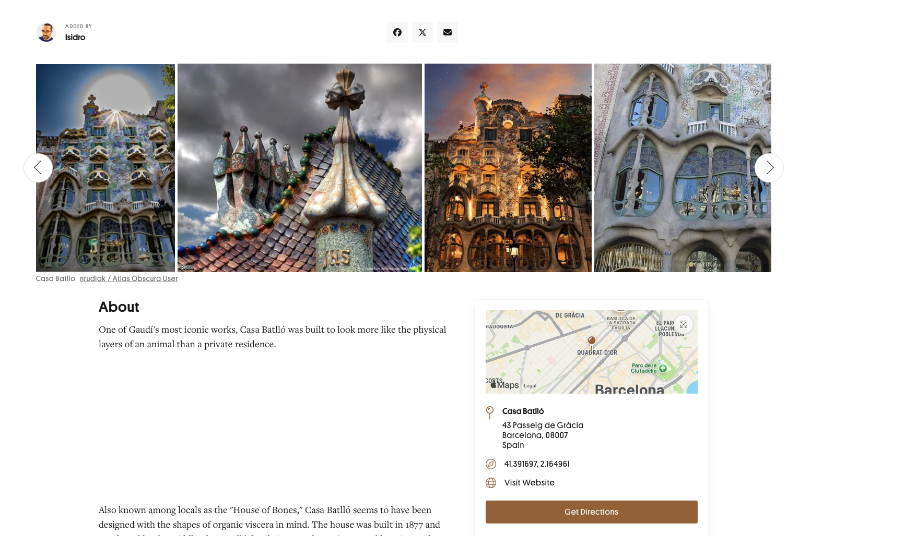
1. Fix Sticky Layout: Update the CSS so the sticky element remains fixed at approximately 20% of the screen height on scroll, ensuring the content/places below remain clearly visible and scrollable.
2. Data Expansion: Add a new, diverse selection of popular tourist destinations across Thailand to the places list.

