IMPLEMENTATION MANUAL · YRSACLICKS.COM · PRO PLAN
Migrating to yrsaclicks.com and Hosting Third-Party Domains
Cloudflare Workers · Custom Hostnames · DNS · Edge hardening
The end-to-end process for putting your customers' own domains, yrsaclicks.com, in front of your application, with Cloudflare terminating SSL and routing traffic into a Worker you control.
Field | Value
Prepared | 16 August 2026
Target domain | yrsaclicks.com
Current placeholder | arymsrv-coder.github.io/yrsaclicks/
Domain status | Registered; nameservers not yet pointed at Cloudflare
Zone plan | Pro
Workers plan | Workers Paid — required, see Phase 0
Site hosting after migration | Cloudflare Workers static assets
Customer CNAME target | customers.yrsaclicks.com
Application | Next.js static export (output: 'export', trailingSlash: true)

1. What you are building
Once the migration is done, one Cloudflare Worker does two jobs at once:
- It serves yrsaclicks.com itself — the Next.js static export, uploaded to Cloudflare as static assets, with no separate host involved.
- It serves your customers' domains — reading the Host header on each request to work out which tenant is being asked for.

For the second job, three things must be true before a customer's domain can serve over HTTPS:
- Their DNS points at you. A CNAME on their hostname resolves to customers.yrsaclicks.com. This is the only change they make, and they keep full ownership of the domain.
- Cloudflare holds a valid certificate for their hostname. Cloudflare for SaaS issues and auto-renews it at no cost, once control of the domain is proven.
- Cloudflare knows where to send the traffic. A fallback origin catches it, and a Worker route intercepts it before it ever leaves the edge.

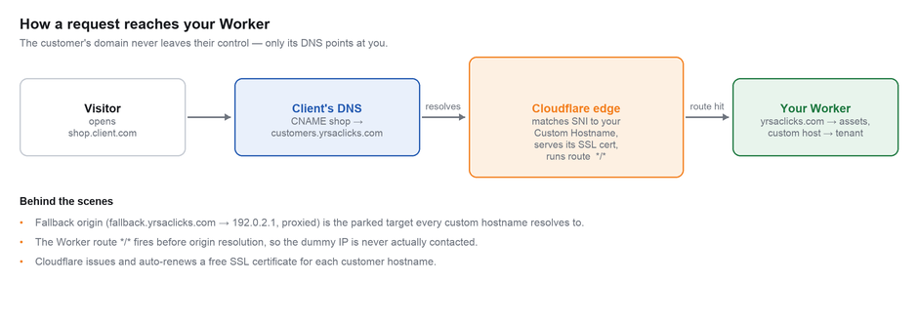
Figure 1 — the request path for a customer's custom hostname

Why there is a dummy IP address in this design
The fallback origin is mandatory: Cloudflare will not activate a custom hostname without one. But your application is a Worker — there is no server to point it at. So you create a DNS record pointing at 192.0.2.1, an address reserved by RFC 5737 for documentation which routes nowhere, mark it Proxied, and let the Worker route intercept first. The dummy IP is never contacted. Cloudflare calls this an "originless" record and recommends exactly this pattern.
The one behavior to know before you write any code
When a Worker route matches an incoming request, the per-hostname custom_origin_server setting is bypassed — the Worker runs before origin resolution. If different customers eventually need different backends, that decision must be made inside your Worker. Phase 3 shows how.

2. What your Pro subscription gives you
Pro does not change how any of this is configured — the steps are identical to what a Free account would follow. What Pro changes is what you may put in front of the traffic, and how far you can scale before anything breaks.

Cloudflare for SaaS entitlements
 | Your Pro plan | Enterprise
Custom hostnames included | 100 | Negotiated
Each additional hostname | $0.10 / month | Negotiated
Ceiling on hostnames | 50,000 | Custom
Cloudflare-issued SSL, auto-renewed | Included | Included
Non-SNI client support | Yes — Pro is where this starts | Yes
Customer-supplied certificates | No | Yes
Wildcard custom hostnames (*.client.com) | No | Yes
Per-hostname WAF rulesets (WAF for SaaS) | No | Yes
mTLS / client certificates | No | Yes

Edge controls Pro entitles you to
Capability | What it means once customer domains are live
Cloudflare Managed Ruleset (full WAF) | The complete managed ruleset rather than the Free subset, applied zone-wide — which includes yrsaclicks.com and every custom hostname.
WAF custom rules | Your own expression-based allow/block/challenge rules across all traffic.
Rate limiting rules | Per-IP or per-hostname request ceilings — the practical defence against one customer's domain being hammered and consuming everyone's Workers budget.
Super Bot Fight Mode | Categorised bot handling rather than the blunt Free-tier toggle.
Polish / image optimisation | Automatic WebP and AVIF conversion. Directly relevant here — this site is image and video heavy.
Enhanced analytics retention | Longer traffic and security history when a customer asks what happened to their domain last Tuesday.

Should you move to Enterprise?
With budget removed as a constraint the question is purely about capability. Four honest triggers, none of which are about cost or scale:
- A customer contractually requires their own certificate. Pro cannot upload a customer-supplied certificate; Enterprise can. The most common forcing function.
- You need wildcard custom hostnames. If customers expect *.client.com to work without registering each subdomain, Pro cannot do it.
- One customer needs security rules that differ from everyone else's. On Pro the WAF policy is zone-wide. Until a customer asks for something different from every other customer, zone-wide is genuinely sufficient.
- You need mTLS or per-hostname analytics to hand to customers. Both are Enterprise-gated.

Recommendation
Stay on Pro. None of the four triggers can be anticipated accurately in advance — they arrive attached to a specific customer with a specific requirement, and that is the right moment to open the Enterprise conversation, with a real deal behind you rather than a hypothetical.

Phase 0 · Migrate yrsaclicks.com onto Cloudflare
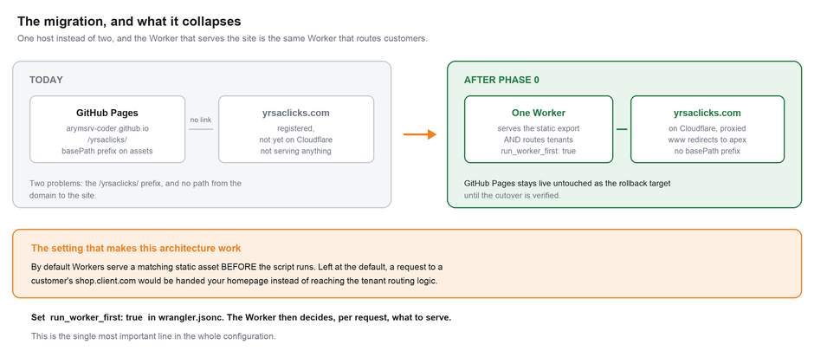
Nothing else in this manual is possible until this is done. Budget roughly half a day, most of which is waiting for nameservers.

Figure 2 — what the migration collapses, and the one setting that makes it work

0.1 Point the domain at Cloudflare
- In the Cloudflare dashboard choose Add a domain, enter yrsaclicks.com, and select the Pro plan.
- Cloudflare scans for existing DNS records and shows you two assigned nameservers.
- At your registrar, replace the current nameservers with the two Cloudflare gave you. This is the only registrar-side change in the entire migration.
- Wait for the zone status to read Active. Usually under an hour, occasionally up to 24. Nothing below works until it does.

0.2 Subscribe to Workers Paid
Go to Workers & Pages → Plans and subscribe before deploying anything. This is $5/month minimum and it is not optional for this architecture.

 | Workers Free | Workers Paid ($5/mo min)
Requests | 100,000 per day | 10 million per month included,  then $0.30 per additional million
CPU per invocation | 10 ms | Up to 5 minutes  (30 s default)
CPU included | — | 30 million CPU-ms per month,  then $0.02 per additional million
Static asset requests | Free | Free

Every request to yrsaclicks.com and to every customer domain passes through this Worker. On the Free plan, 100,000 requests per day is a ceiling shared across your entire customer base — and when you hit it, every domain fails at once, including your own. Static asset requests are free on both plans, but the Worker invocation in front of them is not.

0.3 Build the export without the GitHub Pages prefix
The application is already set up for this. next.config.ts reads basePath from NEXT_PUBLIC_BASE_PATH, and the GitHub Pages workflow is the only thing that sets it — the comments in the file say so explicitly. Building without that variable produces a root-mounted export, which is exactly what Workers wants.
# Confirm the variable is NOT set — this is the whole trick.
unset NEXT_PUBLIC_BASE_PATH

npm run build

# Produces ./out — verify no /yrsaclicks/ prefix survives:
grep -r "/yrsaclicks/" out/ | head
# expect no output. Any hit means the variable leaked into the build.

Check this before deploying, not after
The basePath prefix is baked into the bundle at build time — it is not something you can correct at the edge. If /yrsaclicks/ appears in the built HTML, every asset, video and stylesheet will 404 on the real domain, and the symptom is an unstyled page rather than an obvious error. The grep above takes two seconds and rules it out entirely.

0.4 Configure the Worker to serve the site
This is the configuration that carries the whole architecture. Create wrangler.jsonc at the repository root:
{
"$schema": "./node_modules/wrangler/config-schema.json",
"name": "yrsaclicks",
"main": "./worker/index.ts",
"compatibility_date": "2026-08-16",

"assets": {
"directory": "./out",
"binding": "ASSETS",

// Next's static export writes out/404.html.
"not_found_handling": "404-page",

// THE critical line — see the callout below.
"run_worker_first": true
}
}

run_worker_first: true is not optional here
By default, Cloudflare serves a matching static asset BEFORE your Worker script runs. That default is correct for an ordinary static site and completely wrong for this one: a request to a customer's shop.client.com would match your homepage asset and be served your landing page, never reaching the tenant routing logic at all.
Setting run_worker_first to true inverts the order, so the Worker sees every request first and decides what to serve. Get this wrong and Phase 3 appears to work in testing — because you are testing on yrsaclicks.com, where serving the asset is the right answer — and then fails for every customer.

0.5 Deploy
npx wrangler deploy

# Cloudflare gives you a workers.dev URL. Test the site there
# before any DNS points at it.

0.6 DNS records for the site
A Worker route only fires for a hostname that has a proxied DNS record in the zone. Since the Worker serves the response itself, these records use the same originless trick as the fallback origin — they exist to bring traffic into the zone, not to reach a server.

Type | Name | Value | Proxy status
A | @ | 192.0.2.1 | Proxied
A | www | 192.0.2.1 | Proxied
A | fallback | 192.0.2.1 | Proxied
CNAME | customers | fallback.yrsaclicks.com | Proxied

The last two are for customer domains and are covered in Phase 2 — creating them now saves a second trip through the DNS panel. Every one of these must be Proxied; a grey-cloud record sends traffic to a black-hole IP and returns a connection error.

0.7 Cut over and verify
- Add the Worker route */* as described in Phase 3, pointed at the yrsaclicks Worker.
- Load https://yrsaclicks.com and confirm the site renders with styles, images and video intact — not just that it returns 200.
- Check https://www.yrsaclicks.com redirects to the apex.
- Walk the routes: /, /members/, and a deliberately wrong URL to confirm the 404 page is served.
- Leave the GitHub Pages deploy live for a fortnight. It costs nothing and it is your rollback if something surfaces late.

What to retire, and when
Once yrsaclicks.com has been stable for a couple of weeks, remove the GitHub Pages workflow and the NEXT_PUBLIC_BASE_PATH plumbing from the repository. Leaving a second live copy of the site at a public URL invites it to drift out of date and get indexed by search engines as a duplicate. Do not remove it before then — it is doing useful work as a fallback.

3. Division of labour for customer domains
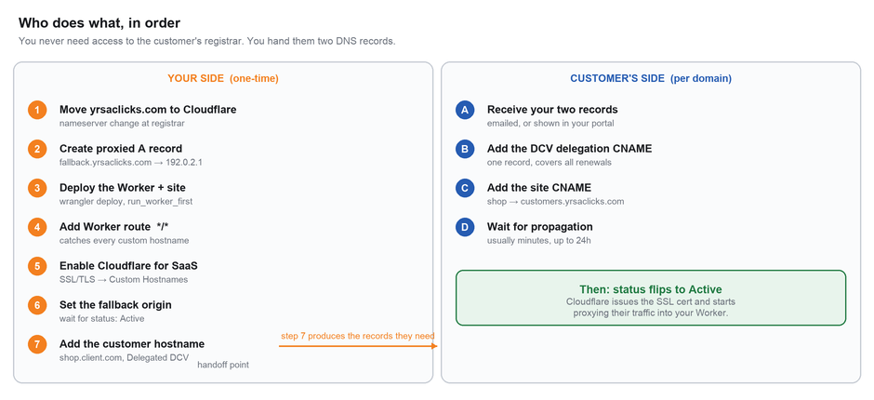
A recurring question: do you need to log into the customer's hosting or registrar account? No. You never need credentials on their end. You generate the DNS records and hand them over; they paste them into whatever provider they use — GoDaddy, Namecheap, Route 53, Cloudflare, anything.

Figure 3 — your one-time setup versus the per-customer handoff

Phase 1 · Decide the CNAME target
A short phase, but one that is expensive to revisit.
Every customer will point their domain at a single hostname on your domain, and it will sit in their DNS panel for as long as they are a customer. Changing it later means going back to every customer you have onboarded and asking them to edit a record — which is precisely the interaction you built a portal to avoid.

Recommended | Why
customers.yrsaclicks.com | Neutral, self-describing, survives any rebrand of the product itself. This is the convention Cloudflare uses in its own examples, and it is the value used throughout this manual.

- Avoid product or campaign names that might be renamed.
- Avoid anything that reads as internal infrastructure — customers see this and infer things from it.
- Avoid reusing fallback.yrsaclicks.com directly. Keeping the customer-facing name separate from the internal one is what lets you re-point your own infrastructure later without touching a single customer's DNS.

Phase 2 · Fallback origin
The destination all customer traffic resolves to before your Worker takes over. If you created the records in Phase 0.6 the first step is already done.

2.1 The originless record

Type | Name | IPv4 address | Proxy status
A | fallback | 192.0.2.1 | Proxied (orange cloud)

2.2 Register it as the fallback origin
- Go to SSL/TLS → Custom Hostnames.
- In the Fallback Origin section enter fallback.yrsaclicks.com and click Add Fallback Origin.
- Wait for the status to read Active. Custom hostnames added against a pending fallback origin will not activate.

2.3 The customer-facing CNAME target

Type | Name | Target | Proxy status
CNAME | customers | fallback.yrsaclicks.com | Proxied (orange cloud)

Official reference: Configuring Cloudflare for SaaS

Phase 3 · The Worker, doing both jobs
The Worker deployed in Phase 0 already serves yrsaclicks.com. This phase extends it to recognise customer hostnames, and adds the route that puts it in front of them.

3.1 The Worker
interface Env {
ASSETS: Fetcher;
TENANTS: KVNamespace;
}

const SITE = "yrsaclicks.com";

export default {
async fetch(request: Request, env: Env): Promise<Response> {
const url = new URL(request.url);
const host = (request.headers.get("host") ?? "").toLowerCase();

// www -> apex, once, permanently.
if (host === `www.${SITE}`) {
url.hostname = SITE;
return Response.redirect(url.toString(), 301);
}

// Your own site: hand straight to the static export.
if (host === SITE) {
return env.ASSETS.fetch(request);
}

// Anything else is a customer's custom hostname. hostMetadata is
// attached at creation time (Phase 5), so the common path costs
// no storage lookup at all.
const tenant =
(request as any).cf?.hostMetadata ??
(await env.TENANTS.get(host, { type: "json" }));

if (!tenant) {
return new Response("Domain not configured", { status: 404 });
}

// Serve the tenant however your product requires — the same static
// assets with tenant context, or a proxied fetch to their backend.
return env.ASSETS.fetch(request);
},
};

Hostname metadata is the fastest tenant lookup available: an arbitrary JSON blob attached to each custom hostname, delivered with the request and readable with no storage call. The KV fallback stays in the code because metadata changes take a short while to propagate after you set them.

3.2 The route
- In your zone, go to Workers Routes and click Add route.
- Set the route to */* and select the yrsaclicks Worker. Cloudflare documents this exact wildcard as the way to catch all traffic entering the zone including requests arriving on custom hostnames. You do not add a route per customer.

Route pattern | Worker
*/* | yrsaclicks

Why there are no exclusion routes here
A multi-host setup normally needs exclusions so the Worker does not swallow your API or dashboard traffic. You have none of those yet — the Worker is the only thing serving anything on this zone, and it handles yrsaclicks.com explicitly in the code above.
The moment you add a subdomain served by something else — api.yrsaclicks.com pointing at a real backend, say — add a route for it assigned to None, or extend the host check in the Worker. Whichever you choose, decide it deliberately rather than discovering it when the subdomain returns your homepage.
Official reference: Use a Worker as your origin

Phase 4 · Enable Cloudflare for SaaS
- Go to SSL/TLS → Custom Hostnames and click Enable Cloudflare for SaaS.
- Set the minimum TLS version. 1.2 is the correct floor in 2026. Going to 1.3 locks out a small tail of older clients on your customers' behalf — a decision to make deliberately, not by default.
- Set the default certificate validation method to Delegated DCV.
- Confirm the fallback origin from Phase 2 reads Active.

Validation method: use Delegated DCV
This decision determines how much work each customer does, and — more importantly — whether their certificate silently expires a year later.

Method | How it works | Customer effort | Verdict
Delegated DCV | Customer places one CNAME delegating _acme-challenge to Cloudflare, once. All future issuance and renewal happens automatically thereafter. | One record, ever | Use this. Cloudflare's own recommendation at scale.
TXT | Customer adds a TXT record proving control of the domain. | One record per hostname, plus renewals | Testing and one-off migrations only
HTTP | Cloudflare fetches a token over HTTP. Requires the hostname to already point at you. | None, but only works after the CNAME is live | Useful for a domain already pointed at you
Email | Validation email to the domain's registered contacts. | Someone must receive and click | Avoid

Why this matters more than it looks
TXT validation puts a renewal obligation on your customer. Renewals fail quietly — nobody notices until a browser shows a certificate error on the customer's live site, and the support ticket arrives blaming you. Delegated DCV moves that obligation to a single one-time record and then never involves the customer again.
Choose it now, with zero customers onboarded. Retrofitting it later means going back to every customer you have.
Official reference: Validate certificates

Phase 5 · Onboard a customer's domain
Everything so far was one-time. This phase repeats per customer domain.

5.1 Dashboard
- Go to SSL/TLS → Custom Hostnames → Add Custom Hostname.
- Enter the exact hostname, e.g. shop.client.com. It must match what visitors type, including www — client.com and www.client.com are two separate custom hostnames and both need registering if both are used.
- Confirm the validation method and minimum TLS version, then click Add Custom Hostname.
- Copy the records Cloudflare returns — these are what you hand the customer.

5.2 API — what a portal actually calls
For self-service the dashboard steps become one call. Create a scoped API token with SSL and Certificates → Edit on the yrsaclicks.com zone. Note custom_metadata: this is what the Worker reads as request.cf.hostMetadata, and setting it here removes the storage lookup from the hot path.
curl -X POST \
"https://api.cloudflare.com/client/v4/zones/$ZONE_ID/custom_hostnames" \
-H "Authorization: Bearer $CF_API_TOKEN" \
-H "Content-Type: application/json" \
-d '{
"hostname": "shop.client.com",
"ssl": {
"method": "txt",
"type": "dv",
"settings": { "min_tls_version": "1.2" }
},
"custom_metadata": {
"tenant_id": "4417",
"plan": "growth"
}
}'

5.3 The portal loop
- Customer types their domain into your dashboard.
- You POST the custom hostname with their tenant metadata, and store the returned id.
- You display the records with copy buttons and a "Check status" action.
- Poll GET /custom_hostnames/{id} until both status and ssl.status read active. That pair being active is the definition of production-ready — do not tell the customer they are live on either one alone.
- Show a green state, notify them by email, and start serving.

Instrument this from the first customer
The onboarding loop is where customers get stuck, and every stall becomes a support ticket. Log the transition timestamps for each hostname (created → validated → active) and alert on anything sitting in pending_validation for more than 24 hours. That single alert turns your most common support ticket into an email you send first.

Phase 6 · What the customer does on their end
Send them this. It is the whole of their job.

Type | Name / Host | Value / Target | Why
CNAME | shop | customers.yrsaclicks.com | Routes their traffic to your platform
CNAME | _acme-challenge.shop | shop.client.com.<id>.dcv.cloudflare.com | Delegated DCV — issues the certificate now and every renewal after, with no further action

Copy-paste email template
Subject: Connecting shop.client.com to your account

Hi <name>,

To point shop.client.com at your site, please add these two records
in your DNS provider (GoDaddy, Namecheap, Route 53, etc.). You keep
full ownership of the domain — this only changes where it resolves.

1) CNAME
Host: shop
Value: customers.yrsaclicks.com
Proxy: DNS only, if your provider offers the choice

2) CNAME
Host: _acme-challenge.shop
Value: <paste delegated DCV target>
Proxy: DNS only

The second record is what keeps your HTTPS certificate valid
automatically — add it once and renewals take care of themselves.

Changes usually take a few minutes, occasionally up to 24 hours.
We'll email you the moment the domain is live with HTTPS.

Thanks,
yrsaclicks

If the customer's DNS is itself on Cloudflare
Their records must be set to DNS only (grey cloud), not Proxied. Two Cloudflare zones both proxying the same hostname creates a resolution loop and the hostname will never activate. Put this in the portal UI, not just in the email — it is the single most common onboarding failure.

Phase 7 · Hardening on Pro
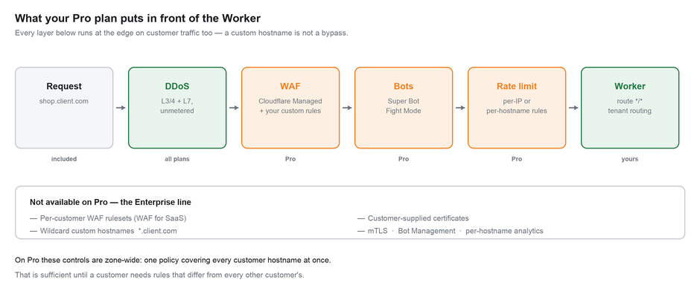
The substantive capability your subscription buys, and the part most platforms skip until an incident forces it. Rules configured at the zone level apply to yrsaclicks.com and to every custom hostname in it — a customer's domain is not a security bypass.

Figure 4 — the layers in front of your Worker, and where Pro stops

7.1 Turn on the managed ruleset
- Go to Security → WAF → Managed rules and deploy the Cloudflare Managed Ruleset. On Pro this is the full ruleset, not the Free subset.
- Deploy in Log mode first, for at least a week. A managed ruleset dropped straight into Block will eventually find a false positive in some customer's checkout flow, and you will hear about it from them rather than from your logs.
- Review the logged matches, add exceptions for legitimate patterns, then switch to Block.

7.2 Rate limiting — the one that actually saves you
A single customer's domain getting hammered consumes your Workers requests and degrades every other tenant, including yrsaclicks.com itself. Rate limiting on Pro caps this per hostname, which is the correct granularity for a multi-tenant platform.
# Security → WAF → Rate limiting rules → Create rule

Rule name: per-tenant request ceiling
If: (http.host ne "yrsaclicks.com")
Counting: by ip.src and http.host
Requests: 300
Period: 1 minute
Action: Managed Challenge
Duration: 10 seconds

Counting by both source IP and hostname means one abusive visitor on one customer's domain cannot exhaust a budget shared with every other tenant. Start with a ceiling well above real traffic, watch it for a fortnight, then tighten.

7.3 Super Bot Fight Mode
- Go to Security → Bots and enable Super Bot Fight Mode.
- Set Definitely automated to Block and Likely automated to Managed Challenge.
- Leave Verified bots allowed. Blocking these de-indexes yrsaclicks.com and every customer site from Google — far worse than the bot traffic saved.

7.4 Polish — worth turning on for this site specifically
This site is image and video heavy: a loading reel of nine stills, a hero clip, a slideshow. Polish converts images to WebP and AVIF automatically at the edge, which is a direct win on exactly the payload this site is dominated by, with no code change. Enable it under Speed → Optimization and measure the transfer size before and after.

7.5 Non-SNI support
Pro is where non-SNI support begins — clients too old to send Server Name Indication during the TLS handshake. A very small tail in 2026, but it costs nothing and removes a category of "it doesn't work on my old phone" report you cannot debug remotely.

Sequence this deliberately
Turn on one layer at a time and leave a week between each. If you enable the WAF, bot mode and rate limiting on the same afternoon and traffic breaks, you have three suspects and no way to tell which. On a multi-tenant platform the blast radius of a bad security rule is every customer at once.

8. Verification

8.1 After the Phase 0 migration
# Nameservers actually moved?
dig +short NS yrsaclicks.com
# expect two *.ns.cloudflare.com

# Site serving, and served by Cloudflare?
curl -sI https://yrsaclicks.com | grep -iE "^(HTTP|server|cf-)"

# www redirects to apex?
curl -sI https://www.yrsaclicks.com | grep -iE "^(HTTP|location)"

# Routes resolve, including the trailing-slash directory index?
curl -s -o /dev/null -w "%{http_code}\n" https://yrsaclicks.com/members/

# 404 page, not a Worker error?
curl -s -o /dev/null -w "%{http_code}\n" https://yrsaclicks.com/nope/

# No GitHub Pages prefix leaked into the deployed bundle?
curl -s https://yrsaclicks.com | grep -c "/yrsaclicks/"
# expect 0

8.2 Per onboarded customer domain
dig +short shop.client.com CNAME
# expect: customers.yrsaclicks.com.

dig +short CNAME _acme-challenge.shop.client.com
# expect: ....dcv.cloudflare.com.

openssl s_client -connect shop.client.com:443 \
-servername shop.client.com < /dev/null 2>/dev/null \
| openssl x509 -noout -subject -dates

curl -s -H "Authorization: Bearer $CF_API_TOKEN" \
"https://api.cloudflare.com/client/v4/zones/$ZONE_ID/custom_hostnames?hostname=shop.client.com" \
| jq '.result[0] | {status, ssl: .ssl.status}'
# both must read "active"

Troubleshooting
Symptom | Cause | Fix
Customer domain serves the yrsaclicks.com homepage | run_worker_first not set — the static asset matched before the Worker ran | Set "run_worker_first": true in the assets block of wrangler.jsonc and redeploy
Site loads unstyled, assets 404 | NEXT_PUBLIC_BASE_PATH leaked into the production build | Rebuild with the variable unset; grep out/ for /yrsaclicks/ before deploying
Zone stuck at pending | Registrar nameservers not updated, or not propagated | Re-check both nameservers at the registrar; allow up to 24 hours
Hostname stuck at pending_validation | Validation record missing, wrong, or not propagated | Re-check the record name — DNS panels often append the domain, producing _acme-challenge.shop.client.com.client.com
SSL error / certificate name mismatch | Certificate not issued, or the customer's record is proxied on their own Cloudflare zone | Confirm ssl.status is active; set their records to DNS only
522 or connection timeout | A DNS record is grey-cloud (DNS only) | Every record in this design must be Proxied
Worker never runs on custom hostnames | Route pattern too narrow (e.g. yrsaclicks.com/*) | Use */* — it is what catches custom hostnames
/members/ returns 404 | Directory index not resolving | Confirm trailingSlash: true is still set and out/members/index.html exists in the build
Customer reports blocked legitimate traffic | WAF managed ruleset false positive | Check Security → Events filtered by their hostname; add an exception rather than disabling the ruleset zone-wide
Sudden challenges on one domain | Rate limiting too tight, or Super Bot Fight Mode misclassifying | Filter Security Events by http.host; raise the ceiling or exempt the pattern
hostMetadata undefined in the Worker | Metadata set very recently, or hostname created without custom_metadata | Allow propagation time; keep the KV fallback path

9. Official Cloudflare documentation
Every link below is Cloudflare's own page for that step, including their current dashboard screenshots and exact wording. Where this manual and Cloudflare disagree, Cloudflare is right — dashboards and pricing change.

Topic | Link
Add a domain to Cloudflare | developers.cloudflare.com/fundamentals/manage-domains/add-site/
Workers static assets — binding | developers.cloudflare.com/workers/static-assets/binding/
Workers static assets — routing and run_worker_first | developers.cloudflare.com/workers/static-assets/routing/worker-script/
Wrangler configuration reference | developers.cloudflare.com/workers/wrangler/configuration/
Cloudflare for SaaS — get started | developers.cloudflare.com/cloudflare-for-platforms/cloudflare-for-saas/start/getting-started/
Cloudflare for SaaS — plans and pricing | developers.cloudflare.com/cloudflare-for-platforms/cloudflare-for-saas/plans/
Worker as your origin | developers.cloudflare.com/cloudflare-for-platforms/cloudflare-for-saas/start/advanced-settings/worker-as-origin/
Certificate validation methods | developers.cloudflare.com/cloudflare-for-platforms/cloudflare-for-saas/security/certificate-management/issue-and-validate/validate-certificates/
Delegated DCV | developers.cloudflare.com/ssl/edge-certificates/changing-dcv-method/methods/delegated-dcv/
Custom Hostnames API reference | developers.cloudflare.com/api/resources/custom_hostnames/
Workers routes | developers.cloudflare.com/workers/configuration/routing/routes/
Workers pricing | developers.cloudflare.com/workers/platform/pricing/
WAF — getting started | developers.cloudflare.com/waf/get-started/
Rate limiting rules | developers.cloudflare.com/waf/rate-limiting-rules/
Bot protection by plan | developers.cloudflare.com/bots/get-started/
Next.js static exports (in-repo) | node_modules/next/dist/docs/01-app/02-guides/static-exports.md

Summary checklist
 | Step
☐ | yrsaclicks.com nameservers pointed at Cloudflare, zone Active on Pro
☐ | Workers Paid subscribed
☐ | npm run build with NEXT_PUBLIC_BASE_PATH unset
☐ | grep out/ for /yrsaclicks/ returns nothing
☐ | wrangler.jsonc assets block written, run_worker_first: true
☐ | wrangler deploy, tested on the workers.dev URL
☐ | Proxied A records for @, www and fallback → 192.0.2.1
☐ | Proxied CNAME customers → fallback.yrsaclicks.com
☐ | Worker route */* added
☐ | yrsaclicks.com loads with styles, images and video intact
☐ | www redirects to apex; /members/ and the 404 page both resolve
☐ | GitHub Pages left live as rollback for two weeks
☐ | Cloudflare for SaaS enabled, minimum TLS 1.2
☐ | Fallback origin set and showing Active
☐ | Delegated DCV set as the default validation method
☐ | First customer hostname added, both statuses reading active
☐ | WAF managed ruleset deployed in Log mode
☐ | WAF switched to Block after a week of clean logs
☐ | Rate limiting rule counting by ip.src and http.host
☐ | Super Bot Fight Mode on, verified bots still allowed
☐ | Polish enabled and transfer size measured
☐ | GitHub Pages workflow and basePath plumbing removed from the repo

