1 8.1 0.2026, 1 4:1 5 ITS61 504 Assignment 1 - Case Study (finaI) (1 ) - GoogIe ğoKyMeHTl



SCHOOL OF COMPUTER SCIENCE
ITS61504 Data Mining

INDIVIDUAL ASSIGNMENT
HAND IN DATE AND TIME: 12 October 2026, 11:59 PM
Instructions to students:
- The assignment should be attempted individually
- Complete this cover sheet and attach it to your submission — this should be your first page.
Module Learning Outcome:
MLO1 - Demonstrate the ability to preprocess and explore datasets to uncover patterns and insights for a given scenario.

Student declaration:
Ideclare that:
- Iunderstand what is meant by plagiarism.
- The implications ofplagiarism and the use ofgenerative AItools have been explained to me by my lecturer.
This assignment is entirely my own work, and Ihave acknowledged any use ofthe published or unpublished works ofother people.
NAME
Name | Student ID
1. Student Name: Arina Bayramova | 0387765

Do not copy andpaste content into your report; this is considered plagiarism. Plagiarism in any form is forbidden, and students who submit plagiarised work will receive 0 marks.

Assessment Criteria

Assessment Task | Weightage | MLO  Assessed | Assessment Instrument | Topics | Week | MQF 2.0
Case Study MLO1 | 30% | 1 | N/A | 1 -2 | 4 | C3C

https://docs.googIe.com/document/d/1 GvxNY„IVE4cpIGN„em2Dd5r5R9zjuof9MWn9IAyY244/edit?tab=t.0 1 /4

ITS61504 DATA MINING
Individual Assignment

Uncovering Clinical Patterns Associated with Respiratory Outcomes in Very-Low-Birth-Weight Infants

Introduction and Background of the Study
As a student specialising in data analytics, I was interested in exploring a topic that connects data mining with a real-world healthcare problem. During the topic selection process, I wanted to investigate an area beyond conventional business datasets and explore how analytical methods could be applied to clinical data. Discussions with my sister also encouraged me to consider neonatal health as a meaningful area of study. This led to an interest in very-low-birth-weight infants and the respiratory outcomes they may experience during their early development.
Bronchopulmonary dysplasia (BPD) is an important respiratory outcome among premature and very-low-birth-weight infants. One commonly used definition of BPD considers the need for respiratory support or supplemental oxygen at 36 weeks postmenstrual age. A systematic review and meta-analysis reported a pooled prevalence of 21% for BPD defined at 36 weeks across 70 studies involving 672,769 neonates (Moreira et al., 2024). The same study also found that birth-weight and gestational-age categories were important factors influencing BPD prevalence. The development of BPD is influenced by multiple clinical and perinatal characteristics. Previous research has investigated factors such as gestational age, premature rupture of membranes, sex, hypertensive disorders of pregnancy, and other clinical characteristics in relation to BPD (Xiong et al., 2025).
This study uses the PreMo dataset, a de-identified clinical and vital-sign dataset of very-low-birth-weight infants from four neonatal intensive care units (German Mesner, 2026). The dataset contains REDCap clinical data together with demographic, perinatal, and outcome information. In this study, the primary outcome is BPD at 36 weeks, represented by the bpd_36_weeks variable. Selected clinical and perinatal variables are analysed through data preprocessing, exploratory analysis, and classification modelling to investigate patterns associated with the outcome and determine which variables contribute most strongly to prediction.

Problem Statement
Very-low-birth-weight infants are at increased risk of respiratory complications, including bronchopulmonary dysplasia (BPD). Although clinical and perinatal information is routinely collected for these infants, identifying meaningful patterns across multiple variables can be challenging. The PreMo dataset contains a range of demographic, perinatal, and clinical characteristics that may be associated with BPD at 36 weeks. However, the presence of multiple numerical and categorical variables, together with missing observations, creates a data-mining challenge when attempting to distinguish infants with and without the outcome.
Therefore, the data-mining problem addressed in this study is to investigate whether selected demographic and perinatal characteristics can be used to classify very-low-birth-weight infants according to their BPD status at 36 weeks. The study also seeks to determine which variables contribute most strongly to the classification and to compare the predictive performance of different classification approaches.

Objectives
- To preprocess and prepare the PreMo clinical dataset by integrating relevant demographic and outcome information, handling missing values, and defining an analytical sample of very-low-birth-weight infants with known BPD status at 36 weeks.
- To explore and identify patterns and relationships between BPD status and selected demographic, perinatal, and clinical characteristics, including gestational age, birth weight, Apgar scores, delivery-related factors, and IVH grade.
- To develop and compare classification models, including Logistic Regression, Decision Tree, Random Forest, and XGBoost, using Accuracy, Recall, Precision, F1 - score, and ROC-AUC as evaluation metrics.
- To identify the most influential predictors associated with BPD classification using XGBoost feature importance and interpret the observed patterns in the context of the study population.

Literature Review
Bronchopulmonary dysplasia (BPD) is an important respiratory outcome associated with prematurity, and previous research has investigated clinical characteristics and prediction models to better understand the factors associated with this condition. Peng et al. (2022) reviewed existing BPD prediction models and found that birth weight, gestational age, and sex were among the most frequently used predictors. However, the authors also identified limitations in the development and evaluation of these models, including inadequate handling of missing data, limited internal validation, and insufficient assessment of model calibration.
Further evidence of these methodological challenges was reported by Romijn et al. (2023). Their systematic review and meta-analysis examined studies involving the development and external validation of BPD prediction models. Although the models demonstrated varying levels of predictive performance, the authors identified a high risk of bias across the included studies, particularly due to limitations in their statistical analyses. They emphasised the need for improved methodology, more complete reporting, and further validation before these models can be considered for clinical practice.
Similarly, Kwok et al. (2023) reviewed 64 studies involving 274,407 infants and found that 97% of the included studies had a high risk of bias. Their findings highlight the importance of evaluating prediction models not only by their performance metrics but also by their reliability and ability to generalise to other populations. Collectively, these reviews indicate that data-driven approaches can help investigate BPD-related patterns, but their findings should be interpreted cautiously.
Building on this previous research, the present study uses the PreMo dataset, which contains de-identified clinical and vital-sign data from very-low-birth-weight (VLBW) infants across four neonatal intensive care units (Mesner et al., 2026). The study applies data preprocessing and exploratory data analysis to examine the relationships between selected demographic and perinatal characteristics and BPD status at 36 weeks. Logistic Regression, Decision Tree, Random Forest, and XGBoost are then compared using a consistent analytical dataset and evaluation metrics. This approach provides an exploratory data-mining perspective on the classification of BPD status while recognising that predictive associations do not establish causation or clinical suitability.

BPD and Clinical Factors
Previous research has identified several clinical and perinatal characteristics associated with bronchopulmonary dysplasia (BPD) in preterm infants. Gestational age and birth weight are considered important factors because infants born earlier and with lower birth weight may be more vulnerable to respiratory complications. A systematic review and meta-analysis by Xiong et al. (2025) also identified other factors associated with BPD, including male sex, premature rupture of membranes (PROM), and hypertensive disorders of pregnancy. These findings suggest that BPD is associated with a combination of infant characteristics and maternal or perinatal factors.
Previous studies have also examined how clinical characteristics can be used to predict BPD in preterm infants. Onland et al. (2013) reviewed 26 clinical prediction models and externally validated eligible models using an independent dataset. The predictive performance varied, with AUC values ranging from 0.50 to 0.76 among the 19 models that could be evaluated.
Only two of the five models with the best discrimination showed good calibration. Similarly, Peng et al. (2022) found that birth weight, sex, and gestational age were among the most frequently used predictors in existing BPD prediction models. However, their review also identified methodological limitations, including inadequate handling of missing data and limited validation. These findings demonstrate the importance of careful data preprocessing and reliable model evaluation when analysing clinical datasets.
Kwok et al. (2023) further investigated the reliability of BPD prediction models in a systematic review and meta-analysis involving 64 studies and 274,407 infants. The authors found that 97% of the included studies had a high risk of bias, particularly in their statistical analyses. They also reported that some models showed poor calibration even when their ability to distinguish between infants with different outcomes was acceptable. This highlights the importance of assessing multiple aspects of model performance rather than relying on accuracy alone. Careful preprocessing, appropriate validation, and critical interpretation of evaluation metrics are therefore important when analysing clinical data.
Based on these findings, the present study examines selected demographic and perinatal characteristics in the PreMo dataset to explore their associations with BPD status at 36 weeks. The selected variables include gestational age at birth, birth weight, sex, delivery mode, and other maternal or delivery-related characteristics. Exploratory data analysis is conducted to identify patterns in the dataset, followed by classification using Logistic Regression, Decision Tree, Random Forest, and XGBoost. By comparing these models using the same analytical dataset and evaluation metrics, this study aims to explore how different data-mining techniques classify BPD outcomes. The results are interpreted as exploratory findings rather than evidence of causation or clinical suitability.

Machine Learning for BPD Prediction
Machine learning and statistical prediction models have been increasingly investigated to identify preterm infants at risk of bronchopulmonary dysplasia (BPD). Hwang et al. (2023) developed a two-stage machine learning approach using data from a nationwide cohort of very-low-birth-weight infants. Their study investigated the prediction of BPD and its severity using prenatal and early postnatal variables, including information related to respiratory support. Similarly, Choi et al. (2025) developed and externally validated a machine learning model that combined static perinatal characteristics with dynamic clinical factors, including respiratory support, inspired oxygen concentration, and blood gas measurements during the first seven days after birth. Their findings showed that incorporating dynamic clinical information improved predictive performance compared with using static perinatal factors alone. These studies demonstrate how machine learning can be used to investigate BPD prediction and evaluate the contribution of different types of clinical information.
Broader perspectives on these approaches were provided by McOmber et al. (2024), who reviewed the development and application of predictive analytics in BPD research. Their review discussed the use of statistical and machine learning methods for risk prediction, as well as challenges related to data bias, model complexity, interpretability, and clinical implementation. In addition, X. Zhang et al. (2025) reviewed the application of artificial intelligence and multimodal data integration to BPD prediction, including the potential use of clinical information, physiological signals, imaging, biomarkers, and other data sources.
Together, these studies highlight the potential of machine learning for clinical prediction while emphasising that model reliability, interpretability, and practical implementation remain important considerations. Previous research has also identified limitations such as missing data, overfitting, limited external validation, and differences in performance across studies. These limitations support the need to evaluate classification approaches carefully and avoid assuming that a model will perform equally well in different clinical settings.
Different classification algorithms provide different approaches to identifying patterns in clinical data. Logistic Regression was selected as a baseline because it provides a relatively simple and interpretable approach to classification. Decision Tree was included because it can represent classification decisions through a series of rules, while Random Forest combines multiple decision trees to improve the robustness of predictions. XGBoost was selected as a more advanced ensemble method that builds trees sequentially to improve predictive performance. Comparing these approaches allows the study to examine whether more complex tree-based methods provide better classification performance than a simpler baseline model.

Research Gap
Previous studies have investigated clinical risk factors for bronchopulmonary dysplasia (BPD) and developed prediction models using statistical and machine learning approaches. However, systematic reviews have identified limitations in the quality, validation, and reliability of existing prediction models (Kwok et al., 2023; Romijn et al., 2023). Recent studies have also explored different machine learning approaches using various combinations of clinical variables. For example, Choi et al. (2025) investigated the use of dynamic postnatal information, while H. Zhang et al. (2025) examined machine learning models in a specific high-altitude clinical setting. Although these studies demonstrate the potential of machine learning for BPD prediction, differences in study populations, available predictors, and modelling approaches highlight the need to evaluate model performance in the context of the dataset being analysed.
The present study addresses this need by analysing the PreMo dataset, which contains clinical and demographic information from very-low-birth-weight infants across four neonatal intensive care units. Rather than developing a clinical prediction tool, this study focuses on preprocessing the available data, exploring associations between selected demographic and perinatal characteristics and BPD status at 36 weeks, and comparing four classification algorithms: Logistic Regression, Decision Tree, Random Forest, and XGBoost. By evaluating these models using the same analytical dataset and performance metrics, the study provides a structured comparison of their classification performance. It also identifies patterns within the available data while recognising limitations related to missing information, predictor selection, and moderate predictive performance. The findings therefore provide an exploratory analysis rather than evidence of clinical readiness or generalisability to other populations.

Explainability and Transparency in Clinical Machine Learning
Explainability and transparency are important considerations when applying machine learning methods to healthcare data. Allgaier et al. (2023) reviewed the use of explainability methods in healthcare and found that many machine learning studies did not provide specific explanations of how their models generated predictions. This is particularly relevant when analysing clinical data, because understanding the factors that influence model predictions can help researchers interpret the results more carefully. In the present study, XGBoost feature importance is used to identify variables that contribute to the model's predictions.
However, feature importance indicates the contribution of a variable to the model and should not be interpreted as evidence that the variable causes BPD.
Collins et al. (2024) introduced the TRIPOD+AI statement, which provides updated recommendations for reporting clinical prediction model studies that use statistical or machine learning methods. The guidance highlights the importance of transparent reporting so that readers can understand how prediction models were developed and evaluated. In this

study, describing the dataset, preprocessing procedures, selected predictors, classification algorithms, and evaluation metrics supports transparency and helps readers understand the analytical process. Nevertheless, transparent reporting alone does not establish that a model is reliable or suitable for clinical use.
Another important methodological concern is data leakage, which occurs when information that should not be available during model training influences the training process or evaluation results. Kapoor and Narayanan (2023) discussed how data leakage can produce overly optimistic findings and affect the reproducibility of machine learning research. To reduce this risk, the present study uses a train-test split and fits preprocessing transformations on the training data only before applying them to the test data. This approach helps ensure that the test set remains separate during model fitting and provides a more appropriate assessment of performance on unseen data.
Finally, Riley et al. (2024) emphasised the importance of external validation when evaluating clinical prediction models. Although a held-out test set can provide an internal assessment of model performance, it does not demonstrate that a model will perform equally well in other hospitals or patient populations. In the present study, the test set is used to compare the classification performance of the four selected algorithms. Further evaluation using independent clinical datasets would be required to establish external validity and assess whether the models could be generalised to other clinical settings.

Methods
This study follows a data mining workflow consisting of data preparation, preprocessing, exploratory data analysis and classification modelling. The clinical datasets were first integrated to create a suitable analytical dataset. Relevant demographic and perinatal variables were then selected as predictors, followed by preprocessing of numerical and categorical variables. Several classification models were developed and compared using selected performance metrics to investigate their ability to classify BPD status at 36 weeks.

Dataset Description
This study uses the PreMo dataset, a de-identified clinical and vital sign dataset of very-low-birth-weight infants collected from four neonatal intensive care units. The dataset contains demographic, perinatal, clinical and outcome information. In this study, the dataset was used to investigate clinical and perinatal patterns associated with bronchopulmonary dysplasia (BPD) at 36 weeks.
The Demographic and Perinatal table contained 6,837 observations and 34 variables, while the Discharge and Outcomes table contained 6,565 observations and 26 variables. The two tables were linked using the de-identified subject number as the common identifier for each infant.

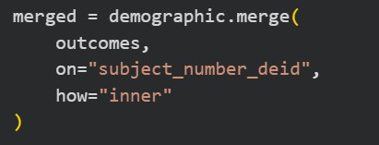
An inner join was used to retain observations available in both tables, resulting in a merged dataset containing 6,565 observations and 59 variables.
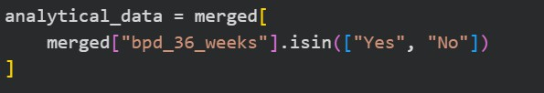
For the primary analysis, only infants with a known BPD status were retained. Observations recorded as “Unknown” or missing for bpd_36_weeks were excluded, resulting in an analytical sample of 3,917 infants. Among these observations, 2,265 infants were classified as not having BPD and 1,652 infants were classified as having BPD at 36 weeks. The resulting analytical sample was subsequently used for exploratory analysis and classification modelling.

Data Preparation and Feature Selection
Following the creation of the analytical dataset, a total of nine predictor variables were selected for the classification models. The selected features included four numerical variables and five categorical variables. This combination was used to represent different aspects of the infants' demographic, clinical, and delivery-related characteristics.
The four numerical features were gestational age at birth, birth weight, Apgar score at 1 minute, and Apgar score at 5 minutes. Gestational age and birth weight provide information about the infant's maturity and size at birth, while the Apgar scores provide information about the infant's condition shortly after delivery. These variables were included as measurable clinical characteristics that may help distinguish infants with different BPD outcomes.
The five categorical features were delivery mode, gender, multiple birth status, premature pre-labour rupture of membranes (PPROM), and indication for delivery. These variables represent demographic and delivery-related characteristics that may provide additional information when distinguishing between infants with and without BPD. Including both
numerical and categorical features allows the classification models to consider different types of information within the analytical dataset.

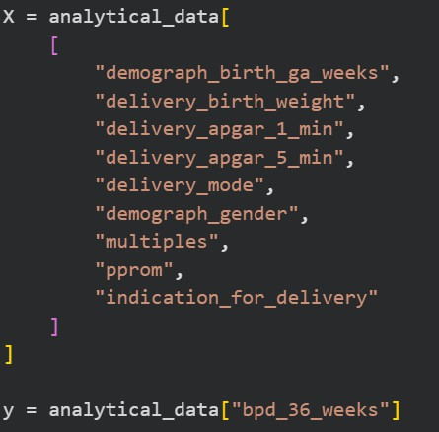

The bpd_36_weeks variable was defined as the target variable, while the nine selected features were used as predictors. Intraventricular haemorrhage (IVH) grade was examined separately during exploratory data analysis and was not included in the primary classification models. This allowed the primary analysis to focus on the selected demographic and perinatal characteristics.

Data Preprocessing
Before developing the classification models, the selected predictor variables were preprocessed to ensure that the data were in a suitable format for modelling. Different preprocessing steps were applied to numerical and categorical features because the two types of variables require different forms of preparation. The preprocessing procedure included handling missing values, encoding categorical variables and standardising numerical variables.

Missing values in numerical features were handled using median imputation, while missing values in categorical features were replaced using the most frequent category. Median imputation was selected for numerical variables because it is less sensitive to extreme values than the mean, while the most frequent category provides a simple approach for completing missing categorical observations.

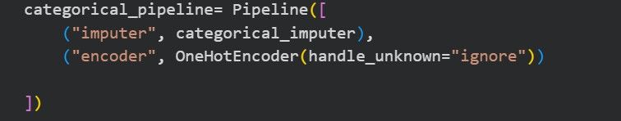

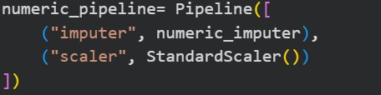

The numerical preprocessing pipeline combined imputation with standardisation using StandardScaler. Categorical variables were first imputed and then converted into numerical representations using one-hot encoding. The handle_unknown="ignore" option was used to prevent errors when previously unseen categories were encountered during testing.



A ColumnTransformer was used to apply the appropriate preprocessing steps to each feature type. This ensured that numerical and categorical variables were preprocessed separately within a consistent preprocessing workflow.

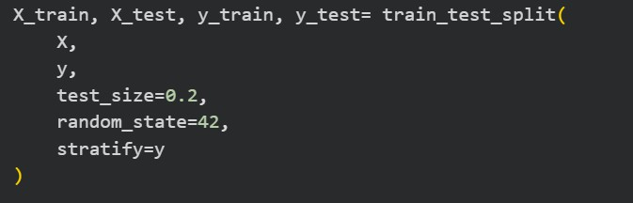

The analytical dataset was divided into training and testing sets using an 80:20 split. Stratified sampling was applied to preserve the proportion of BPD outcomes in both sets. The training data were used to fit the preprocessing steps and classification models, while the test data were reserved for evaluating model performance.
The preprocessing operations were organised using pipelines to ensure that transformations were applied consistently. By fitting the preprocessing transformations on the training data only and then applying them to the test data, the study reduced the risk of data leakage between the training and testing datasets.

Classification Models
Four classification models were developed to investigate whether the selected demographic and perinatal features could be used to classify infants according to their BPD status at 36 weeks. The models were selected to provide a comparison between a relatively simple statistical approach and tree-based classification methods. Logistic Regression was used as the baseline model, followed by a Decision Tree, Random Forest, and XGBoost.

Logistic Regression
Logistic Regression was used as a baseline classification model because it provides a relatively simple and interpretable approach for modelling a binary outcome. In this study, it was used to establish a baseline against which the performance of the tree based models could be compared.

Decision Tree
A Decision Tree was included because it can represent classification decisions through a sequence of decision rules. An initial Decision Tree was developed and its performance was assessed. A second version with a maximum depth of five was then used to reduce model complexity and examine whether limiting the tree depth could improve generalisation to unseen data.

Random Forest
Random Forest was included as an ensemble method that combines multiple decision trees to produce predictions. In this study, the model was configured with 100 trees and a fixed random state to provide reproducible results.

XGBoost
XGBoost was included as an advanced tree-based ensemble method that builds decision trees sequentially to improve predictive performance. The model was configured with 100 estimators and evaluated using the same test data and performance metrics as the other classification models. This allowed its performance to be compared consistently with the baseline model and the other tree-based approaches.

Evaluation Metrics
The performance of the classification models was evaluated using Accuracy, Precision, Recall, F1-score and ROC-AUC. These metrics were selected to provide a broader assessment of model performance rather than relying on accuracy alone.
Accuracy measures the proportion of correctly classified observations out of all observations. Precision measures the proportion of observations predicted as BPD that were actually

classified as BPD, while Recall measures the proportion of infants with BPD that were correctly identified by the model. F1-score provides a balance between Precision and Recall. ROC-AUC was used to assess the model’s ability to distinguish between infants with and without BPD across different classification thresholds.
The same evaluation metrics and test dataset were used for all classification models to allow a consistent comparison of their performance.

Preprocessing and Exploratory Analysis
This section presents the data preparation and exploratory analysis conducted on the PreMo dataset, followed by the results of the classification models. The analysis examines the distribution of BPD outcomes, explores relationships between selected clinical and perinatal characteristics and BPD status, and investigates missing values and data quality. The classification results are then compared using several performance metrics, followed by an examination of model overfitting and feature importance.

Data Preparation and Outcome Distribution
After merging the Demographic and Perinatal table with the Discharge and Outcomes table, the resulting dataset contained 6,565 observations and 59 variables. Records with unknown or missing values for the bpd_36_weeks outcome were excluded, leaving an analytical sample of 3,917 infants with a known BPD status. This analytical sample was used for the subsequent exploratory analysis and classification modelling.

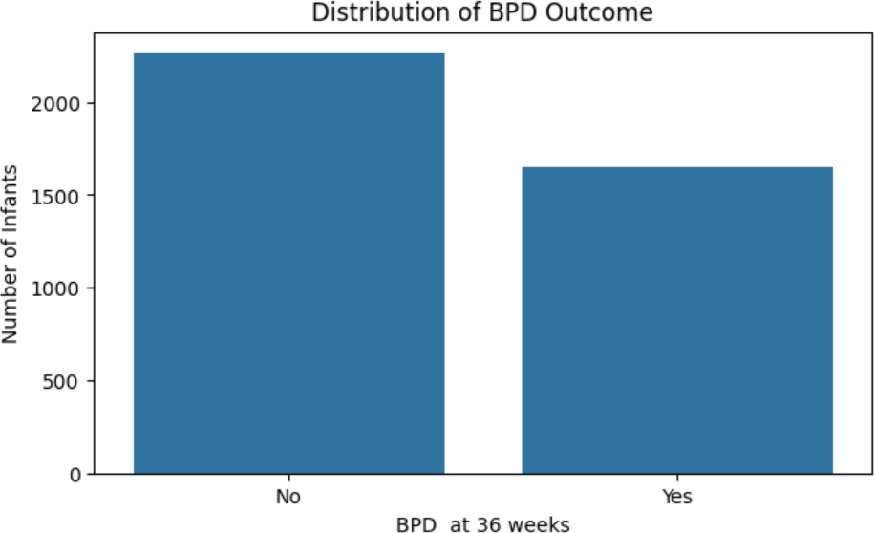

Figure 1. Distribution of BPD Outcomes at 36 weeks

Figure 1 illustrates the distribution of BPD outcomes in the analytical sample. Of the 3,917 infants included in the analysis, 2,265 (57.8%) were classified as not having BPD, while 1,652 (42.2%) were classified as having BPD. Although the non-BPD group was larger, both outcome categories were represented in the dataset for the subsequent exploratory analysis and classification modelling.

Exploratory Analysis of Clinical Characteristics
Gestational age was examined to explore its relationship with BPD status at 36 weeks. The mean gestational age was approximately 28.08 weeks for infants without BPD and 26.19 weeks for infants with BPD. This indicates that infants in the BPD group were born at lower gestational age on average than those in the non-BPD group. The observed pattern suggests an association between lower gestational age and BPD status in the analytical sample.
However, this descriptive finding does not establish a causal relationship.

Birth weight was also examined to investigate differences between infants with and without BPD. The mean birth weight was approximately 1093.8 grams for infants without BPD and
859.1 grams for infants with BPD. This shows that infants in the BPD group had a lower mean birth weight in the analytical sample. The result suggests that lower birth weight was associated with BPD status in the dataset. As with gestational age, this observed association should not be interpreted as evidence of causation.

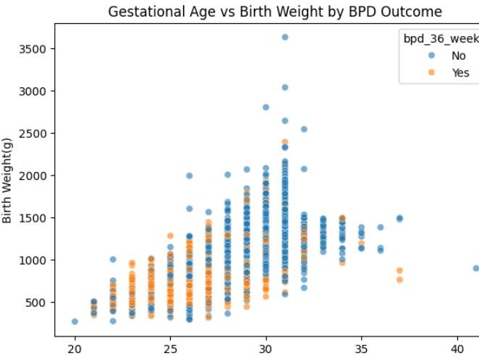

Figure 2. Relationship Between Gestational Age, Birth Weight and BPD Outcome

The scatter plot illustrates the relationship between gestational age at birth and birth weight, with observations distinguished by BPD status at 36 weeks. Overall, birth weight tends to increase with gestational age in the analytical sample. However, the two BPD outcome groups overlap considerably, indicating that these two variables alone do not clearly separate infants with and without BPD. This supports examining the variables together with other demographic and perinatal characteristics during classification modelling.

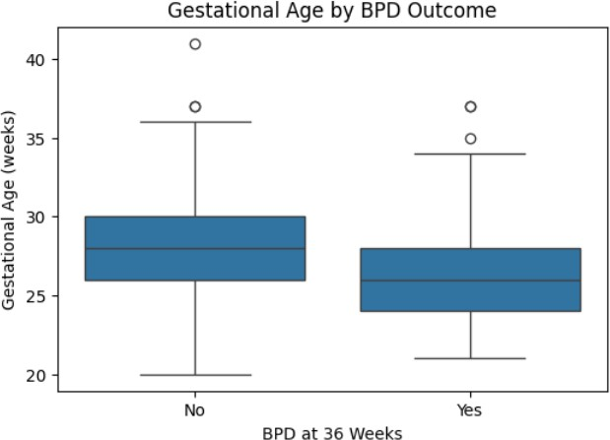

Figure 3. Distribution of Gestational Age by BPD Outcome
The boxplot compares the distribution of gestational age at birth between infants who developed BPD and those who did not. The median gestational age was approximately 26 weeks in the BPD group, compared with approximately 28 weeks in the non-BPD group. The BPD group also shows a different spread of gestational age values. Overall, the graph suggests an association between lower gestational age at birth and BPD in the analysed sample. However, this descriptive finding does not establish a causal relationship.

Missing Data and Data Quality
Missing values were examined to assess the completeness of the selected variables in the analytical dataset. The analysis showed the amount of missing data varied across variables. PPROM and indication for delivery had the highest proportions of missing values among the selected predictors, approximately 16.16% and 15.96% respectively. Missing values were less common in birth weight, delivery mode and gender, while gestational age had no missing values in the analytical sample.
To prepare the data for classification modelling, missing numerical values were replaced using the median, while missing categorical values were replaced using the most frequent category. These imputation methods allowed the selected predictors to be retained in the modelling process rather than removing all observations containing missing values. The preprocessing steps were implemented within the modelling pipeline to ensure consistent treatment of the training and testing data.

During data quality assessment, some observations showed gestational age and birth-weight values outside the typical ranges expected for very-low-birth-weight infants. These observations were retained because there was insufficient evidence to classify them as data-entry errors. This approach avoided removing potentially valid observations solely because their values appeared unusual.

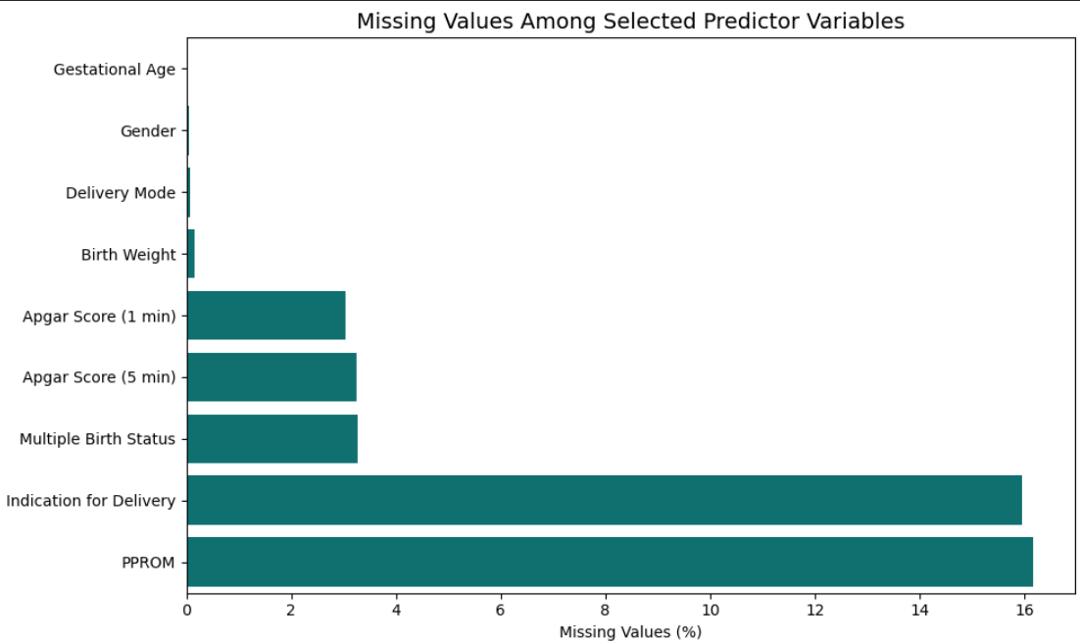

Figure 4. Missing Values Among Selected Predictor Variables

Figure 4 presents the percentage of missing values among the nine selected predictor variables. The graph shows clear differences in data completeness across the variables, with PPROM and indication for delivery having the highest proportions of missing values. In contrast, gestational age had no missing values, while birth weight, delivery mode, and gender had very few missing observations. These differences highlight the importance of applying appropriate preprocessing methods before classification modelling.

Classification Model Performance
The performance of the four classification models was evaluated using Accuracy, Precision, Recall, F1-score and ROC-AUC. The results are presented in Table 1 and compared visually in Figure 5.

Model | Accuracy (%) | Precision (%) | Recall(%) | F1-score(%) | ROC-AUC (%)
Logistic Regression | 63.39 | 57.05 | 53.78 | 55.37 | 67.39
Tuned Decision Tree | 64.03 | 58.31 | 51.96 | 54.90 | 66.19
Random Forest | 62.76 | 55.96 | 55.29 | 55.62 | 67.27
XGBoost | 60.33 | 52.84 | 56.19 | 54.47 | 65.91

Table 1. Classification Model Performance Comparison

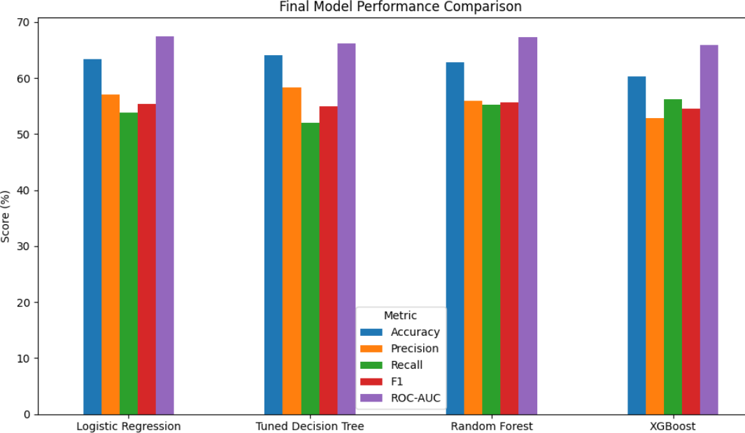

Figure 5. Final Model Performance Comparison

Figure 5 compares the performance of the four classification models across five evaluation metrics. The tuned Decision Tree achieved the highest Accuracy (64.03%) and Precision

(58.31%), while Random Forest obtained the highest F1-score (55.62%). XGBoost achieved the highest Recall (56.19%), whereas Logistic Regression recorded the highest ROC-AUC (67.39%).
These results indicate that model performance varied across the evaluation metrics, with no single model outperforming all others in every category. Overall, the models demonstrated moderate classification performance. This suggests that the selected demographic and perinatal characteristics provided some predictive information about BPD status at 36 weeks, although their ability to distinguish between infants with and without BPD remained limited.

Overfitting and Model Generalisation
The initial Decision Tree showed a substantial difference between training and testing performance. Its training accuracy was 99.87%, while the test accuracy was only 54.21%. This large gap indicates overfitting, meaning that the model fitted training data very closely but did not generalise well to unseen observations. To address this issue, the maximum tree depth was limited to five. The tuned Decision Tree achieved a training accuracy of 69.90% and test accuracy was approximately 64.03%. Compared with the initial tree, the tuned model improved test accuracy by 9.82 percentage points and reduced the train-test accuracy gap from 45.66 to 5.87 percentage points.
These results suggest that limiting tree complexity improved generalisation on the test dataset. However, the tuned model’s overall classification remains moderate. Therefore, the improvement should be interpreted as a reduction in overfitting rather than evidence that the model is suitable for clinical deployment.

XGBoost Feature Importance

XGBoost feature importance was examined to identify which predictors contributed most strongly to the model's classification decisions. As shown in Figure 6, gestational age at birth and birth weight were among the most influential numerical features. Several categories of indication for delivery and PPROM also appeared among the top-ranked features. These findings suggest that the model used a combination of infant characteristics and delivery-related information when classifying BPD status at 36 weeks. However, feature importance reflects the contribution of variables to the model's predictions and should not be interpreted as evidence of causation.

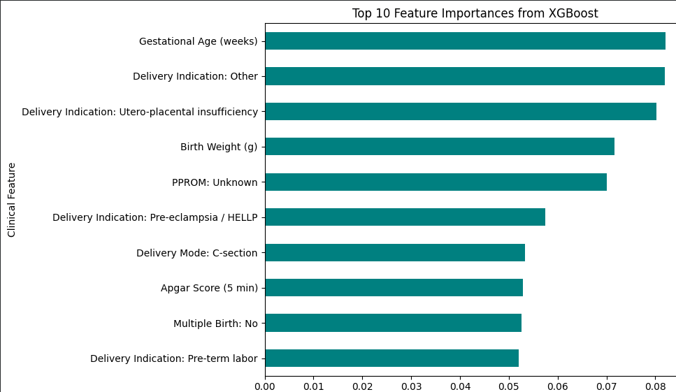

Figure 6. Top 10 Feature Importances from XGBoost

The feature importance results provide further insight into how the selected predictors contributed to the XGBoost model. However, feature importance reflects the contribution of variables to the model's predictions and does not establish a causal relationship with BPD. Therefore, these findings should be interpreted as patterns identified by the model within the analytical dataset rather than evidence that any individual feature directly causes BPD.

7. Conclusion

This study investigated clinical and perinatal characteristics associated with bronchopulmonary dysplasia (BPD) status at 36 weeks in very-low-birth-weight infants using the PreMo dataset. The analysis involved data preparation, missing-value imputation, exploratory data analysis, and the development and comparison of four classification models: Logistic Regression, Decision Tree, Random Forest and XGBoost.
The exploratory analysis showed that infants with BPD had a lower mean gestational age and birth weight than infants without BPD. These findings suggest that both characteristics were associated with BPD status in the analytical sample.

However, the classification results showed that the selected predictors provided only moderate predictive performance. The tuned Decision Tree achieved an accuracy of 64.03%, while Logistic Regression achieved the highest ROC-AUC of 67.39%. No single model performed best across all evaluation metrics.
These results indicate that identifying patterns in clinical data and accurately classifying outcomes can be challenging, even when several machine learning approaches are compared.

One important lesson from this study was that more advanced models do not necessarily produce better results. I initially expected that using more complex algorithms might improve classification performance, but the results did not fully meet these expectations. Some models achieved lower performance than simpler approaches. In addition, the initial Decision Tree achieved training accuracy of 99.87% but a test accuracy of only 54.21%, indicating substantial overfitting. After limiting the tree depth, the difference between training and test performance was reduced, although overall predictive performance remained moderate. This highlights the importance of evaluating models on unseen data rather than relying solely on training accuracy.
The study has several limitations. It was based on the variables available in the PreMo dataset, and missing values required imputation. The models were evaluated using a held-out test set from the same dataset, so their performance may not generalise to other hospitals or patient populations. In addition, the observed associations and feature-importance results do not establish causal relationships.
Future research could examine additional clinical predictors, alternative modelling and feature-selection methods, and independent datasets to improve model performance and assess generalisability. Overall, this assignment provided practical experience in applying data-mining and machine-learning methods to clinical data. It also demonstrated that effective modelling requires careful preprocessing, critical evaluation, and an understanding of model limitations rather than simply pursuing the highest possible accuracy.

References

Allgaier, J., Mulansky, L., Draelos, R. L., & Pryss, R. (2023). How does the model make predictions? A systematic literature review on the explainability power of machine learning in healthcare. Artificial Intelligence in Medicine, 143, Article 102616. https://doi.org/10.1016/j.artmed.2023.102616
Choi, H. J., Lee, G., Shin, S. H., Lee, S. M., Lee, H.-C., Sohn, J. A., Lee, J. A., & Kim, H.
(2025). Development and external validation of a machine learning model to predict bronchopulmonary dysplasia using dynamic factors. Scientific Reports, 15, Article 13620. https://doi.org/10.1038/s41598-025-98087-9
Collins, G. S., Moons, K. G. M., Dhiman, P., Riley, R. D., Beam, A. L., Van Calster, B., Ghassemi, M., Liu, X., Reitsma, J. B., van Smeden, M., Boulesteix, A.-L., Camaradou, J. C., Celi, L. A., Denaxas, S., Denniston, A. K., Glocker, B., Golub, R. M., Harvey, H., Heinze, G., ... Logullo, P. (2024). TRIPOD+AI statement: Updated guidance for reporting clinical prediction models that use regression or machine learning methods. BMJ, 385, Article e078378. https://doi.org/10.1136/bmj-2023-078378
German Mesner, I. (2026). PreMo: A clinical and vital sign dataset of very-low-birth-weight infants from 4 neonatal intensive care units (Version 1.0) [Data set]. University of Virginia Dataverse. https://doi.org/10.18130/V3/KCBTMS
Hwang, J. K., Kim, D. H., Na, J. Y., Son, J., Oh, Y. J., Jung, D., Kim, C.-R., Kim, T. H., &
Park, H.-K. (2023). Two-stage learning-based prediction of bronchopulmonary dysplasia in very low birth weight infants: A nationwide cohort study. Frontiers in Pediatrics, 11, Article 1155921. https://doi.org/10.3389/fped.2023.1155921
Kapoor, S., & Narayanan, A. (2023). Leakage and the reproducibility crisis in machine-learning-based science. Patterns, 4(9), Article 100804. https://doi.org/10.1016/j.patter.2023.100804
Kwok, T. C., Batey, N., Luu, K. L., Prayle, A., & Sharkey, D. (2023). Bronchopulmonary dysplasia prediction models: A systematic review and meta-analysis with validation.
Pediatric Research, 94, 43–54. https://doi.org/10.1038/s41390-022-02451-8

McOmber, B. G., Moreira, A. G., Kirkman, K., Acosta, S., Rusin, C., & Shivanna, B. (2024). Predictive analytics in bronchopulmonary dysplasia: Past, present, and future. Frontiers in Pediatrics, 12, Article 1483940. https://doi.org/10.3389/fped.2024.1483940
Mesner, I. G., Lake, D. E., Kausch, S. L., Krahn, K. N., Gummadi, A., Clark, T. W., Niestroy, J. C., Sahni, R., Vesoulis, Z. A., Gootenberg, D. B., Ambalavanan, N., Travers, C. P., Fairchild, K. D., & Sullivan, B. A. (2026). Vital signs, demographics, and clinical events for low-birth-weight infants from four intensive care units. medRxiv. https://doi.org/10.64898/2026.04.15.26350178
Moreira, A., Noronha, M., Joy, J., Bierwirth, N., Tarriela, A., Naqvi, A., Zoretic, S., Jones, M., Marotta, A., Valadie, T., Brick, J., Winter, C., Porter, M., Decker, I., Bruschettini, M., &

Ahuja, S. K. (2024). Rates of bronchopulmonary dysplasia in very low birth weight neonates: A systematic review and meta-analysis. Respiratory Research, 25, Article 219. https://doi.org/10.1186/s12931-024-02850-x
Onland, W., Debray, T. P., Laughon, M. M., Miedema, M., Cools, F., Askie, L. M., Asselin,
J. M., Calvert, S. A., Courtney, S. E., Dani, C., Durand, D. J., Marlow, N., Peacock, J. L.,
Pillow, J., Soll, R. F., Thome, U. H., Truffert, P., Schreiber, M. D., Van Reempts, P. J., ... Offringa, M. O. (2013). Clinical prediction models for bronchopulmonary dysplasia: A systematic review and external validation study. BMC Pediatrics, 13, Article 207. https://doi.org/10.1186/1471-2431-13-207
Peng, H.-B., Zhan, Y.-L., Chen, Y., Jin, Z.-C., Liu, F., Wang, B., & Yu, Z.-B. (2022).
Prediction models for bronchopulmonary dysplasia in preterm infants: A systematic review.
Frontiers in Pediatrics, 10, Article 856159. https://doi.org/10.3389/fped.2022.856159

Riley, R. D., Archer, L., Snell, K. I. E., Ensor, J., Dhiman, P., Martin, G. P., Bonnett, L. J., & Collins, G. S. (2024). Evaluation of clinical prediction models (part 2): How to undertake an external validation study. BMJ, 384, Article e074820. https://doi.org/10.1136/bmj-2023-074820
Romijn, M., Dhiman, P., Finken, M. J. J., van Kaam, A. H., Katz, T. A., Rotteveel, J., Schuit, E., Collins, G. S., Onland, W., & Torchin, H. (2023). Prediction models for bronchopulmonary dysplasia in preterm infants: A systematic review and meta-analysis. The Journal of Pediatrics, 258, Article 113370. https://www.sciencedirect.com/science/article/pii/S0022347623000513
Xiong, P., Li, L., Yu, Z., Pu, Y., & Tang, H. (2025). Risk factors for bronchopulmonary dysplasia in preterm infants: A systematic review and meta-analysis. PeerJ, 13, Article e20202. https://doi.org/10.7717/peerj.20202
Zhang, H., Wang, F., Jiang, O., Lin, Y., Tang, L., Li, Z., Ba, R., Xu, X., & Mi, H. (2025).
Machine learning-based risk prediction models for bronchopulmonary dysplasia in preterm infants: A high-altitude cohort study. BMJ Paediatrics Open, 9(1), Article e003652. https://doi.org/10.1136/bmjpo-2025-003652
Zhang, X., Wang, A., Xu, R., & Liu, D. (2025). Enhancing bronchopulmonary dysplasia prediction in preterm infants using artificial intelligence and multimodal data integration. Frontiers in Pediatrics, 13, Article 1629795. https://doi.org/10.3389/fped.2025.1629795



The similarity score of 32% appears to include matches from internet sources. Most of the similarities are related to the reference list and standard medical and data mining terminology used in academic research. These technical terms are necessary to maintain the accuracy and clarity of the assignment. Relevant sources have been cited accordingly.

