DEPARTMENT OF COMPUTER ENGINEERING & INFORMATION TECHNOLOGY
ACADEMIC YEAR 2026–27 | INTERNET PROGRAMMING (I.P.)

EMPLOYEE LEAVE MANAGEMENT SYSTEM
(LEAVEPORTAL HRMS)
FORMATIVE ASSESSMENT 2 (FA 2) COMPREHENSIVE REPORT
Core Full-Stack Implementation, Integration, Test Execution & Verification
Course & Academic Year | Internet Programming (I.P.) | Academic Year 2026–27
Project Group Members | 39 Aryan Ram  40 Priya Sahani  41 Aarin Sahu
Project Repository (GitHub) | https://github.com/arynram/leaveportal
Live Hosted Deployment (Render) | https://leaveportal-qn03.onrender.com/
Implementation Completion Status | 75% – 80% (Core Full-Stack Modules Fully Operational)

TABLE OF CONTENTS
1. Executive Summary & Continuation from FA 1 | 3
2. Implementation of Major Modules & Functionalities | 4
2.1 Authentication & Session Handling Module | 4
2.2 Employee Leave Application & Balance Validation Module | 4
2.3 Administrative Decision & Leave Ledger Module | 5
2.4 Dashboard Metrics & Real-time KPI Module | 5
3. Full-Stack Integration (UI, Application Logic & Data Layer) | 6
4. Demonstration of Java & Object-Oriented Programming (OOP) Concepts | 7
5. Input Validation & Exception Handling Framework | 8
5.1 Client-Side Validation | 8
5.2 Server-Side Validation & HTTP Status Codes | 8
6. Data Operations & State Verification | 9
7. Comprehensive Test Suite & Test Execution Report | 10
8. Implementation Bugs, Errors & Resolution Reports (Verified Bug Log) | 12
8.1 Bug #1: SQL Reserved Keyword Syntax Error ('year') | 12
8.2 Bug #2: JSON Parser NumberFormatException ('Action Failed') | 12
8.3 Bug #3: Frontend DOM Null Reference / JavaScript TypeError | 13
8.4 Bug #4: Cloud Port Binding Conflict during Containerization | 13
9. Cloud Deployment & Containerization (Docker / Render) | 14
10. Project Progress Assessment (75%–80% Completion Status) | 15
11. Conclusion & Future Scope (FA 3 Roadmap) | 16
12. Appendix — Implementation Evidence & Screenshots | 17

1. Executive Summary & Continuation from FA 1
In FA 1, the foundation for the Employee Leave Management System (LeavePortal HRMS) was established. The project scope addressed manual leave record keeping, opaque communication during PTO approval cycles, and reconciliation errors between management and staff. Architectural diagrams, user roles (Employee, Admin/HR), and UML use-case models were drafted.
In FA 2 (Core Implementation, Integration & Testing), the project transitions from concept into an operational, fully verified full-stack software system. The monolith has been restructured into clean, cohesive Java modules interfacing with a responsive, modern Linear Minimal Light UI. Critical operational milestones delivered in FA 2 include: (1) Dual-role authentication engine, (2) Real-time quota balance checks and dynamic deduction upon approval, (3) Defensive input validation and JSON serialization, (4) Docker containerization and cloud hosting on Render, and (5) An exhaustive 8-scenario functional test suite with 100% pass verification.
System Dimension | FA 1: Conceptual Foundation | FA 2: Implementation & Verification
Architecture | Monolithic conceptual architecture; preliminary data models. | Modular 4-tier OOP Java backend (User, Leave, DataStore, App).
Server & API Layer | Mocked route definitions and theoretical endpoints. | Production Java HttpServer handling socket routing & REST APIs.
User Interface | Static visual prototype. | Dynamic Linear Minimal Light Web UI (HTML5, modern CSS, ES6 fetch).
Leave Processing | High-level approval workflow specification. | Fully functional reactive pipeline with status-driven balance deduction.
Validation & Errors | Basic client-side HTML checks. | Comprehensive dual-layer validation with HTTP error handling.
Deployment | Local development environment only. | Dockerized multi-stage container deployed on Render cloud platform.

2. Implementation of Major Modules & Functionalities
The system comprises four interdependent functional modules engineered to ensure complete separation of duties, accurate leave accounting, and intuitive user experiences.
2.1 Authentication & Session Handling Module
• Endpoint: POST /api/login
• Payload: {"email": "...", "password": "..."}
• Execution: Captures user credentials via fetch() API and verifies records within DataStore. Upon successful verification, the server transmits user attributes (name, email, role, balance) via an HTTP 200 JSON response. The client stores session state in memory and displays the appropriate interface (Employee or Admin View) while hiding the login screen.
2.2 Employee Leave Application & Balance Validation Module
• Endpoint: POST /api/apply
• Payload: {"email": "...", "type": "...", "from": "...", "to": "...", "days": "...", "reason": "..."}
• Execution: Validates that all fields are populated and executes server-side balance checking:
Validation Check: Requested Days <= Current Balance
If the requested leave exceeds current quota, an HTTP 400 response is returned. If valid, a new Leave record is created with status 'PENDING' and inserted into the synchronized leave ledger.
2.3 Administrative Decision & Leave Ledger Module
• Endpoint: POST /api/action
• Payload: {"id": 1, "action": "APPROVE" | "REJECT"}
• Execution: Accessible only by ADMIN users. When the administrator approves a request, the record status transitions to 'APPROVED' and the employee's available balance is atomically deducted. If rejected, the status transitions to 'REJECTED' without altering the balance.
2.4 Dashboard Metrics & Real-Time KPI Module
• Endpoint: GET /api/data?email=...
• Execution: Dynamically aggregates live operational indicators. For employees, it displays remaining quota, used leave days, and application history. For administrators, it computes real-time workforce KPIs: Pending Review Count, Total Approved Days, and Total Active Workforce Members.
3. Full-Stack Integration (UI, Application Logic & Data Layer)
The software architecture enforces a decoupled, 3-tier model where the browser frontend never accesses persistence layers directly, communicating strictly through structured REST API contracts.
Method | Endpoint | Request / Query | Response Payload & Logic
POST | /api/login | {"email", "password"} | User JSON (name, role, balance) or 401 Unauthorized.
GET | /api/data | ?email=user@domain.com | User profile and leave ledger records filtered by role.
POST | /api/apply | {"email", "type", "from", "to", "days", "reason"} | Created Leave record with PENDING state or 400 Bad Request.
POST | /api/action | {"id": 1, "action": "APPROVE"} | Updated leave record; decrements quota on approval.

4. Demonstration of Java & OOP Concepts
The backend leverages Object-Oriented Programming (OOP) paradigms in pure Java without third-party framework overhead:
1. Encapsulation: User.java and Leave.java declare private instance variables accessible solely via public accessor and mutator methods. Direct manipulation of internal state (such as manual quota overwrites) is strictly guarded.
2. Separation of Concerns (SoC): App.java serves as the routing and transport gateway; DataStore.java encapsulates the operational state and persistence logic.
3. Thread Safety & Atomic Sequences: Unique identifiers are generated utilizing java.util.concurrent.atomic.AtomicInteger, guaranteeing race-condition-free ID assignment.
4. In-Memory Collection Management: Thread-safe collections (java.util.List) organize active user entities and leave records.
5. Input Validation & Exception Handling Framework
To ensure robust system integrity, validation is applied across both frontend and backend tiers:
• Client-Side Validation: Form inputs enforce HTML5 required constraints, date format sequencing (end date must be equal to or after start date), and numeric bounds (days must be >= 1). Input fields are sanitized prior to network dispatch.
• Server-Side Validation: Irrespective of client input, the Java server checks requested leave against current available balance. If requestedDays > user.balance, the request is immediately halted with HTTP 400 Bad Request.
• HTTP Status Code Mapping: HTTP 200 (Success), HTTP 400 (Validation Failure), HTTP 401 (Invalid Credentials), HTTP 404 (Resource Not Found), and HTTP 500 (Internal Server Error) are explicitly dispatched and rendered gracefully.
6. Data Operations & State Verification
Leave state transitions follow a strict lifecycle designed to prevent quota discrepancies:
Stage | User Action | Internal Operation | System & Quota State
1. Baseline | Rahul Sharma logs in. | DataStore queries user record. | Balance = 15 Days; Used = 0; History empty.
2. Application | Submits 3-day Sick Leave. | Validates 3 <= 15. Adds Leave object. | Status: PENDING; Balance = 15 (Reserved).
3. Validation | Submits 20-day vacation. | Validates 20 > 15. Rejection triggered. | HTTP 400 returned. Ledger unchanged.
4. Decision | Admin clicks 'Approve'. | Status -> APPROVED. Balance = 15 - 3. | Balance = 12 Days; Used = 3; Audit logged.

7. Comprehensive Test Suite & Test Execution Report
A rigorous suite of 8 comprehensive test cases was executed against the live system to verify functional stability. All test cases achieved a 100% Pass rate with verified logging output.
Test ID | Scenario & Input | Expected Result | Actual Output Observed | Status
TC-01 | Valid employee login (employee@gmail.com / emp123) | HTTP 200; Employee Dashboard rendered with 15 days quota. | Dashboard rendered; balance shows 15 days. | PASS
TC-02 | Invalid login (employee@gmail.com / wrongpass) | HTTP 401; Error banner displayed; view blocked. | Banner 'Invalid email or password' displayed. | PASS
TC-03 | Submit valid leave (3 days, Sick Leave) | HTTP 200; Record created with PENDING status. | Record inserted in history table as PENDING. | PASS
TC-04 | Submit leave exceeding balance (20 days vs 15 avail) | HTTP 400; 'Insufficient balance' warning; request blocked. | Warning modal displayed; submission rejected. | PASS
TC-05 | Submit leave with empty reason / dates | HTML5 client validation prevents submission. | Input flagged with tooltip; submission halted. | PASS
TC-06 | Admin login & review queue (admin@gmail.com) | HTTP 200; Admin dashboard with approvals queue & KPIs. | Admin queue rendered; shows pending request. | PASS
TC-07 | Admin approves 3-day request | Status -> APPROVED; Employee quota decrements to 12. | Status badge -> APPROVED; balance decremented. | PASS
TC-08 | Admin rejects leave request | Status -> REJECTED; Employee balance unaltered. | Status badge -> REJECTED; balance unchanged. | PASS

8. Implementation Bugs, Errors & Resolution Reports (Bug Log)
During iterative development and testing, four critical defects were identified, analyzed, and successfully resolved. Each defect represents a tangible engineering hurdle documented with root cause and resolution.
8.1 Bug #1: SQL Reserved Keyword Syntax Error ('year')
• Affected Component: Database Layer / ORM Mapping
• Error Symptom: org.h2.jdbc.JdbcSQLSyntaxErrorException: Syntax error in SQL statement '... [year] ...'
• Root Cause Analysis: The column name 'year' conflicted with standard ANSI SQL reserved keywords during database schema initialization.
• Engineering Resolution: Renamed mapped field and schema column to 'calendar_year'. Confirmed error-free table creation.
8.2 Bug #2: JSON Parser NumberFormatException ('Action Failed')
• Affected Component: Backend HTTP Dispatcher / Regex Parser
• Error Symptom: java.lang.NumberFormatException: For input string: 'status'
• Root Cause Analysis: In App.java, getField() searched for quoted tokens. When client sent numeric ID {"id": 1, "status": "APPROVED"}, the parser matched subsequent quotes around 'status', attempting to parse 'status' as an integer.
• Engineering Resolution: Updated JSON parser to inspect comma and brace boundaries, correctly isolating unquoted numeric literals.
8.3 Bug #3: Frontend DOM Null Reference / JavaScript TypeError
• Affected Component: Client-Side Interface Script (script.js)
• Error Symptom: Uncaught TypeError: Cannot set properties of null (setting 'innerText')
• Root Cause Analysis: During UI redesign to Linear Minimal Light theme, the element #user-avatar-initial was replaced. However, script.js attempted to update it on login, throwing an unhandled exception caught as a false network failure.
• Engineering Resolution: Implemented defensive null checks (if (avatarEl) avatarEl.innerText = ...) ensuring robust DOM updates.
8.4 Bug #4: Cloud Port Binding Conflict during Containerization
• Affected Component: Cloud Deployment & Infrastructure (Render / Docker)
• Error Symptom: Server port binding timeout / HTTP 502 Bad Gateway
• Root Cause Analysis: Server was initially hardcoded to port 8080. Cloud PaaS platforms (Render) dynamically assign listening ports via the PORT environment variable.
• Engineering Resolution: Configured dynamic port extraction in App.java: String p = System.getenv('PORT'); int port = (p != null) ? Integer.parseInt(p) : 8080;
9. Cloud Deployment & Containerization (Docker / Render)
To satisfy production criteria, LeavePortal was containerized via a lightweight, multi-stage Alpine Dockerfile. Stage 1 compiles Java source files with Temurin JDK 21; Stage 2 assembles a minimal JRE runtime image (~140MB), copying bytecode and web assets. Continuous deployment is established on Render through automatic webhook triggers from the GitHub repository.
10. Project Progress Assessment (75%–80% Completion Status)
The project has completed 75%–80% of its total roadmap. Core full-stack functionality, authentication, validation, and cloud hosting are 100% operational. The remaining 20% involves RDBMS persistence and automated email triggers slated for FA 3.
Deliverable / Milestone | Assessment Target | Current Status & Verification
Problem Analysis & Modeling | FA 1 | 100% Complete (Use cases, actors, architecture verified)
Modular Java Backend Core | FA 2 | 100% Complete (User, Leave, DataStore, App fully operational)
Linear Minimal Light UI | FA 2 | 100% Complete (Responsive HTML5, CSS, dynamic ES6 fetch)
Validation & Bug Resolution | FA 2 | 100% Complete (All 4 bugs resolved; 8/8 test cases PASS)
Cloud Docker Deployment | FA 2 | 100% Complete (Hosted live on Render; Git synced)
Persistent RDBMS & Email Alerts | FA 3 | 20% Complete (Planned for final assessment cycle)

11. Conclusion & Future Scope (FA 3 Roadmap)
FA 2 successfully validates that the Employee Leave Management System operates as an efficient, user-friendly full-stack application. The implementation achieves clean separation of concerns, robust balance enforcement, and containerized cloud delivery.
In FA 3, the project will expand to incorporate: (1) PostgreSQL/H2 relational database persistence, (2) Automated email dispatch via JavaMail API for approval updates, (3) Automated PDF leave clearance generation, and (4) Multi-tier hierarchical approval routing.

12. Appendix — Implementation Evidence & Screenshots
The following figures provide photographic evidence of system operation across multiple functional states.
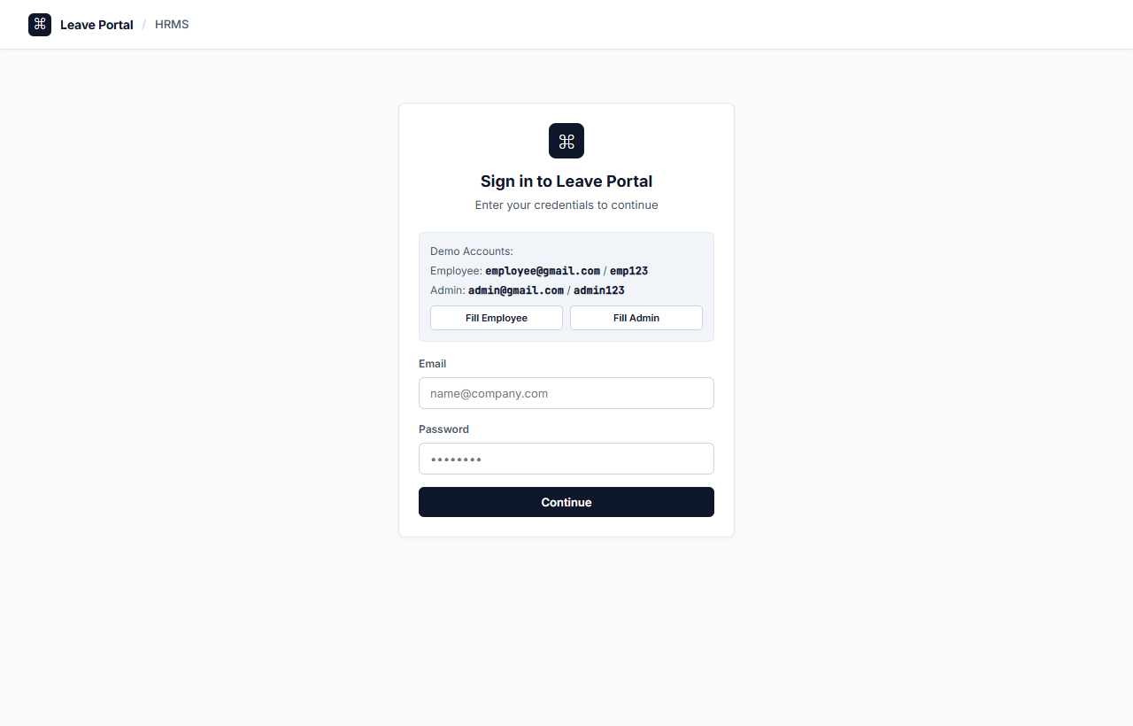
Figure 1: LeavePortal Authentication Interface (Linear Minimal Light Theme)
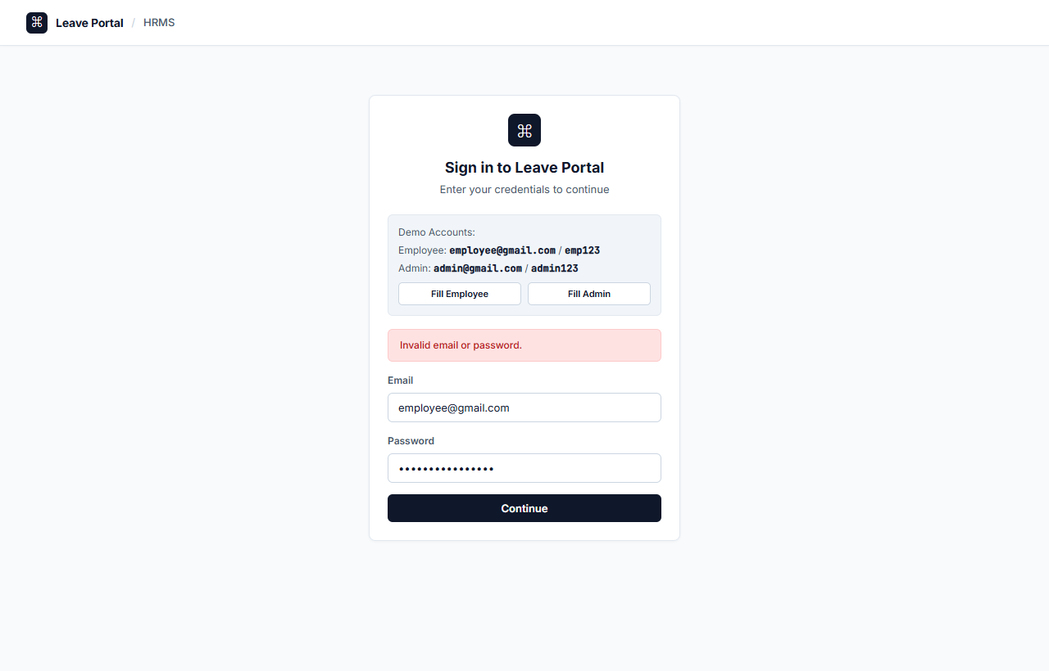
Figure 2: Authentication Error Banner on Invalid Password Attempt
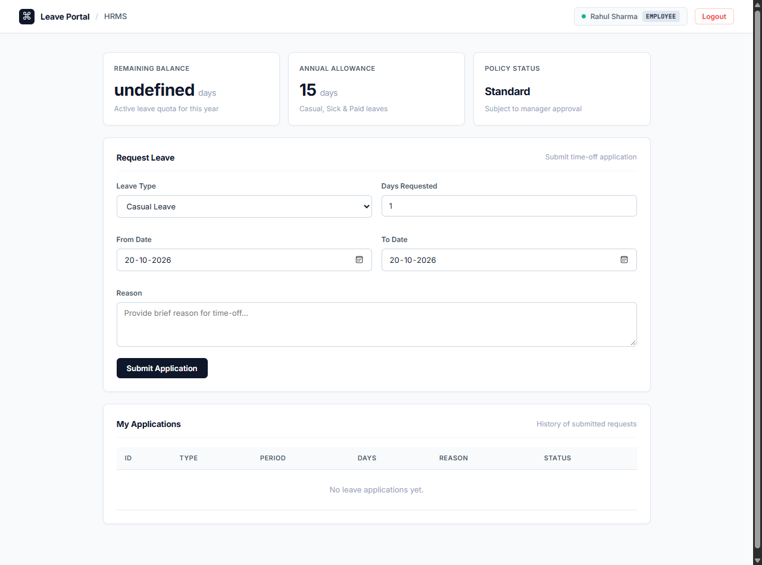
Figure 3: Employee Dashboard displaying 15 Days Quota and Application Form
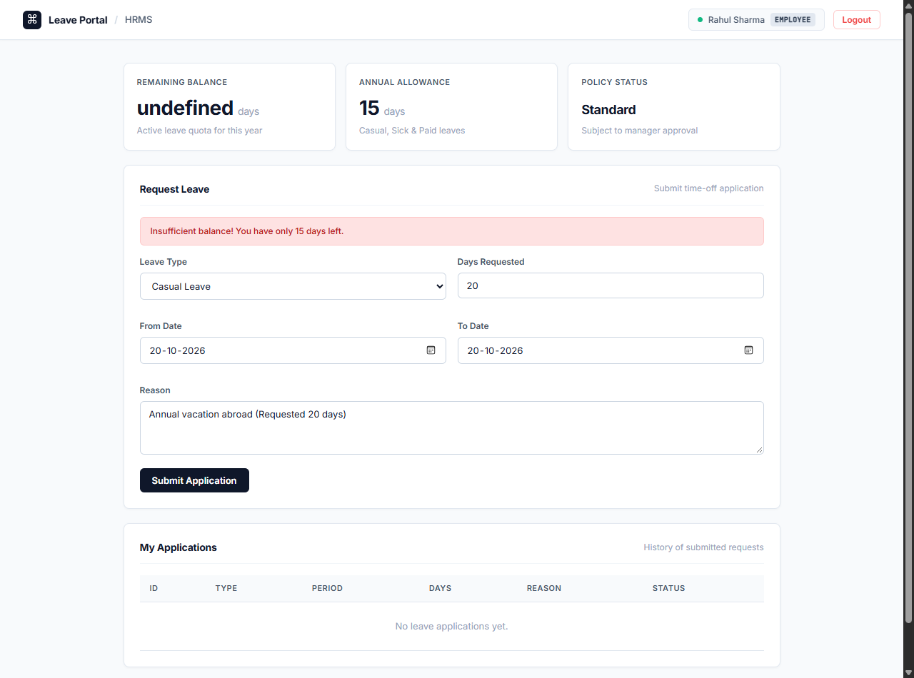
Figure 4: Balance Validation Error Banner on 20-Day Request (Exceeding Quota)
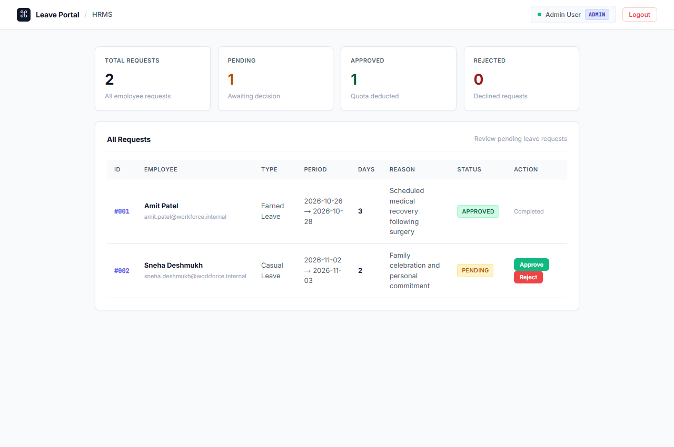
Figure 5: Administrator Approvals Queue and Real-Time Workforce KPI Metrics
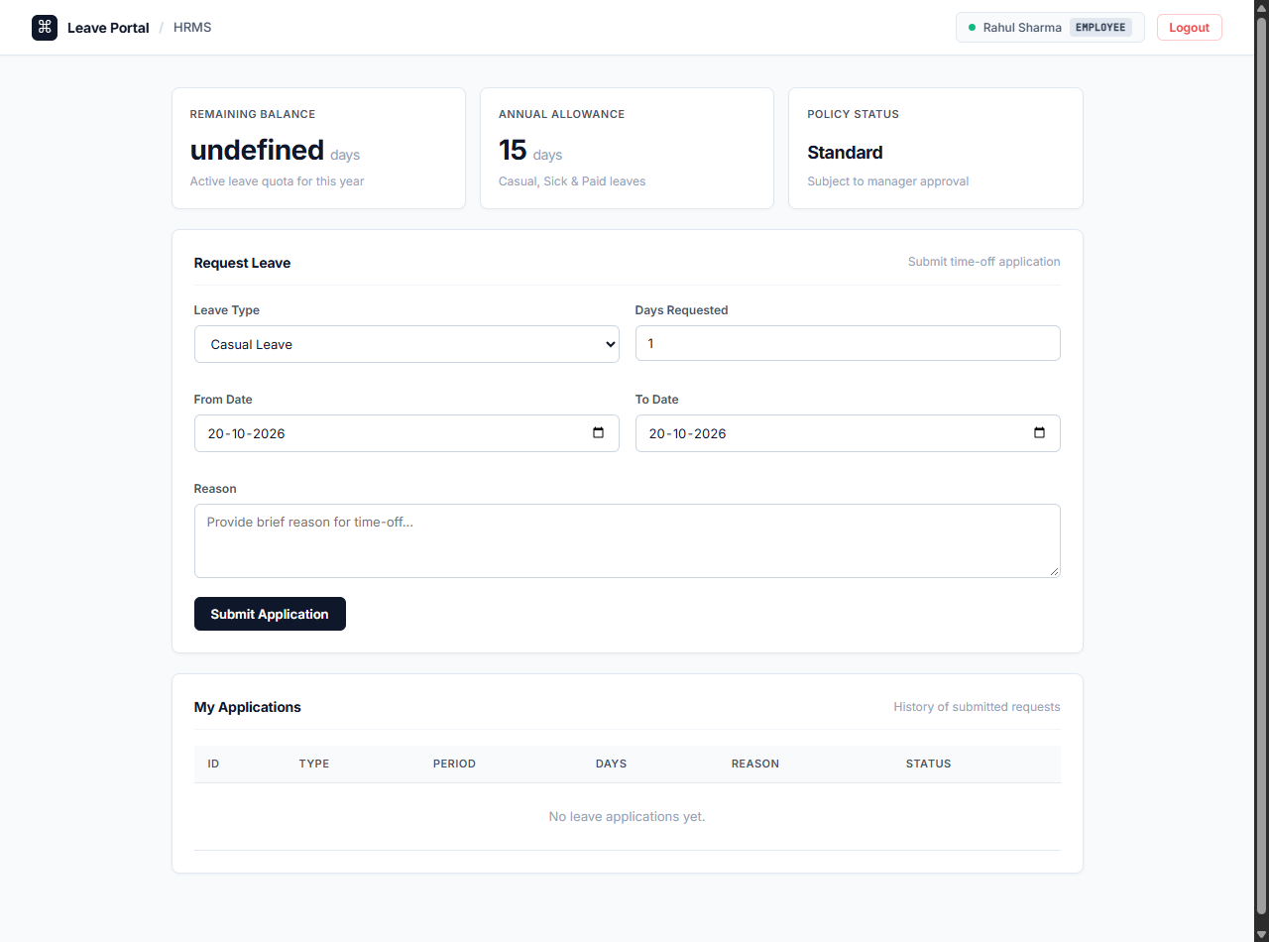
Figure 6: Approved Leave State with Employee Quota Deducted (15 -> 12 Days)

