APPLICATION FUNCTION: AUDIT TRAIL

Final Research Result and Implementation Technique
June 9, 2000

These research results have been tested with MSDE on Windows 2000 Professional.

Introduction

Audit trail is implemented using trigger functionality of MSDE (see “Trigger Defined”). Audit trail technique discussed on this report has the following advantages:
- It will not affect the programming style of each developers
- Keep track of not only the historic dates, but the actual change history of each record.
- An option to implement a rollback function (undo).

The audit trail function could only be implemented after the database structure is stable since it requires an exact mirror of the database structure to store the history data. The mirrored database is built into the application database itself.

Implementation technique for the rollback function is outside the scope on the research.

Trigger Defined

Triggers are pieces of code that attach to a particular table and respond to specific events. The code in triggers is automatically run whenever the event(s) specified in the triggers occurred. There are three types of triggers (corresponding to the tree types of events) plus hybrids (from combination of events):
- INSERT triggers
- DELETE triggers
- UPDATE triggers
- Combination of the above

The code for INSERT trigger will be executed anytime a new row is inserted into a table. For each row that is inserted, SQL Server will create a copy of that new row, and inserted into a special table that exist only within the scope of the trigger. That table is called Inserted.

The DELETE trigger works as an INSERT trigger, save that the Inserted table is not created. Instead a copy of each record that was deleted is inserted into another table called Deleted. Like Inserted table, the Deleted table is limited in scope to the life of the trigger.

UPDATE trigger also works as the other triggers; it will be fired whenever an existing record in a table is changed. The difference is that there’s no such table as Updated, but two special tables called Inserted and Deleted. SQL Server treats each row as if the existing record has been deleted, and a new record was inserted.

Audit Trail

Audit Trail work by utilizing the SQL Server’s triggers and having its own database structure that mirrored the application’s database. The Audit trail will keep track of the dates when a record is added, updated, and deleted. All record additions and changes to the record will also be store in the audit trails’ database if necessary. Take for instance the following simple database structure to illustrate the Audit Trail process:

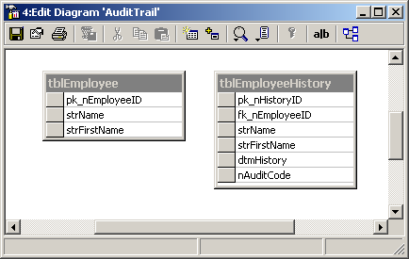
When a new record is added into tblEmployee (strFirstName: ‘Donald’, strName: ‘Duck’) automatically in the tblEmployeeHistory table the new record also inserted, including the timestamp and type of process (0 - Add, 1 - Edit, or 2 - Delete). When the value of field strFirstName is changed into “Desi”, a new record is automatically inserted in the EmployeeHistory table:

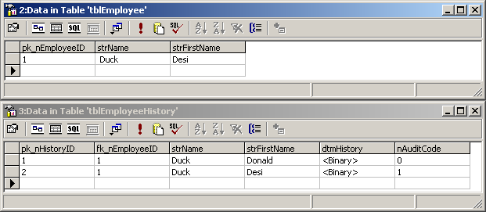
On deletion of record ‘Donald Duck’ in the tblEmployee, a new record is automatically added in the tblEmployeeHistory, as follow:

