CREATING DATABASE

Step 1.

- Create New SQL Server Registration
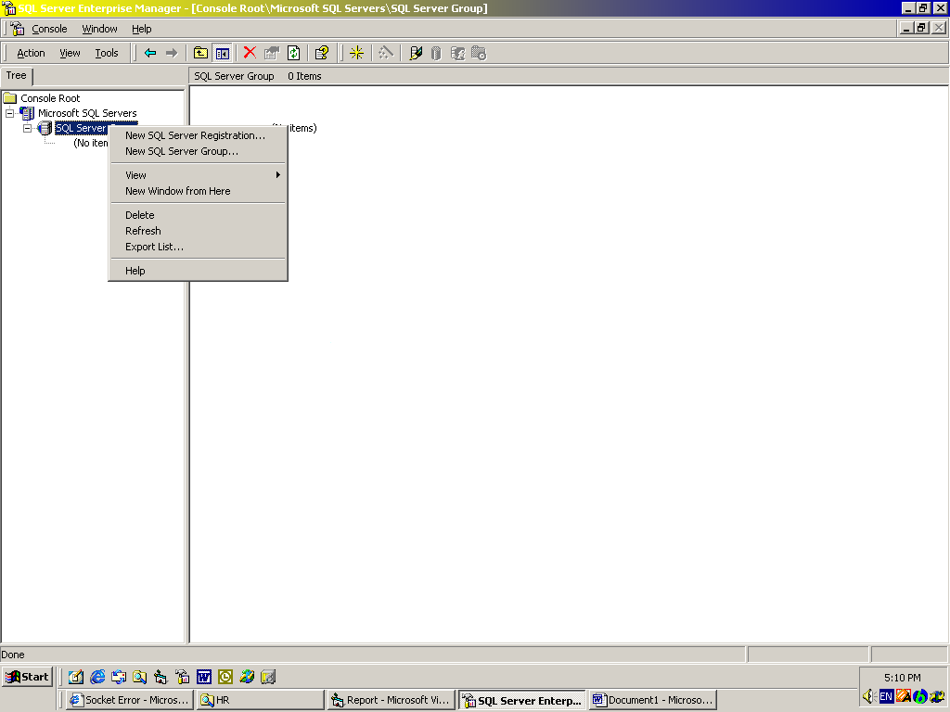

- Click Next

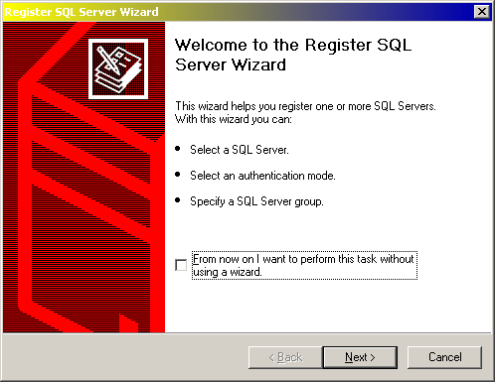

- Fill Available Server with “LOCAL” / Server Name, then click Button Add, the Added Servers content is Server Name, click next

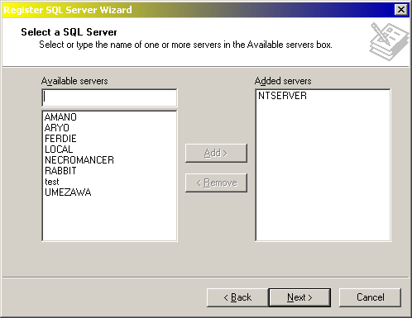

- Choose The Windows Nt Account…..

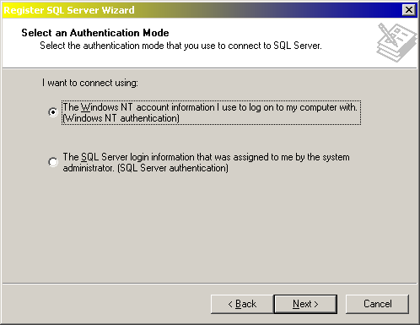

click next button

- Choose Add the SQL Server(s) to an existing SQL Server Group, then choose SQL Server Group in Group name combo

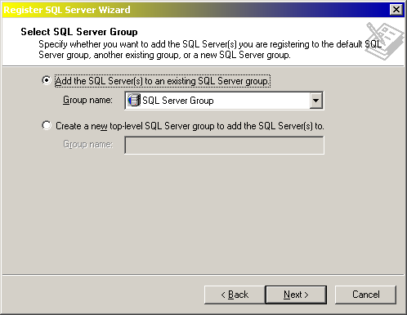

click next button

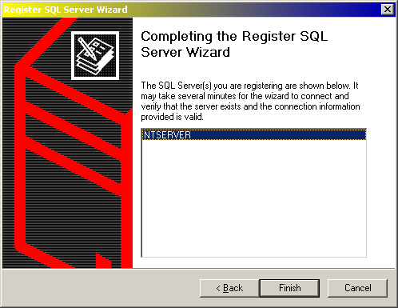

click finish button

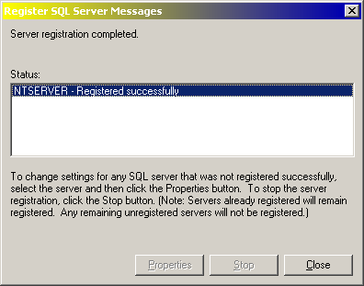

Server Registration completed, click close button

Step 2

- Make a New Database

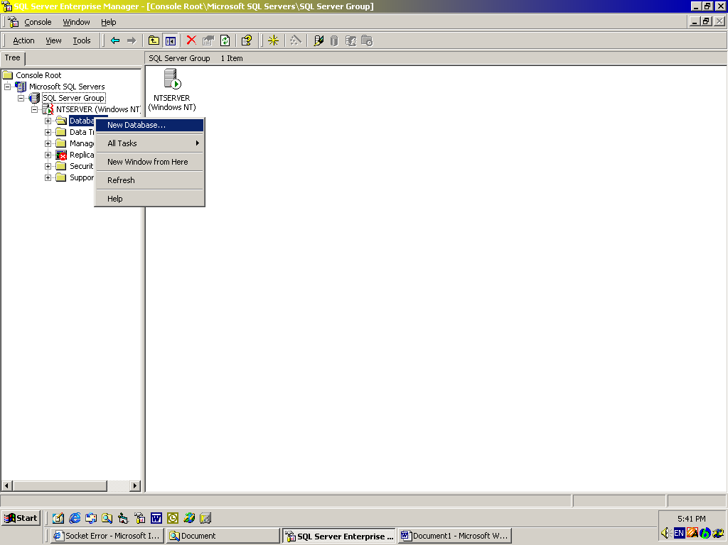

- Fill Name with “Amano”
- Check the Automatically grow File
- in File Grow Frame, fill 1 in megabytes

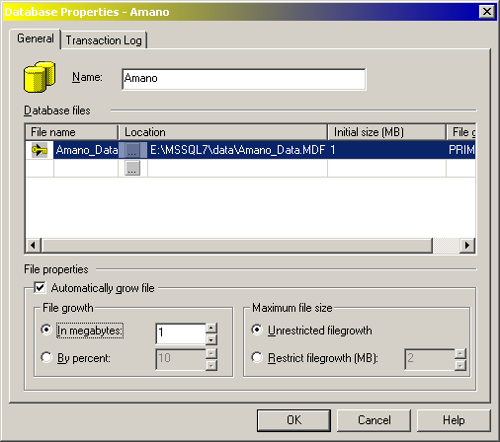

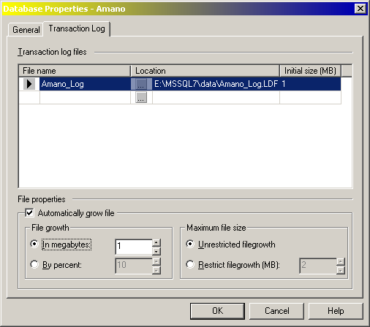

click OK button

Step 3

- Run SQL Server Query Analyzer

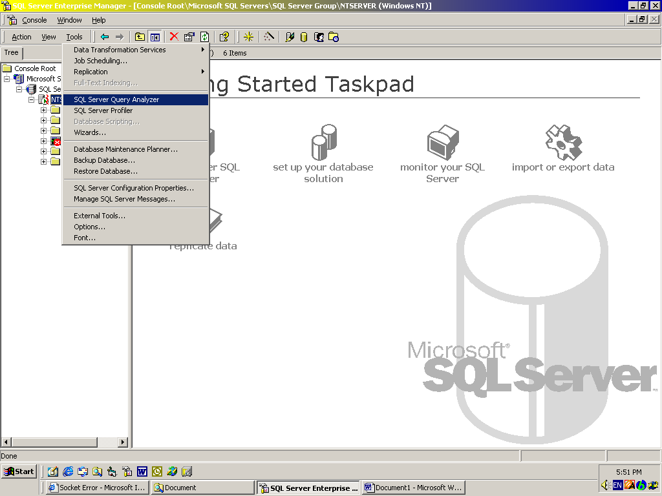

- In SQL Server Query Analyzer, choose Amano in DB combo

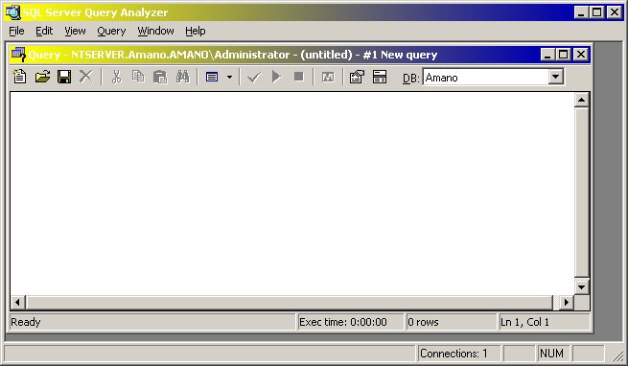

- Load SQL Script, open Amano.sql

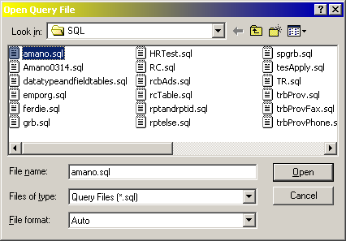

- Execute Query

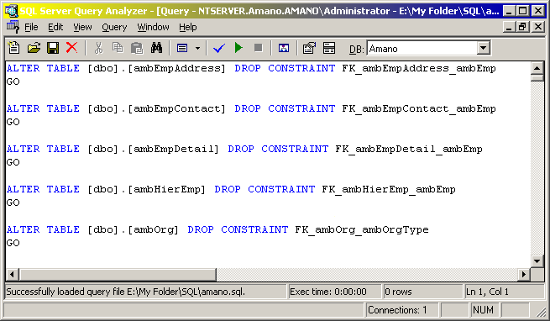

- End

