Development Environment

Operating System | Microsoft Windows 2000 or Microsoft Windows XP
Programming Tools | Microsoft Visual Basic 6.0 with Service Pack 5
Database Tools | Microsoft SQL Server 2000
Help Tools | RoboHELP Office 3.20

Executable File | T&A.EXE
Data Access DLL Files | TM.DLL  tmData.DLL  tmDB.DLL
Security DLL File | tmSecurity.DLL
Application DLL Files | AutoShift.DLL  CalculationEngine.DLL  CalculationScript.DLL  Calendar.DLL  Codes.DLL  DailyWeeklyOT.DLL  DayType.DLL  EmpEditDaily.DLL  EmpEditPeriodically.DLL  EmpReport.DLL  HoursRounding.DLL  ImportAttend.DLL  ImportEmp.DLL  MissingEmp.DLL  MissingGroup.DLL  MissingPunch.DLL  MissingSchedule.DLL  MissingShift.DLL  PayPeriod.DLL  Schedule.DLL  ScheduleIndividual.DLL  Shift.DLL  tmOrgType.DLL  Zone.DLL

Creating the Installer

1. Open the TimeAttendance.VBP project with Microsoft Visual Basic 6.0.
2. Click the menu Add-Ins | Package and Deployment Wizard...
If the menu Package and Deployment Wizard... doesn’t exists under the menu Add-Ins, you can load the menu Package and Deployment Wizard... by click the menu Add-Ins | Add-In Manager...
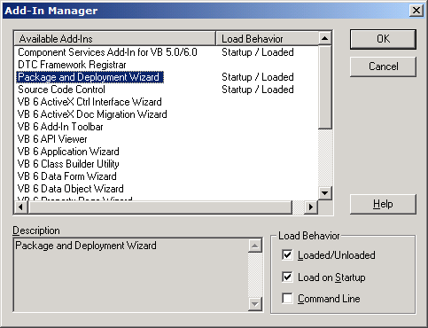
Highlight Package and Deployment Wizard, then on the right pane below, click Loaded/Unloaded (and also you can click Load on Startup if you want too), then click OK to close the Add-In Manager dialog box.
3. Click Package button to make the new package.
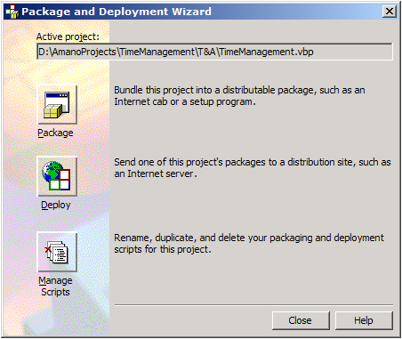
4. If you don’t compile the VBP project to the EXE executable yet, or if the VBP project is newer than the EXE executable, this message will be coming up.
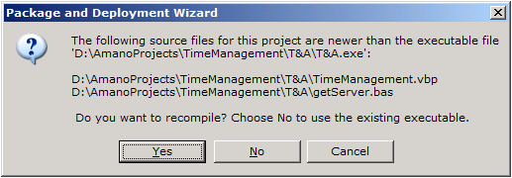
If you already have the EXE executable and you don’t want to recompile, you can click No button. Click Yes button if you want to recompile the VBP project.
5. Select Standard Setup Package from Package type list, click Next to continue to the next wizard.
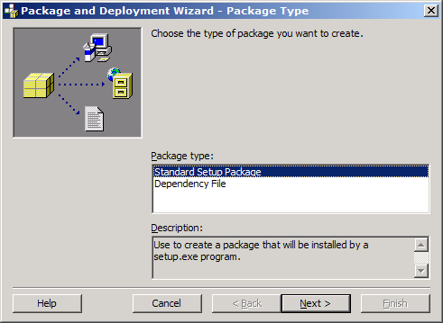
6. You can make another folder or you can use the default folder for the Package Folder for your setup files. Click Next button.
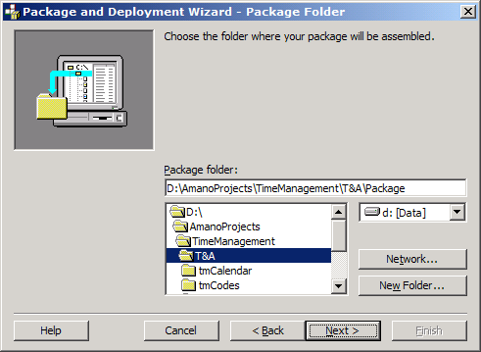
After you click Next button, this message will be coming up to confirm to make a new package folder. Click Yes.
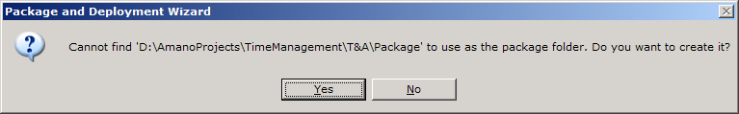
7. Probably you will receive this message window to inform you the dependecy information for the files in the list could not be found. Click OK.
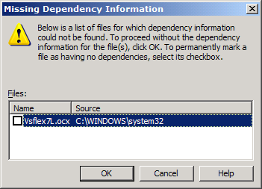
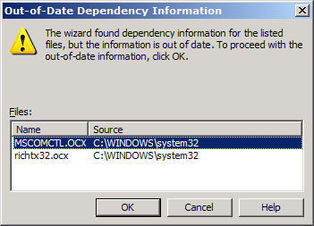

8. In this step, maybe you want to include additional files (example: DLL files) that your application need it, you can click Add button to add the necessary files into your package.
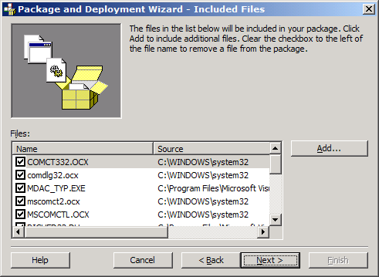
In this case you should include all the DLL files (see the table) where this application needs. Browse the DLL folder by select Dynamic-Link Libraries (*.dll) on Files of type list in this dialog window.
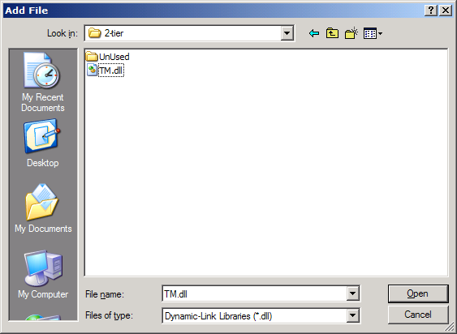
Click OK on this message window.
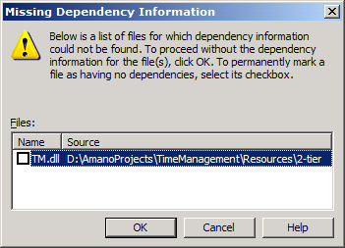
The DLL files must be include in the package are:
Data Access DLL Files | TM.DLL  tmData.DLL  tmDB.DLL
Security DLL File | tmSecurity.DLL
Application DLL Files | AutoShift.DLL  CalculationEngine.DLL  CalculationScript.DLL  Calendar.DLL  Codes.DLL  DailyWeeklyOT.DLL  DayType.DLL  EmpEditDaily.DLL  EmpEditPeriodically.DLL  EmpReport.DLL  HoursRounding.DLL  ImportAttend.DLL  ImportEmp.DLL  MissingEmp.DLL  MissingGroup.DLL  MissingPunch.DLL  MissingSchedule.DLL  MissingShift.DLL  PayPeriod.DLL  Schedule.DLL  ScheduleIndividual.DLL  Shift.DLL  tmOrgType.DLL  Zone.DLL

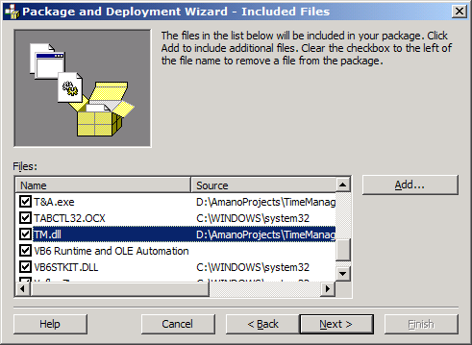
9. You can choose Single cab if you want to make just one CAB file, or you can choose Multiple cabs if you want to make to several CAB files, depends on Cab size you selected (usually if you want to make the installer into the diskettes). Click Next.
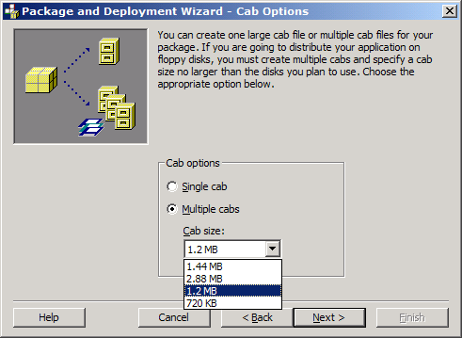
10. Enter the Installation title. Click Next button.
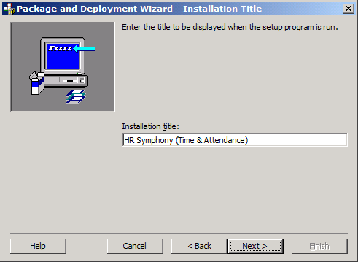
11. Change the start menu from Time & Attendance to HR Symphony by click Properties... button.
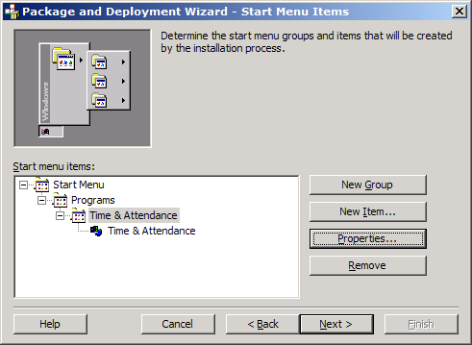
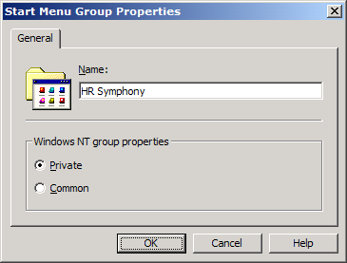
12. Change the install locations for all DLL files to the $(AppPath).
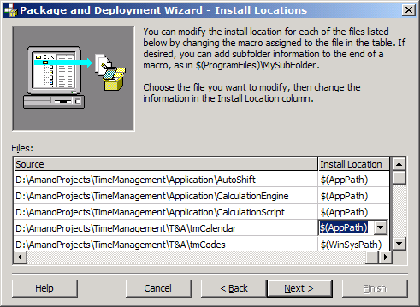
Click Next button.
13. Uncheck all Shared files in the list. Click Next button.
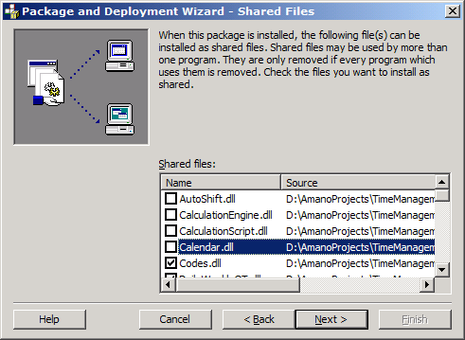
14. You can name the Script name. Click Finish button.
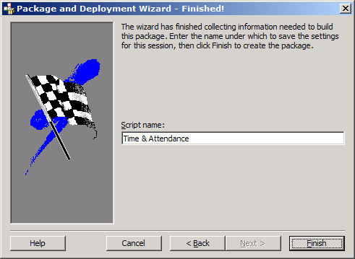
15. After the Package/Setup already made, you will receive this message window. You can click Save Report to save the report into the text file if you want.
