Project Title:
Event-Triggered Multi-Camera Person Search with Spatiotemporal Filtering and Selective Clip Preservation

Project summary: (max. 500 words) (Please state the main objectives of the project and its realistic constraints clearly, and the broadly final results, also ensure that the project is attainable in one semester)
Project goal:
Develop an AI-assisted system that supports missing-person searches by retrieving likely appearances across CCTV cameras, reconstructing a probable route, and displaying the person’s last observed / predicted location and time.
Example:
A child goes missing in a shopping mall. Security staff open a search case and upload a recent photograph provided by the child’s parents. The system searches selected CCTV recordings and presents likely matches for staff review. It then organizes the sightings into a probable route, displays the last observed camera zone and timestamp on a mall map, and preserves relevant clips.
Objectives:
- Event-triggered activation for an authorized search case.
- A person re-identification (Re-ID) pipeline using pretrained models.
- Multi-camera route reconstruction using appearance and spatial–temporal constraints.
- Candidate match scoring to support operator review.
- Selective preservation of potentially relevant footage.
- Privacy-footprint reduction through case-specific processing and data cleanup.
- A demonstration dashboard for searching, reviewing, and visualizing results.
Necessity:
AI-based CCTV search already exists. This project investigates how it can be integrated into a case-specific workflow that helps operators find likely sightings, reconstruct a probable route, and preserve relevant footage before routine retention policies remove it. The aim is to reduce manual review effort while limiting unnecessary processing and storage.
Constraints:
The prototype will cover three to four fixed cameras and one target person per case, using recorded footage and pretrained open-source components. It will run on a single consumer GPU workstation, with the hardware configuration documented during evaluation. Processing speed and search quality will be measured against an appearance-only baseline, while review effort will be compared with manual search. Guaranteed real-time operation and text-based search are outside the initial scope.
Limitations:
- Privacy: Searches still require processing images of other people within the selected footage. Processing will therefore be restricted to active cases, selected cameras, and defined time windows, with temporary search data deleted after case closure.
- False matches: Changes in lighting, viewpoint, occlusion, or clothing can reduce Re-ID accuracy. Results will be presented as candidates requiring operator review.
- Incomplete observations: The system cannot establish a person’s current location outside camera coverage or recover footage that has already been deleted.
Expected results:
- An end-to-end prototype.
- Benchmarks covering retrieval quality, processing speed, and operator review effort.
- A clip-preservation module with temporary holds, confirmed retention, and cleanup.
- A final presentation and demonstration.

Problem Statement: (max. 200 words) (Define what is the problem the project will try to solve)
When a person is reported missing, we have to inspect footage from many CCTV cameras, which is very time-consuming when cameras are distributed across different locations. Sometimes the answer must be urgent and precise, making manual search impossible due to time constraints. Therefore, a semi-automated, interconnected, reducing manual review effort, and reliable solution is needed.

Related works (No words limit) (describe what are the existing solutions available to solve this problem and you can include Figures or Tables to this section).
NVIDIA DeepStream (Multi-View 3D Tracking in DeepStream): https://github.com/NVIDIA/DeepStream/blob/main/src/apps/reference_apps/deepstream-tracker-3d-multi-view/README.md - is a distributed, real-time multi-view multi-target 3D tracking framework built for large-scale, calibrated camera networks. It is designed to deliver robust object tracking and identity consistency across complex environments, leveraging camera calibration data as a prerequisite for accurate geometric reasoning. The sample applications support three detector models: PeopleNet Transformer, a general-purpose people detection transformer model, PeopleNet v2.6.3, a high-performance people detection model based on DetectNet_v2, and RT-DETR 2D Warehouse, a real-time DETR model optimized for warehouse environments with multiple object classes.
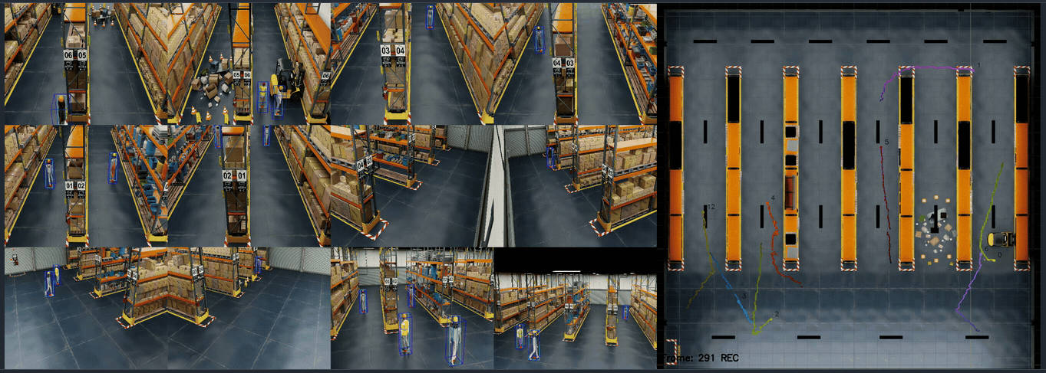

Meethu51 MTS: https://github.com/meethu51/ReID-framework/blob/main/README.md - a multi-camera person re-identification (ReID) system designed for environments where persons wear visually similar uniforms under top-down cameras. Standard appearance-based ReID is insufficient in these conditions — identical clothing gives high similarity for different people and unstable similarity for the same person across views.
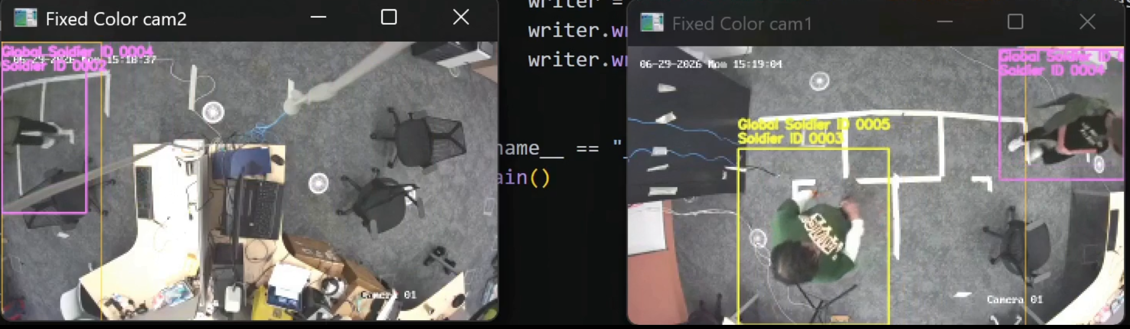

Library Torchreid: Deep learning person re-identification in PyTorch: https://kaiyangzhou.github.io/deep-person-reid/

NVIDIA Documentation: https://docs.nvidia.com/mms/text/Multi-Camera_Tracking_toc.html

Text-based person search: https://arxiv.org/pdf/2608.17044 (10th AI City Challenge, Track 4)

Detector and tracker BoxMOT: https://github.com/mikel-brostrom/boxmot - independent detector, segmentor, appearance-encoder, and tracker components built around validated Torch structures. Pipelines compose those components; the CLI owns sources, outputs, materialized datasets, evaluation, tuning, research, and ReID workflows.
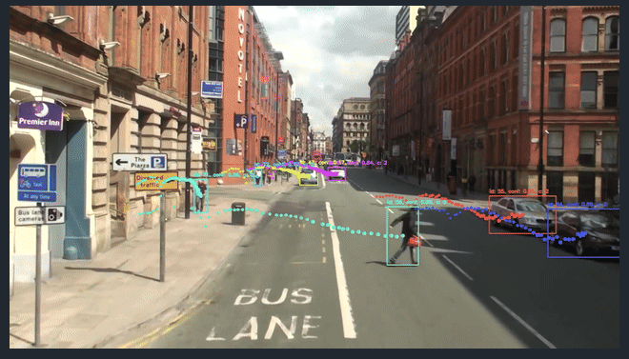

To sum up, currently there exist solutions related to multi-camera tracking, but they are focused on real-time multi-object detection and route tracking, while our goal is to track only the missing person, and by default the system will not be trying to identify everyone. The path is also recovered from data, and it is not stored by default. Current/Estimated location is highlighted.

Proposed Solution (No words limit) (describe the team vision to solve this project problem. This section can include any technical details. Please note that the described solution in this section can be changed later once you start implementing the project solution) You can elaborate on your idea by adding Figures, resources, references, or extra explanations to clarify the proposed solution
Prototype:
Given a reference image, a last-known camera, and a time window, search 3–4 camera feeds for likely appearances of that person, use time/location constraints to rank the matches, reconstruct the probable route, and preserve only the relevant video clips. Show the clips (merged), map with a path, real-time location.

Example:

Query: reference.jpg/text description | Last known: 1st floor north-west building area (possible cameras: A or B), around 14:15 | Search: 14:00 - now

Steps:
1. Embedding creation: Reference image → Person crop → OSNet → Target embedding
2. For each possible camera: Video → YOLO → Person detection → ByteTrack → Person Tracklets → Representative crops → OSNet → Tracklet embedding
3. Decide on confidence (similarity score), calculate speed and distance
4. Estimate route: Camera A 14:15, Camera B 14:17, Camera E 14:22 → 1st floor north-west side, 1st floor north side, 2nd floor north-east side

Main functions of the project (Items that describe the main functions of the project. These functions can be modified or increased later in the implementation stage)
- Case creation & activation
- Cross-camera person search (Re-ID)
- Confidence scoring
- Route reconstruction & location estimate
- Selective evidence preservation
- Privacy lifecycle management
- Demo dashboard

Time Plan and Roles of Team Members (this includes time plan for the project stages)
Number of Students (min. 3 students, max. 4 students):
List of students: Jungwoo Lee,
Student ID | Student Name | Contact or Email | Initial Project Role
2026318686 | Arystan Kamalov | arystan.kamalov@edu.em-lyon.com | Perception and Re-ID
2026319098 | Viktor Korotkov | viktor.korotkov@edu.em-lyon.com | Routing
2019310575 | Jeong Sihyun | sihyunnn1999@gmail.com | Infrastructure
2020314556 | Jungwoo Lee | jglee0814@g.skku.edu | Product

Task | Assignment | W3 | W4 | W5 | W6 | W7 | W8 | W9 | W10 | W11 | W12 | W13 | W14 | W15
 | Arystan Kamalov
YOLO + baseline
ByteTrack + tracklets
OsNET +cross-cam matching
Confidence + tuning
Metrics + fixes
 | Viktor Korotkov
CCTV graph + topology
Route reconstruction + edge weights
Predictions + exit nodes
Integration with confidence
Tests + edge cases
 | Jungwoo Lee
UX + Streamlit draft
Clip player
Map + route draw
Search status + confidence display
Integration + tests
 | Jeong Sihyun
DB + deploy (server, streaming)
Clip preservation
Privacy lifecycle
Benchmarking + inference
Final deploy

