Lead management system
DASHBOARD :
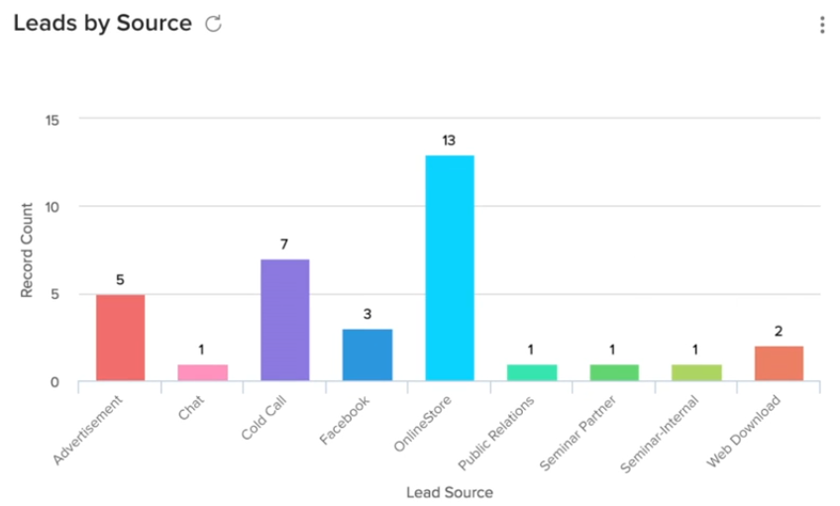
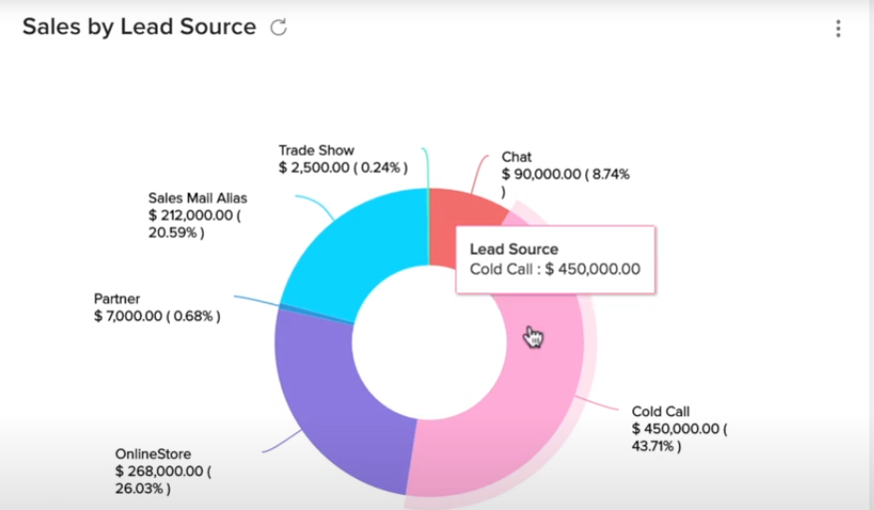
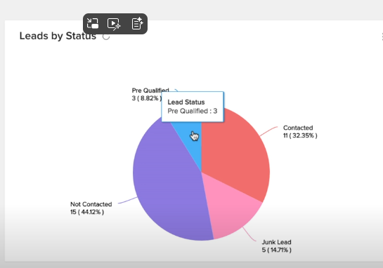
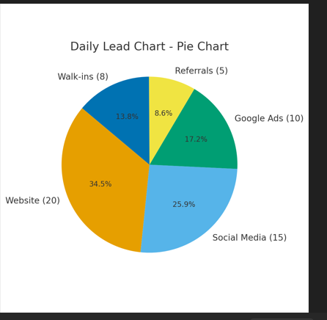
FIields:
Common fields:
1.search Text field
2.filters-course-source-counseller-status-date filters
3.Download file option
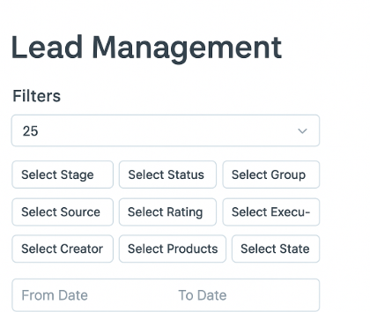
COURSE Enquiry
STATUS:
1.PENDING/NEW
2.CONTACTED{ IF}-1.Entrolled
2.demo booked-when
3.Not interested/closed-why?
4.unqualified
5.intersted
6.future lead
2.Not picked

