Admin Portal
Tue, 28 Oct
1) The details in the Settings category cannot be saved.
STATUS: Yet to be Rectified
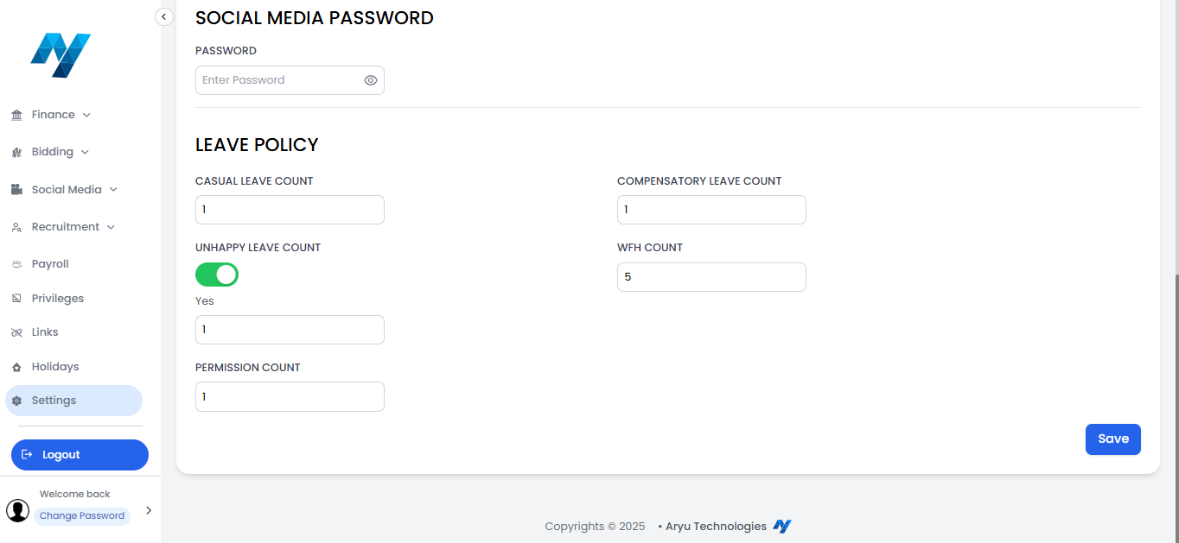
2) Only one request is displaying in the Leaves, WFH, and Requests tab for a single candidate even if that candidate applied for multiple requests.
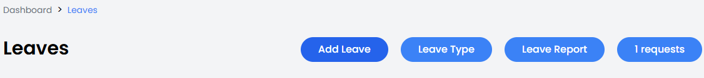
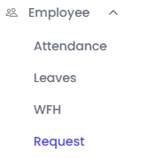
3) The pop-up tab disappears as soon as the cursor moves to scroll down the data.
STATUS: Rectified
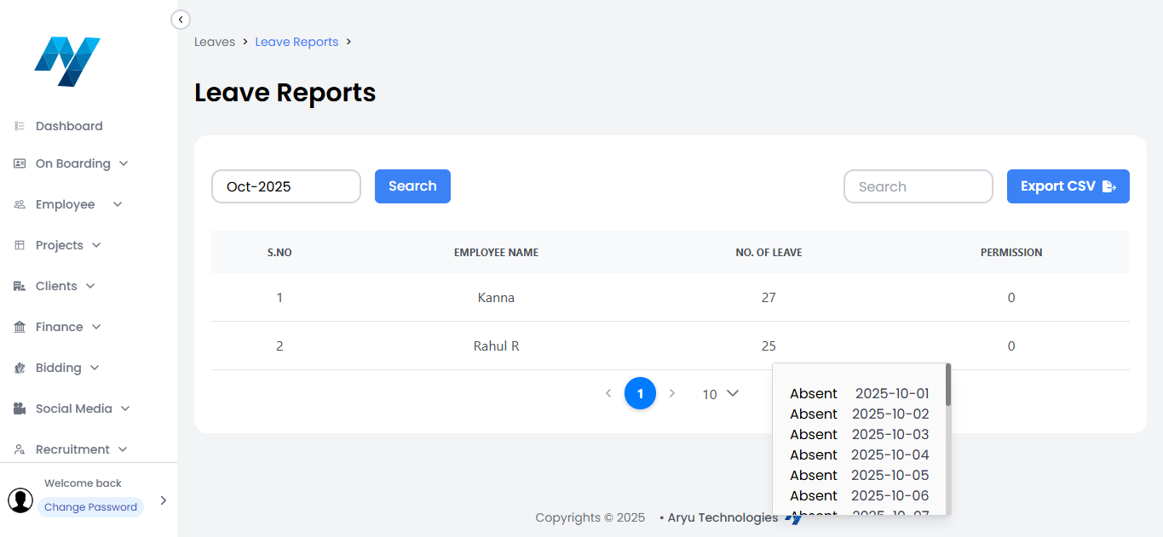
4) The added attendance data is not listed in the Attendance Add Section.
STATUS: Rectified
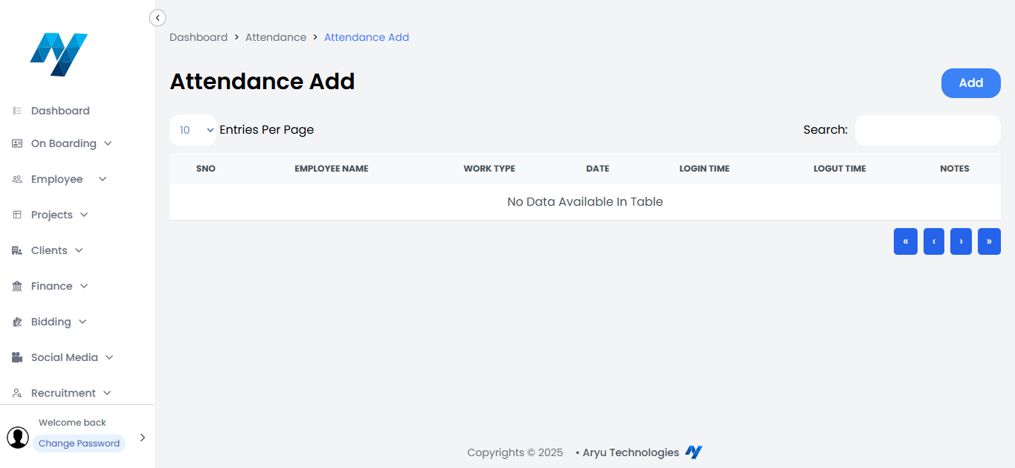
5) The UAN NO in the PF info is exceeding the 12-digit limit.
STATUS: Yet to be Rectified
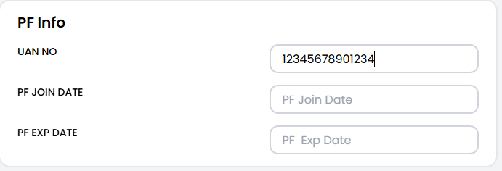
Wed, 29 Oct
6) I have added myself as an employee with the official mail ID. I have deleted that account. I cannot add myself again with the same mail ID. The notification "Email already exists" pops up.
STATUS: Yet to be Rectified
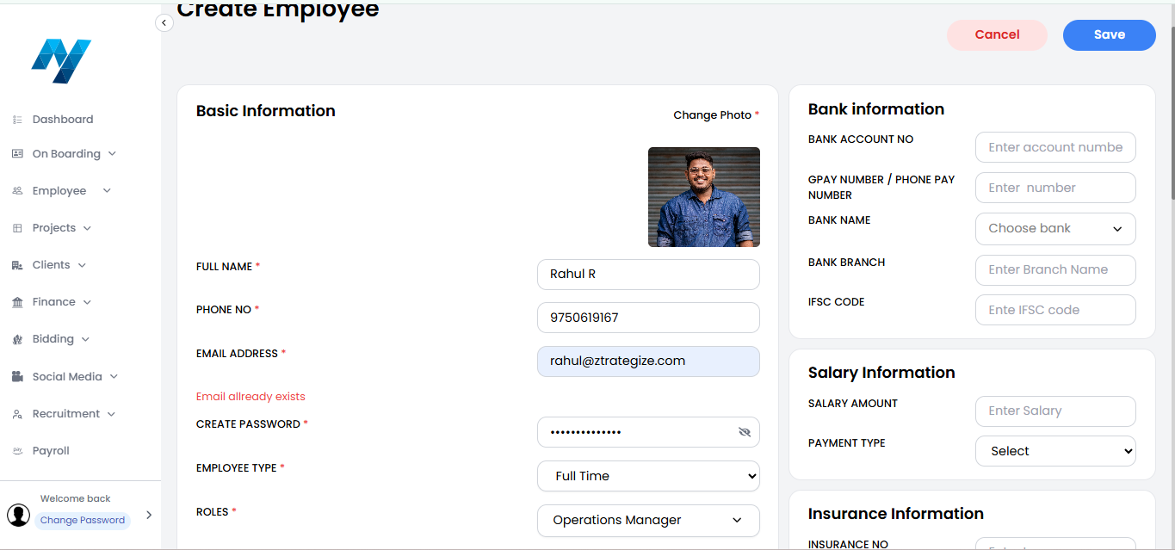
7) The budget of the Project has been changed in the Project List section, but it was not updated in the Payments tab under the Finance section.
STATUS: Yet to be Rectified
Project List:
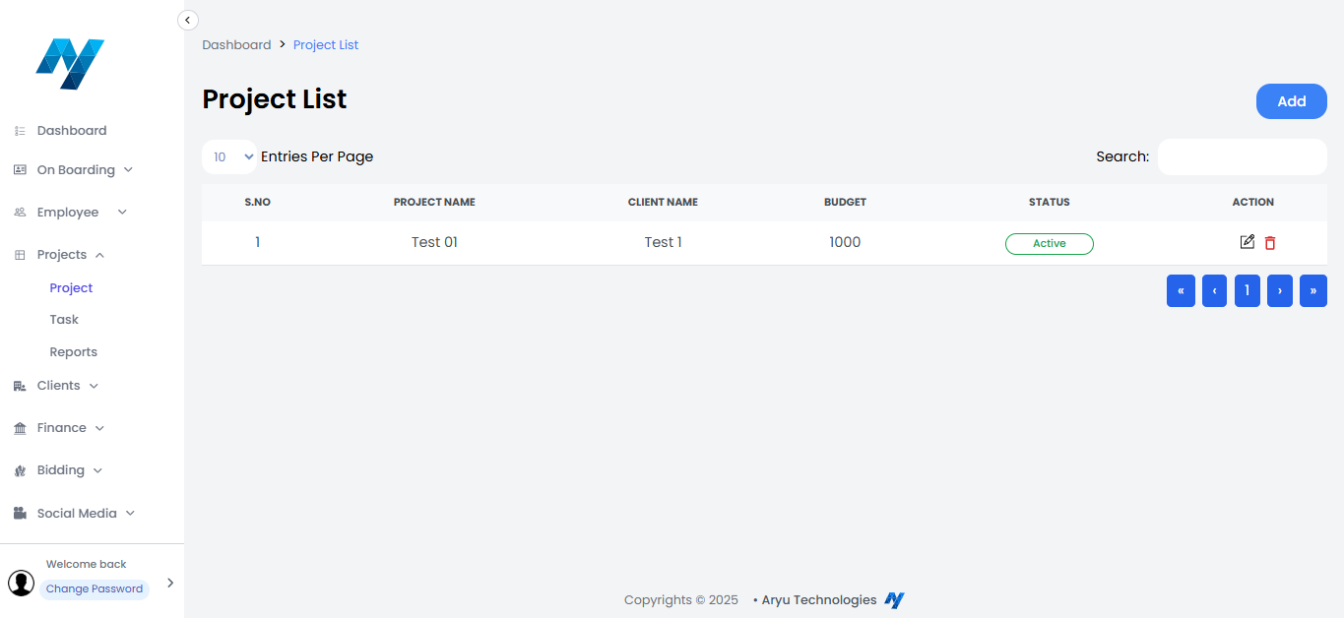
Payment Type:
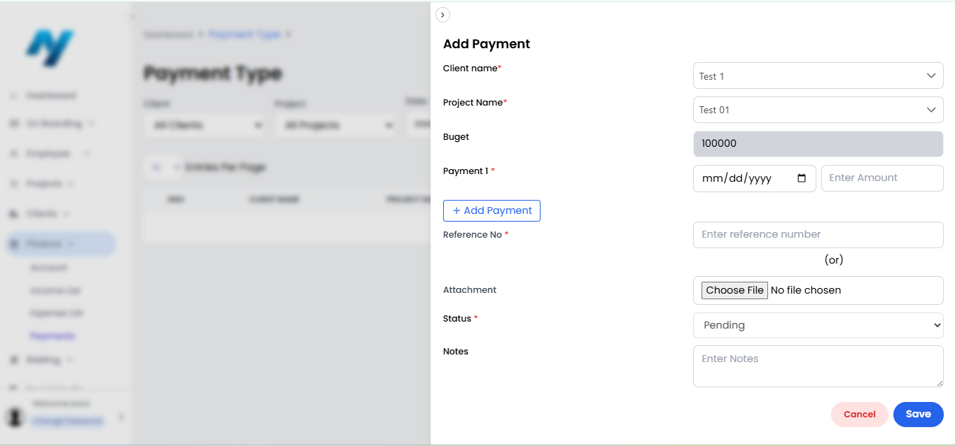
8) The Account tab and Technology tab under the Bidding section cannot be saved after re-editing the existing account item.
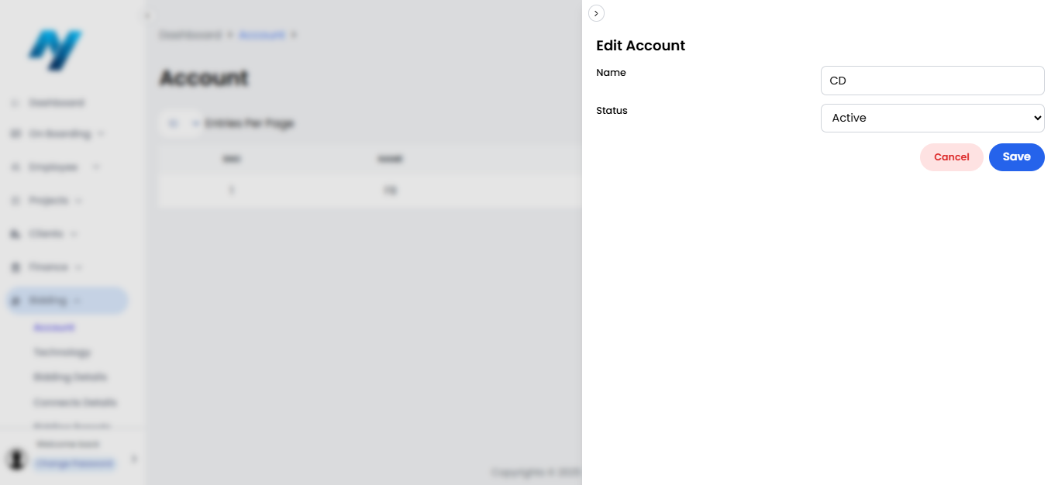
9) There is no Add button in the Bidding Details category and Bidding Reports category under the Bidding Section.
STATUS: Yet to be Rectified
Bidding Details:
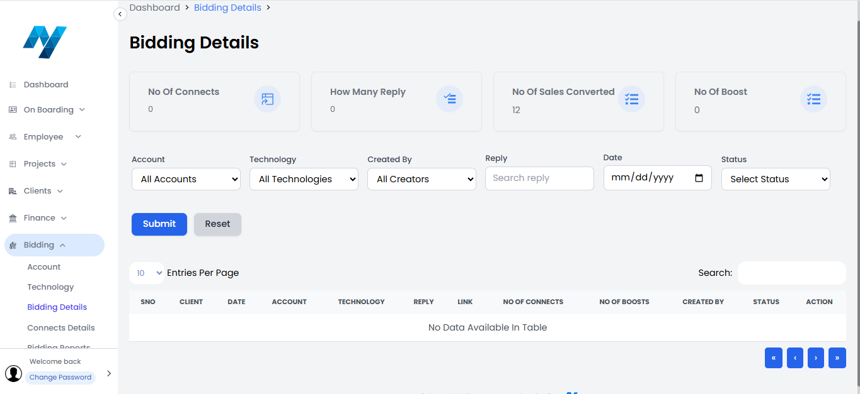
Bidding Reports:
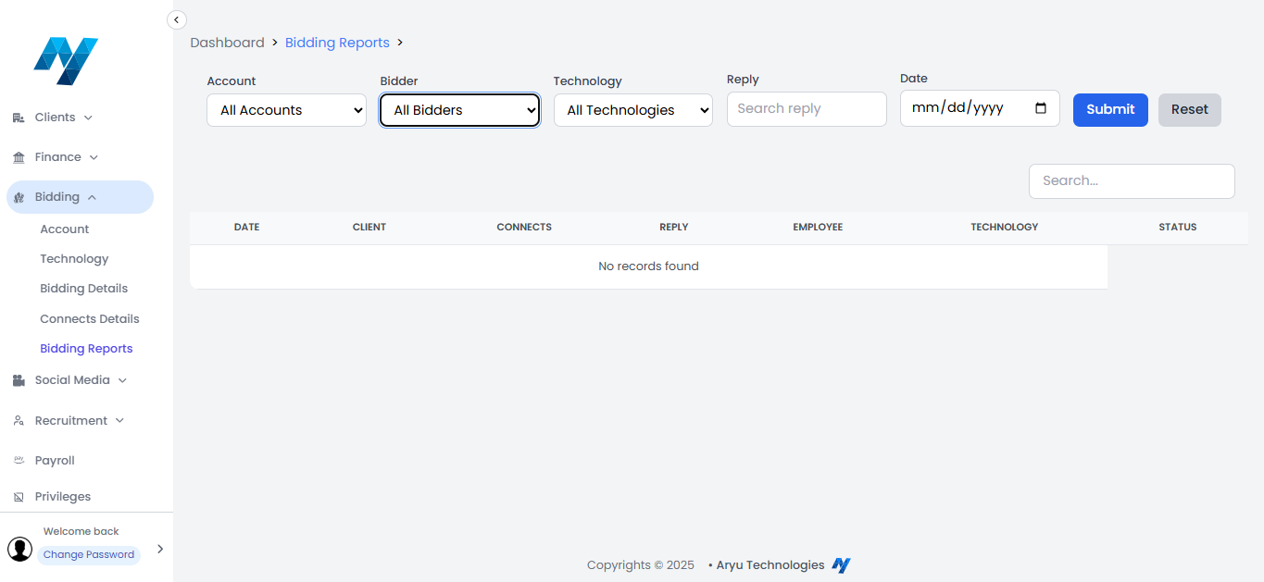
10) The Account and Technology are added, but they are not reflected on the dropdowns of the Bidding Details category and the Bidding Reports category under the Bidding section.
STATUS: Yet to be Rectified
Bidding Details: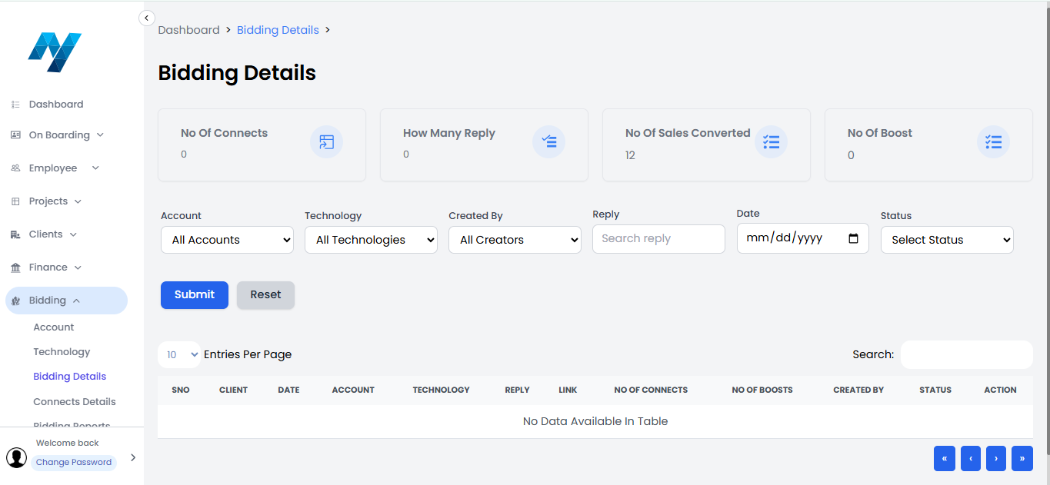
Bidding Reports:
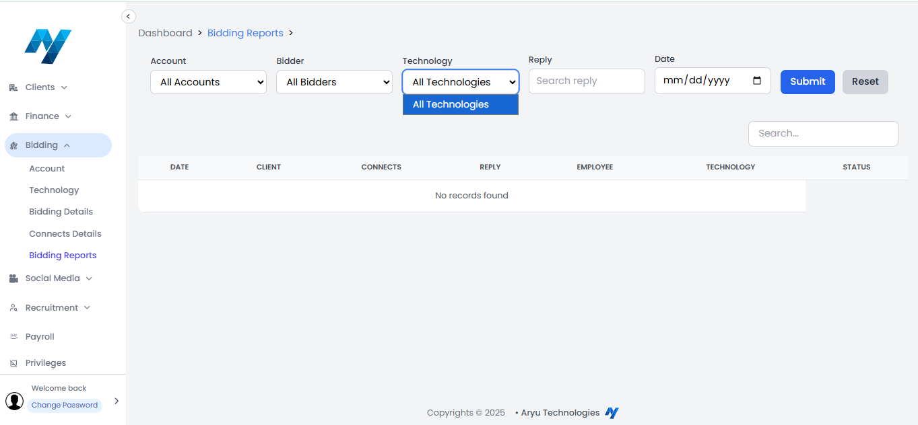
11) The Credentials category under the social media section is displaying an error like the below.
STATUS: Yet to be Rectified
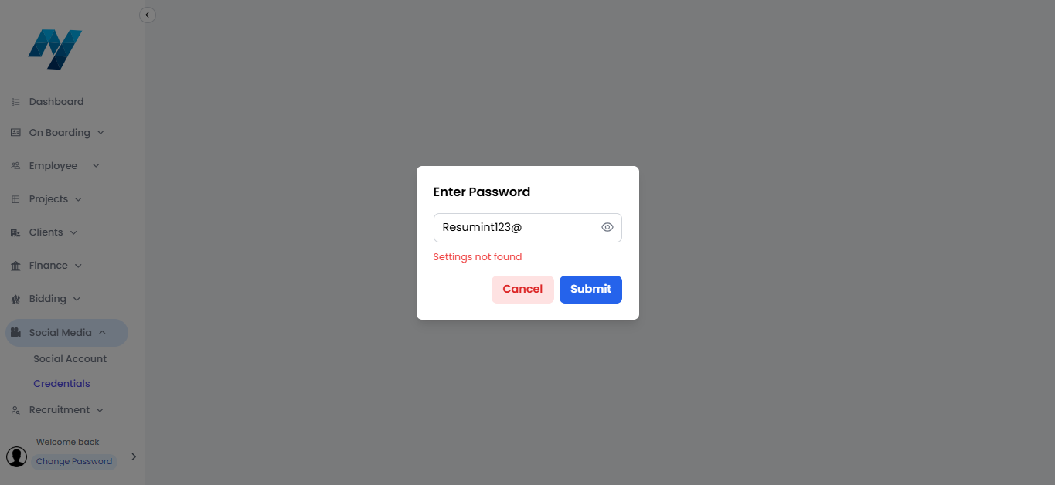
12) After clicking the Payroll section, a blank white page appears.
STATUS: Yet to be Rectified
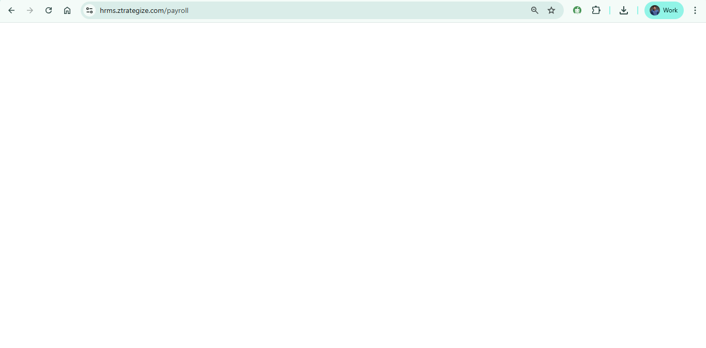
13) After clicking the Links section, the page loads endlessly.
STATUS: Yet to be Rectified
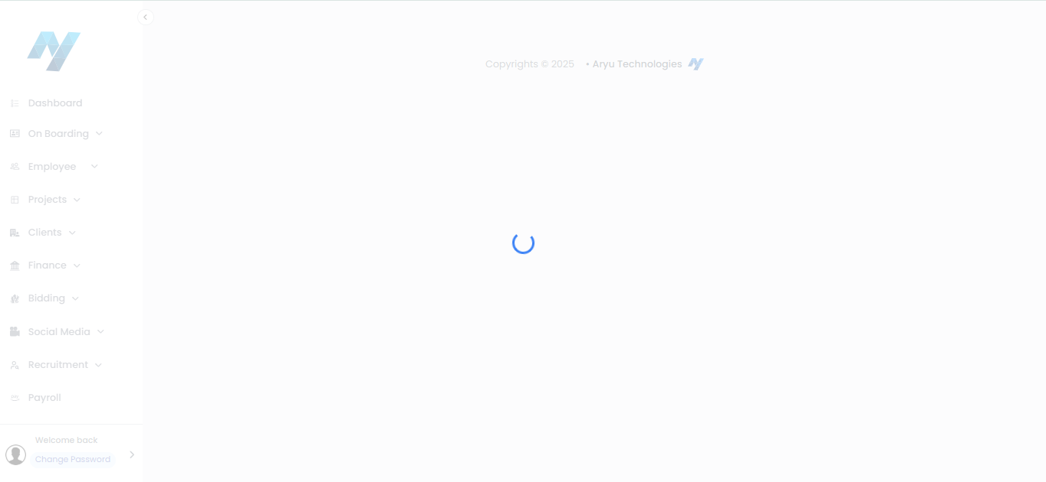
14) Spelling error:
Under the Settings Section.
Employee EEESI which must be Employee ESI.
Employee ERESI which must be Employer ESI.
STATUS: Yet to be Rectified

Employee Portal
Tue, 28 Oct
1) Pop-up of expected employee relieving tab during every login, page refresh, and dashboard page click.
NOTE: It still pops up even after submitting the relieving date.
STATUS: Rectified
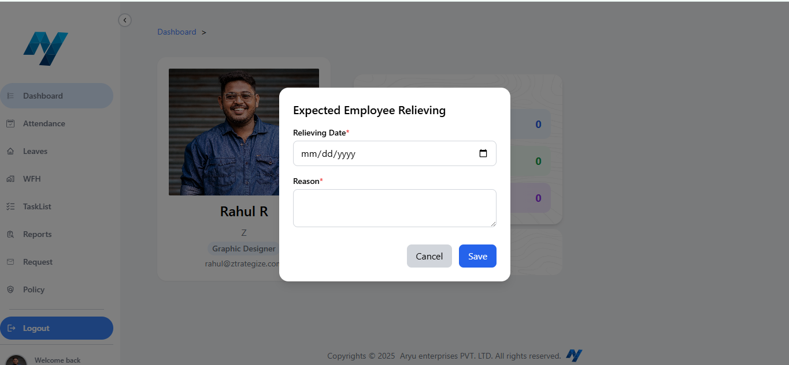
2) The WFH option in the Work Type category cannot be selected.
STATUS: WFH is enabled, but WFO option cannot be selected.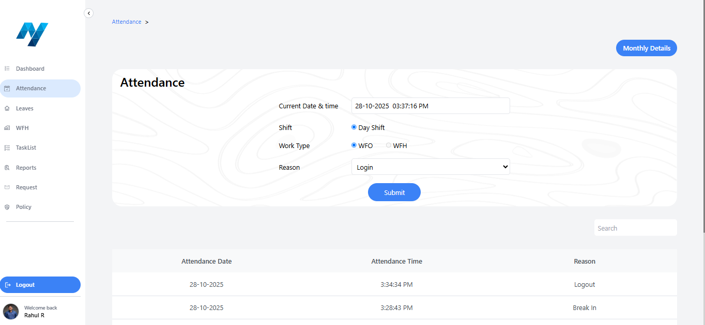
3) Permission Type in Leave can be submitted without even filling the time.
Note: Timing is mandatory for Permission.
STATUS: Rectified
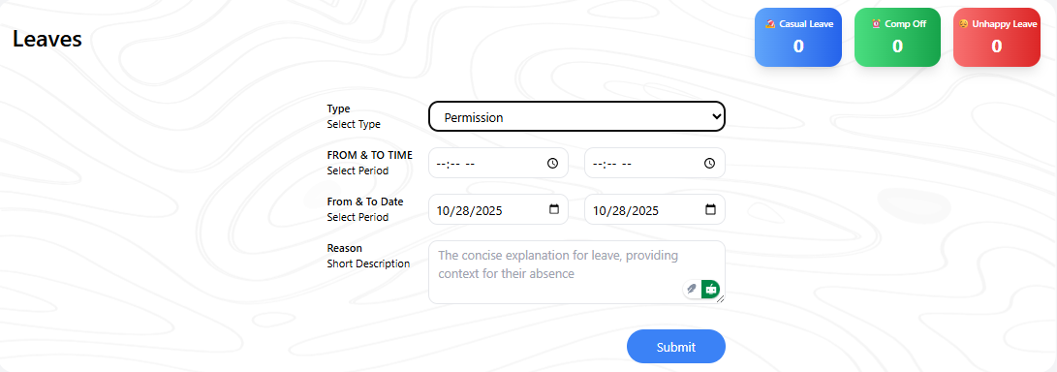
4) Leave can be submitted without filling in the reason.
Note: A Reason is mandatory for Leaves.
STATUS: Rectified
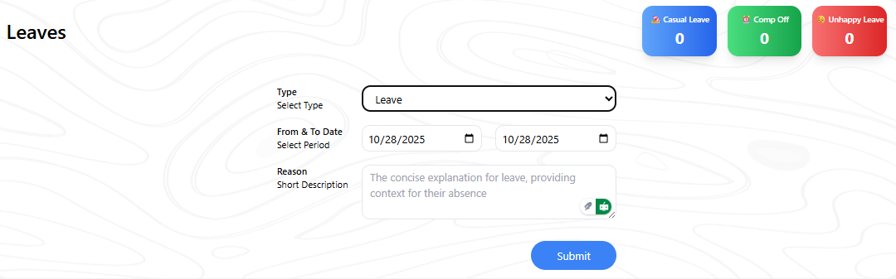

5) After filling in all the details of the candidate in the admin portal, the details section of the employee portal becomes a blank white page.
Admin Portal:
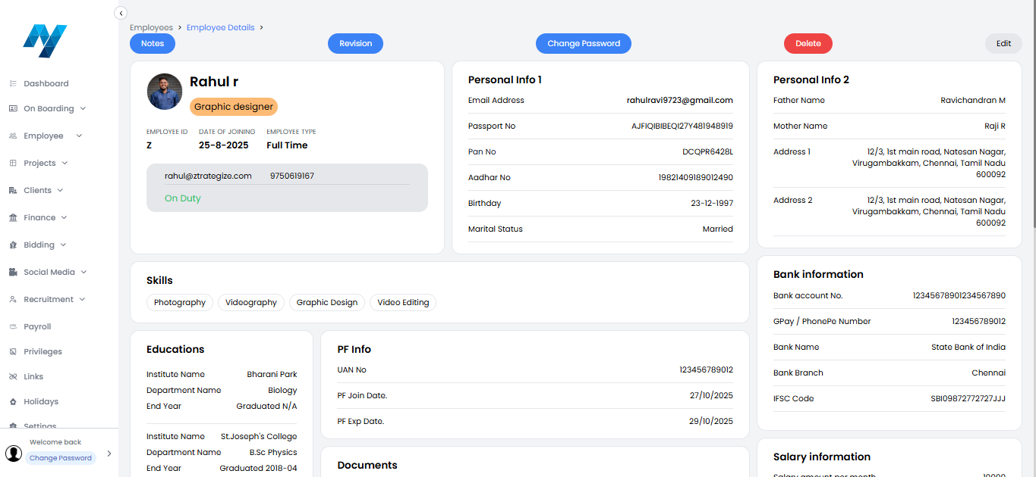
Employee Portal:
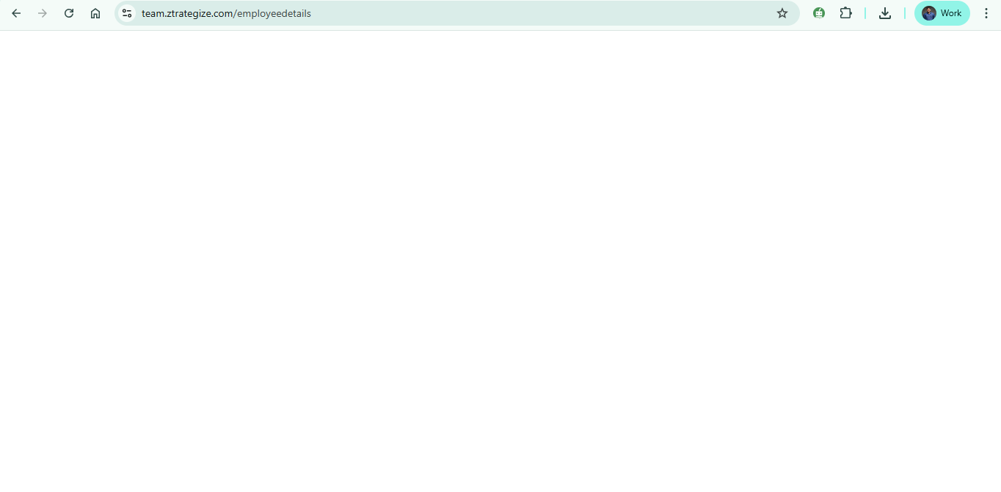
Wed, 29 Oct
6) The changes in the Profile Picture, Employee ID, Role and Mail ID are not reflected on the dashboard and Welcome Back section but are reflected on the Employee Details page.
STATUS: Rectified
Dashboard:
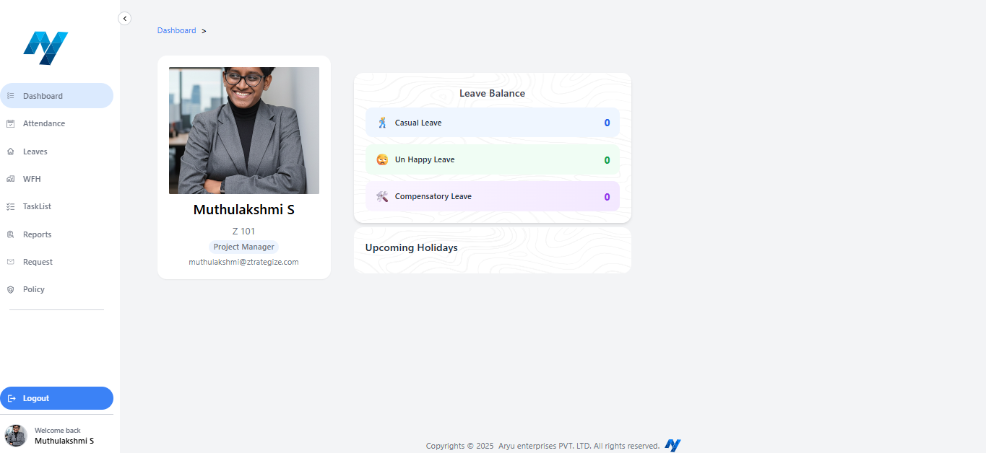
Employee Details:
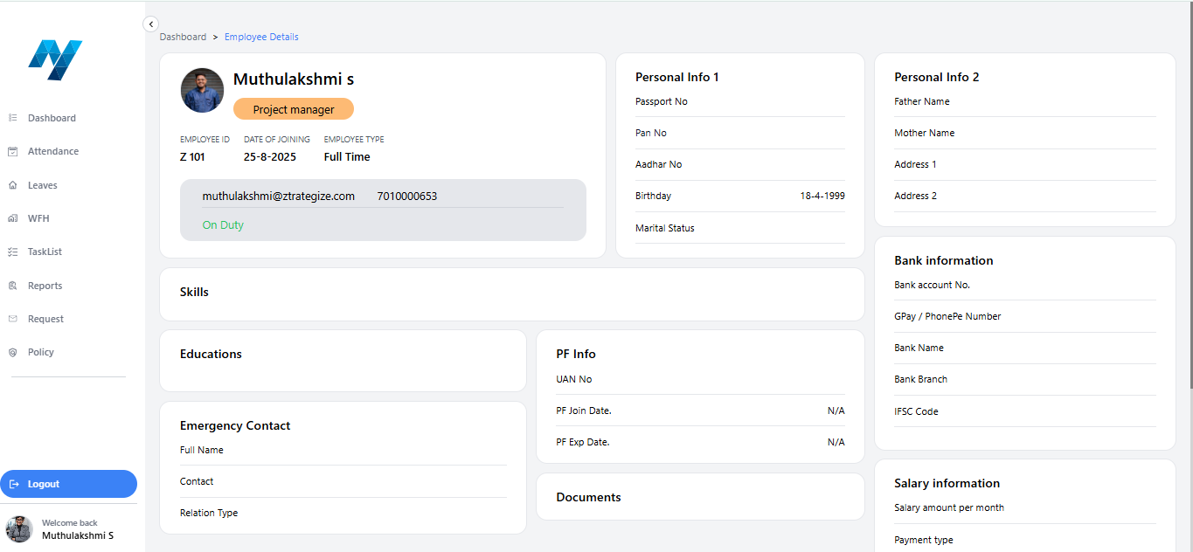

Requirements
Tue, 28 Oct
1) Can we change the following:
i) Break Out into Start Break.
ii) Break In into End Break.
STATUS: Rectified
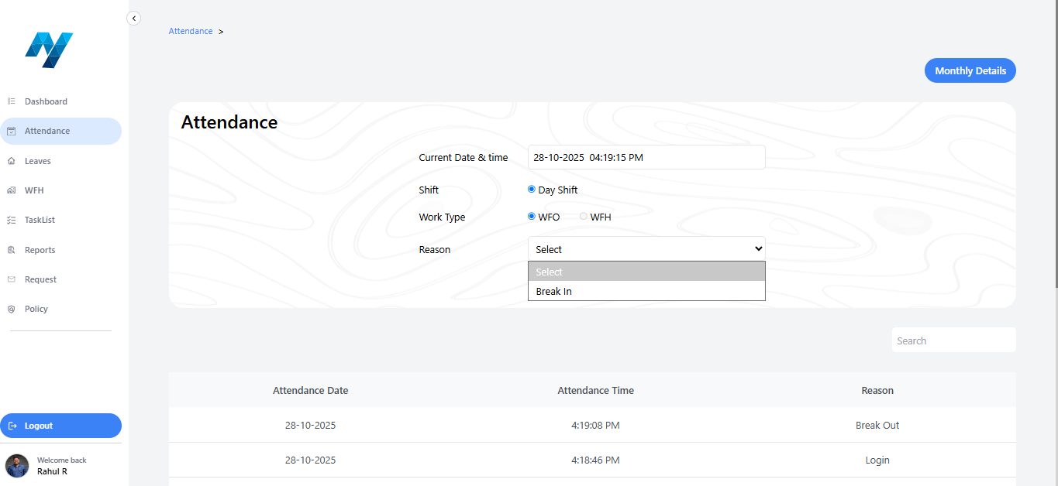
2) Require options in the Leave type.
i) Casual Leave.
ii) Unhappy Leave.
iii) Loss Of Pay.
iv) Comp-off.
STATUS: Rectified
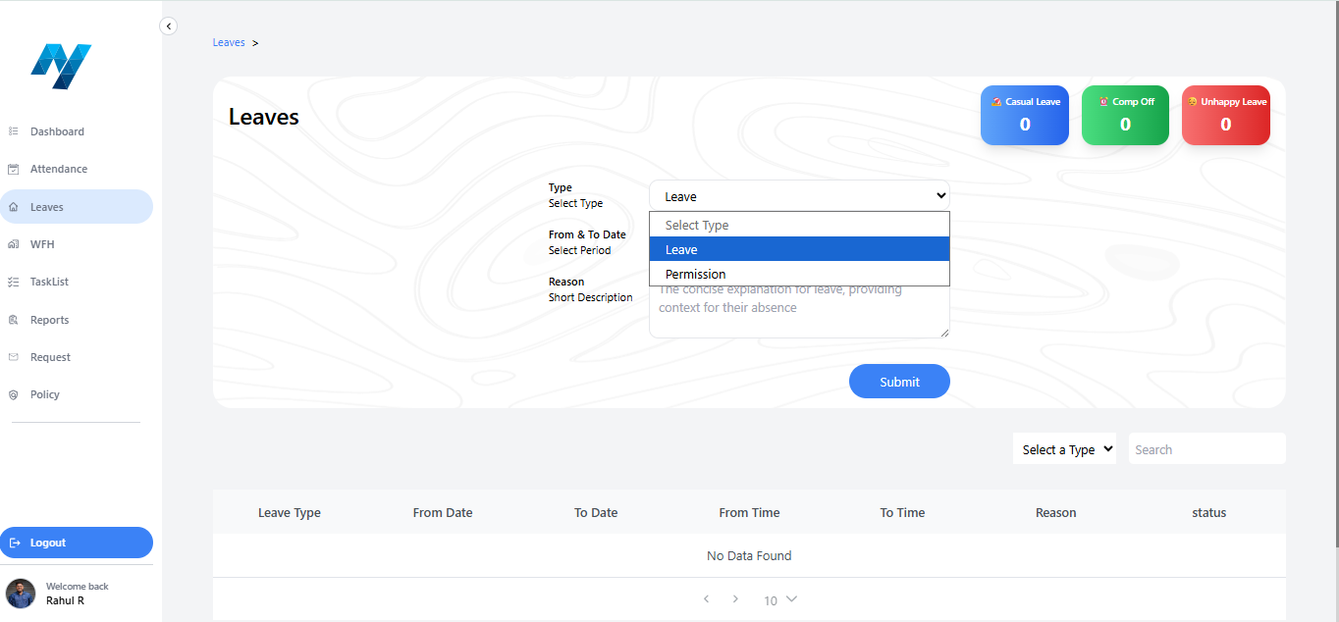
3) Can we add Night Shift in the Shift category.
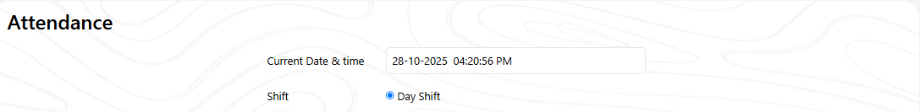
STATUS: Yet to add Night shift
4) Can we link the Leave Type from the admin to the employee portal. A new section need to be added between the type and From & To Date as Leave type so that the employees can select the leave types which will be added in the admin portal.
STATUS: Rectified
Admin Portal:
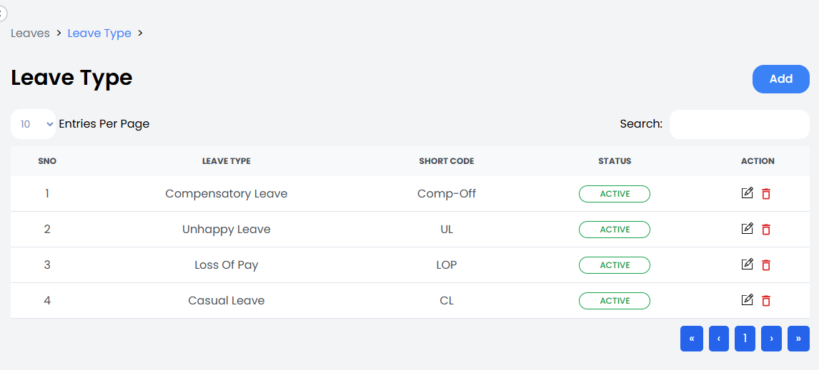
Employee Portal:
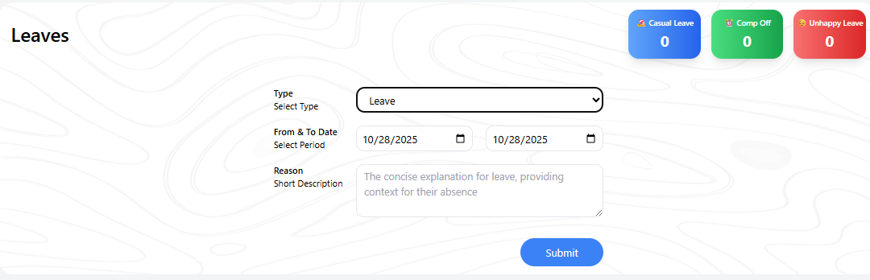
5) Can the type Spouse be added in the Relation Type under the Emergency Contact if the Marital status has been selected as Married.
STATUS: Spouse need to be added in the Relation Type under Emergency Contact
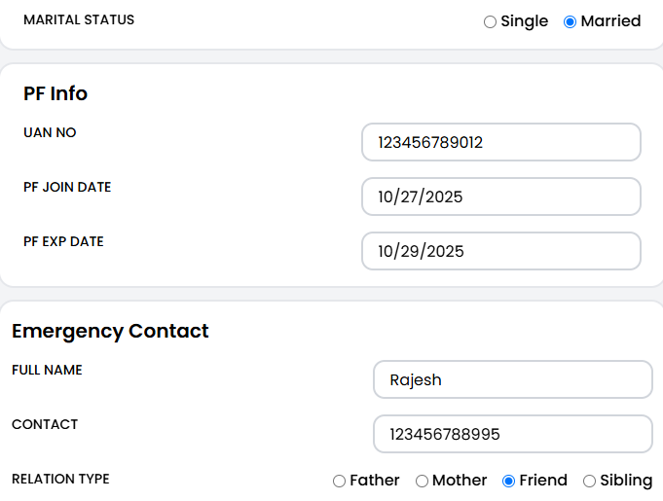
6) Can a new section for the Leave requests be added like the request section on the dashboard.
STATUS: Rectified
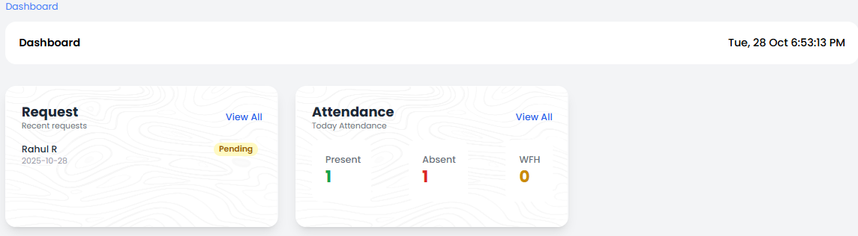
Wed, 29 Oct
7) Can we add the option of change password in the employee portal so that the credentials can we be confidential.
STATUS: Need to be added
