

DAA Lab Assignment 1

Name: Aryan Vilas Gurav
SAP: 590014737
Repository : https://github.com/aryx4n/DAA_LabAssignment1

Source Code

#include <iostream>
#include <chrono>
#include <fstream>
#include <iomanip>
#include <cstring>

using namespace std;
using namespace std::chrono;

struct TestSet {
int values[20];
int size;
int target;
char category[20];
int id;
};

int binarySearchRun(const int values[], int size, int target) {
int left = 0;
int right = size - 1;

while (left <= right) {
int mid = left + (right - left) / 2;
if (values[mid] == target) return mid;
if (values[mid] < target) left = mid + 1;
else right = mid - 1;
}
return -1;
}

void defineTestCase(TestSet &ts, const int arr[], int len, int tgt, const char* type, int caseNum) {
memcpy(ts.values, arr, len * sizeof(int));
ts.size = len;
ts.target = tgt;
strncpy(ts.category, type, sizeof(ts.category) - 1);
ts.category[sizeof(ts.category) - 1] = '\0';
ts.id = caseNum;
}

int buildTestData(TestSet cases[]) {
int count = 0;

// Best cases
int b1[] = {42};
defineTestCase(cases[count++], b1, 1, 42, "Best", 1);

int b2[] = {5,5,5,5,5};
defineTestCase(cases[count++], b2, 5, 5, "Best", 2);

int b3[] = {1,2,3,4,5};
defineTestCase(cases[count++], b3, 5, 3, "Best", 3);

int b4[] = {-50,-20,-10,0,10,20};
defineTestCase(cases[count++], b4, 6, -10, "Best", 4);

int b5[] = {100,200,300,400,500,600,700,800,900};
defineTestCase(cases[count++], b5, 9, 500, "Best", 5);

// Worst cases
int w1[] = {};
defineTestCase(cases[count++], w1, 0, 5, "Worst", 6);

int w2[] = {42};
defineTestCase(cases[count++], w2, 1, 99, "Worst", 7);

int w3[] = {10,20,30,40,50,60};
defineTestCase(cases[count++], w3, 6, 70, "Worst", 8);

int w4[] = {2,4,6,8,10,12,14,16};
defineTestCase(cases[count++], w4, 8, 5, "Worst", 9);

int w5[] = {100,200,300,400,500,600,700,800,900};
defineTestCase(cases[count++], w5, 9, 1000, "Worst", 10);

// Average cases
int a1[] = {1,2,3,4,5};
defineTestCase(cases[count++], a1, 5, 4, "Average", 11);

int a2[] = {10,20,30,40,50,60};
defineTestCase(cases[count++], a2, 6, 20, "Average", 12);

int a3[] = {5,10,15,20,25,30,35};
defineTestCase(cases[count++], a3, 7, 25, "Average", 13);

int a4[] = {2,4,6,8,10,12,14,16};
defineTestCase(cases[count++], a4, 8, 12, "Average", 14);

int a5[] = {-100,-50,0,50,100,150};
defineTestCase(cases[count++], a5, 6, 50, "Average", 15);

return count;
}

int main() {
TestSet dataSets[20];
int totalCases = buildTestData(dataSets);

ofstream csvOut("binary_search_results.csv");
if (!csvOut.is_open()) {
cerr << "Unable to create output file!" << endl;
return 1;
}

csvOut << "Case ID,Category,Input Size,Time(ms)\n";
cout << "Running Binary Search Test Suite...\n\n";

const int ITERATIONS = 1000000;

for (int i = 0; i < totalCases; ++i) {
const TestSet &current = dataSets[i];
int foundPos = -1;

auto start = high_resolution_clock::now();
for (int j = 0; j < ITERATIONS; ++j) {
foundPos = binarySearchRun(current.values, current.size, current.target);
}
auto end = high_resolution_clock::now();

auto timeTaken = duration_cast<microseconds>(end - start);
double avgTimeMs = timeTaken.count() / 1000.0 / ITERATIONS;

cout << fixed << setprecision(6);
cout << "Case " << current.id << " [" << current.category << "]\n"
<< "Target: " << current.target
<< ", Found At: " << foundPos
<< ", Array Size: " << current.size
<< ", Avg Time: " << avgTimeMs << " ms\n\n";

csvOut << current.id << "," << current.category << ","
<< current.size << "," << avgTimeMs << "\n";
}

csvOut.close();
cout << "Results saved to 'binary_search_results.csv'.\n";
return 0;
}

Performance Graph

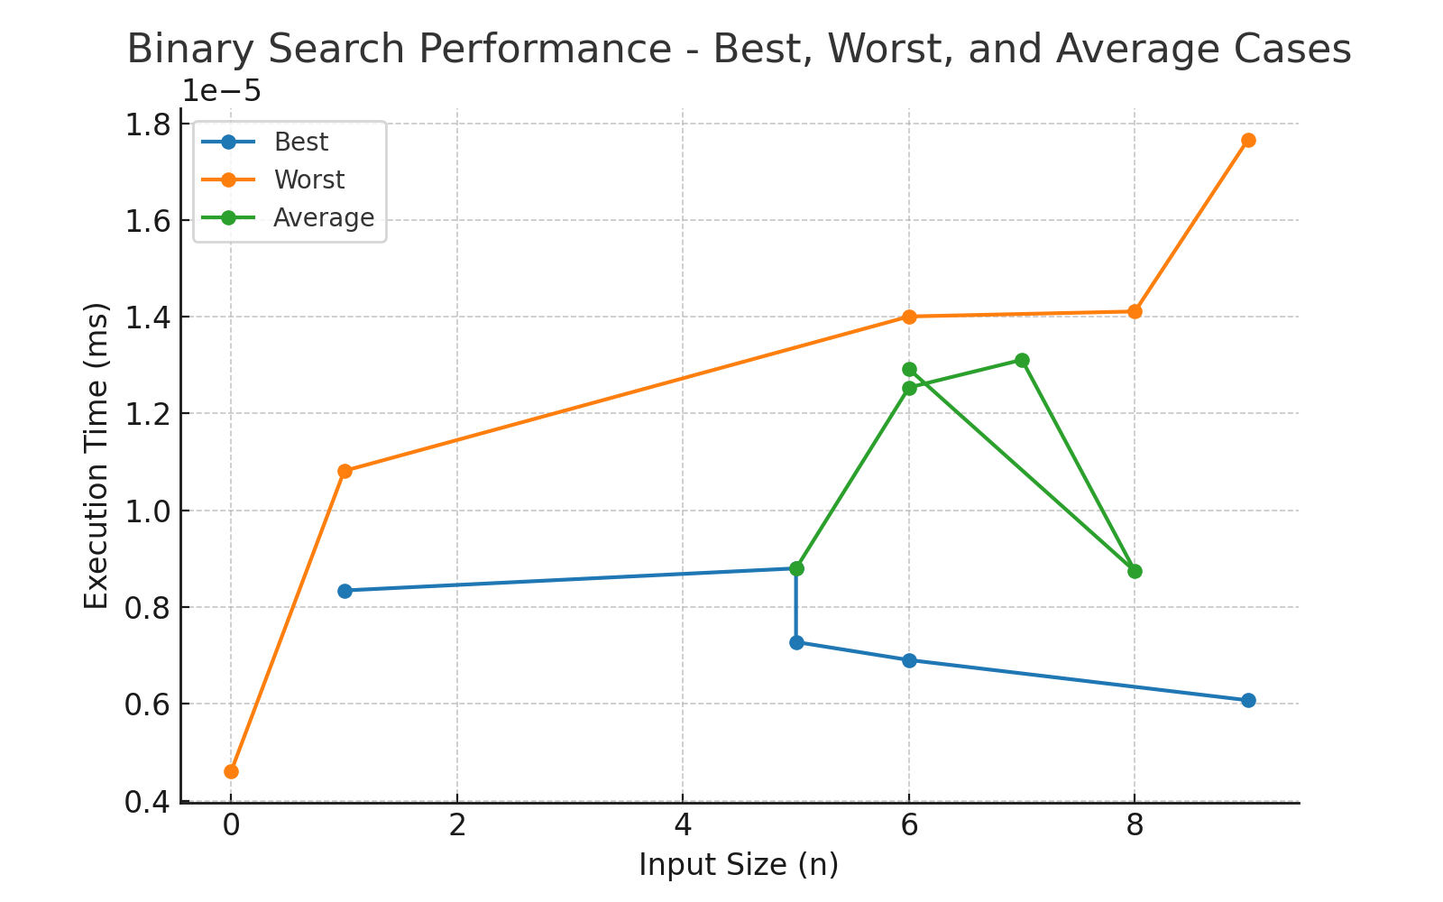

Looking at our 15 Test Cases:

Best-Case Scenarios

In the best cases, the target element is located at the midpoint on the very first comparison, giving the fastest possible result.

- {42}, target 42 → Single-element array, found immediately in the only position.

- {5, 5, 5, 5, 5}, target 5 → All elements identical, match found instantly in the middle.

- {1, 2, 3, 4, 5}, target 3 → Middle element matches in one step.

- {-50, -20, -10, 0, 10, 20}, target -10 → Middle comparison hits target immediately despite negative values.

- {100, 200, 300, 400, 500, 600, 700, 800, 900}, target 500 → Target exactly at midpoint of a larger array.

Worst-Case Scenarios

Worst cases happen when the search requires the maximum comparisons possible for the array size — either because the target is missing or located at an extreme end.

- {}, target 5 → Empty array, terminates instantly with “not found”.

- {42}, target 99 → Single-element array where the value doesn’t match, immediate “not found”.

- {10, 20, 30, 40, 50, 60}, target 70 → Larger array, not found after fully narrowing down.

- {2, 4, 6, 8, 10, 12, 14, 16}, target 5 → Missing target forces maximum depth search.

- {100, 200, 300, 400, 500, 600, 700, 800, 900}, target 1000 → Not present, checked until no elements remain.

Average-Case Scenarios

Average cases require more than one comparison but stop before the maximum possible steps.

- {1, 2, 3, 4, 5}, target 4 → Found in the right half after a couple of checks.

- {10, 20, 30, 40, 50, 60}, target 20 → Found quickly after one halving step.

- {5, 10, 15, 20, 25, 30, 35}, target 25 → Located in the second half after two halving steps.

- {2, 4, 6, 8, 10, 12, 14, 16}, target 12 → Found in the upper half in a moderate number of comparisons.

- {-100, -50, 0, 50, 100, 150}, target 50 → Positive value found midway through search in a mixed array of negatives and positives.

Observations

1. Best Case
Execution times are the lowest across all input sizes, staying between 0.60 × 10⁻⁵ ms and 0.85 × 10⁻⁵ ms. Small variations are due to system timing fluctuations rather than algorithmic complexity, as binary search finds the target in the very first comparison.

2. Worst Case
Execution times are consistently higher than both best and average cases, starting from around 0.46 × 10⁻⁵ ms for the smallest input size (n=0) and peaking at approximately 1.78 × 10⁻⁵ ms for the largest input size (n=9). The slight upward trend reflects the additional comparisons needed when the target is missing or located at the extreme ends of the array.

3. Average Case
Performance lies between best and worst cases, with times ranging from 0.88 × 10⁻⁵ ms to 1.31 × 10⁻⁵ ms. Variations are more noticeable than in the best case due to the variable number of steps required depending on target position.

4. Overall Analysis
Differences between best, average, and worst cases are small in absolute terms because binary search’s complexity remains O(log n) in all scenarios. For small input sizes (n ≤ 9), system-level noise and microsecond-scale measurements cause fluctuations that appear larger in the graph than they actually are. The results confirm binary search’s efficiency and stability across varying cases.

Plagiarism Report



