Create model in Fabric, use it in Azure ML with MLFlow
Aryan Shah

We will develop and train a model on AzureML and then host it on Fabric as an endpoint.
There are some complications involved as Fabric is relatively new and the API and ML support is still heavily in development.
First let’s create a compute instance in AzureML, this will give your notebook the compute needed to run the code. Head to https://ml.azure.com and navigate to compute.
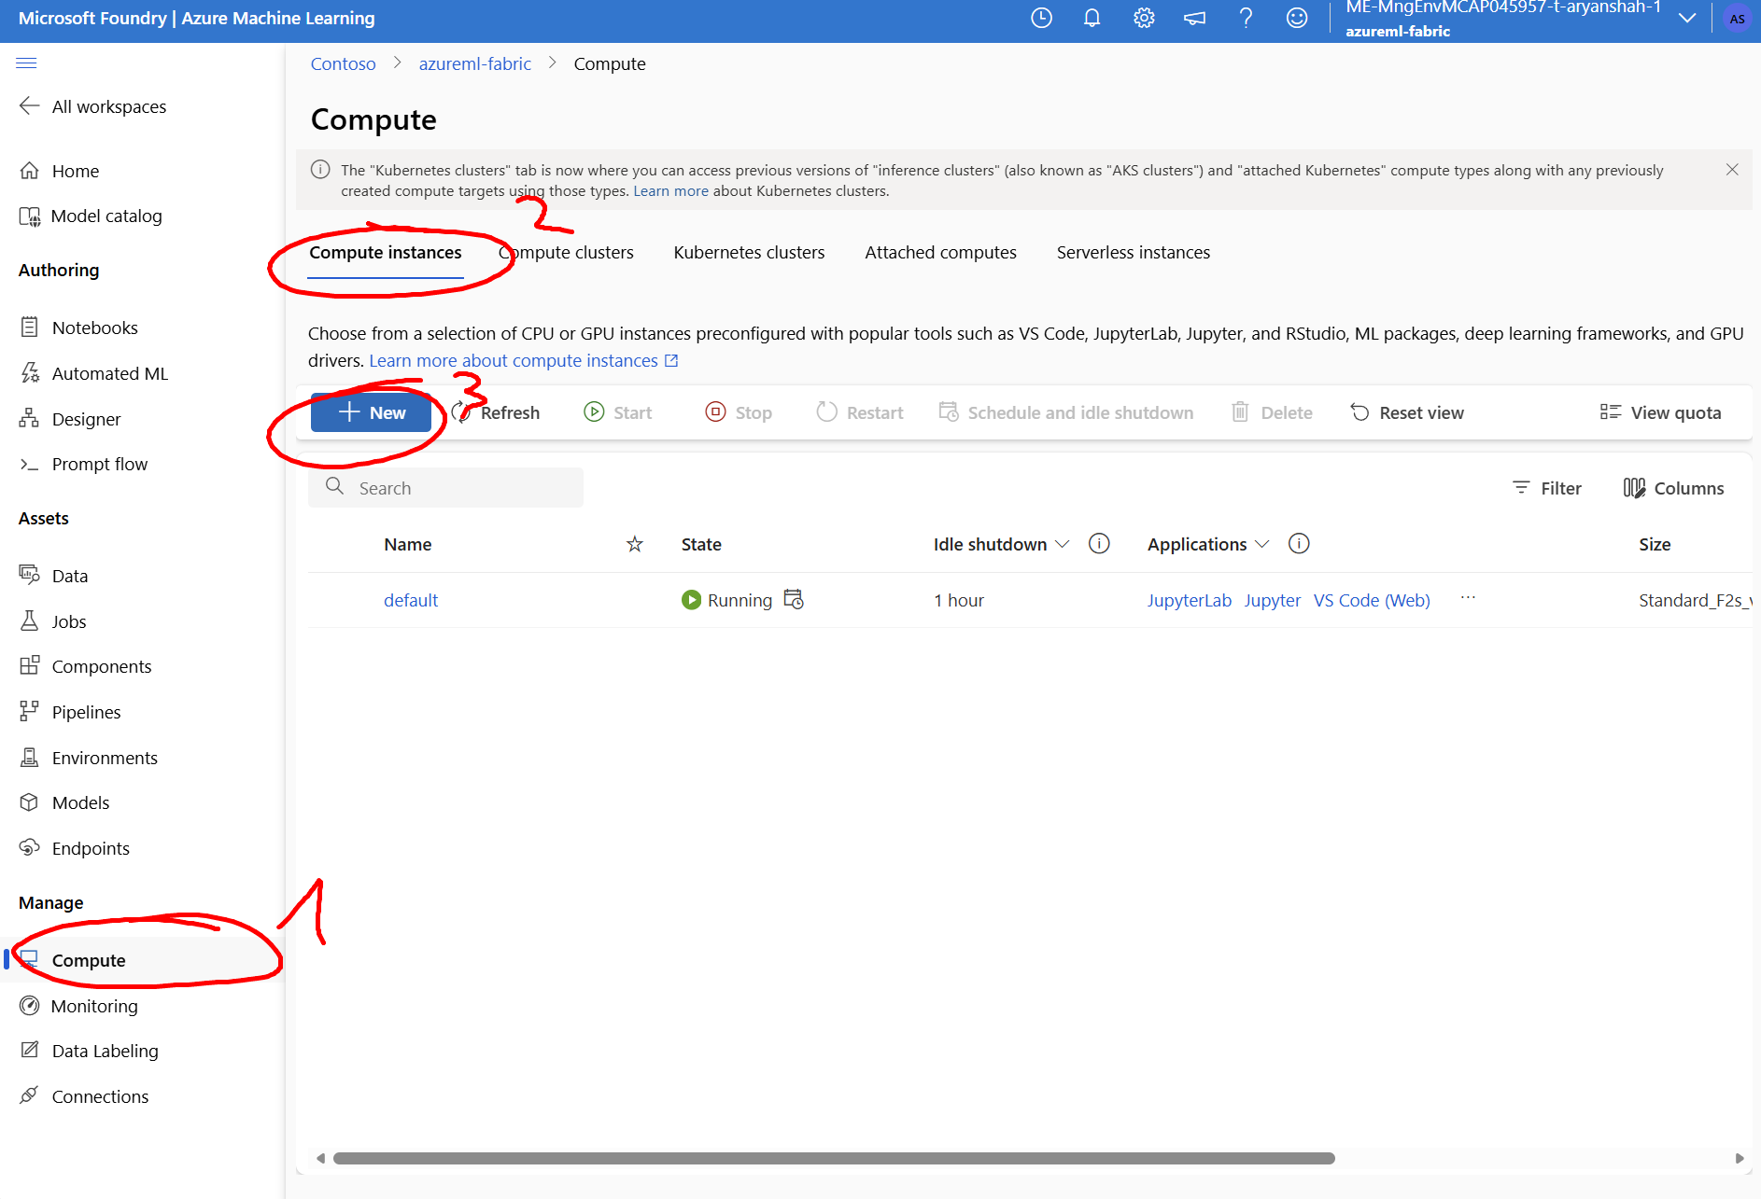

We do not need to configure anything here, fill in what is required to your choice and click on “Review + Create”
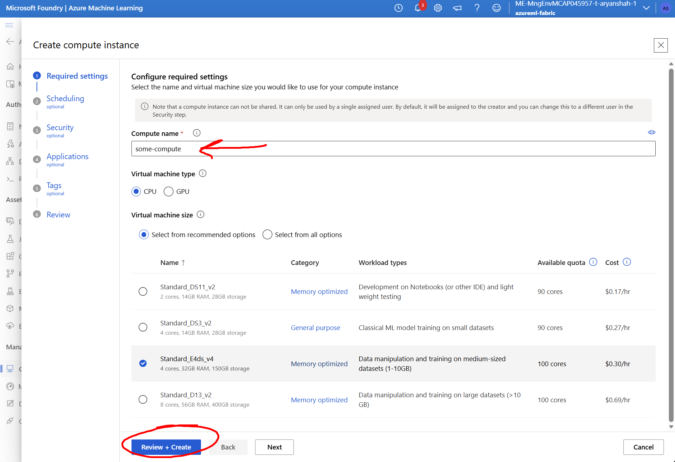

Now we can start with the fun part, using AzureML to build the model and then host it on Fabric, through a notebook on AzureML.
We will use an Azure ML quickstart notebook, which provides code to train a model and log it with MLflow. MLflow is ideal because it’s an open-source platform and model format that works across Azure ML, Microsoft Fabric, and many other tools. We won’t be going through all the ML steps, since the goal here is to explain how we can have the model running on Fabric through an AzureML Notebook.
Head to the “Notebooks” tab and upload the `upload_to_azureml` folder.
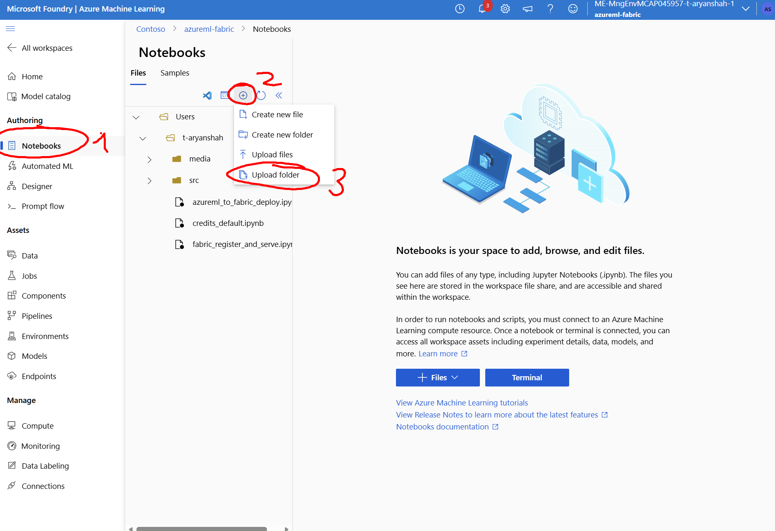
Since we will be using your Azure credentials for authentication into the Fabric workspace, you need to login with `az cli` in the built-in terminal in the AzureML compute instance.
First open a terminal in the compute instance. Enter the command and go through the authentication process. This method assumes that you have at least “Contributor” access in the Fabric workspace where you want to host the model.
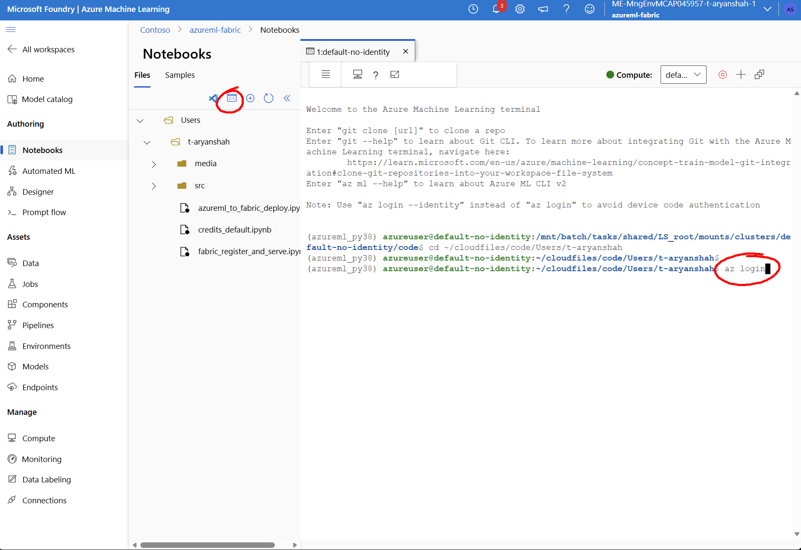
Then open the `credits_default.ipynb` notebook, add compute and select Python 3.10 SDK v2. You may be asked to authenticate, to use the AzureML compute.
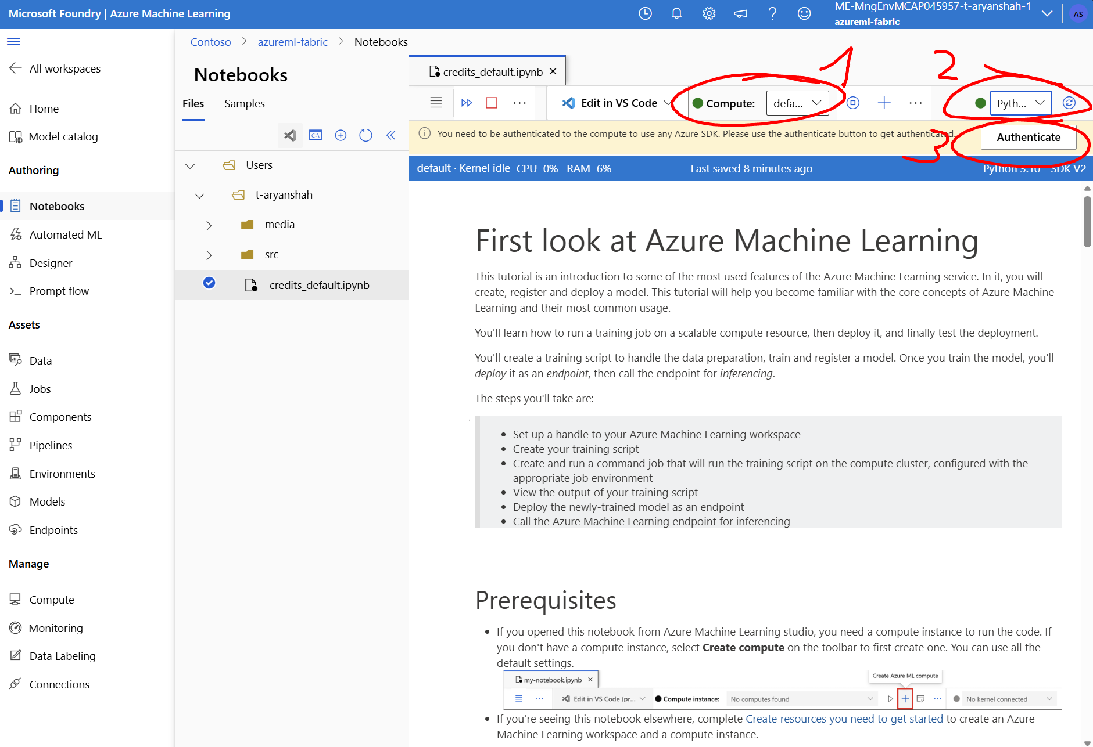

Now we can start training the model and registering it in AzureML. Run all the cells in order, in `credits_default.ipynb`, until the section where it highlights in bold that the following parts are to host the AzureML model as an endpoint within AzureML, this is not what we want for this exercise.
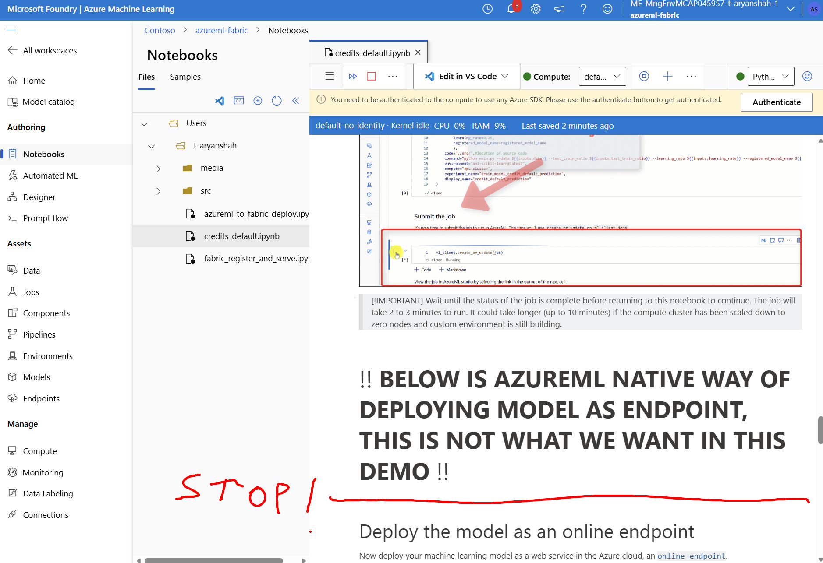
Now we can deploy the model on Fabric, go to the notebook “azureml_to_fabric_deploy.ipynb”. Here you can run all cells, everything is well documented for you to understand what is going on.
IMPORTANT: Make sure you have at least 1 lakehouse available in your Fabric workspace, this lakehouse will be used to store model artifacts
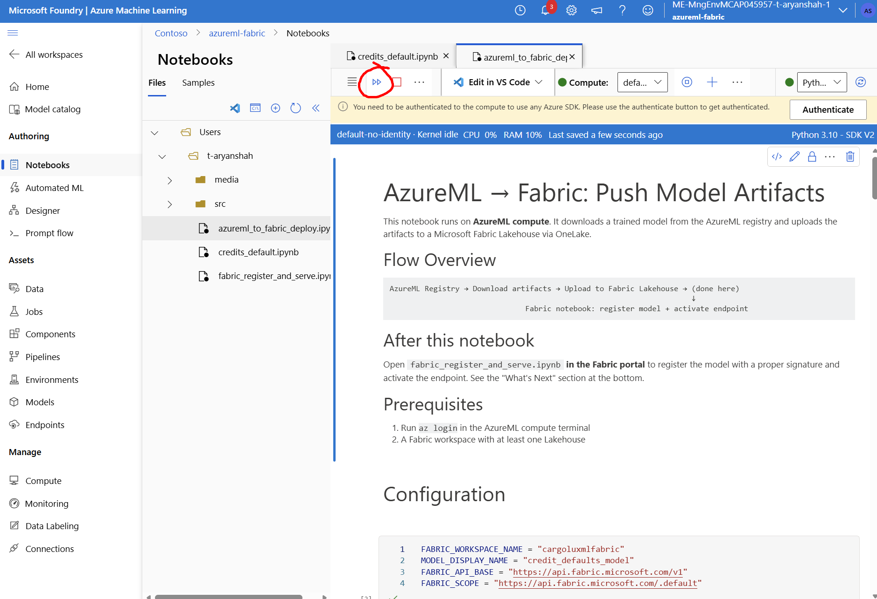
This will have created a notebook in your Fabric workspace which you will have to trigger manually. The reason being that the Fabric API is not mature enough at the moment to seamlessly support model transfer and hosting it on a Fabric endpoint. Automation is limited since RestAPI notebook trigger will give an error. Head to Fabric and open in your workspace “fabric_register_and_serve.ipynb”.
We have to manually attach the lakehouse in which your model artifacts were stored.
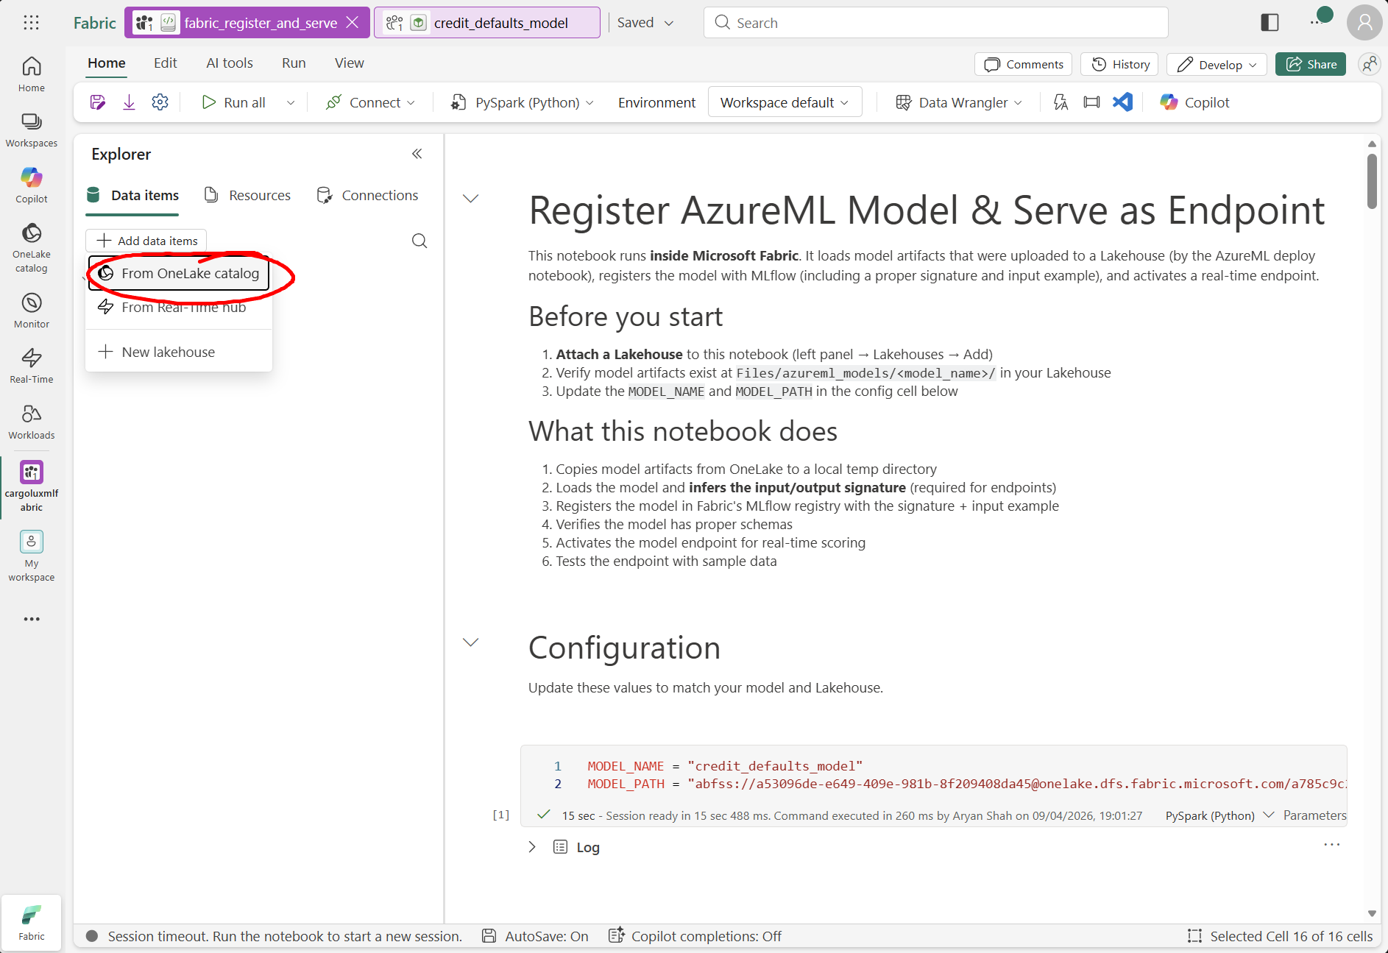
Once attached, simply run all, if you would like to see what’s going on, the notebook documents every step clearly.
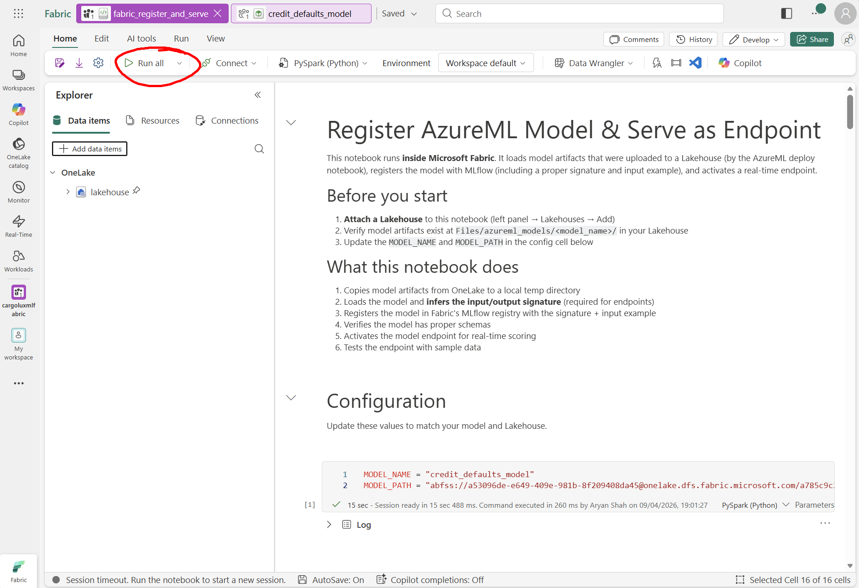
This will create the model and host the endpoint automatically. Once finished, if you would like to see the model and the endpoint in the UI, go to your main workspace and find “credit_defaults_model”
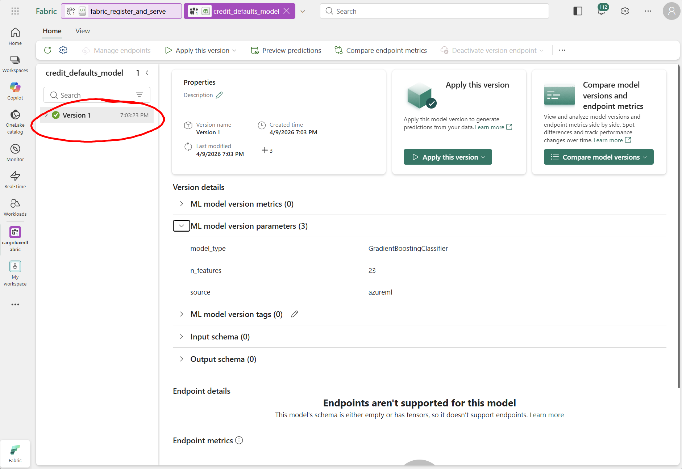
The limitation here is that although the model inferences correctly and is hosted, you will not see all the things you would see in the details, like input schema, output schema, endpoint details, etc. This is a limitation of training it on AzureML and hosting the model on Fabric.

