Menu Screenshots:
The running Menu
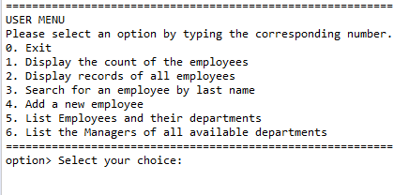

Option 1: Display the count of the Employees
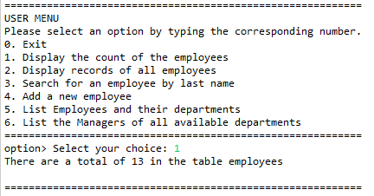

Option 2: Display records of all Employees
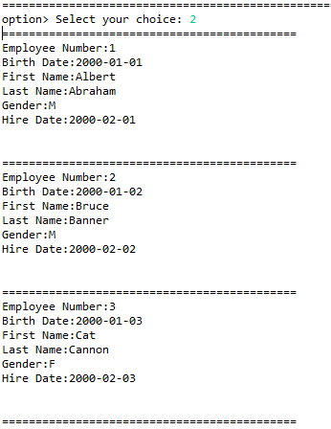

Option 3: Add a new Employee (Input screen, with values input)
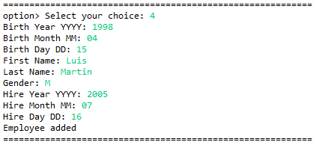

Option 3: Add a new Employee (Output screen)
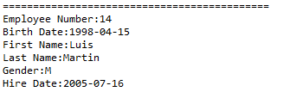

Run option 2 again after Option 3 has been run, (option 2, output):
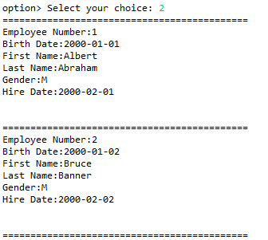


Option 4: Search for an Employee by last name (Input & output)
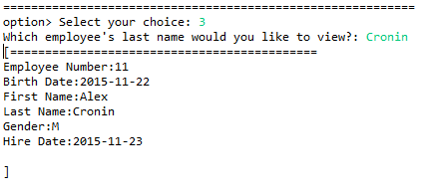

Option 5: To be added by Student (Input & output)
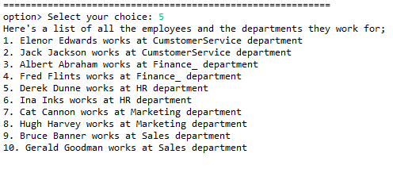

Option 6: To be added by Student (Input & Output)
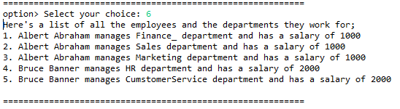

Additional Screenshot A (if necessary):

Additional Screenshot B (if necessary):

Procedures screenshots:
Procedure for option 1: Display the count of the employees

Procedure for option 2: Display records of all employees

Procedure for option 3: Search for an employee by last name

Procedure for option 4: Add a new employee
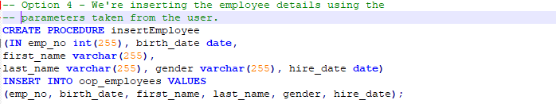

Procedure for option 5: We're getting the Employee name and the department they belong to by joining the oop_employees and oop_departments tables all joined by the oop_emp_dept
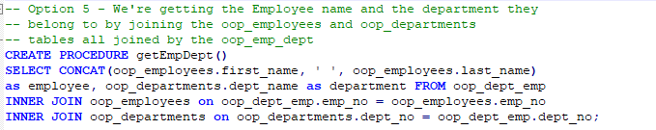

Procedure for option 6: We're displaying all the departments and their managers and the salaries of those managers. Joins the oop_employees, oop_dept_manager and oop_departments
