Met_Master Merge with Eddy_Pro_Master: Data from 2019-11-18

library(tidyverse)

## Registered S3 methods overwritten by 'ggplot2':  
## method from   
## [.quosures rlang  
## c.quosures rlang  
## print.quosures rlang

## -- Attaching packages ------------------------------------------------------- tidyverse 1.2.1 --

## v ggplot2 3.1.1 v purrr 0.3.2  
## v tibble 2.1.2 v dplyr 0.8.1  
## v tidyr 0.8.3 v stringr 1.4.0  
## v readr 1.3.1 v forcats 0.4.0

## -- Conflicts ---------------------------------------------------------- tidyverse_conflicts() --  
## x dplyr::filter() masks stats::filter()  
## x dplyr::lag() masks stats::lag()

source("calc_footprint_FFP.R")  
library(ggplot2)  
library(modelr)  
options(na.action = na.warn)

# Lists

rm(list=ls())

# Defining the data I/O directory for the Eddy Master File

**

path_eddy<-"C:\\Users\\Tommy\\flux\\Data-exploring\\02_Concord\\"  
path.in_eddy<-paste(path_eddy,"01_Proccessed_Data",sep="")  
path.out_eddy<-paste(path_eddy,"03_combined_data",sep="")  
ver<-"Master_Eddy"   
file.name_eddy<-paste("master_eddy_pro_concord",sep="")

# read in eddypro full output Master file, parse variable names

data_master_eddy<-read.csv(paste(path.in_eddy,"\\",ver,"\\",file.name_eddy,".csv",sep=""),  
 header=F,  
 skip=3,  
 na.strings=c(-9999),  
 stringsAsFactors = F)  
colnames(data_master_eddy)<-colnames(  
 read.csv(paste(path.in_eddy,"\\",ver,"\\",file.name_eddy,".csv",sep=""),  
 header=T,  
 skip=1))

# Defining the data I/O directory for the Master met_data

path_met<-"C:\\Users\\Tommy\\flux\\Data-exploring\\02_Concord\\"  
path.in_met<-paste(path_met,"01_Proccessed_Data",sep="")  
path.out_met<-paste(path_met,"03_combined_data",sep="")  
ver<-"met_data"   
file.name<-paste("MET_data_master",sep="")

#read in Met_Data Master file, parse variable names and define N/As#

met_data_master<-read.csv(paste(path.in_met,"\\",ver,"\\",file.name,".csv",sep=""),  
 header=F,  
 skip=4,  
 na.strings=c("NAN"),  
 stringsAsFactors = F)  
colnames(met_data_master)<-colnames(  
 read.csv(paste(path.in_met,"\\",ver,"\\",file.name,".csv",sep=""),  
 header=T,  
 skip= 1))

# Parsing the time stamp converting it into a POSIXlt vector

**interpreting date and time into new timestamp column**

**Then taking that time stamp column and turning each time into a unique number (time.id) so I can join based on that. As it can be really tricky to join/merge based on time stamps alone**

**Or I could make sure both time stamps are characters and match them that way**

**Finally ploting time.id to make sure my times translate linearily**

data_master_eddy$TIMESTAMP<-strptime(paste(data_master_eddy$date,data_master_eddy$time,sep=" "),format="%m/%d/%Y %H:%M", tz = "GMT")  
  
data_master_eddy$time.id<-data_master_eddy$TIMESTAMP$year+1900+(data_master_eddy$TIMESTAMP$yday)/366+(data_master_eddy$TIMESTAMP$hour)/366/24+ (data_master_eddy$TIMESTAMP$min)/366/24/60  
  
data_master_eddy$time.id[1:50]

## [1] 2019.450 2019.450 2019.450 2019.450 2019.450 2019.450 2019.450  
## [8] 2019.450 2019.451 2019.451 2019.451 2019.451 2019.451 2019.451  
## [15] 2019.451 2019.451 2019.451 2019.451 2019.451 2019.451 2019.451  
## [22] 2019.451 2019.451 2019.451 2019.451 2019.452 2019.452 2019.452  
## [29] 2019.452 2019.452 2019.452 2019.452 2019.452 2019.452 2019.452  
## [36] 2019.452 2019.452 2019.452 2019.452 2019.452 2019.452 2019.452  
## [43] 2019.452 2019.453 2019.453 2019.453 2019.453 2019.453 2019.453  
## [50] 2019.453

plot(data_master_eddy$time.id)

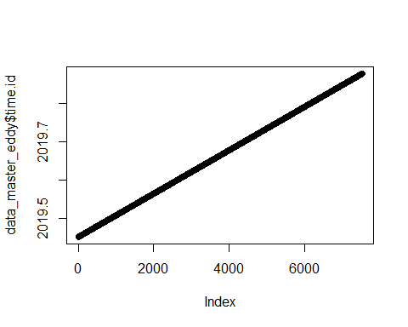

which(duplicated(data_master_eddy$time.id))

## integer(0)

#Taking the met_data and turning the time stamp into posixt format#

met_data_master$TIMESTAMP<-strptime(met_data_master$TIMESTAMP,  
 format ="%m/%d/%Y %H:%M", tz = "GMT")  
  
met_data_master$TIMESTAMP[1:20]

## [1] "2019-06-25 09:00:00 GMT" "2019-06-25 09:30:00 GMT"  
## [3] "2019-06-25 10:00:00 GMT" "2019-06-25 10:30:00 GMT"  
## [5] "2019-06-25 11:00:00 GMT" "2019-06-25 11:30:00 GMT"  
## [7] "2019-06-25 12:00:00 GMT" "2019-06-25 12:30:00 GMT"  
## [9] "2019-06-25 13:00:00 GMT" "2019-06-25 13:30:00 GMT"  
## [11] "2019-06-25 14:00:00 GMT" "2019-06-25 14:30:00 GMT"  
## [13] "2019-06-25 15:00:00 GMT" "2019-06-25 15:30:00 GMT"  
## [15] "2019-06-25 16:00:00 GMT" "2019-06-25 16:30:00 GMT"  
## [17] "2019-06-25 17:00:00 GMT" "2019-06-25 17:30:00 GMT"  
## [19] "2019-06-25 18:00:00 GMT" "2019-06-25 18:30:00 GMT"

#Making sure timestamp columns line up#

met_data_master$TIMESTAMP[1:10]

## [1] "2019-06-25 09:00:00 GMT" "2019-06-25 09:30:00 GMT"  
## [3] "2019-06-25 10:00:00 GMT" "2019-06-25 10:30:00 GMT"  
## [5] "2019-06-25 11:00:00 GMT" "2019-06-25 11:30:00 GMT"  
## [7] "2019-06-25 12:00:00 GMT" "2019-06-25 12:30:00 GMT"  
## [9] "2019-06-25 13:00:00 GMT" "2019-06-25 13:30:00 GMT"

data_master_eddy$TIMESTAMP[1:10]

## [1] "2019-06-14 17:30:00 GMT" "2019-06-14 18:00:00 GMT"  
## [3] "2019-06-14 18:30:00 GMT" "2019-06-14 19:00:00 GMT"  
## [5] "2019-06-14 19:30:00 GMT" "2019-06-14 20:00:00 GMT"  
## [7] "2019-06-14 20:30:00 GMT" "2019-06-14 21:00:00 GMT"  
## [9] "2019-06-14 21:30:00 GMT" "2019-06-14 22:00:00 GMT"

#creating a time id for the MET Data so I I can join the MET and Eddy Pro Data#

met_data_master$time.id <-met_data_master$TIMESTAMP$year+1900+(met_data_master$TIMESTAMP$yday)/366+(met_data_master$TIMESTAMP$hour)/366/24 + (met_data_master$TIMESTAMP$min)/366/24/60   
  
met_data_master$time.id[1:20]

## [1] 2019.479 2019.479 2019.479 2019.479 2019.479 2019.479 2019.480  
## [8] 2019.480 2019.480 2019.480 2019.480 2019.480 2019.480 2019.480  
## [15] 2019.480 2019.480 2019.480 2019.480 2019.480 2019.480

plot(met_data_master$time.id)

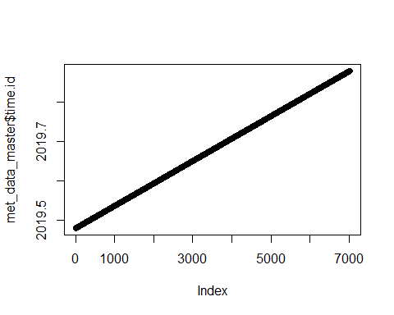

which(duplicated(met_data_master$time.id))

## integer(0)

#Joining the Met_Data and Eddy Pro Data Sets#

**with merge**

combo_master_ed_met<- merge(met_data_master[,-which(colnames(met_data_master)=="TIMESTAMP")], data_master_eddy[,-which(colnames(data_master_eddy)=="TIMESTAMP")], by = "time.id")  
  
  
  
colnames(combo_master_ed_met)

## [1] "time.id" "RECORD"   
## [3] "BattV_Avg" "PTemp_C_Avg"   
## [5] "AM25T_ref_Avg" "TC_Avg.1."   
## [7] "TC_Avg.2." "TC_Avg.3."   
## [9] "TC_Avg.4." "TC_Avg.5."   
## [11] "TC_Avg.6." "TC_Avg.7."   
## [13] "TC_Avg.8." "TC_Avg.9."   
## [15] "TC_Avg.10." "TC_Avg.11."   
## [17] "TC_Avg.12." "TC_Avg.13."   
## [19] "TC_Avg.14." "TC_Avg.15."   
## [21] "TC_Avg.16." "TC_Avg.17."   
## [23] "TC_Avg.18." "TC_Avg.19."   
## [25] "TC_Avg.20." "TC_Avg.21."   
## [27] "TC_Avg.22." "TC_Avg.23."   
## [29] "TC_Avg.24." "TC_Avg.25."   
## [31] "AirT_Avg" "RH_Avg"   
## [33] "AtmPressure_Avg" "NR_mV_Avg"   
## [35] "NR_Wm2_Avg" "PAR_in_mV_Avg"   
## [37] "PAR_in_uEm2_Avg" "PAR_out_mV_Avg"   
## [39] "PAR_out_uEm2_Avg" "SHF_1_mV_Avg"   
## [41] "SHF_1_Wm2_Avg" "SHF_2_mV_Avg"   
## [43] "SHF_2_Wm2_Avg" "WaterP_Avg"   
## [45] "WaterT_Avg" "Precip_mm_Tot"   
## [47] "VWC_Avg" "EC_Avg"   
## [49] "T_Avg" "P_Avg"   
## [51] "PA_Avg" "VR_Avg"   
## [53] "filename" "date"   
## [55] "time" "DOY"   
## [57] "daytime" "file_records"   
## [59] "used_records" "Tau"   
## [61] "qc_Tau" "H"   
## [63] "qc_H" "LE"   
## [65] "qc_LE" "co2_flux"   
## [67] "qc_co2_flux" "h2o_flux"   
## [69] "qc_h2o_flux" "H_strg"   
## [71] "LE_strg" "co2_strg"   
## [73] "h2o_strg" "co2_v.adv"   
## [75] "h2o_v.adv" "co2_molar_density"   
## [77] "co2_mole_fraction" "co2_mixing_ratio"   
## [79] "co2_time_lag" "co2_def_timelag"   
## [81] "h2o_molar_density" "h2o_mole_fraction"   
## [83] "h2o_mixing_ratio" "h2o_time_lag"   
## [85] "h2o_def_timelag" "sonic_temperature"   
## [87] "air_temperature" "air_pressure"   
## [89] "air_density" "air_heat_capacity"   
## [91] "air_molar_volume" "ET"   
## [93] "water_vapor_density" "e"   
## [95] "es" "specific_humidity"   
## [97] "RH" "VPD"   
## [99] "Tdew" "u_unrot"   
## [101] "v_unrot" "w_unrot"   
## [103] "u_rot" "v_rot"   
## [105] "w_rot" "wind_speed"   
## [107] "max_wind_speed" "wind_dir"   
## [109] "yaw" "pitch"   
## [111] "roll" "u."   
## [113] "TKE" "L"   
## [115] "X.z.d..L" "bowen_ratio"   
## [117] "T." "model"   
## [119] "x_peak" "x_offset"   
## [121] "x_10." "x_30."   
## [123] "x_50." "x_70."   
## [125] "x_90." "un_Tau"   
## [127] "Tau_scf" "un_H"   
## [129] "H_scf" "un_LE"   
## [131] "LE_scf" "un_co2_flux"   
## [133] "co2_scf" "un_h2o_flux"   
## [135] "h2o_scf" "spikes_hf"   
## [137] "amplitude_resolution_hf" "drop_out_hf"   
## [139] "absolute_limits_hf" "skewness_kurtosis_hf"   
## [141] "skewness_kurtosis_sf" "discontinuities_hf"   
## [143] "discontinuities_sf" "timelag_hf"   
## [145] "timelag_sf" "attack_angle_hf"   
## [147] "non_steady_wind_hf" "u_spikes"   
## [149] "v_spikes" "w_spikes"   
## [151] "ts_spikes" "co2_spikes"   
## [153] "h2o_spikes" "chopper_LI.7500"   
## [155] "detector_LI.7500" "pll_LI.7500"   
## [157] "sync_LI.7500" "mean_value_RSSI_LI.7500"   
## [159] "u_var" "v_var"   
## [161] "w_var" "ts_var"   
## [163] "co2_var" "h2o_var"   
## [165] "w.ts_cov" "w.co2_cov"   
## [167] "w.h2o_cov" "vin_sf_mean"   
## [169] "co2_mean" "h2o_mean"   
## [171] "dew_point_mean" "co2_signal_strength_7500_mean"

#Add back time stamp to the combo_master_ed_met#

combo_master_ed_met$TIMESTAMP<-strptime(paste(combo_master_ed_met$date,combo_master_ed_met$time,sep=" "),format="%m/%d/%Y %H:%M", tz = "GMT")  
  
combo_master_ed_met$TIMESTAMP[1:10]

## [1] "2019-06-25 09:00:00 GMT" "2019-06-25 09:30:00 GMT"  
## [3] "2019-06-25 10:00:00 GMT" "2019-06-25 10:30:00 GMT"  
## [5] "2019-06-25 11:00:00 GMT" "2019-06-25 11:30:00 GMT"  
## [7] "2019-06-25 12:00:00 GMT" "2019-06-25 12:30:00 GMT"  
## [9] "2019-06-25 13:00:00 GMT" "2019-06-25 13:30:00 GMT"

#Creating a CSV File of my combine Master File!#

write.csv(combo_master_ed_met,  
 paste(path.out_eddy,ver,"combo_master_ed_met",sep=""),  
 quote = T,  
 row.names = F)

#filtering data for quality control filters# **filtering latent heat, sensible heat, co2 flux, qc_tau and h20flux by quality controls**

combo_master_ed_met$LE.[!is.na(combo_master_ed_met$qc_LE)&combo_master_ed_met$qc_LE==2]<-NA  
  
combo_master_ed_met$qqc_h2o_flux[!is.na(combo_master_ed_met$qc_h2o_flux)&combo_master_ed_met$qc_h2o_flux==2]<-NA  
  
combo_master_ed_met$H[!is.na(combo_master_ed_met$qc_H)&combo_master_ed_met$qc_H==2]<-NA  
  
combo_master_ed_met$u.[!is.na(combo_master_ed_met$qc_Tau)&combo_master_ed_met$qc_Tau==2]<-NA  
  
combo_master_ed_met$co2_flux[!is.na(combo_master_ed_met$co2_flux)&combo_master_ed_met$co2_flux==2]<-NA

# latent heat, sensible heat, h20_flux, and relative humidity by day for whole period

plot(combo_master_ed_met$TIMESTAMP ,combo_master_ed_met$LE)

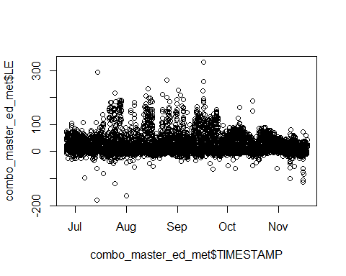

hist(combo_master_ed_met$LE)

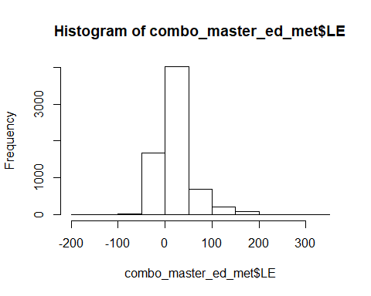

plot(combo_master_ed_met$TIMESTAMP ,combo_master_ed_met$h2o_flux)

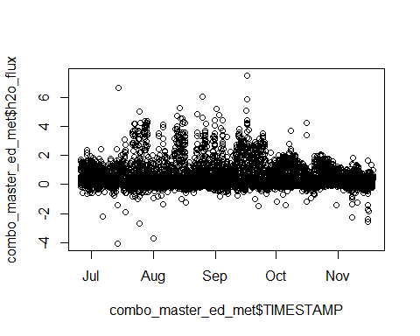

plot(combo_master_ed_met$TIMESTAMP ,combo_master_ed_met$H)

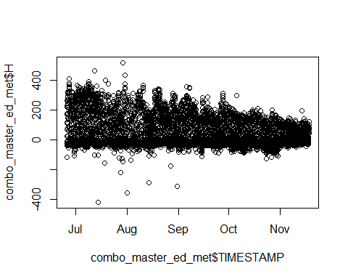

plot(combo_master_ed_met$TIMESTAMP ,combo_master_ed_met$RH)

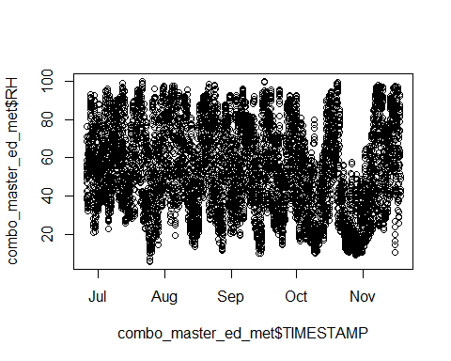

#Plotting Co2 flux by timstamp on x-axis.

plot(combo_master_ed_met$TIMESTAMP ,combo_master_ed_met$co2_flux, ylim = c(-10,10),cex=0.6)

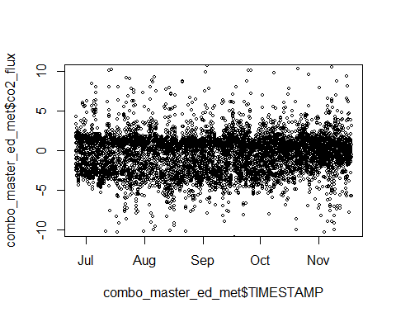

plot(tapply(combo_master_ed_met$H,round(combo_master_ed_met$DOY),function(x) mean(x,na.rm=T)))

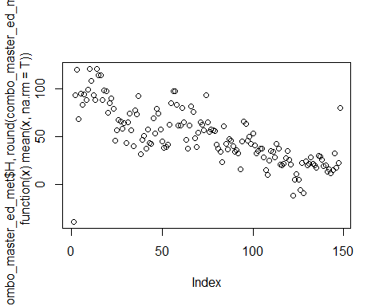

#line plot of c02_fluxes#

ggplot(data = combo_master_ed_met) +   
 geom_line(mapping = aes(x = time.id , y = co2_flux))

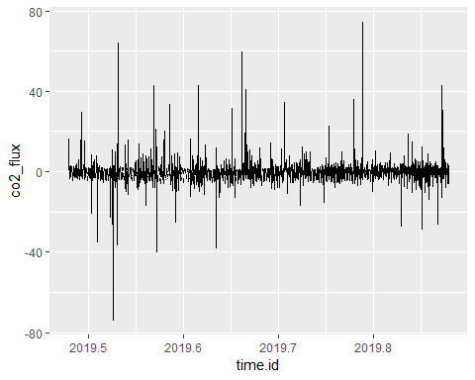

#latent heat and Sensible heat plotted over eachother

plot(combo_master_ed_met$TIMESTAMP ,combo_master_ed_met$LE,pch=1,col="blue",cex=0.6)  
points(combo_master_ed_met$TIMESTAMP ,combo_master_ed_met$H,col="red",pch=1,cex=0.6)

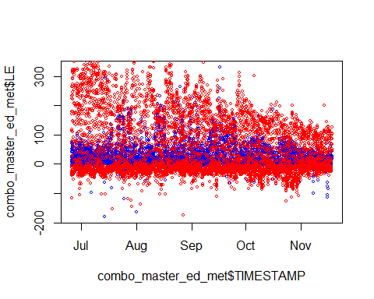

#air temperatue by sensible heat an U* by co2 flux

plot(combo_master_ed_met$air_temperature-273.15,combo_master_ed_met$H,xlim=c(10,40),ylim=c(-100,500))

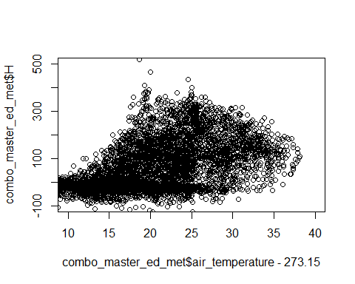

plot(combo_master_ed_met$u. ,combo_master_ed_met$co2_flux, ylim = c(0, 10), xlim = c(0,1))

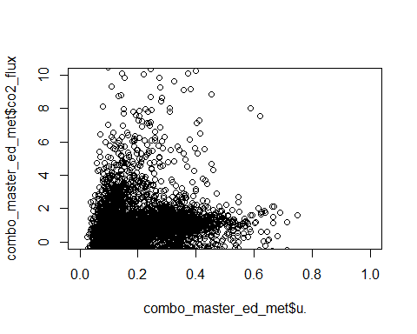

#Adding best fit line to air temperature by sensible heat

ggplot(data = combo_master_ed_met) +   
 geom_point(mapping = aes(x = air_temperature-273.15, y = H)) +  
 geom_smooth(mapping = aes(x = air_temperature-273.15, y = H))

## `geom_smooth()` using method = 'gam' and formula 'y ~ s(x, bs = "cs")'

## Warning: Removed 875 rows containing non-finite values (stat_smooth).

## Warning: Removed 875 rows containing missing values (geom_point).

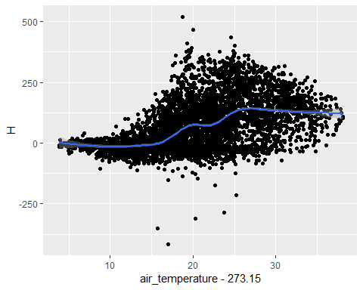

#best fit line to U* bt co2 flux

ggplot(data = combo_master_ed_met) +   
 geom_point(mapping = aes(x = u., y = co2_flux)) +  
 geom_smooth(mapping = aes(x = u., y = co2_flux))

## `geom_smooth()` using method = 'gam' and formula 'y ~ s(x, bs = "cs")'

## Warning: Removed 725 rows containing non-finite values (stat_smooth).

## Warning: Removed 725 rows containing missing values (geom_point).

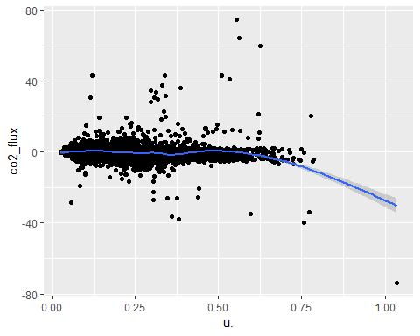

library(tidyverse)  
hist(combo_master_ed_met$wind_dir, xlim = c(0,370), breaks = 36, main = "Wind Direction")

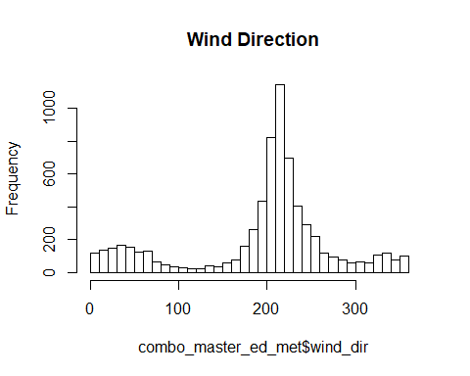

#Comparing MET Temperature data to temperature reading from Licor intruments#

plot(combo_master_ed_met$TIMESTAMP ,combo_master_ed_met$PTemp_C_Avg)  
points(combo_master_ed_met$TIMESTAMP,combo_master_ed_met$air_temperature-273.15,col="red",pch=2)

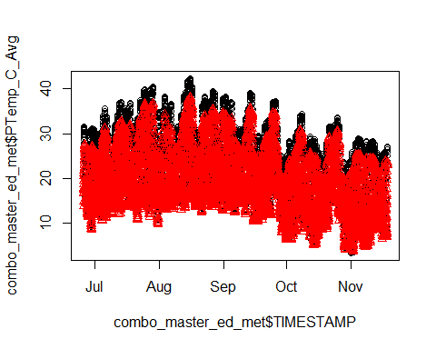

#Adding coefficient to Net radiation#

combo_master_ed_met$Correct_NR = (combo_master_ed_met$NR_Wm2_Avg*10)/14.2

summary(combo_master_ed_met$Correct_NR[c(1:600,2500:4000)])

## Min. 1st Qu. Median Mean 3rd Qu. Max.   
## -106.27 -69.79 -17.23 121.53 339.30 644.37

plot(combo_master_ed_met$Correct_NR)

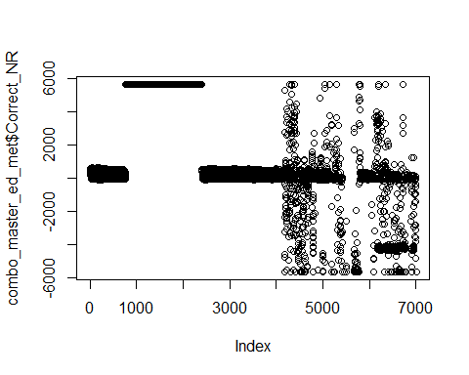

filtering out bad NR numbers

combo_master_ed_met$Correct_NR[!is.na(combo_master_ed_met$Correct_NR)&(combo_master_ed_met$Correct_NR<(-150)|combo_master_ed_met$Correct_NR>800)]<-NA  
summary(combo_master_ed_met$Correct_NR)

## Min. 1st Qu. Median Mean 3rd Qu. Max. NA's   
## -146.97 -67.96 -49.57 88.05 250.14 775.35 3106

plot(combo_master_ed_met$Correct_NR)

