Absolutely! Let’s go step by step, breaking each OOP concept in Java into beginner-friendly explanations with examples, but also giving deep understanding so you can crack exams and also truly understand the logic behind OOP. I’ll organize it carefully.

1. Class and Object Fundamentals

What is a Class?
A class is like a blueprint or template for creating objects.
- Imagine you are designing a car. The car itself is an object, but the blueprint is the class.
- Classes define what properties (variables) and what actions (methods) an object can have.
// Example of a simple class
class Car {
String color; // property
int speed; // property

void drive() { // behavior
System.out.println("Car is driving at " + speed + " km/h");
}
}

Class Structure
A class typically contains:
- Instance variables – to store object data.
- Methods – to perform actions.
- Constructors – special methods to create objects.
class Car {
// Instance variables
String name;
int speed;

// Method
void display() {
System.out.println(name + " is running at " + speed + " km/h");
}
}

Instance Variables
- Variables defined inside a class but outside methods.
- Each object gets its own copy.
Car car1 = new Car();
Car car2 = new Car();

car1.name = "Toyota";
car2.name = "Honda";

System.out.println(car1.name); // Toyota
System.out.println(car2.name); // Honda
Each car has its own name.

Methods
- Define actions that objects can perform.
- Can have parameters and return types.
void accelerate(int increase) {
speed += increase;
}

Object
- An instance of a class.
- You create objects using new keyword.
Car myCar = new Car(); // Object creation

Object Reference
- The variable that points to an object.
Car car1 = new Car(); // car1 is the reference
Car car2 = car1; // car2 points to the same object

Object Memory Model
- Objects are stored in heap memory.
- References are stored in stack memory.
- Modifying object through any reference affects the same object in heap.

Constructors
- Special methods used to initialize objects.
- Same name as the class.
- No return type (not even void).
class Car {
String name;
int speed;

// Constructor
Car(String n, int s) {
name = n;
speed = s;
}
}

Types of Constructors
- Default constructor – no parameters, provided automatically if none exists.
- Parameterized constructor – initializes with values.
- Constructor overloading – multiple constructors with different parameters.
- Constructor chaining – calling one constructor from another using this().
class Car {
String name;
int speed;

Car() { // default
name = "Unknown";
speed = 0;
}

Car(String n) { // parameterized
this.name = n;
}

Car(String n, int s) { // chaining example
this(n); // calls Car(String n)
this.speed = s;
}
}

Methods in Detail
- Method Declaration
void show() { System.out.println("Hello"); }
- Method Invocation
myCar.show(); // calls the method
- Return Types
int getSpeed() { return speed; }
- Method Parameters
void setSpeed(int s) { speed = s; }
- Pass by Value
- Java always passes primitive types by value, objects by reference value.
- Modifying primitives inside methods does not change original.
void changeSpeed(int sp) {
sp = 100; // only local copy changes
}

2. The Four Pillars of OOP

Encapsulation
- Wrapping data (variables) and methods inside one unit (class).
- Control access to variables using private + getter/setter.
class Car {
private int speed; // hidden from outside

public void setSpeed(int s) { speed = s; }
public int getSpeed() { return speed; }
}
Data hiding: prevents accidental modification of internal data.

Inheritance
- Types: Single, Multilevel, Hierarchical.

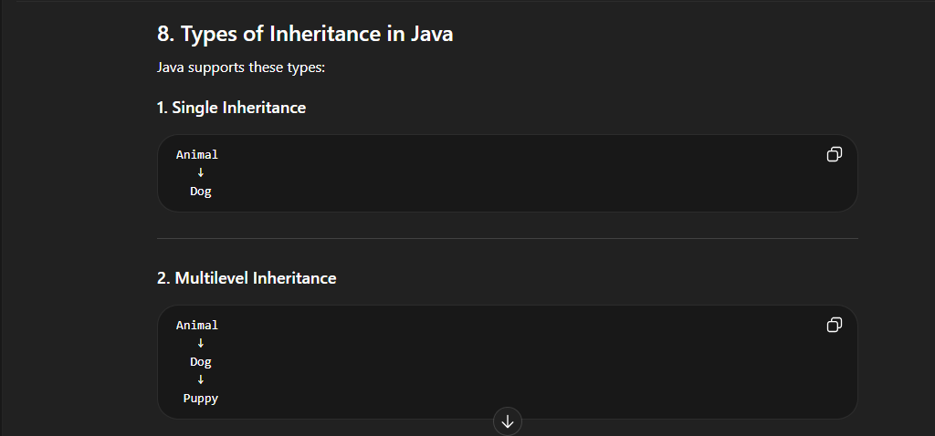
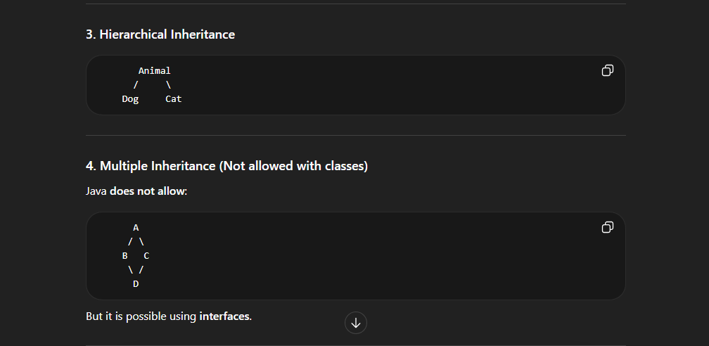
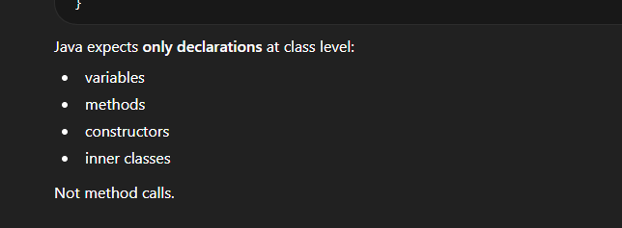
- Reuse code of existing class.
- extends keyword is used.
class Vehicle {
void start() { System.out.println("Vehicle started"); }
}

class Car extends Vehicle {
void honk() { System.out.println("Car honks"); }
}
- Method overriding: child class provides its own version of a parent method.
class Car extends Vehicle {
void start() { System.out.println("Car started"); } // override
}
- super keyword: access parent methods or constructor.
- 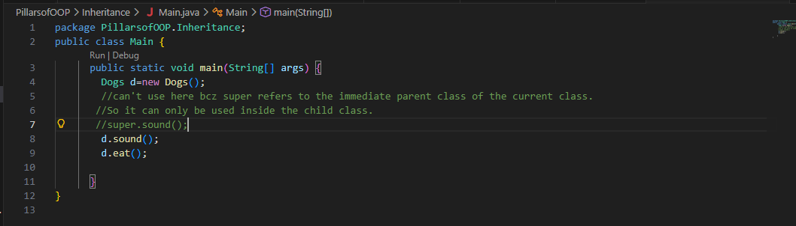
- 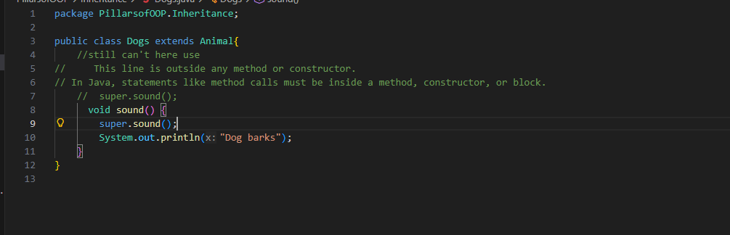
super.start();
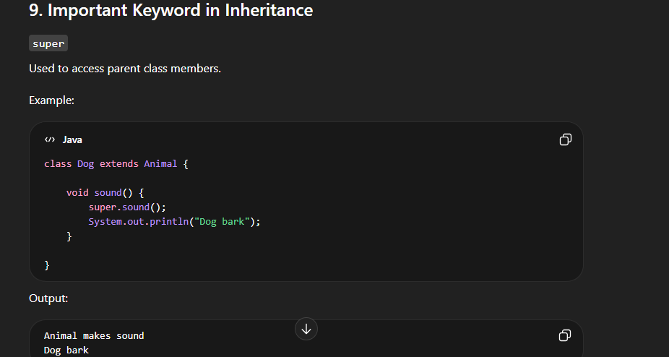

Polymorphism
- Compile-time (Method Overloading)
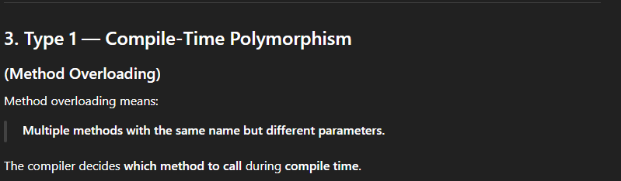
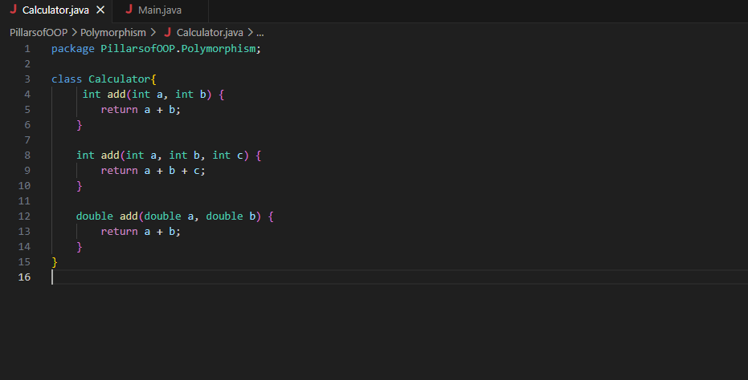
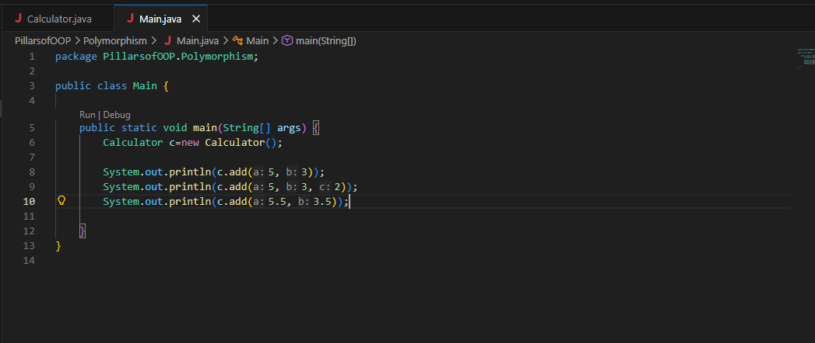
- Runtime (Method Overriding)
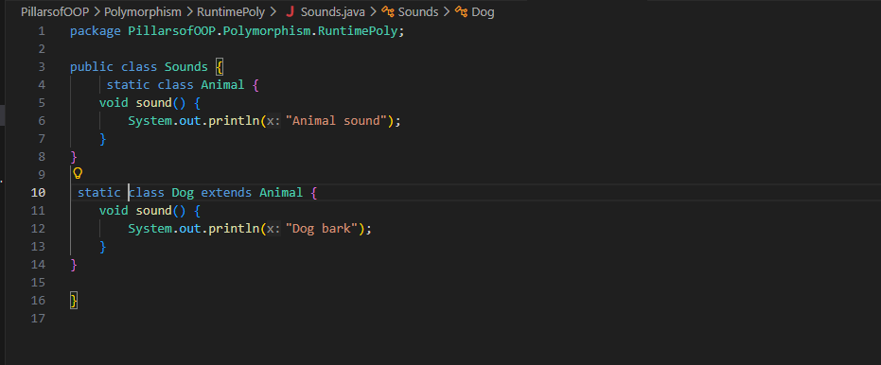
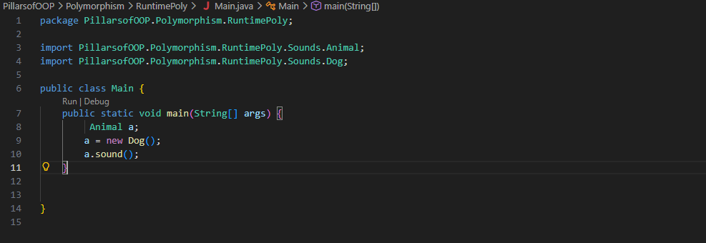

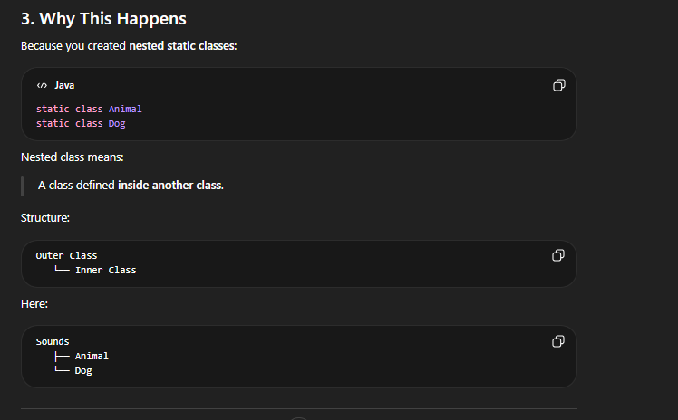
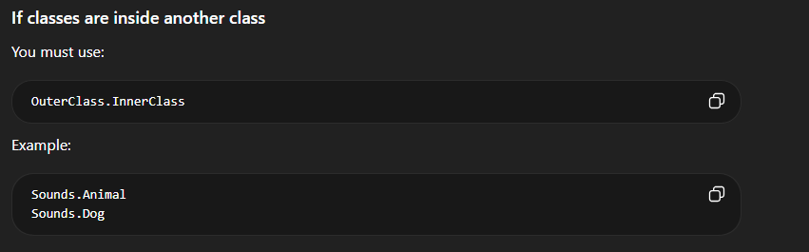
- Overriding method in child class.
- 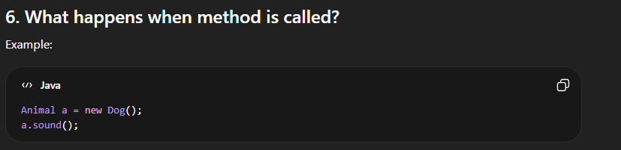
- Dynamic method dispatch: object decides method at runtime.
- 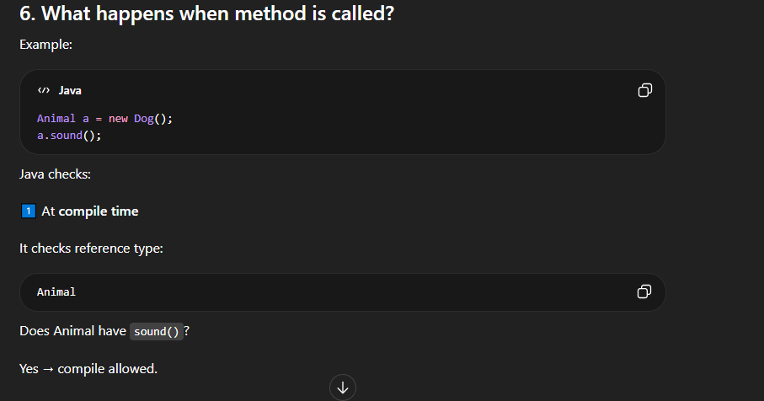
- 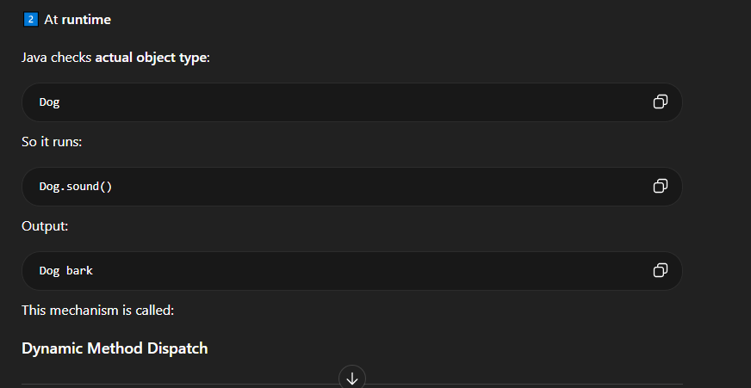
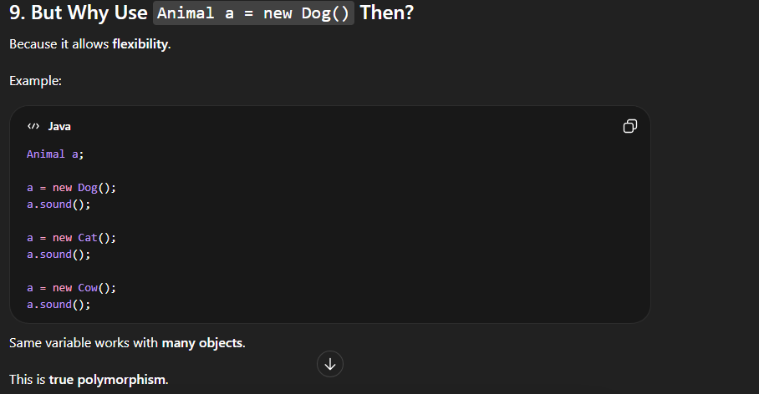

Abstraction
- Hides implementation, shows only essential features.
- Use abstract class or interface.
abstract class Vehicle {
abstract void start();
}

class Car extends Vehicle {
void start() { System.out.println("Car starts"); }
}

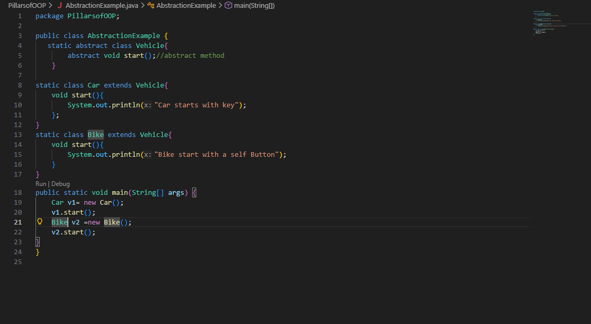

3. Access Modifiers
Modifier | Class | Package | Subclass | World
private | ✅ | ❌ | ❌ | ❌
default | ✅ | ✅ | ❌ | ❌
protected | ✅ | ✅ | ✅ | ❌
public | ✅ | ✅ | ✅ | ✅

4. Packages
- Groups related classes together.
- Built-in: java.util, java.io
- User-defined:
package mypackage;
class Car {}
- Importing:
import mypackage.Car;

In Java OOP, final and private are modifiers, but they control different things.
Feature | final | private
Main purpose | Prevent modification or inheritance | Restrict access/visibility
Controls | Behavior (can it change?) | Access (who can see it?)
Used with | variables, methods, classes | variables, methods, constructors
Access outside class | Possible (if not private) | Not accessible outside the class
Inheritance effect | Prevents overriding or extending | Not inherited / not visible

1. final (Stop Changes)
final means once something is defined, it cannot be changed or overridden.

1. Final Variable
Value cannot change after assignment.
class Test {
final int speed = 90;

void show() {
// speed = 120; // ERROR
System.out.println(speed);
}
}
Think of it like a constant.
Example:
final double PI = 3.14159;

2. Final Method
A final method cannot be overridden in a child class.
class Vehicle {
final void start() {
System.out.println("Vehicle starting");
}
}

class Car extends Vehicle {
// void start() {} // ERROR (cannot override)
}
Reason: Sometimes developers want to protect core logic.

3. Final Class
A final class cannot be inherited.
Example:
final class Animal {
}
class Dog extends Animal { } // ERROR
Real example in Java:
- Java String Class is final.
Reason: Security + immutability.

2. private (Hide Data)
private means only the same class can access it.
Example:
class Student {
private int marks;

void setMarks(int m) {
marks = m;
}

int getMarks() {
return marks;
}
}
Usage:
Student s = new Student();
s.setMarks(90);
System.out.println(s.getMarks());
But this will fail:
s.marks = 90; // ERROR
Because it is private.

Real-Life Analogy
Imagine a bank locker.

private
Locker key only with owner.
No one outside the class can access it.

final
Locker value cannot be changed once stored.

Quick Comparison Example
class Example {

private int age = 20;
final int id = 101;

}
Meaning:
- age → only accessible inside class
- id → value cannot change

Important Concept (Interview Favorite)
private methods cannot be overridden.
Why?
Because they are not visible to child classes.
Example:
class A {
private void show() {
System.out.println("Hello");
}
}
Child class cannot see this method.

Short Memory Trick
private → who can access
final → can it change

If you want, I can also explain the difference between
- final vs static
- private vs protected vs public
- final vs finally vs finalize
These are very common Java exam and interview questions.

5. Static and Final
- Static: belongs to class, not object.
static int count;
static void showCount(){}
- Final: cannot change.
final int MAX = 100;
final void doSomething(){}
final class MyClass{}

6. Nested Classes
- Inner class – non-static inside class
- Static nested class – static inside class
- Local inner class – inside method
- Anonymous class – no name, single-use
class Outer {
class Inner {} // inner class
static class Nested {} // static nested
}

7. Interfaces
- 100% abstraction (except default/static methods)
- Supports multiple inheritance
interface Vehicle {
void start();
}
class Car implements Vehicle {
public void start() { System.out.println("Car starts"); }
}
- Functional interfaces: single abstract method
- Marker interfaces: empty, e.g., Serializable

8. Abstract Classes
- Mix of abstract + concrete methods
- Cannot create object of abstract class
abstract class Vehicle {
abstract void start();
void stop() { System.out.println("Stopped"); }
}
- Abstract vs Interface
  - Abstract: partial implementation allowed
  - Interface: full abstraction + multiple inheritance

This is the complete roadmap of OOP in Java with beginner-friendly explanations.
If you want, I can make a visual diagram with memory layout, object references, and all relationships—this makes it super easy to remember for exams and real coding.
Do you want me to make that diagram?

Here is the video you shared:
This is a complete beginner JavaScript course (~3 hours 26 minutes) created by freeCodeCamp and taught by Beau Carnes. It covers the fundamentals of JavaScript step-by-step. (Toomva.com)
Below is a section-wise list of all major topics taught in the video.

1. Introduction to JavaScript
- What JavaScript is
- How JavaScript works with HTML
- Running JavaScript in the browser
- Using the browser console
- Writing your first JavaScript code

2. Variables
- var keyword
- Declaring variables
- Storing values in variables
- Initializing variables
- Variable naming rules

3. Data Types
- Strings
- Numbers
- Boolean
- Undefined
- Null

4. Working with Variables
- Assignment operator (=)
- Assigning one variable to another
- Variable case sensitivity
- Updating variable values

5. Arithmetic Operations
- Addition
- Subtraction
- Multiplication
- Division
- Increment (++)
- Decrement (--)
- Decimal numbers
- Remainder operator (%)

6. Strings in JavaScript
- Creating strings
- Escaping characters in strings
- Quotation marks in strings
- Concatenating strings
- Appending variables to strings
- String length

7. String Manipulation
- Accessing characters using bracket notation
- First character of a string
- Last character of a string
- Changing characters in strings
- Word blanks exercise

8. Arrays
- Creating arrays
- Nested arrays
- Accessing array elements
- Modifying array data

9. Array Methods
- push() – add element at end
- pop() – remove last element
- shift() – remove first element
- unshift() – add element at start

10. Functions
- Creating functions
- Calling functions
- Passing arguments to functions
- Global scope vs local scope
- Return values from functions

11. Boolean Logic
- Boolean values (true / false)
- Comparison operators
- Equality (==)
- Strict equality (===)
- Inequality (!=)
- Strict inequality (!==)

12. Conditional Statements
- if statements
- else statements
- else if
- Logical operators (&&, ||)
- Order of conditions

13. Switch Statements
- Using switch
- Multiple case options
- Default case

14. Objects
- Creating objects
- Object properties
- Accessing object properties
- Dot notation vs bracket notation
- Updating object properties
- Adding new properties
- Deleting properties

15. Testing Objects
- Checking object properties
- hasOwnProperty()

16. Nested Objects & Arrays
- Accessing nested objects
- Accessing nested arrays

17. Loops
- while loops
- for loops
- Nested loops
- Iterating through arrays

18. Random Numbers
- Math.random()
- Generating random numbers in range
- Parsing integers

19. Ternary Operator
- Conditional (ternary) operator
- Multiple ternary conditions

20. Building Small Algorithms
Practice examples:
- Counting cards
- Profile lookup
- Random number generator

✅ In short:
The video teaches complete JavaScript fundamentals including:
- Variables
- Data types
- Strings
- Arrays
- Functions
- Conditions
- Loops
- Objects
- Basic algorithms

✅ If you want, I can also:
- Break this video into a study roadmap (Day 1 → Day 7 plan)
- Or give you the exact timestamps for each section so you can jump directly to topics.

Day1
These are core JavaScript fundamentals. I’ll explain them clearly so you can remember them easily for exams and also understand them for real programming.

1. Variables in JavaScript
Variables store data values.
JavaScript mainly uses three keywords:

1. var
- Old way to declare variables.
- Function-scoped.
- Can be redeclared and updated.
var age = 20;
var age = 25; // allowed
age = 30; // allowed
⚠ Problem: Can cause bugs because it allows redeclaration.

2. let
- Modern way (introduced in ES6).
- Block scoped (works inside {}).
- Can be updated, but cannot be redeclared in same scope.
let age = 20;
age = 25; // allowed
// let age = 30; // error
Example:
if(true){
let x = 10;
}
console.log(x); // error (block scope)

3. const
- Used for constant values.
- Cannot be updated or redeclared.
const pi = 3.14;

pi = 3.141; // error
But objects/arrays inside const can change internally:
const person = {name:"Ali"};
person.name = "Ahmed"; // allowed

Quick Memory Trick
Keyword | Redeclare | Update | Scope
var | Yes | Yes | Function
let | No | Yes | Block
const | No | No | Block
In modern JavaScript:
- Use const by default
- Use let if value changes
- Avoid var

2. Data Types in JavaScript
JavaScript has two main categories.

A. Primitive Data Types
These store single simple values.

1. String
Text data.
let name = "Ali";

2. Number
Includes integers and decimals.
let age = 21;
let price = 99.5;

3. Boolean
True or False.
let isStudent = true;

4. Null
Represents intentional empty value.
let data = null;
Meaning: value is empty intentionally.

5. Undefined
Variable declared but not assigned value.
let x;
console.log(x); // undefined

Primitive Summary
Type | Example
String | "Hello"
Number | 10
Boolean | true
Null | null
Undefined | undefined

B. Complex (Reference) Data Types
These store multiple values or structures.

1. Object
Collection of key-value pairs.
let student = {
name: "Ali",
age: 20
};
Access value:
student.name

2. Array
Stores multiple values in order.
let fruits = ["apple", "banana", "mango"];
Access element:
fruits[0] // apple

3. Function
Block of reusable code.
function greet(){
console.log("Hello");
}
Call function:
greet();

3. JavaScript Operators
Operators perform operations on values.

Arithmetic Operators
Operator | Meaning | Example
+ | Addition | 5 + 3
- | Subtraction | 5 - 2
* | Multiplication | 5 * 3
% | Modulus (remainder) | 5 % 2 → 1
Example:
let a = 10;
let b = 3;

console.log(a + b); // 13
console.log(a % b); // 1

Logical Operator

! (NOT)
Reverses boolean value.
let isLoggedIn = true;

console.log(!isLoggedIn); // false

Comparison Operators

== (Loose equality)
Compares values only.
5 == "5" // true
Because JavaScript converts types automatically.

=== (Strict equality)
Compares value AND type.
5 === "5" // false
Best practice: always use ===

!= (Not equal)
5 != 3 // true

Special Operators

typeof
Tells the data type of variable.
let x = "Hello";

console.log(typeof x); // string
Examples:
typeof 10 // number
typeof true // boolean
typeof "Hi" // string

instanceof
Checks whether an object belongs to a class/type.
let arr = [1,2,3];

console.log(arr instanceof Array); // true
Example:
let obj = {};
obj instanceof Object // true

One Small Exam Cheat Sheet
Variables
var → old, function scope
let → block scope, update allowed
const → constant
Primitive Types
String
Number
Boolean
Null
Undefined
Complex Types
Object
Array
Function
Operators
+ - * %
! == != ===
typeof
instanceof

If you want, I can also give you:
- 20 MCQs from these topics (exam style)
- 5 tricky viva questions teachers usually ask in Web Technology exams.

