Assignment-1:

1) Create a users table with the following fields:

i. user_id (UUID, Primary Key)
ii. first_name
iii. last_name
iv. email
v. password (encrypted)
vi. created_by (user_id)
vii. created_date
viii. modified_by (user_id)
ix. modified_date
x. is_active
xi. is_deleted
xii. birth_date
xiii. address
xiv. mobile_number

SQL QUERY:

-- Enable UUID generation
CREATE EXTENSION IF NOT EXISTS "uuid-ossp"
CREATE TABLE hc.users (
user_id UUID PRIMARY KEY DEFAULT uuid_generate_v4(),
first_name VARCHAR(100) NOT NULL,
last_name VARCHAR(100) NOT NULL,
email VARCHAR(255) NOT NULL UNIQUE,
password TEXT NOT NULL, -- store HASHED password (bcrypt/argon2)
created_by UUID DEFAULT uuid_generate_v4(),
created_date TIMESTAMP WITHOUT TIME ZONE DEFAULT CURRENT_TIMESTAMP,
modified_by UUID DEFAULT uuid_generate_v4(),
modified_date TIMESTAMP WITHOUT TIME ZONE DEFAULT CURRENT_TIMESTAMP,
is_active BOOLEAN DEFAULT TRUE,
is_deleted BOOLEAN DEFAULT FALSE,
birth_date DATE,
address TEXT,
mobile_number VARCHAR(20)
);

2)Insert at least 10 user records with unique email addresses.

SQL QUERY:
Insert Into hc.users(
first_name,
last_name,
email,
password,
created_date,modified_date,
is_active,is_deleted,
birth_date,
address,
mobile_number)
VALUES(
‘Kiran',
'Shah',
'kiran@example.com',
'1234YU',CURRENT_DATE,
CURRENT_DATE,
false,false,
'12/09/2005',
'ahmedabad','78589393869');
('Komeel',
'padharshi',
'komeel@example.com','879HH',
CURRENT_DATE,
CURRENT_DATE,
true,false,
'30/09/2006',
'ahmedabad','7858939669'),
(‘khushbu',
'kothariya',
'khushbu@example.com',
'779HH',CURRENT_DATE,
CURRENT_DATE,
true,false,
'15/09/2006',
'Rajkot','8858939669'),
('Divya',
'padhariya',
'divya@example.com',
'879HL',CURRENT_DATE,
CURRENT_DATE,
TRUE,FALSE,
'15/09/2003',
'Mumbai','8958939669'),
('Sophie',
'Christian',
'sophie@gmail.com','879HH',
CURRENT_DATE,
CURRENT_DATE,
true,false,
'30/11/2006',
'Pune','7858939669'),
('Jignasha',
'Vanara',
'Jignasha@gmail.com',
'879HP',
CURRENT_DATE,
CURRENT_DATE,
TRUE,FALSE,'11/09/2006',
'usa','7858936669'),
('jahnvi','patel',
'jan@gmail.com',
'669HP',
CURRENT_DATE,
CURRENT_DATE,
TRUE,FALSE,
'08/09/1999',
'surat','7858936896'),
('Jignasha',
'Vanara',
'Jigi@gmail.com',
'879HP',
CURRENT_DATE,
CURRENT_DATE,
TRUE,FALSE,'11/09/2006',
'usa','7858936669'),
('Shivani',
'Patel',
'shivani@gmail.com','879HP',
CURRENT_DATE,
CURRENT_DATE,
TRUE,FALSE,
'11/09/1995',
'VAPI','7858936669'),
('Aarush',
'Patel',
'Aarush@gmail.com',
'UY9HP',
CURRENT_DATE,
CURRENT_DATE,
TRUE,FALSE,
'11/09/2010',
'Baroda','7758936669'),
('Zidan',
'Kothariya',
'zidan@gmail.com',
'879HP',
CURRENT_DATE,
CURRENT_DATE,
TRUE,FALSE,
'18/09/2006',
'Surat','7858936669');

3) Fetch all users
SQL QUERY:

select * from hc.users;

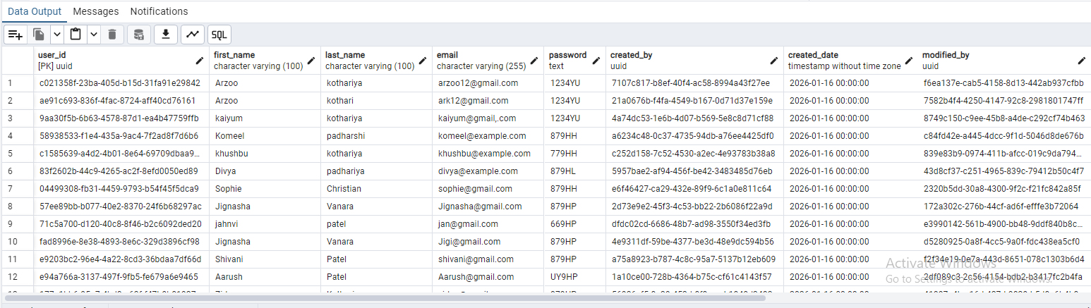

4)Fetch only user name (first_name + last_name) and email

SQL QUERY:
select first_name, last_name, email from hc.users;

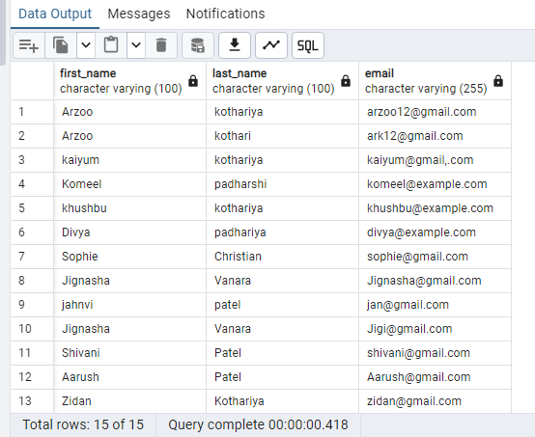
5)Fetch only inactive users
SQL QUERY:
SELECT *FROM hc.users
WHERE is_active IS FALSE;

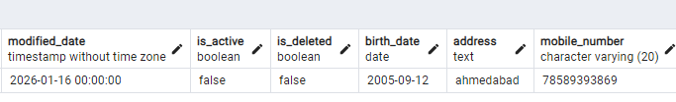

6)Users whose first_name starts with 'A' and last_name ends with ' i’

SQL QUERY:
SELECT * FROM hc.users
WHERE first_name LIKE 'A%i';
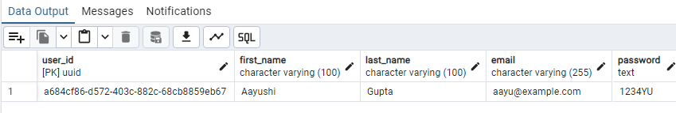

7)Users whose email contains '@example'
SQL QUERY:
SELECT *
FROM hc.users
WHERE email LIKE '%@example%';

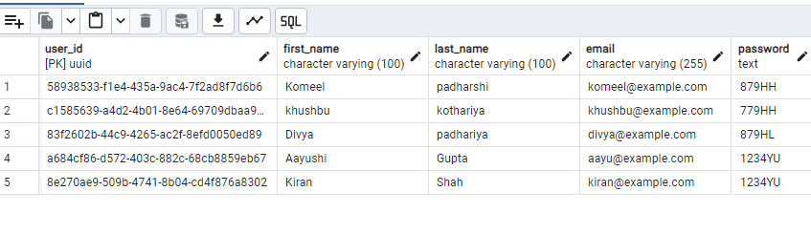
8)Case-insensitive search for first_name starting with 'A’
SQL QUERY:
SELECT *
FROM hc.users
WHERE first_name ILIKE 'A%';

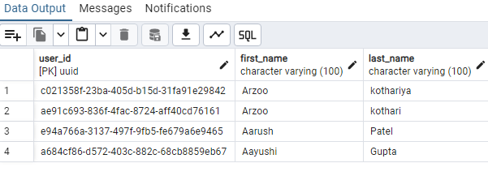
9)Users ordered by created_date (descending)
SQL QUERY:
SELECT *
FROM hc.users
ORDER BY created_date DESC;

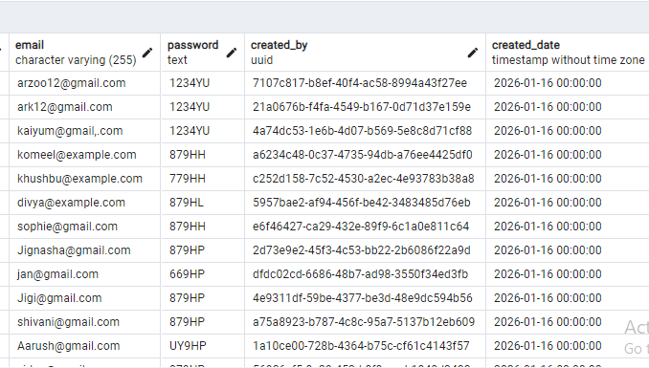
10)Top 5 latest created users
SQL QUERY:
SELECT *
FROM hc.users
ORDER BY created_date DESC
LIMIT 5;
