


Public Crowding Risk Monitor
  - Research Trail
Github
Pitch Video Link
Front End Interface
Figma Prototype

Team Intruders
Raina Chi, Jingyan Zhang
Catalyst Ingenium 2026

Pitch
AttnShift is a research-led prototype that flags unusual changes in public attention and directional language, then shows the evidence, coverage and limitations behind each alert.
Note: AttnShift does not observe institutional positions, confirm alpha decay, predict returns or give buy/sell advice. Public attention is an exploratory screening proxy, not actual crowding data.

What we investigated
- Is crowding a real problem worth monitoring?
- When deeper positioning data is unavailable, can public attention provide a useful early warning?
- What information would make that warning understandable enough to investigate?

Current evidence position
- Supported: crowding can contribute to drawdown and liquidity risk.
- Supported: public attention and sentiment contain market-relevant information, but their meaning differs by platform and time horizon.
- Supported: professional crowding tools use deeper positioning, holdings, factor and liquidity data.
- Supported inference: an explanation-first public signal may help a resource-constrained researcher decide where to spend more investigation time.
- Not validated: target users have a strong unmet need for this product or would adopt it.
- Not validated: the prototype signal predicts crowding, reversal, alpha decay or returns.

1. Research journey and pivot
We began with the Fundamentum direction 'alpha decay and model drift'. Detecting whether a strategy was losing its edge was too broad to test honestly in two days with public data.
Research produced two pivots. We narrowed the problem to public attention as an early investigation signal, then dropped the single-score framing because attention, sentiment and platform effects are different signals.
Step | What we thought | What changed
Starting assumption | Alpha decay or model drift could be detected early. | Too broad; public data cannot directly show a strategy's edge decaying.
First narrowing | Public attention might reveal rising crowding. | Attention is not institutional positioning. We kept it only as a public proxy.
Interface correction | One score would make the dashboard simple. | Studies show attention, sentiment and platforms behave differently. We separated the measures and exposed the sources.
User-demand correction | Smaller quant teams may need a cheaper tool. | Outreach produced no participants. We kept this as a hypothesis, not a validated customer claim.
Current framing | Use public signals to decide what deserves deeper research. | Build one explainable screening flow and state the limitations next to the signal.
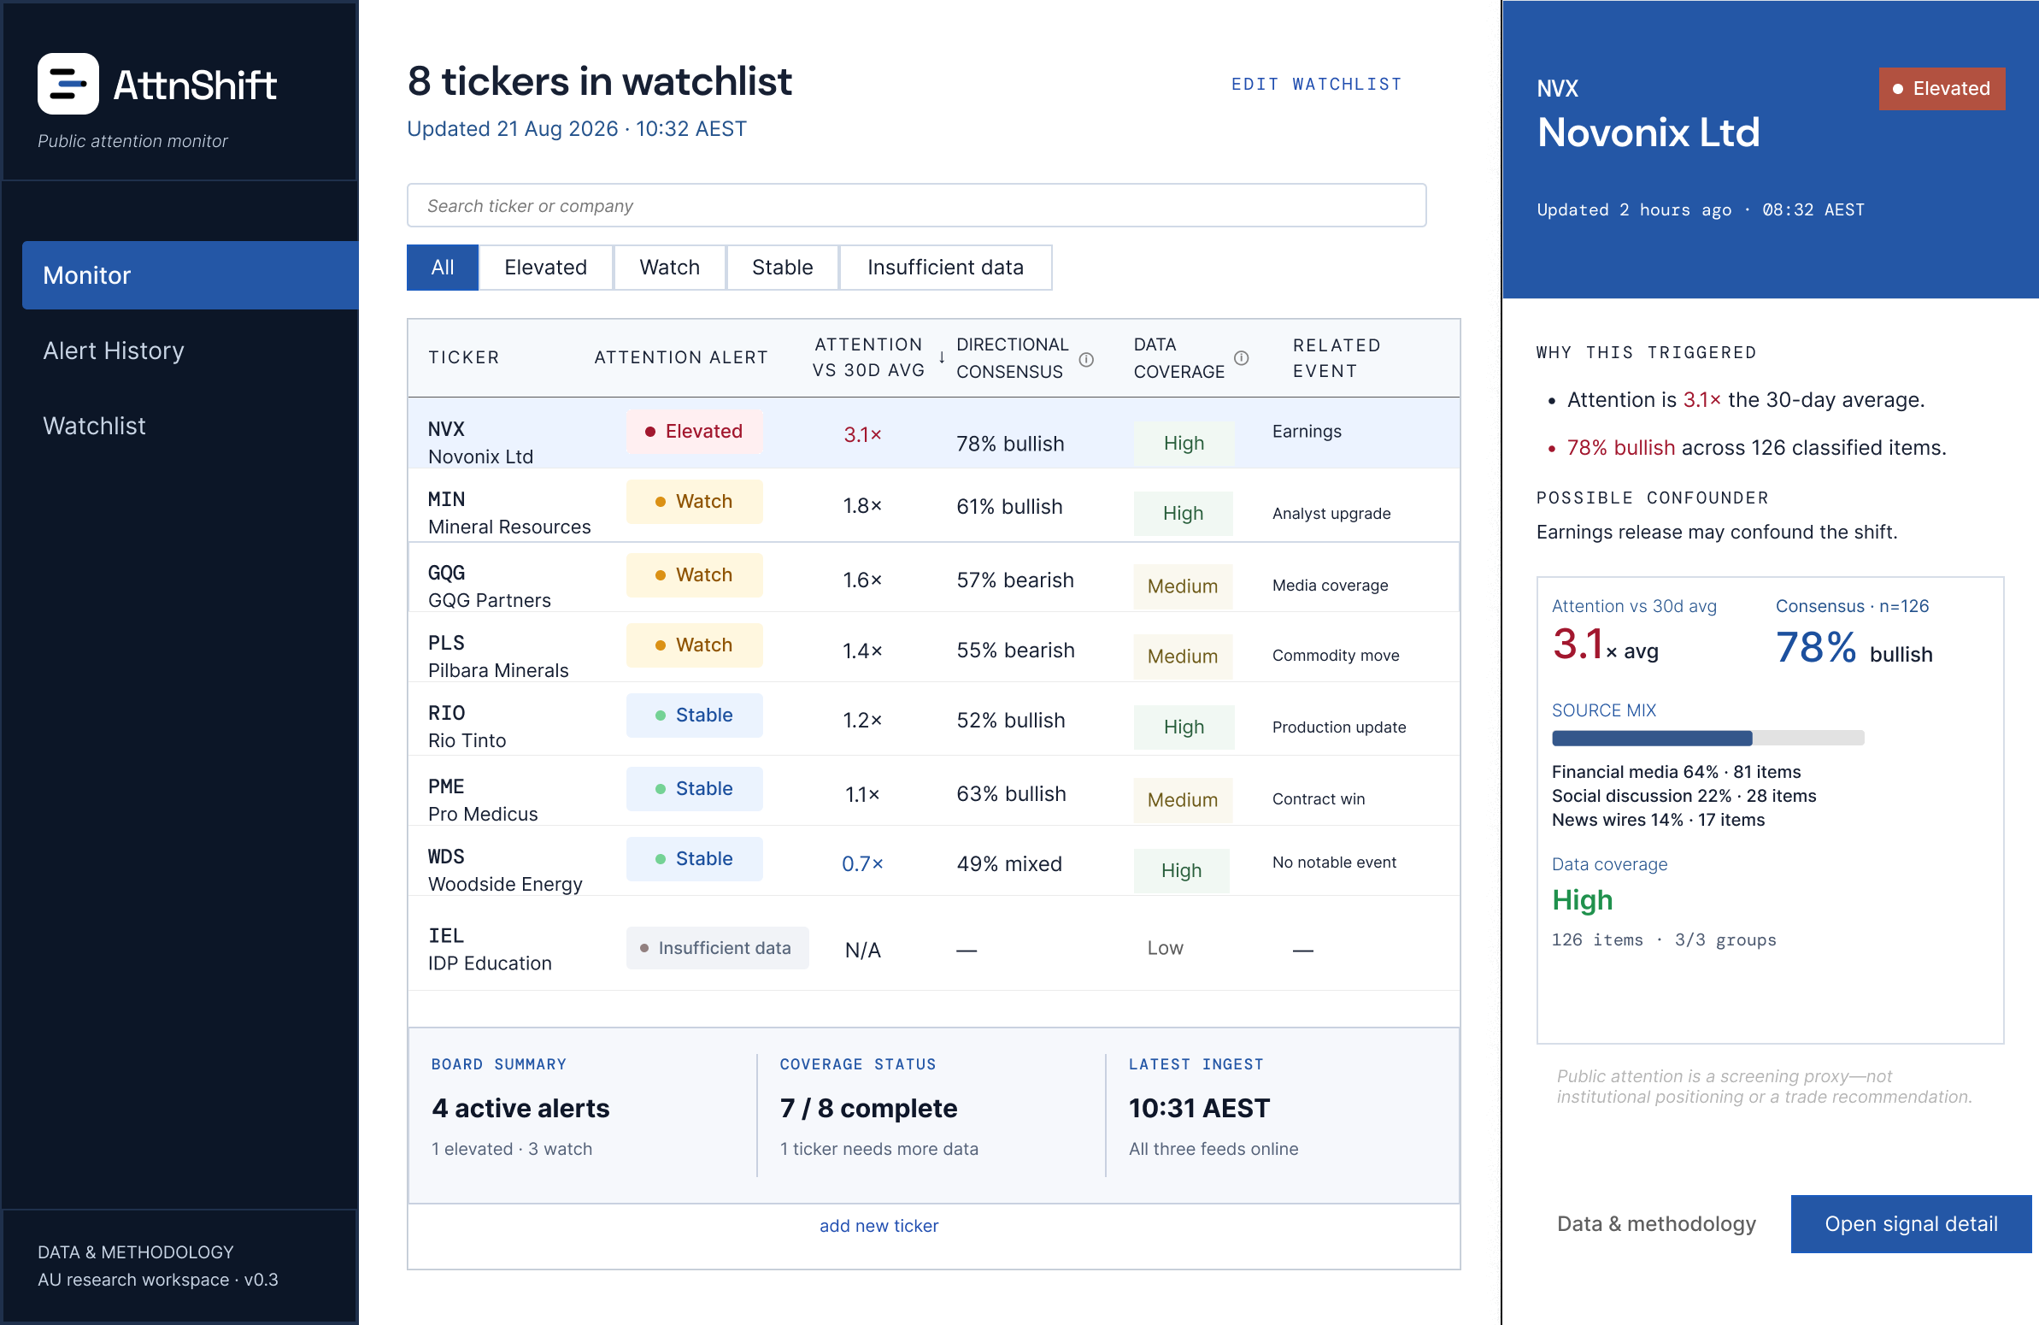
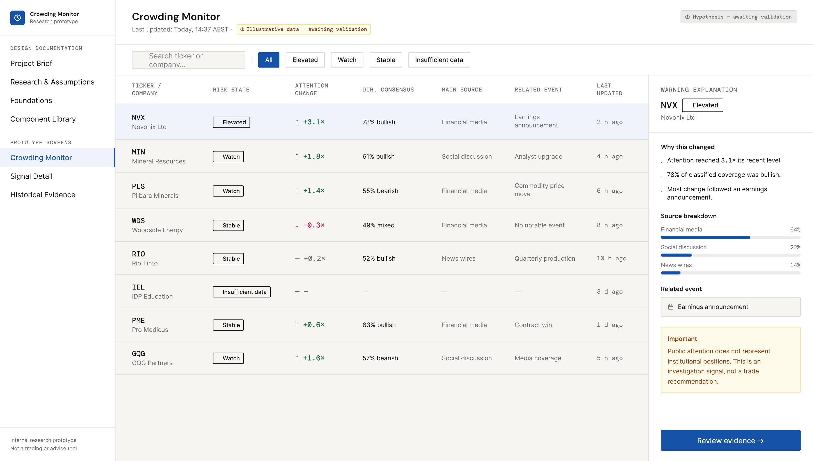
Figure 1. Figma Make provided the initial high-fidelity draft. Manual refinement replaced the generic dashboard and black-box framing with an explanation-first research workflow.

2. Hypotheses and what happened

H1 - Problem hypothesis
Hypothesis: Resource-constrained quant researchers may lack an affordable and interpretable way to monitor unusual changes in public attention around a trade idea.
Method: A short survey, outreach to relevant student and alumni channels, and a review of existing products.
Result: Not directly validated. The survey and outreach received no responses within the available window.
Decision: Keep the target group as a reasoned beneficiary, not a confirmed customer segment. Do not say that small quant teams asked for this product.

H2 - Signal hypothesis
Hypothesis: A large change in public attention and directional language may be useful as an early investigation signal.
Method: A deterministic prototype backend was tested on 12 synthetic tickers across 90 trading days. It recalculated the baseline, score and ranking for 7-, 30- and 90-day windows and exposed the results through four HTTP routes.
Result: The automated verification passed all six checks. It confirmed that the displayed attention multiple, directional consensus, coverage, alert state and API values can be reproduced from the saved inputs.
Decision: Treat this as evidence of a transparent and repeatable calculation path, not predictive validation. The thresholds remain prototype heuristics and the product remains an evidence explorer, not a trading model.

H3 - Interface hypothesis
Hypothesis: A researcher will understand an alert better when it shows what changed, where the data came from and what could be misleading.
Method: Secondary research, competitor review, Figma iteration and an internal review of the implemented frontend.
Result: The interface is implemented and internally reviewed, but no target practitioner completed a task-based test.
Decision: Use Attention vs 30-day average, Directional Consensus with sample count, Source Mix, Data Coverage, Related Event and clear limitations. Do not show an unsupported confidence badge.

3. Core evidence reviewed
We used five peer-reviewed finance papers, one BIS report and two official product sources. This is strong secondary evidence for the problem and the signal boundary. It is not a substitute for interviews or user testing.
Evidence | What we learned | What it cannot prove
[1] Brown et al. (2022) | Crowded hedge-fund holdings are linked to larger drawdowns during industry stress. | Shows that crowding matters. Does not validate public attention as a crowding measure.
[2] BIS (2024) | Common carry exposure and leverage can amplify stress and cross-asset spillovers. | Authoritative system-level context, not evidence about small quant teams or this product.
[3] Cookson et al. (2024) | Attention is more consistent across social platforms than sentiment. Attention and sentiment contain different short-horizon information. | Supports separating attention, consensus and source mix. Does not measure institutional positions.
[4] Barber and Odean (2008) | Individual investors are more likely to buy attention-grabbing stocks because attention narrows their choice set. | Shows that attention can affect behaviour. It does not establish crowding or future performance.
[5] Da et al. (2011) | Google search volume provides a direct attention measure and is linked to short-term market behaviour. | Supports an attention baseline. Effects are historical and do not prove a live trading signal.
[6] Antweiler and Frank (2004) | Message-board activity contains information about volatility and volume; the return effect is economically small. | Useful counterweight against overclaiming sentiment or discussion as strong alpha.
[7] MSCI | Professional crowding products use security, factor, hedge-fund, positioning and liquidity measures and are offered through institutional channels. | Shows the mature category and the deeper data requirement. Public pages do not prove affordability or satisfaction.
[8] Quiver Quantitative | Quiver aggregates alternative data such as social trends, search, government and institutional data through free and paid products. | Shows that accessible data aggregation already exists. Our public-feature comparison cannot prove a complete competitor gap.

4. Existing solutions and the narrow gap
We did not treat existing products as proof that the market needs another dashboard. We used them to understand what is already available and where a two-day prototype could make a smaller, testable improvement.
Current option | What it already does | Observed boundary | Our narrow response
MSCI Crowding Solutions | Security, factor and hedge-fund crowding analytics using deeper market and positioning inputs. | Professional, institutional workflow; request-demo access. | AttnShift must not claim equivalent measurement. It can only be an earlier public-data screen.
Quiver Quantitative | Accessible alternative-data dashboards and APIs, including social and search trends, government data and institutional data. | Retail and research users; free and paid access. | Accessibility alone is not new. The proposed difference is the explanation workflow and clear proxy boundary.
Notebook / spreadsheet workflow | A researcher can collect public data, calculate baselines and inspect events manually. | Flexible, but the workflow cost is a team assumption rather than validated user evidence. | The prototype tests whether one screen can make the investigation path easier to follow.

OUR IMPROVEMENT CLAIM
AttnShift does not claim better data than MSCI or more datasets than Quiver. It tests a simpler idea: can an explanation-first public signal help a researcher decide whether deeper crowding investigation is worth the time?

5. Outreach attempt
Primary validation did not produce participants within the hackathon window. It documents a genuine research attempt, not user validation.
ID | Attempt | Outcome
OUT-01 | 10-question Google Form; estimated completion time 2-3 minutes. | Completed and distributed.
OUT-02 | Posted to the University of Melbourne Quantitative Trading Society group (approximately 700 members) on the first evening. | No responses by the second afternoon.
OUT-03 | UNIT group/contact search. | Relevant group chat not located; no reply received.
OUT-04 | Alumni and early-career outreach. | Limited network and insufficient time; no interview completed.

Result and decision: H1 remains unvalidated. We narrowed the customer claim, kept the product exploratory and moved practitioner interviews into future work.
Evidence retained: the survey instrument, QTS distribution post and Google Forms response summary showing zero responses.
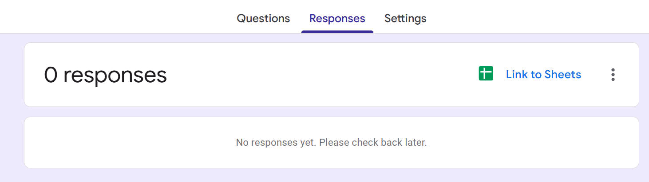
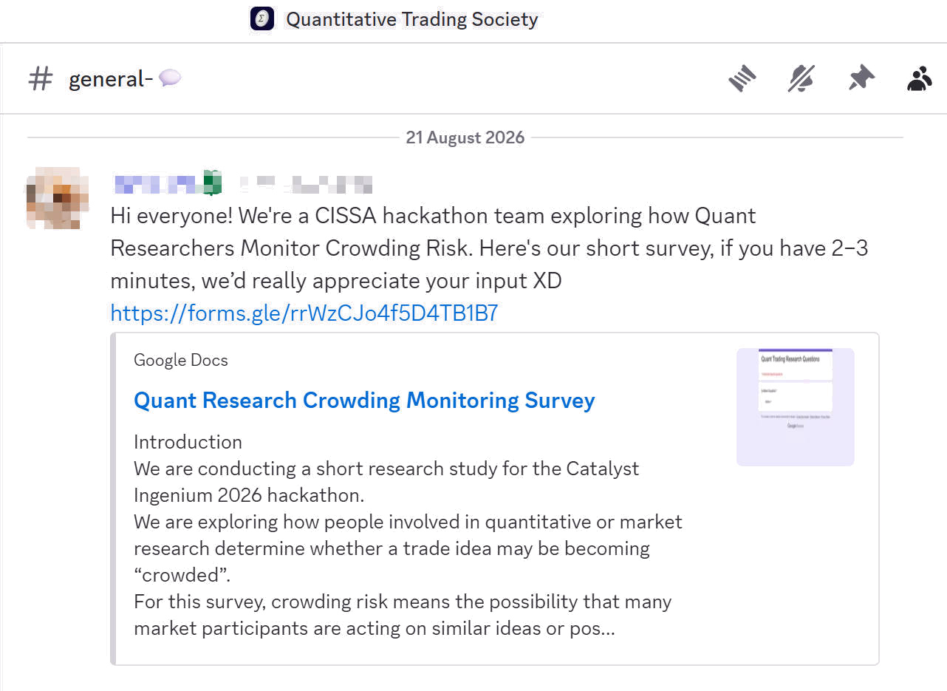

Figure 2. Outreach was distributed through QTS, but the form recorded zero responses during the hackathon window. This is evidence of an attempt, not validation.

6. Evidence to product decisions
Finding and evidence | Product decision | What appears in the design | Boundary
Crowding can increase downside risk.  [1], [2] | Use investigation language; no buy/sell recommendation. | Monitor and detail screens show an alert plus a permanent proxy disclaimer. | Does not prove this alert predicts loss.
Attention and sentiment are different.  [3] | Show Attention and Directional Consensus separately. | Attention vs 30-day average; consensus includes a visible sample count in the illustrative state. | Sample and result must come from the backend data.
Platforms and attention proxies differ.  [3], [5], [6] | Show source mix, sample size and missing-data state. | Source breakdown, Data Coverage and Insufficient Data state. | Coverage describes availability, not predictive confidence.
News or company events can explain attention.  [3], [5] | Show a possible related event next to the signal. | Earnings/event field is labelled as a possible confounder, not a cause. | Event matching remains simple in the prototype.
Actual crowding uses deeper data.  [7] | Make the public-proxy boundary visible. | Data & Methodology is a secondary trust page; disclaimer remains on detail views. | AttnShift cannot identify institutional positioning.
Two-day prototype must prove one flow.  Scope decision | Prioritise Monitor to Signal Detail. | The implemented build prioritises Monitor to Signal Detail; Alert History and Watchlist remain secondary views. | Authentication, trading and production ingestion were cut.
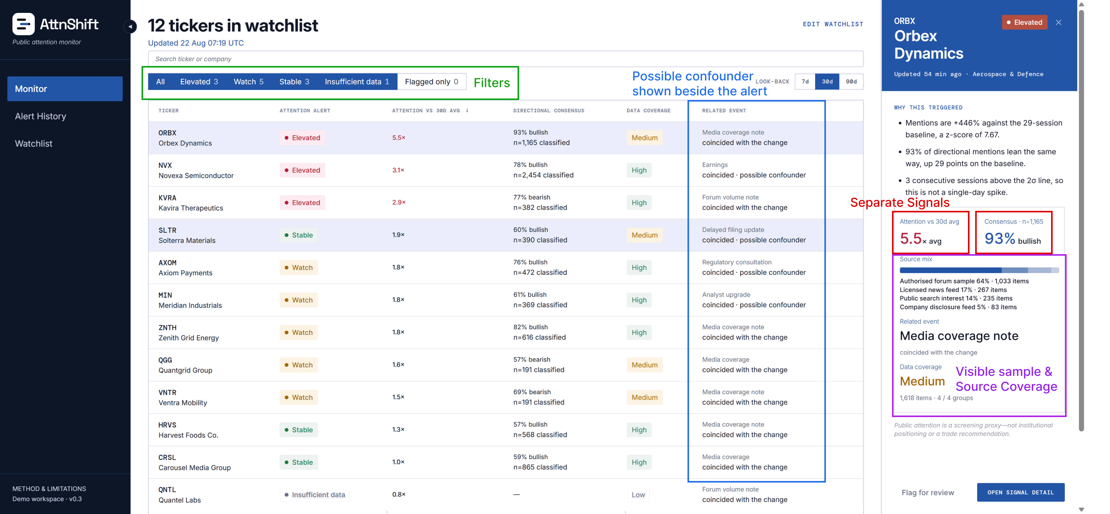
Figure 3. Implemented monitor: the watchlist supports rapid scanning while the evidence drawer keeps sample size, source mix, coverage and event context beside the alert.
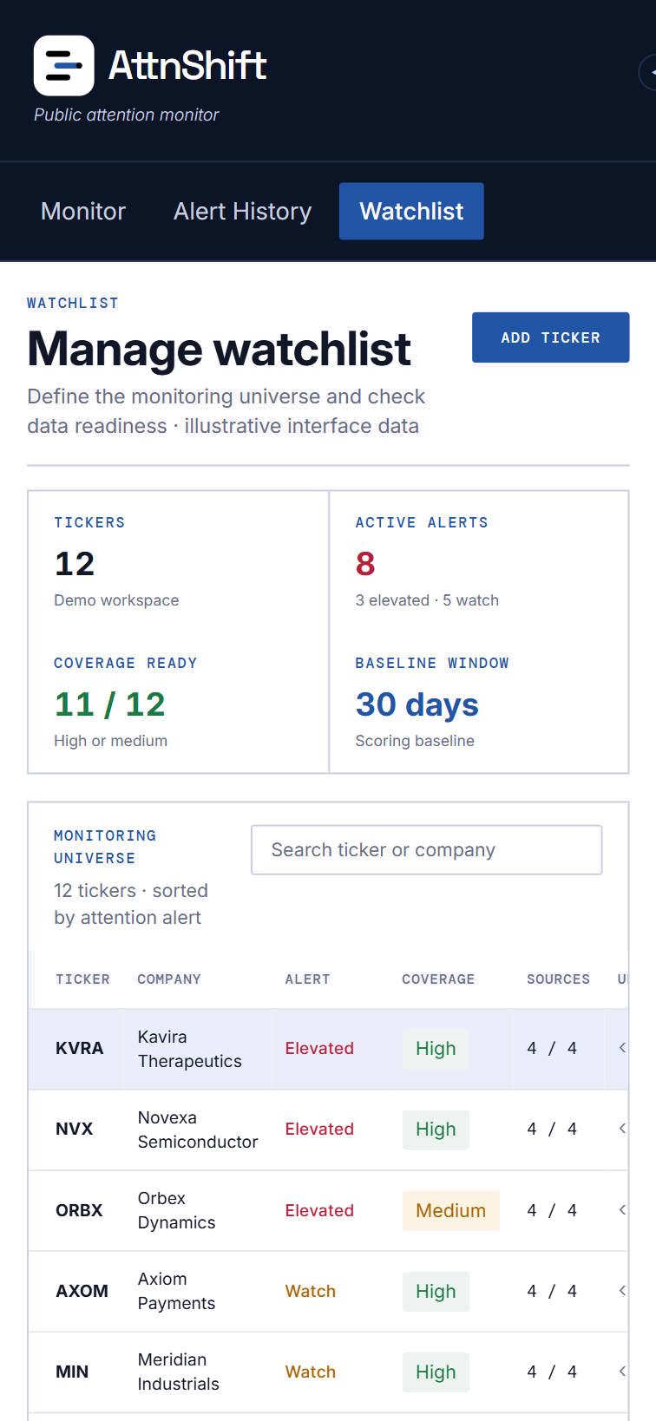
Figure 4. Mobile Screens

7. Prototype and technical proof

Core user flow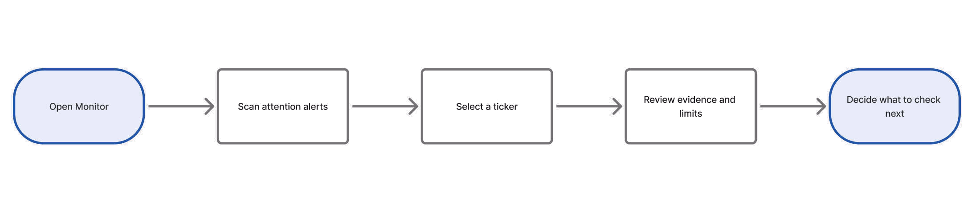
Figure 5. Five-step core user flow from scanning an alert to deciding what to investigate next.
The core flow moves from scanning an alert to reviewing its evidence, limits and possible next checks.
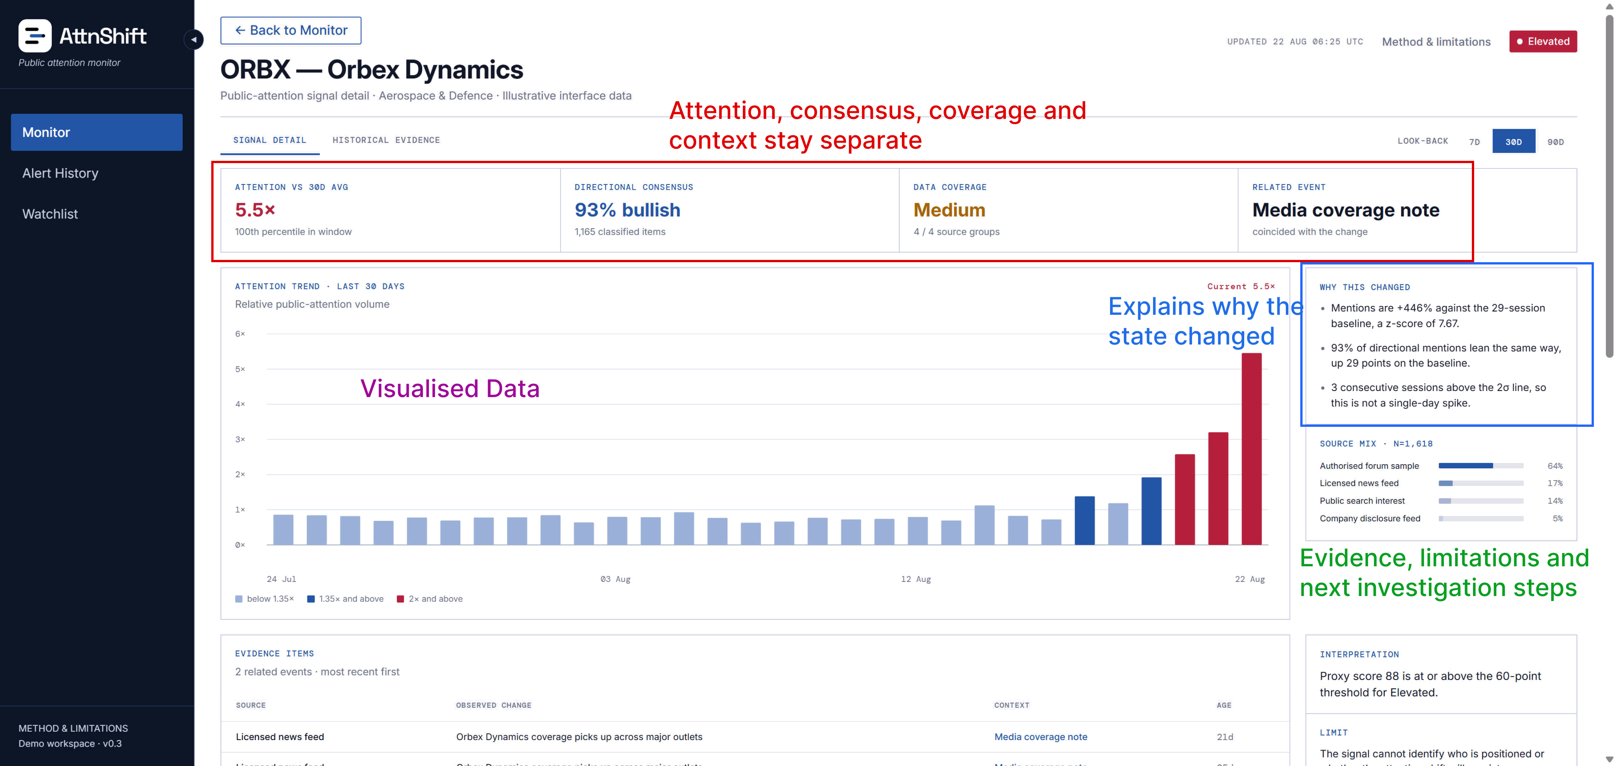

Figure 6. Implemented Signal Detail separates attention, directional consensus, coverage and event context, then exposes the evidence and limitations behind the state.

Final Build status
- Figma prototype complete: Monitor, Signal Detail, Alert History, Watchlist and Method & Limitations.
- Frontend implementation complete for the desktop demonstration flow.
    - Core interactions include collapsible navigation, a closable ticker evidence drawer and linked product views.
- Prototype backend completed and verified on a saved synthetic sample; the frontend can consume the same calculated values through the API.
- Displayed financial values are synthetic demonstration data. A static mobile mock-up is included as a design direction, not a working mobile demonstration.

End-to-end Technical verification
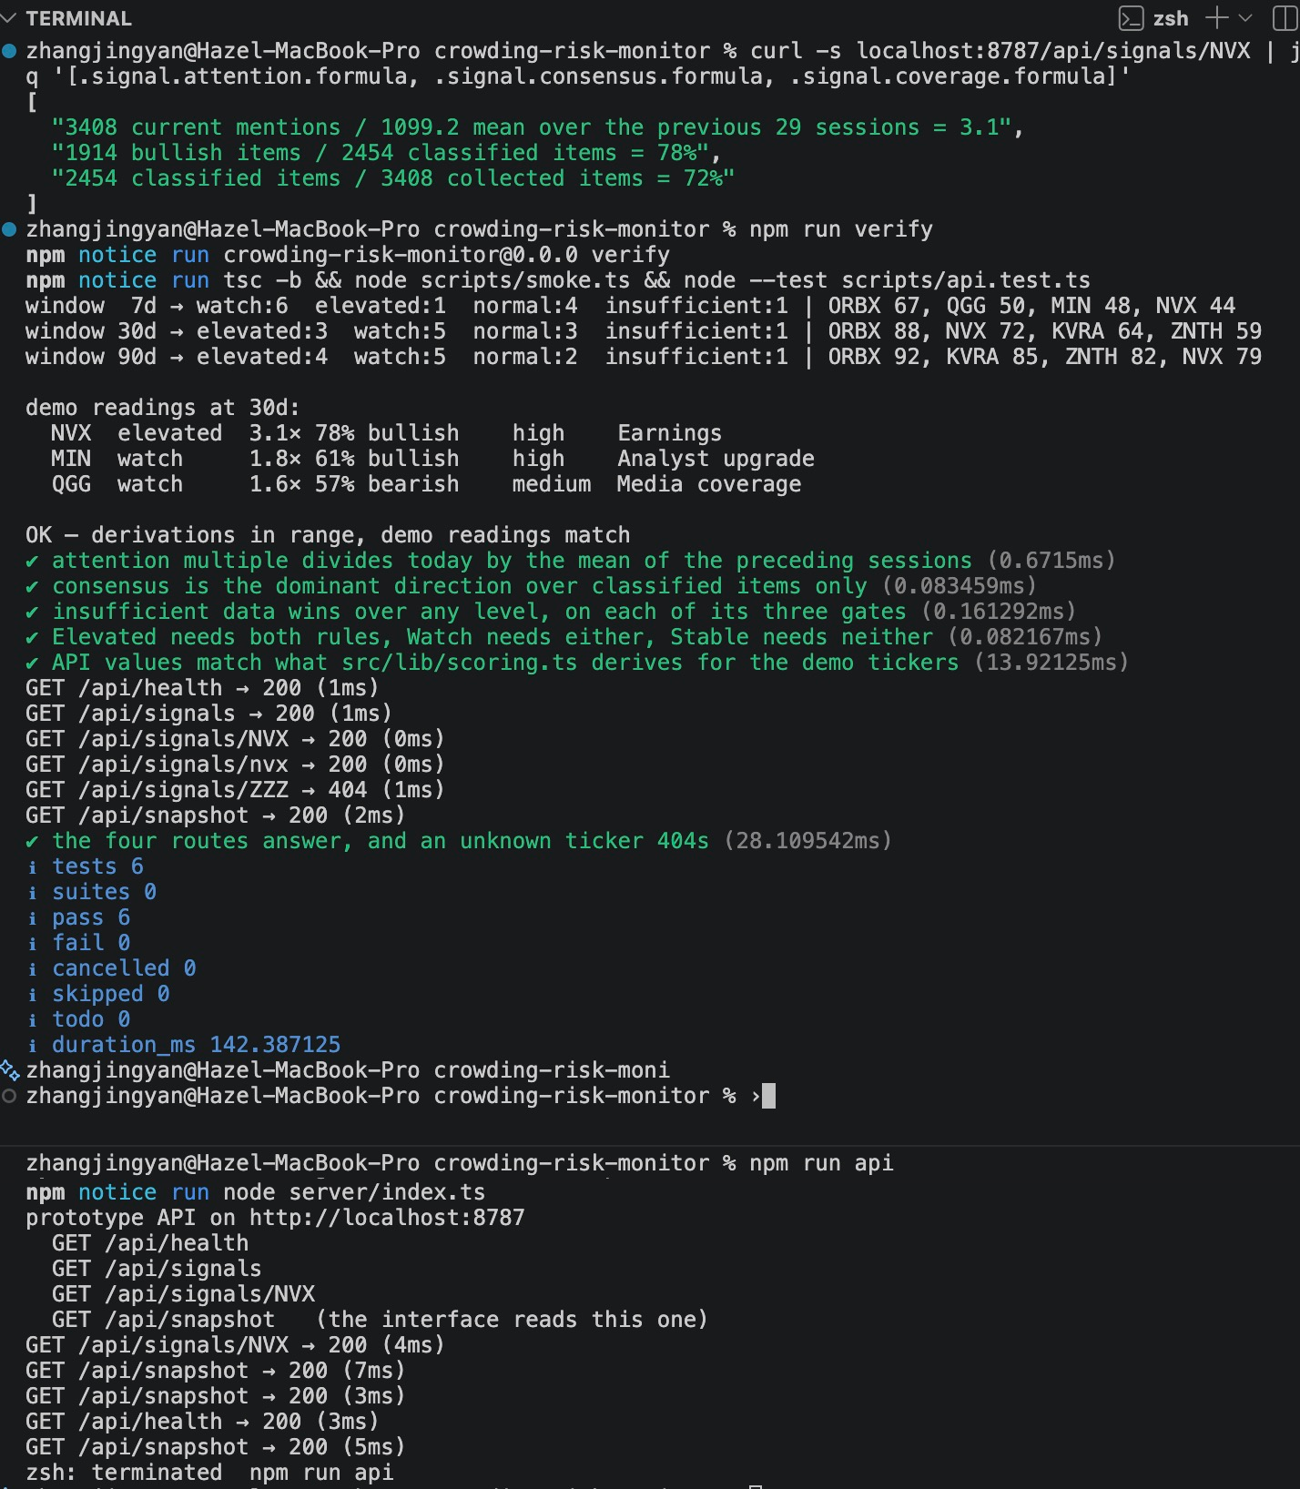
TEST-02 verified the end-to-end path from fixed synthetic inputs through transparent scoring and HTTP responses into the existing interface. The suite passed 6/6 checks and confirmed that changing the lookback window recalculates the result. This proves repeatability and implementation consistency, not predictive performance.
Proof element | Verified implementation
Inputs | 12 fictional tickers across 90 synthetic trading days; generation is rejected if the saved readings cannot be derived by the scoring code.
Transparent score | Attention 45 points + directional consensus 35 + persistence 20, followed by visible coverage and confounder adjustments. No hidden weights.
Window behaviour | The 7-, 30- and 90-day controls recalculate the baseline, score and ranking rather than changing only the label.
API path | Four routes returned the saved snapshot and ticker-level calculations; a missing ticker returned the expected 404 response.
Automated verification | npm run verify passed 6/6 checks, including formula derivation, alert gates and agreement between API values and scoring.ts.
Boundary | This verifies deterministic arithmetic and integration only. All tickers and values are synthetic, and the heuristic has not been empirically validated.

Figure 7. TEST-02 terminal output: the deterministic scoring checks passed 6/6, the API routes returned the expected responses, and the 7-, 30- and 90-day windows produced recalculated results.

Internal design review - TEST-01
An internal review on 22 August checked whether the design matched the evidence and the backend reality. This was a design QA pass, not target-user validation.
- Removed the confidence badge because no agreed calculation supported it.
- Changed Historical Evidence into Alert History, a product activity log.
- Moved Method & Limitations out of primary navigation and kept Data & Methodology as a secondary trust page.
- Filled the monitor's evidence drawer with sample size, source mix, coverage, event context and a path to Signal Detail.
- Added collapsible navigation and a closable evidence drawer without changing the core research flow; mobile remained a static design mock-up.
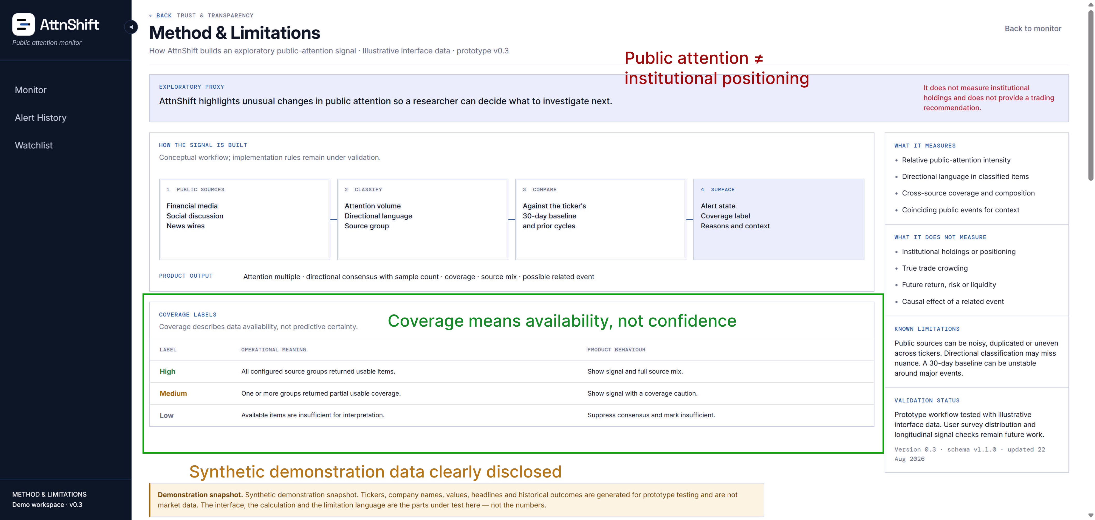
Evidence included: implemented monitor, signal detail and method screens. TEST-02 later verified the deterministic calculation and API path; target-user validation remains incomplete.

Figure 8. Method & Limitations makes the proxy boundary, coverage meanings and synthetic-data status visible inside the product rather than hiding them in documentation.

Cut from the hackathon build
- User registration, avatar and personalised account settings.
- Brokerage, live trading, portfolio management and trade recommendations.
- Production scraping, large ticker coverage and a full backtesting platform.
- An unexplained AI score or a claim that attention equals institutional crowding.

8. Limitations & Future Plan

What remains unproven
- No target practitioner completed an interview, survey or usability test.
- The target segment is a reasoned beneficiary group, not a validated customer segment.
- Public attention is noisy, platform-dependent and vulnerable to duplication or manipulation.
- A 30-day baseline can be unstable around earnings and major market events.
- The prototype does not establish long-horizon usefulness, false-positive rates or predictive performance.

Future work
Next step | What it should answer
User validation | Re-run the survey over a longer window and interview 5-8 interns, alumni or practitioners about their latest real crowding investigation.
Task test | Ask 2-3 relevant users to explain an alert, identify the confounder and decide what they would check next.
Historical test | Use a longer sample, record supporting cases and counterexamples, and separate news effects from attention changes.
Data quality | Define coverage rules, deduplication, source weighting and missing-data behaviour before reintroducing any confidence measure.
Product value | Test whether the screen actually saves investigation time or improves the quality of a hand-off decision.

Sources
[1] G. W. Brown, P. Howard, and C. T. Lundblad, "Crowded trades and tail risk," The Review of Financial Studies, vol. 35, no. 7, pp. 3231–3271, 2022, doi: 10.1093/rfs/hhab107.
[2] F. Packer, A. Schrimpf, V. Sushko, and C. Zarra, "Hedge fund exposure to the carry trade," BIS Quarterly Review, Sep. 2024.
[3] J. A. Cookson, R. Lu, W. Mullins, and M. Niessner, "The social signal," Journal of Financial Economics, vol. 158, Art. no. 103870, 2024, doi: 10.1016/j.jfineco.2024.103870.
[4] B. M. Barber and T. Odean, "All that glitters: The effect of attention and news on the buying behavior of individual and institutional investors," The Review of Financial Studies, vol. 21, no. 2, pp. 785–818, 2008, doi: 10.1093/rfs/hhm079.
[5] Z. Da, J. Engelberg, and P. Gao, "In search of attention," The Journal of Finance, vol. 66, no. 5, pp. 1461–1499, 2011, doi: 10.1111/j.1540-6261.2011.01679.x.
[6] W. Antweiler and M. Z. Frank, "Is all that talk just noise? The information content of internet stock message boards," The Journal of Finance, vol. 59, no. 3, pp. 1259–1294, 2004, doi: 10.1111/j.1540-6261.2004.00662.x.
[7] MSCI, "Crowding Solutions," official product page and Security Crowding Model overview. Accessed: Aug. 22, 2026.
[8] Quiver Quantitative, "Platform, FAQ and API pricing," official product pages. Accessed: Aug. 22, 2026. [Online]. Available: https://www.quiverquant.com/faqs/ and https://api.quiverquant.com/pricing/.

Appendix A – Online Survey
Survey link: https://forms.gle/rrWzCJo4f5D4TB1B7
The form took approximately 2-3 minutes and asked respondents not to share confidential strategies or proprietary company information. No responses were received in the available window.
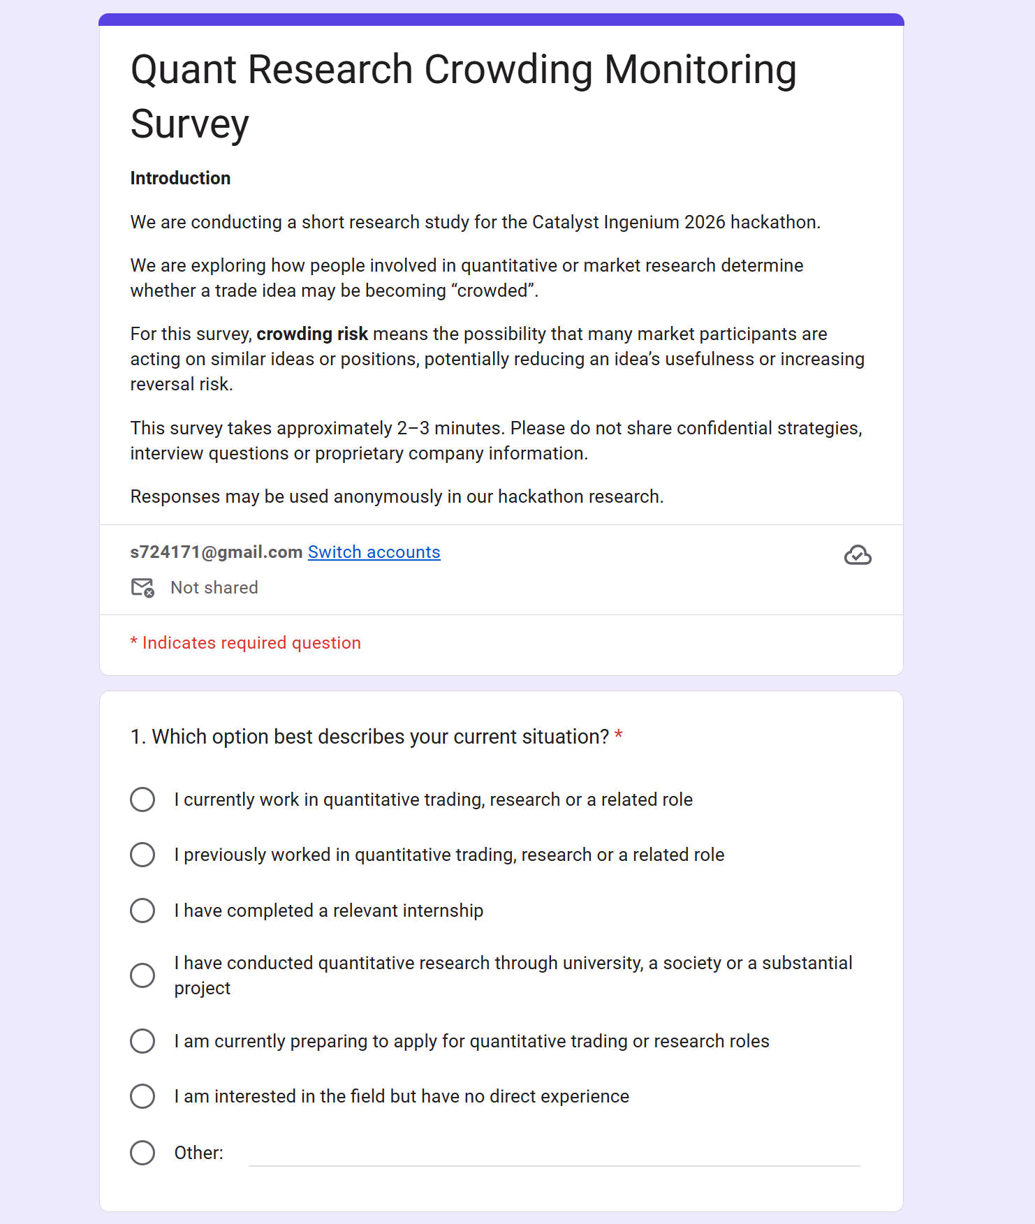
Figure 9. The short survey was designed for rapid hackathon distribution and avoided requests for confidential strategies or proprietary information.
Q1. Which option best describes your current experience?
Q2. In what environment did your most relevant experience take place?
Q3. Have you ever been unsure whether a trade idea or market view was becoming crowded?
Q4. What happened in the most recent situation?
Q5. How did you or your team assess crowding risk?
Q6. What made the assessment difficult?
Q7. What was the main consequence of the uncertainty?
Q8. How significant was the issue in the research workflow?
Q9. What information or support would have made the process easier?
Q10. Would you take part in a short follow-up conversation?

