Final term exam | fall |  | 2026

 | Program: | BS Computer Science -OPEN |  |  |  | Class: | Lab 4
 | Course Name: |  | Data Structure and Algorithm-lab |  |  | Duration: |  | 2.5 hrs
 | Instructor’s Name: |  |  | Abdul Basit Naveed |  | Total Marks: |  |  | 40
 | Course Code: CSCL2102 Date: 4/9/26 _____________

IMPORTANT instructions:
- Students are strictly advised not to bring cell phones/smart watch and/or any kind of electronic devices in the examination hall except for a simple calculator (if allowed). If they bring any such devices in the examination hall, they should make sure that the cell phones/smart watch and/or any other electronic device is properly switched off. Otherwise, a penalty including “F” grade could be awarded.
- Read all the questions carefully first and then ask for clarifications.
- Question paper related queries will not be entertained after 30 minutes for midterm exams and 60 minutes for final exam after the start of the exam.
- Do not write anything on the question paper unless specifically asked to do so by your course instructor.
- Marks of each question are mentioned at the end of each question.

QUESTIONS:
QUESTION 1: (12 marks)
Create a given tree and write a program for preorder inorder and post order.
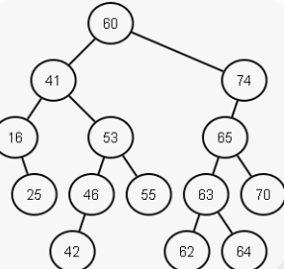

QUESTION 2: (16 marks)
An instructor has a list of student marks stored in an array.
Write a program that:
- Sorts the marks using Bubble Sorting
- Applies Binary Search to find a specific student’s mark entered by the user
- Display whether the mark is found or not. also mention the number of iterations to find the target value.

Question 3: (12 marks)
In a programming lab, a compiler checks whether the parentheses in an expression are balanced or not.
If character is {push and if character is} pop the element.
At the end, if stack empty means, balance parenthesis else not balanced.
Write a program using Stack to check whether a given expression containing parentheses {}is balanced or not balanced.
Example:
- Input: {{{}}} Balanced
- Input: {{}}}}}}} → Not Balanced

