ÖNEMLİ!! ESP32 nin diğerine göre daha fazla dijital pine sahiptir.

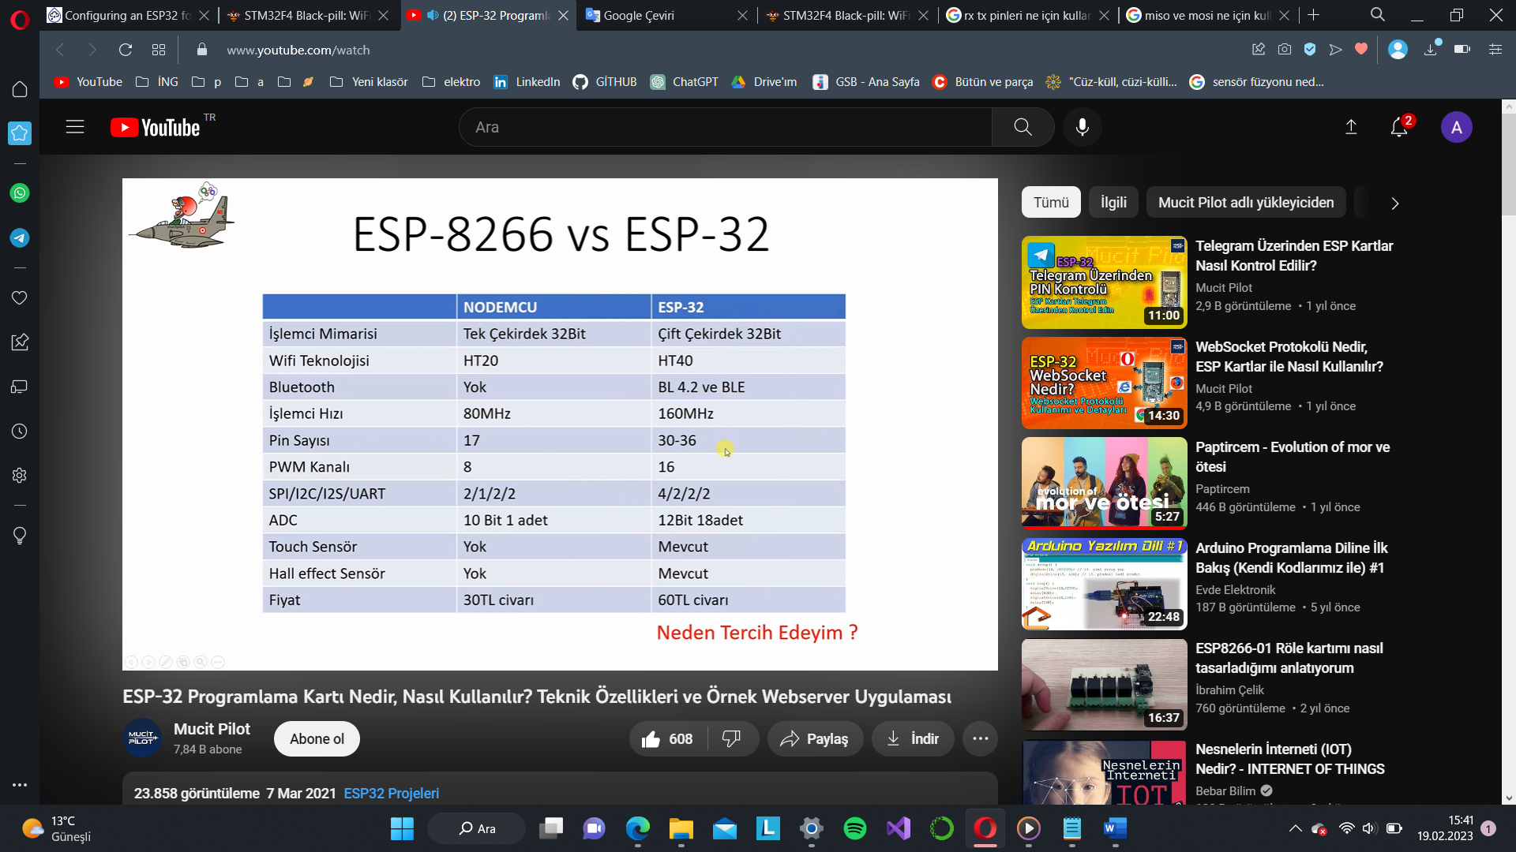

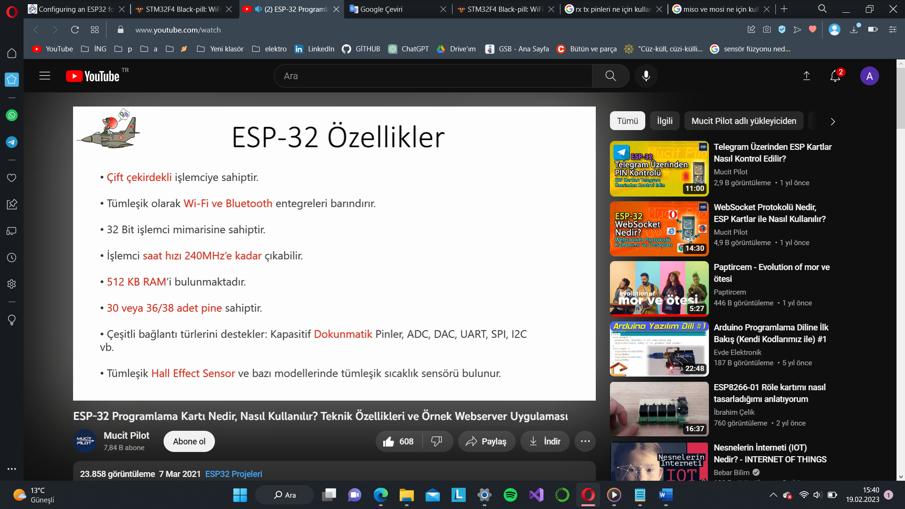

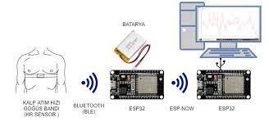

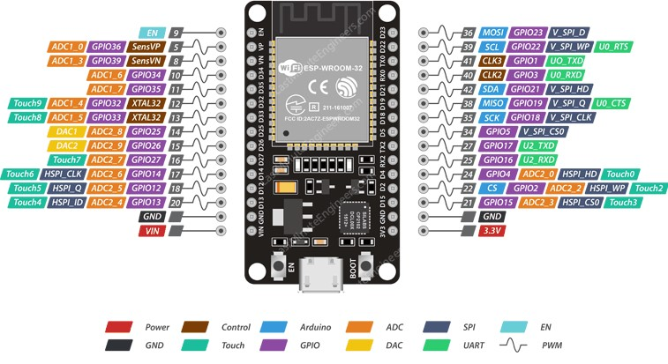

<https://www.espressif.com/sites/default/files/documentation/esp32_datasheet_en.pdf>

gerber dosyası içindeki layersler sayesinde üretici firmalar üretim yapabiliyo.

alt+3:3botutlu çizim

jtag pinleri: programlarken bu pinler üzerinden iletişim kurulur. yani koslar onun üzerinden atılır. (otg)

<https://makeradvisor.com/esp32-vs-esp8266/>

<https://www.espressif.com/sites/default/files/documentation/esp32_datasheet_en.pdf>

<https://www.muratdonmez.com.tr/esp8266-modulu-nedir-ne-ise-yarar/>

<https://medium.com/@zaferaltun/esp8266-wifi-modul-nedir-nasil-kullanilir-neler-yapabiliriz-9216886ef604>

<http://www.elektrobot.net/esp32-kullanimi-arduino-ile-programlama/#:~:text=ESP8266%E2%80%B2%20da%20oldu%C4%9Fu%20gibi%20haz%C4%B1r,uygulamalar%20i%C3%A7in%20de%20kullan%C4%B1ma%20uygundur>.

<https://devreyakan.com/kiyaslama-nodemcu-esp8266-vs-arduino-kartlari/>

<https://akademi.robolinkmarket.com/esp8266-ve-esp32-karsilastirmasi/>

<https://www.utmel.com/components/esp32-vs-esp8266-which-is-better?id=921>

<https://arduinodestek.com/esp32esp-wroom-32-modulu-nedir-ve-ozellikleri-nelerdir/>

<https://www.youtube.com/watch?v=krgToSGEtp0>

<https://www.mischianti.org/2022/09/10/stm32f4-black-pill-wifi-shield-wifinina/>

<https://drugscore.blog.fc2.com/blog-category-6.html>

<https://www.google.com/search?q=stm32f401re+kicad&client=opera&hl=en&sxsrf=AJOqlzXJ6pcYgoqNfeIb6jZo108-_bi3-Q:1676910166847&source=lnms&tbm=vid&sa=X&ved=2ahUKEwikqcKWwaT9AhXEQPEDHRGtAJUQ_AUoAnoECAEQBA&biw=1870&bih=894&dpr=1#fpstate=ive&vld=cid:0ec0d12e,vid:S24RvYZWYUQ>

<https://www.youtube.com/watch?v=aVUqaB0IMh4&t=13s>

<https://www.youtube.com/watch?v=C7-8nUU6e3E&t=1s>

<https://www.google.com/search?q=stm32f401+kicad+pcb&client=opera&hs=Ggw&sxsrf=AJOqlzX84lctuexwtslxsNhoOiNyWDPYAg:1677006019394&source=lnms&tbm=isch&sa=X&ved=2ahUKEwiBwcmgpqf9AhUVR_EDHQqeBa8Q_AUoAXoECAEQAw&biw=1870&bih=894&dpr=1#imgrc=y0L8IVnGnv7xWM>

<https://community.st.com/s/question/0D50X00009XkYDuSAN/hi-what-is-boot0-in-stm32>

<https://refcircuit.com/articles/16-hs402-wifi-android-oscilloscope-esp32-stm32.html>

<https://techoverflow.net/2021/07/26/how-to-connect-esp32-wroom-32-sensor_vp-sensor_vn-pins/>

<https://www.youtube.com/watch?v=1mtisPdA_Vg>

<http://www.robotiksistem.com/jfet_nedir_jfet_cesitleri.html>