On The IoT-based Implementation in The Field of Wireless Controlled Sensor and Network Communications for Home Appliance Control

- Behiye Tarımcı¹, Göksal Adıgüzel², and Asuman Savaşcıhabeş³

¹Özyeğin Universitesi, Turkey
behiye.tarimci@ozu.edu.tr,
²Turkcell İletişim Hizmetleri, Turkey
goksal.adiguzel@turkcell.com.tr
³Nuh Naci Yazgan Universitesi, Turkey
ahabes@nny.edu.tr

Abstract

The Internet of Things (IoT) is a kind of advanced information technology, the IoT attracts the big attention of abroad and domestic experts and scholars and government departments. This paper introduces a Java application which uses the network architecture of the IoT. In this paper we developed an application for wireless control of indoor light and fan. With this study, we aimed to not only remote controlling devices by using web application also we intended to find best web application platform.

1. Introduction

The technology is a great treasure to a certain extent, which helps to facilitate the living conditions of every presence in the universe. The Augment on the Nanotechnology, the embedded systems and the short wave data transmission were fundamental enhancements in the last decade, which made to increase interest and study on the small devices and embedded systems.
The Internet of Things (IoT) concept has evolved rapidly in recent years, which can be seen as an umbrella term for interconnected technologies, devices, objects and services [3]. The Internet of Things also refers to some objects which may link to inform about them, or which transmit information about their state via real-time sensors [4]. The spread of sensor technologies in the past decade has given rise to several ideas and methods [1]. In addition to improvement on sensor technologies, we see the samples of utilization of existing social networking infrastructures and their Web-based APIs in order to integrate Smart Homes to the Web in the researches [2].
We see the development a dynamic trust management protocol samples for the IoT and the applied samples of the monitoring the convergence, accuracy, and resiliency properties of the protocol [5]. With the strong support and guarantee for the IoT technology, a kind of intelligent, accessible and communicative system will be the expected trend of future development [6].
This paper focuses on the specific application of the Internet of Things in the field of wireless sensor networks, including microprocessor and sensor control, web application, device network, system output, and real-time temperature values. Through the introduction of the Internet-of-Things technology, we propose a new concept of the wireless sensor networks Internet-of-Things. Combing with the Java application GUI interface and challenge which the electricity switch and fan information encountered, we analyze that the IoT has obvious advantages in the perceiving, transmission and application of information, and it will have a broad prospect of application in the field of indoor light and device control.
The rest of the paper is organized as follows. Section II includes the system description and technical properties of modules, Section III describes the GUI, experimental results take place in Section IV and finally, Section V concludes the paper.

2. System Description and Technical Properties

This paper presents an application on wireless controlled outputs for both light and machine control. We designed and developed a system based on wireless control mechanism. The GUI controls the system outputs, turning on/off the light and also the other control unit is the fan. The system structure is shown in Fig.1.

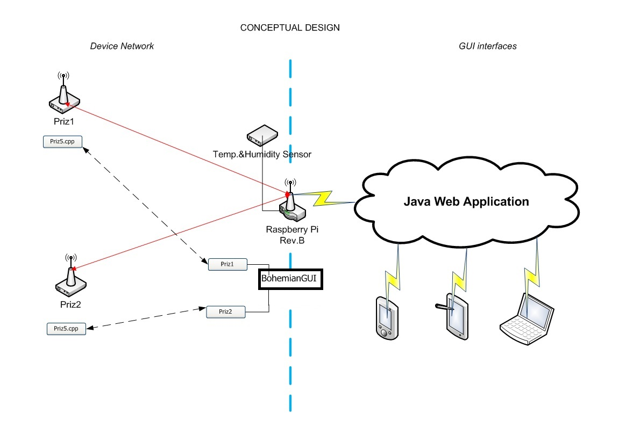

Fig. 1. The shematic view of the system design

Technical details for our system are given in Table.1-3.

Table 1. RaspberryPi-2 MOD B

Specs | Value
Core Architecture | ARM7
Bit | 32
Clock Speed | 900 MHz
RAM | 1GB
Core | Quad
I/O Pin | 40
USB ports | 4
Storage | 8GB SD-card
DC power | 5V Min 600mA

Table 2. Arduino Pro Mini 328

Specs | Value
Core Architecture | Atmel©AVR© 8-bit
Bit | 8
Clock Speed | 16 MHz
Flash Memory | 32 KB
SRAM | 3 KB
EEPROM | 1 KB
I/O PIN | 8A +14D.
Output | 40 mA
DC power | 5-12 V

Table 3. NRF24L01+

Specs | Value
Air Data Rate | 256 Kbps, 1 Mbps, 2Mbps
Clock Speed | 2.4GHz ISM
DC Power | 1.9V-3.6V
Power Consumption | 13.5mA RX at 2 Mbps
 | 900nA Power Down
 | 26 uA in stand by
 | 11.3 mA TX
Channel | 126
Payload | 1-32 Bytes
Data Pipe | Max. 6 nodes star networks
Operating Temperature | -40 +85C
Range | 256 Kbps 100m, 2Mbps 25m

2.1. First Page

In indoor systems wireless communication standards such as IEEE802.11n realize high-speed and reliable transmission [8].

We are currently working on the development of the system structure. The structure is working at ISM band with 2.4 GHz central frequency ad 2Mbps bandwidth to air with maximal distance of 100 meters.

First, the study began with 2Mbps bandwidth and approximately 25m indoor distance was operated successfully, however, due to the very small amount of data transfer, it has become apparent that we don’t need a bandwidth of 2Mbps, thus, in order to increase the distance, we reduced the bandwidth to 256 Kbps and the maximum communication distance then reached to 100 meters.

In the center of the system, we use the Raspberry PI with Linux operating system, which is used as HUB or "Central Management Unit" with the connection accessed via 3G / GPRS or other ADSL or fiber over the Web.

Sockets, sensors or RS232 - RS485 clients are equipped with the "Arduino Pro Mini" model microcontroller cards.

Clients communicate with HUB through Nordic NRF24L01+ transceiver.

Today, the "Zigbee" protocol is commonly used in some areas such as the mesh network, the Smart Home Network, etc. Because of the "Zigbee" increases our of R & D costs and also because of the additional cost of bringing ZigBee development license, Nordic companies’ lower cost of tranciever NRF24L01 + model is preferred in this work.

Also, due allowing development, the development of our own communication protocol continues at the same time.

Basic NRF24L01 procedure is used on the system we are currently working on, but to create an advanced protocol and provide a standard, our development process still continues to take the advantage of all the opportunities of mesh network.

The GUI interface is used to control the two system output over Raspberry Pi mainboard.

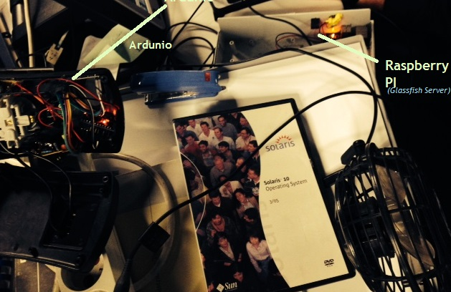

Fig. 2. Fan connection on the system design

3. GUI

In order to manage by remote control of the temperature and power, we developed a controlling API which is named as “Bohemian API”. The Bohemian API is developed by Java EE7 standards and runs on Glassfish Server[9] on Raspberry Pi[10]. The Application contains GUI and Scheduler Application. The GUI application is designed to show humidity and temperature statistics last 10 hours and turn on-off of remote controlling to the connected power devices, the Scheduler part is used to creating alert mechanism like sending email and SMS message.

Running a GUI application in Raspberry Pi, which shows that it is very costly for memory and CPU usage? More lightweight web application is required for similar applications.

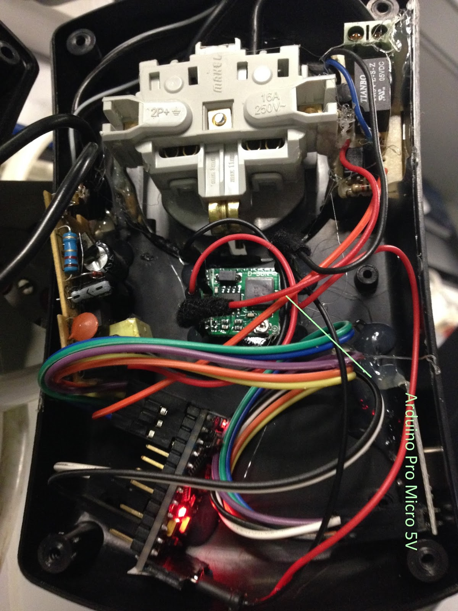

Fig. 3. Microprocessor

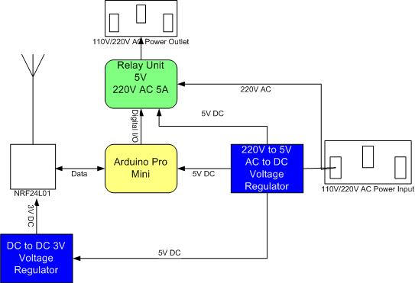
(a)
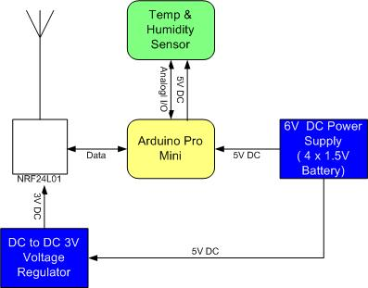
(b)
Fig. 4. System Schematics, (a): Socket
(b): Temperature and humidity sensor unit

4. System Outputs

3.1. Weather Temprature Statistics

The statistics on the temperature and humidity report are given in Fig.5. Every half an hour, the humidity sensor write the humidity value into a specific file, the Scheduler application reads the data and saved into history database. The humidity changes could be seen in the application by using any internet browser. The temperature measurements and history is saved like humidity. The Scheduler application has alert mechanism. When the measured temperature value reaches to a specific value, the application sends an email to the specific users. This threshold value for sending email and the email addresses are determined and configured in the configuration file of the application.

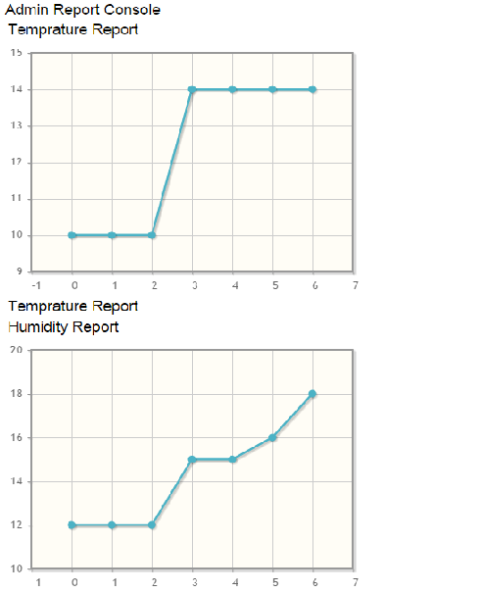
Fig. 5. Sample view of temperature and humidity reports

6. Conclusions

In this work, we determined to configure a new protocol which is automatically configured and used with other transceivers such as NRF24L01, automatically allowing to establish a self-forming network, secure, and allowing to extend NRF24L01’s 6 node star network structure to thousands node.
As a result we see that the communication and interaction of connected devices could be simpler to manage them. The communication standards as architectural standard model and security models are necessarily parts of the Internet of Things. The future work is to replace the application running on the HUB with a Semantic Web based application in order to connect devices with a standard language and protocol.

7. References

[1] P.Doody, A.Shields. “Mining Network Relationships in the Internet of Things.” in the conference of Self-IoT '12: Proceedings of the 2012 international workshop on Self-aware internet of things,2012
[2] A. Kamilaris, A. Pitsillides. “Social Networking of the Smart Home” . In the Conf of the 21st IEEE International Symposium on Personal, Indoor and Mobile Radio Communications (PIMRC 2010), October 2010.
[3] A.Bassi, M. Bauer, M.Fiedler, T. Kramp, R. van K., S. Lange, S. Meissner, “The History and Reasoning Behind the IoT-A Project” Designing IoT solutions with the IoT Architectural Reference Model, 2013
[4] C. Aggarwal, N. Ashish, and A. Sheth. “The Internet of Things: A Survey from The Data-Centric Perspective”, Book Chapter in "Managing and Mining Sensor Data", pp.383-428, Springer, 2013.
[5] F. Bao and Ing-Ray Chen. “Dynamic Trust Management for Internet of Things Applications” in the conference of Self-IoT '12: Proceedings of the 2012 international workshop on Self-aware internet of thing, 2012.
[6] L. Atzori,A. Iera, G. Morabito, “The Internet of Things: A survey”, Computer Networks, vol.54, issue 15, pp.2787-2805, 2010.
[7] K. Ashton, “That ‘Internet of Things’ Thing”, In: RFID Journal,2009. http://www.rfidjournal.com/articles/view?4986
[8] R. Nakamura, Y. Sanada, “Experimental Investigation of IEEE802.11n Reception with Fractional Sampling”, 21stPIMRC Conference Proceedings, pp.1043-1047,2010.
[9] The Glassfish Web Application Server. https://glassfish.java.net/
[10] Debian OS for Raspberry Pi, https://www.raspberrypi.org/downloads/

