**Assignment 5 Student Application Overview**

This Excel application lets users import data from Access files and choose the course for which they want to compute data using a user form. The user can also enter the file path to the desired access file.

In the custom ribbon “Student Grades” you can display the user form using the import button.

Use the clear button to delete all imported data.

The application calculates the final grade for each student upon importing the data.

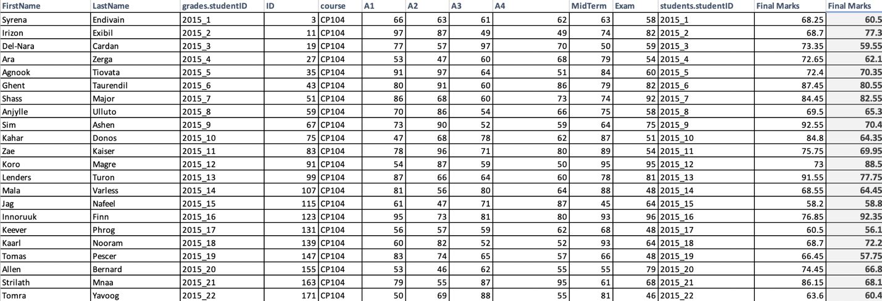

A table that consists of the min, max, mode, median, average, and standard deviation of all course work is created using the data below.

A histogram is formed using data from the created frequency table.

Use the histogram button to create a docx file which contains all the calculated data.